Supplementary Tables and Figures
Table S1. SPICE Survey components
Figure S1. DCE 1 instructions and example
Figure S2. DCE 2 instructions and example
Figure S3. SPICE survey definitions
Figure S4. Predictive margins plots of DCE 1 exploratory outcomes
Figure S5. Predictive margins plots of DCE 2 exploratory outcomes

Table S1. SPICE Survey components

Survey overview
Section overview | Description
Socio-demographic characteristics | Questions regarding participant age, gender, sex, relationship status, employment status, housing status, highest level of education, personal income, and ethnicity.
Clinical and substance use history | Questions related to participants’ past psychiatric and substance use history, including frequency of cannabis consumption, and other substance use.
Acceptability and preferences for types and modalities of cannabis harm reduction interventions | Multiple-choice questions on acceptability and preferences regarding cannabis harm reduction interventions and clinical trial designs
DCE 1: preferences for cannabis harm reduction interventions | DCE 1 on patient preferences regarding interventions and modalities. DCE 1 tested the following attributes (levels in parentheses):  - Preferred session length of an intervention (10 min/30 min/60 min)  - Frequency of sessions of an intervention (daily/weekly/monthly)  - Duration of an intervention (1 month/3 months/6 months)  - Mode of access of intervention (only in person/only technology/combined in-person and technology)
DCE 2: preferences for post-intervention booster sessions | DCE 2 on patient preference regarding booster sessions. DCE 2 tested the choice to opt-in/out to booster session and the following attributes (levels in parentheses):  - Mode of access of booster session (only in person/only technology/combined in-person and technology)  - Frequency of booster sessions (weekly/every two weeks/monthly)  - Duration of booster sessions (1 month/2 months/3 months)
Abbreviation: DCE: discrete choice experiment

Figure S1. DCE 1 instructions and example

Part 4: DISCRETE CHOICE SURVEY 1

Hover your mouse over the underlined words to read their definitions.

In this next section, you will be asked to complete two surveys that will allow us to better understand your preferences.
The first set of questions will identify the characteristics of preventive interventions that you prefer (Survey 1).
The second set of questions will identify the type of booster sessions (popup with definition) you prefer to receive after the intervention (Survey 2).
For each question, you will be given three (3) options. Please choose the option you would prefer.

INSTRUCTIONS
For this first part, we would like you to imagine that healthcare professional is offering you three (3) different intervention options to help you change your cannabis use habits.

The intervention options will change according to the following characteristics:

- SESSION LENGTH:
This is how long each session would last during the intervention.
In the survey, the following options will be offered:

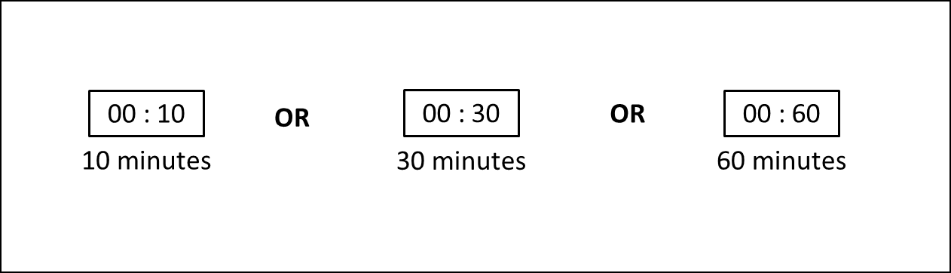

- INTERVENTION FREQUENCY:
This is the how often sessions would take place during the intervention period.
In the survey, the following options will be offered:
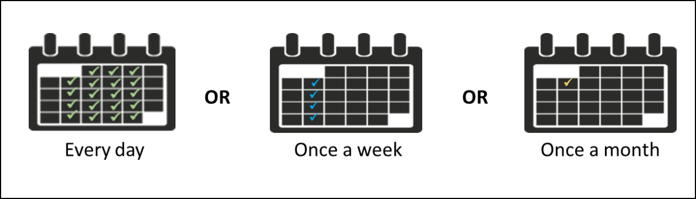

- INTERVENTION DURATION:

This is the total duration of the intervention.
In the survey, the following options will be offered:

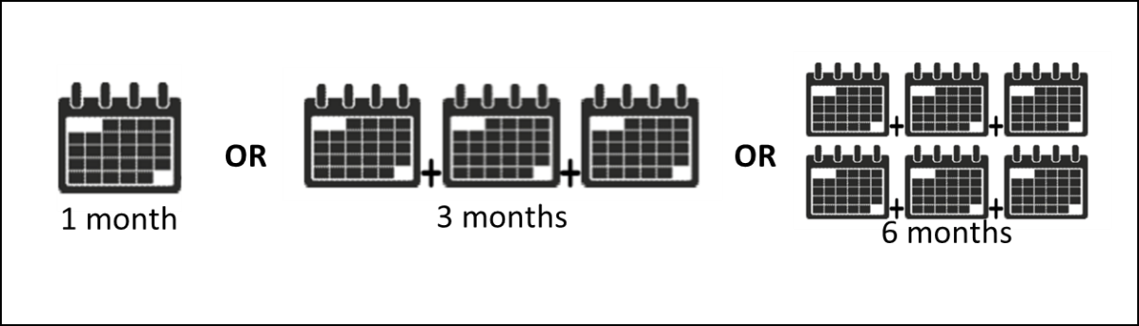
- PREFERRED FORM OF ACCESS TO THE INTERVENTION:

This is how you would prefer to access the intervention.
In the survey, the following options will be offered:
*Technology-based intervention (popup with definition)
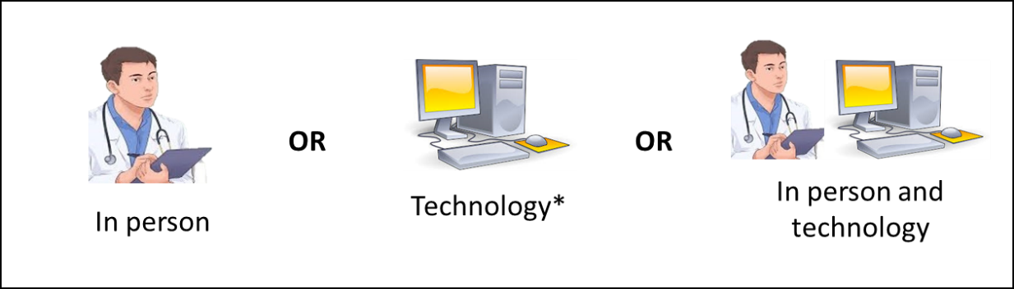
Click < NEXT > to start.
DCE 1 EXAMPLE SCENARIO

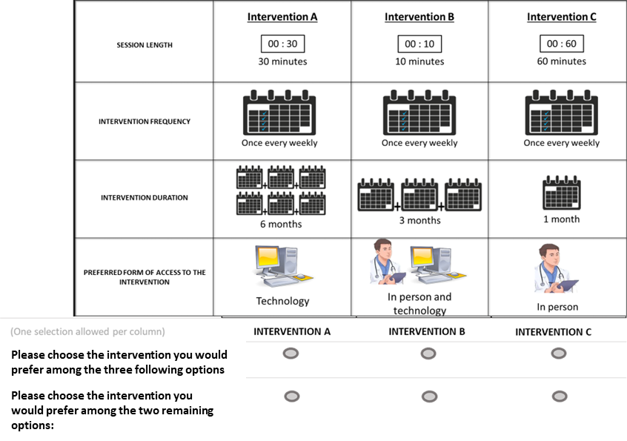

Figure S2. DCE 2 instructions and example

DISCRETE CHOICE SURVEY 2

Hover your mouse over the underlined words to read their definition.

A BOOSTER SESSION (popup with definition) is an intervention session offered after the main intervention has ended that aims to maintain over the long-term the skills, knowledge and changes you acquired during the intervention.
For this second part, we would like you to imagine that a healthcare professional is offering you the option to choose between three (3) different booster session (popup with definition).

The booster session (popup with definition) options will change according to the following characteristics:

- BOOSTER SESSION (popup with definition) FREQUENCY:
This is how often booster sessions would take place after the intervention.
In the survey, the following options will be offered:

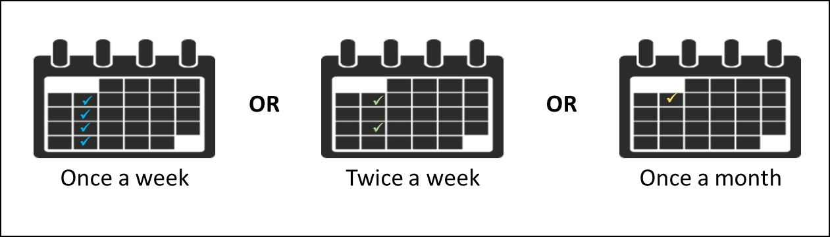
2. BOOSTER SESSION (popup with definition) DURATION:

This is the total duration of the booster sessions (popup with definition) after the intervention.
In the survey, the following options will be offered:

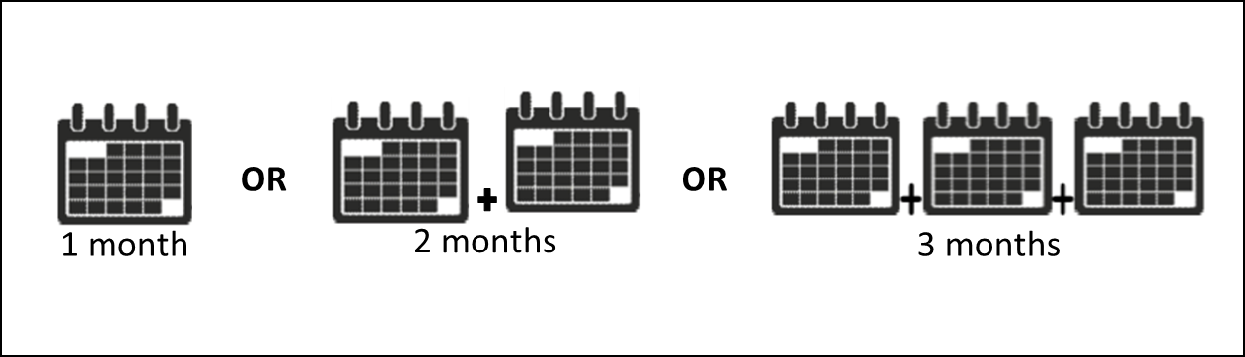

3. PREFERRED FORM OF ACCESS TO THE BOOSTER SESSION (popup with definition).

This is how you would prefer to access the booster session (popup with definition).
In the survey, the following options will be offered:
*Technology-based session (popup with definition)

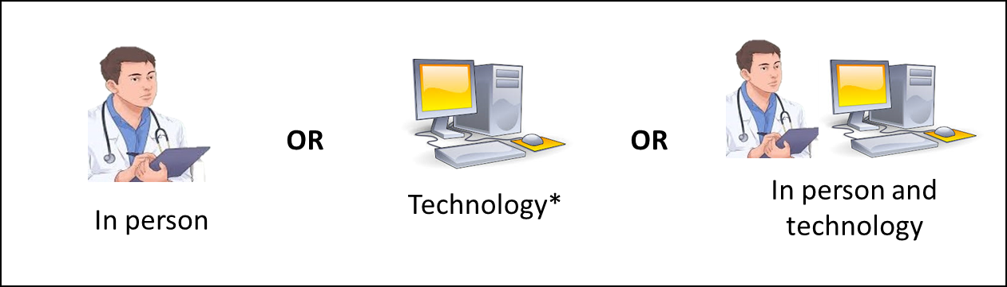
Click < NEXT >.

DCE 2 EXAMPLE SCENARIOª:
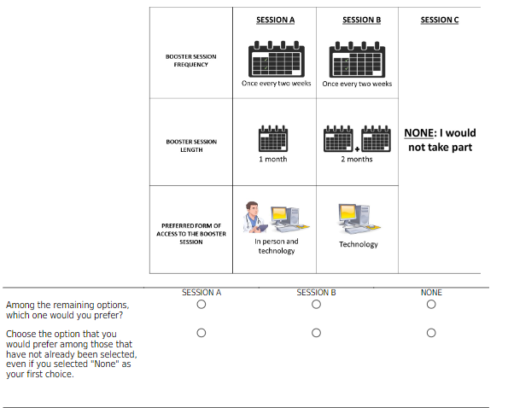

Footnotes:
a: The first prompt for English participants read “Among the remaining options…” instead of “Among the following options…”, which was an error that occurred when we translated the DCE 2 survey from French to English. Participants then had to select Session A, Session B or None. Once participants responded to the first prompt, they were given the second prompt “Choose the option…”

Figure S3. SPICE survey definitions

DEFINITIONS

- Stable housing is defined here as living in a room, an apartment or a house, or with your family, for a period of 6 months or more from the start of the accommodation until its planned end.

- A motivational interviewing intervention is a therapeutic intervention that uses collaborative conversation to strengthen your motivation for and commitment to behavioural change (for example, cannabis use).

- A family-based intervention is a group intervention that involves your family members and aims to help you or your family function better. In this case, it could be used to help you change a certain behavior, such as cannabis use.

- Cognitive-behavioural therapy is a form of therapy that can help you recognize and change the thoughts, attitudes, beliefs and emotions that may lead you to develop certain behaviours such as cannabis use.

- Brief interventions are short interventions that help you make informed choices about your cannabis use.

- Medication therapy is a medication taken to treat certain physical or psychological conditions.

- A booster session is an intervention session offered after the main intervention has ended, and which aims to help maintain the skills, knowledge and changes you have acquired during the intervention period.

- Technology-based intervention (using technology) is an intervention provided through an application or a website, is accessible via smartphones, videos, social media, virtual reality, games, etc., and that can be done at the clinic, where you live or in public spaces.

Figure S4. Predictive margins plots of DCE 1 exploratory outcomes

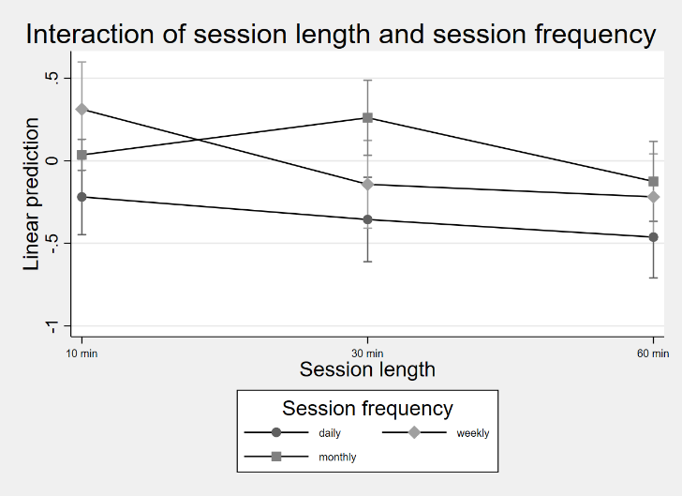
Figure S4A. Predictive margins plot for interaction of DCE 1 attributes session length x session frequency

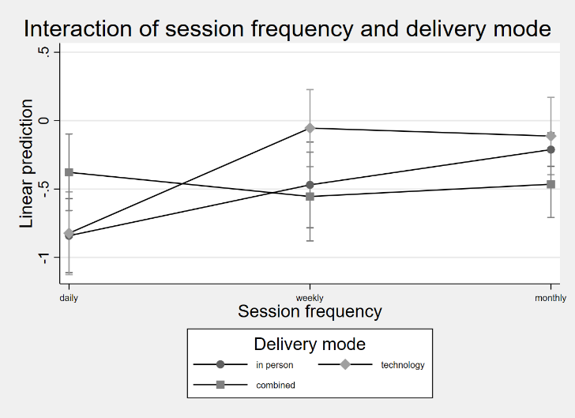
Figure S4B. Predictive margins plot for interaction of DCE 1 attributes session frequency x delivery mode

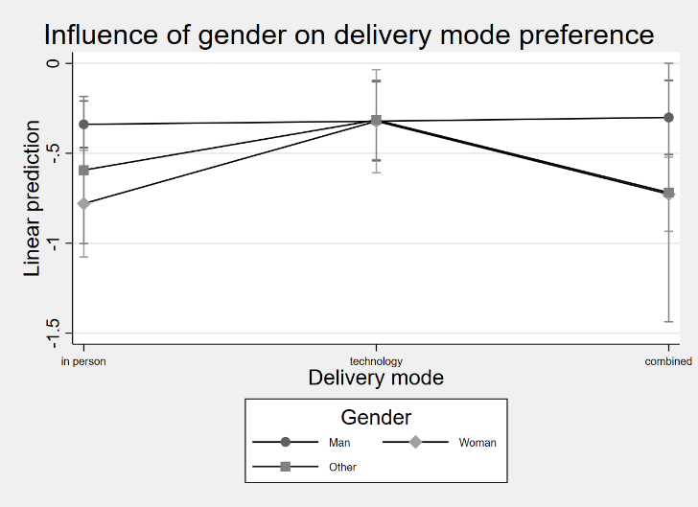
Figure S4C. Predictive margins plot exploring influence of gender on preference for delivery mode

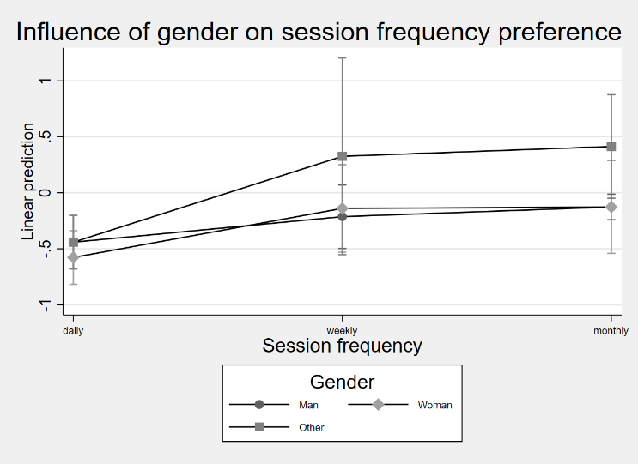
Figure S4D. Predictive margins plot exploring influence of gender on preference for session frequency

Figure S5. Predictive margins plots of DCE 2 exploratory outcomes

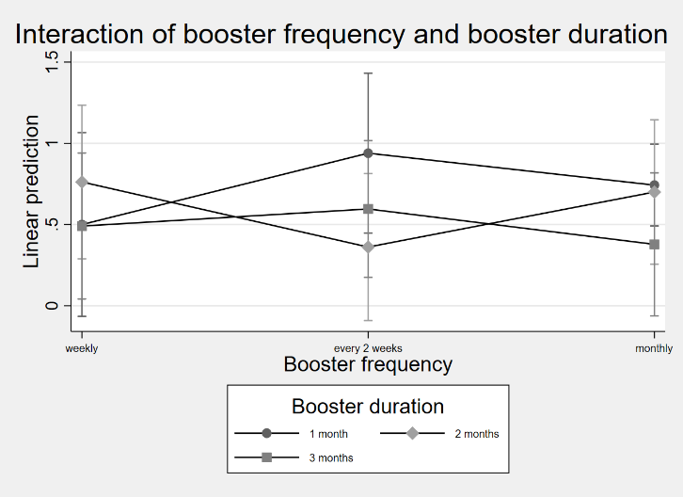
Figure S5A. Predictive margins plot for interaction of DCE 2 attributes booster frequency x booster duration

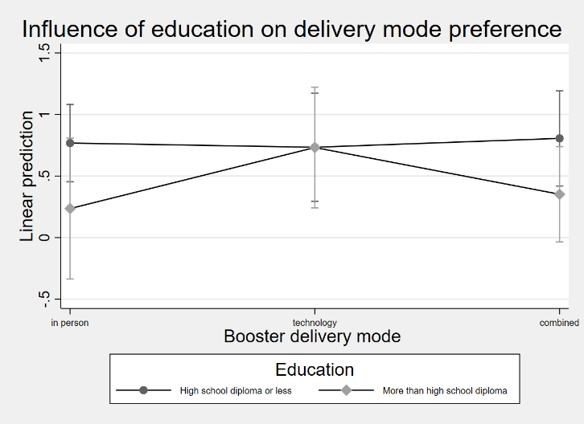
Figure S5B. Predictive margins plot exploring influence of education on preference for booster delivery mode

