Supplementary Material

Table S1: Key physical and chemical properties of the soil used as pot substrate for the trial.
Property | Value
Silt (%) | 65
Sand (%) | 15
Clay (%) | 20
pH | 8.15
Organic Matter (%) | 1.77
N (%) | 0.11
C/N | 9.72
CEC (cmol (+) kg⁻¹) | 15.4
Total P (mg P₂O₅ kg⁻¹) | 810
Available P (mg P₂O₅ kg⁻¹) | 8.46
Exchangeable K (mg K₂O kg⁻¹) | 59.9
Exchangeable Mg (mg kg⁻¹) | 247
Exchangeable Ca (mg kg⁻¹) | 2,619
Exchangeable Na (mg kg⁻¹) | 26.1
Total S (mg kg⁻¹) | 408

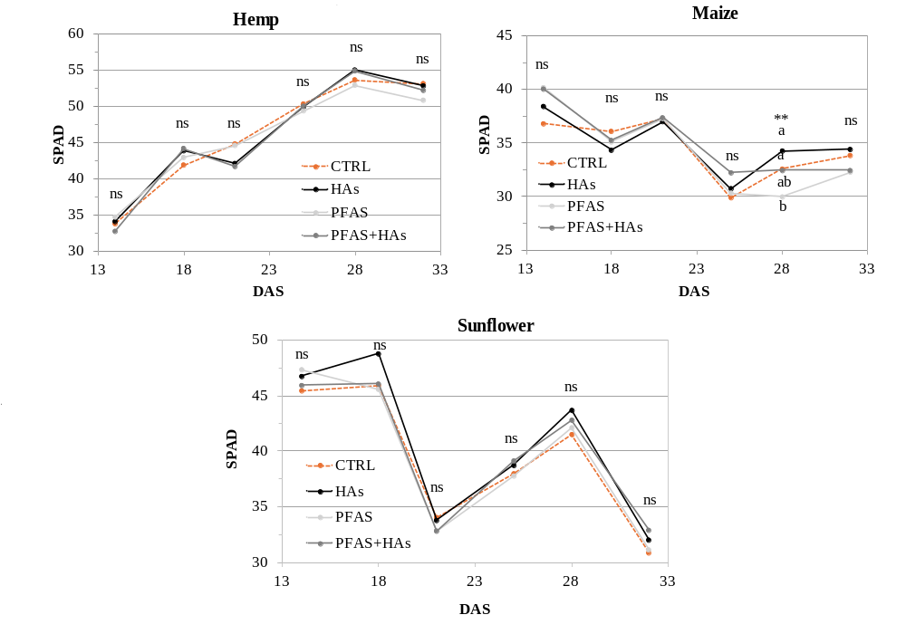
Figure S1: Dynamics of foliar chlorophyll content, expressed as Soil Plant Analysis Development (SPAD) values, in hemp (mean±S.E.; n=6), maize and sunflower plants (mean±S.E.; n=3) under CTRL (control), HAs (humic acids), PFAS (soil contamination), and PFAS+HAs (soil contamination + humic acids) treatments. Within each date (DAS, Days After Sowing), asterisks indicate significant differences among treatments (* p≤0.05; ** p≤0.01; *** p≤0.001; n.s.=not significant). Letters: statistical comparison among treatments within the same date (Tukey’s test, p≤0.05).

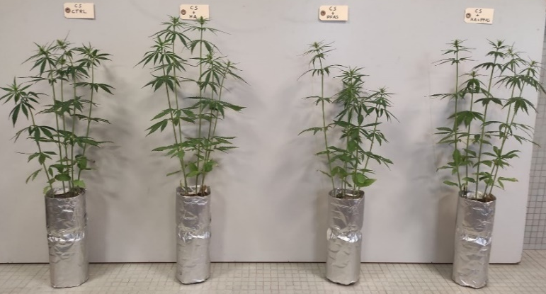
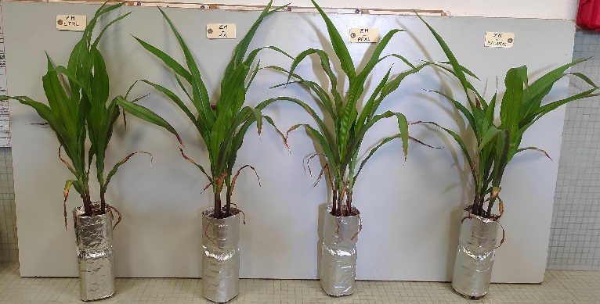
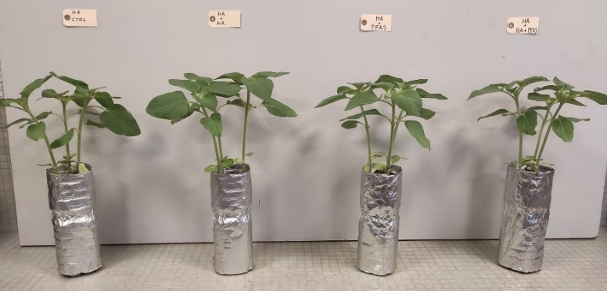
Figure S2: Visual representation of treatments at the end of the experiment (32 DAS). From left to right: CTRL (control), HAs (humic acids), PFAS (soil contamination), and PFAS+HAs (soil contamination + humic acids) in hemp (top), maize (middle) and sunflower (bottom).
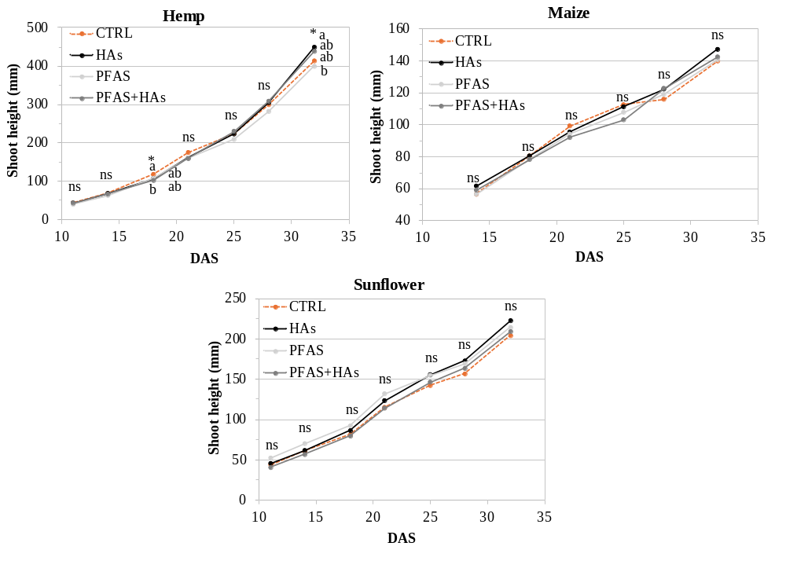
Figure S3: Dynamics of shoot height in hemp (mean±S.E.; n=6), maize and sunflower (mean±S.E.; n=3) under CTRL (control), HAs (humic acids), PFAS (soil contamination), and PFAS+HAs (soil contamination + humic acids) treatments. Within each date (DAS, Days After Sowing), asterisks indicate significant differences among treatments (* p≤0.05; ** p≤0.01; *** p≤0.001; n.s. = not significant). Letters: statistical comparison among treatments within the same date (Tukey’s test, p≤0.05).

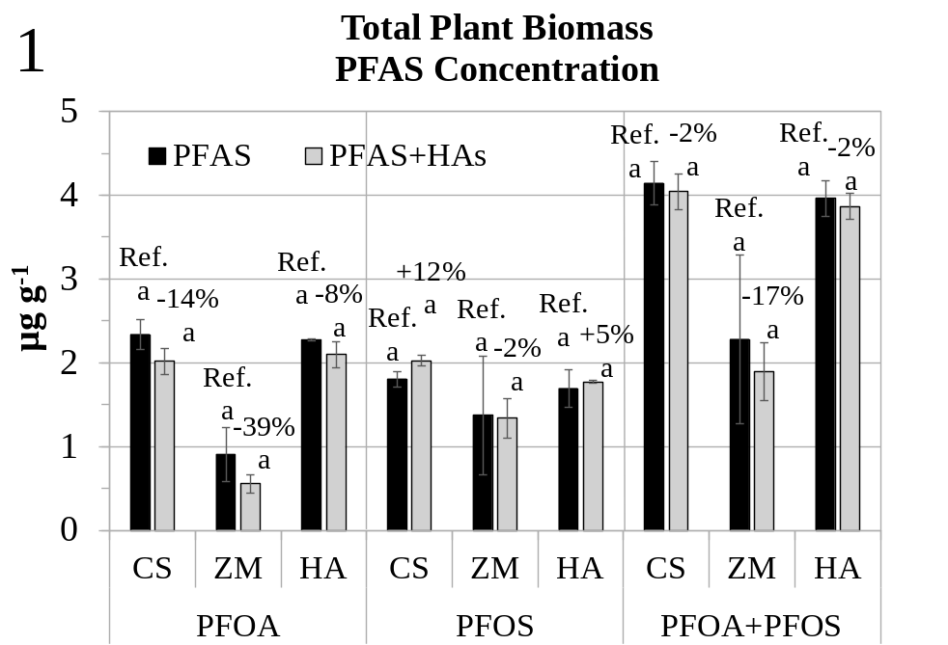
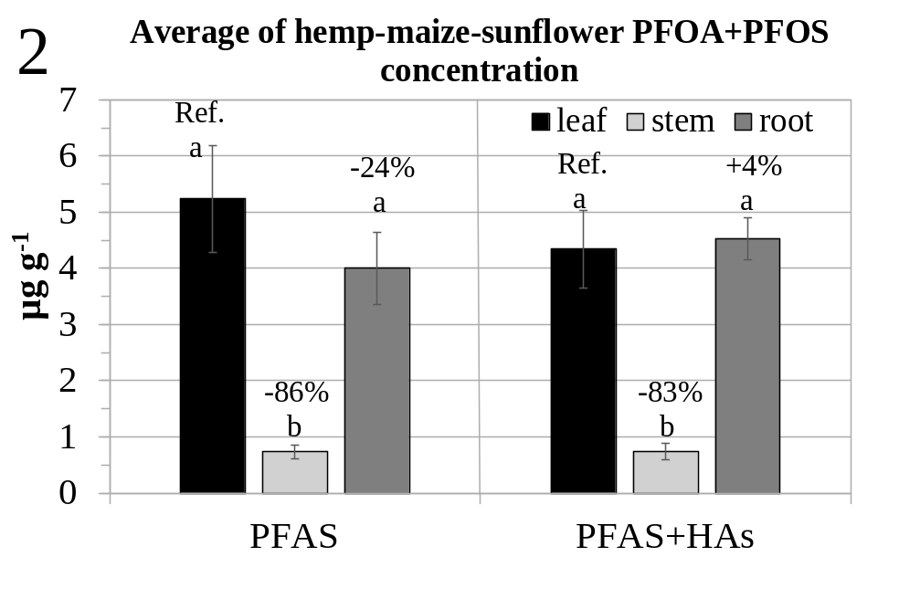
Figure S4: Panel 1 shows PFOA, PFOS and PFOA+PFOS concentrations in total plant biomass of hemp (CS) (mean±S.E.; n=6), maize (ZM) and sunflower (HA) (mean±S.E.; n=3), and panel 2 shows PFOA+PFOS concentrations in leaves, stems and roots as an average of the three species (main effect) (mean±S.E.; n=12) under PFAS (soil contamination) and PFAS+HAs (soil contamination + humic acids) treatments. Percentages: variations vs. reference (Ref.). Letters: statistical comparison within the factor under study namely treatment in Panel 1 and tissue Panel 2, (Tukey’s test, p≤0.05).
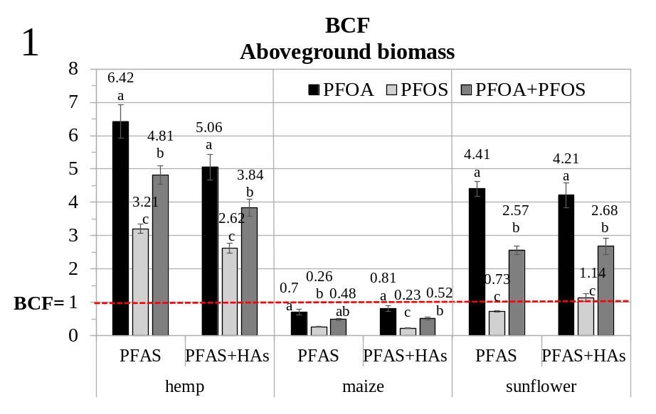

Figure S5: Aboveground biomass bioconcentration factor (BCF) of PFOA, PFOS and their sum in hemp (mean±S.E.; n=6), maize and sunflower plants (mean±S.E.; n=3), under PFAS (soil contamination) and PFAS+HAs (soil contamination + humic acids) treatments. BCF values are reported above bars. Letters: statistical comparison among PFOA, PFOS and PFOA+PFOS (Tukey’s test, p ≤ 0.05). The horizontal dashed red line indicates reference line at BCF=1.

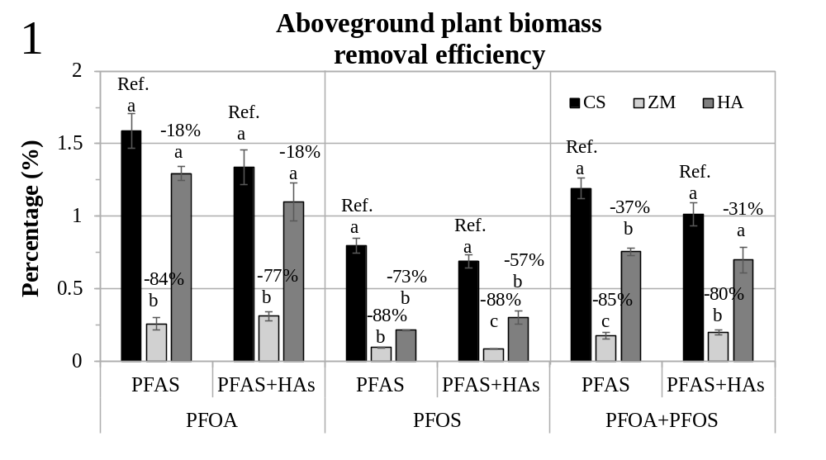
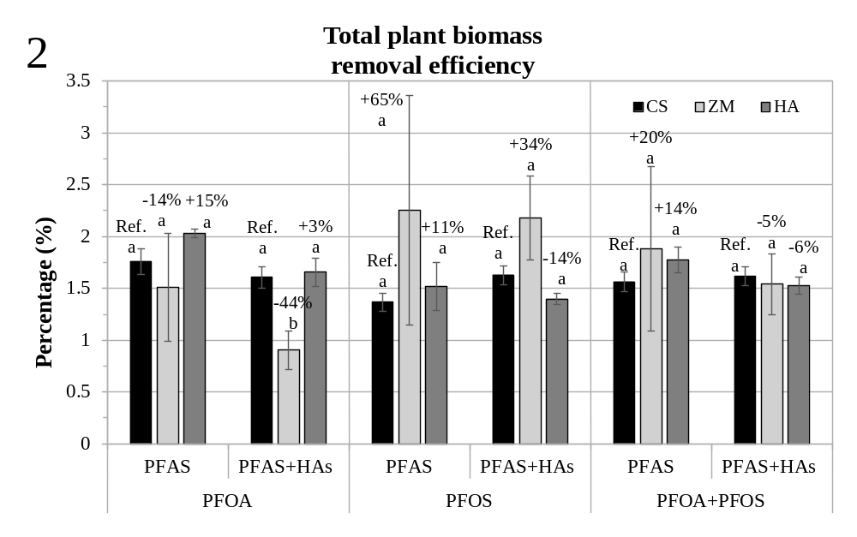
Figure S6: Panel 1 shows the aboveground plant biomass removal efficiency (%) and panel 2 shows the total plant biomass removal efficiency (%) of PFOA, PFOS and PFOA+PFOS in hemp (CS) (mean±S.E.; n=6), maize (ZM) and sunflower (HA) plants (mean±S.E.; n=3) grown in a pot, under PFAS (soil contamination) and PFAS+HAs (soil contamination + humic acids) treatments. Percentages: variation vs. hemp (Ref.). Letters: statistical comparison among plant species (Tukey’s test, p ≤ 0.05).

