Supplementary materials

Appendix 1. Details of measures
Scoring of variables
For cannabis, the most intensive period of use over the last 12 months was scored as zero (none), one (less than weekly), two (weekly) or three (daily). Tobacco smoking was scored zero (absent) or one (present).
The CTQ-SF is a retrospective self-report questionnaire that originally consisted of 25 items. However, in our study, the item “molestation” was removed due to improper translation into Dutch. The CTQ-SF thus consisted of 24 items, that are scored on a Likert scale from one (never true) to five (always true). The CTQ-SF measures five different types of childhood maltreatment: physical neglect, physical abuse, emotional neglect, emotional abuse, and sexual abuse.

Details of cognitive tests
To assess verbal memory, the delayed recall score of the Auditory Verbal Learning Test (Brand & Jolles, 1985) was used. To measure attention, we used the sensitivity measure of the continuous performance test-HQ (Rosvold et al., 1956). To assess processing speed, working memory, and reasoning/problem solving, respectively the scaled scores of the WAIS-III Digit symbol substitution, the WAIS-III arithmetic, and the WAIS-III block design test (Wechsler, 1997) were used. Finally, as an addition to the MATRICS domains, we included visuoperception, as measured with the Benton Facial Recognition Test (Benton et al., 1983). See Table 1 for the test-retest reliability of all cognitive tests.

Table 1
Test-retest reliability of the cognitive tests
Test | Test-retest reliability | Reference
Auditory Verbal Learning Test | > 0.7 | (Geffen et al., 1994)
Continuous performance test | > 0.65 | (Halperin et al., 1991)
WAIS-III Digit symbol Test | > 0.75 | (Iverson, 2001)
WAIS-III Arithmetic | > 0.75 | (Iverson, 2001)
WAIS-III Block design | > 0.75 | (Iverson, 2001)
Benton Facial Recognition Test | > 0.6 | (Albonico et al., 2017)
Note. This table shows the minimum test-retest reliability per cognitive test. No one number can be reported because the test-retest reliability is investigated in multiple samples, and therefore differs.

Appendix 2. Plausible value imputation
Why? The questionnaires we used to assess childhood trauma and psychopathological symptoms consist of many items. Because estimating a network with all these items included separately would result in an unstable and uninterpretable network we decided to aggregate the data into sum scores that represent the latent variables of childhood trauma, positive, negative, and depressive symptoms. However, directly using sum scores of Likert scales as indications of latent variables is problematic, because the labels of the initial items are meaningless and sum scores do not take into account the uncertainty of the latent variable estimation. De Ron et al. (2022), showed that the most precise way to estimate a network with unobserved (latent) variables is by directly estimating a network on the implied latent variance-covariance structure of the data. However, this approach is very computationally expensive.
We therefore took a different approach, inspired by Marsman et al. (2016). Note first that network analysis would be straightforward if the latent variable would have been observed. It would then simply be one of the variables in the network. Of course the latent variables are not observed, and we need to estimate them from the data at hand. In the context of latent variable modelling, specifically item response theory modelling, it is well-known that the maximum likelihood (ML) estimates are biased, and using these estimates as stand in for the real latent variable lead to biased estimates of population quantities (Mislevy, 1991). The problem with the ML estimates is that they crucially miss the fact that we have “measured” the latent variable with uncertainty. In this context, plausible values have proven to be a much more convenient estimator. A plausible value is a draw from the posterior distribution of the latent variable. It captures the uncertainty that we have about the latent variable. Importantly, these plausible values allowed us to analyse the latent variables as if they would be observed (Marsman et al., 2016). We used these plausible values as stand in for the latent variable in the network.
How? To create the plausible values, we first estimated an item response theory model to the observed ordinal variables. We estimated a generalized partial credit model (GPCM; Muraki, 1990) using the mirt package (Chalmers, 2012). We used the “Davidian-6” option for the latent variable distribution, as it is a liberal distribution for the latent variables using semi-parametric Davidian curves (Woods & Lin, 2009). We fixed the item parameters of the GPCM, and used these to generate the plausible values. We used a Metropolis method with matching kernels described by Marsman et al. (2017) to generate the plausible values. As a prior for the latent variable, we used a mixture of normal densities because it allows for fast convergence of the plausible distribution ((Marsman et al., 2016). We generated a hundred plausible values per latent variable for each person, which resulted in hundred datasets. The different plausible values for an individual convey the uncertainty associated with its estimation. Although this method is suboptimal compared to the latent network modelling, it is currently the most feasible way to approximate it. The code that was used to impute the plausible values can be found in Box 1.

Appendix 3. Missing data
Of our full sample of 2,064 participants, 1,516 participants had no missing data on the 12 variables used in the current study. 548 participants had missing values on at least one of the variables. We examined the correlations between missingness and scores on the remaining variables, and found no correlations above 0.1. The table with all correlations can be found in Table 2. We also investigated differences between participants with complete and incomplete data, and found an expected difference in status, with the incomplete group having a slightly higher proportion of patients than the complete group. We also found that the incomplete group had slightly higher frequency of cannabis use, cigarette smoking, CTQ scores and slightly lower scores on the WAIS digit-symbol substitution task. These differences could be explained by the fact that the incomplete group had a higher proportion of patients than the incomplete group. Scores on all other variables, including demographic variables, did not differ between the incomplete and complete groups. A table with all de differences between participants with complete and incomplete data can be found in supplementary materials Table 3.

Appendix 4. Outliers
No outliers were removed because all tests were performed under supervision. Therefore, we expected that any extreme values represent real scores that we were interested in. We did remove three extremely low values of the Benton facial recognition test that appear to have been caused by a data entering mistake.

Appendix 5. Result of sensitivity analyses
As expected, the networks with a prior of 0.25 and 0.75 on the network structure showed approximately the same structure as the network with a prior of 0.5, with only small differences in the number of included connections with small edge weights. The visualized networks can be found in supplementary materials, Figure 8-9. The networks of patients and siblings without controlling for SFS differed somewhat from the controlled networks. These visualized networks, associated inclusion probabilities, and edge weights can be found in supplementary materials, Figure 10-14.

Table 2.
Correlations between missingness and scores on remaining variables
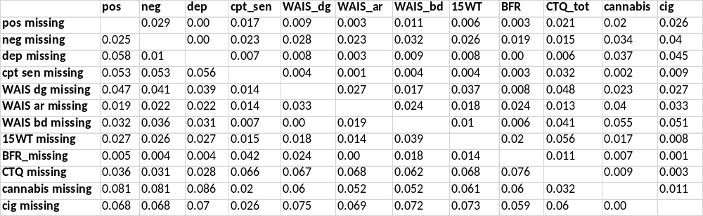

Table 3.
Mean scores and p-values of differences between participants with complete and incomplete data
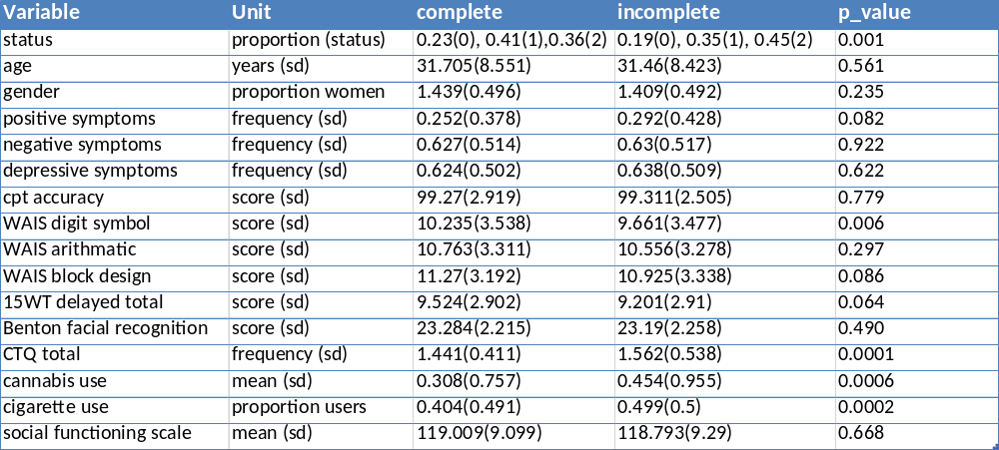

Figure 1.
Schematic overview of methods.
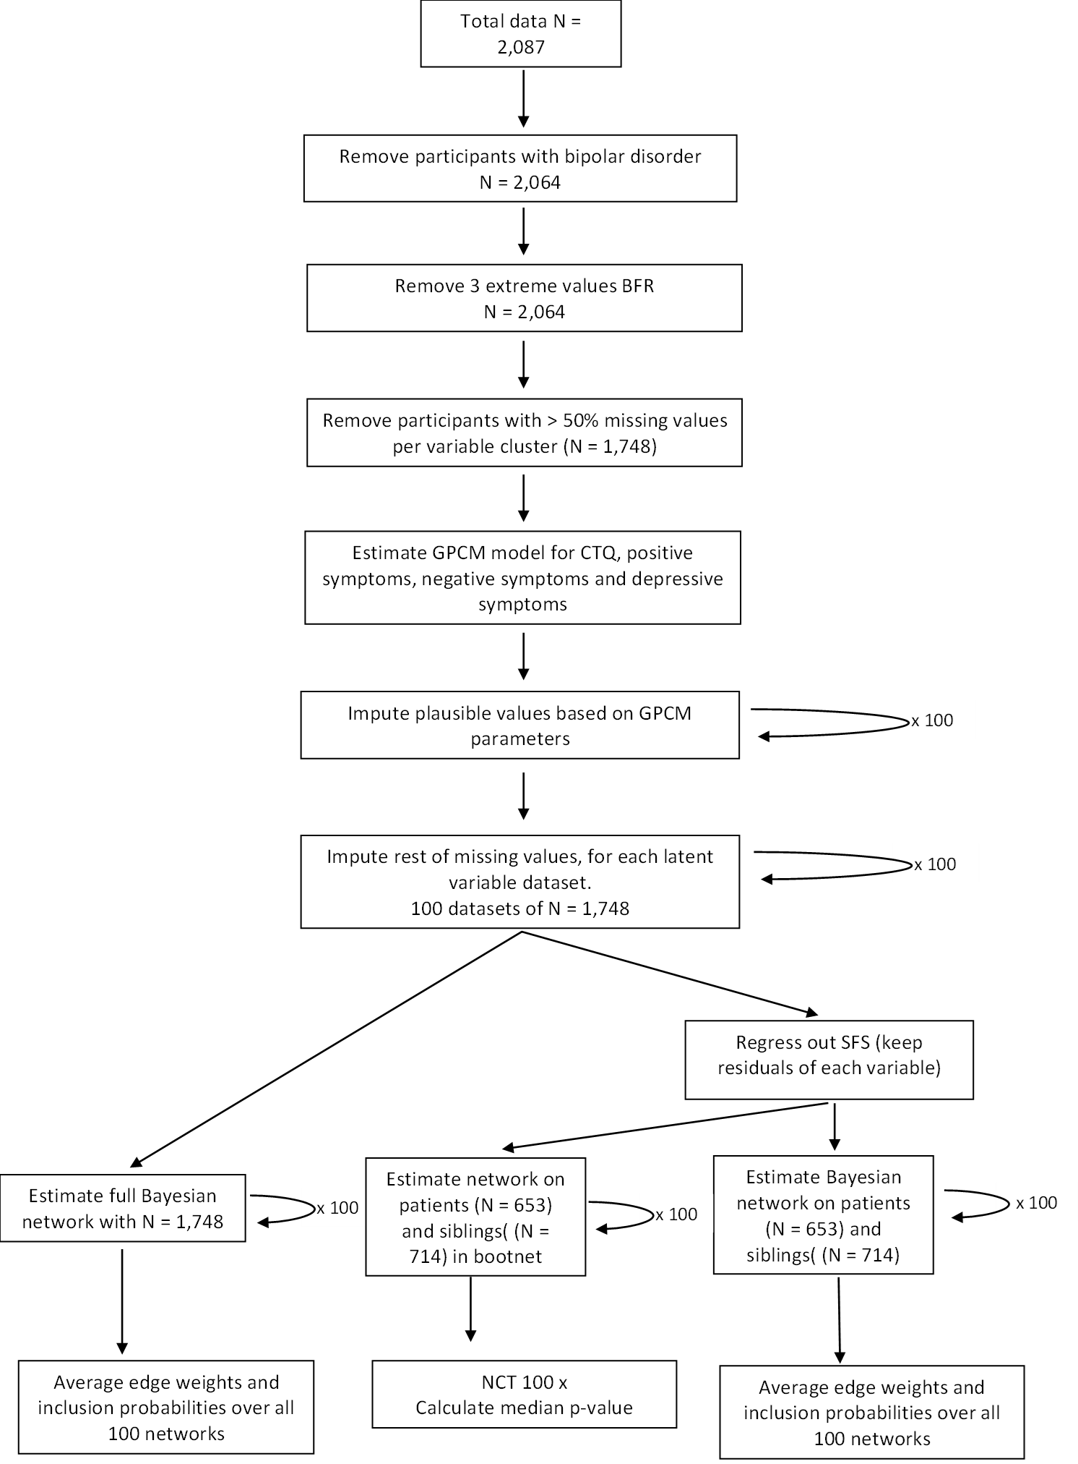
Figure 2
HDI of estimated edge weights in all 100 samples
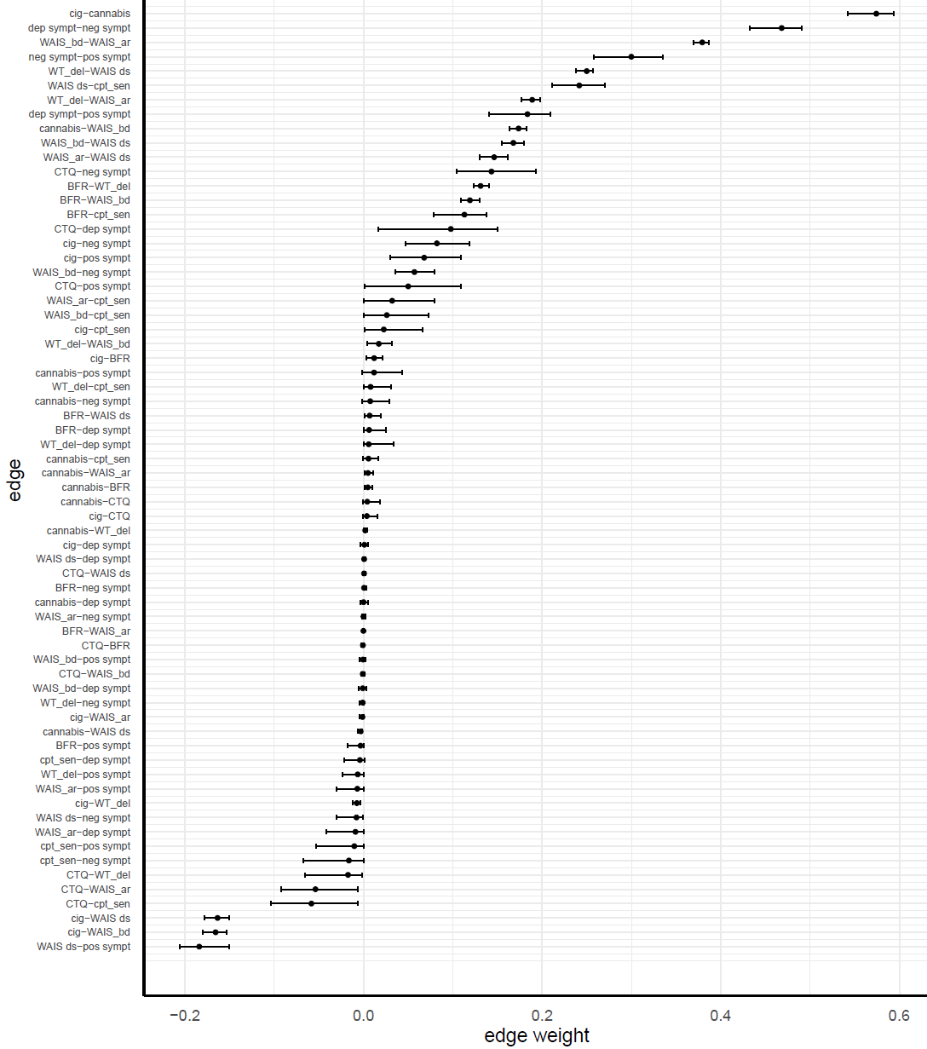

Figure 3
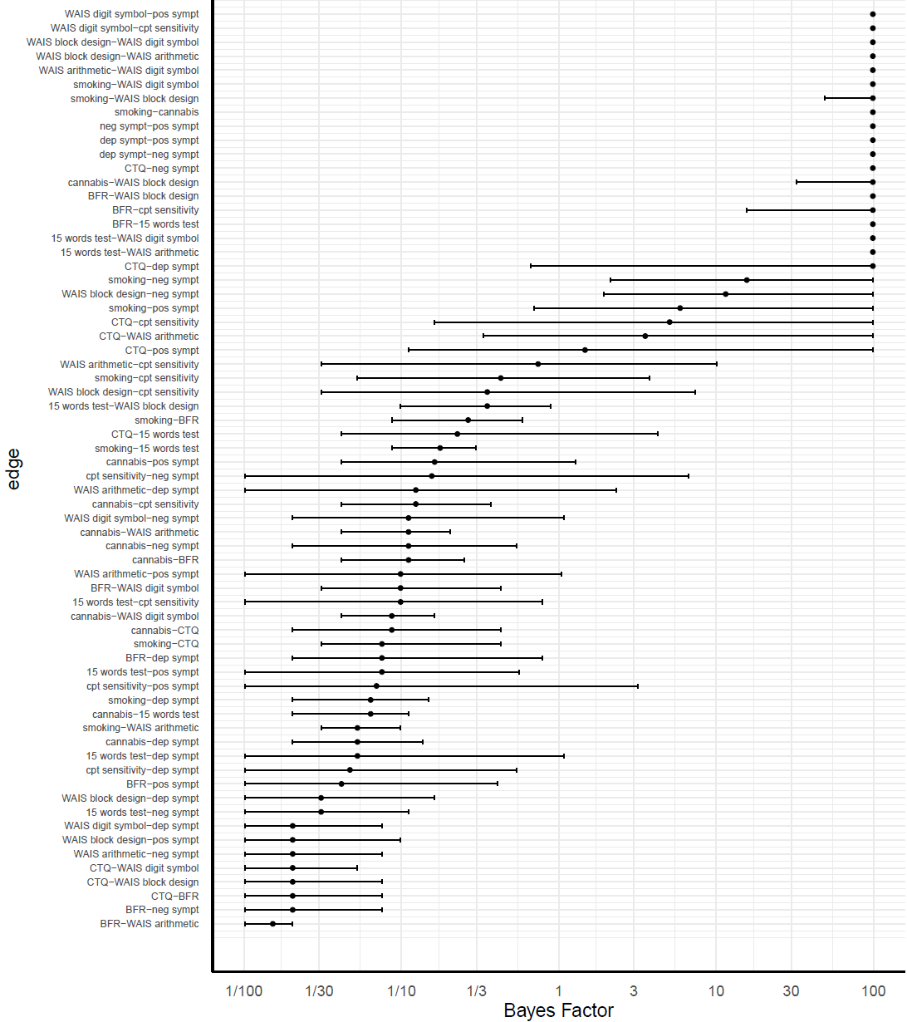
HDI of Bayes factors for all the edges

Figure 4
Strength centrality of each node, including HDI intervals
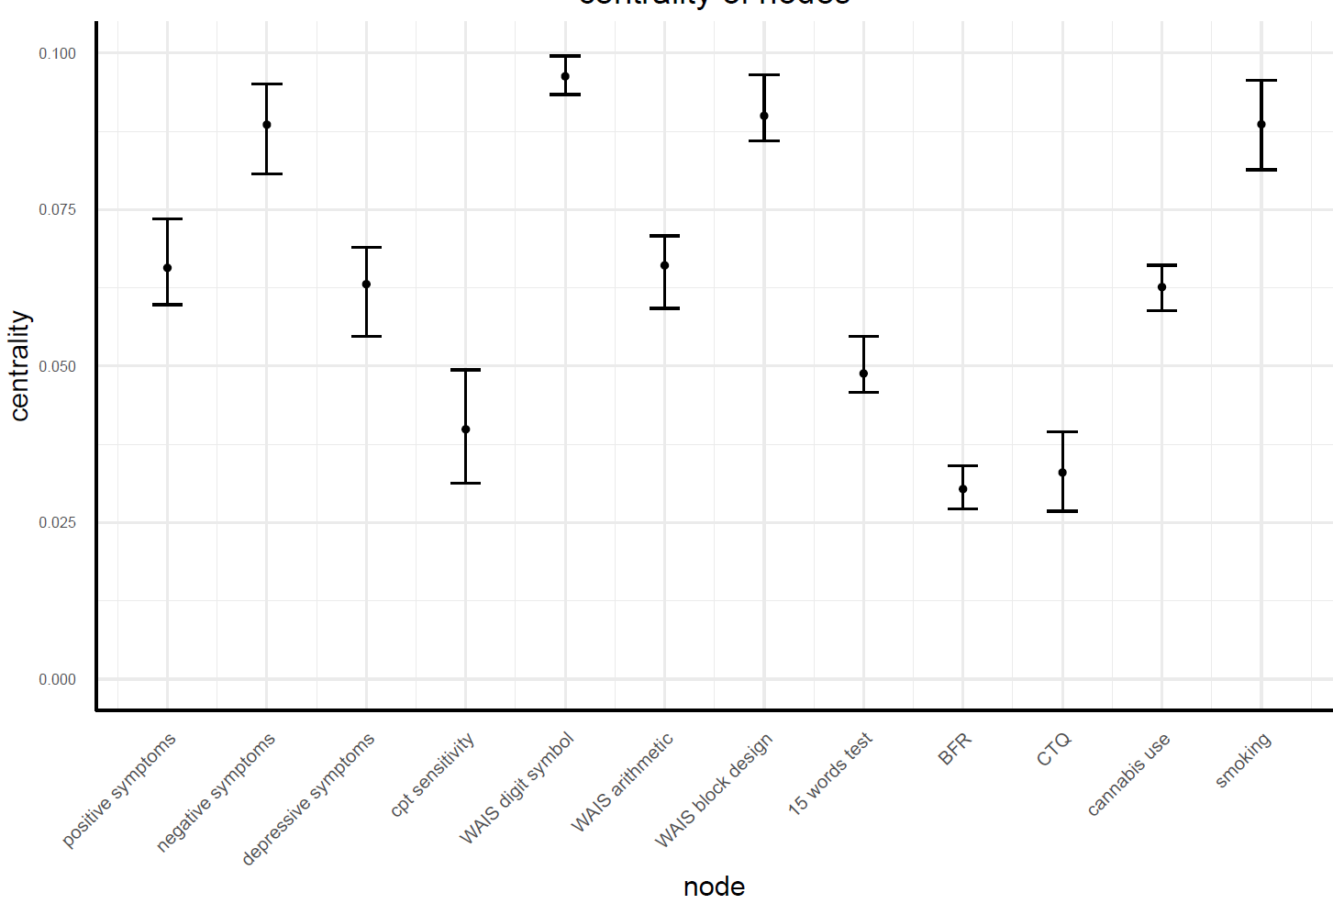

Figure 5
Centrality of Nodes in Networks of Patients and Siblings
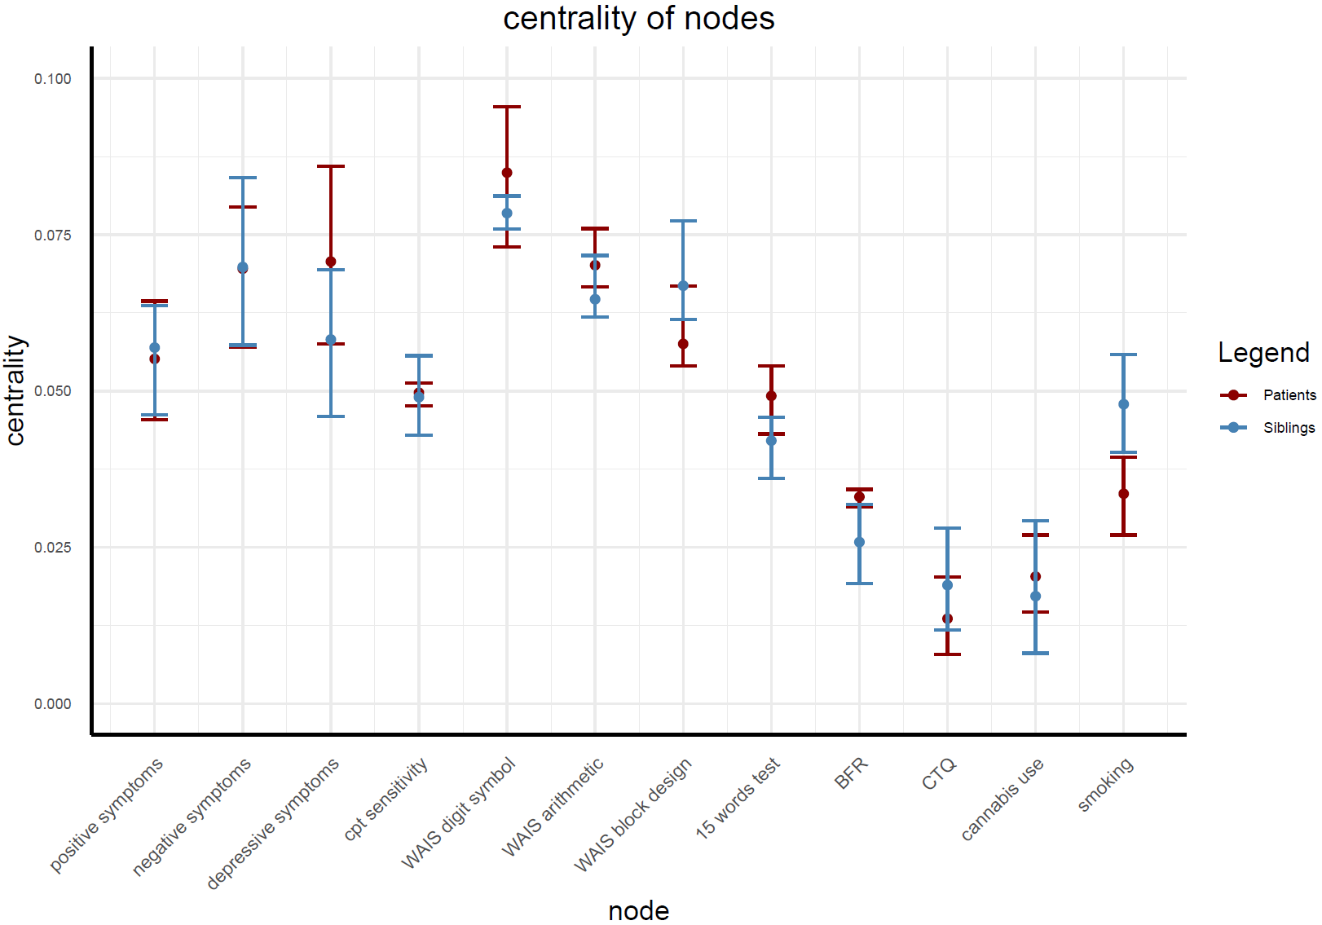

Figure 6
Edge weights in the different networks of patients and siblings, including HDI.
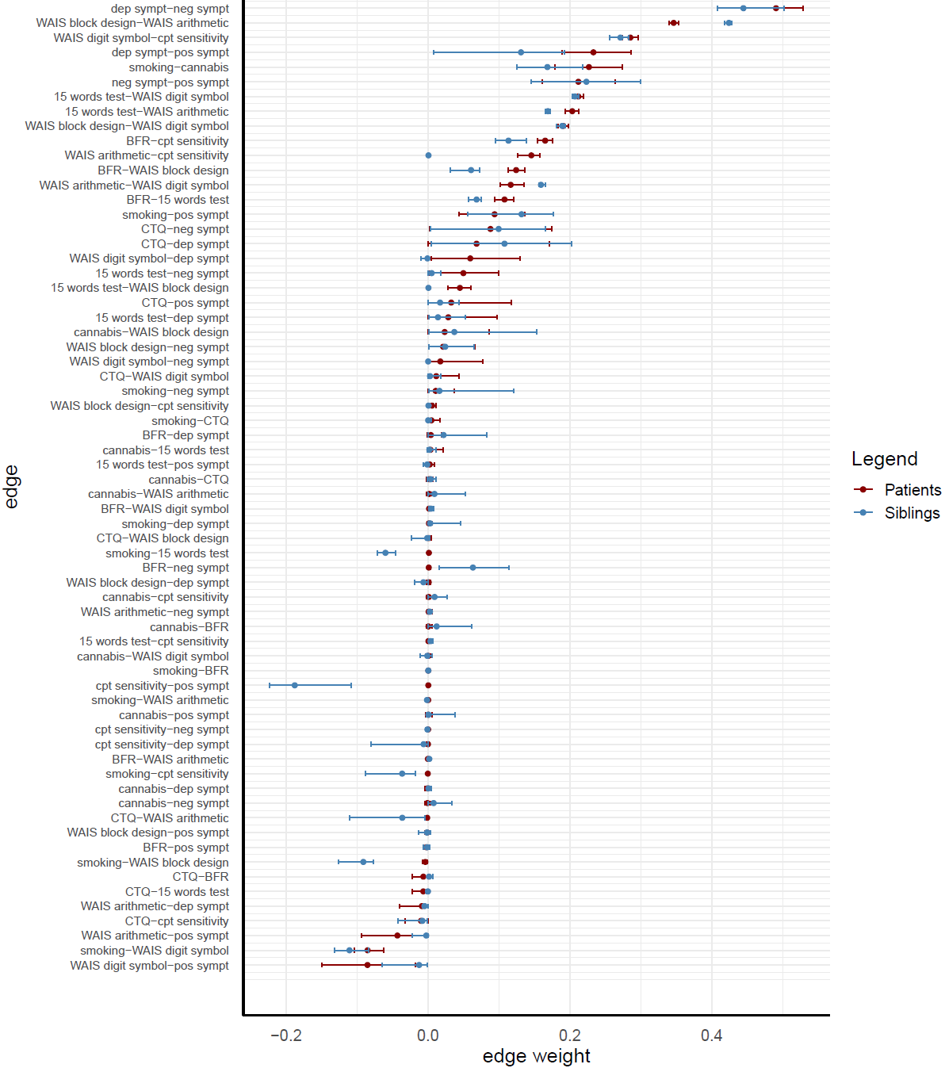

Figure 7
Posterior edge inclusion probabilities of patients and siblings, including HDI
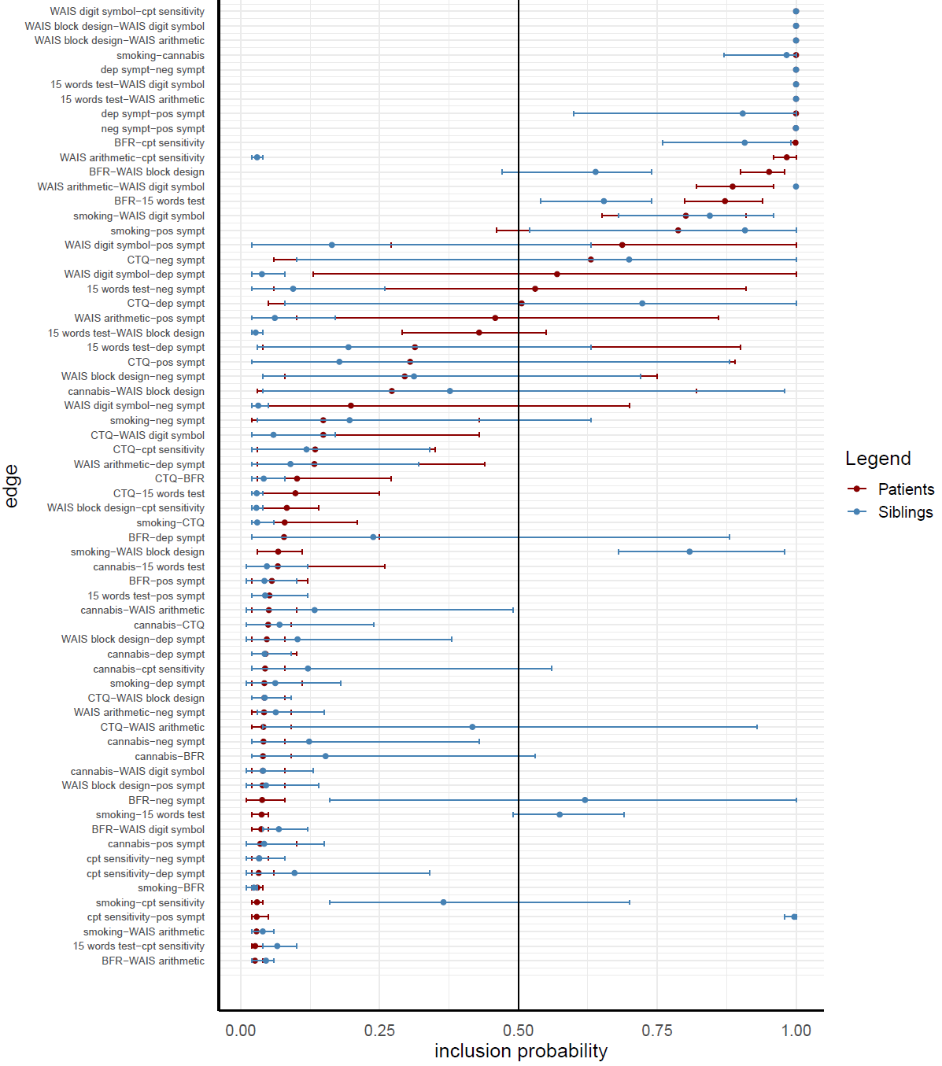

Table 2.
Weight matrix of network estimated on sample of patients, siblings and controls
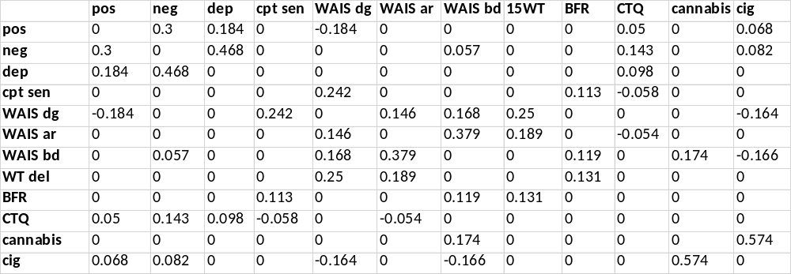

Table 3.
Weight matrix of network patients, controlled for SFS
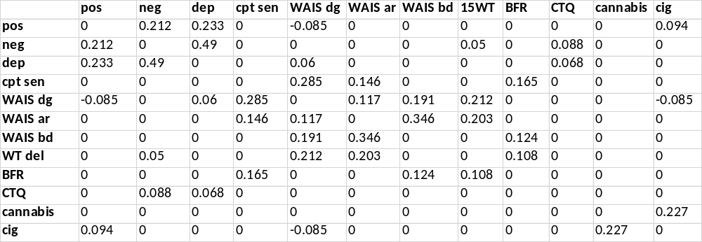

Table 4.
Weight matrix of network siblings, controlled for SFS
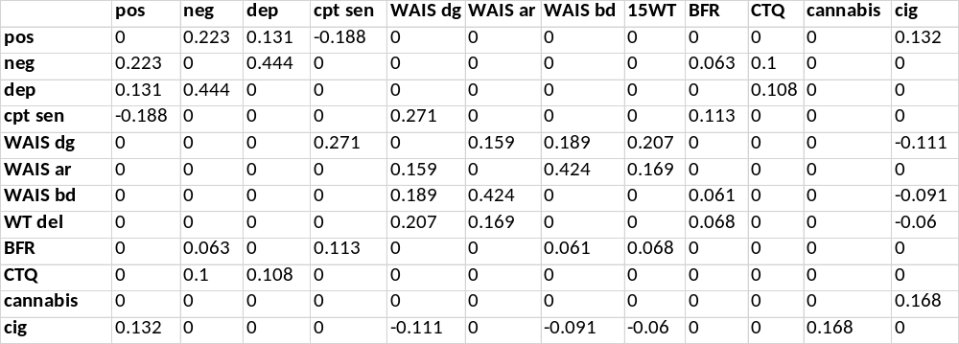

Table 5.
Weight matrix of network patients
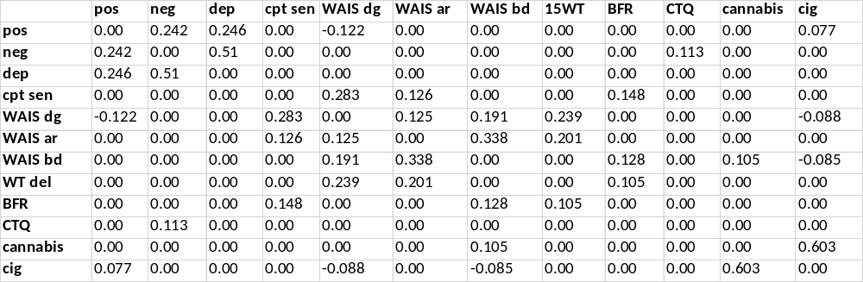

Table 6.
Weight matrix of network siblings
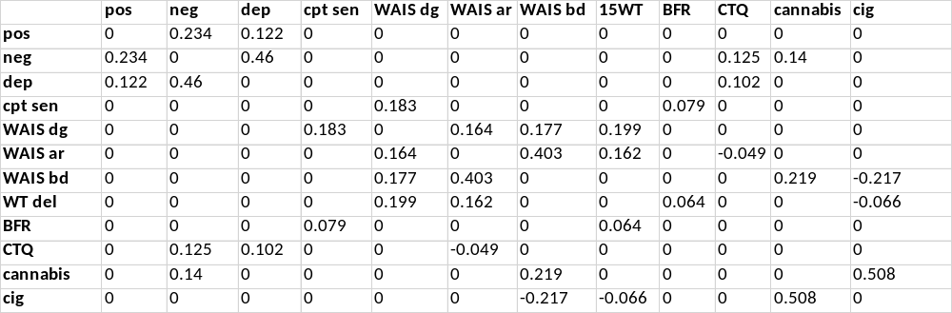

Figure 8
Average estimated network of patients, siblings and controls with a prior of 0.75.
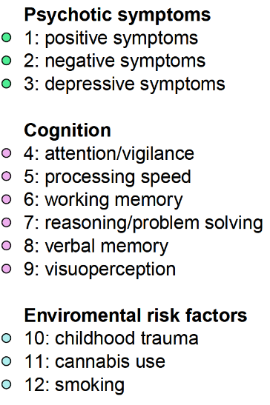
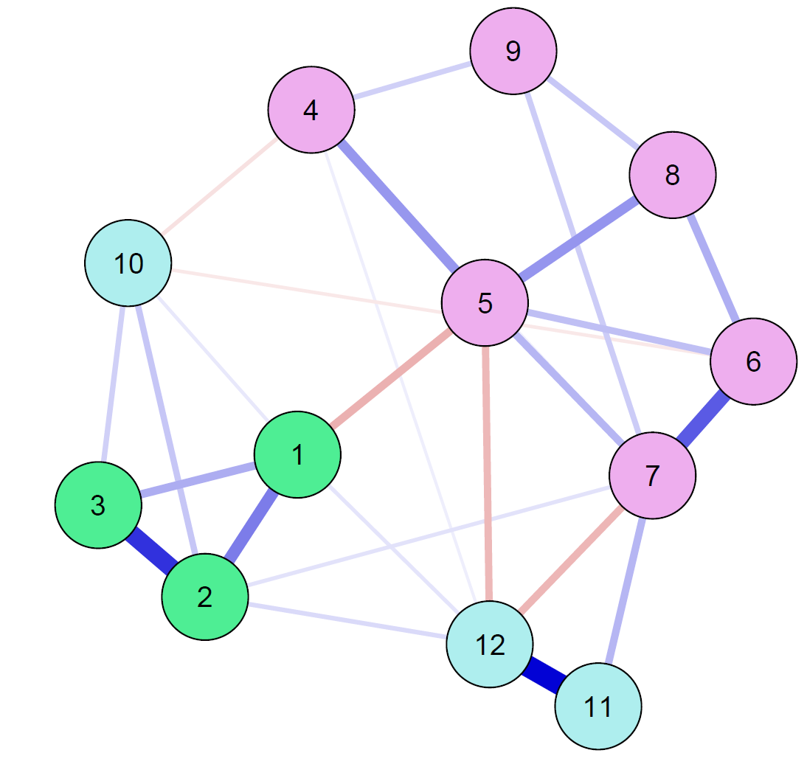

Figure 9
Average estimated network of patients, siblings and controls with a prior of 0.25
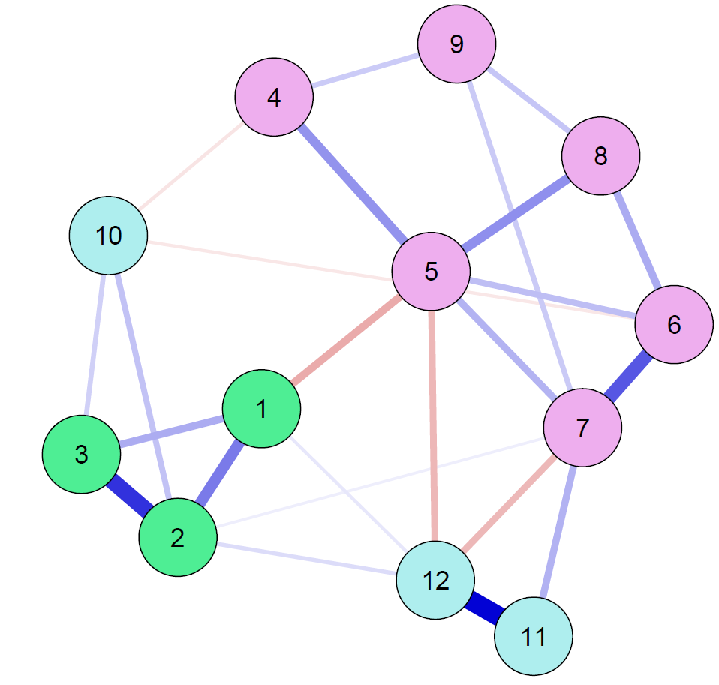

Figure 10
Average estimated network of patients, without controlling for SFS
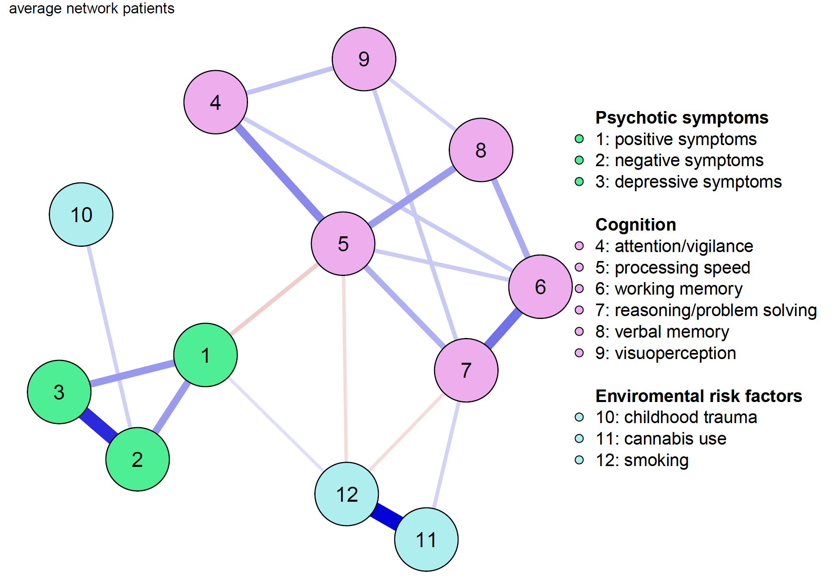

Figure 11
Average network of siblings, without controlling for SFS
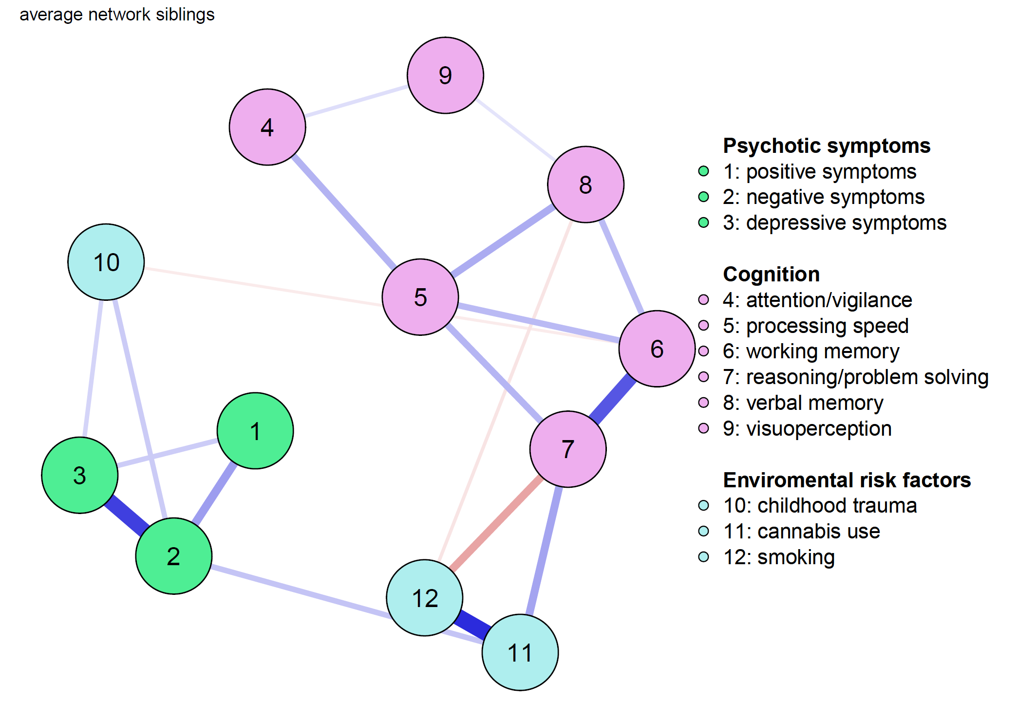

Figure 12
Centrality of nodes in networks of patients and siblings, without controlling for SFS
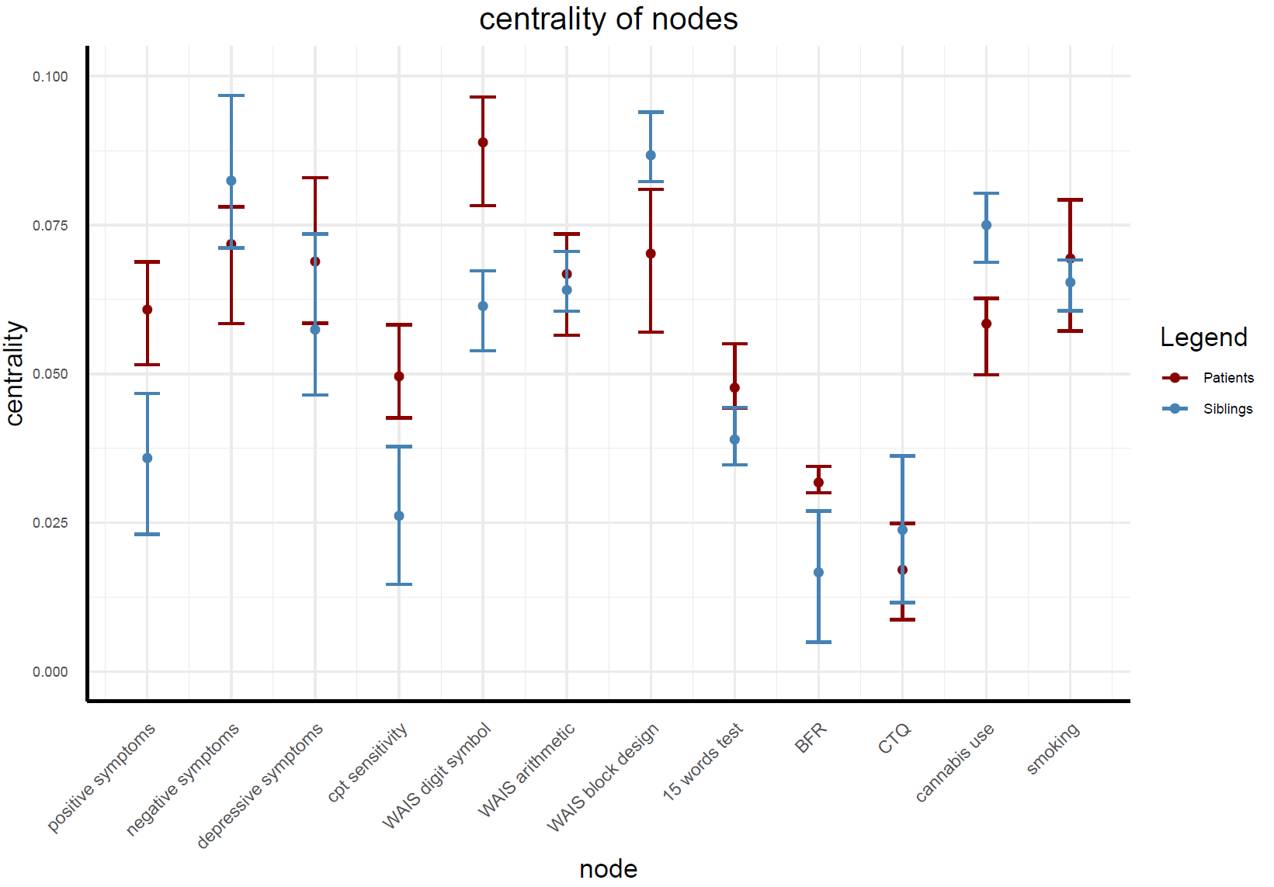

Figure 13
HDI of estimated edge weights in networks of patients and siblings, without controlling for SFS
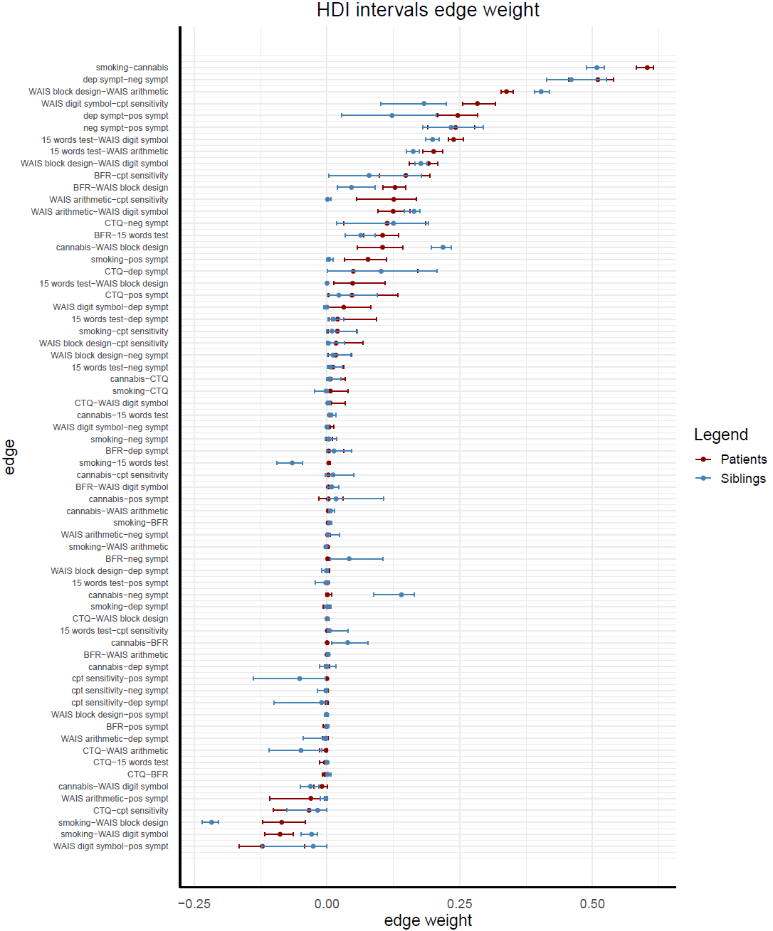

Figure 14
HDI of edge inclusion probabilities in networks of patients and siblings, without controlling for SFS
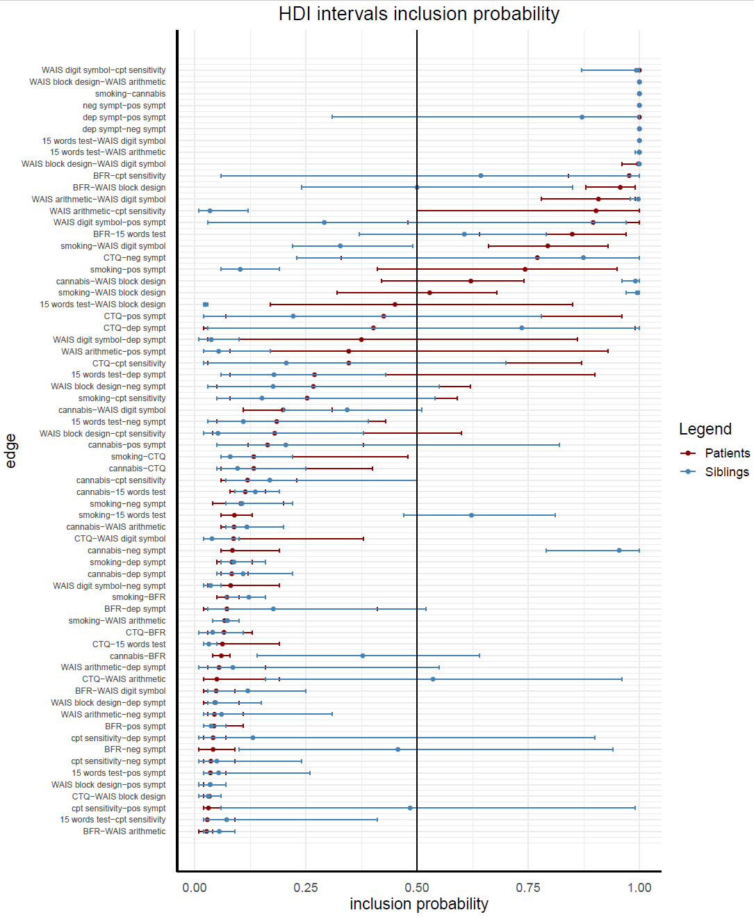
References

Albonico, A., Malaspina, M., & Daini, R. (2017). Italian normative data and validation of two neuropsychological tests of face recognition: Benton Facial Recognition Test and Cambridge Face Memory Test. Neurological Sciences, 38(9), 1637–1643. https://doi.org/10.1007/S10072-017-3030-6/TABLES/5
Benton, A. L., Van Allen, M. W., Hamsher, K. D., & Levin, H. S. (1973). Test of facial recognition. Manual. Neurosurgery Center Publication, (287).
Brand, N., & Jolles, J. (1985). Learning and Retrieval Rate of Words Presented Auditorily and Visually. The Journal of General Psychology, 112(2), 201–210. https://doi.org/10.1080/00221309.1985.9711004
de Ron, J., Robinaugh, D. J., Fried, E. I., Pedrelli, P., Jain, F. A., Mischoulon, D., & Epskamp, S. (2022). Quantifying and addressing the impact of measurement error in network models. Behaviour Research and Therapy, 157, 104163. https://doi.org/10.1016/J.BRAT.2022.104163
Geffen, G. M., Butterworth, P., & Geffen, L. B. (1994). Test-retest reliability of a new form of the auditory verbal learning test (AVLT). Archives of Clinical Neuropsychology, 9(4), 303–316. https://doi.org/10.1016/0887-6177(94)90018-3
Halperin, J. M., Sharma, V., Greenblatt, E., & Schwartz, S. T. (1991). Assessment of the Continuous Performance Test: Reliability and Validity in a Nonreferred Sample. Psychological Assessment, 3(4), 603–608. https://doi.org/10.1037/1040-3590.3.4.603
Iverson, G. L. (2001). Interpreting change on the WAIS-III/WMS-III in clinical samples. Archives of Clinical Neuropsychology, 16(2), 183–191. https://doi.org/10.1016/S0887-6177(00)00060-3
Marsman, M., Maris, G., Bechger, T., & Glas, C. (2016). What can we learn from Plausible Values? Psychometrika, 81(2), 274–289. https://doi.org/10.1007/S11336-016-9497-X/TABLES/3
Marsman, M., Maris, G., Bechger, T., & Glas, C. (2017). Turning Simulation into Estimation: Generalized Exchange Algorithms for Exponential Family Models. PLOS ONE, 12(1), e0169787. https://doi.org/10.1371/JOURNAL.PONE.0169787
Mislevy, R. J. (1991). Randomization-based inference about latent variables from complex samples. Psychometrika 1991 56:2, 56(2), 177–196. https://doi.org/10.1007/BF02294457
Muraki, E. (1990). Fitting a Polytomous Item Response Model to Likert-Type Data. Applied Psychological Measurement, 14(1), 59–71. https://doi.org/10.1177/014662169001400106
Rosvold, H. E., Mirsky, A. F., Sarason, I., Bransome, E. D., & Beck, L. H. (1956). A continuous performance test of brain damage. Journal of Consulting Psychology, 20(5), 343–350. https://doi.org/10.1037/H0043220
Wechsler D. (1997) WAIS-III: Wechsler Adult Intelligence Scale (3rd edition) Administration and Scoring Manual, San Antonio, TX, Psychological Corporation.
Woods, C. M., & Lin, N. (2009). Item response theory with estimation of the latent density using Davidian curves. Applied Psychological Measurement, 33(2), 102–117. https://doi.org/10.1177/0146621608319512

