Supplemental Materials for:

fMRI study of neural sensitization to hedonic stimuli in long-term, daily cannabis users Francesca M. Filbey, Ph.D.*, Joseph Dunlop, Ph.D., Ariel Ketcherside, Jessica Baine, Tyler Rhinehardt, Brittany Kuhn, Sam DeWitt and Talha Alvi
*Center for BrainHealth, School of Behavioral and Brain Sciences
University of Texas at Dallas

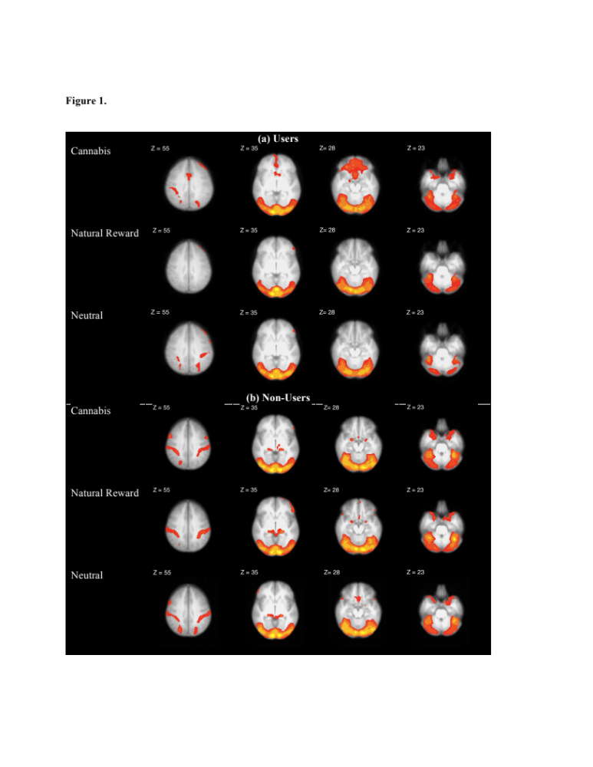
Figure S.1. Main effects of cues for users (a) and non-users (b) (cluster-threshold z=2.3, p<.05).

Figure S.2 In-scanner trial-by-trial subjective urge ratings for cannabis users during the two fMRI runs.

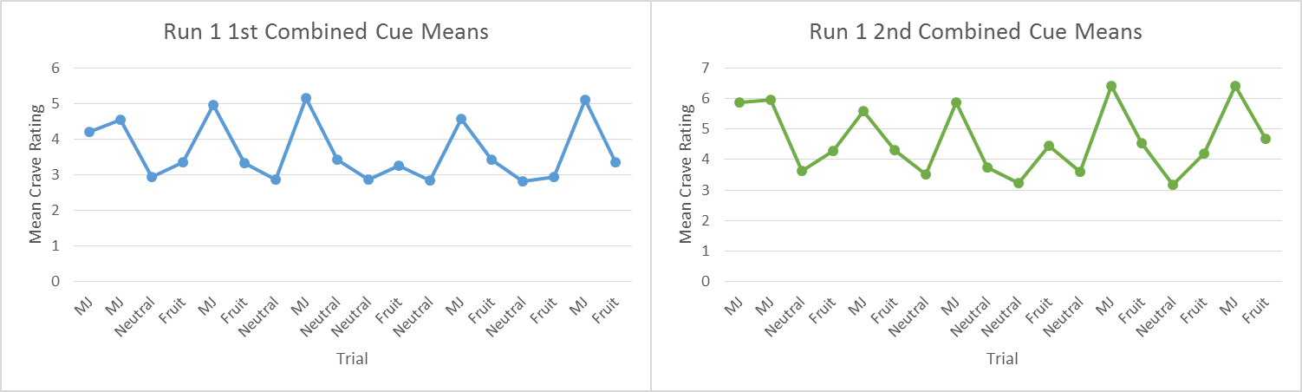
Run A
Run B

Table S.1. Cannabis User Peaks: cannabis versus neutral control cue. Loci of significant activation for the contrast of cannabis cues versus neutral control cues at a z-value threshold of 3.1 and GRF cluster-corrected p-value of exceeding .05.

a. Users: cannabis cue > neutral control cue: Z>3.1 threshold
Cluster 1
# voxels | Z | x | y | z | Localization | BA
13123 | 5.95 | 14.08 | -7.93 | -9.83 | R Parahippocampal Gyrus | 28
13123 | 5.78 | 2.63 | -23.92 | 3.53 | R Thalamus | -
13123 | 5.53 | 14.12 | -.23 | -11.14 | R Subcallosal Gyrus | 34
13123 | 5.45 | 4.59 | -4.98 | 4.78 | R Thalamus | -
13123 | 5.41 | 8.38 | -3.12 | 4.92 | R Thalamus | -
13123 | 5.38 | -3.04 | -21.98 | 3.62 | L Thalamus | -
Cluster 2
# voxels | Z | x | y | z | Localization | BA
3038 | 4.93 | .88 | 24.69 | 17.54 | L Anterior Cingulate Gyrus | 24
3038 | 4.66 | 2.57 | .8 | 63.05 | R Medial Frontal Gyrus | 6
3038 | 4.58 | 2.59 | 4.71 | 61.49 | R Medial Frontal Gyrus | 6
3038 | 4.43 | -.95 | 34.65 | 10.94 | L Anterior Cingulate Gyrus | 24
3038 | 4.38 | 4.61 | 18.04 | 31.61 | R Mid-Cingulate Gyrus | 32
3038 | 4.37 | -6.6 | 45.84 | 15.25 | L Medial Frontal Gyrus | 9
Cluster 3
# voxels | Z | x | y | z | Localization | BA
1117 | 4.74 | 30.92 | -71.72 | -26.55 | R Cerebellum Uvula | -
1117 | 4.65 | 31.01 | -50.52 | -30.6 | R Cerebellum Anterior Lobe | -
1117 | 4.36 | 29.14 | -43.15 | -26.51 | R Cerebellum Culmen | -
1117 | 4.3 | 17.83 | -29.78 | -25.71 | R Cerebellum Culmen | -
1117 | 4.17 | 40.41 | -69.68 | -29.98 | R Cerebellum Tuber | -
1117 | 4.1 | 34.75 | -60.38 | -25.79 | R Cerebellum Culmen | -
Cluster 4
# voxels | Z | x | y | z | Localization | BA
515 | 4.46 | 42.6 | 24.17 | -9.38 | R Inferior Frontal Gyrus | 47
515 | 4.42 | 31.25 | 24.5 | -13.05 | R Inferior Frontal Gyrus | 47
515 | 4.26 | 48.23 | 16.19 | -4.44 | R Inferior Frontal Gyrus | 47
515 | 3.76 | 34.94 | 4.81 | -3.45 | R Claustrum | -
515 | 3.71 | 48.21 | 19.17 | 8.43 | R Precental Gyrus | 44
515 | 3.65 | 34.93 | 6.36 | 2.08 | R Claustrum | -
b. Users: neutral control cue > cannabis cue: Z>3.1 threshold
# voxels | Z | x | y | z | Localization | BA
38 | 4.32 | -18.33 | -85.11 | 30.14 | Cuneus | 19
38 | 4.31 | -18.22 | -87.96 | 20.86 | Cuneus | 18
38 | 4.02 | -21.87 | -83.87 | 17.58 | Middle Occipital Gyrus | 18

Table S.2. Cannabis User Peaks: Fruit cue versus neutral control cue. Loci of significant activation for the contrast of Appetitive control cues versus neutral control cues at a z-value threshold of 3.1 and GRF cluster-corrected p-value of exceeding .05.

a. Users: fruit cue > neutral control cue: Z>3.1 threshold
Cluster 1
# voxels | Z | x | y | z | Localization | BA
3730 | 5.86 | 21.51 | -56.59 | -23.81 | R Dentate | -
3730 | 5.76 | -31.5 | -59.8 | -26.16 | L Culmen | -
3730 | 5.27 | -14.43 | -45.25 | -17.87 | L Culmen | -
3730 | 4.96 | 8.23 | -60.73 | -16.93 | R Declive | -
3730 | 4.8 | 31.03 | -43.17 | -26.5 | R Culmen | -
3730 | 4.58 | -20.17 | -65.7 | -24.66 | L Anterior Lobe of Cerebellum | -
Cluster 2
# voxels | Z | x | y | z | Localization | BA
2336 | 5.17 | .75 | -20.23 | 5.57 | L Medial Dorsal Nucleus (Thalamus) | -
2336 | 4.79 | -14.36 | -22.85 | -10.98 | L Substantia Nigra | -
2336 | 4.7 | -1.19 | -24.59 | 14.32 | L Thalamus | -
2336 | 4.68 | -1.08 | -3.04 | 4.87 | L Thalamus | -
2336 | 4.44 | -20.1 | -20.51 | 12.66 | L Lateral Posterior Nucleus (Thalamus) | -
2336 | 4.42 | 10.2 | -22.33 | 7.3 | R Medial Dorsal Nucleus (Thalamus) | -
Cluster 3
# voxels | Z | x | y | z | Localization | BA
201 | 4.32 | 34.87 | -8.92 | 2.9 | R Claustrum | -
201 | 3.94 | 34.91 | 2.57 | 1.83 | R Claustrum | -
b. Users: neutral control cue > fruit cue: Z>3.1 threshold
# voxels | Z | x | y | z | Localization | BA
305 | 4.01 | -19.58 | -91.57 | -19.14 | Precuneus | 31
305 | 4 | -28.91 | -86.63 | -11.63 | Cuneus | 19
305 | 3.93 | -28.96 | -88.84 | -8.23 | Precuneus | 31
305 | 3.82 | -23.48 | -96.67 | -5.28 | Precuneus | 7
305 | 3.79 | -6.57 | -82.15 | -19.83 | Cuneus | 18
305 | 3.78 | 2.78 | -81.5 | -26.82 | Cuneus | 18

Table S.3. Cannabis User Peaks: cannabis versus fruit cue. Loci of significant activation for the contrast of cannabis cues versus fruit cues at a z-value threshold of 2.3 and GRF cluster-corrected p-value of exceeding .05.
a. Users: cannabis > fruit cue : Z>2.3 threshold
Cluster 1
# voxels | Z | x | y | z | Localization | BA
15253 | 5.59 | 4.7 | 47 | 5.21 | R Anterior Cingulate Gyrus | 32
15253 | 5.55 | 1.1 | 40.43 | -4.49 | R Anterior Cingulate Gyrus | 32
15253 | 5.22 | -8.42 | 43.98 | 17.31 | L Medial Frontal Gyrus | 9
15253 | 5.2 | -4.72 | 43.96 | 17.37 | L Medial Frontal Gyrus | 9
15253 | 5.12 | 0.82 | 47.48 | 19.6 | L Medial Frontal Gyrus | 9
15253 | 5.05 | -6.28 | 47.92 | -3.9 | L Anterior Cingulate Gyrus | 32
Cluster 2
# voxels | Z | x | y | z | Localization | BA
2358 | 4.43 | -1.49 | -41.82 | 29.12 | L Posterior Cingulate Gyrus | 31
2358 | 3.97 | 2.32 | -42.83 | 20.08 | R Posterior Cingulate Gyrus | 29
2358 | 3.78 | 4.24 | -42.32 | 14.75 | R Posterior Cingulate Gyrus | 29
2358 | 3.75 | 5.96 | -50.65 | 23 | R Posterior Cingulate Gyrus | 23
2358 | 3.71 | -1.4 | -15.56 | 29.81 | L Posterior Cingulate Gyrus | 23
2358 | 3.56 | 6.02 | -24.56 | 25.47 | R Posterior Cingulate Gyrus | 23
Cluster 3
# voxels | Z | x | y | z | Localization | BA
1290 | 4.7 | -19.58 | -91.57 | -19.14 | L Declive | -
1290 | 4.68 | -28.91 | -86.63 | -11.63 | L Inferior Occipital Gyrus | 18
1290 | 4.68 | -28.96 | -88.84 | -8.23 | L Inferior Occipital Gyrus | 18
1290 | 3.76 | -23.48 | -96.67 | -5.28 | L Lingual Gyrus | 18
1290 | 2.95 | -6.57 | -82.15 | -19.83 | L Declive | -
1290 | 2.93 | 2.78 | -81.5 | -26.82 | R Cerebellum | -
Cluster 4
# voxels | Z | x | y | z | Localization | BA
804 | 4.22 | 24.73 | -81.67 | -6.65 | R Lingual Gyrus | 18
804 | 4.2 | 24.81 | -88.43 | -14.49 | R Inferior Occipital Gyrus | 18
804 | 4.18 | 22.99 | -84.52 | -15.95 | R Declive | -
804 | 4.17 | 21.1 | -90.27 | -14.73 | R Fusiform Gyrus | 18
804 | 2.83 | 35.73 | -88.01 | 0.15 | R Middle Occipital Gyrus | 18
804 | 2.8 | 17.28 | -98.4 | -8.36 | R Lingual Gyrus | 17
b. Users: fruit cue > cannabis cue : Z>2.3 threshold
Cluster 1
# voxels | Z | x | y | z | Localization | BA
2389 | 4.35 | 11.48 | -89.28 | 14.03 | R Middle Occipital Gyrus | 18
2389 | 3.73 | -25.23 | -57.54 | -1.6 | L Parahippocampal Gyrus | 19
2389 | 3.69 | 0.39 | -81.77 | 14.55 | L Cuneus | 18
2389 | 3.55 | -10.63 | -86.61 | 6.7 | L Cuneus | 17
2389 | 3.54 | -8.85 | -76.14 | 14.93 | L Cuneus | 18
2389 | 3.5 | -1.42 | -85.14 | 10.6 | L Cuneus | 17

Table S.4. Non-User Peaks: cannabis versus neutral control cue. Loci of significant activation for the contrast of cannabis cues versus neutral control cues at a z-value threshold of 2.3 and GRF cluster-corrected p-value of exceeding .05.

a. Non-Users: cannabis cue > neutral control cue: Z>2.3 threshold
Cluster 1
# voxels | Z | x | y | z | Localization | BA
2803 | 4.05 | 11.99 | 2.24 | 1.09 | R Medial Globus Pallidus | -
2803 | 3.98 | 0.98 | -17.15 | -11.74 | L Red Nucleus | -
2803 | 3.63 | -2.89 | -7.35 | 3.53 | L Thalamus | -
2803 | 3.62 | -27.1 | -4.71 | 15.98 | L Claustrum | -
2803 | 3.56 | 15.41 | -7.15 | 20.08 | R Caudate Body | -
2803 | 3.43 | -8.34 | -24.9 | -9.03 | L Substantia Nigra | -
Cluster 2
# voxels | Z | x | y | z | Localization | BA
1901 | 4.85 | 19.52 | -48.05 | -23.37 | R Dentate | -
1901 | 4.77 | 25.06 | -44.53 | -21.14 | R Culmen | -
1901 | 4.22 | 30.69 | -22.02 | -20.71 | R Parahippocampal Gyrus | 36
1901 | 3.73 | 19.54 | -68.02 | -30.66 | R Pyramis | -
1901 | 3.69 | 38.07 | -58.8 | -29.48 | R Tuber | -
1901 | 3.66 | 39.87 | -26.32 | -15.56 | R Parahippocampal Gyrus | 36
Cluster 3
# voxels | Z | x | y | z | Localization | BA
1445 | 4.12 | -40.45 | -29.44 | 38.64 | L Inferior Parietal Lobule | 40
1445 | 3.75 | -44.35 | -27.27 | 54.99 | L Postcentral Gyrus | 2
1445 | 3.62 | -53.51 | -33.8 | 45.21 | L Inferior Parietal Lobule | 40
1445 | 3.56 | -33.38 | -44.79 | 60.73 | L Postcentral Gyrus | 5
1445 | 3.49 | -47.83 | -32.96 | 36.38 | L Inferior Parietal Lobule | 40
1445 | 3.48 | -47.93 | -33.66 | 43.52 | L Inferior Parietal Lobule | 40
b. Non-Users: neutral control > cannabis cue: Z>2.3 threshold
Cluster 1
# voxels | Z | x | y | z | Localization | BA
7861 | 4.43 | 13.28 | -89.64 | 17.63 | R Middle Occipital Gyrus | 18
7861 | 4.42 | -18.32 | -88.66 | 28 | L Cuneus | 19
7861 | 4.32 | 20.74 | -85.6 | 14.54 | R Middle Occipital Gyrus | 18
7861 | 4.25 | 13.68 | -50.11 | -2.04 | R Culmen | -
7861 | 4.23 | 15.12 | -75.09 | 22.64 | R Cuneus | 18
7861 | 4.22 | -12.76 | -86.83 | 28.27 | L Cuneus | 19

Table S.5. Non-User Peaks: Fruit cue versus neutral control cue. Loci of significant activation for the contrast of Appetitive control cues versus neutral control cues at a z-value threshold of 2.3 and GRF cluster-corrected p-value of exceeding .05.

a. Non-Users: fruit cue > neutral control cue: Z>2.3 threshold
Cluster 1
# voxels | Z | x | y | z | Localization | BA
16128 | 5.85 | 19.65 | -47.09 | -23.21 | R Cerebellum: Anterior Lobe | -
16128 | 5.25 | -8.74 | -27.61 | 3.22 | L Thalamus: Pulvinar | -
16128 | 5.21 | -27.68 | -48.57 | -23.59 | L Culmen | -
16128 | 5.11 | -1.26 | -55.89 | -2.19 | L Culmen | -
16128 | 5.05 | 8.27 | -49.24 | -17.99 | R Culmen | -
16128 | 5.03 | -2.97 | -4.8 | 2.93 | L Thalamus | -
Cluster 2
# voxels | Z | x | y | z | Localization | BA
1962 | 4.45 | -41.03 | -31.55 | 38.96 | L Inferior Parietal Lobule | 40
1962 | 3.91 | -4.96 | -12.09 | 27.78 | L Cingulate Gyrus | 23
1962 | 3.52 | -31.63 | -55.7 | 28.4 | L Superior Temporal Gyrus | 39
1962 | 3.35 | -3.13 | -29.29 | 28.48 | L Posterior Cingulate Gyrus | 23
1962 | 3.35 | -44.85 | -49.66 | 25.09 | L Superior Temporal Gyrus | 39
1962 | 3.23 | -3.13 | -25.73 | 32.33 | L Posterior Cingulate Gyrus | 23
b. Non-Users: neutral control > fruit cue: Z>2.3 threshold
Cluster 1
# voxels | Z | x | y | z | Localization | BA
2049 | 4.91 | 17.47 | -83.13 | 34.15 | R Cuneus | 19
2049 | 4.09 | 42.19 | -79.13 | -1.63 | R Inferior Occipital Gyrus | 18
2049 | 3.92 | 21.32 | -78.33 | 18.2 | R Cuneus | 18
2049 | 3.68 | 25.08 | -85.83 | 15.93 | R Middle Occipital Gyrus | 18
2049 | 3.63 | 19.38 | -84.47 | 25.03 | R Cuneus | 19
2049 | 3.57 | 8.01 | -84.71 | 30.37 | R Cuneus | 19
Cluster 2
# voxels | Z | x | y | z | Localization | BA
1770 | 4.62 | -18.51 | -86.61 | 33.7 | L Cuneus | 19
1770 | 4.3 | -22.27 | -68.66 | 51.13 | L Precuneus | 7
1770 | 3.64 | -26.05 | -87.74 | 22.73 | L Cuneus | 19
1770 | 3.59 | -56.24 | -69.49 | 9.25 | L Middle Occipital Gyrus | 19
1770 | 3.56 | -14.73 | -83.32 | 41.18 | L Precuneus | 19
1770 | 3.56 | -18.49 | -65.37 | 58.61 | L Superior Parietal Lobule | 7

Table S.6. Non-User Peaks: cannabis versus fruit cue. Loci of significant activation for the contrast of cannabis cues versus Appetitive control cues at a z-value threshold of 2.3 and GRF cluster-corrected p-value of exceeding .05.

a. Non-Users: cannabis > fruit cue: Z>2.3 threshold
No significant difference
b. Non-Users: fruit cue > cannabis cue: Z>2.3 threshold
# voxels | Z | x | y | z | Localization | BA
8023 | 4.69 | -2.99 | -55.62 | -2.84 | L Culmen | -
8023 | 4.56 | 6.13 | -63.99 | 5.53 | R Lingual Gyrus | 18
8023 | 4.41 | 4.45 | -49.89 | -3.98 | R Culmen | -
8023 | 4.36 | -37.66 | -51.78 | -40.9 | L Cerebellar Tonsil | -
8023 | 4.33 | -3.63 | -71.32 | 42.5 | L Precuneus | 7
8023 | 4.05 | -12.63 | -63.94 | 25.03 | L Precuneus | 31

Table S.7. Brain-Behavior correlations for cannabis cues vs. neutral object. Loci of significant correlations in the cannabis users between total scores on the (a) Marijuana Problem Scale (MPS) and (b) Marijuana Craving Questionnaire for the cannabis cues versus neutral control cues contrast at a z-value threshold of 2.3 and GRF cluster-corrected p-value of exceeding .05. Cluster size in terms of number of voxels, Z values for peak voxels along with corresponding MNI coordinates, anatomical localization and Brodmann areas are provided.

(a) MPS: cannabis cue > neutral cue
# voxels | Z | x | y | z | Localization | BA
839 | 4.07 | -58.66 | -30.81 | 14.78 | L Superior Temporal Gyrus | 42
839 | 3.36 | -56.86 | -44.04 | 15.36 | L Superior Temporal Gyrus | 22
839 | 3.29 | -43.79 | -24.95 | 11.98 | L Transverse Temporal Gyrus | 41
839 | 3.22 | -45.58 | -19 | 8.91 | L Superior Temporal Gyrus | 13
839 | 3.09 | -62.29 | -21.13 | 12.03 | L Superior Temporal Gyrus | 42
839 | 3.07 | -40.03 | -22.76 | 8.65 | L Superior Temporal Gyrus | 13
(b) MCQ: cannabis cue > neutral cue
# voxels | Z | x | y | z | Localization | BA
958 | 3.9 | 59.38 | -25.23 | 16.46 | R Postcentral Gyrus | 40
958 | 3.51 | 40.42 | -30.87 | 17.79 | R Superior Temporal Gyrus | 41
958 | 3.31 | 42.32 | -23.77 | 25.5 | R Insula | 13
958 | 3.01 | 59.31 | -40.63 | 19.08 | R Superior Temporal Gyrus | 13
958 | 2.98 | 44.15 | -49.63 | 12.97 | R Superior Temporal Gyrus | 39

Table S.8. Post-hoc analyses to determine confounding effects of alcohol on BOLD response to cues in contrasts with significant differences (z=2.3, cluster-corrected p<.05). Cluster size in terms of number of voxels, Z values for peak voxels along with corresponding MNI coordinates, anatomical localization and Brodmann areas are provided.

(1) cannabis cue > neutral cue
Users > Non-Users
# voxels | Z | x | y |  | z | Localization |  | BA
985 | 3.45 | -16 | -22 |  | -16 | L Parahippocampal Gyrus |  | 35
985 | 3.45 | -18 | -22 |  | -26 | L Parahippocampal Gyrus |  | 28
985 | 3.25 | -10 | -38 |  | -6 | L Culmen |  | -
985 | 3.24 | -2 | -44 |  | 14 | L Posterior Cingulate Gyrus |  | 29
985 | 3.09 | 2 | -44 |  | 20 | R Posterior Cingulate Gyrus |  | 30
985 | 3.06 | 12 | -54 |  | 28 | R Posterior Cingulate Gyrus |  | 31
699 | 3.83 | 8 | 0 |  | -18 | R Subcallosal Gyrus |  | 34
699 | 3.69 | 4 | 10 |  | -16 | R Medial Frontal Gyrus |  | 25
699 | 3.54 | 4 | -10 |  | -12 | R Mammillary Body |  | -
699 | 3.42 | 2 | 4 |  | -2 | R Anterior Cingulate Gyrus |  | 25
699 | 3.31 | 2 | 6 |  | -12 | R Subcallosal Gyrus |  | 25
699 | 3.28 | 2 | 16 |  | -20 | R Rectal Gyrus |  | 11
Non-Users > Users
No significant difference
(2) cannabis cue > fruit cue
Users > Non-Users
# voxels | Z | x | y |  | z | Localization |  | BA
1355 | 4.11 | 6 | -46 |  | 2 | R Culmen |  | -
1355 | 4.03 | 4 | -50 |  | 4 | R Culmen |  | -
1355 | 3.91 | 2 | -38 |  | 32 | R Posterior Cingulate Gyrus |  | 31
1355 | 3.62 | 10 | -36 |  | 32 | R Posterior Cingulate Gyrus |  | 31
1355 | 3.51 | 6 | -58 |  | 8 | R Posterior Cingulate Gyrus |  | 30
1355 | 3.33 | 4 | -36 |  | 20 | R Posterior Cingulate Gyrus |  | 23
1238 | 3.74 | 0 | 52 |  | -18 | L Medial Frontal Gyrus |  | 11
1238 | 3.68 | 0 | 60 |  | 26 | L Superior Frontal Gyrus |  | 10
1238 | 3.56 | -4 | 48 |  | -20 | L Orbital Gyrus |  | 11
1238 | 3.47 | 6 | 52 |  | -4 | R Medial Frontal Gyrus |  | 10
1238 | 3.43 | 10 | 50 |  | -4 | R Medial Frontal Gyrus |  | 10
1238 | 3.35 | -6 | 52 |  | 12 | L Medial Frontal Gyrus |  | 10
Non-Users > Users
No significant difference
(3) fruit cue > neutral cue
Users > Non-Users
No significant difference
Non-users > Users
No significant difference

Table S.10. Post-hoc analyses to determine confounding effects of education on BOLD response cues in contrasts with significant differences (z=2.3, cluster-corrected p<.05). Cluster size in terms of number of voxels, Z values for peak voxels along with corresponding MNI coordinates, anatomical localization and Brodmann areas are provided.

(1) cannabis cue > neutral cue
Users > Non-Users
# voxels |  | Z | x | y |  | z | Localization | BA
19032 |  | 4.52 | 34 | -34 |  | 8 | R Transverse Temporal Gyrus | 41
 |  | 4.46 | 14 | 0 |  | -16 | R Parahippocampal Gyrus | 34
 |  | 4.39 | 12 | -12 |  | -16 | R Parahippocampal Gyrus | 34
 |  | 4.38 | 16 | -52 |  | 36 | R Precuneus | 31
 |  | 4.33 | 14 | -8 |  | -14 | R Parahippocampal Gyrus | 28
 |  | 4.33 | -20 | -34 |  | -34 | L Cerebellar Tonsil | --
Non-users > Users
No significant difference
(2) cannabis cue > fruit cue
Users > Non-Users
# voxels | Z |  | x | y | z |  | Localization | BA
15400 | 5.17 |  | 6 | 52 | -4 |  | R Medial Frontal Gyrus | 10
15400 | 5.06 |  | 0 | 52 | -16 |  | L Medial Frontal Gyrus | 11
15400 | 4.93 |  | 0 | 44 | -14 |  | L Medial Frontal Gyrus | 11
15400 | 4.87 |  | -8 | 50 | 12 |  | L Medial Frontal Gyrus | 10
15400 | 4.74 |  | -6 | 54 | 12 |  | L Medial Frontal Gyrus | 10
15400 | 4.58 |  | 0 | -38 | 32 |  | L Posterior Cingulate Gyrus | 31
15400 | 3.51 |  | -28 | -76 | -30 |  | L Cerebellum: Tuber | -
15400 | 3.07 |  | -40 | -66 | -32 |  | L Cerebellum: Pyramis | -
15400 | 3.04 |  | -34 | -58 | -36 |  | L Cerebellar Tonsil | -
Non-users > Users
No significant difference
(3) fruit cue > neutral cue
Users > Non-users
No significant difference
Non-users > Users
No significant difference

