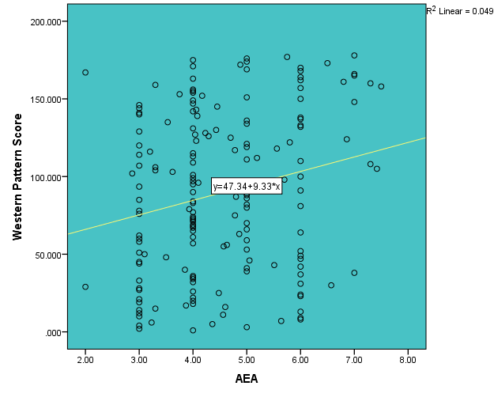
Fig. 1 The association between Western Pattern Score and AEA

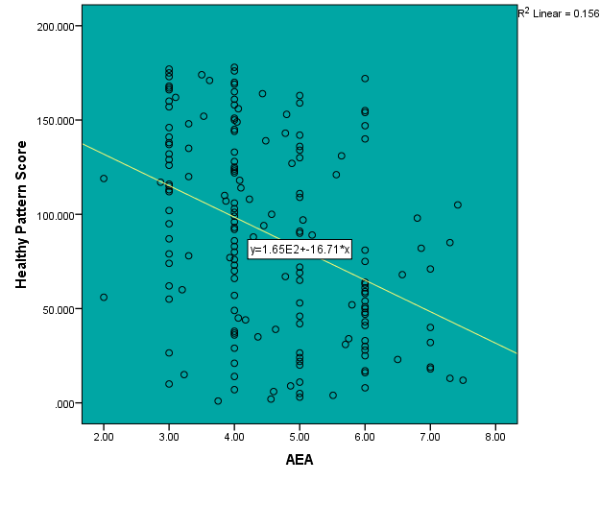
Fig. 2 The association between Healthy Pattern Score and AEA
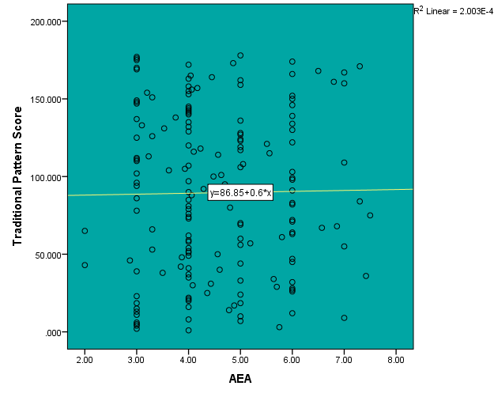
Fig. 3 The association between Traditional Pattern Score and AEA
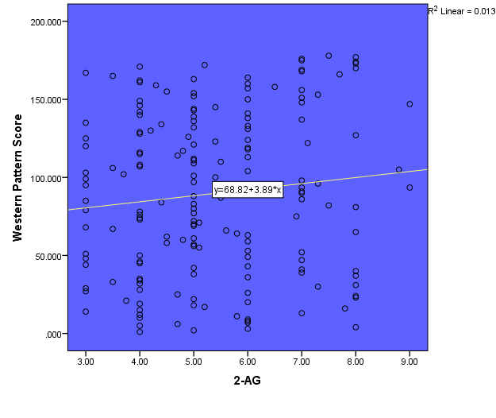
Fig. 4 The association between Western Pattern Score and 2-AG
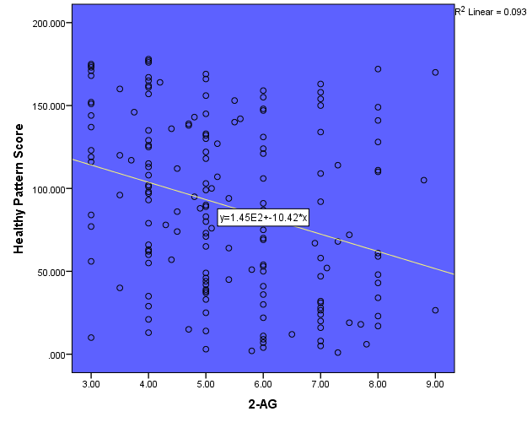
Fig. 5 The association between Healthy Pattern Score and 2-AG
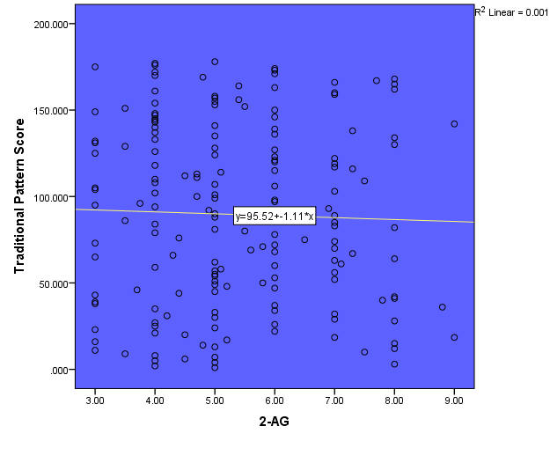
Fig. 6 The association between Traditional Pattern Score and 2-AG

