Supplementary Material for: The Impact of Influenza Vaccination on Antibiotic Prescribing in Older Adults
Thomas Spain, MSc¹, Marc Y Henrion, PhD^{2,3}, David Singleton, PhD⁴, Roberto Vivancos, MD^{5,6,7,8}, Valerie Decraene, PhD⁷, Daniel Hungerford, PhD^{4,5}*, Neil French, PhD^{4,6}*
1. Department of Health Data Science, Institute of Population Health, University of Liverpool, Liverpool, UK
2. Malawi Liverpool Wellcome Research Programme, Blantyre, Malawi,
3. Department of Clinical Sciences, Liverpool School of Tropical Medicine, Liverpool, United Kingdom
4 Department of Clinical Infection, Microbiology and Immunology, Institute of Infection, Veterinary and Ecological Sciences, University of Liverpool, Liverpool, UK
5. National Institute for Health and Care Research Health Protection Research Unit in Gastrointestinal Infections, University of Liverpool, Liverpool, UK
6. National Institute for Health and Care Research Health Protection Research Unit in Emerging and Zoonotic Infections, University of Liverpool, Liverpool, UK
7 Field Services, UK Health Security Agency, Liverpool, UK
8 Warwick Medical School, University of Warwick, Coventry, UK
* Joint senior authors
Correspondence to: N French french@liverpool.ac.uk or D Hungerford d.hungerford@liverpool.ac.uk (+44151 795 1455)

Table of Contents
Additional cohort descriptives 2
Sensitivity analysis: removing herpes zoster vaccination variable 3
Unadjusted analysis: including only influenza vaccination as an exposure 5

Additional cohort descriptives
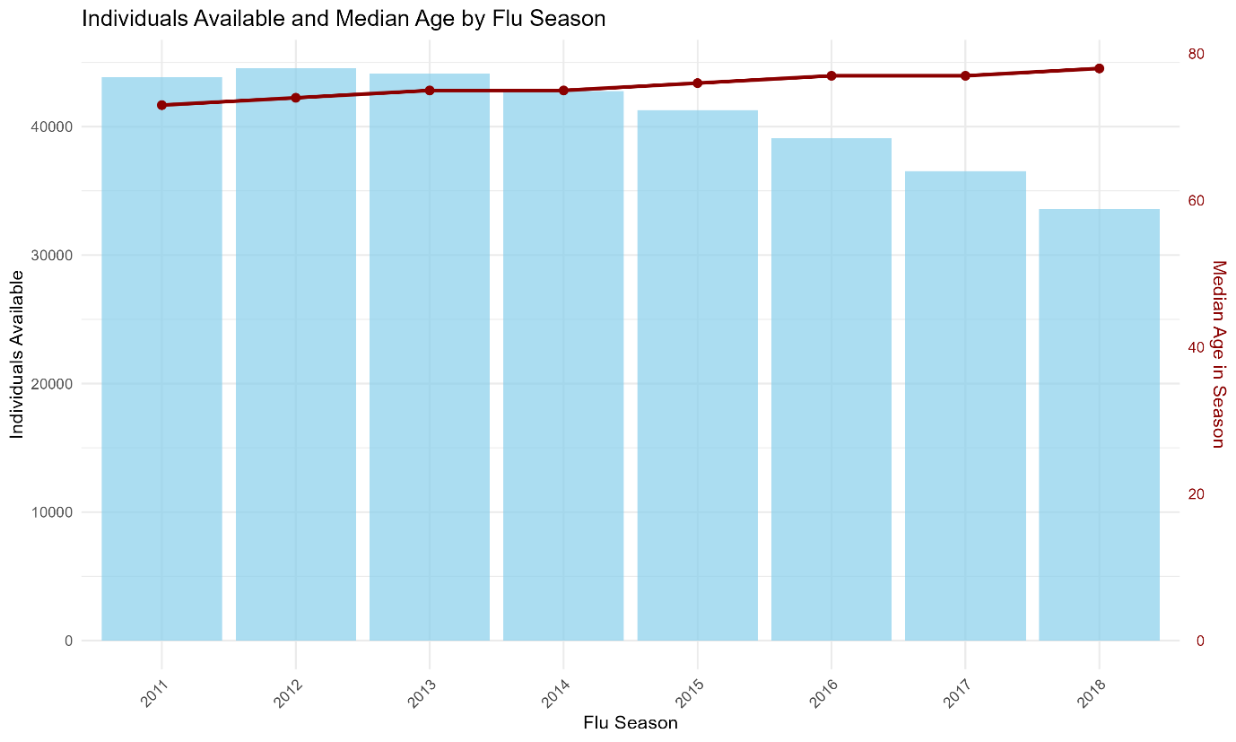
Figure S1: Number of individuals available and median age by influenza season (2011/12-2018/19). Bars (left axis) show the count of individuals contributing to each season; the dark red line (right axis) shows median age in season.

Sensitivity analysis: removing herpes zoster vaccination variable
Table S1: Multivariable self-controlled case series conditional Poisson regression analysis for predictors of number of days prescribed antibiotics, excluding herpes zoster vaccine covariate (September–April time window).
Variable | Incidence Rate Ratio for all antibiotic prescriptions (95% CI) | Incidence Rate Ratio for RTI-related antibiotic prescriptions (95% CI) | Incidence Rate Ratio for UTI-related antibiotic prescriptions (95% CI)
Influenza vaccine | 1.03 (1.02–1.03) | 0.96 (0.95–0.98) | 1.14 (1.11–1.17)
Influenza season
2011/12 | 1 | 1 | 1
2012/13 | 1.04 (1.04–1.05) | 1.06 (1.05–1.07) | 1.05 (1.03–1.07)
2013/14 | 1.07 (1.07–1.08) | 0.99 (0.97–1.00) | 1.06 (1.04–1.08)
2014/15 | 1.14 (1.13–1.14) | 1.11 (1.10–1.13) | 1.13 (1.11–1.16)
2015/16 | 1.19 (1.18–1.19) | 1.05 (1.03–1.06) | 1.35 (1.33–1.38)
2016/17 | 1.20 (1.19–1.21) | 1.13 (1.11–1.15) | 1.52 (1.49–1.55)
2017/18 | 1.22 (1.21–1.23) | 1.17 (1.15–1.19) | 1.53 (1.49–1.56)
2018/19 | 1.15 (1.14–1.15) | 0.92 (0.91–0.94) | 1.56 (1.52–1.60)
Pneumococcal vaccine | 1.00 (0.99–1.01) | 0.89 (0.87–0.91) | 1.02 (0.99–1.06)
Patient-clinical staff Interaction count | 1.02 (1.02–1.02) | 1.03 (1.03–1.03) | 1.04 (1.04–1.04)
Combined sum comorbidity score | 1.04 (1.04–1.04) | 1.03 (1.03–1.04) | 1.05 (1.05–1.06)
Out-of-season prescribing | 1.01 (1.01–1.01) | 1.01 (1.01–1.01) | 1.01 (1.00–1.01)
Centred age*influenza vaccine | 1.00 (1.00–1.00) | 1.00 (1.00–1.01) | 1.00 (0.99–1.00)

Table S2: Multivariable self-controlled case series conditional Poisson regression analysis for predictors of number of days prescribed antibiotics, excluding herpes zoster vaccine covariate (January–April time window).
Variable | Incidence Rate Ratio for all antibiotic prescriptions (95% CI) | Incidence Rate Ratio for RTI-related antibiotic prescriptions (95% CI) | Incidence Rate Ratio for UTI-related antibiotic prescriptions (95% CI)
Influenza vaccine | 1.01 (1.01–1.02) | 0.90 (0.88–0.93) | 1.14 (1.10–1.18)
Influenza season
2011/12 | 1 | 1 | 1
2012/13 | 1.02 (1.02–1.02) | 1.07 (1.05–1.08) | 1.04 (1.01–1.07)
2013/14 | 1.06 (1.06–1.06) | 0.93 (0.91–0.95) | 1.01 (0.98–1.04)
2014/15 | 1.11 (1.11–1.12) | 1.09 (1.07–1.11) | 1.16 (1.12–1.19)
2015/16 | 1.19 (1.18–1.19) | 1.07 (1.05–1.09) | 1.37 (1.33–1.41)
2016/17 | 1.20 (1.20–1.21) | 1.12 (1.10–1.14) | 1.53 (1.48–1.57)
2017/18 | 1.22 (1.21–1.23) | 1.20 (1.17–1.22) | 1.55 (1.50–1.60)
2018/19 | 1.18 (1.17–1.18) | 0.90 (0.88–0.93) | 1.57 (1.52–1.62)
Pneumococcal vaccine | 0.99 (0.98–1.00) | 0.82 (0.80–0.85) | 1.00 (0.96–1.05)
Patient-clinical staff Interaction count | 1.02 (1.02–1.02) | 1.03 (1.03–1.03) | 1.04 (1.04–1.04)
Combined sum comorbidity score | 1.04 (1.03–1.04) | 1.03 (1.02–1.03) | 1.05 (1.04–1.06)
Out-of-season prescribing | 1.01 (1.01–1.01) | 1.01 (1.01–1.01) | 1.00 (1.00–1.00)
Centred age*influenza vaccine | 1.00 (1.00–1.00) | 1.01 (1.01–1.01) | 0.99 (0.99–1.00)
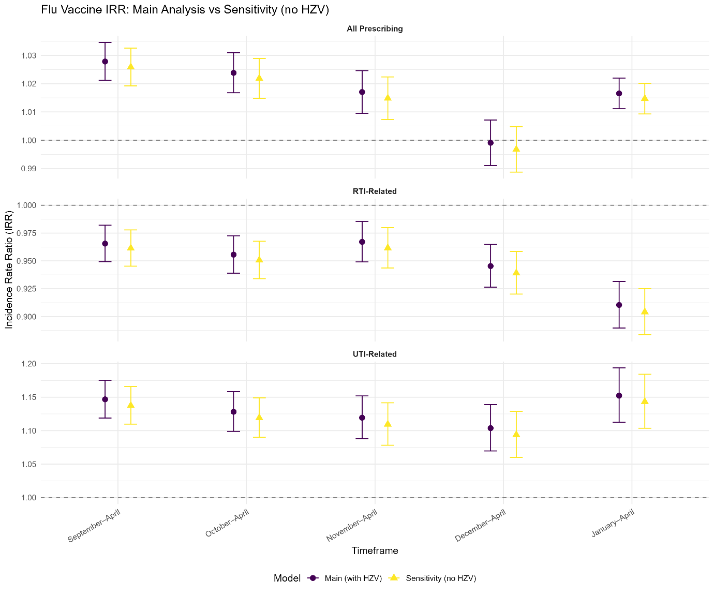
Figure S2: Incidence Rate Ratio (IRR) for the effect of influenza vaccination on antibiotic prescribing days by prescribing type (All, RTI-related, and UTI-related) across different seasonal timeframes: main analysis (with herpes zoster vaccine covariate) versus sensitivity analysis (without herpes-zoster vaccine covariate). Points show IRR estimates; error bars indicate Wald 95% confidence intervals.

Unadjusted analysis: including only influenza vaccination as an exposure
Table S3: Univariable self-controlled case series conditional Poisson regression analysis estimating the association between seasonal influenza vaccination and number of days prescribed antibiotics (unadjusted models).
Variable | Incidence Rate Ratio for all antibiotic prescriptions (95% CI) | Incidence Rate Ratio for RTI-related antibiotic prescriptions (95% CI) | Incidence Rate Ratio for UTI-related antibiotic prescriptions (95% CI)
September-April | 1.08 (1.08–1.09) | 1.07 (1.06–1.08) | 1.11 (1.10–1.12)
October-April | 1.08 (1.08–1.08) | 1.07 (1.06–1.08) | 1.10 (1.09–1.12)
November-April | 1.07 (1.07–1.08) | 1.07 (1.06–1.08) | 1.10 (1.08–1.11)
December-April | 1.06 (1.05–1.06) | 1.06 (1.05–1.07) | 1.10 (1.08–1.11)
January-April | 1.07 (1.06–1.07) | 1.03 (1.02–1.07) | 1.08 (1.06–1.10)

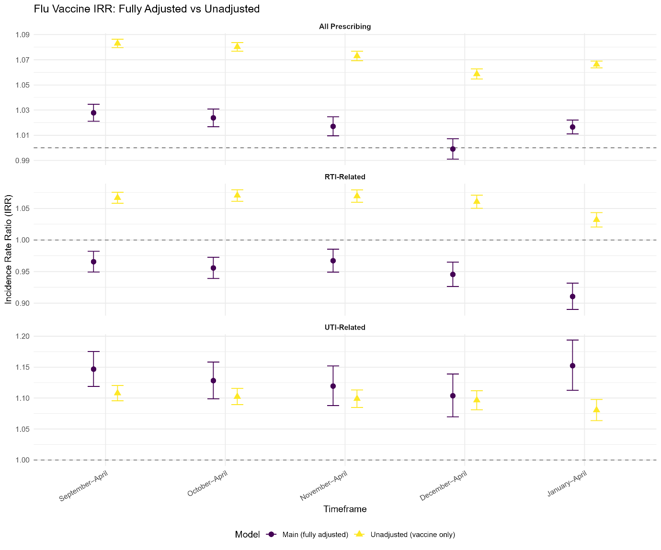
Figure S3: Incidence Rate Ratio (IRR) for the effect of influenza vaccination on antibiotic prescribing days by prescribing type (All, RTI-related, and UTI-related) across different seasonal timeframes: fully adjusted main analysis versus unadjusted model (influenza vaccine indicator only). Points show IRR estimates; error bars indicate Wald 95% confidence intervals.

