Supplementary Material
A novel tetrahydrocurcumin derivative as a potential anti-colorectal agent: Studies on its design, synthesis, and in vitro and in vivo biological evaluation
Yixin Chen ^{ab, 1}, Ao Duan ^{a,1}, Wenzhang Li ª, Meitao Duan ^{ac}, Jiahui Yu ª, Ahmed Mahal ^{d}, Yongyan Zhu ^{ab*}, Quanhong Zhu ^{ab*}
a School of Traditional Chinese Medicine, Southern Medical University, Guangzhou, 510515, China.
b Guangdong Provincial Key Laboratory of Chinese Medicine Pharmaceutics, Guangzhou, 510515, China.
c School of Pharmacy, Xiamen Medical College, Xiamen 361023, China.
d Department of Medical Biochemical Analysis, College of Health Technology, Cihan University Erbil, Erbil, Kurdistan Region, Iraq

¹ These authors contributed equally to this work.
* Corresponding author: zqh@smu.edu.cn (Quanhong Zhu.)
yongyanzhu0521@smu.edu.cn (Yongyan Zhu)

Content
1. Table S1 1
2. HRMS, ¹H NMR, and ¹³C NMR spectra for compounds C1-C18, H5 2

1. Table S1
Table S1. The predicted targets of compound 5 by databases of SwissTargetPredition
SwissTargetPredition
ALOX5, BACE1, HTR1A, PDK1, GLO1, EGFR, WEE1, ESRRA, ESRRB, MELK, MDM2, RPS6KB1, AURKA, SPHK2, SPHK1, BMP1, SIGMAR1, TKT, PARP1, DNM1, IKBKG, IKBKB, CHUK, AURKB, CHEK2, ALDH2, SYK, MMP8, TRPM8, HDAC8, PIM1, PIM2, CTSK, ADAM17, ADAM10, CSF1R, EPHX2, CCNE1, CDK2, ADAMTS5, EHMT2, CDK2, CCNA1, CCNA2, NPY5R, PTGS1, TYR, KDM1A, SLC29A1, FCER2, CHEK1, RAF1, AKT2, SLC5A2, BRAF, SLC9A1, ERN1, TNF, AVPR1A, CCND1, CDK4, GCGR, CCNE2, CDK2, CCNE1, JAK1, JAK2, CDC25A, MMP14, HSP90AA1, AVPR2, PDGFRB, CXCR2, TSHR, AGTR1, CDC25C, ALOX5AP, APP, GPR142, CFD, ESR1, ESR2, INSR, FNTA, FNTB, ROCK2, LIMK1, LIMK2, MAPK8, CCNC, CDK8, HCK, PRKCZ, MAPK12, MKNK1, ECE1, CDK8, ALPL, PLAA, HDAC4, NOS1, HSP90AB1, PDE10A

- HRMS, ¹H NMR, and ¹³C NMR spectra for compounds C1-C18, H5
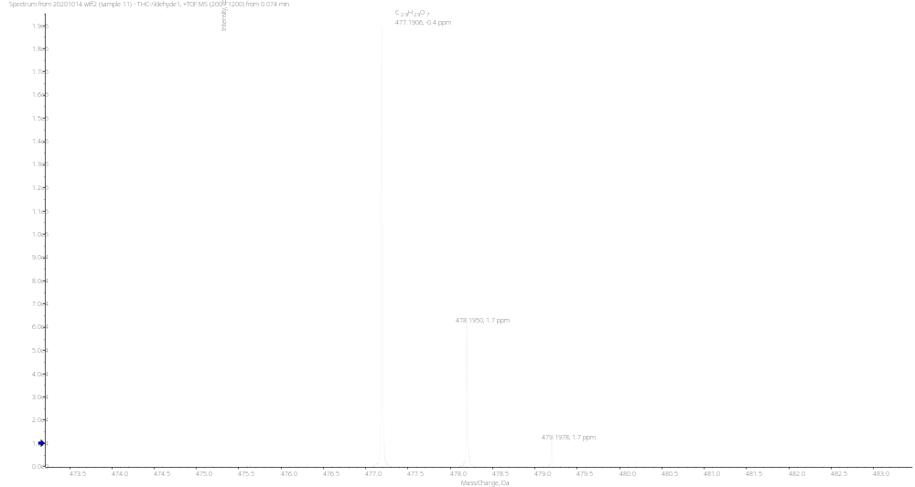
Figure S3. HRMS spectrum of C1

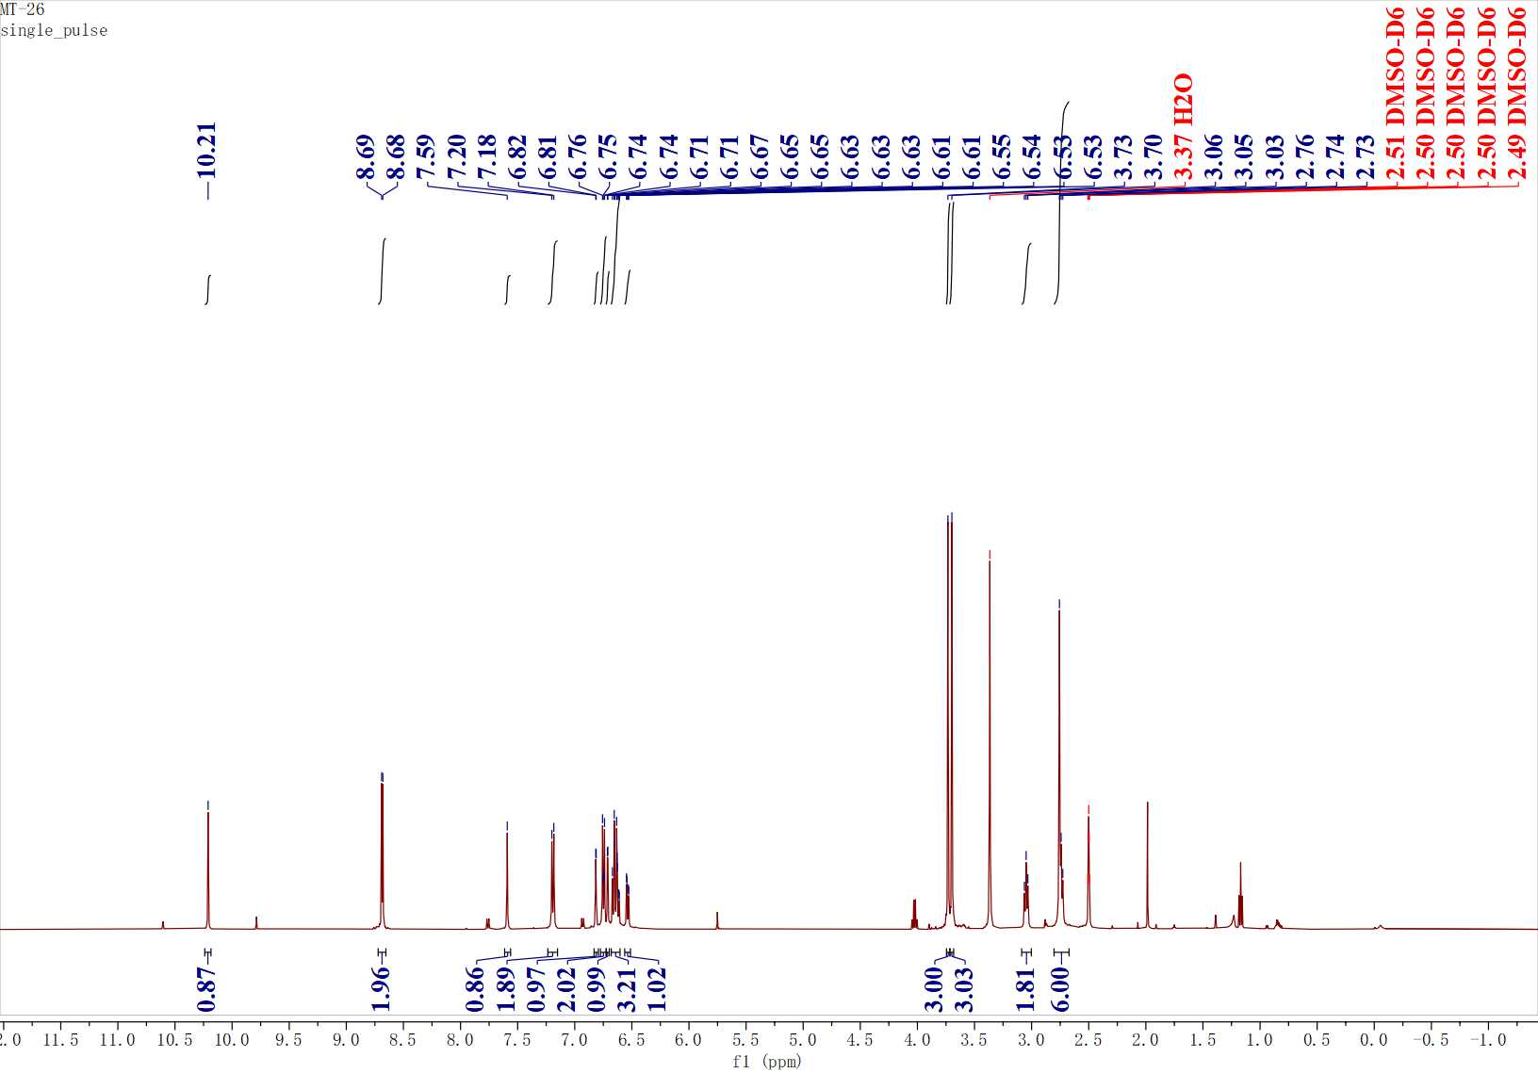
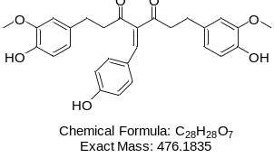
Figure S4. ¹H NMR spectrum of C1

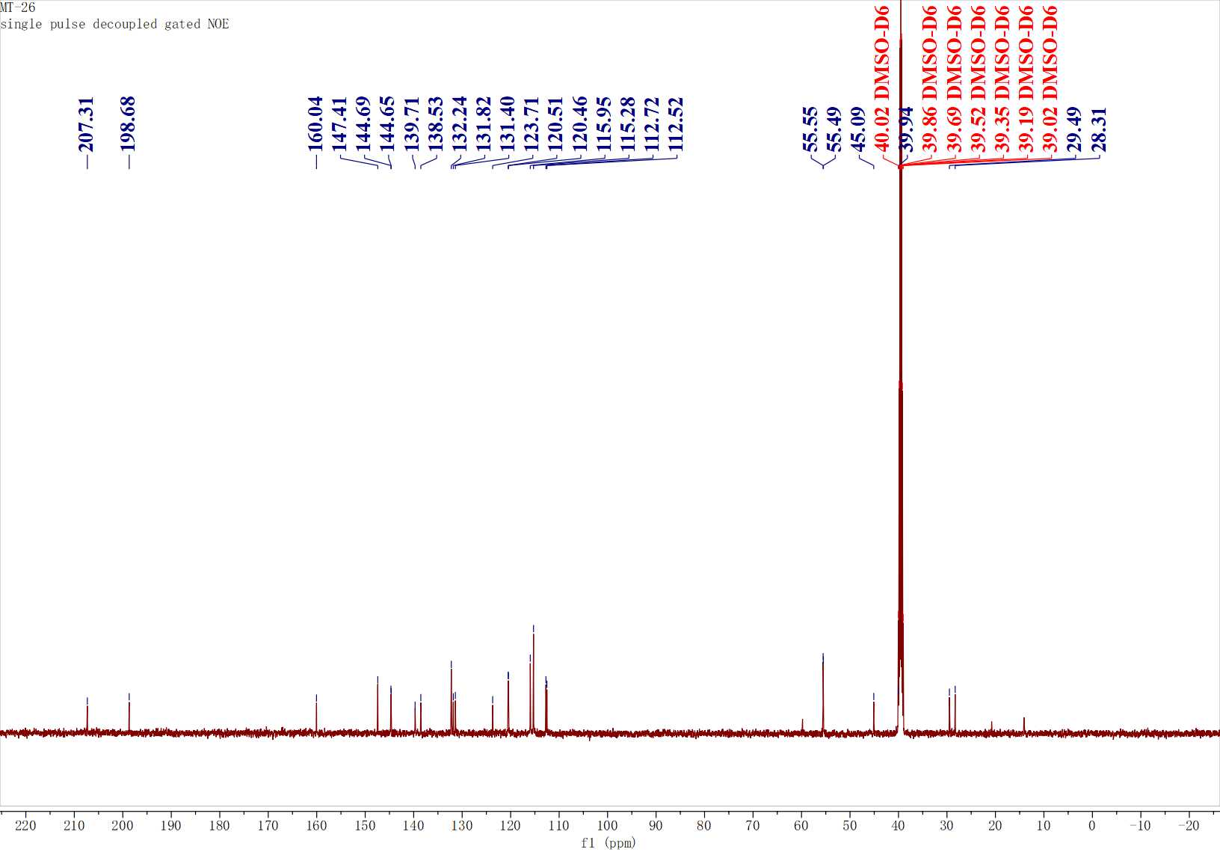
Figure S5. ¹³C NMR spectrum of C1
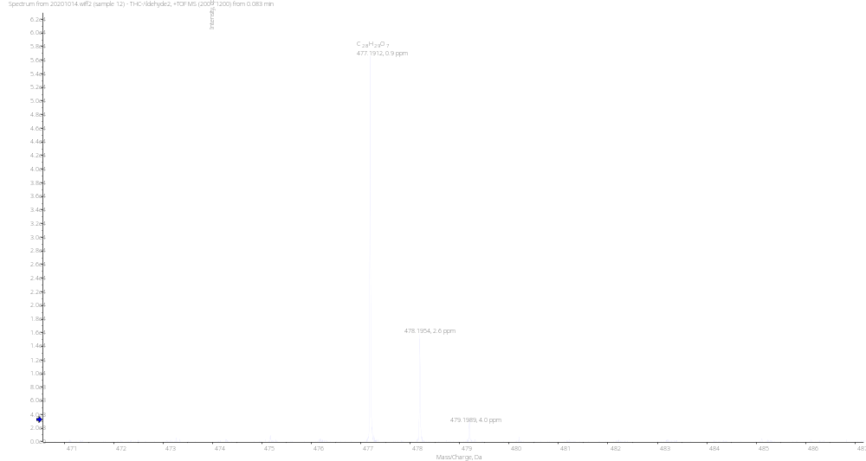
Figure S6. HRMS spectrum of C2

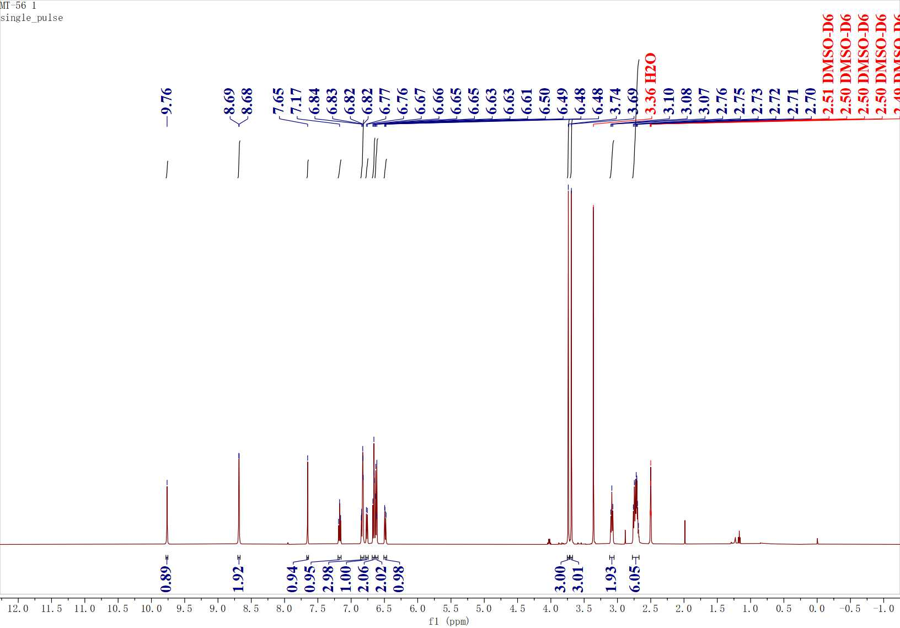
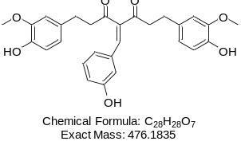
Figure S7. ¹H NMR spectrum of C2

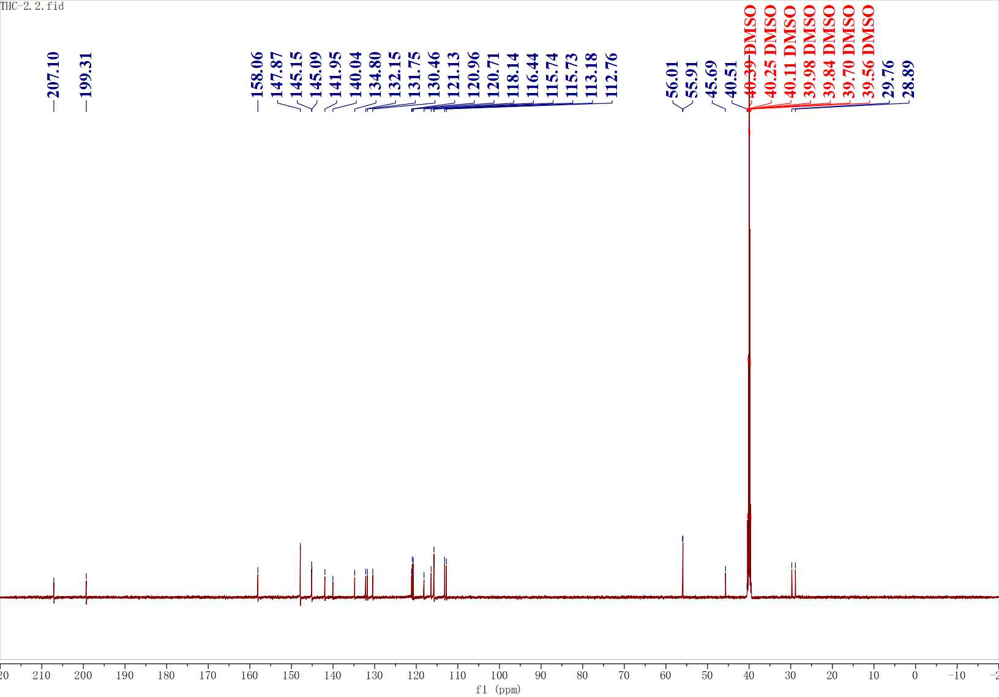
Figure S8. ¹³C NMR spectrum of C2

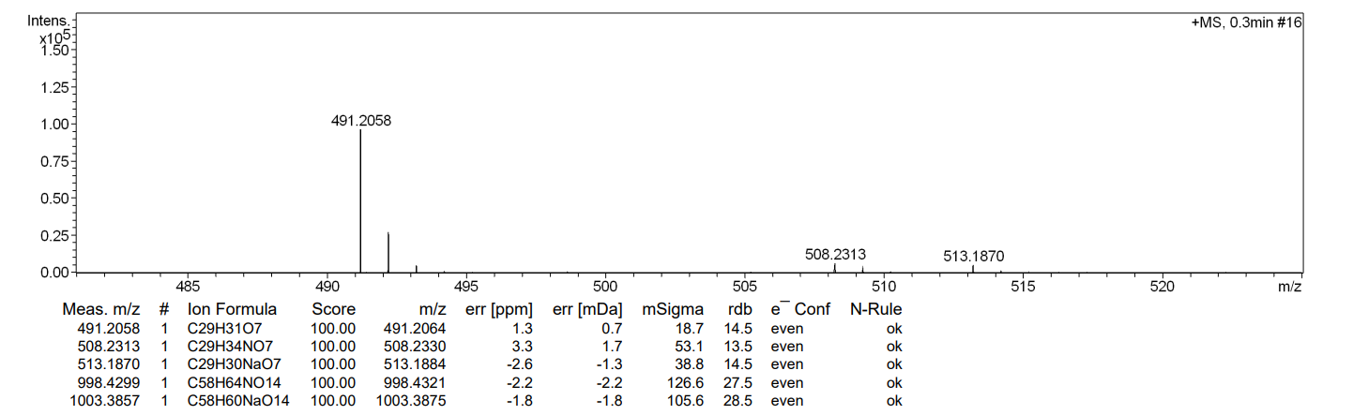
Figure S9. HRMS spectrum of C3

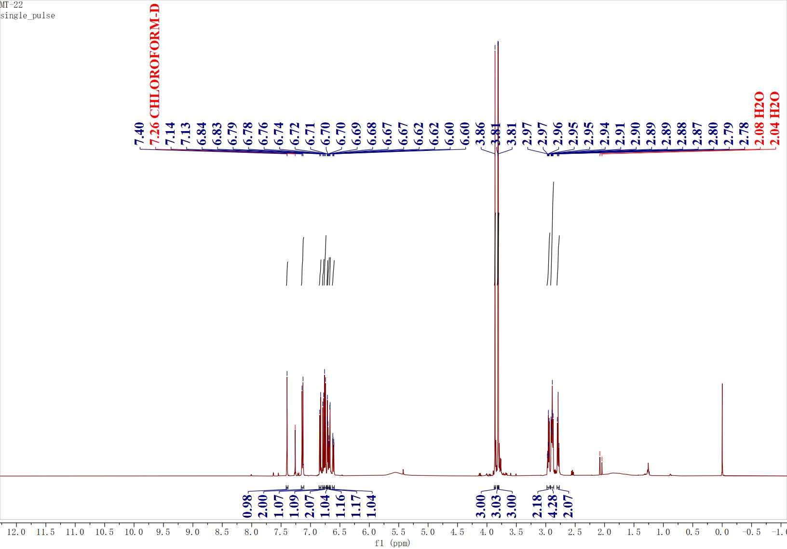
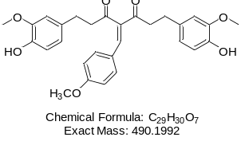
Figure S10. ¹H NMR spectrum of C3

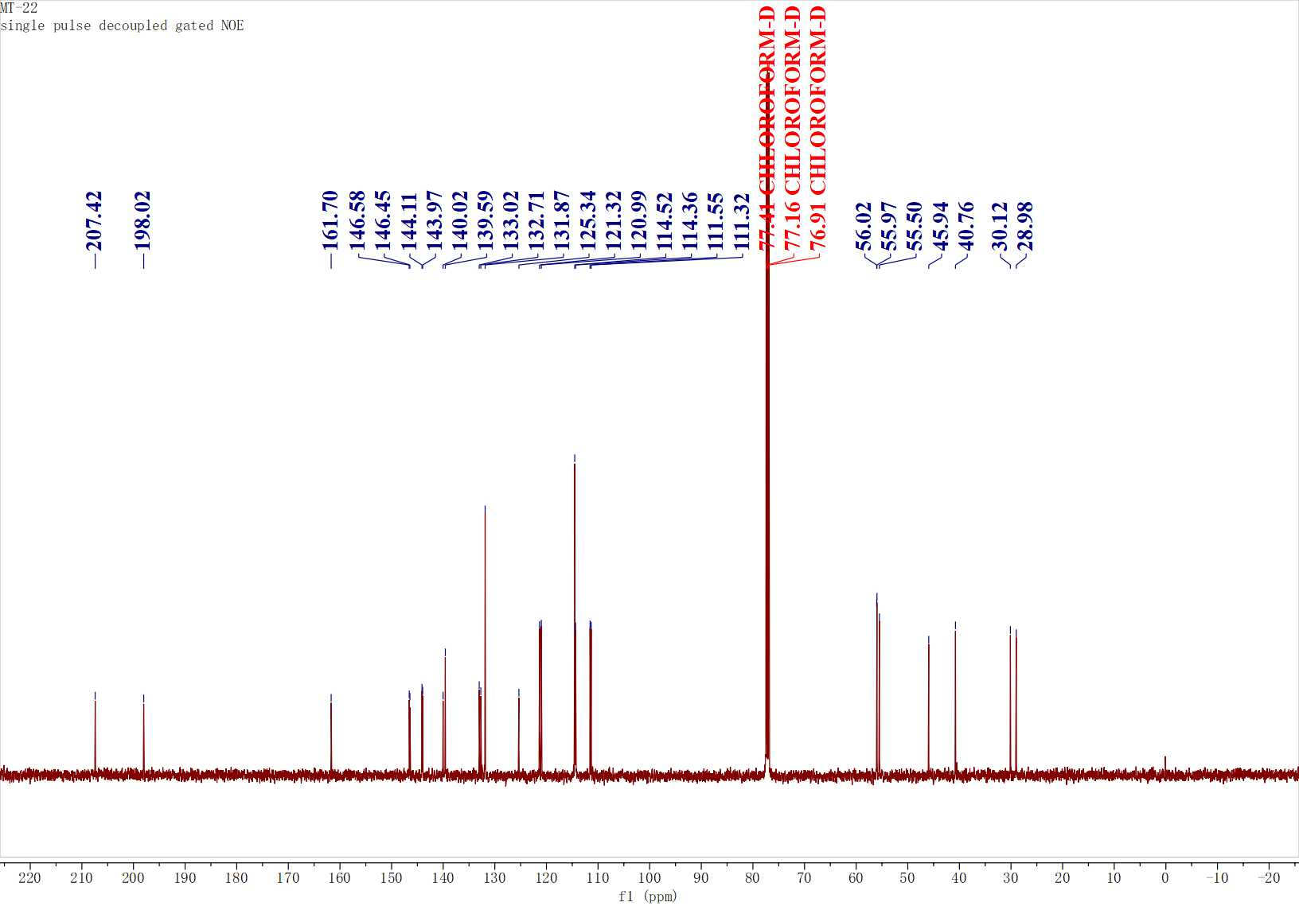
Figure S11. ¹³C NMR spectrum of C3

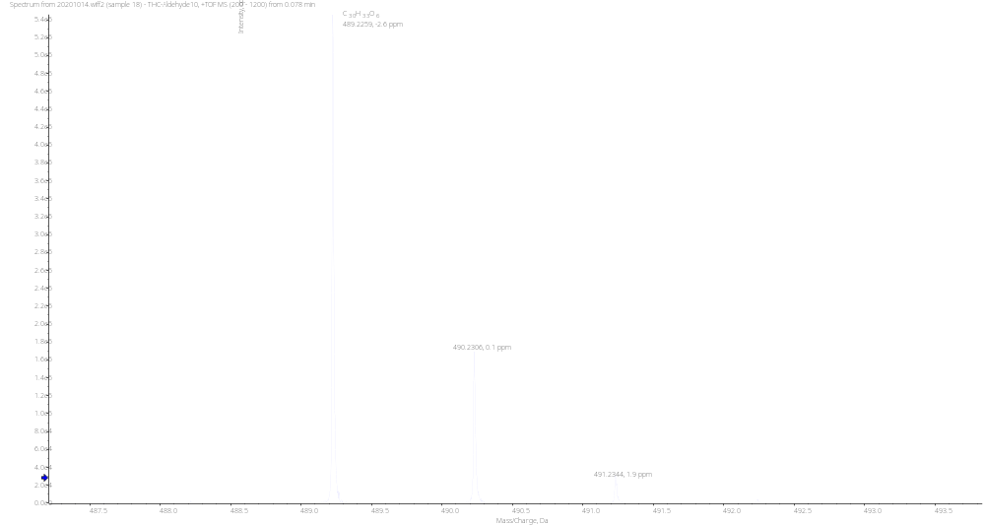
Figure S12. HRMS spectrum of C4

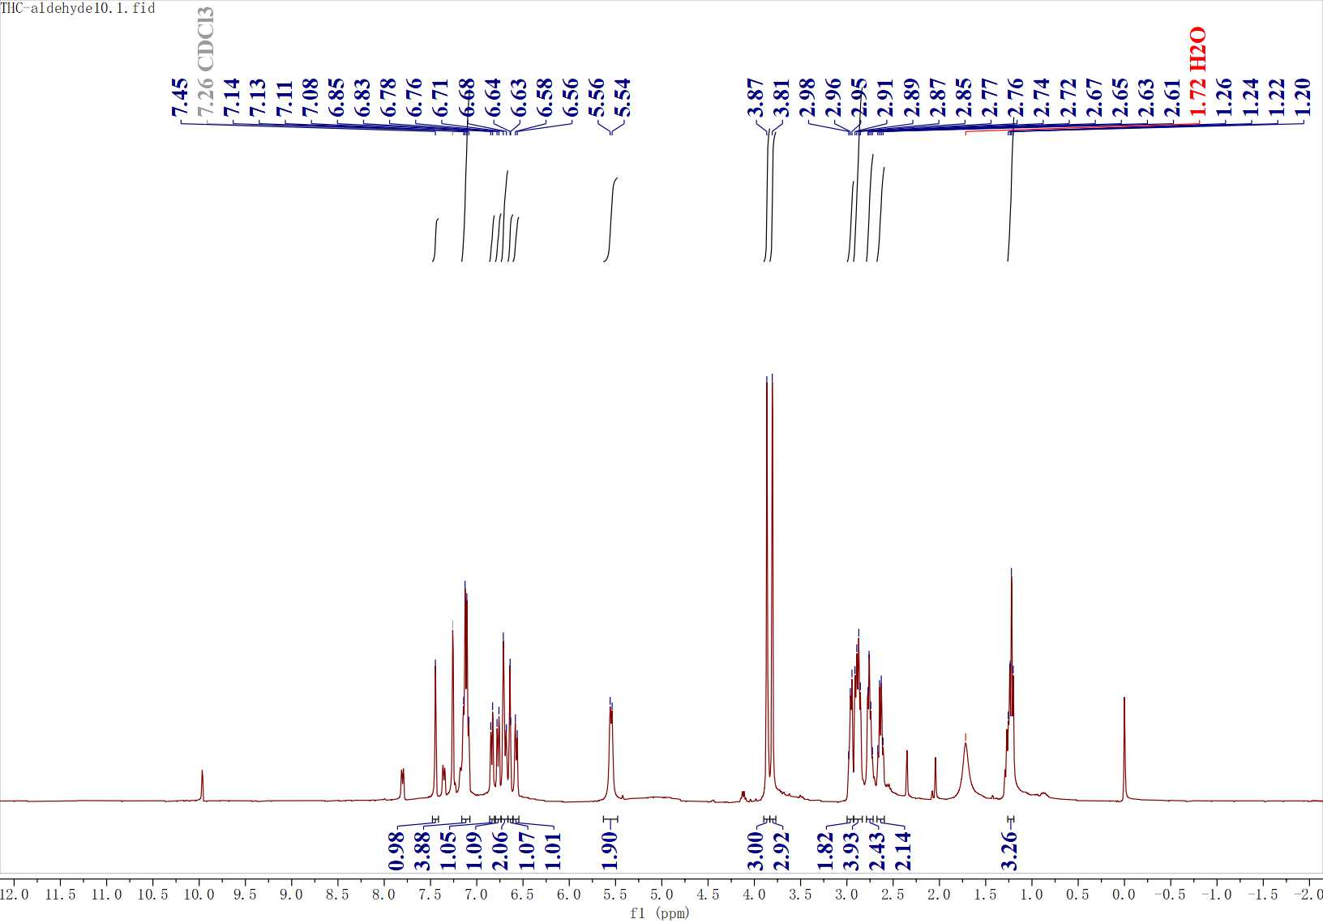
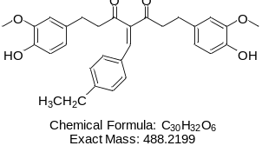
Figure S13. ¹H NMR spectrum of C4

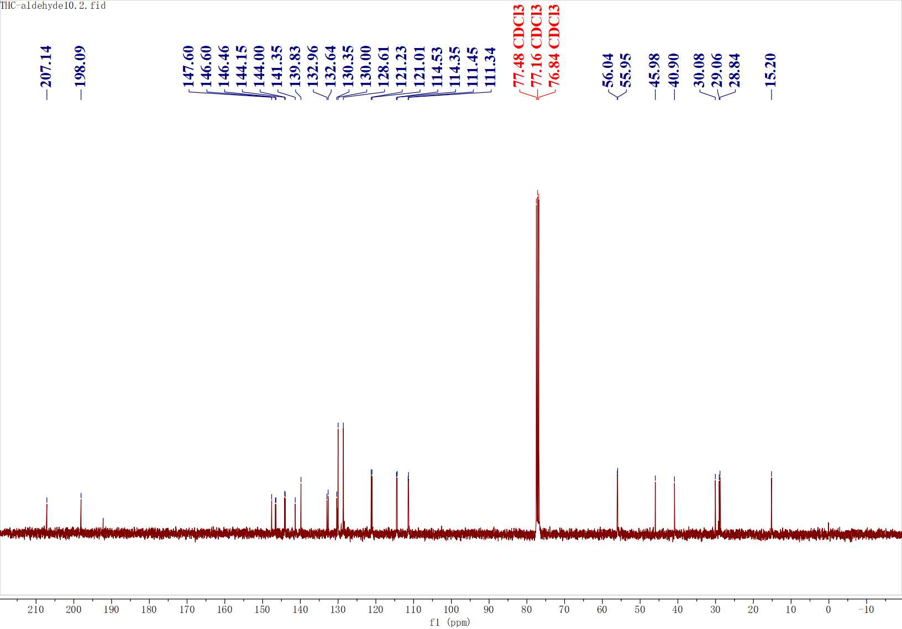
Figure S14. ¹³C NMR spectrum of C4

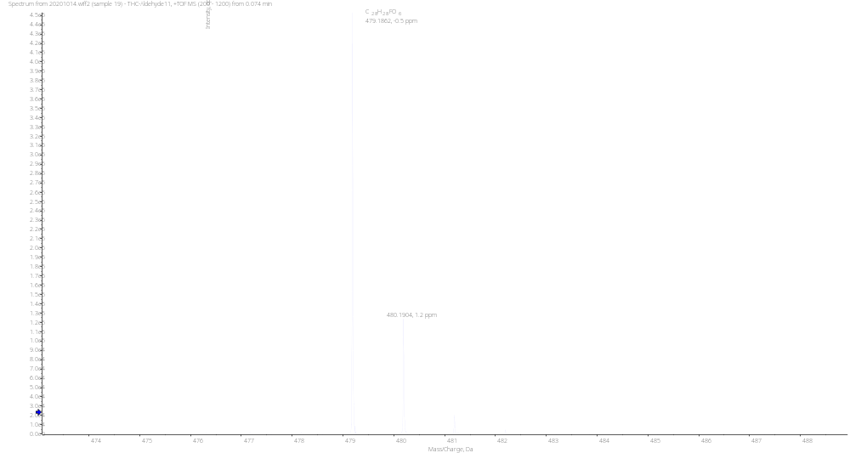
Figure S15. HRMS spectrum of C5

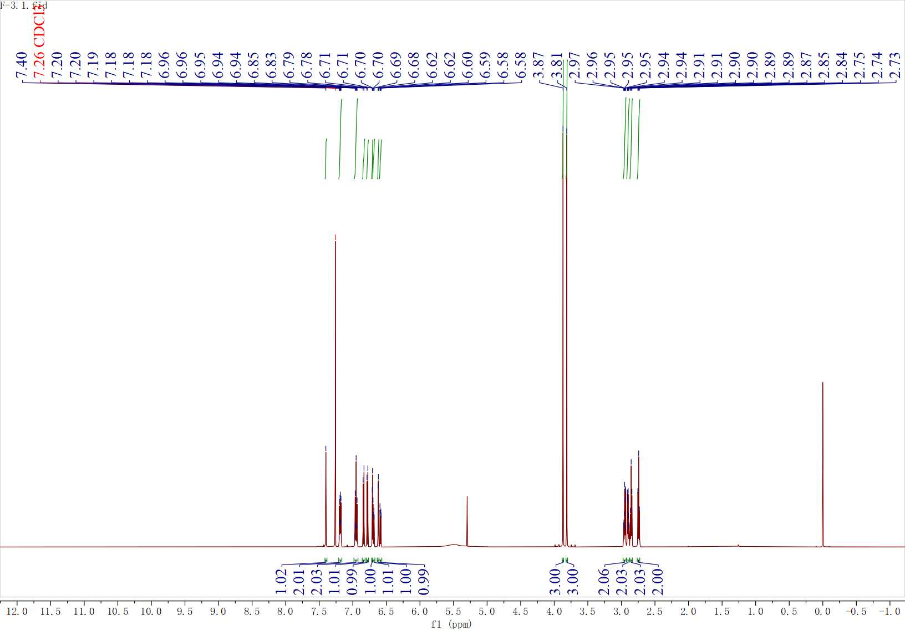
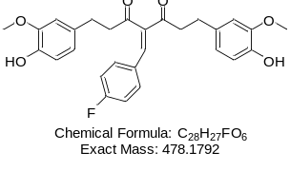
Figure S16. ¹H NMR spectrum of C5

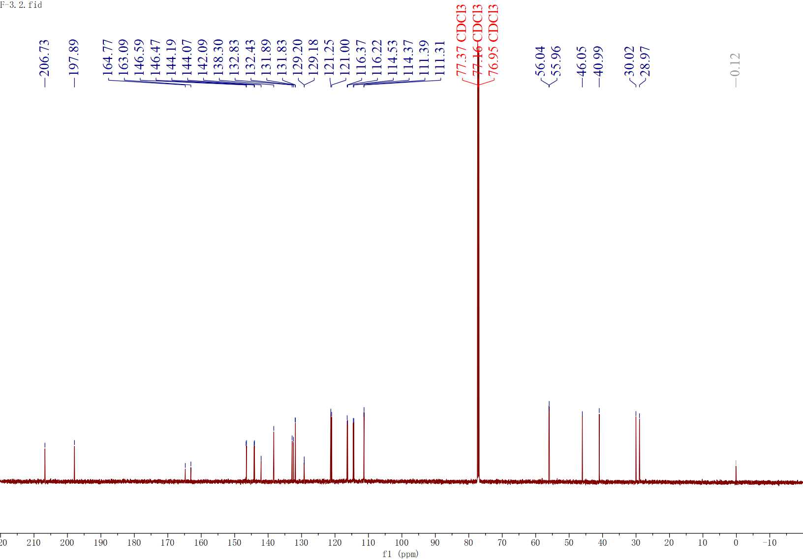
Figure S17. ¹³C NMR spectrum of C5

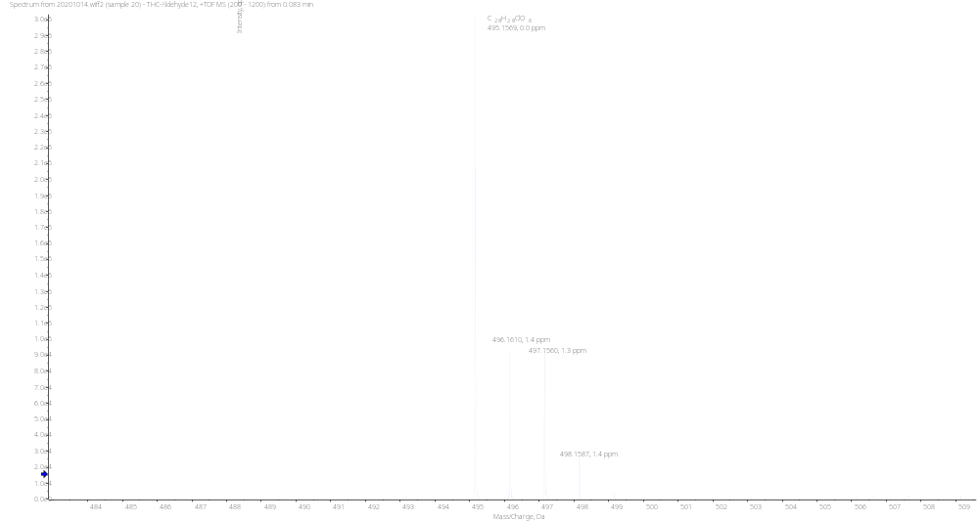
Figure S18. HRMS spectrum of C6

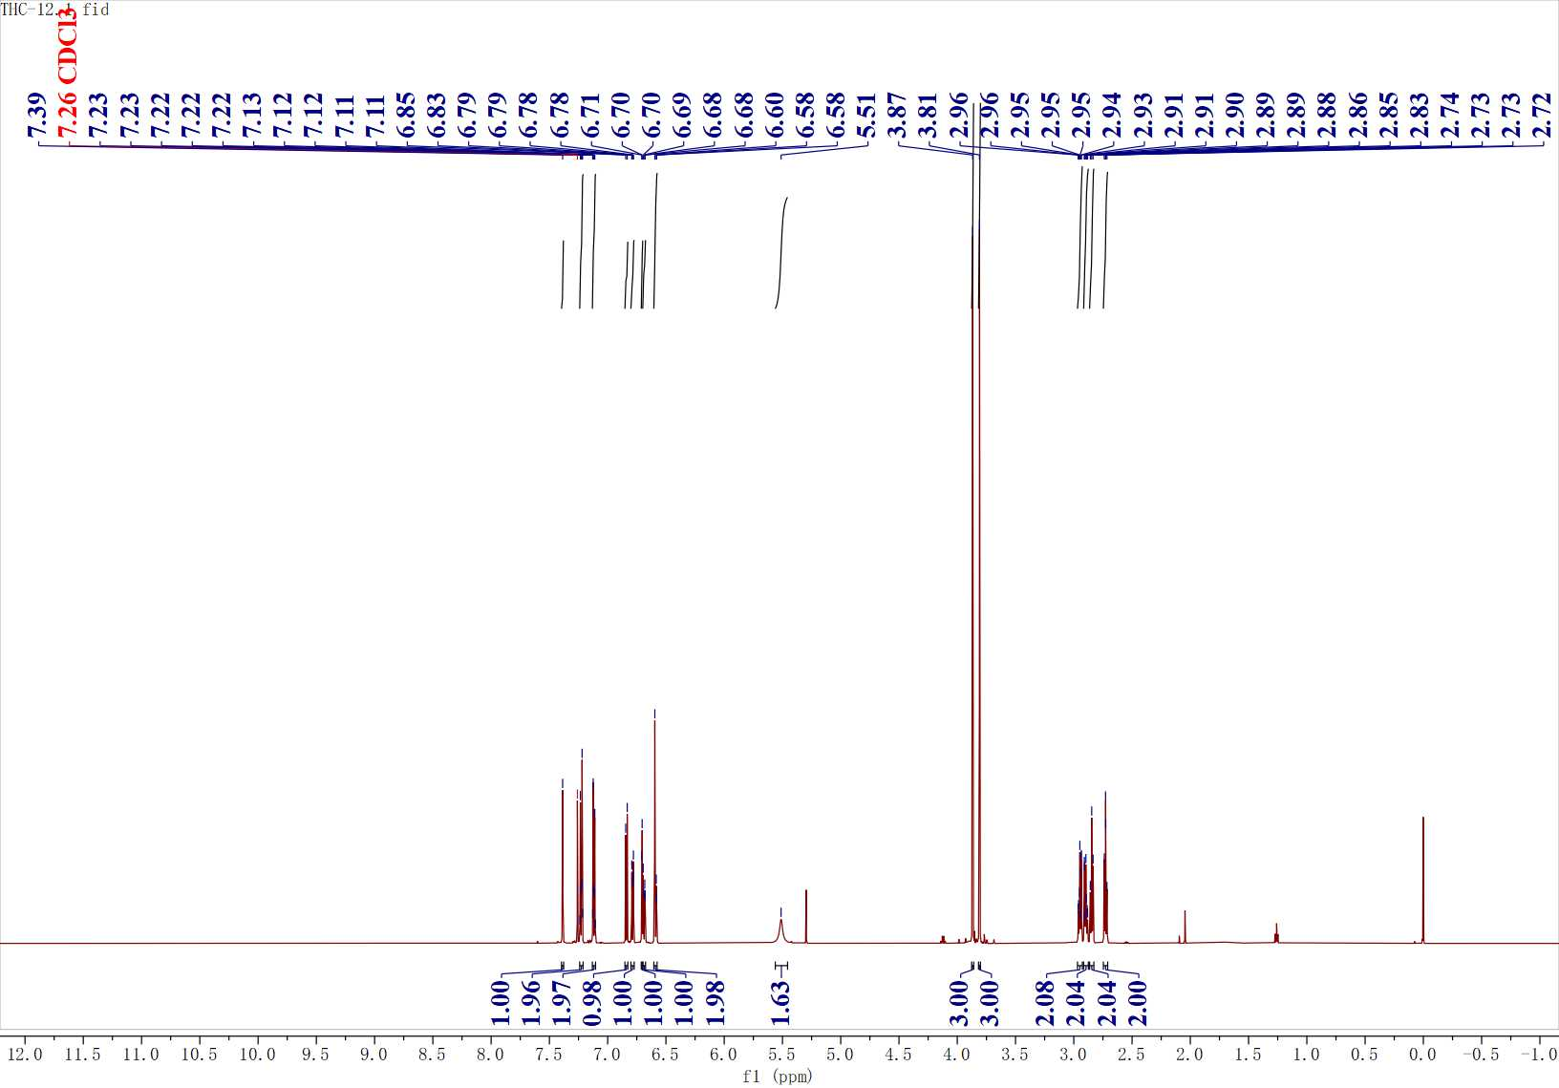
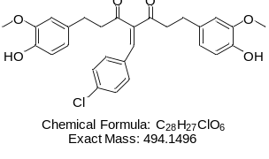
Figure S19. ¹H NMR spectrum of C6

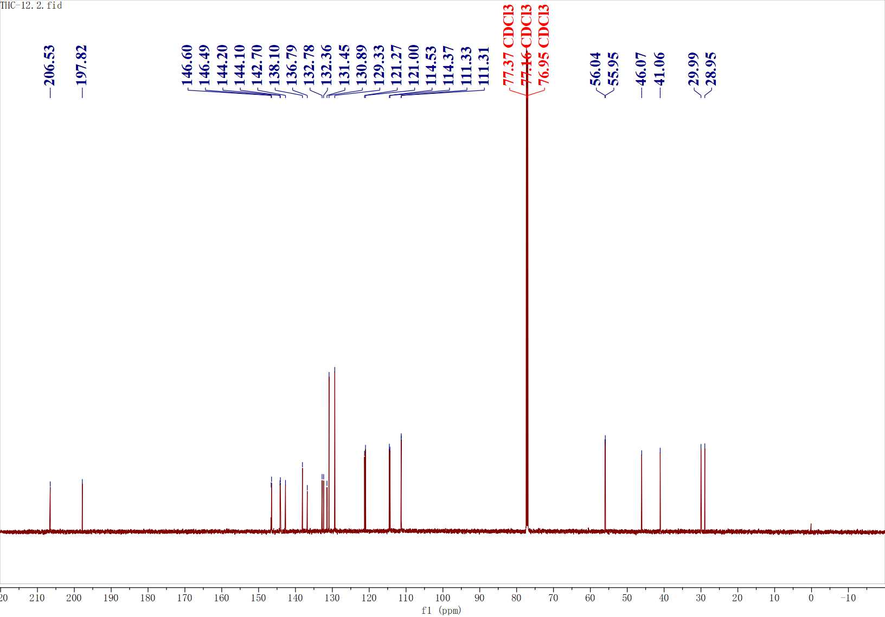
Figure S20. ¹³C NMR spectrum of C6

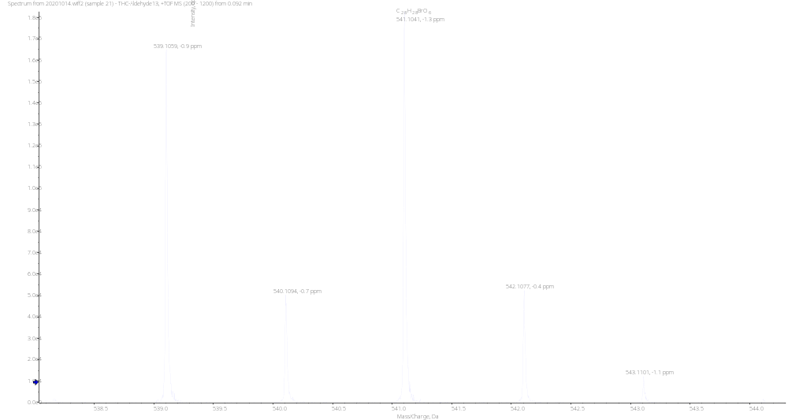
Figure S21. HRMS spectrum of C7

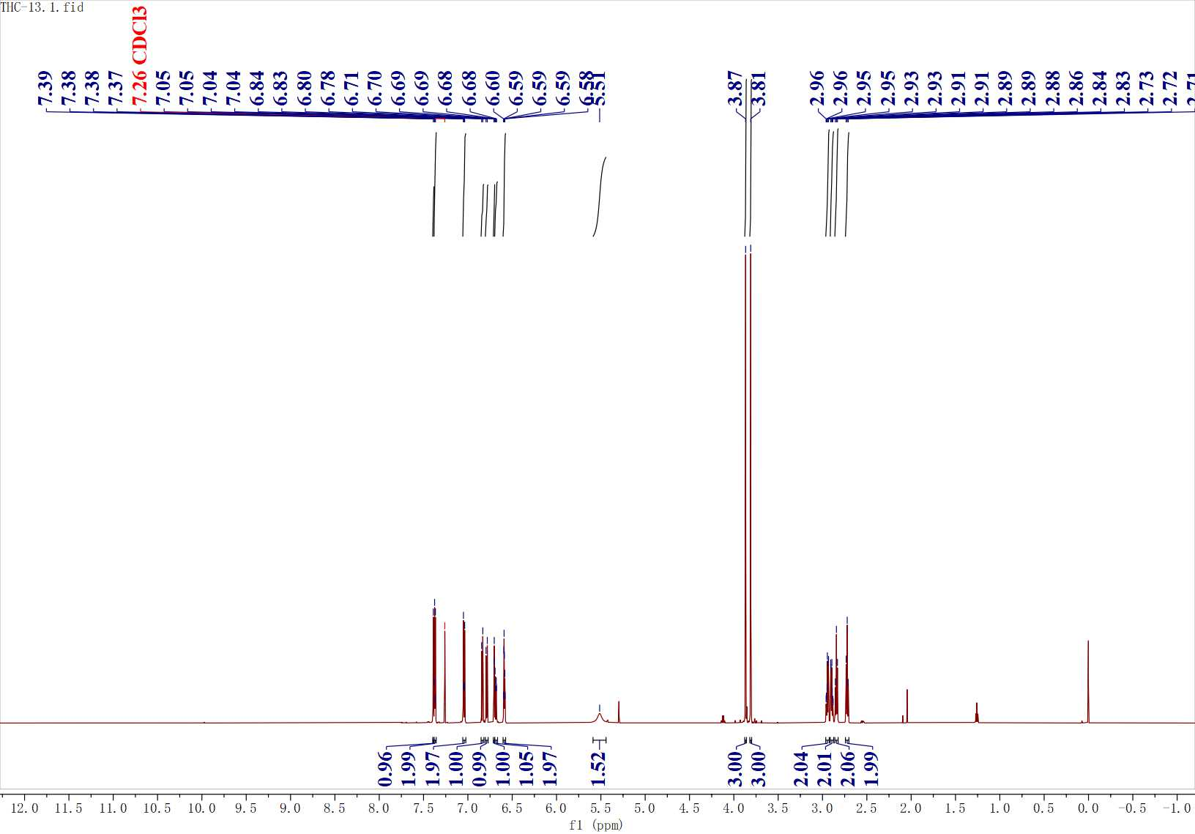
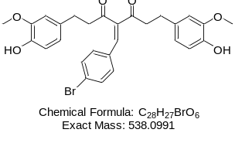
Figure S22. ¹H NMR spectrum of C7

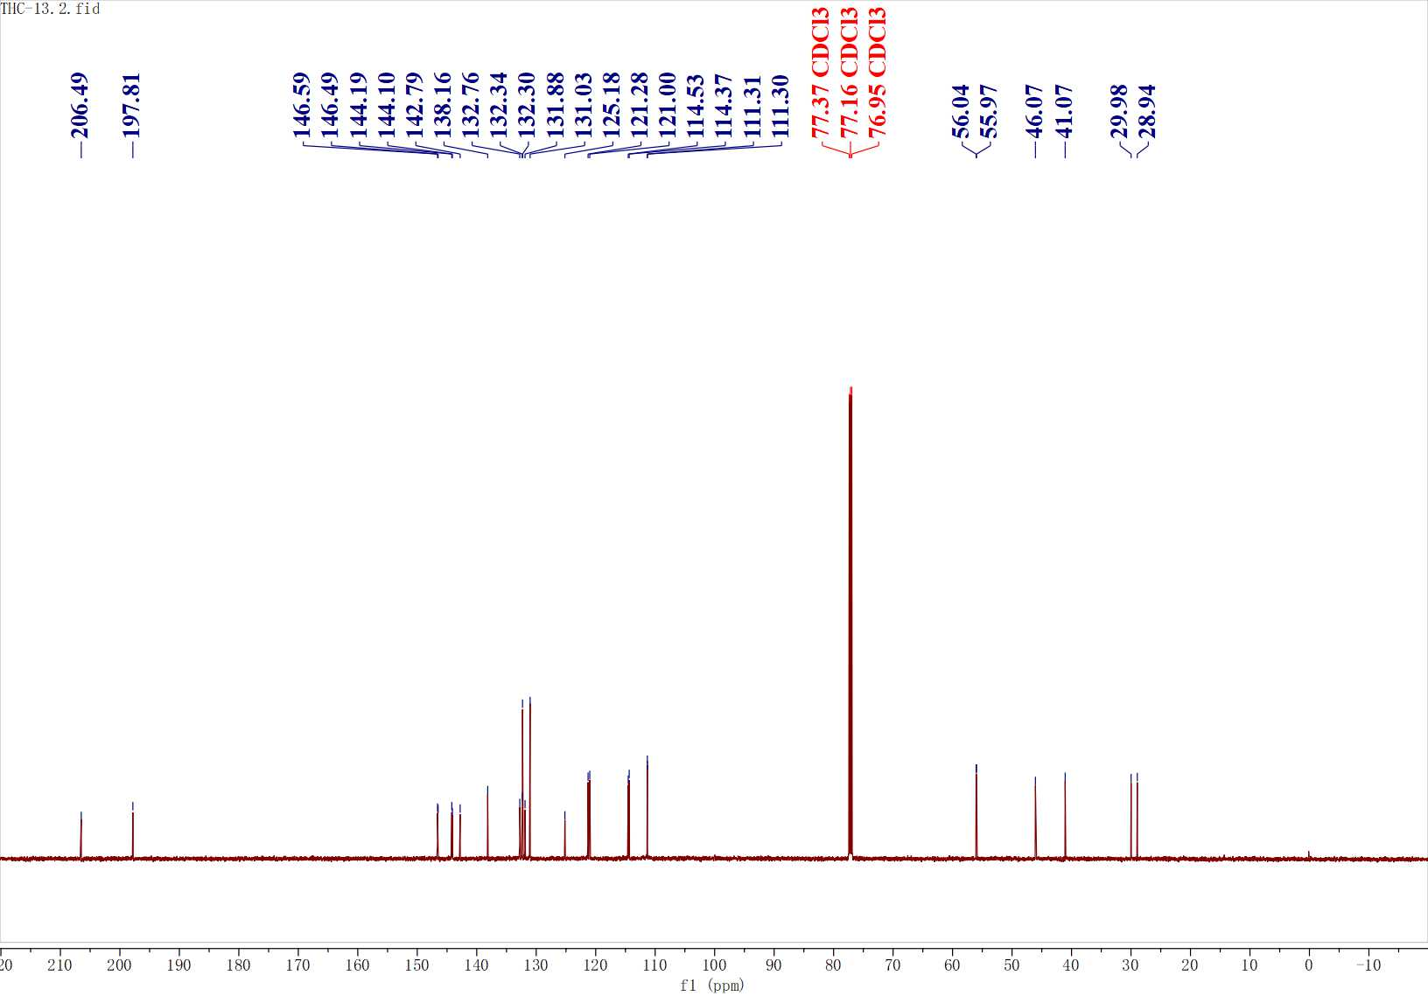
Figure S23. ¹³C NMR spectrum of C7

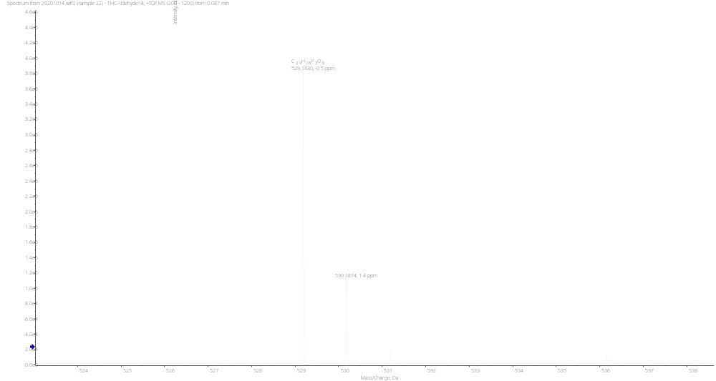
Figure S24. HRMS spectrum of C8

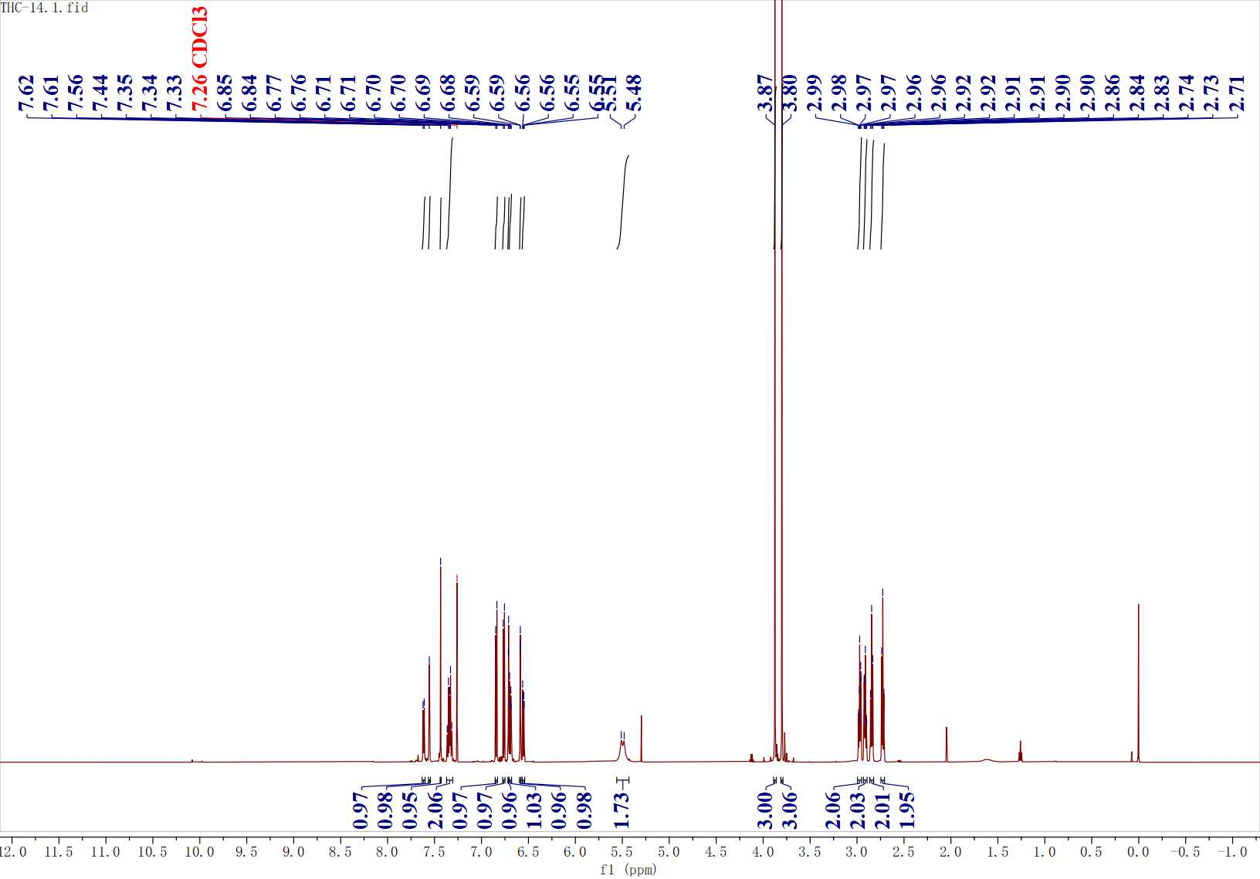
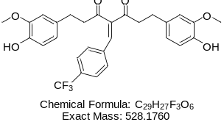
Figure S25. ¹H NMR spectrum of C8
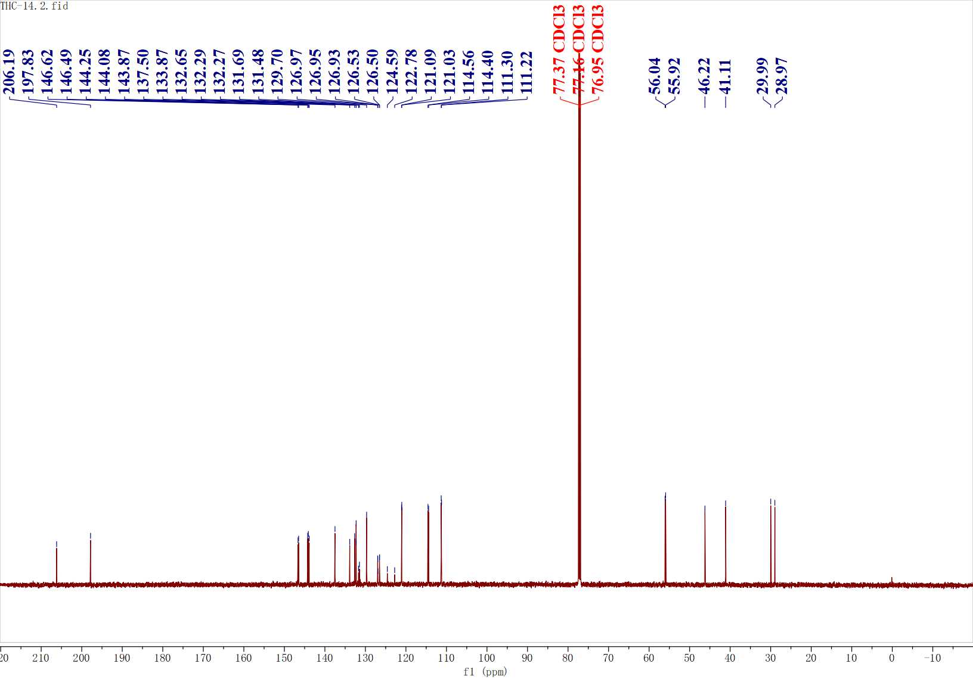
Figure S26. ¹³C NMR spectrum of C8

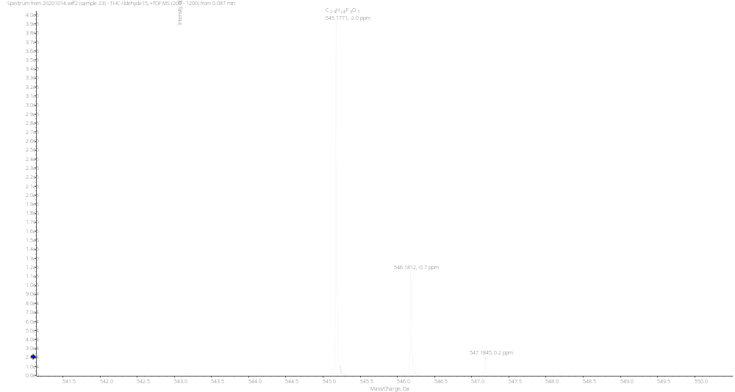
Figure S27. HRMS spectrum of C9

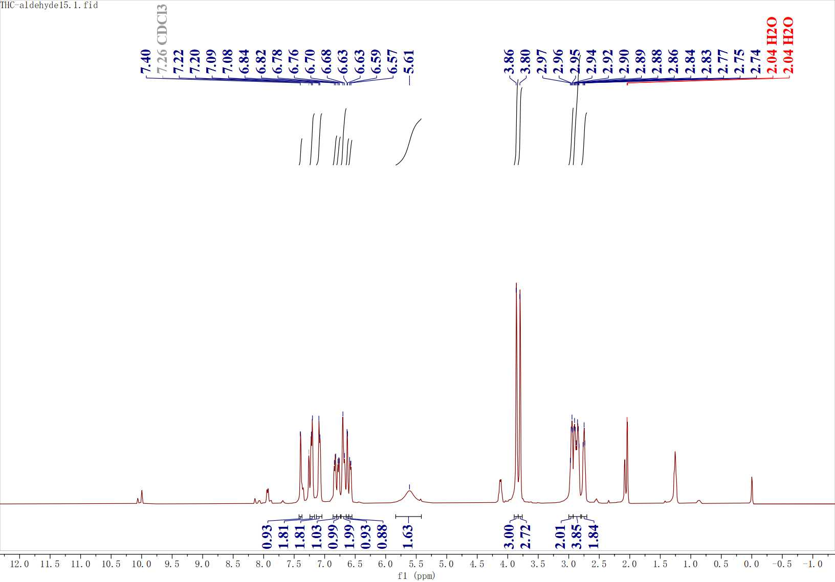
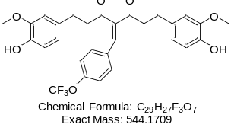
Figure S28. ¹H NMR spectrum of C9

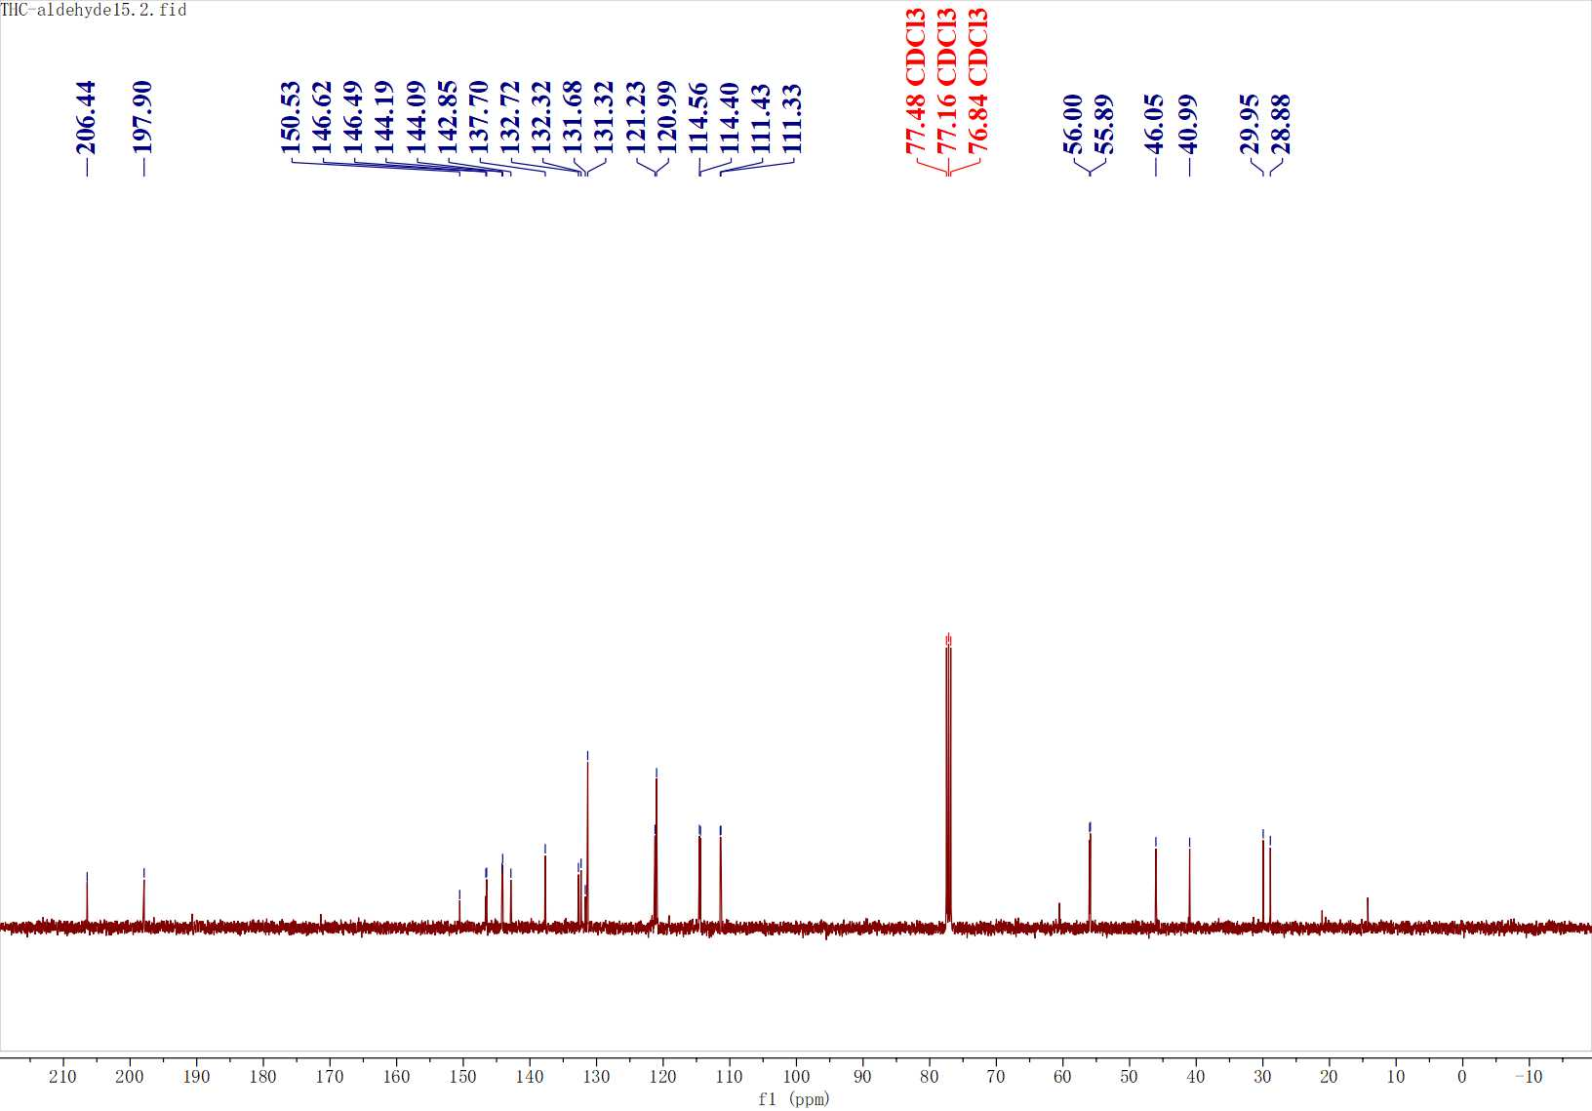
Figure S29. ¹³C NMR spectrum of C9

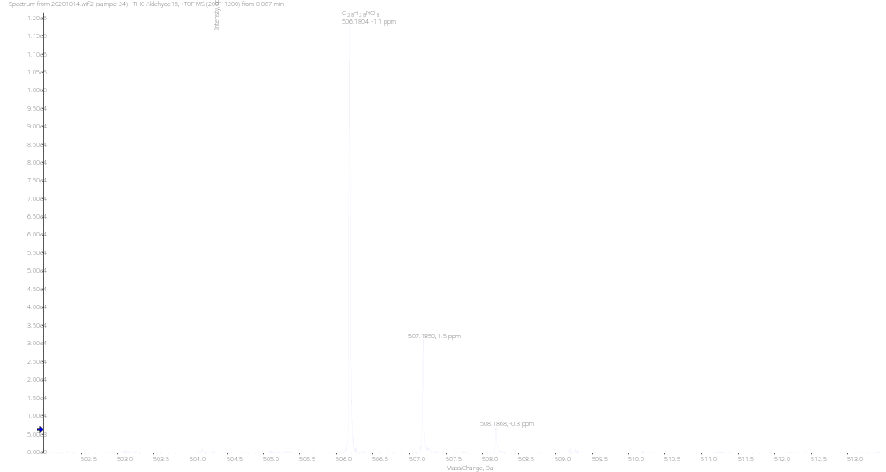
Figure S30. HRMS spectrum of C10

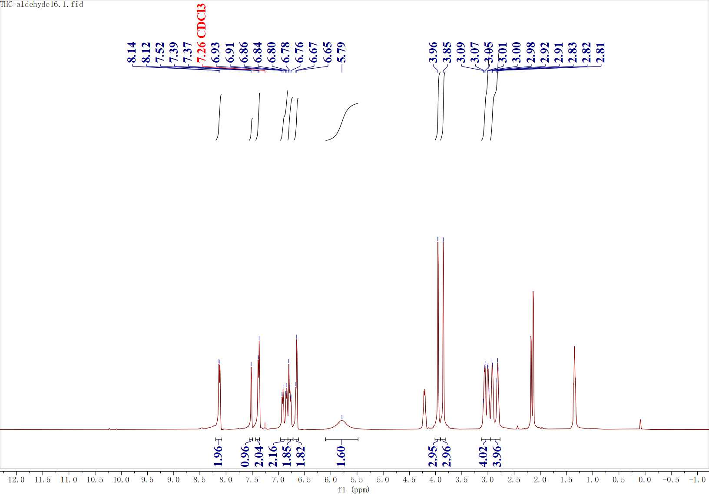
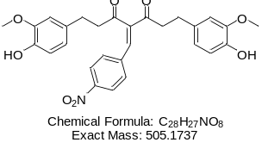
Figure S31. ¹H NMR spectrum of C10

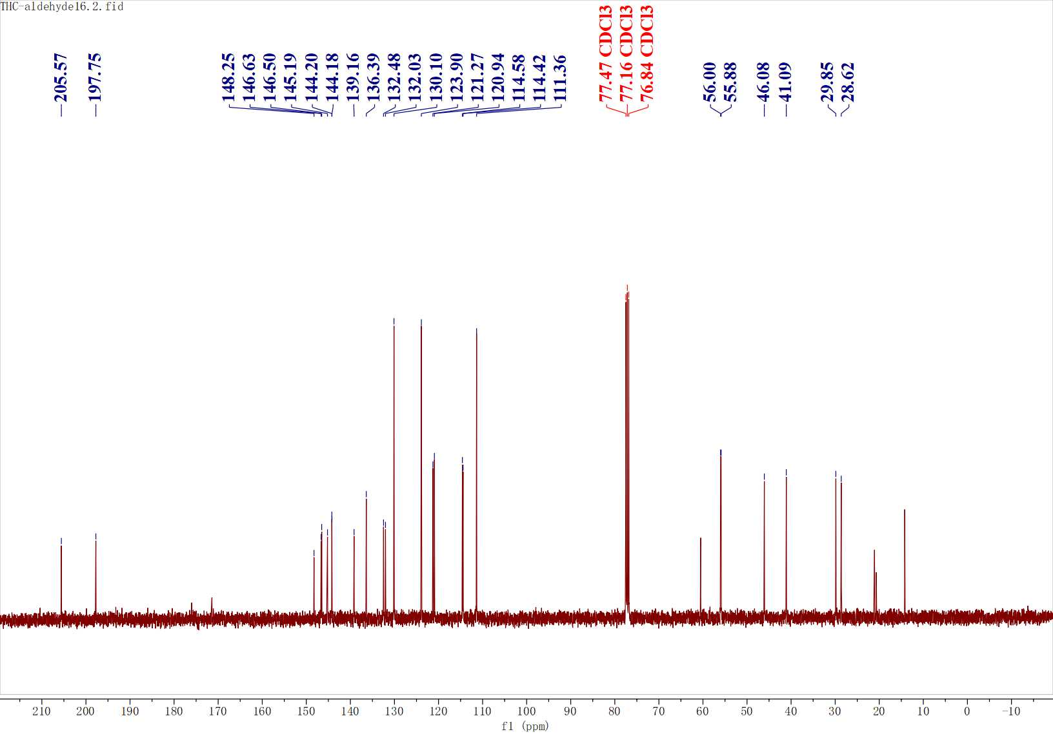
Figure S32. ¹³C NMR spectrum of C10

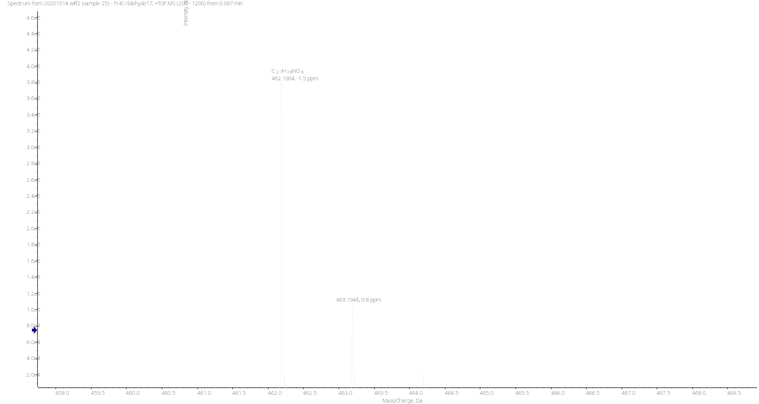
Figure S33. HRMS spectrum of C11

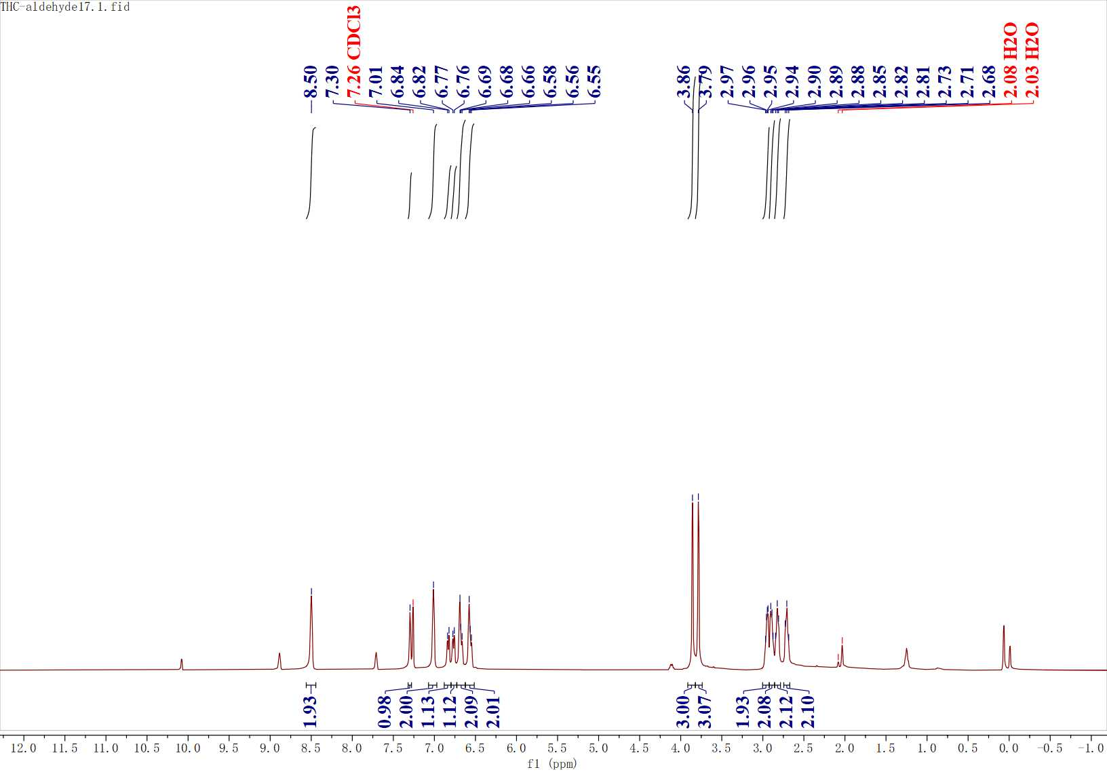
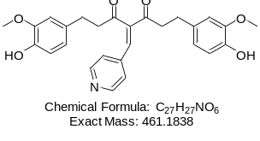
Figure S34. ¹H NMR spectrum of C11

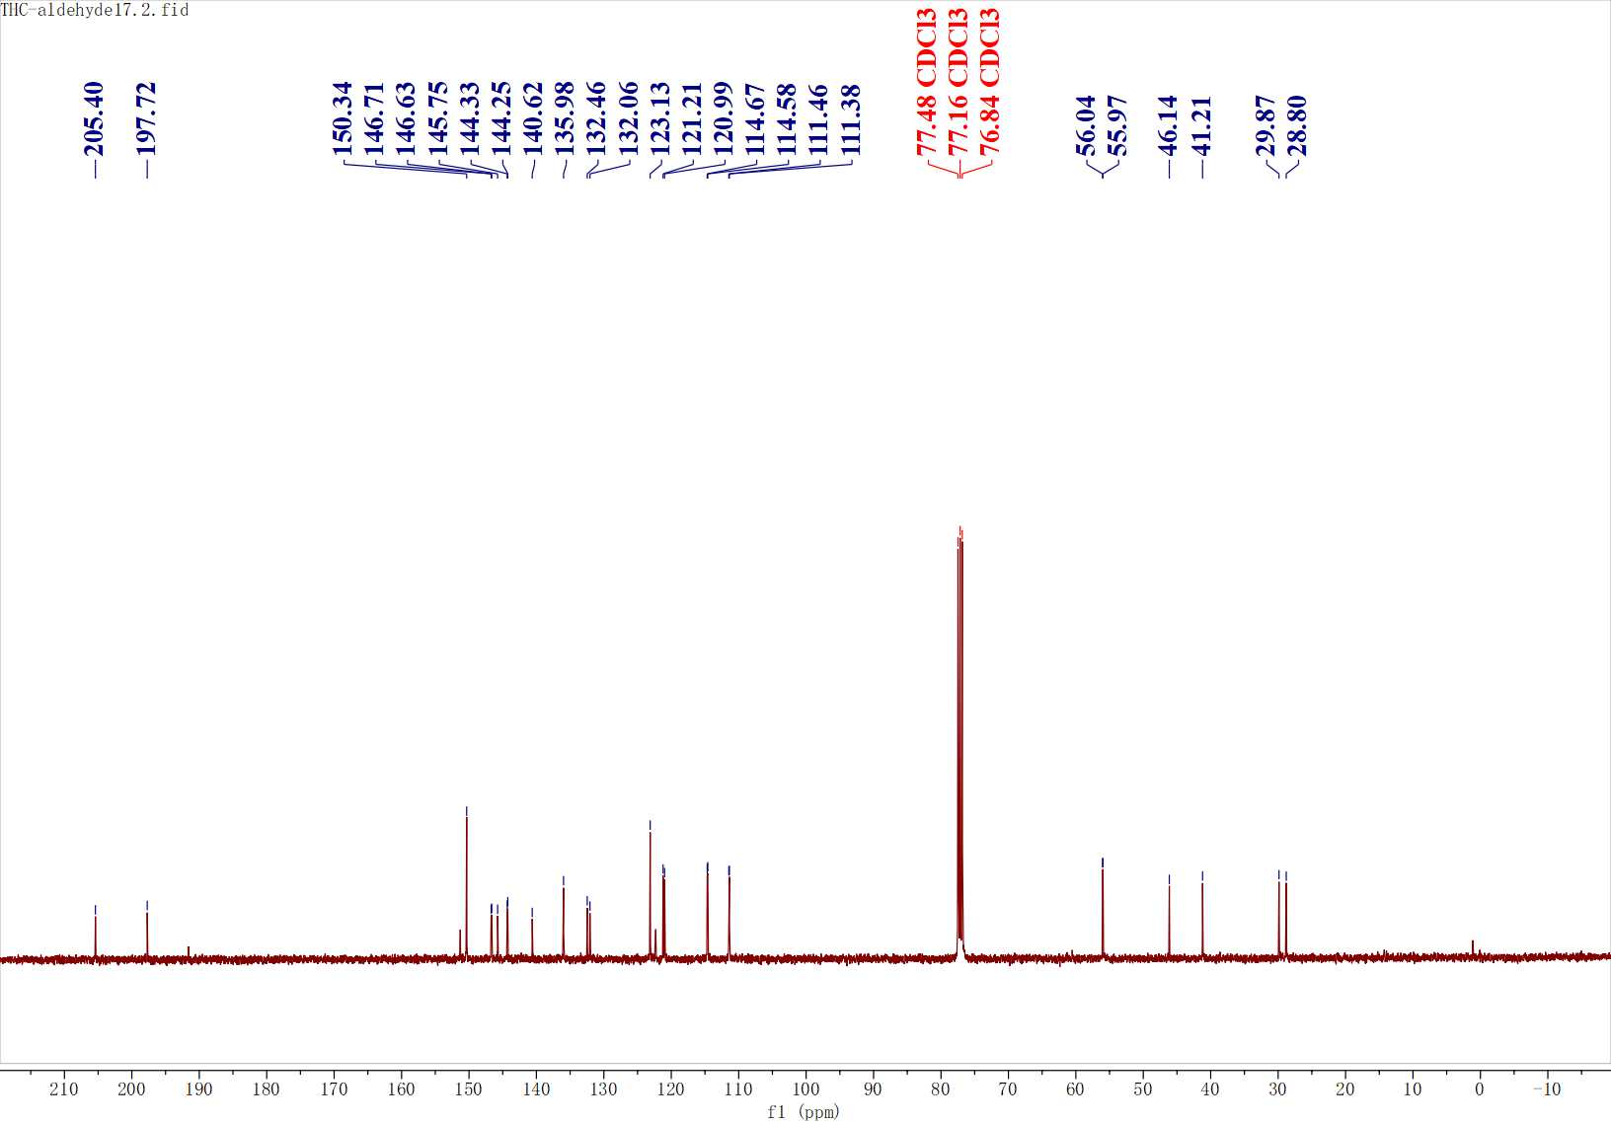
Figure S35. ¹³C NMR spectrum of C11

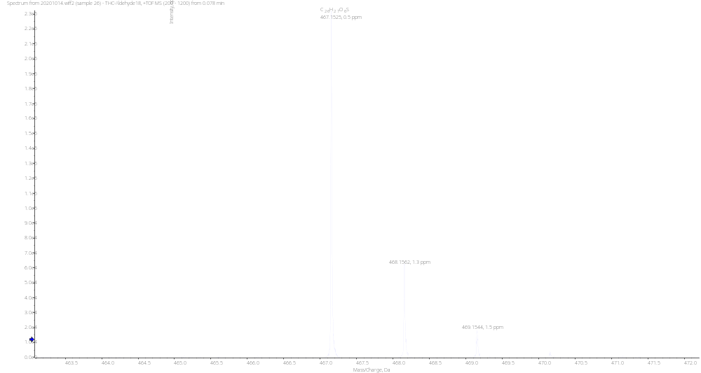
Figure S36. HRMS spectrum of C12

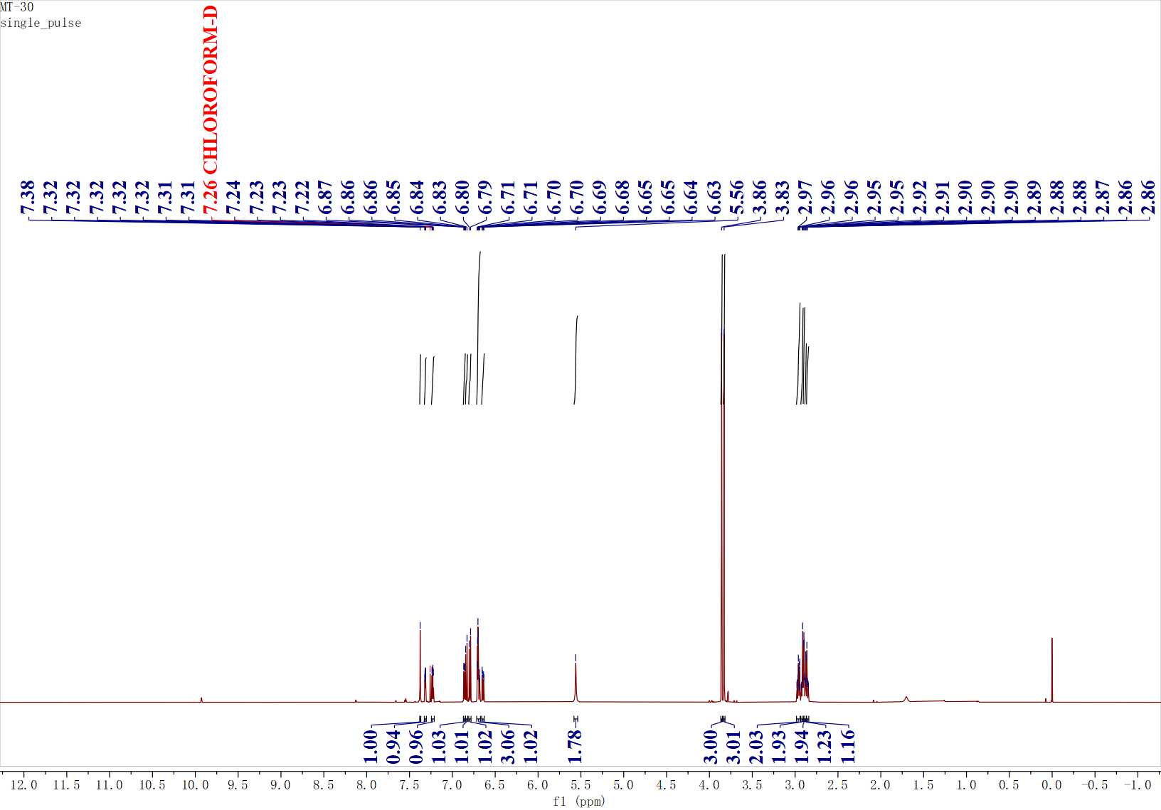
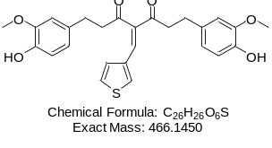
Figure S37. ¹H NMR spectrum of C12

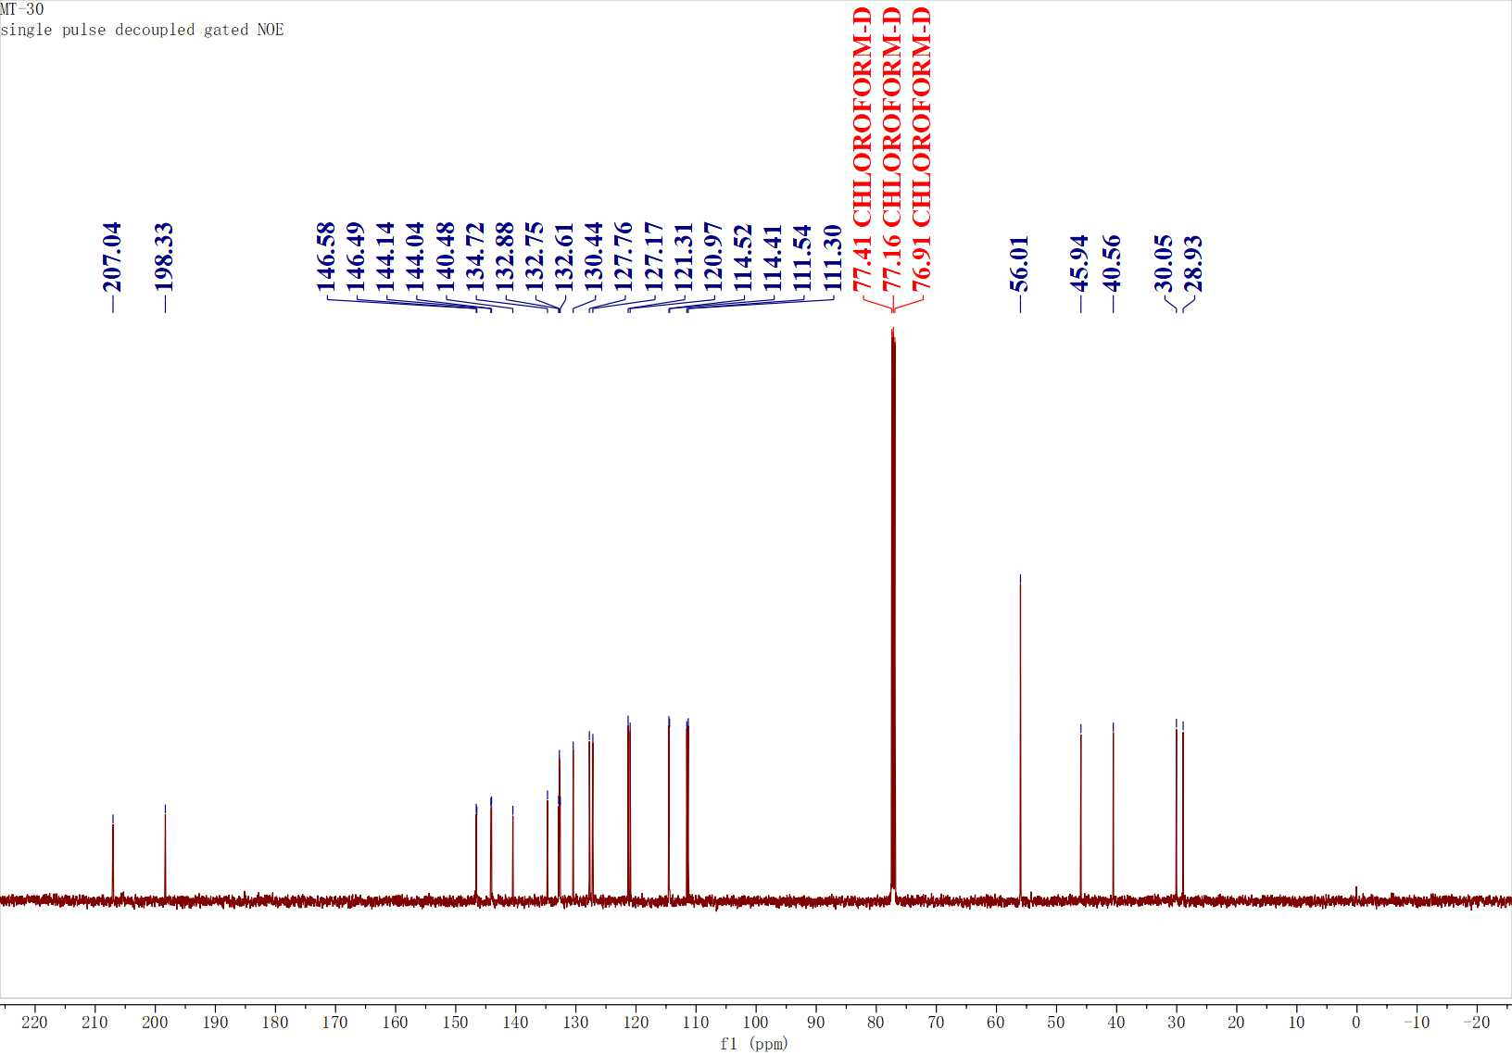
Figure S38. ¹³C NMR spectrum of C12

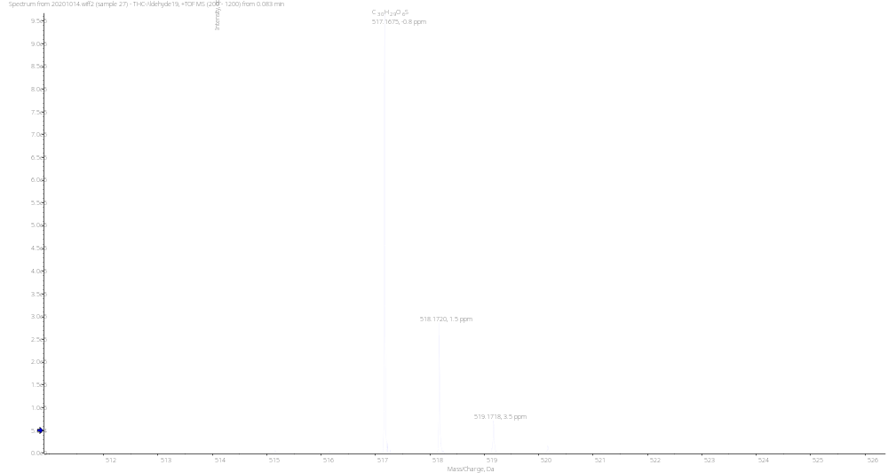
Figure S39. HRMS spectrum of C13

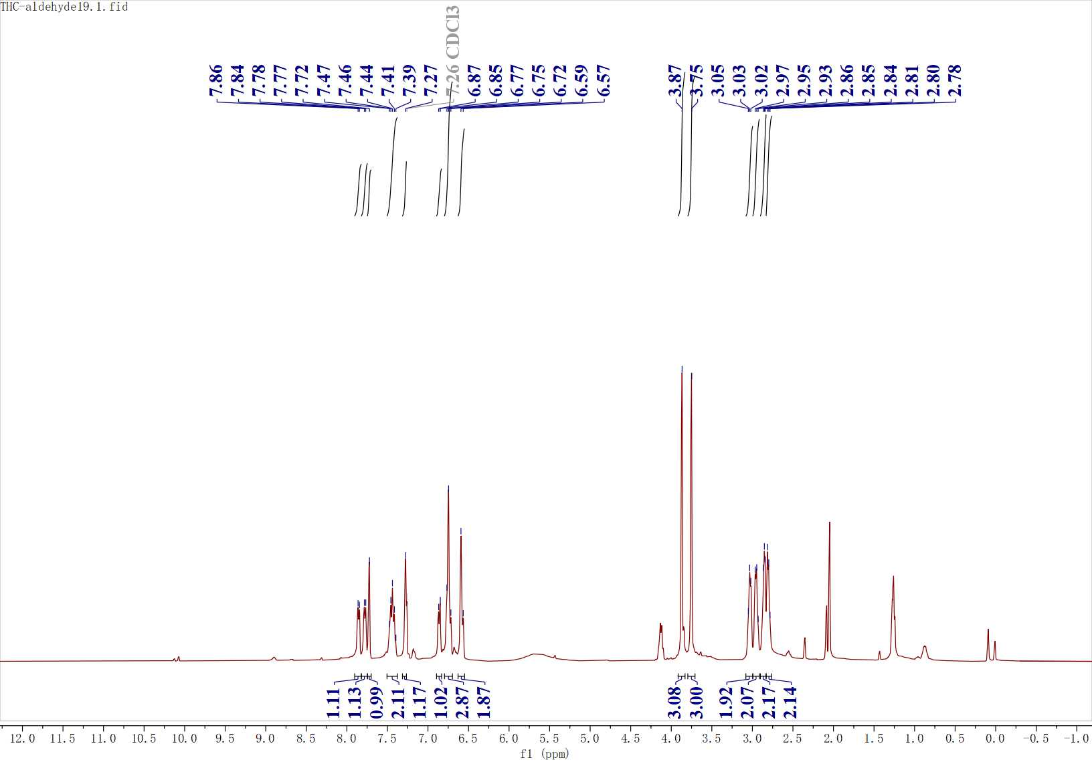
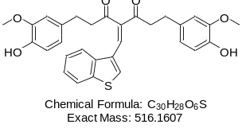
Figure S40. ¹H NMR spectrum of C13

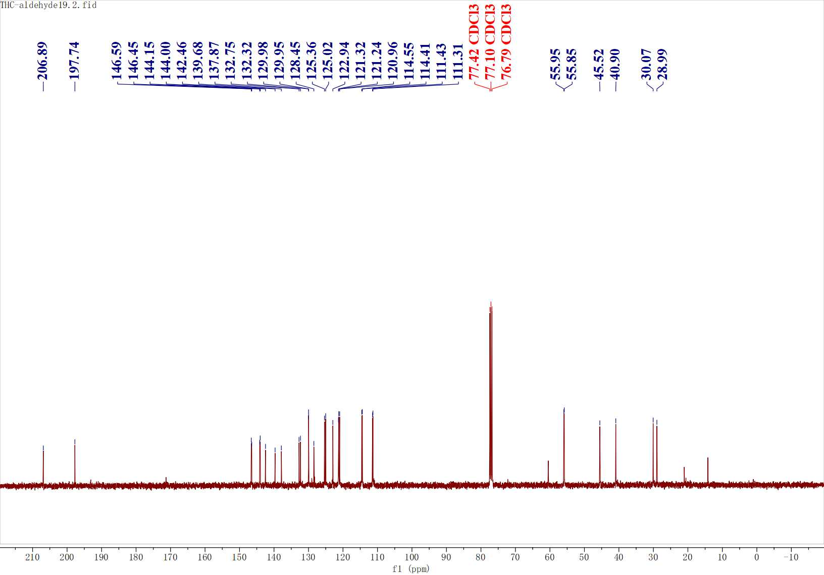
Figure S41. ¹³C NMR spectrum of C13

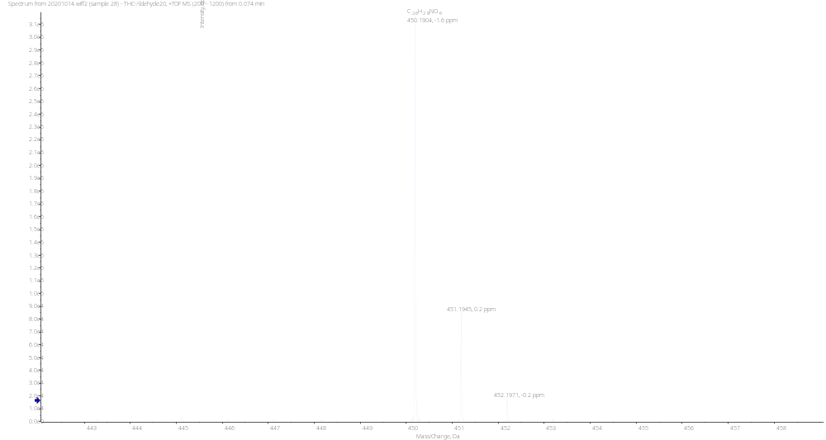
Figure S42. HRMS spectrum of C14

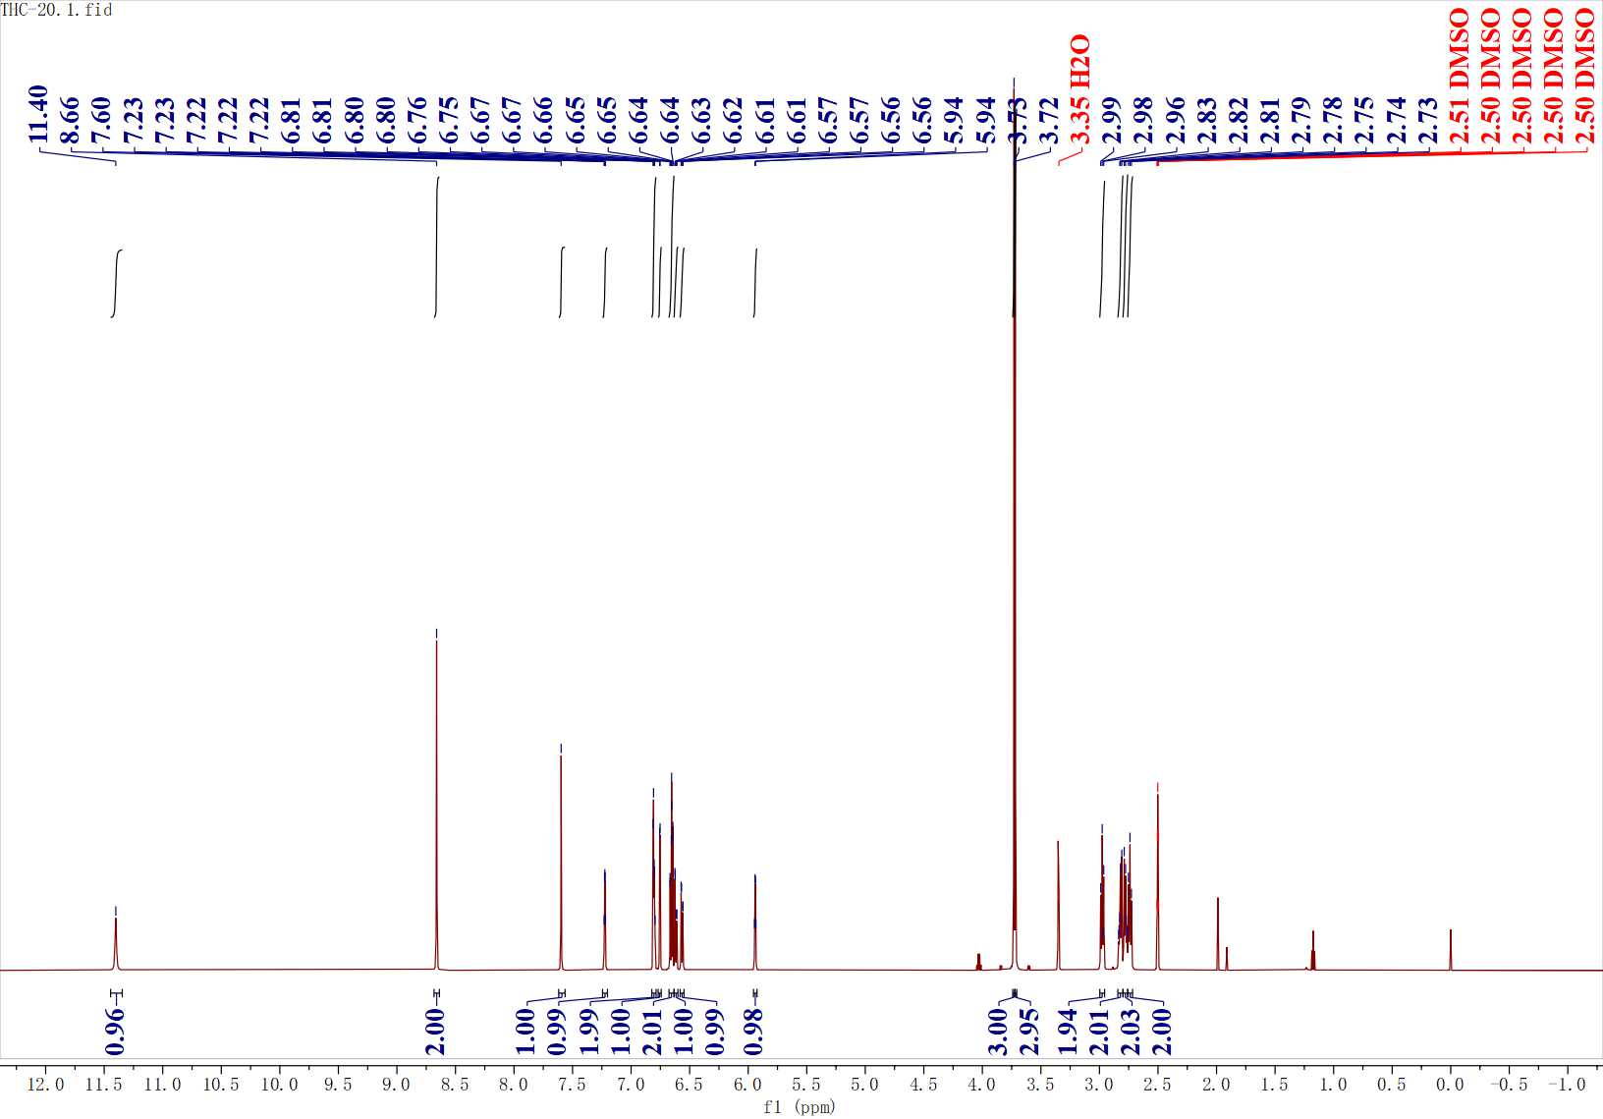
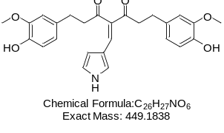
Figure S43. ¹H NMR spectrum of C14

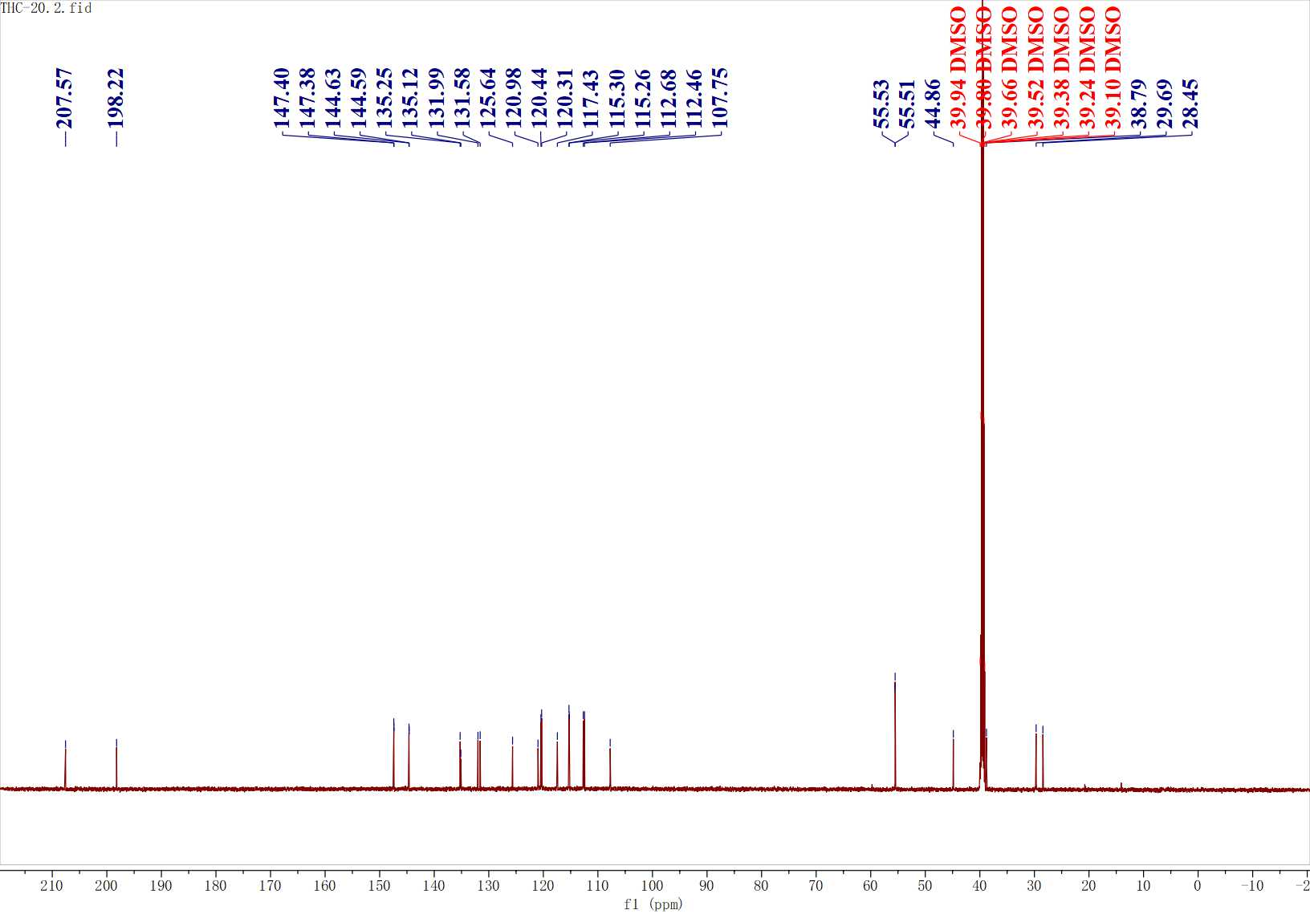
Figure S44. ¹³C NMR spectrum of C14

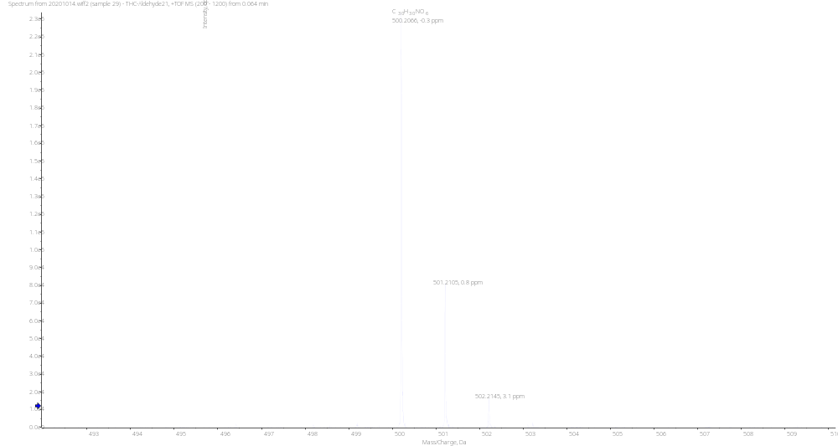
Figure S45. HRMS spectrum of C15

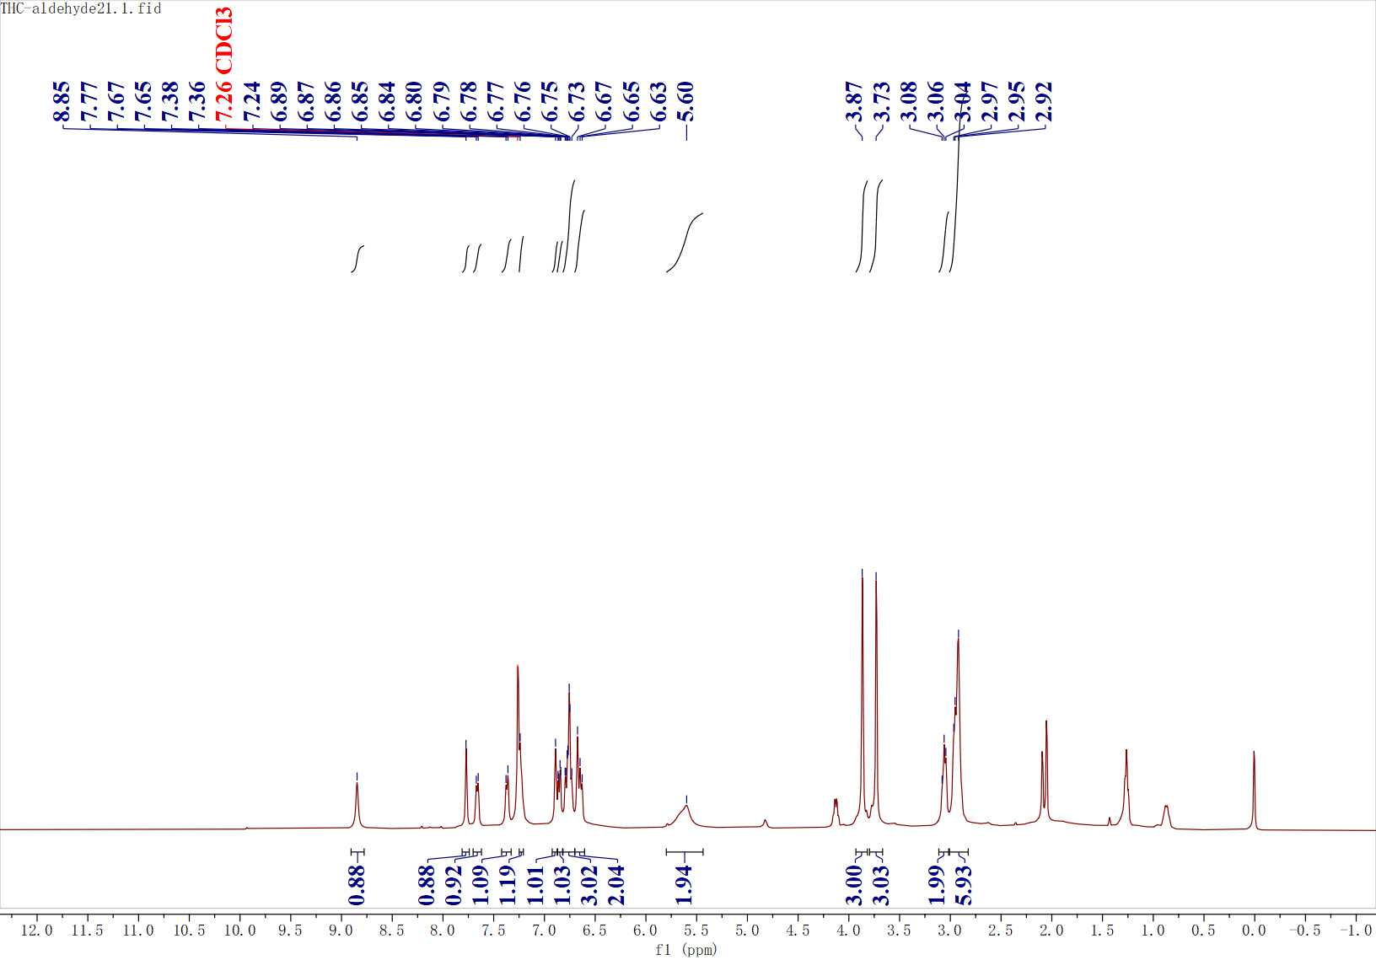
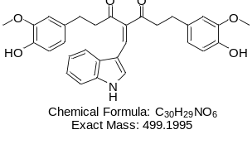
Figure S46. ¹H NMR spectrum of C15

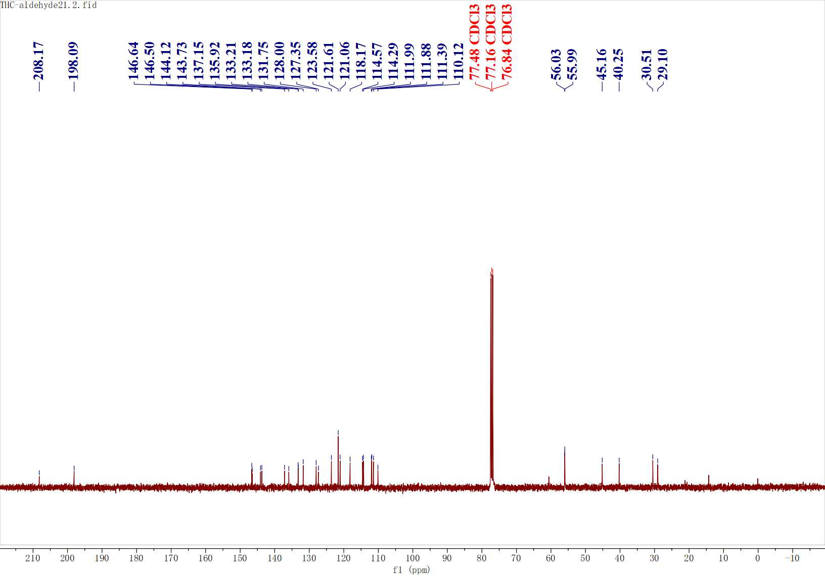
Figure S47. ¹³C NMR spectrum of C15

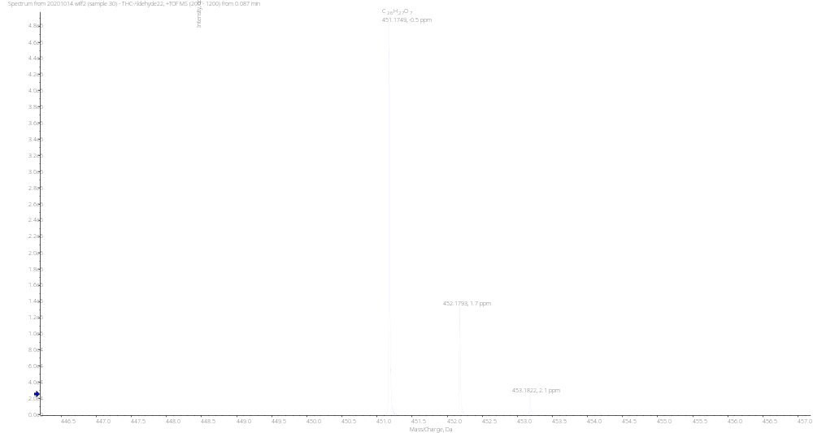
Figure S48. HRMS spectrum of C16

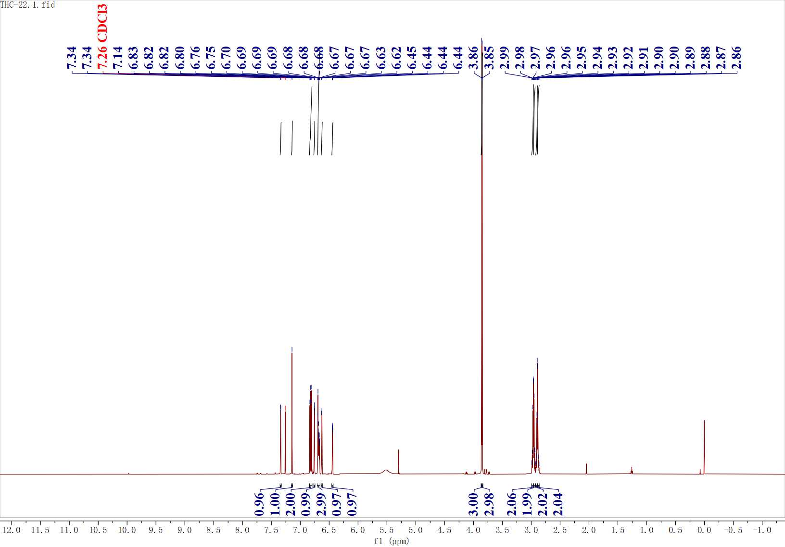
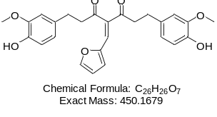
Figure S49. ¹H NMR spectrum of C16

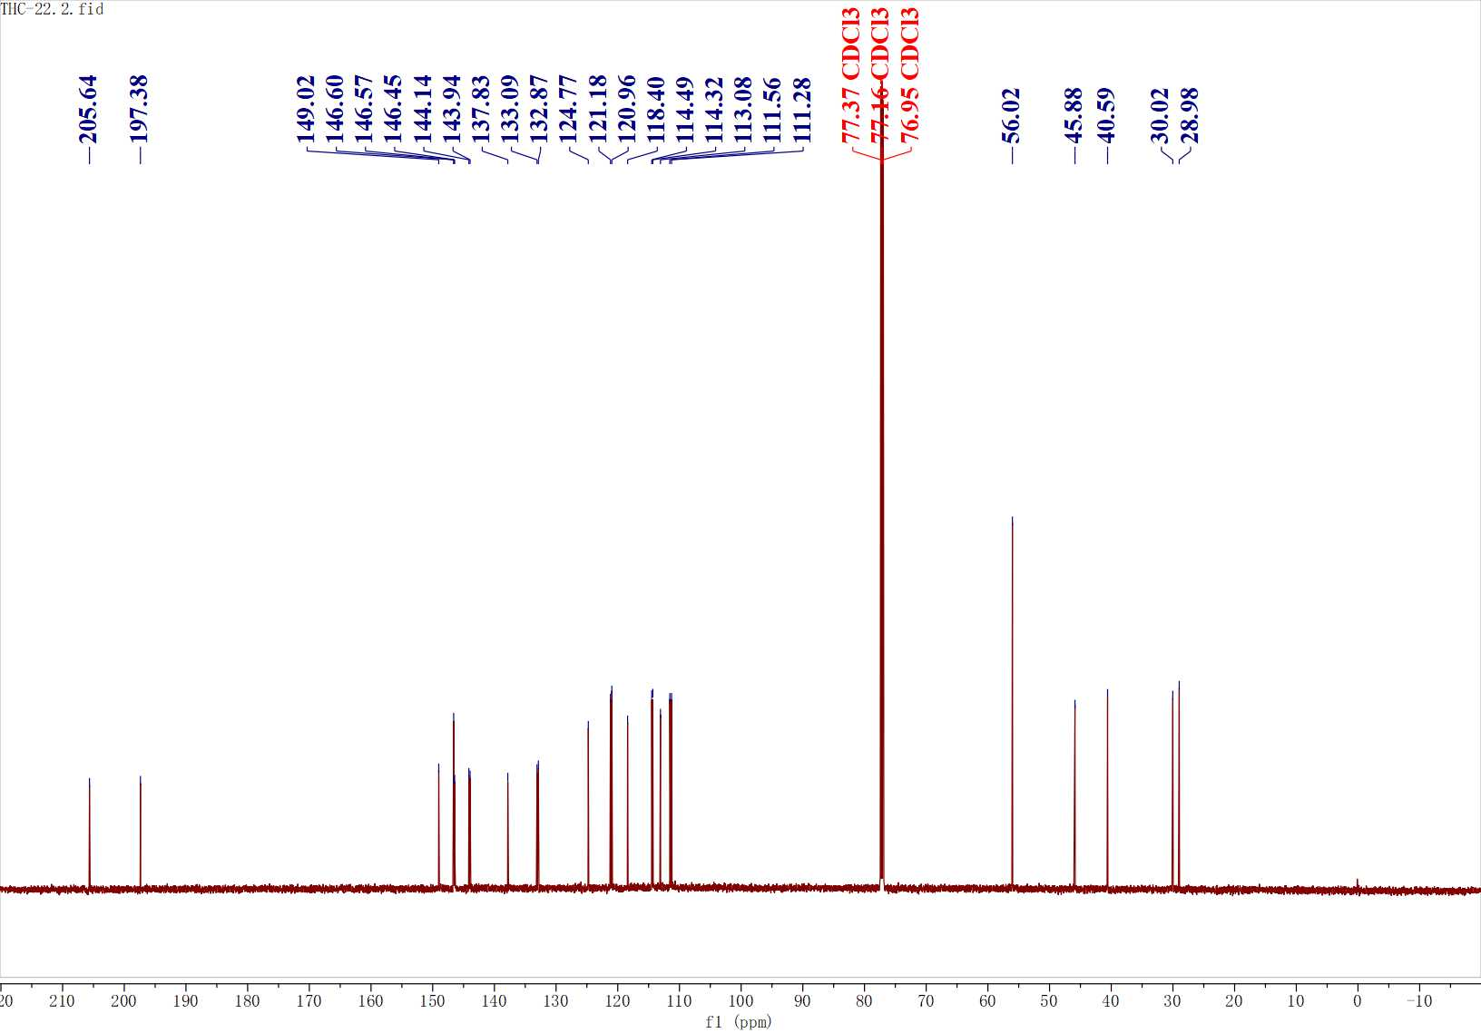
Figure S50. ¹³C NMR spectrum of C16

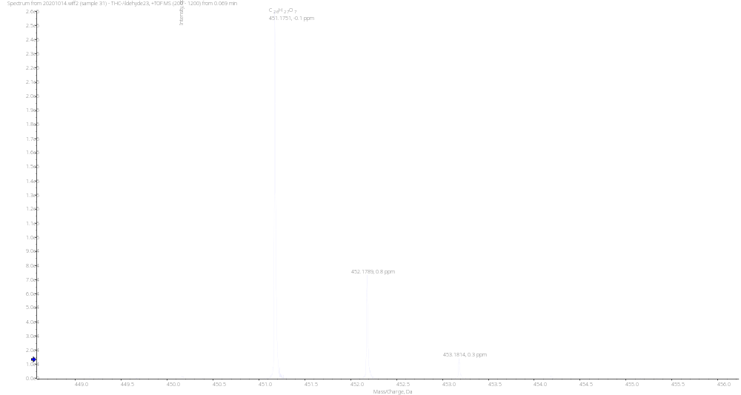
Figure S51. HRMS spectrum of C17

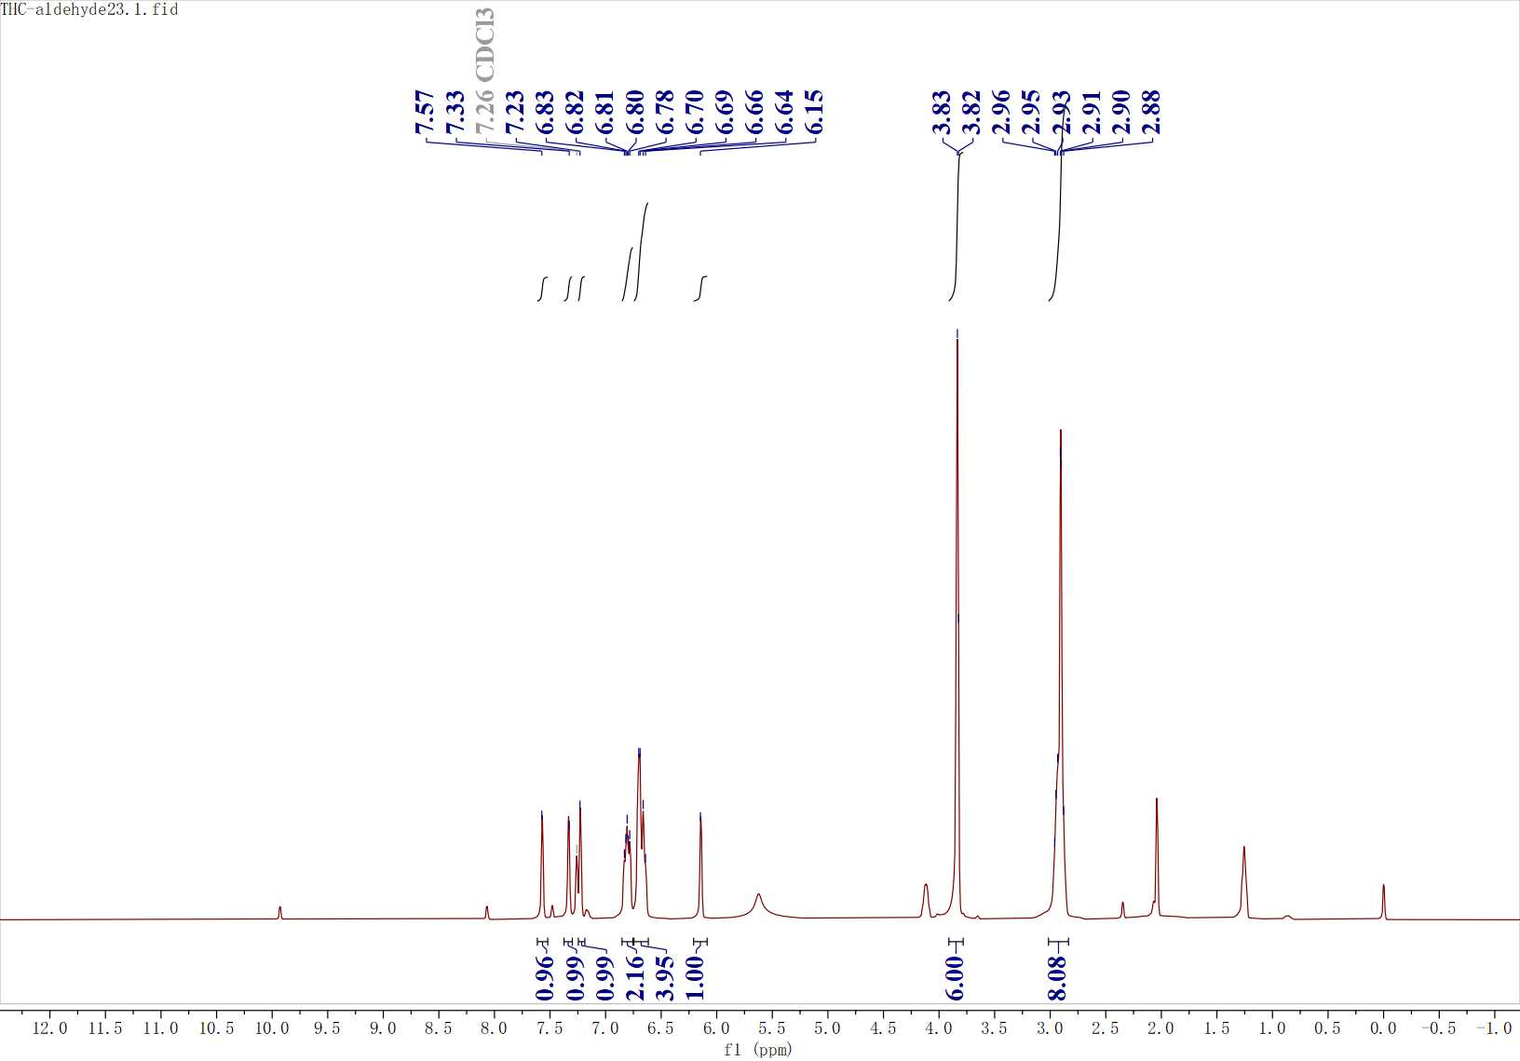
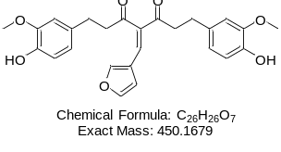
Figure S52. ¹H NMR spectrum of C17

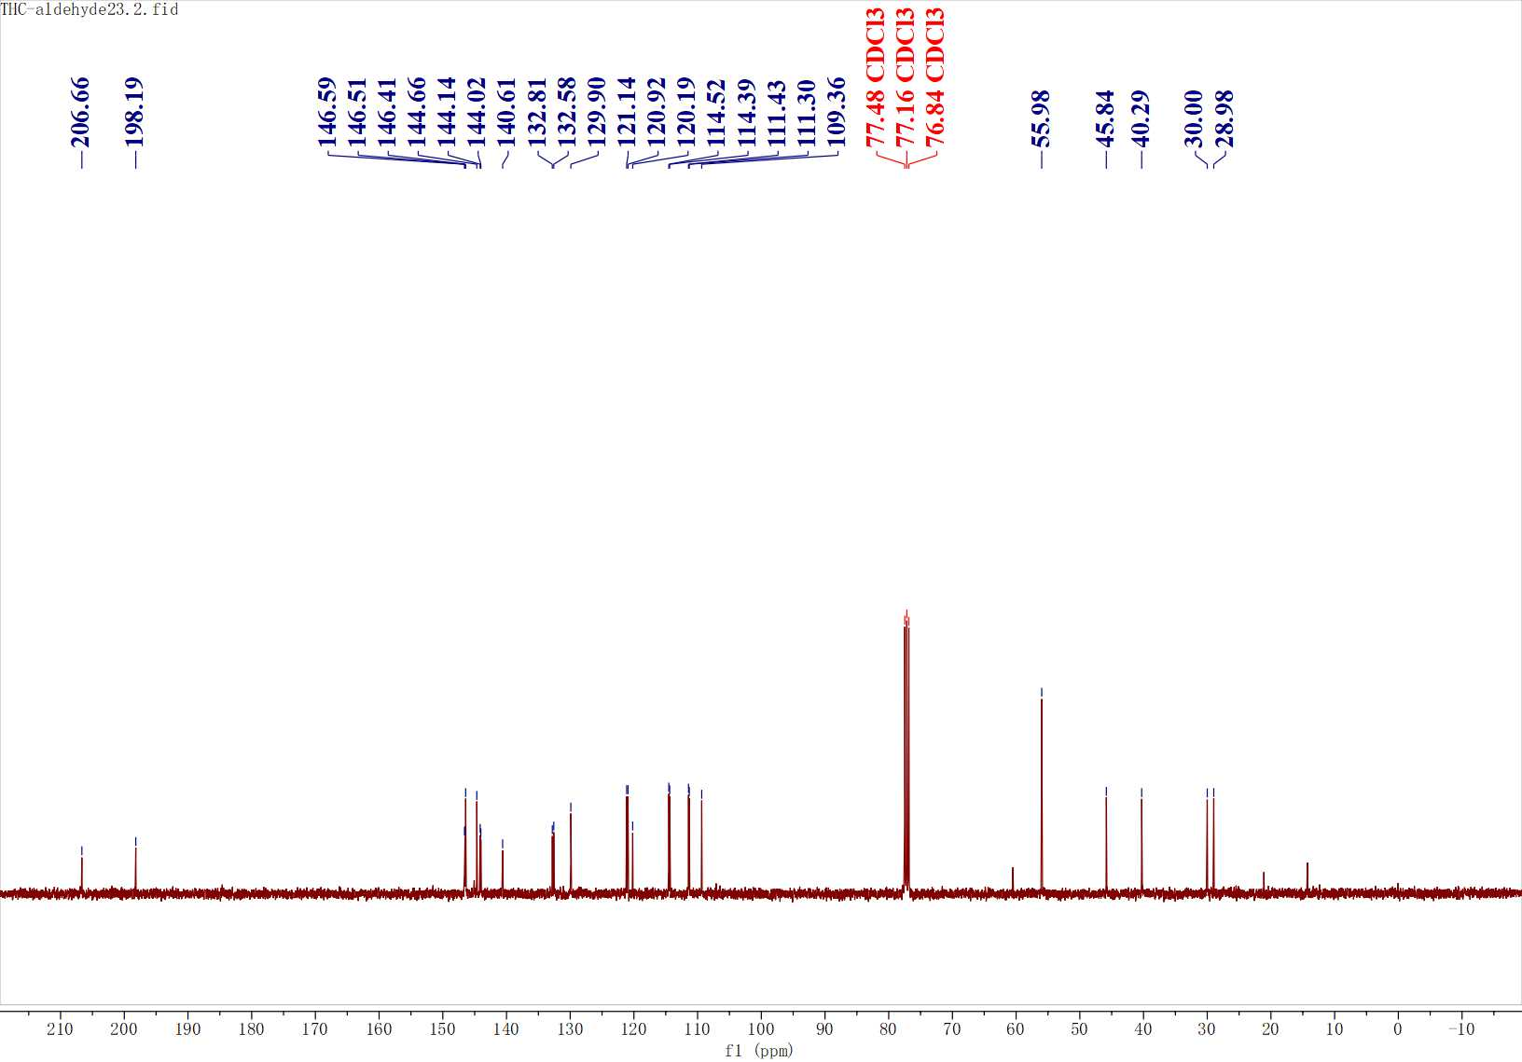
Figure S53. ¹³C NMR spectrum of C17

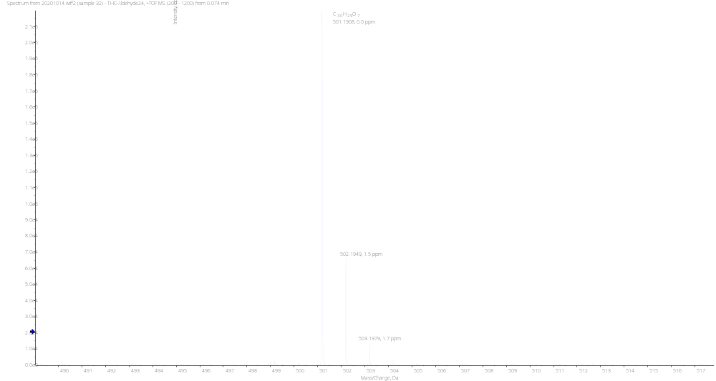
Figure S54. HRMS spectrum of C18

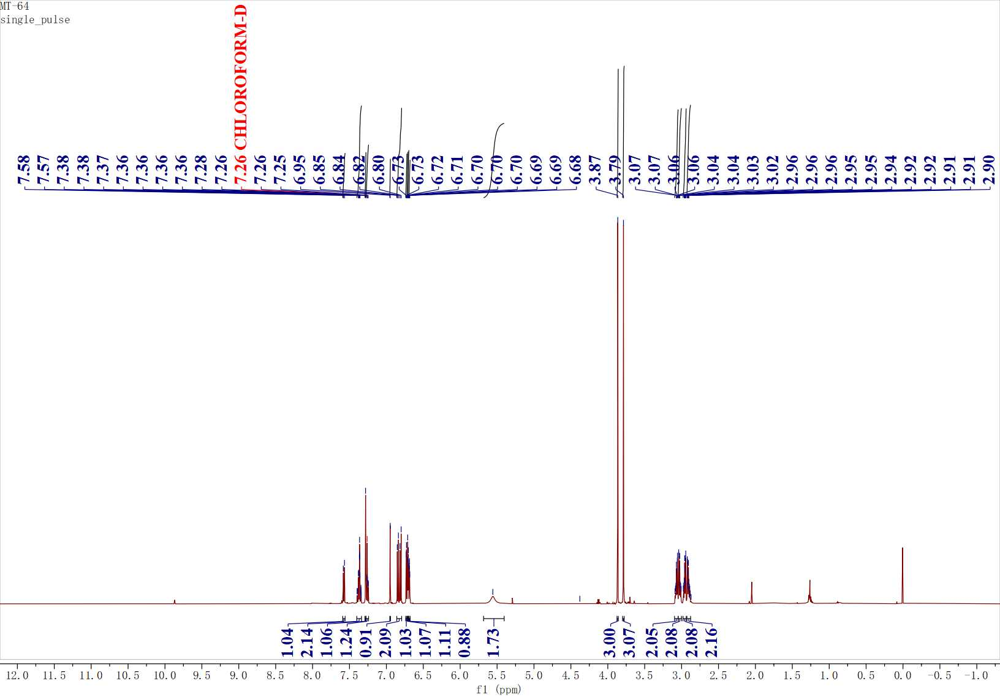
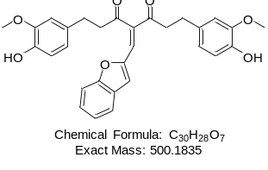
Figure S55. ¹H NMR spectrum of C18

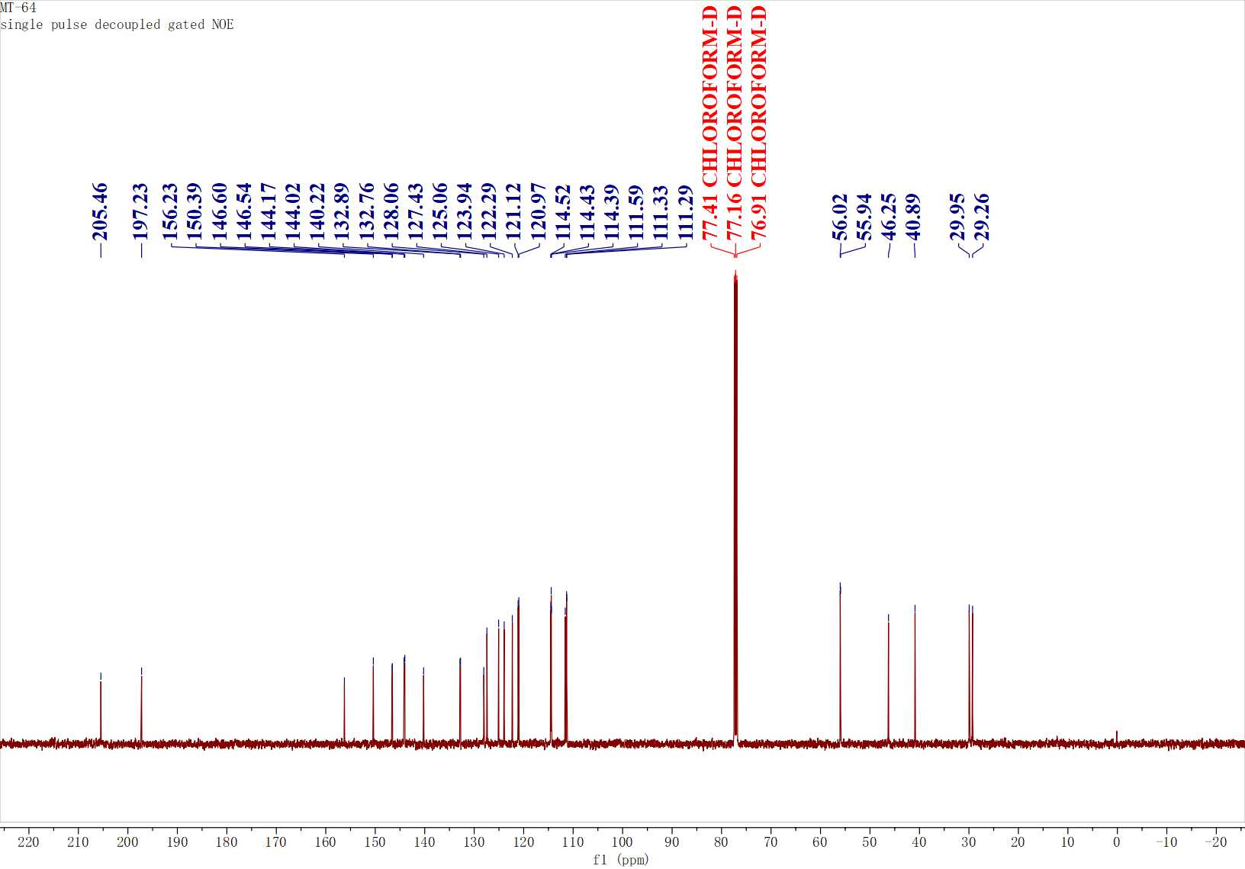
Figure S56. ¹C NMR spectrum of C18
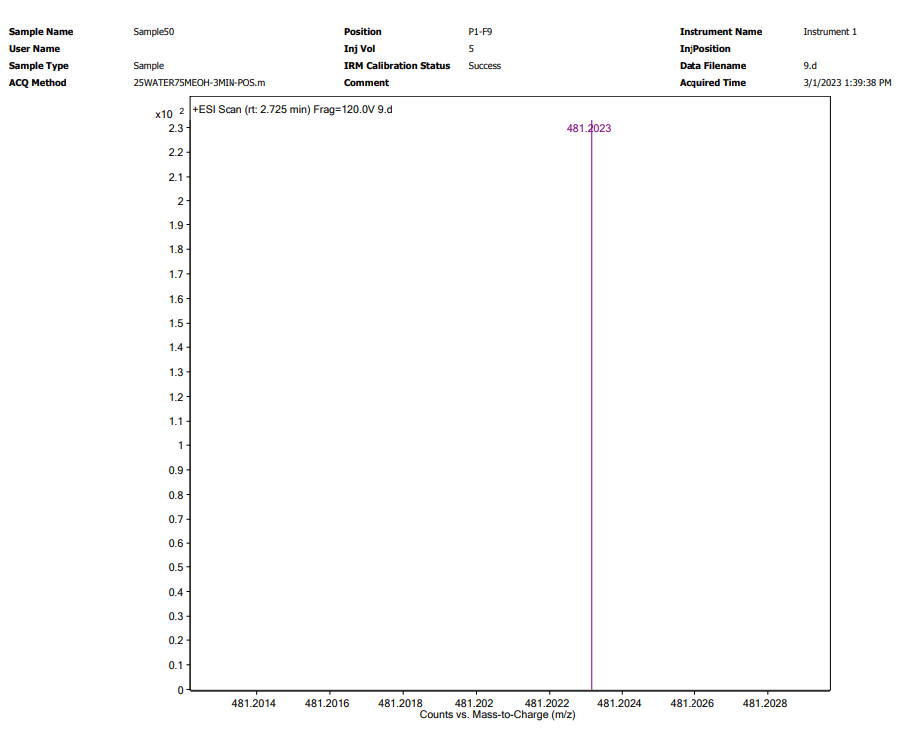
Figure S57. HRMS spectrum of H5
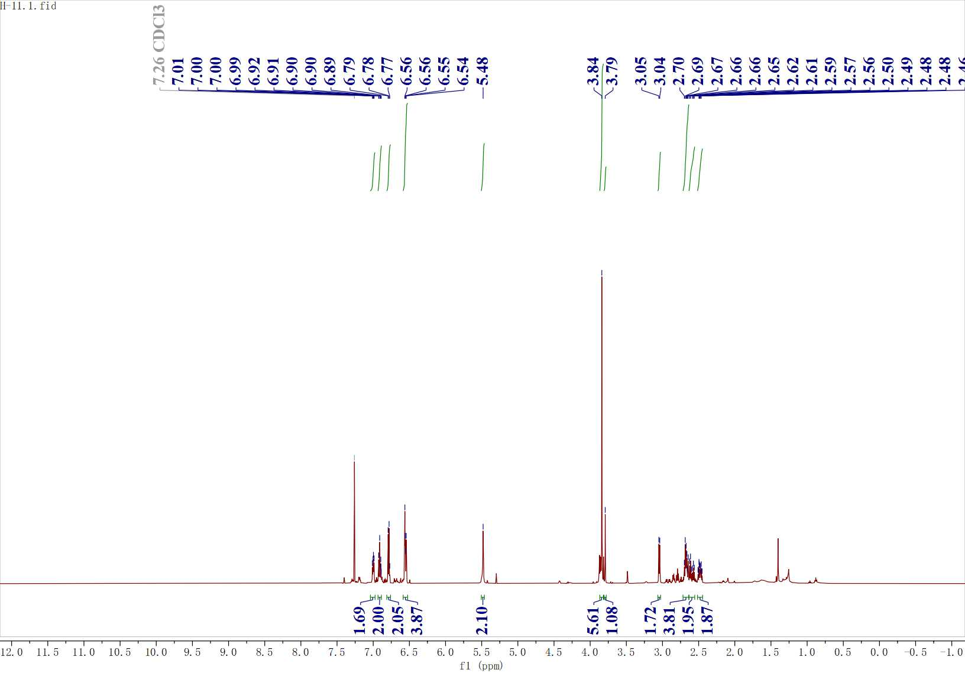
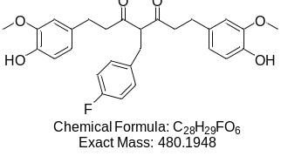
Figure S58. ¹H NMR spectrum of H5

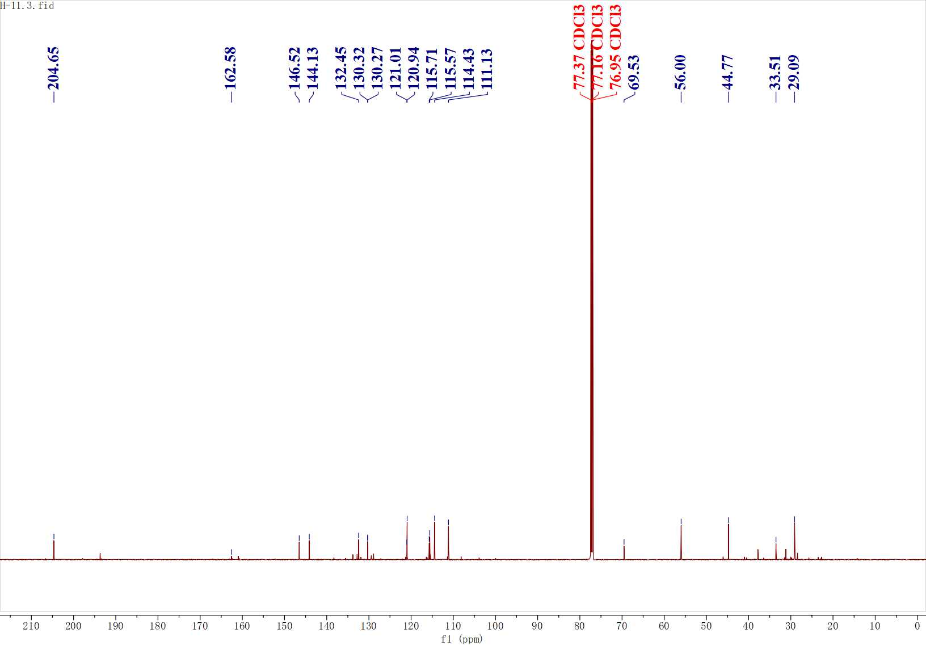
Figure S59. ¹³C NMR spectrum of H5

