Supplementary Material
Supplementary Table 1. Influence of pulmonary hypertension (PH), applied treatment [1400W (1400), JD5037 (JD), their combination (1400+JD)], and respective vehicles (veh_1400, veh_JD) on selected physiological parameters of monocrotaline-induced pulmonary hypertensive (MCT-PH) rats and their controls (CTR).
Group/  parameter |  | CTR+veh_1400 | CTR+veh_JD | CTR+1400 | CTR+JD | CTR+1400+JD | MCT+veh_1400 | MCT+veh_JD | MCT+1400 | MCT+JD | MCT+1400+JD
n |  | 6-11 | 7-9 | 6-10 | 6-10 | 6-11 | 4-14 | 6-9 | 15-19 | 14 | 10-12
HR [echo]  (beats/min) | Day 7 | 454±  10 | 444±7 | 444±9 | 460±4 | 471±7 | 424±7 | 441±11 | 433±8 | 421±9 | 441±9
HR [echo]  (beats/min) | Day 24 | 424±9 | 435±9 | 431±6 | 429±11 | 444±8 | 376±27 | 424±16 | 412±11 | 422±7 | 428±11
LV wall thickness in diastole [echo]  (mm) | Day 7 | 1.77±0.04 | 1.58±0.04 | 1.62±0.02 | 1.58±0.07 | 1.67±0.09 | 1.70±0.07 | 1.47±0.07 | 1.63±0.06 | 1.47±0.07 | 1.61±0.07
LV wall thickness in diastole [echo]  (mm) | Day 24 | 1.76±0.1 | 1.66±0.06 | 1.75±0.07 | 1.70±0.11 | 1.75±0.11 | 1.86±0.5 | 1.84±0.22 | 1.69±0.1 | 1.94±0.11$ | 1.64±0.1
LV wall thickness in systole  [echo] (mm) | Day 7 | 3.46±0.12 | 3.29±0.12 | 3.09±0.03 | 3.10±0.13 | 3.21±0.13 | 3.23±0.1 | 3.05±0.13 | 3.19±0.08 | 3.02±0.13 | 3.24±0.12
LV wall thickness in systole  [echo] (mm) | Day 24 | 3.24±0.12 | 3.33±0.12 | 3.33±0.09 | 3.33±0.13 | 3.21±0.12 | 3.61±0.01 | 3.65±0.06 | 3.21±0.14 | 3.60±0.13 $$ | 3.4±0.2
LV+S weight (mg) |  | 652±27 | 620±17 | 627±18 | 636±9 | 629±16 | 570±14 | 596±23 | 585±15 | 584±20 | 566±17
LV+S weight/BW  (mg/g) |  | 1.99±0.07 | 1.97±0.04 | 1.90±0.05 | 2.02±0.05 | 1.98±0.05 | 2.11±0.06 | 2.17±0.09 | 2.16±0.05 | 2.11±0.1 | 2.07±0.04
LV+S weight/TL  (mg/mm) |  | 18.1±0.8 | 17.2±0.6 | 17.4±0.4 | 17.5±0.3 | 17.2±0.5 | 15.6±0.4 | 16.5±0.7 | 16.4±0.4 | 16.1±0.5 | 15.8±0.5
LA weight (mg) |  | 25.0±1.4 | 26.0±2.5 | 25.0±1.0 | 24.6±1.6 | 24.8±1.3 | 20.7±1.5 | 23.9±1.4 | 20.6±1 | 22.9±2.3 | 21.1±1.8
LA weight/BW  (mg/g) |  | 0.08±0.00 | 0.08±0.01 | 0.08±0.00 | 0.08±0.00 | 0.08±0.00 | 0.08±0.01 | 0.08±0.01 | 0.08±0.00 | 0.08±0.01 | 0.08±0.01
LA weight/TL (mg/mm) |  | 0.69±0.04 | 0.74±0.07 | 0.70±0.02 | 0.68±0.04 | 0.68±0.04 | 0.57±0.04 | 0.66±0.04 | 0.58±0.03 | 0.64±0.06 | 0.59±0.05
Kidney weight (mg) |  | 1227±32 | 1157±25 | 1150±27 | 1196±42 | 1239±33 | 971±36 | 1061±49 | 1020±29 | 1062±33 | 1097±40
Kidney weight/BW  (mg/g) |  | 3.8±0.1 | 3.7±0.1 | 3.5±0.0 | 3.7±0.1 | 3.9±0.1 | 3.6±0.1 | 3.9±0.2 | 3.8±0.1 | 3.8±0.1 | 4.0 ±0.1
Kidney weight/TL  (mg/mm) |  | 34 ±1 | 32±1 | 32±1 | 33±1 | 34±1 | 27±1 | 30±1 | 29±1 | 29±1 | 31±1
Glucose  (mg/dL) |  | 138±4 | 128±6 | 134±3 | 124±3 | 135±4 | 98±7 | 113±4 | 119±5 | 116±9 | 126±4
Triglycerides  (mg/dL) |  | 173±21 | 133±16 | 126±10 | 135±9 | 147±17 | 148±15 | 146±8 | 122±7 | 141±10 | 148±12
Cholesterol  (mg/dL) |  | 156±2 | 154±2 | 154±2 | 155±2 | 155±2 | 157±2 | 154±1 | 157±2 | 156±2 | 156±2
Lactate  (mM) |  | 3.7±0.3 | 3.8±0.3 | 3.1±0.3 | 4.5±0.3 | 3.7±0.3 | 5.8±1.5 | 3.6±0.5 | 4.8±0.4 | 5.7±0.9 | 3.9±0.4
1400W (10 mg/kg), JD5037 (3 mg/kg), and their combination (1400W+JD5037; 10+3 mg/kg) were administered orally once daily for 17 days, starting on day 8 after PH induction; veh groups received vehicle instead. Data are expressed as the means ± SEM. $ p < 0.05; $$ p < 0.01—significant differences from day 7.
Abbreviations: BW, body weight; HR, heart rate; LA, left atrium; LV, left ventricle; S, intraventricular septum; TL, tibia length.

Supplementary Table 2. Influence of pulmonary hypertension (PH), applied treatment [1400W (1400), JD5037 (JD), their combination (1400+JD)], and respective vehicles (veh_1400, veh_JD) on the baseline developed tension and isoprenaline (ISO, 0.0001 – 10 μM)‐induced positive inotropic effects in right ventricular papillary muscles isolated from monocrotaline‐induced pulmonary hypertensive (MCT-PH) rats and their controls (CTR).
 |  |  | CTR+veh_1400 | CTR+veh_JD | CTR+1400 | CTR+JD | CTR+1400+JD
CTR
n |  |  | 5 | 6 | 6 | 6 | 8
Baseline developed tension (mN/cm²) |  |  | 10.17±3.60 | 11.58±2.42 | 9.77±2.63 | 9.66±3.10 | 17.14±4.81
ISO  (% of basal) | pEC₅₀ |  | 7.52±0.25 | 8.44±0.37 | 8.52±0.41 | 8.16±0.27 | 8.20±0.36
ISO  (% of basal) | E_{max} (%) |  | 62.63±6.34 | 55.12±13.45 | 62.37±14.18 | 54.36±11.10 | 42.33±3.52
ISO (delta) | pEC₅₀ |  | 7.43±0.41 | 8.32±0.37 | 7.88±0.42 | 8.03±0.23 | 7.67±0.60
ISO (delta) | Maximal developed tension  ₍mN/cm²) |  | 6.02±1.85 | 5.68±1.91 | 5.54±1.48 | 4.40±1.00 | 7.05±1.86
MCT
 |  |  | MCT+veh_1400 | MCT+veh_JD | MCT+1400 | MCT+JD | MCT+1400+JD
n |  |  | 4 | 3 | 5 | 6 | 7
Baseline developed tension (mN/cm²) |  |  | 27.10±5.95* | 26.59±4.34* | 32.81±10.96 | 26.00±7.54 | 24.89±5.02
ISO  (% of basal) |  | pEC₅₀ | 8.26±0.43 | 8.52±0.36 | 6.57±0.29** | 8.84±0.52 | 8.54±0.49
 |  | E_{max} (%) | 39.04±12.93 | 33.06±10.12 | 65.00±11.74 | 46.20±13.25 | 31.09±7.86
ISO (delta) |  | pEC₅₀ | 8.47±0.27 | 8.04±0.31 | 6.73±0.41 | 8.44±0.71 | 8.16±0.52
 |  | Maximal developed tension  ₍mN/cm²) | 9.19±0.34 | 9.03±3.24 | 19.96±6.61* | 12.88±5.72 | 6.58±2.67

Values are extracted from the concentration‐response curves shown in Figure 4C-D. 1400W (10 mg/kg), JD5037 (3 mg/kg), and their combination (1400W+JD5037, 10+3 mg/kg) were administered by oral gavage once daily for 17 days, starting on day 8 from PH induction; veh groups received vehicles instead. Data are expressed as the means ± SEM; *p < 0.05; **p < 0.01 – significant differences vs respective CTR group.
Abbreviations: E_{max}, the maximum effect; pEC₅₀, the negative logarithm of effective concentration producing 50% of maximum response.

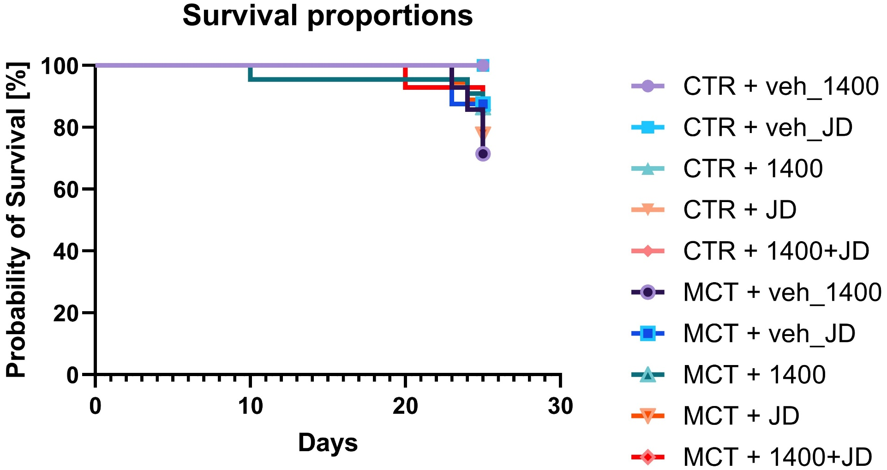
Supplementary Figure 1. Survival proportions of monocrotaline (MCT)-induced pulmonary hypertensive (PH) rats and their controls (CTR). 1400W (1400, 10 mg/kg), JD5037 (JD, 3 mg/kg), and their combination (1400+JD; 10+3 mg/kg) were administered orally once daily for 17 days, starting on day 8 after PH induction; veh groups received vehicle instead. At the end of the protocol (day 25), 100% survival was reported in all CTR groups. In MCT-PH groups survival rates were reported as follows: 71.4% (MCT+veh_1400); 87.5% (MCT+veh_JD); 86.4% (MCT+1400); 77.8% (MCT+JD); 85.7% (MCT+1400+JD).

TNF-α
Sample order from the left (rows):
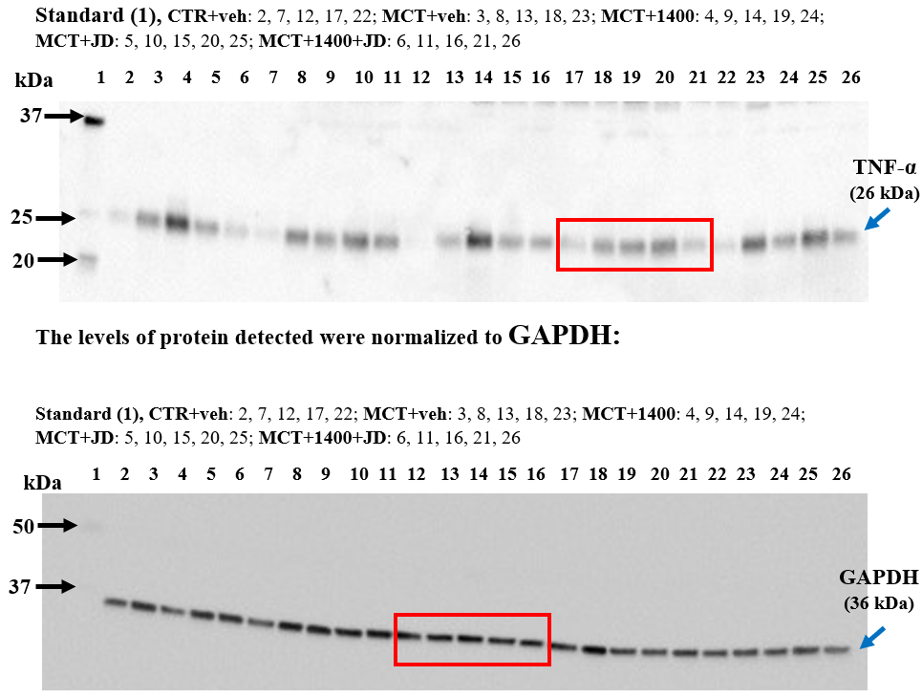
Bands detected with the primary antibody are indicated by blue arrows. Specific molecular weights determined using the Western C® standard are indicated with black arrows. The red rectangles highlight the bands shown in Figure 7A of the manuscript.

Supplementary Figure 2. Original images of Western blot analysis of tumor necrosis factor alpha (TNF-α) and GAPDH (loading control).

IL-6
Sample order from the left (rows):
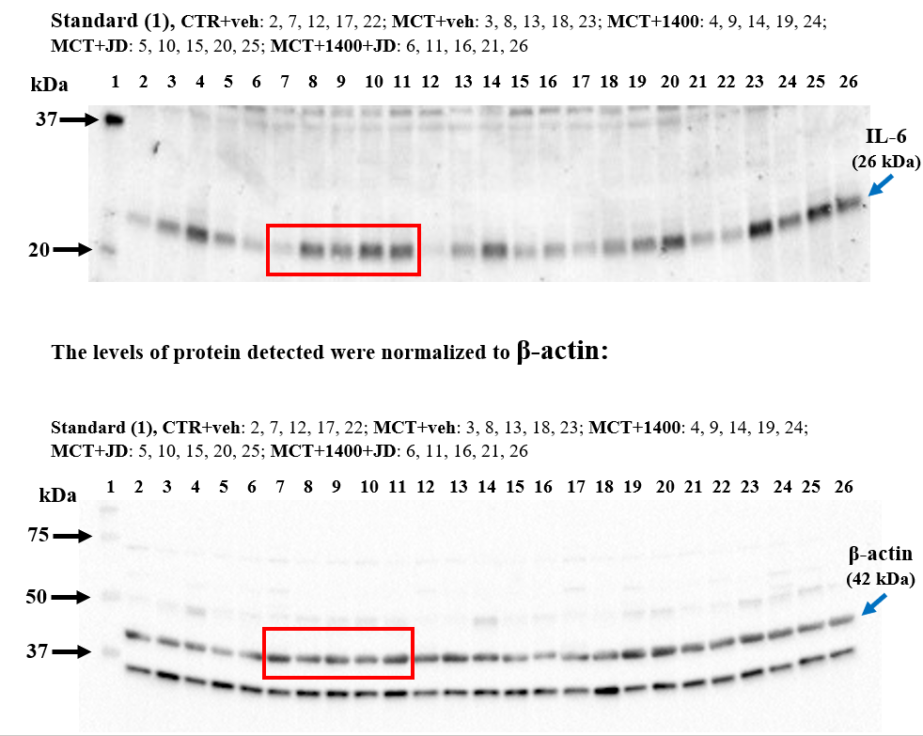
Bands detected with the primary antibody are indicated by blue arrows. Specific molecular weights determined using the Western C® standard are indicated with black arrows. The red rectangles highlight the bands shown in Figure 7B of the manuscript.

Supplementary Figure 3. Original images of Western blot analysis of interleukin-6 (IL-6) and β-actin (loading control).

Gal-3
Sample order from the left (rows):
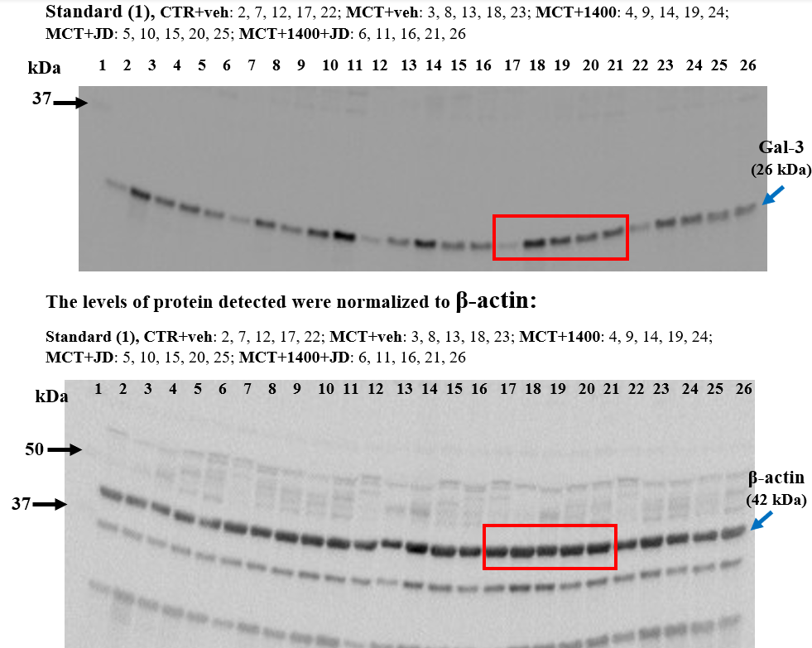
Bands detected with the primary antibody are indicated by blue arrows. Specific molecular weights determined using the Western C® standard are indicated with black arrows. The red rectangles highlight the bands shown in Figure 7C of the manuscript.

Supplementary Figure 4. Original images of Western blot analysis of galectin 3 (Gal-3) and β-actin (loading control).

TGF-β1
Sample order from the left (rows):
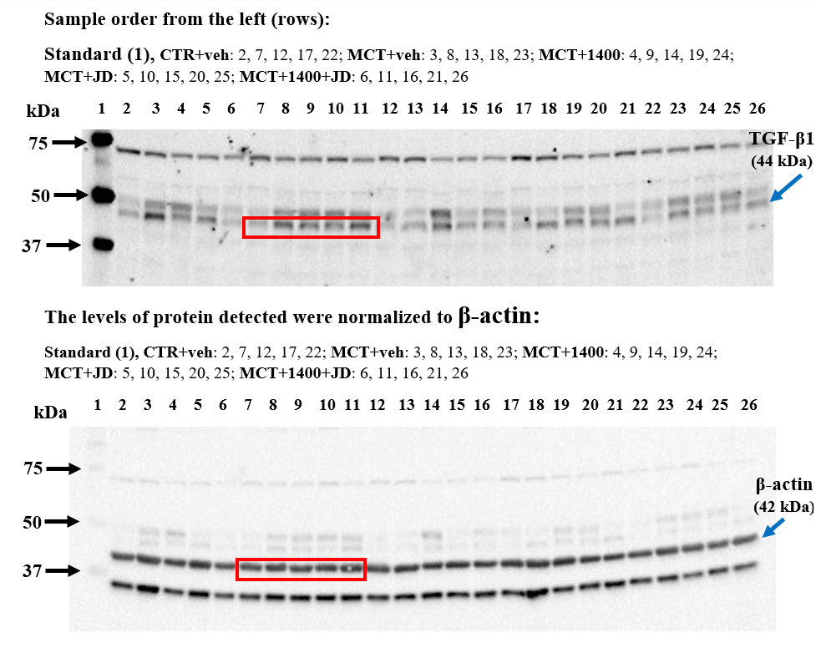
Bands detected with the primary antibody are indicated by blue arrows. Specific molecular weights determined using the Western C® standard are indicated with black arrows. The red rectangles highlight the bands shown in Figure 7D of the manuscript.

Supplementary Figure 5. Original images of Western blot analysis of transforming growth factor β1 (TGF-β1) and β-actin (loading control).

iNOS
Sample order from the left (rows):
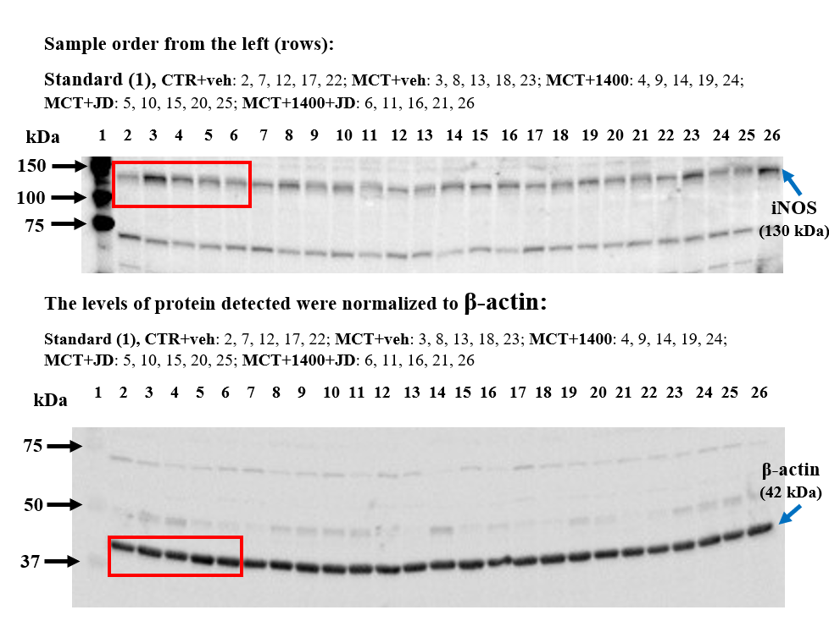
Bands detected with the primary antibody are indicated by blue arrows. Specific molecular weights determined using the Western C® standard are indicated with black arrows. The red rectangles highlight the bands shown in Figure 7E of the manuscript.

Supplementary Figure 6. Original images of Western blot analysis of inducible nitric oxide synthase (iNOS) and β-actin (loading control).

eNOS
Sample order from the left (rows):
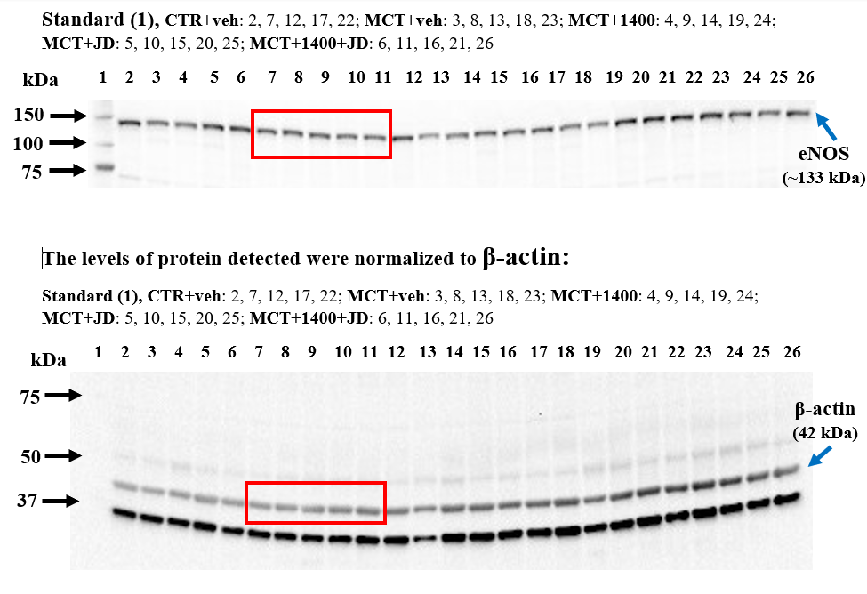
Bands detected with the primary antibody are indicated by blue arrows. Specific molecular weights determined using the Western C® standard are indicated with black arrows. The red rectangles highlight the bands shown in Figure 7F of the manuscript.

Supplementary Figure 7. Original images of Western blot analysis of endothelial nitric oxide synthase (eNOS) and β-actin (loading control).

CB₁R
Sample order from the left (rows):
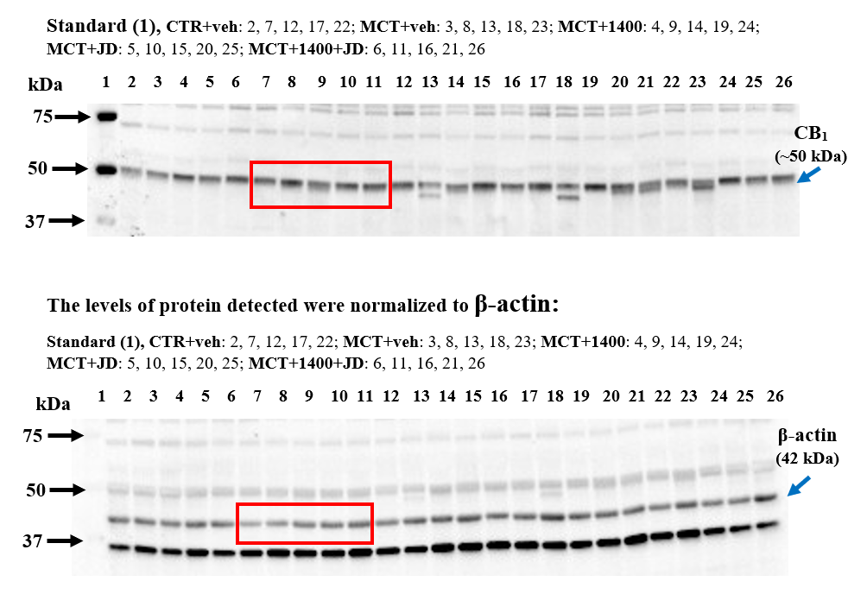
Bands detected with the primary antibody are indicated by blue arrows. Specific molecular weights determined using the Western C® standard are indicated with black arrows. The red rectangles highlight the bands shown in Figure 7G of the manuscript.

Supplementary Figure 8. Original images of Western blot analysis of cannabinoid CB₁ receptor (CB₁R) and β-actin (loading control).

Nrf2
Sample order from the left (rows):
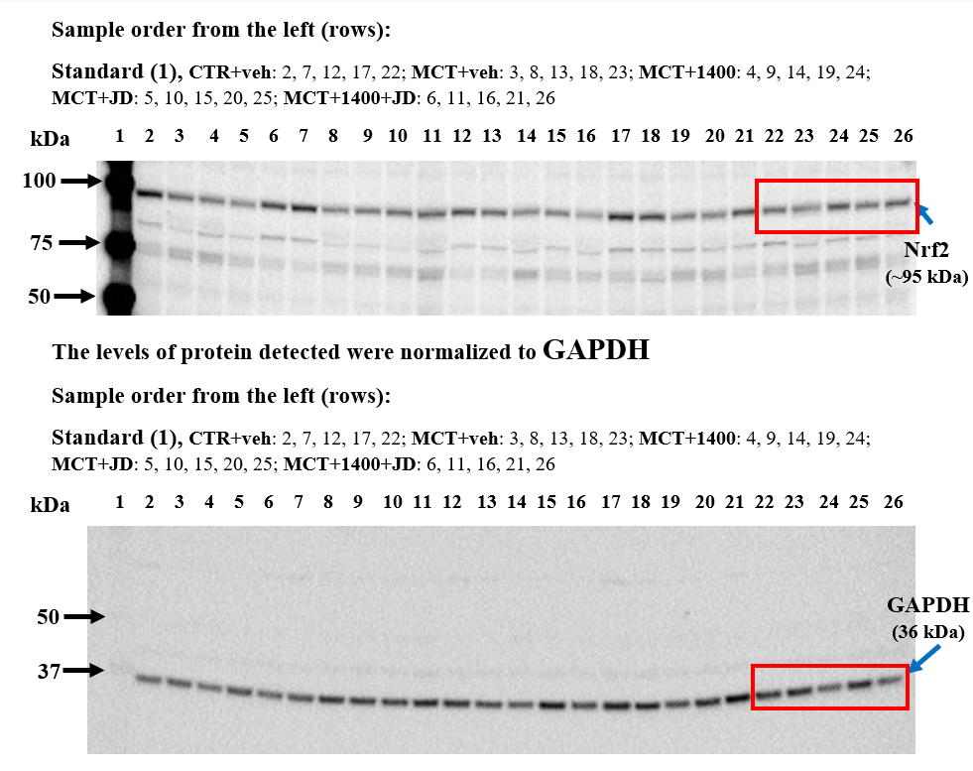
Bands detected with the primary antibody are indicated by blue arrows. Specific molecular weights determined using the Western C® standard are indicated with black arrows. The red rectangles highlight the bands shown in Figure 7H of the manuscript.

Supplementary Figure 9. Original images of Western blot analysis of nuclear factor erythroid 2-related factor 2 (Nrf2) and GAPDH (loading control).

