Supplementary Material
Figure S1: Molecular Interaction over the simulation time between L1R and Trans-CBT.

Figure S2: H-Bonds number evolution over the simulation time between L1R and Trans-CBT.

Figure S3: Molecular Interaction over the simulation time between E8L and Trans-CBT.
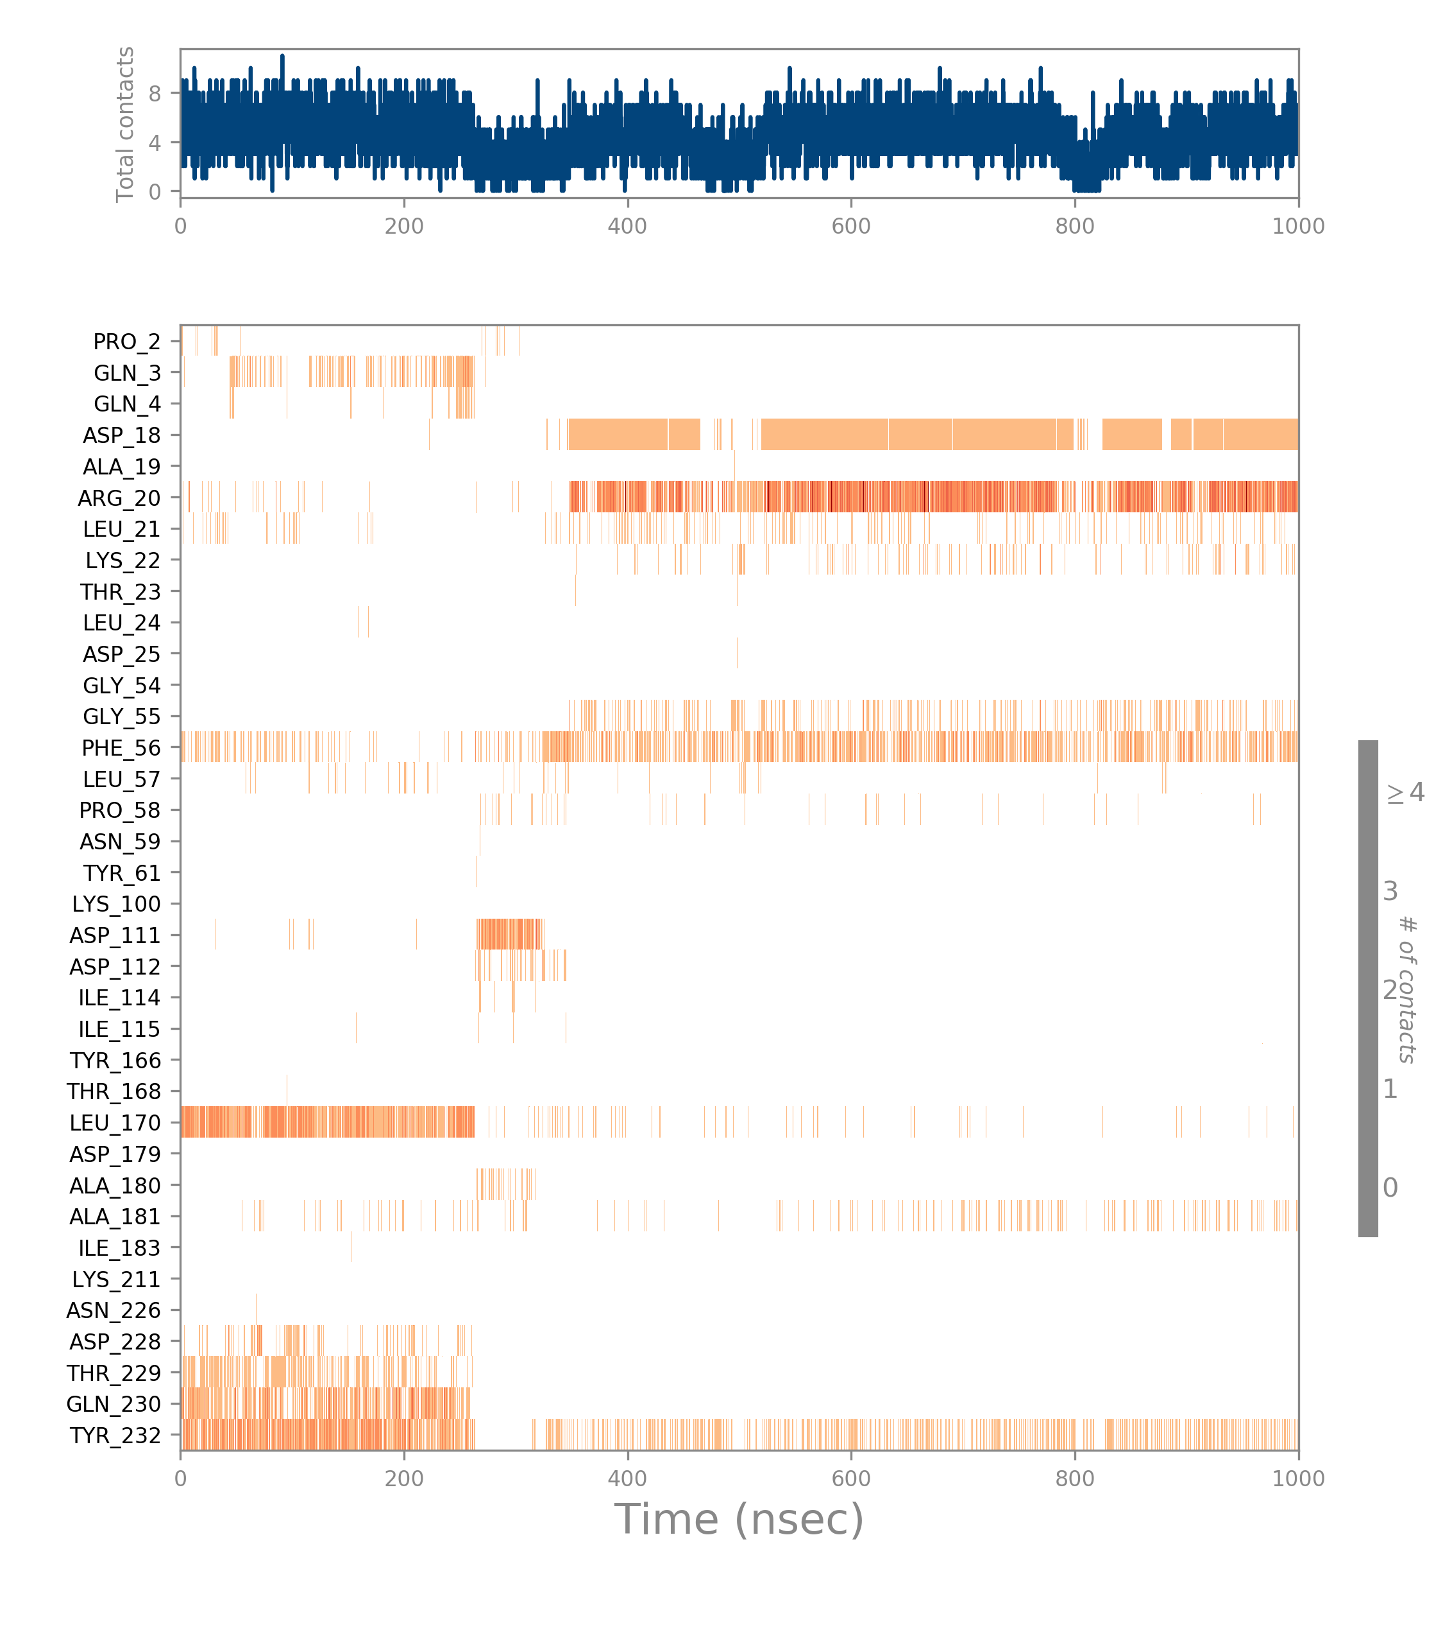

Figure S4: H-Bonds number evolution over the simulation time between E8L and Trans-CBT.

Figure S5: H3L-Trans-CBT MD simulation details.
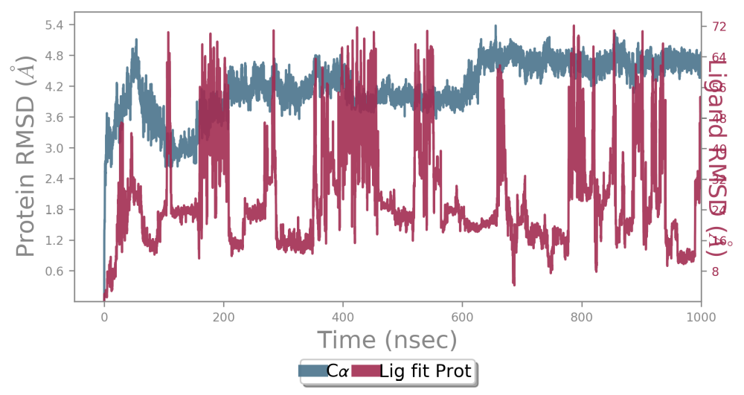
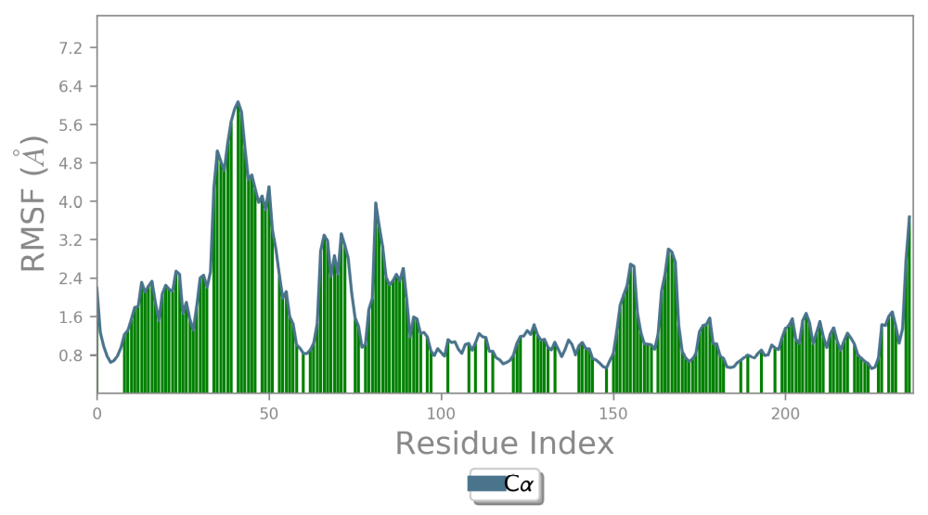
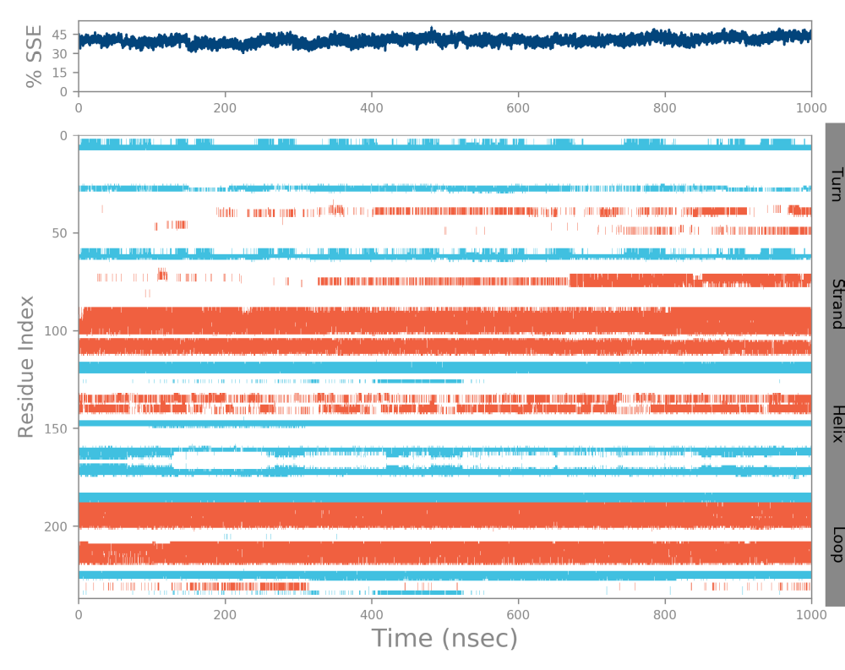

Table S1: Top Predicted Human Protein Targets of Trans-Cannabitriol Identified by SwissTargetPrediction.
Target | Common name | Uniprot ID | ChEMBL ID | Probability
Cannabinoid receptor 1 | CNR1 | P21554 | CHEMBL218 | 0.31466877
Cannabinoid receptor 2 | CNR2 | P34972 | CHEMBL253 | 0.31466877
Tyrosine-protein kinase JAK3 | JAK3 | P52333 | CHEMBL2148 | 0.10467194
Cyclin-dependent kinase 4/cyclin D1 | CCND1 CDK4 | P24385 P11802 | CHEMBL1907601 | 0.10467194
Cyclin-dependent kinase 2/cyclin E | CCNE2 CDK2 CCNE1 | O96020 P24941 P24864 | CHEMBL2094126 | 0.10467194
Tyrosine-protein kinase JAK2 | JAK2 | O60674 | CHEMBL2971 | 0.10467194
Cyclin-dependent kinase 2 | CDK2 | P24941 | CHEMBL301 | 0.10467194
Protein kinase C gamma | PRKCG | P05129 | CHEMBL2938 | 0.10467194
Protein kinase C delta | PRKCD | Q05655 | CHEMBL2996 | 0.10467194
Protein kinase C alpha | PRKCA | P17252 | CHEMBL299 | 0.10467194
Protein kinase C beta | PRKCB | P05771 | CHEMBL3045 | 0.10467194
Protein kinase C (PKC) | PRKCZ | Q05513 | CHEMBL3438 | 0.10467194
Protein kinase C eta | PRKCH | P24723 | CHEMBL3616 | 0.10467194
Liver glycogen phosphorylase | PYGL | P06737 | CHEMBL2568 | 0.10467194
Leucine-rich repeat serine/threonine-protein kinase 2 | LRRK2 | Q5S007 | CHEMBL1075104 | 0.10467194
G protein-coupled receptor kinase 7 | GRK7 | Q8WTQ7 | CHEMBL1075133 | 0.10467194
Serine/threonine-protein kinase 38 | STK38 | Q15208 | CHEMBL1075155 | 0.10467194
Homeodomain-interacting protein kinase 4 | HIPK4 | Q8NE63 | CHEMBL1075167 | 0.10467194
Serine/threonine-protein kinase TAO2 | TAOK2 | Q9UL54 | CHEMBL1075195 | 0.10467194
Serine/threonine-protein kinase/endoribonuclease IRE1 | ERN1 | O75460 | CHEMBL1163101 | 0.10467194
Serine/threonine-protein kinase OSR1 | OXSR1 | O95747 | CHEMBL1163104 | 0.10467194
Serine/threonine-protein kinase MAK | MAK | P20794 | CHEMBL1163106 | 0.10467194
STE20/SPS1-related proline-alanine-rich protein kinase | STK39 | Q9UEW8 | CHEMBL1163108 | 0.10467194
Cyclin-dependent kinase-like 5 | CDKL5 | O76039 | CHEMBL1163112 | 0.10467194
Cyclin-dependent kinase-like 3 | CDKL3 | Q8IVW4 | CHEMBL1163117 | 0.10467194
U4/U6 small nuclear ribonucleoprotein Prp4 | PRPF4 | O43172 | CHEMBL1163119 | 0.10467194
Phosphatidylinositol-4-phosphate 3-kinase C2 domain-containing subunit gamma | PIK3C2G | O75747 | CHEMBL1163120 | 0.10467194
Mitogen-activated protein kinase kinase kinase 6 | MAP3K6 | O95382 | CHEMBL1163123 | 0.10467194
Mitogen-activated protein kinase kinase kinase 13 | MAP3K13 | O43283 | CHEMBL1163124 | 0.10467194
Serine/threonine-protein kinase ICK | ICK | Q9UPZ9 | CHEMBL1163126 | 0.10467194
Mitogen-activated protein kinase kinase kinase 15 | MAP3K15 | Q6ZN16 | CHEMBL1163127 | 0.10467194
Microtubule-associated serine/threonine-protein kinase 1 | MAST1 | Q9Y2H9 | CHEMBL1163128 | 0.10467194
Serine/threonine-protein kinase SBK1 | SBK1 | Q52WX2 | CHEMBL1163129 | 0.10467194
Hormonally up-regulated neu tumor-associated kinase | HUNK | P57058 | CHEMBL1795165 | 0.10467194
Cyclin-dependent kinase 13 | CDK13 | Q14004 | CHEMBL1795192 | 0.10467194
Tyrosine-protein kinase FYN | FYN | P06241 | CHEMBL1841 | 0.10467194
Macrophage colony stimulating factor receptor | CSF1R | P07333 | CHEMBL1844 | 0.10467194
Tyrosine-protein kinase ABL | ABL1 | P00519 | CHEMBL1862 | 0.10467194
Vascular endothelial growth factor receptor 1 | FLT1 | P17948 | CHEMBL1868 | 0.10467194
Peripheral plasma membrane protein CASK | CASK | O14936 | CHEMBL1908381 | 0.10467194
Serine/threonine-protein kinase PRP4 homolog | PRPF4B | Q13523 | CHEMBL1908382 | 0.10467194
Dual serine/threonine and tyrosine protein kinase | DSTYK | Q6XUX3 | CHEMBL1908386 | 0.10467194
Mitogen-activated protein kinase kinase kinase 12 | MAP3K12 | Q12852 | CHEMBL1908389 | 0.10467194
Platelet-derived growth factor receptor beta | PDGFRB | P09619 | CHEMBL1913 | 0.10467194
Vascular endothelial growth factor receptor 3 | FLT4 | P35916 | CHEMBL1955 | 0.10467194
Insulin-like growth factor I receptor | IGF1R | P08069 | CHEMBL1957 | 0.10467194
Tyrosine-protein kinase receptor FLT3 | FLT3 | P36888 | CHEMBL1974 | 0.10467194
Insulin receptor | INSR | P06213 | CHEMBL1981 | 0.10467194
Platelet-derived growth factor receptor alpha | PDGFRA | P16234 | CHEMBL2007 | 0.10467194
Epidermal growth factor receptor erbB1 | EGFR | P00533 | CHEMBL203 | 0.10467194
Kinesin-1 heavy chain/ Tyrosine-protein kinase receptor RET | RET | P07949 | CHEMBL2041 | 0.10467194
Ephrin type-A receptor 2 | EPHA2 | P29317 | CHEMBL2068 | 0.10467194
Tyrosine-protein kinase YES | YES1 | P07947 | CHEMBL2073 | 0.10467194
Dual specificity mitogen-activated protein kinase kinase 3 | MAP2K3 | P46734 | CHEMBL2109 | 0.10467194
AMP-activated protein kinase, alpha-2 subunit | PRKAA2 | P54646 | CHEMBL2116 | 0.10467194
Serine/threonine-protein kinase PIM1 | PIM1 | P11309 | CHEMBL2147 | 0.10467194
Dual specificity mitogen-activated protein kinase kinase 6 | MAP2K6 | P52564 | CHEMBL2171 | 0.10467194
Serine/threonine-protein kinase Aurora-B | AURKB | Q96GD4 | CHEMBL2185 | 0.10467194
MAP kinase-activated protein kinase 2 | MAPKAPK2 | P49137 | CHEMBL2208 | 0.10467194
Tyrosine-protein kinase BLK | BLK | P51451 | CHEMBL2250 | 0.10467194
c-Jun N-terminal kinase 1 | MAPK8 | P45983 | CHEMBL2276 | 0.10467194
Dual-specificity tyrosine-phosphorylation regulated kinase 1A | DYRK1A | Q13627 | CHEMBL2292 | 0.10467194
Ribosomal protein S6 kinase alpha 3 | RPS6KA3 | P51812 | CHEMBL2345 | 0.10467194
Phosphorylase kinase gamma subunit 2 | PHKG2 | P15735 | CHEMBL2349 | 0.10467194
Myosin light chain kinase, smooth muscle | MYLK | Q15746 | CHEMBL2428 | 0.10467194
Serine/threonine-protein kinase AKT2 | AKT2 | P31751 | CHEMBL2431 | 0.10467194
Death-associated protein kinase 3 | DAPK3 | O43293 | CHEMBL2468 | 0.10467194
CaM kinase I alpha | CAMK1 | Q14012 | CHEMBL2493 | 0.10467194
CaM kinase IV | CAMK4 | Q16566 | CHEMBL2494 | 0.10467194
Serine/threonine-protein kinase Chk2 | CHEK2 | O96017 | CHEMBL2527 | 0.10467194
3-phosphoinositide dependent protein kinase-1 | PDPK1 | O15530 | CHEMBL2534 | 0.10467194
Ribosomal protein S6 kinase alpha 1 | RPS6KA1 | Q15418 | CHEMBL2553 | 0.10467194
Death-associated protein kinase 1 | DAPK1 | P53355 | CHEMBL2558 | 0.10467194
Tyrosine-protein kinase LCK | LCK | P06239 | CHEMBL258 | 0.10467194
Protein kinase C (PKC) | PRKD3 | O94806 | CHEMBL2595 | 0.10467194
Protein kinase C iota | PRKCI | P41743 | CHEMBL2598 | 0.10467194
Tyrosine-protein kinase SYK | SYK | P43405 | CHEMBL2599 | 0.10467194
Glycogen synthase kinase-3 beta | GSK3B | P49841 | CHEMBL262 | 0.10467194
Tyrosine-protein kinase CSK | CSK | P41240 | CHEMBL2634 | 0.10467194
c-Jun N-terminal kinase 3 | MAPK10 | P53779 | CHEMBL2637 | 0.10467194
Macrophage-stimulating protein receptor | MST1R | Q04912 | CHEMBL2689 | 0.10467194
Focal adhesion kinase 1 | PTK2 | Q05397 | CHEMBL2695 | 0.10467194
Mitogen-activated protein kinase kinase kinase 11 | MAP3K11 | Q16584 | CHEMBL2708 | 0.10467194
Fibroblast growth factor receptor 3 | FGFR3 | P22607 | CHEMBL2742 | 0.10467194
myosin light chain kinase 2 | MYLK2 | Q9H1R3 | CHEMBL2777 | 0.10467194
CaM kinase II | CAMK2D | Q13557 | CHEMBL2801 | 0.10467194
Tyrosine-protein kinase ZAP-70 | ZAP70 | P43403 | CHEMBL2803 | 0.10467194
Nerve growth factor receptor Trk-A | NTRK1 | P04629 | CHEMBL2815 | 0.10467194
Tyrosine-protein kinase JAK1 | JAK1 | P23458 | CHEMBL2835 | 0.10467194
Glycogen synthase kinase-3 alpha | GSK3A | P49840 | CHEMBL2850 | 0.10467194
Mitogen-activated protein kinase kinase kinase 9 | MAP3K9 | P80192 | CHEMBL2872 | 0.10467194
Mitogen-activated protein kinase kinase kinase 10 | MAP3K10 | Q02779 | CHEMBL2873 | 0.10467194
cGMP-dependent protein kinase 2 | PRKG2 | Q13237 | CHEMBL2896 | 0.10467194
Dual specificity mitogen-activated protein kinase kinase 4 | MAP2K4 | P45985 | CHEMBL2897 | 0.10467194
cAMP-dependent protein kinase beta-1 catalytic subunit | PRKACB | P22694 | CHEMBL2918 | 0.10467194
MAP kinase p38 delta | MAPK13 | O15264 | CHEMBL2939 | 0.10467194
Tyrosine-protein kinase ITK/TSK | ITK | Q08881 | CHEMBL2959 | 0.10467194
Dual specificity mitogen-activated protein kinase kinase 2 | MAP2K2 | P36507 | CHEMBL2964 | 0.10467194
Rho-associated protein kinase 2 | ROCK2 | O75116 | CHEMBL2973 | 0.10467194
Serine/threonine-protein kinase PAK 3 | PAK3 | O75914 | CHEMBL2999 | 0.10467194

