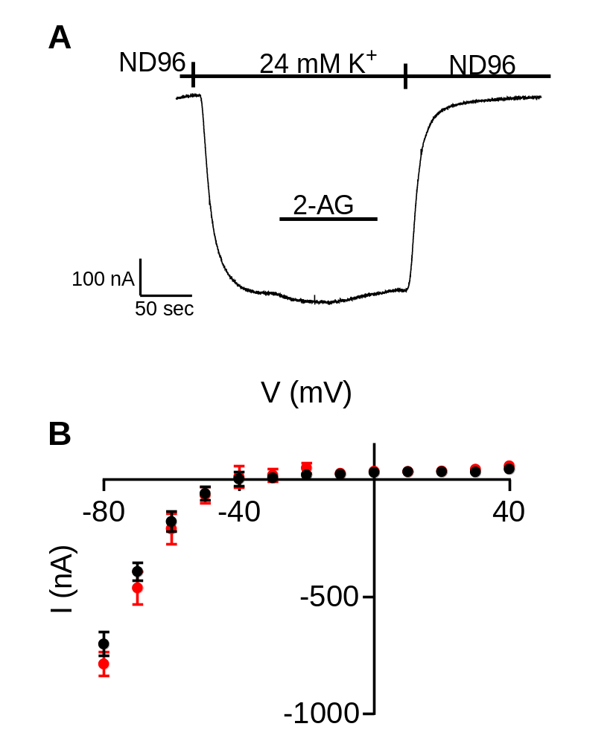

Figure S1. Effect of 2-AG on GIRK channels. (A) A representative recording from an oocyte expressing the GIRK channel. Application of 10 µM 2-AG did not evoke GIRK currents or inhibited basal GIRK currents. (B) Current -Voltage (I-V) curve of I_{K} before (black) and after (red) the application of 2-AG. The oocytes were voltage clamped to -80 mV and the currents after depolarizing pulses to various holding potentials from –80 mV to +40 mV at 10 mV increments were measured. Data is mean ± SEM from 7 oocytes. The difference between the two conditions is not significant (paired t-test, p>0.11 for all voltages).

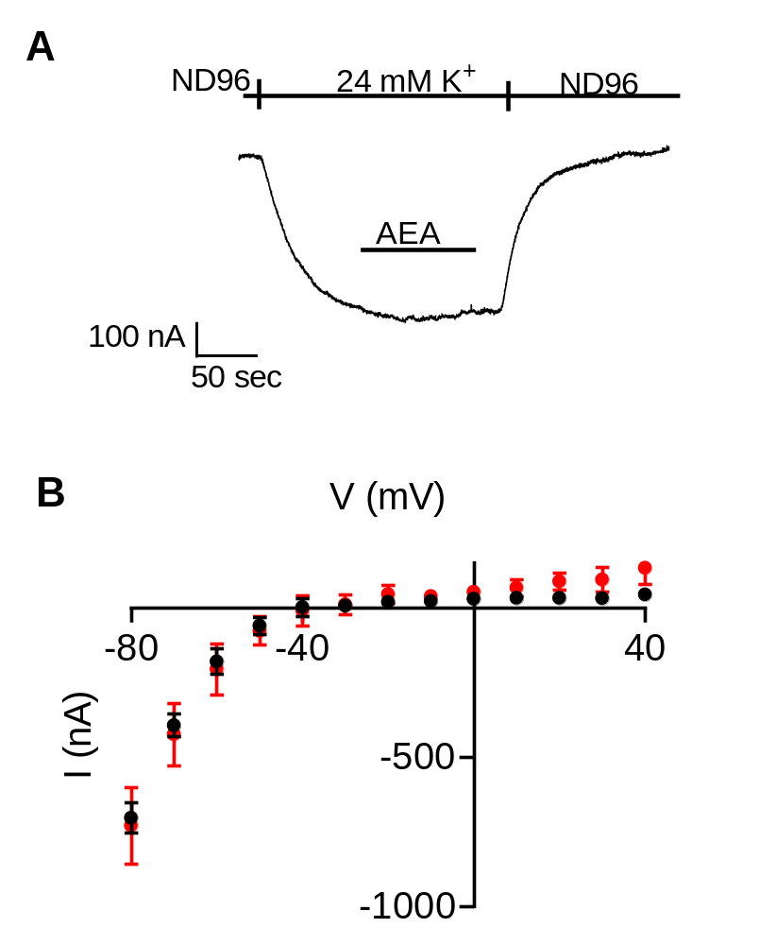
Figure S2. Effect of AEA on GIRK channels. (A) A representative recording from an oocyte expressing the GIRK channel. Application of 10 µM AEA did not evoke GIRK currents or inhibited basal GIRK currents. (B) Current-voltage I-V curve of I_{K} before (black) and after (red) the application of AEA. The oocytes were voltage clamped to -80 mV and the currents after depolarizing pulses to various holding potentials from –80 mV to +40 mV at 10 mV increments were measured. Data is mean ± SEM from 7 oocytes. The difference between the two conditions is not significant (paired t-test, p>0.13 for all voltages).

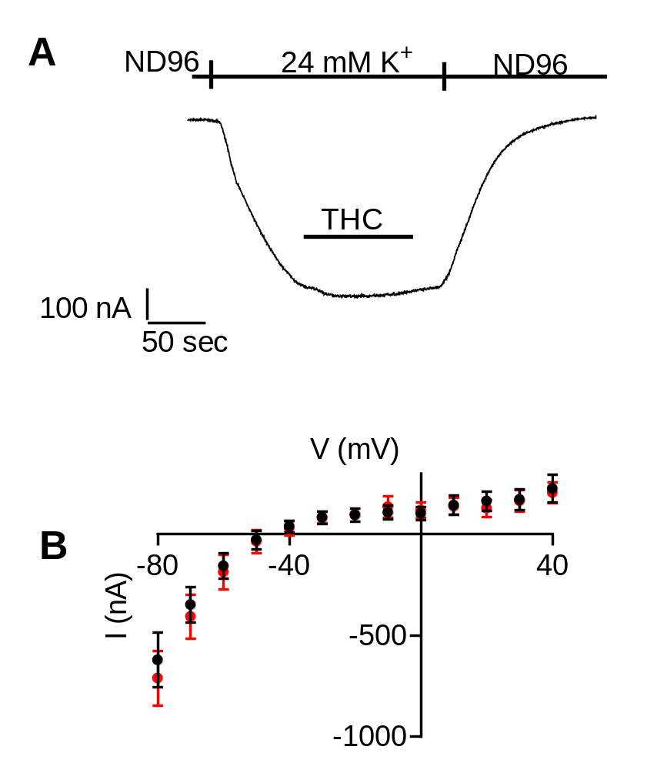

Figure S3. Effect of THC on GIRK channels. (A) A representative recording from an oocyte expressing the GIRK channel. Application of 10 µM THC did not evoke GIRK currents or inhibited basal GIRK currents. (B) I-V curve of I_{K} before (black) and after (red) the application of THC. The oocytes were voltage clamped to -80 mV and the currents after depolarizing pulses to various holding potentials from –80 mV to +40 mV at 10 mV increments were measured. Data is mean ± SEM from 5 oocytes. The difference between the two conditions is not significant (paired t-test, p>0.23 for all voltages).

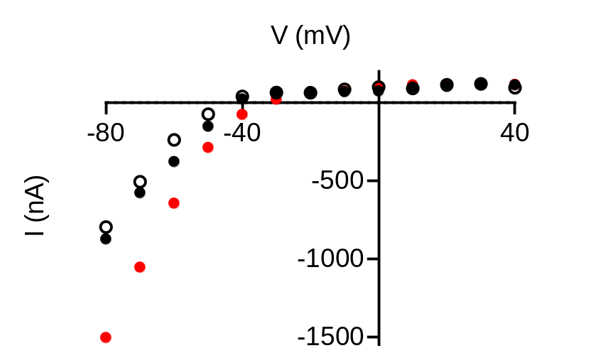

Figure S4. I-V curve of I_{K} before (empty circles) and after the application of 100 and 10000 nM 2-AG (black and red symbols, respectively), measured from one oocyte. The oocyte was voltage clamped to -80 mV and the currents after depolarizing pulses to various holding potentials from –80 mV to +40 mV at 10 mV increments were measured.

