Supplementary material

Supp. Table 1 – Reasons for COVID-19 vaccine uptake hesitancy in our study sample across nationalities
 | Total |  | Lebanese |  | Syrian |  | Other Nationalities |  | P-value
 | n | Weighted % | n | Weighted % | n | Weighted % | n | Weighted %
For those unvaccinated, the main reason why they did not receive the COVID-19 vaccine
Plan to register on platform | 56 | (8.5) | 10 | (4.5) | 43 | (13.2) | 3 | (15.7) | 0.013
Prefer other precautionary measures | 121 | (23.0) | 50 | (24.9) | 71 | (23.5) | 0 | (0.0) | 0.013
Do not believe vaccine is essential | 252 | (49.3) | 103 | (51.5) | 137 | (44.7) | 12 | (59.3) | 0.013
Do not believe COVID-19 requires a vaccine | 46 | (9.2) | 17 | (8.3) | 25 | (9.0) | 4 | (20.5) | 0.013
Other* | 52 | (10.0) | 21 | (10.8) | 30 | (9.6) | 1 | (4.5) | 0.013
Reasons only one dose of the COVID-19 vaccine was taken
Medical condition/Doctor advise | 9 | (7.6) | 3 | (6.4) | 6 | (10.7) | 0 | (0.0) | 0.129
Not wanting to for fear of side effects | 31 | (35.3) | 17 | (43.9) | 14 | (24.8) | 0 | (0.0) | 0.129
Think one dose is enough | 25 | (27.5) | 13 | (29.0) | 10 | (19.7) | 2 | (67.1) | 0.129
Waiting for second dose | 27 | (28.3) | 8 | (20.7) | 18 | (41.1) | 1 | (32.9) | 0.129
Other | 2 | (1.3) | 0 | (0.0) | 2 | (3.7) | 0 | (0.0) | 0.129
A P-value less than 0·05 was considered statistically significant.
*Other reasons include: Mistrust, fear or hesitancy because of controversial information and the vaccine being new ; Medical reasons

Supp. Table 2 - Characteristics of other nationalities in our study area and associations with COVID-19 vaccine uptake
 | Total  (n=57) |  | Not vaccinated  (n=22) |  | Vaccinated  (n=35) |  | COVID-19  vaccine uptake
 | n | Weighted  % | n | Weighted  % | n | Weighted  % | Weighted  Unadjusted OR [95% CI]
Age (years) Median(IQR) | 57 | 35 (30-46) | 22 | 31 (27-35) | 35 | 40 (34-52) | 1.06 [0.97-1.16]
Sex
Male | 18 | (33.0) | 9 | (42.9) | 9 | (26.5) | 1
Female | 39 | (67.0) | 13 | (57.1) | 26 | (73.5) | 2.08 [0.63-6.89]
Missing | 0 |  | 0 |  | 0
Presence of an older adult in the household
No | 47 | (80.3) | 18 | (79.3) | 29 | (81.0) | 1
Yes | 10 | (19.7) | 4 | (20.7) | 6 | (19.0) | 0.90 [0.21-3.85]
Missing | 0 |  | 0 |  | 0
Education
School not attended | 18 | (33.5) | 6 | (29.6) | 12 | (36.2) | 1
School not completed | 21 | (43.5) | 11 | (54.4) | 10 | (35.8) | 0.54 [0.14-2.12]
School completed | 3 | (6.3) | 1 | (5.2) | 2 | (7.2) | 1.14 [0.08-16.88]
Vocational | 1 | (2.4) | 0 | (0.0) | 1 | (4.1) | .
Higher Education | 7 | (14.3) | 2 | (10.8) | 5 | (16.7) | 1.27 [0.17-9.43]
Missing | 7 |  | 2 |  | 5
Assets-based wealth index
1 | 37 | (66.2) | 13 | (62.6) | 24 | (68.5) | 1
2 | 11 | (19.3) | 5 | (22.8) | 6 | (17.1) | 0.69 [0.16-2.93]
3 | 8 | (14.5) | 3 | (14.6) | 5 | (14.4) | 0.90 [0.17-4.70]
Missing | 1 |  | 1 |  | 0
Receiving cash assistance
No | 49 | (87.7) | 20 | (95.0) | 29 | (83.1) | 1
Yes | 7 | (12.3) | 1 | (5.0) | 6 | (16.9) | 3.86 [0.40-37.56]
Missing | 1 |  | 1 |  | 0
Presence of chronic illness
No | 47 | (81.6) | 19 | (84.9) | 28 | (79.5) | 1
Yes | 10 | (18.4) | 3 | (15.1) | 7 | (20.5) | 1.45 [0.31-6.75]
Missing | 0 |  | 0 |  | 0
Believing COVID-19 is a serious infection
True | 45 | (82.7) | 15 | (71.9) | 30 | (89.3) | 1
False | 10 | (17.3) | 6 | (28.1) | 4 | (10.7) | 0.31 [0.07-1.38]
Missing | 2 |  | 1 |  | 1
Consider themselves susceptible to a COVID-19 infection
No | 22 | (39.9) | 12 | (57.7) | 10 | (28.4) | 1
Yes | 35 | (60.1) | 10 | (42.3) | 25 | (71.6) | 3.43 [1.06-11.07]
Missing | 0 |  | 0 |  | 0
Vaccines are safe and/or effective
Agree | 37 | (68.2) | 7 | (35.8) | 30 | (86.2) | 1
Neither agree or disagree | 8 | (13.9) | 5 | (25.3) | 3 | (7.6) | 0.12 [0.02-0.74]
Disagree | 9 | (17.9) | 7 | (38.9) | 2 | (6.2) | 0.07 [0.01-0.42]
Missing | 3 |  | 3 |  | 0
Previous receipt of the flu vaccine
No | 39 | (79.3) | 18 | (97.7) | 21 | (68.0) | 1
Yes | 12 | (20.7) | 1 | (2.3) | 11 | (32.0) | 20.02 [2.16-185.73]
Missing | 6 |  | 3 |  | 3
Data are n and weighted % or median (IQR), OR=odds ratio. CI=confidence interval.
Age was a continuous variable.
The wealth index was generated from the presence in the household of functional transportation, communication, home technology and cooking assets.
The chronic illnesses assessed included hypertension, type II diabetes, vascular diseases, dyslipidemia, chronic respiratory diseases, rheumatoid arthritis, chronic kidney diseases, cancer.

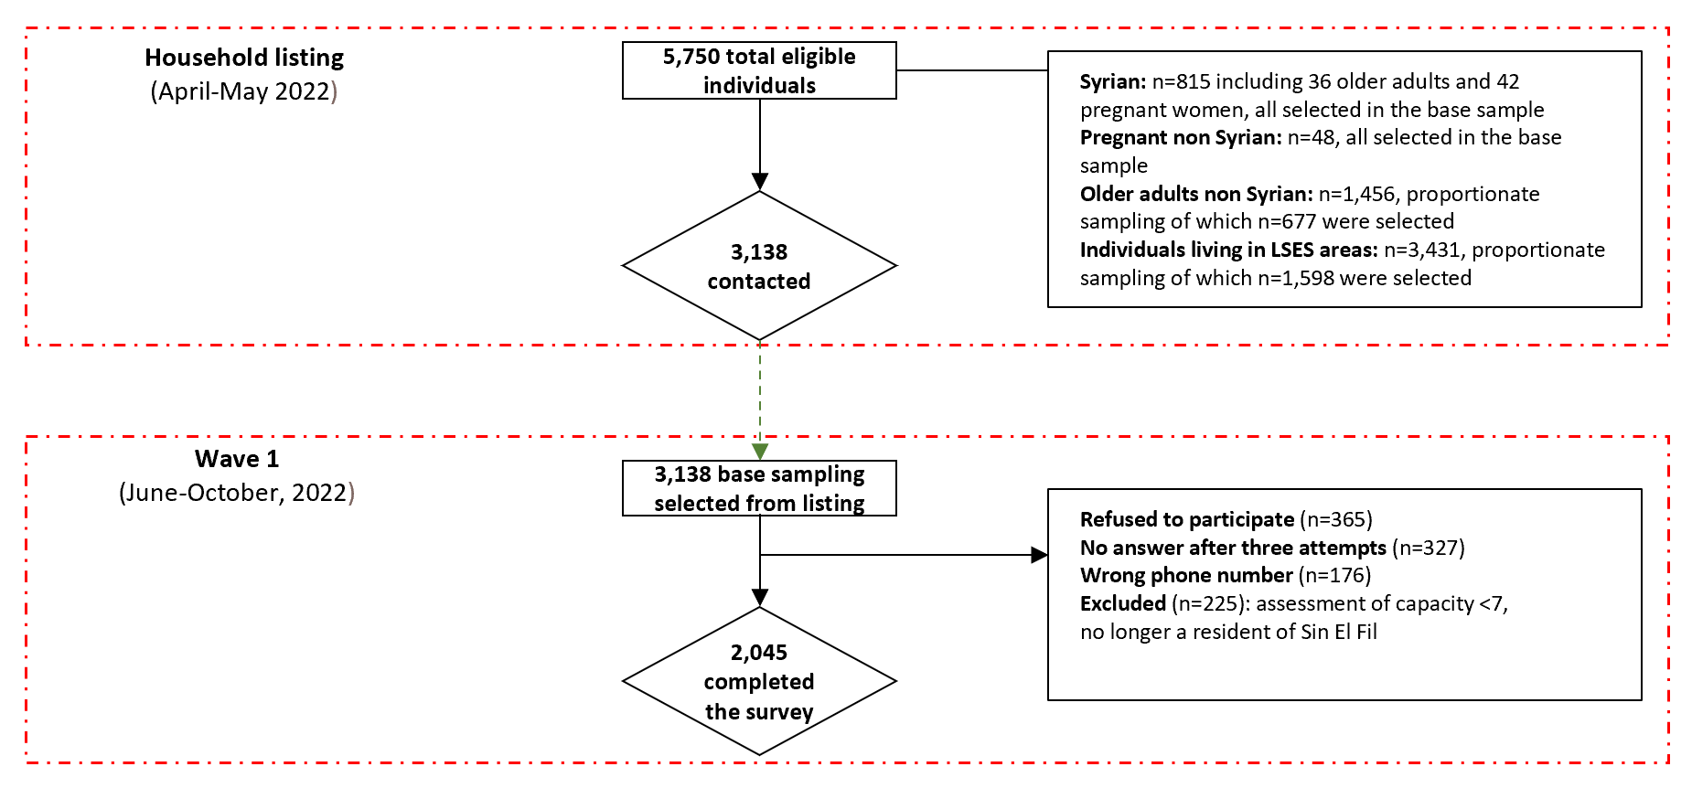
Supp. Figure 1. Flow diagram of the study population who completed the survey at wave 1

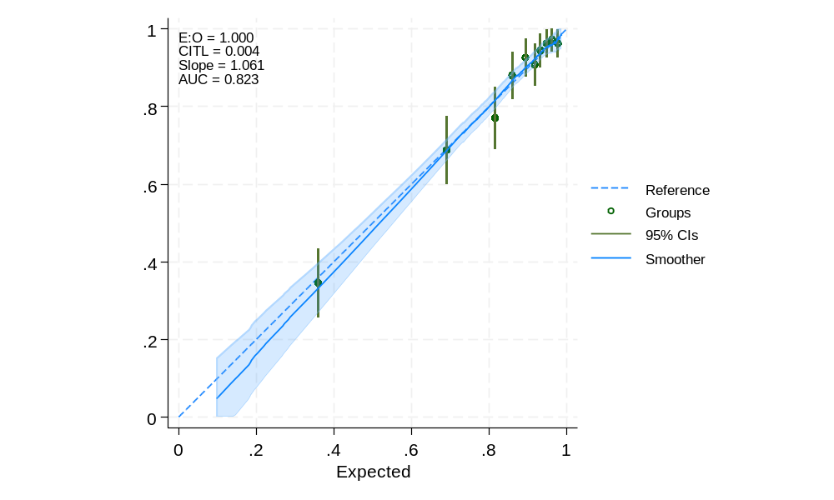
Supp. Figure 2. Final model performance for the Lebanese sample
E:O= Expected to Observed ratio (calibration) ; CITL= calibration-in-the-large ; Slope=Calibration-slope ; AUC= Area Under the Curve (discrimination)

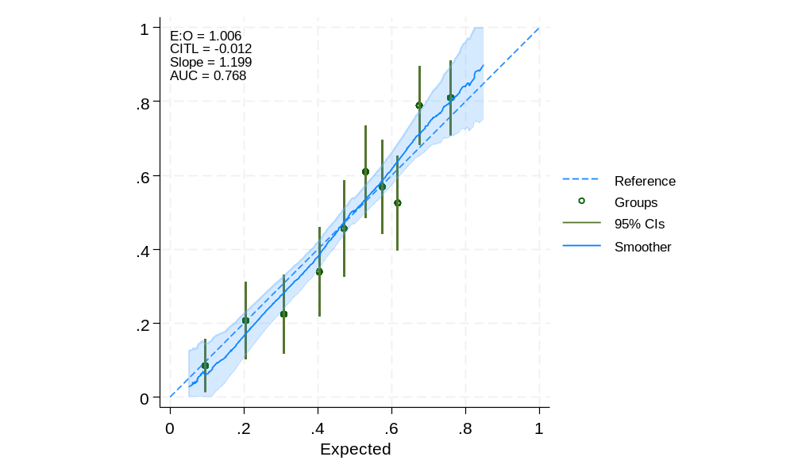
Supp. Figure 3. Final model performance for the Syrian sample
E:O= Expected to Observed ratio (calibration) ; CITL= calibration-in-the-large ; Slope=Calibration-slope ; AUC= Area Under the Curve (discrimination)

