Supplemental Online Content

Reducing diagnostic delays in Acute Hepatic Porphyria using electronic health records data and machine learning: a multicenter development and validation study

Authors: Balu Bhasuran, PhD¹, Katharina Schmolly, BS², Yuvraaj Kapoor³, Nanditha Lakshmi Jayakumar,MBBS³, Raymond Doan, PharmD⁴, Jigar Amin, PharmD⁴, Stephen Meninger, PharmD⁴, Nathan Cheng, PharmD⁴, Robert Deering, PharmD, PhD⁴, Karl Anderson⁵, Simon W. Beaven, MD, PhD², Bruce Wang, MD³, Vivek A. Rudrapatna, MD, PhD^{1,6}

¹Bakar Computational Health Sciences Institute, San Francisco, CA, 94143
²David Geffen School of Medicine & Pfleger Liver Institute, University of California at Los Angeles, Los Angeles, CA 90095
³Department of Medicine, University of California San Francisco, San Francisco, CA, 94143
⁴Alnylam Pharmaceuticals, Cambridge, Massachusetts, MA 02142
⁵Division of Gastroenterology and Hepatology, University of Texas Medical Branch, School of Medicine, Galveston, TX, 77555
⁶Division of Gastroenterology and Hepatology, Department of Medicine, University of California, San Francisco, San Francisco, CA, 94143

TABLE OF CONTENTS:

eFigure 1: Most predictive features in the diagnosis model

eFigure 2: Selection of the prospective cohort for model validation

eFigure 3: Running probabilities of a model-based diagnosis as compared to the actual diagnosis year.

eTable 1: Sample size calculations pertaining to a prospective test of the model accuracy

Supplemental Methods

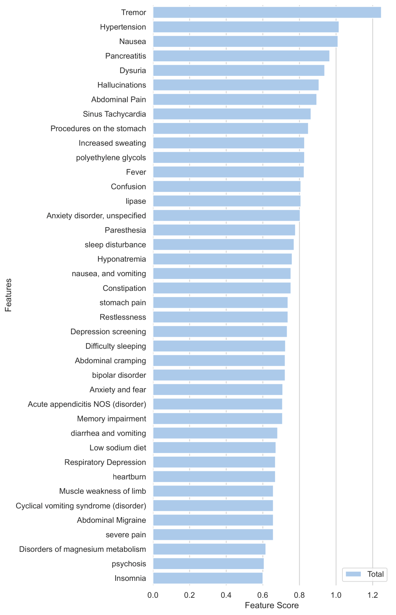
eFigure 1: Most predictive features in the diagnosis model

eFigure 2: Selection of the prospective cohort for model validation. From the pool of recently seen patients at UCSF and UCLA who lack an AHP diagnosis, we applied 10% referral probability and 50% diagnosis probability cutoffs (red lines) to identify potential recruitable subjects for a prospective test of our modeling framework.

eFigure 3: Running probabilities of a model-based diagnosis as compared to the actual diagnosis year. Each plot represents the running probability of a model-based diagnosis in a different AHP patient. Because the diagnosis models are only suitable for use on a cohort of patients with a non-trivial probability of being tested for AHP (to limit extrapolation), all plots begin at the earliest year at which a given patient achieves a current referral probability ≥ 10%. The red solid line represents the actual year of diagnosis, whereas the black dotted line represents the earliest date that a patient is calculated as having a referral probability ≥ 10% and a diagnosis probability ≥ 50%. In cases where the black dotted line occurs earlier than the red solid line, the horizontal difference corresponds to potential years saved.

 | High probability patient cohort | Expected number of new diagnoses | 95% confidence interval
UCSF | 168 | 31 | (22-42)
UCLA | 283 | 37 | (27-49)
Total | 451 | 68 | (54-84)
+ Assuming 20% participation | NA | 14 | (7-24)

eTable 1: Sample size calculations pertaining to a prospective test of the model accuracy

Supplemental Methods:

See our github page for the full code pipeline: https://github.com/rwelab/AHPPrediction. A few code snippets of interest to the feature engineering pipeline are reproduced below.

Python code snippet for processing EHR data from the 'Encounter' Table

df2.columns = ["PatientDurableKey", "PrimaryDiagnosisName", "PrimaryProcedureName","PrimaryProcedureCategory"]
df2['PrimaryDiagnosisName'] = df2['PrimaryDiagnosisName'].astype(str)+'_DX'
df2['PrimaryProcedureName'] = df2['PrimaryProcedureName'].astype(str)+'_PROC'

new = df2[['PatientDurableKey', 'PrimaryDiagnosisName']].copy()
new1 = df2[['PatientDurableKey', 'PrimaryProcedureName']].copy()
new.rename(columns={'PrimaryDiagnosisName': 'Feature'}, inplace=True)
new1.rename(columns={'PrimaryProcedureName': 'Feature'}, inplace=True)
dfq=new.groupby(["PatientDurableKey","Feature"]).size().reset_index(name="DepFreq")
dfw=new1.groupby(["PatientDurableKey","Feature"]).size().reset_index(name="DepFreq")
df_final=dfq.append(dfw, ignore_index=True)
df_final=df_final[~df_final.Feature.str.contains('\*Not Applicable')]
df_final=df_final[~df_final.Feature.str.contains('\*Unspecified')]
encounter=df_final

Code snippet for processing EHR from 'Medication' Table:

df5.columns = ["PatientDurableKey", "MedicationName", "MedicationTherapeuticClass", "MedicationPharmaceuticalClass" ]
new = df5[['PatientDurableKey', 'MedicationName']].copy()
new1 = df5[['PatientDurableKey', 'MedicationTherapeuticClass']].copy()
new2 = df5[['PatientDurableKey', 'MedicationPharmaceuticalClass']].copy()
new.rename(columns={'MedicationName': 'Feature'}, inplace=True)
new1.rename(columns={'MedicationTherapeuticClass': 'Feature'}, inplace=True)
new2.rename(columns={'MedicationPharmaceuticalClass': 'Feature'}, inplace=True)
dfq=new.groupby(["PatientDurableKey","Feature"]).size().reset_index(name="DepFreq")
dfw=new1.groupby(["PatientDurableKey","Feature"]).size().reset_index(name="DepFreq")
dfx=new2.groupby(["PatientDurableKey","Feature"]).size().reset_index(name="DepFreq")
df_final=dfq.append(dfw, ignore_index=True)
df_final=df_final.append(dfx, ignore_index=True)
df_final=df_final[~df_final.Feature.str.contains('\*Not Applicable')]
df_final=df_final[~df_final.Feature.str.contains('\*Unspecified')]
medication=df_final
medication.sort_values('DepFreq',ascending=False)

One hot encoding:

from sklearn.preprocessing import OneHotEncoder
encoder = OneHotEncoder(categories='auto')
# fit the encoder to the data
encoder.fit(data)
# transform the data
encoded_data = encoder.transform(data)

