Table S1. Weekly fertigation strength.
Week | EC | Coco A&B nutrients (mL/L)
1 | 1.1 | 1.75
2 | 1.3 | 2.25
3 | 1.5 | 2.75
4 | 1.5 | 2.75
5 | 1.8 | 3.50
6 | 1.8 | 3.50
7 | 2.0 | 4.00
8 | 2.0 | 4.00
9 | 2.2 | 4.25
10 | 2.0 | 4.00
11 | 1.8 | 3.50
12 | 1.5 | 2.75

Table S2. Weekly fertigation pump schedule
Week | Pump duration (s)
1 | 10
2–3 | 15
4–5 | 20
6 | 30
7–12 | 40

Table S3. Chromatic pixel colour assignment criteria using Lab*.
 |  | Red | Orange | Yellow | Green | Cyan | Blue | Purple | Pink | Brown
Band | L* | Hue range | Hue range | Hue range | Hue range | Hue range | Hue range | Hue range | Hue range | Hue range
1 | L* < 20 | 15° – 35° | 50° – 65° | 65° – 100° | 88° – 195° | 180° – 240° | 240° – 290° | 290° – 345° | 345° – 15° | 35° – 50°
2 | 20 ≤ L* < 35 | 15° – 35° | 55° – 75° | 75° – 90° | 88° – 195° | 180° – 240° | 240° – 290° | 290° – 345° | 345° – 15° | 35° – 55°
3 | 35 ≤ L* < 50 | 15° – 40° | 40° – 70° | 70° – 95° | 88° – 195° | 180° – 240° | 240° – 290° | 290° – 345° | 345° – 15° | NDª
4 | 50 ≤ L* < 65 | 15° – 48° | 45° – 75° | 75° – 100° | 100° – 180° | 180° – 240° | 240° – 290° | 290° – 345° | 345° – 15° | NDª
5 | 65 ≤ L* < 80 | 15° – 48° | 45° – 75° | 75° – 102° | 102° – 180° | 180° – 240° | 240° – 290° | 290° – 345° | 345° – 15° | NDª
6 | L* ≥ 80 | 15° – 47° | 45° – 75° | 75° – 105° | 105° – 180° | 180° – 240° | 240° – 290° | 290° – 345° | 345° – 15° | NDª
ªNot defined

Table S4. Biomass and yield
 | Control |  |  | BC1 |  |  |  |  | BC2
Measure | N | Mean | StDev | N | Mean | StDev | P-valueª | F-C^{b} | N | Mean | StDev | P-valueª | F-C^{b}
Stem thickness (mm) | 6 | 13.38 | 1.13 | 6 | 12.73 | 1.08 | 0.332 | 0.95 | 6 | 14.09 | 1.55 | 0.386 | 1.05
Biomass (g FW) | 6 | 605.00 | 43.20 | 6 | 583.30 | 67.20 | 0.521 | 0.96 | 6 | 615.80 | 65.60 | 0.743 | 1.02
Weight (g CW) | 6 | 12.93 | 2.22 | 6 | 15.13 | 1.93 | 0.097 | 1.17 | 6 | 28.73 | 9.41 | 0.003 | 2.22
ª2-sample t-test compared to control, ^{b}Fold-change compared to control

Table S5. Flower dimensions
 | Control |  |  | BC1 |  |  |  |  | BC2
Measure | N | Mean | StDev | N | Mean | StDev | P-value | F-Cª | N | Mean | StDev | P-value | F-Cª
Flower size (mm) | 18 | 19.00 | 6.60 | 18 | 19.50 | 5.85 | 0.642^{b} | 1.03 | 18 | 24.33 | 7.80 | 0.003^{b} | 1.28
Flower area (cm²) | 6 | 2.97 | 0.32 | 6 | 3.10 | 0.30 | 0.487^{c} | 1.04 | 6 | 3.69 | 0.84 | 0.098^{c} | 1.24
ªFold-change compared to control, ^{b}treatment effects compared to control by general linear model GLM), accounting for ‘plant’ as a nested random factor, ^{c}2-sample t-test compared to control

Table S6. Flower size grading
 | Control |  |  | BC1 |  |  |  |  | BC2
Measure | N | Count | % | N | Count | % | P-valueª | F-C^{b} | N | Count | % | P-valueª | F-C^{b}
Grade A | 18 | 11 | 61.11 | 18 | 12 | 66.67 | 0.728 | 1.09 | 18 | 16 | 88.89 | 0.042 | 1.45
Grade B | 18 | 5 | 27.78 | 18 | 5 | 27.78 | 1.000 | 1.00 | 18 | 2 | 11.11 | 0.196 | 0.40
Shake | 18 | 2 | 11.11 | 18 | 1 | 5.56 | 0.544 | 0.50 | 18 | 0 | 0.00 | 0.134 | 0.00
ª2-proportions compared to control, ^{b}Fold-change compared to control

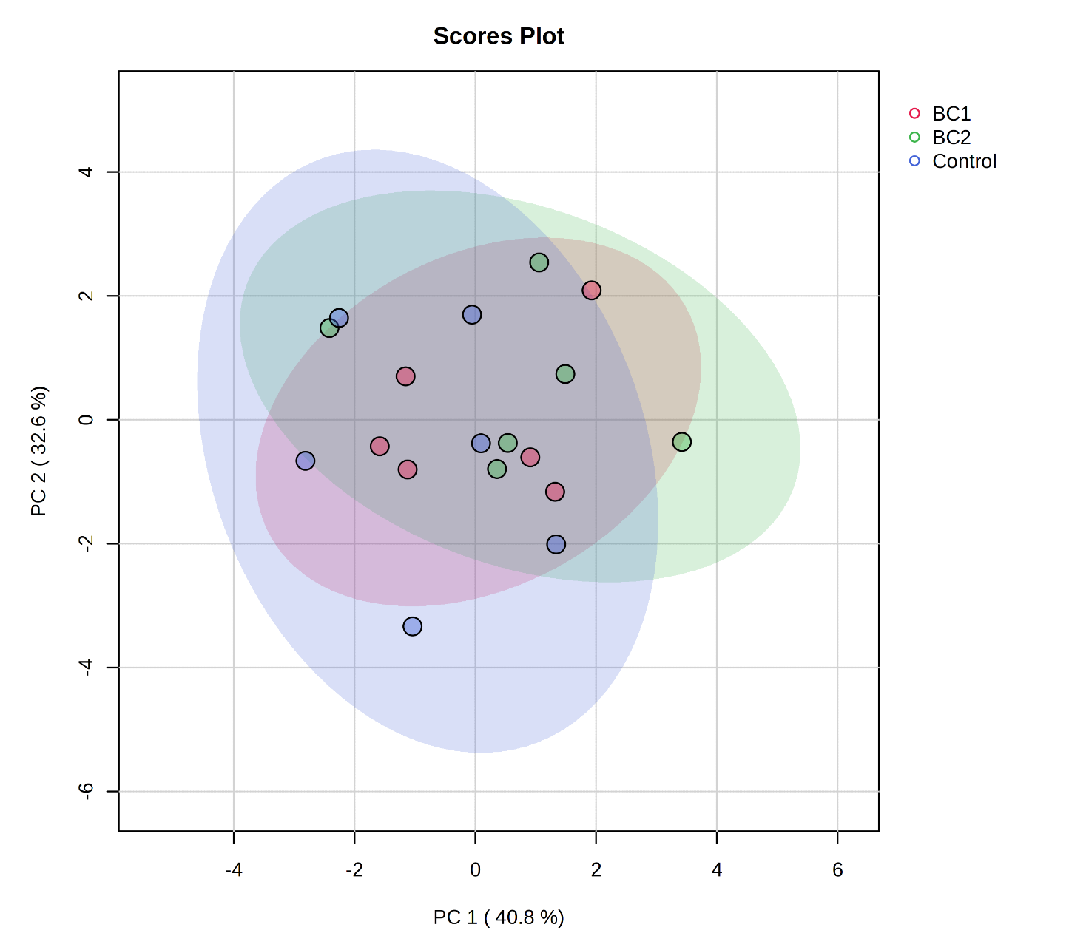
Figure S1. Flower colour PCA
Table S7. Flower colour
 | Control |  |  | BC1 |  |  |  |  | BC2
Measureª | N | Mean | StDev | N | Mean | StDev | P-value^{b} | F-C^{c} | N | Mean | StDev | P-value^{b} | F-C^{c}
Black (%) | 6 | 0.92 | 0.28 | 6 | 1.12 | 0.61 | 0.505 | 1.21 | 6 | 1.22 | 0.42 | 0.189 | 1.32
Green (%) | 6 | 83.86 | 1.67 | 6 | 84.07 | 1.54 | 0.828 | 1.00 | 6 | 84.95 | 2.28 | 0.372 | 1.01
Grey (%) | 6 | 2.48 | 0.80 | 6 | 2.04 | 0.58 | 0.302 | 0.82 | 6 | 1.32 | 0.37 | 0.014 | 0.53
Orange (%) | 6 | 0.45 | 0.11 | 6 | 0.36 | 0.09 | 0.158 | 0.80 | 6 | 0.35 | 0.07 | 0.085 | 0.76
Red (%) | 6 | 0.38 | 0.08 | 6 | 0.31 | 0.05 | 0.129 | 0.83 | 6 | 0.31 | 0.06 | 0.126 | 0.82
White (%) | 6 | 2.94 | 1.11 | 6 | 2.51 | 0.56 | 0.422 | 0.85 | 6 | 2.90 | 0.48 | 0.938 | 0.99
Yellow (%) | 6 | 8.96 | 1.76 | 6 | 9.58 | 1.00 | 0.475 | 1.07 | 6 | 8.95 | 1.98 | 0.996 | 1.00
ªBlue not detected, Pink and Brown accounted for a total of 0.002-0.007%, ^{b}2-sample t-test compared to control, ^{c}Fold-change compared to control

Table S8. Abundance of functional groups within flowers determined from N-IR
 |  | Control |  |  | BC1 |  |  |  |  | BC2
Measure | µm range | N | Meanª | StDev | N | Meanª | StDev | P-value^{b} | F-C^{c} | N | Meanª | StDev | P-value^{b} | F-C^{c}
RNH₂ | 1.017–1.043 | 6 | 0.6621 | 0.1284 | 6 | 0.8632 | 0.1307 | 0.023 | 1.30 | 6 | 0.8438 | 0.1102 | 0.025 | 1.27
ArCH | 1.094–1.099 | 6 | 0.0052 | 0.0028 | 6 | 0.0050 | 0.0044 | 0.927 | 0.96 | 6 | 0.0108 | 0.0030 | 0.007 | 2.08
CH₃ | 1.118–1.194 | 6 | 4.7150 | 0.2910 | 6 | 5.2360 | 0.3400 | 0.017 | 1.11 | 6 | 5.2580 | 0.3600 | 0.017 | 1.12
ªPer-treatment average determined from the sum of absorbances across the µm range, ^{b}2-sample t-test compared to control, ^{c}Fold-change compared to control

Table S9. Flower cannabinoids determined from N-IR
 | Control |  |  | BC1 |  |  |  |  | BC2
Measure | N | Mean | StDev | N | Mean | StDev | P-valueª | F-C^{b} | N | Mean | StDev | P-valueª | F-C^{b}
THC | 6 | ND^{c} | N/A | 6 | ND^{c} | N/A | N/A | N/A | 6 | ND^{c} | N/A | N/A | N/A
CBD (% g CW) | 6 | 2.870 | 0.324 | 6 | 3.831 | 0.445 | 0.002 | 1.33 | 6 | 2.978 | 0.453 | 0.642 | 1.04
ª2-sample t-test compared to control, ^{b}Fold-change compared to control^{, c}Not detected

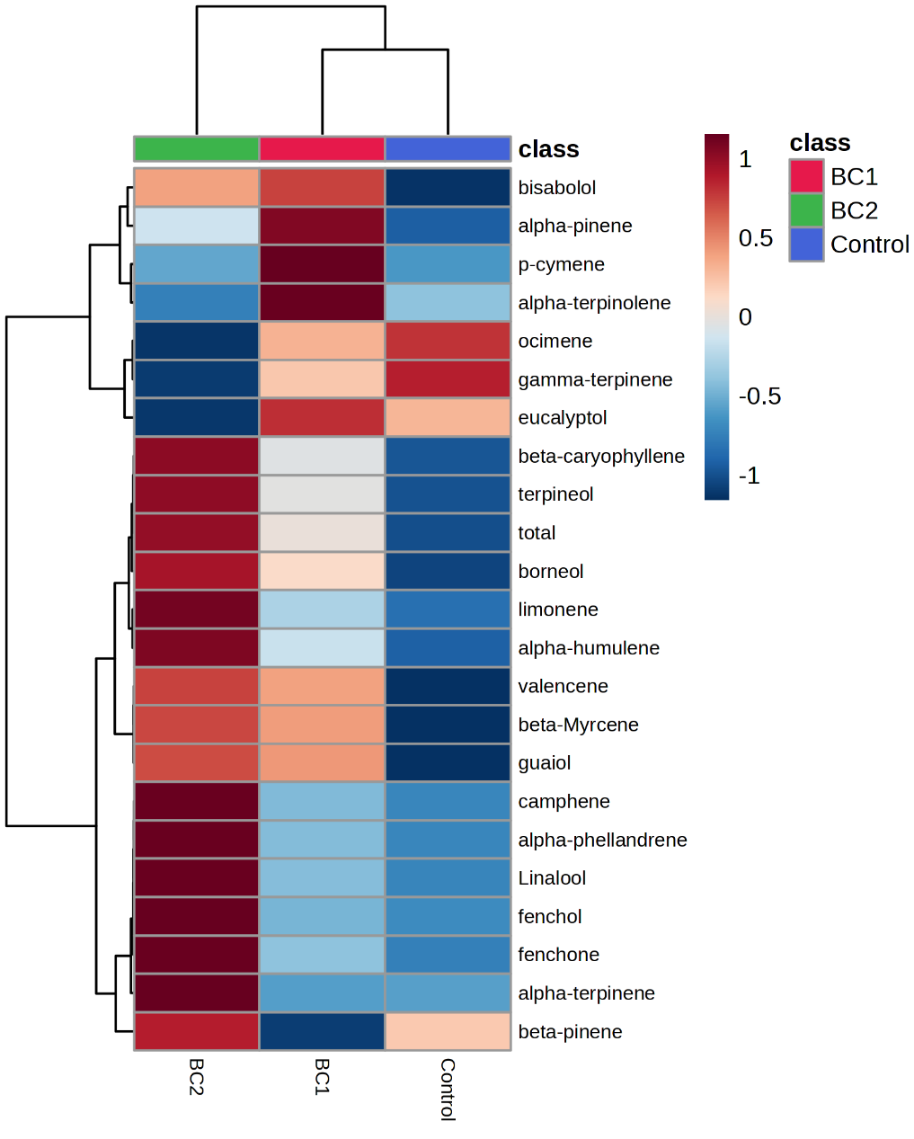
Figure S2. Heatmap of impact of BCs to volatile profiles

Table S10. Impact of BCs to individual volatiles
 | Control |  |  | BC1 |  |  |  |  | BC2
Measure | N | Mean | StDev | N | Mean | StDev | P-valueª | F-C^{b} | N | Mean | StDev | P-valueª | F-C^{b}
α-humulene | 6 | 28.77 | 3.60 | 6 | 33.33 | 6.42 | 0.160 | 1.16 | 6 | 40.69 | 7.76 | 0.007 | 1.41
α -phellandrene | 6 | 3.32 | 0.55 | 6 | 3.57 | 0.62 | 0.477 | 1.07 | 6 | 4.96 | 1.36 | 0.021 | 1.49
α -pinene | 6 | 11.03 | 2.32 | 6 | 11.57 | 3.15 | 0.742 | 1.05 | 6 | 11.24 | 2.44 | 0.882 | 1.02
α -terpinene | 6 | 0.96 | 0.18 | 6 | 0.96 | 0.32 | 1.000 | 1.00 | 6 | 1.87 | 0.82 | 0.024 | 1.95
α -terpinolene | 6 | 0.31 | 0.06 | 6 | 0.38 | 0.06 | 0.071 | 1.22 | 6 | 0.30 | 0.06 | 0.779 | 0.95
β-caryophyllene | 6 | 102.56 | 12.97 | 6 | 118.89 | 21.67 | 0.144 | 1.16 | 6 | 138.00 | 29.90 | 0.024 | 1.35
β-myrcene | 6 | 123.04 | 23.03 | 6 | 142.60 | 66.10 | 0.509 | 1.16 | 6 | 145.30 | 76.50 | 0.510 | 1.18
β-pinene | 6 | 7.77 | 2.41 | 6 | 6.18 | 3.98 | 0.422 | 0.80 | 6 | 8.58 | 3.03 | 0.619 | 1.10
bisabolol | 6 | 0.71 | 0.35 | 6 | 0.98 | 0.14 | 0.110 | 1.39 | 6 | 0.94 | 0.17 | 0.178 | 1.32
borneol | 6 | 9.05 | 1.30 | 6 | 10.48 | 1.28 | 0.084 | 1.16 | 6 | 11.48 | 3.09 | 0.106 | 1.27
camphene | 6 | 3.68 | 1.00 | 6 | 3.62 | 1.93 | 0.947 | 0.98 | 6 | 3.74 | 1.17 | 0.926 | 1.02
eucalyptol | 6 | 0.76 | 0.22 | 6 | 0.81 | 0.21 | 0.696 | 1.06 | 6 | 0.63 | 0.17 | 0.279 | 0.83
fenchol | 6 | 19.69 | 5.04 | 6 | 20.35 | 3.32 | 0.794 | 1.03 | 6 | 25.16 | 10.91 | 0.291 | 1.28
fenchone | 6 | 6.67 | 1.30 | 6 | 6.88 | 1.26 | 0.782 | 1.03 | 6 | 7.83 | 1.83 | 0.234 | 1.17
γ-terpinene | 6 | 0.61 | 0.05 | 6 | 0.60 | 0.06 | 0.760 | 0.98 | 6 | 0.58 | 0.03 | 0.236 | 0.95
guaiol | 6 | 29.77 | 6.55 | 6 | 44.03 | 19.08 | 0.114 | 1.48 | 6 | 46.56 | 8.47 | 0.003 | 1.56
limonene | 6 | 64.88 | 17.37 | 6 | 72.60 | 31.80 | 0.613 | 1.12 | 6 | 91.70 | 21.39 | 0.038 | 1.41
linalool | 6 | 1.63 | 0.17 | 6 | 1.65 | 0.47 | 0.924 | 1.01 | 6 | 1.77 | 0.12 | 0.130 | 1.09
ocimene | 6 | 0.33 | 0.05 | 6 | 0.31 | 0.05 | 0.504 | 0.93 | 6 | 0.24 | 0.06 | 0.018 | 0.72
p-cymene | 6 | 0.32 | 0.04 | 6 | 0.35 | 0.06 | 0.332 | 1.08 | 6 | 0.32 | 0.03 | 1.000 | 1.00
terpineol | 6 | 8.93 | 1.59 | 6 | 10.75 | 1.85 | 0.098 | 1.20 | 6 | 12.73 | 5.32 | 0.125 | 1.43
valencene | 6 | 2.98 | 0.39 | 6 | 3.44 | 0.43 | 0.081 | 1.15 | 6 | 3.55 | 0.78 | 0.140 | 1.19
Total | 6 | 427.80 | 73.70 | 6 | 494.30 | 122.00 | 0.280 | 1.16 | 6 | 558.20 | 82.70 | 0.016 | 1.30
ª2-sample t-test compared to control, ^{b}Fold-change compared to control

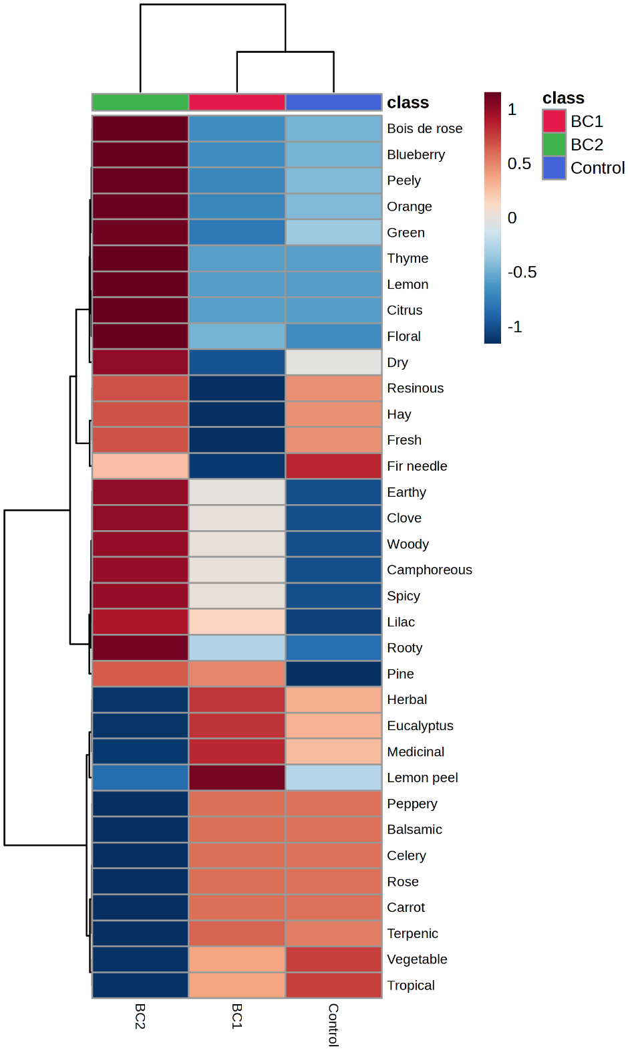
Figure S3. Heatmap of impact of BCs to odour profiles

Table S11. Impact of BCs to flower odour
 | Control |  |  | BC1 |  |  |  |  | BC2
Measure | N | Mean | StDev | N | Mean | StDev | P-valueª | F-C^{b} | N | Mean | StDev | P-valueª | F-C^{b}
Balsamic | 6 | 1.625 | 0.037 | 6 | 1.630 | 0.127 | 0.930 | 1.00 | 6 | 1.412 | 0.693 | 0.486 | 0.87
Blueberry | 6 | 0.940 | 0.017 | 6 | 0.939 | 0.041 | 0.958 | 1.00 | 6 | 0.955 | 0.012 | 0.115 | 1.02
Bois de rose | 6 | 1.880 | 0.035 | 6 | 1.877 | 0.081 | 0.936 | 1.00 | 6 | 1.909 | 0.023 | 0.128 | 1.02
Camphoreous | 6 | 4.537 | 0.456 | 6 | 4.678 | 0.354 | 0.564 | 1.03 | 6 | 4.830 | 0.436 | 0.285 | 1.06
Carrot | 6 | 1.015 | 0.023 | 6 | 1.019 | 0.080 | 0.911 | 1.00 | 6 | 0.882 | 0.433 | 0.486 | 0.87
Celery | 6 | 1.160 | 0.026 | 6 | 1.165 | 0.091 | 0.902 | 1.00 | 6 | 1.009 | 0.495 | 0.489 | 0.87
Citrus | 6 | 11.422 | 0.372 | 6 | 11.436 | 0.807 | 0.970 | 1.00 | 6 | 11.778 | 0.247 | 0.087 | 1.03
Clove | 6 | 3.260 | 0.063 | 6 | 3.331 | 0.089 | 0.145 | 1.02 | 6 | 3.403 | 0.103 | 0.020 | 1.04
Dry | 6 | 1.987 | 0.279 | 6 | 1.874 | 0.354 | 0.554 | 0.94 | 6 | 2.122 | 0.232 | 0.386 | 1.07
Earthy | 6 | 1.162 | 0.112 | 6 | 1.204 | 0.097 | 0.505 | 1.04 | 6 | 1.248 | 0.079 | 0.163 | 1.07
Eucalyptus | 6 | 4.486 | 0.254 | 6 | 4.548 | 0.248 | 0.679 | 1.01 | 6 | 4.305 | 0.264 | 0.257 | 0.96
Fir needle | 6 | 0.206 | 0.097 | 6 | 0.223 | 0.122 | 0.795 | 1.08 | 6 | 0.207 | 0.114 | 0.987 | 1.01
Floral | 6 | 2.994 | 0.061 | 6 | 3.002 | 0.125 | 0.892 | 1.00 | 6 | 3.059 | 0.049 | 0.072 | 1.02
Fresh | 6 | 0.358 | 0.109 | 6 | 0.282 | 0.172 | 0.387 | 0.79 | 6 | 0.388 | 0.119 | 0.660 | 1.08
Green | 6 | 1.439 | 0.035 | 6 | 1.430 | 0.073 | 0.793 | 0.99 | 6 | 1.470 | 0.025 | 0.111 | 1.02
Hay | 6 | 0.215 | 0.065 | 6 | 0.169 | 0.103 | 0.382 | 0.79 | 6 | 0.233 | 0.071 | 0.658 | 1.08
Herbal | 6 | 11.971 | 0.380 | 6 | 12.084 | 0.728 | 0.746 | 1.01 | 6 | 11.662 | 1.044 | 0.521 | 0.97
Lemon | 6 | 0.000 | 0.000 | 6 | 0.000 | 0.000 | N/A | N/A | 6 | 0.084 | 0.111 | 0.061^{c} | N/A
Lemon peel | 6 | 0.086 | 0.038 | 6 | 0.126 | 0.035 | 0.090 | 1.47 | 6 | 0.075 | 0.042 | 0.646 | 0.87
Lilac | 6 | 3.254 | 0.193 | 6 | 3.441 | 0.180 | 0.117 | 1.06 | 6 | 3.569 | 0.335 | 0.086 | 1.10
Medicinal | 6 | 1.496 | 0.085 | 6 | 1.516 | 0.083 | 0.690 | 1.01 | 6 | 1.446 | 0.082 | 0.327 | 0.97
Orange | 6 | 2.942 | 0.142 | 6 | 2.927 | 0.394 | 0.933 | 1.00 | 6 | 3.120 | 0.114 | 0.040 | 1.06
Peely | 6 | 1.177 | 0.057 | 6 | 1.171 | 0.158 | 0.933 | 1.00 | 6 | 1.248 | 0.046 | 0.042 | 1.06
Peppery | 6 | 2.031 | 0.046 | 6 | 2.038 | 0.159 | 0.922 | 1.00 | 6 | 1.765 | 0.866 | 0.486 | 0.87
Pine | 6 | 5.621 | 0.498 | 6 | 6.059 | 0.339 | 0.113 | 1.08 | 6 | 6.105 | 0.445 | 0.110 | 1.09
Resinous | 6 | 0.154 | 0.047 | 6 | 0.121 | 0.074 | 0.383 | 0.79 | 6 | 0.166 | 0.051 | 0.682 | 1.08
Rooty | 6 | 0.272 | 0.047 | 6 | 0.280 | 0.028 | 0.729 | 1.03 | 6 | 0.308 | 0.059 | 0.272 | 1.13
Rose | 6 | 1.354 | 0.031 | 6 | 1.359 | 0.106 | 0.916 | 1.00 | 6 | 1.177 | 0.577 | 0.487 | 0.87
Spicy | 6 | 6.552 | 0.140 | 6 | 6.696 | 0.190 | 0.169 | 1.02 | 6 | 6.838 | 0.193 | 0.017 | 1.04
Terpenic | 6 | 10.151 | 0.293 | 6 | 10.227 | 0.704 | 0.815 | 1.01 | 6 | 9.410 | 2.980 | 0.571 | 0.93
Thyme | 6 | 0.000 | 0.000 | 6 | 0.000 | 0.000 | N/A | N/A | 6 | 0.036 | 0.047 | 0.060^{c} | N/A
Tropical | 6 | 1.998 | 0.162 | 6 | 1.926 | 0.165 | 0.465 | 0.96 | 6 | 1.656 | 0.237 | 0.019 | 0.83
Vegetable | 6 | 0.400 | 0.032 | 6 | 0.385 | 0.033 | 0.445 | 0.96 | 6 | 0.331 | 0.047 | 0.018 | 0.83
Woody | 6 | 10.587 | 0.644 | 6 | 10.843 | 0.793 | 0.555 | 1.02 | 6 | 11.087 | 0.586 | 0.193 | 1.05
ª2-sample t-test compared to control, ^{b}Fold-change compared to control, ^{c}For odours not detected in treatment but not control samples the P-value was determined by 1-sample t-test

Table S12: Impact of lemon odour detection to consumer impressions of cannabis.
Variable | Lemonª | N | Mean | StDev | FC^{b} | 2-sample t
Interest | 0 | 681 | 7.3084 | 2.2226
 | 1 | 112 | 8.25 | 1.504 | 1.13 | <0.001
Price | 0 | 681 | 11.941 | 3.922
 | 1 | 112 | 12.929 | 3.69 | 1.08 | 0.010
ªDetection of lemon odour No (0) or Yes (1), ^{b}Fold-change, mean for odour detected divided by mean for odour not detected. Data sourced from Gilbert and DiVerdi (2018).

Table S13: Impact of orange odour detection to consumer impressions of cannabis.
Variable | Orangeª | N | Mean | StDev | FC^{b} | 2-sample t
Interest | 0 | 722 | 7.331 | 2.1855
 | 1 | 71 | 8.563 | 1.481 | 1.17 | < 0.001
Price | 0 | 722 | 11.914 | 3.879
 | 1 | 71 | 13.775 | 3.773 | 1.16 | < 0.001
ªDetection of orange odour No (0) or Yes (1), ^{b}Fold-change, mean for odour detected divided by mean for odour not detected. Data sourced from Gilbert and DiVerdi (2018).

Table S14: Impact of citrus odour detection to consumer impressions of cannabis.
Variable | citrusª | N^{b} | Total^{c} | Proportion | 2-proportions test | FC^{d}
High quality | 0 | 77 | 15 | 0.19 | 0.043 | 2.93
 | 1 | 7 | 4 | 0.57
Desirable | 0 | 77 | 23 | 0.30 | 0.204 | 1.91
 | 1 | 7 | 4 | 0.57
ªDetection of citrus odour No (0) or Yes (1), ^{b}Number of samples per odour detection category, ^{c}Total samples assigned as high quality (quality scored ≥ 1) or desirable (desirability scored ≥ 1). ^{d}Fold-change, proportion for odour detected divided by proportion for odour not detected. Data sourced from Wise et al. (2025).

Table S15: Impact of tropical fruit odour detection to consumer impressions of cannabis.
Variable | Tropical fruitª | N | Mean | StDev | FC^{b} | 2-sample t
Interest | 0 | 713 | 7.2917 | 2.1805
 | 1 | 80 | 8.775 | 1.387 | 1.20 | 0.000
Price | 0 | 713 | 11.927 | 3.833
 | 1 | 80 | 13.45 | 4.269 | 1.13 | 0.003
ªDetection of tropical fruit odour No (0) or Yes (1), ^{b}Fold-change, mean for odour detected divided by mean for odour not detected. Data sourced from Gilbert and DiVerdi (2018).

Table S16: Impact of flowery odour detection to consumer impressions of cannabis.
Variable | Floweryª | N | Mean | StDev | FC^{b} | 2-sample t
Interest | 0 | 573 | 7.281 | 2.2171
 | 1 | 220 | 7.859 | 1.948 | 1.08 | 0.000
Price | 0 | 573 | 11.874 | 3.845
 | 1 | 220 | 12.618 | 4.011 | 1.06 | 0.019
ªDetection of flowery odour No (0) or Yes (1), ^{b}Fold-change, mean for odour detected divided by mean for odour not detected. Data sourced from Gilbert and DiVerdi (2018).

Table S17: Impact of floral odour detection to consumer impressions of cannabis.
Variable | floralª | N^{b} | Total^{c} | Proportion | 2-proportions test | FC^{d}
High quality | 0 | 61 | 6 | 0.10 | 0.000 | 5.75
 | 1 | 23 | 13 | 0.57
Desirable | 0 | 61 | 14 | 0.23 | 0.008 | 2.46
 | 1 | 23 | 13 | 0.57
ªDetection of floral odour No (0) or Yes (1), ^{b}Number of samples per odour detection category, ^{c}Total samples assigned as high quality (quality scored ≥ 1) or desirable (desirability scored ≥ 1). ^{d}Fold-change, proportion for odour detected divided by proportion for odour not detected. Data sourced from Wise et al. (2025).

Table S18: Impact of spicy odour detection to consumer impressions of cannabis.
Variable | Spicyª | N | Mean | StDev | FC^{b} | 2-sample t
Interest | 0 | 704 | 7.4645 | 2.1332
 | 1 | 89 | 7.258 | 2.367 | 0.97 | 0.435
Price | 0 | 704 | 12.125 | 3.84
 | 1 | 89 | 11.73 | 4.382 | 0.97 | 0.419
ªDetection of spicy odour No (0) or Yes (1), ^{b}Fold-change, mean for odour detected divided by mean for odour not detected. Data sourced from Gilbert and DiVerdi (2018).

Table S19: Impact of clove odour detection to consumer impressions of cannabis.
Variable | cloveª | N^{b} | Total^{c} | Proportion | 2-proportions test | FC^{d}
High quality | 0 | 78 | 17 | 0.22 | 0.614 | 1.53
 | 1 | 6 | 2 | 0.33
Desirable | 0 | 78 | 24 | 0.31 | 0.381 | 1.63
 | 1 | 6 | 3 | 0.50
ªDetection of clove odour No (0) or Yes (1), ^{b}Number of samples per odour detection category, ^{c}Total samples assigned as high quality (quality scored ≥ 1) or desirable (desirability scored ≥ 1). ^{d}Fold-change, proportion for odour detected divided by proportion for odour not detected. Data sourced from Wise et al. (2025).

Table S20: Impact of spicy odour detection to consumer impressions of cannabis.
Variable | spicyª | N^{b} | Total^{c} | Proportion | 2-proportions test | FC^{d}
High quality | 0 | 72 | 17 | 0.24 | 0.726 | 0.71
 | 1 | 12 | 2 | 0.17
Desirable | 0 | 72 | 24 | 0.33 | 0.743 | 0.75
 | 1 | 12 | 3 | 0.25
ªDetection of spicy odour No (0) or Yes (1), ^{b}Number of samples per odour detection category, ^{c}Total samples assigned as high quality (quality scored ≥ 1) or desirable (desirability scored ≥ 1). ^{d}Fold-change, proportion for odour detected divided by proportion for odour not detected. Data sourced from Wise et al. (2025).

Table S21: Impact of earthy odour detection to consumer impressions of cannabis.
Variable | Earthyª | N | Mean | StDev | FC^{b} | 2-sample t
Interest | 0 | 465 | 7.804 | 1.9193
 | 1 | 328 | 6.927 | 2.371 | 0.89 | 0.000
Price | 0 | 465 | 12.516 | 3.647
 | 1 | 328 | 11.463 | 4.168 | 0.92 | 0.000
ªDetection of earthy odour No (0) or Yes (1), ^{b}Fold-change, mean for odour detected divided by mean for odour not detected. Data sourced from Gilbert and DiVerdi (2018).

Table S22: Impact of earthy odour detection to consumer impressions of cannabis.
Variable | earthyª | N^{b} | Total^{c} | Proportion | 2-proportions test | FC^{d}
High Quality | 0 | 52 | 13 | 0.25 | 0.597 | 0.75
 | 1 | 32 | 6 | 0.19
Desirable | 0 | 52 | 18 | 0.35 | 0.633 | 0.81
 | 1 | 32 | 9 | 0.28
ªDetection of earthy odour No (0) or Yes (1), ^{b}Number of samples per odour detection category, ^{c}Total samples assigned as high quality (quality scored ≥ 1) or desirable (desirability scored ≥ 1). ^{d}Fold-change, proportion for odour detected divided by proportion for odour not detected. Data sourced from Wise et al. (2025).

Table S23: Ordinal logistic regression modelling desirability from citrus, clove, floral, and spicy odour detections
 | Coefficient | P-value | Odds Ratio
Constant | -1.18 | < 0.001 | 0.31
Citrus | 0.37 | 0.679 | 1.45
Clove | 0.50 | 0.598 | 1.65
Floral | 1.46 | 0.010 | 4.30
Spicy | -0.68 | 0.378 | 0.50
Data sourced from Wise et al. (2025).

Table S24: Ordinal logistic regression modelling quality from citrus, clove, floral, and spicy odour detections
 | Coefficient | P-value | Odds Ratio
Constant | -2.16 | < 0.001 | 0.12
Citrus | 0.64 | 0.514 | 1.90
Clove | -0.19 | 0.866 | 0.83
Floral | 2.54 | < 0.001 | 12.65
Spicy | -1.02 | 0.290 | 0.36
Data sourced from Wise et al. (2025).

Table S25. Summary of relationships between BC-associated odour changes and consumer perceptions
BC/OD | FCª | Relationship with liking/quality/other | Expected impact to perceived quality
BC1  - Lemon Peel | 1.47-fold | Positive | Positive
BC2  - Citrus | 1.03-fold | Positive | Positive
- Clove | 1.04-fold | Neutral | Neutral
- Floral | 1.02-fold | Positive | Positive
- Lemon | Present (absent in control and BC1) | Positive | Positive
- Lilac | 1.10-fold | Positive | Positive
- Orange | 1.06-fold | Positive | Positive
- Peely | 1.06-fold | Positive | Positive
- Spicy | 1.04-fold | Neutral | Neutral
- Thyme | Present (absent in control and BC1) | Neutral | Neutral
- Tropical | 0.83-fold | Positive | Negative
- Vegetable | 0.83-fold | Negative-neutral | Neutral-positive
ªFold-change, mean for BC divided by mean for control.

References:
Gilbert, A. N., & DiVerdi, J. A. (2018). Consumer perceptions of strain differences in Cannabis aroma. PLoS One, 13(2), e0192247.
Wise, K., Simovich, T., Gill, H., & Selby-Pham, J. (2025). Modulation of cannabis flower characteristics and THC through a biostimulant complex of molasses, Aloe vera extract, and fish-hydrolysate. Folia Horticulturae, 37(3), 1-53. https://doi.org/10.2478/fhort-2025-0022

