SUPPLEMENT PART I (METHODS, REFERENCES, S1-S9)

Therapeutic targeting of prenatal pontine ID1 signaling in diffuse midline glioma

Authors: Dana Messinger^{1^}, Micah K. Harris^{1^}, Jessica R. Cummings¹, Chase Thomas¹, Tao Yang², Stefan R. Sweha¹⁴, Rinette Woo³, Robert Siddaway⁴, Martin Burkert⁵, Stefanie Stallard¹,Tingting Qin⁷, Brendan Mullan¹, Ruby Siada¹, Ramya Ravindran¹, Michael Niculcea¹, Abigail Dowling¹, Joshua Bradin¹, Kevin F. Ginn⁸, Melissa A.H. Gener⁹, Kathleen Dorris¹⁰, Nicholas A. Vitanza¹¹, Susanne V. Schmidt¹², Jasper Spitzer¹², Jiang Li¹³, Mariella G. Filbin¹³, Xuhong Cao¹⁴, Maria G. Castro¹⁵, Pedro R. Lowenstein¹⁴, Rajen Mody¹, Arul Chinnaiyan¹⁴, Pierre-Yves Desprez³, Sean McAllister³, Matthew D. Dun¹⁶, Cynthia Hawkins⁴, Sebastian M. Waszak^{5,6}, Sriram Venneti^{1,14}, Carl Koschmann¹*, and Viveka Nand Yadav¹*
^ denotes equal contribution

MATERIALS AND METHODS
PPK-IUE model of pHGG (Pediatric high-grade gliomas)
PiggyBac transposon plasmids containing PDGFRA mutation, TP53 mutation, H3F3A-K27M, and H3F3A-WT, were gifts from Dr. Timothy Phoenix (Cincinnati Children’s Hospital, Cincinnati, OH) ¹. IUE was performed using sterile technique on isoflurane/oxygen-anesthetized pregnant CD1 females at E13.5. Uterine horns were exposed through a 1 cm incision and embryos digitally manipulated into the correct orientation. Borosilicate capillaries were loaded with endotoxin-free DNA and Fast Green dye (0.05%, Sigma) for visualization. Lateral ventricles were injected with the DNA-dye mixture using a microinjector (Eppendorf). 3-5 plasmids were injected simultaneously, each at a concentration of 2 μg/μl. 1-2 μl of total solution was injected into each embryo. DNA was electroporated into cortical neural progenitors using 3 mm tweezertrodes (BTX), applying 5 square pulses at 35 V, 50 ms each with 950 ms intervals. Embryos were then returned into abdominal cavity, muscle/skin sutured, and animal monitored until full recovery. Subcutaneous delivery of Carpofen at 0.1 mg/kg and 5 mg/kg, respectively, was also provided. Tumor growth was monitored by IVIS as mice are treated starting 33 days post injection (dpi). Primary neurosphere cell lines with specific genetic alterations were generated from freshly dissected IUE-induced tumors as previously described ².
Whole exome and transcriptome sequencing (Sick Kids, Toronto)
Use of patient tissues was approved by the Hospital for Sick Children (Toronto) Research Ethics Board. WES/WGS (accession EGAS00001000575) from DMG samples plus matched normal was using DNA extracted from fresh-frozen tissues as described ³. Fresh-frozen tissue was used for total RNA extraction with the RNeasy mini kit (QIAGEN, CA, USA). 34 DMG and 17 normal brain samples passed quality control. The TruSeq Stranded Total RNA Library Prep with Ribo-Zero Gold Kit (Illumina, CA, USA) was used and paired end sequencing generated with Illumina HiSeq 2500 machines (accession EGAD00001006450) ⁴. Sequencing quality was confirmed with FastQC v0.11 (http://www.bioinformatics.babraham.ac.uk/projects/fastqc/). Reads were quality trimmed with Trimmomatic ⁵ v0.35 before being aligned with RSEM⁶ v1.2 to human transcriptome build GRCh37 v75. Gene expression was quantified FPKM.
Whole exome and transcriptome sequencing of tumor/normal tissue (University of Michigan)
Clinically integrated sequencing was performed according to previously published methodology ^{7,8}. For living patients with DMG/HGG, the PEDS-MIONCOSEQ study was approved by the Institutional Review Board of the University of Michigan Medical School and all patients or their parents or legal guardians provided informed consent (written assent if >10 years). For deceased patients, parents were consent for research autopsy and brain tumor/normal banking separately from the MIONCOSEQ protocol. Tumor (FFPE or frozen) and normal (cheek swab or blood, when available) samples were submitted for whole exome (paired tumor and germline DNA) and transcriptome (tumor RNA) sequencing. Nucleic acid preparation, high-throughput sequencing, and computational analysis were performed by the Michigan Center for Translational Pathology (MCTP) sequencing laboratory using standard protocols in adherence to the Clinical Laboratory Improvement Amendments (CLIA) ⁹.
Analysis of tumors from Institute for Cancer Research (ICR)
Whole exome and transcriptome sequencing data from 1067 pediatric high grade gliomas (pHGGs) (compiled from the Jones lab, ICR London, Cancer Cell 2017) was retrieved from the ICR cohort ¹⁰. Specimens with mRNA sequencing (n=247) were then separated by location into brainstem/pons (n=68), hemispheric (n=130), and midline (n=49). PHGGs of the brainstem were considered DMGs. Of the 68 DMGs from the ICR cohort, 2 did not have survival data and were removed. Overall survival was defined from day of diagnosis to death of patient. High ID1 expression was defined as having a z-score greater than 0.2 (n=38), and low ID1 expression as less than 0.2 (n=25).
MiNT-ChIP-sequencing of tumor tissue
Analyses for the two classical histone modifications H3K27ac and H3K27me3 representing accessible and repressed chromatin states were performed as part of a MiNT-ChIP analysis for 9 tumor samples of DMG patients in comparison to a control tissue sample of healthy pons according to the protocol published by Buenstro et al., 2013. Up to 50 mm³ snap frozen tumor tissue was digested with 2.5 mg/ml collagenase IV (Sigma-Aldrich, Germany) and dissociated via the gentleMACS Dissociator (Miltenyi, Germany). Subsequent immunoprecipitation for H3K27Ac and H3K27me3 was performed with 5 µg of ChIP-grade antibodies, monoclonal murine anti-H3K27Ac (MABI0309, ActiveMotif, Belgium) and a polyclonal rabbit anti-H3K27me3 (Merck Millipore, Germany).
Over 50 mio reads were sequenced in 50 bp paired-end sequencing runs on a NovaSeq 6000 system (NGS Core Facility, University Hospital, Bonn, Germany) and demultiplexed as described by Buenstro et al., 2013 (Core Unit Bioinformatics Data Analysis, University Hospital Bonn, Germany). Reads were aligned against the human reference genome hg19 by Bowtie2 (v2.4.2). Tag directories of piled up reads were created using HOMER (v4.11) makeTagDirectory and visualized makeUCSCfile with the -fsize 5e8 option.
Native ChIP-qPCR Protocol for native ChIP-qPCR was adapted from previously described methods, and optimized for frozen human tissue ¹¹. Antibodies against H3K27ac (2 μl, cat# 07360, Millipore Sigma), H3K27me3 (1 μg, cat# 07449, Millipore Sigma), and control IgG (2 μg Cat#12370, Millipore Sigma) were used for immunoprecipitation.
Quantitative-PCR was performed per below methods, using 1μl of eluted ChIP DNA. Primers for ID1 enhancer and promoter region target sites were predicted based on H3K27ac peaks observed in the four H3K27M DMG tumor tissue samples analyzed via ChIP-sequencing in main Figure 2C. For a complete list of primers used in ChIP-qPCR, see Supplementary Table S1. NCBI RefSeq hg19 was used as reference genome ¹². Enrichment at target sites was quantified using the percent input method as has been previously described¹³. Gene expression was quantified relative to GAPDH using the comparative C_{T} method as previously described ¹⁴. For a complete list of primer sequences used in qPCR for gene expression, see Supplementary Table S2.
Analysis of developing murine brain
Call sets from the ENCODE portal (https://encodeproject.org/) were downloaded with the following identifiers: ENCSR691NQH, ENCSR428GHF, and ENCSR066XFL. ChIP-Sequencing peaks were quantified using EaSeq (http://easeq.net) ¹⁵. Graphic depictions of H3K27ac peaks at the ID1 locus were generated using IGV browser ¹⁶. ID1 in situ hybridization (ISH) data and images from the 2014 Allen Developing Mouse brain Atlas (http://developingmouse.brain-map.org/) were downloaded and analyzed.
ScRNA-seq analysis from developing brain and H3K27M-mutant DMGs

Single-cell gene expression data and their clusters in the developing brain were obtained from GSE133531 (mouse pons), GSE120046 (human pons, gestational week 8-28), and GSE144462 (human cortex, gestational week 21-26). Raw mouse expression data was normalized to counts-per-million for each cell. Cells were assigned to clusters based on the joint clustering of cells from all four developmental stages (E15.5, P0, P3, P6). 1,792 cells were removed due to missing cluster assignments and Id1 expression was analyzed in the remaining 22,682 cells. Analysis of normalized human pontine expression data was restricted to 4,228 cells that were detected across 18 gestational time points in the pons (>=3 cells per gestational week). Normalized human expression data for H3K27M-mutant DMGs was obtained from GSE102130. Tumor cells with an astrocytic differentiation (AC-like), oligodendrocytic differentiation (OC-like), and OPC-like program were determined using stemness- and lineage scores from Filbin et al. ¹⁷ and k-means clustering. Mann-Whitney U (MWU) tests were used to identify for each patient genes that separate AC-like and OPC-like cells. Cell type enrichments were calculated using significant marker genes (cell type set A) and full summary statistics obtained from differential marker gene analysis (enrichment score=z-transformed median -log10 MWU P values). Functional enrichment analysis of marker genes was performed using the Enrichr web service ¹⁸ and top 200 marker genes (sorted by MWU P-value).
DMG IHC staining and quantification
Mouse PPK tumor and human DMG paraffin embedded tissue were sectioned and sent to Dr. Daniel Martinez (Department of Pathology, Children’s Hospital of Philadelphia, PA) for ID1 (Biocheck BCH-1) and Ki67 (Abcam ab16667) staining. Briefly, slides were rinsed in 2 changes of xylene for 5 min each then rehydrated in a series of descending concentrations of ethanol. Slides were treated with .3% H2O2/methanol for 30min. and then treated in a pressure cooker (Biocare Medical) with 0.01M Citrate buffer pH 7.6. After cooling, slides were rinsed in 0.1M Tris Buffer and then blocked with 2% fetal bovine serum for 5 min. Slides were then incubated with ID1 antibody at a 1:25 dilution overnight at 4ºC. Slides were then rinsed and incubated with biotinylated anti-Rabbit IgG (Vector Laboratories BA-1000) for 30 min at room temp. After rinsing, slides were incubated with the avidin biotin complex (Vector Laboratories PK-6100) for 30 min at room temp. Slides were then rinsed and incubated with DAB (DAKO Cytomation K3468) for 10 min at room temp. Slides were counterstained with hematoxylin, then rinsed, dehydrated through a series of ascending concentrations of ethanol and xylene, then coverslipped. After drying, slides were scanned at 20x magnification with Aperio CS-O (Leica Biosystems) slide scanner and images viewed using the Aperio ImageScope software. An individual blinded to the experiment captured five random images from each IHC slide at 10X magnification. Quantification of percent positive area was measured by ImageJ software.
Human cell cultures
Primary H3.3K27M-mutant cell line DIPG007 was obtained from Dr. Rintaru Hashizume from (Northwestern University, Chicago, IL). DIPG-XIIIP* was obtained from Dr. Michelle Monje (Stanford University, Stanford, CA). PBT-29 was obtained from Dr. Nicholas Vitanza, (Seattle Children’s, Seattle, WA) and JUMP4 was obtained from Matthew Dr. D. Dun from University of Newcastle, School of Biomedical Sciences and Pharmacy, Australia. DIPGXIIIP, DIPGXIIIP-KO, BT245 and BT245-KO cells were obtained (Dr. Nada Jabado, from McGill University, Montreal, Canada).

DIGP007, DIPGXIIIP*, PBT-29 and JUMP4, BT245 and BT245-KO cells were cultured in TSM N5 media: 250 ml DMEM (1X, Cat#11995065, Gibco); 250 ml NeuroBasal-A Medium (1X, Cat#0888022, Gibco); 5 ml HEPES (1M, Cat#15630080, Gibco); 5 ml Sodium Pyruvate (100mM, Cat#11360070, Gibco); B-27 Supplement without Vitamin A (50X, Cat #12587010, Gibco); 5 ml MEM NEAA (100X, Cat#11140050, Gibco); 5 ml Antibiotic-Antimycotic (100X, Cat#15240062, Gibco); 250 μl Heparin Solution (Cat#07980, STEMCELL Technologies); 10 μl human PDGF-AA every 3 days (10 ng/ml, Cat#10016, Shenandoah Biotechnology); 1 ml Normocin (Cat#antnr1, InvivoGen); 10 μl human PDGF-BB every 3 days (10 ng/ml, Cat#10018, Shenandoah Biotechnology); 20 μl FGF every 3 days (20 ng/ml, Cat#10018B, PeproTech); 20 μl EGF every 3 days (20 ng/ml, Cat#10047, PeproTech). For adherent conditions, FBS was diluted in media to 10%. For neurosphere culture, FBS was not added. At each passage, cells were dissociated using StemPro Accutase (Cat#A1110501, Gibco).
ShRNA-mediated gene silencing by lentiviral transduction of cultured cells
ShRNA-mediated gene silencing for DIPG007 and HEK293 cell cultures was performed by lentiviral transduction with pGIPZ shRNAs (Dharmacon, GE) targeting ID1 (Clone ID’s V2LHS_133263, V2LHS_133264) or scrambled control (Cat#RHS4346). A map of this vector is provided in Supplementary Figure S15. 24 hours prior to transduction, cells were split into 6-well tissue culture plates at a density that they would reach approximately 60% confluency the following day. The next day, media was aspirated and replaced with 1.35 ml of fresh media. Then, 0.15 ml of 10x viral supernatant was added, along with 2.5 μl of 4mg/ml Polybrene (Cat#G062, ABM). Plate was then rocked gently on shaker to evenly distribute virus and Polybrene. Cells were then placed in cell incubator at 37ºC for approximately 24 hours. Exact time was dependent on when cells began expressing GFP, which was contained in the lenti-vector.
Western blotting
Western blotting was performed using antibodies against ID1 (1:1000, Cat#133104, Santa Cruz Biotechnology), Vinculin (1:10000, Cat#700062, Invitrogen), H3K27M (1:500, EMD, Cat#ABE419), H3K27me3 (1:500, EMD, Cat#07-449) and ACTB (1:10000, Cat#A2228, Sigma-Aldrich), Secondary antibodies biotinylated horse anti-mouse IgG (Cat#BA2000, Vector Laboratories), HRP goat anti-rabbit IgG (Cat#PI1000, Vector Laboratories), and m-IgG_{k} BP-HRP (Cat#sc516102, Santa Cruz Biotechnology) were used. Chemiluminescent blots were imaged and processed using the FluroChem M system (ProteinSimple, San Jose, CA).
Cannabidiol treatment studies in vitro
Treatment was performed as previously described¹⁹. 3,000 primary DIPG007 and PPK cells were plated in 96-well plates and incubated for 24 hours. The next day, cells were treated with different doses of cannabidiol (CBD) cat # 90080 (Cayman Chemical). After 72 hours, in vitro cell viability was monitored by XTT Cell Proliferation Assay kit (Cayman Chemical).
Invasion assay
Invasion assays were performed using growth factor-reduced matrigel invasion chambers with 8 uM pores (Cat #354483, Corning) as described in previously published work ²⁰. Seeding density and incubation time was optimized for each cell line. FBS was used as chemoattractant. Invading cells were stained with crystal violet. To count invading cells, transwell membranes were viewed underneath an inverted microscope at 10x magnification, and four pictures were taken at random locations to get an average sum.
Migration (scratch) assay
Migration assays were performed following a previously published protocol with slight modifications ²¹. Cells were seeded in 6-well plates, and grown to approximately 80% confluence. Scratches were made using a 200 μl pipette tip, and migration was then monitored using the IncuCyte® live-cell analysis system (Sartorius, Ann Arbor, MI). Images were analyzed using ImageJ’s MRI Wound healing tool (http://dev.mri.cnrs.fr/projects/imagej-macros/wiki/Wound_Healing_Tool). Percent closure was calculated as [(Area_{t=0} – Area_{t}) / Area_{t=0}]*100.
Proliferation and viability assays
For proliferation, cells were seeded in 96-well plates (3000 cells/well). Cell viability was quantified after 72 hours incubation using the XTT Cell Proliferation Assay Kit (Cayman Chemical).
ROS measurements
The production of cellular ROS was measured using 20-70 Dichlorodihydrofluorescein (DCFH-DA, Sigma-Aldrich). DIPG007 cells were plated into T25 tissue culture flasks and treated with DMSO control, 2.0 or 5.0μM of CBD for 2 days before ROS level and cell viability were measured. Untreated and DMSO-treated DIPG007 cells were used for controls. After 48 hours, 10 μM DCFH-DA was added to the DMSO- and CBD-treated cells followed by 12 hours of incubation. The next day, cells were dissociated with accutase, washed with 1xDPBS, and ROS production was measured using a FACS Calibur. Data was analyzed using Flowjo software 10.7.2.
Implantation of DIPG007 and DIPGXIIIP* cells in brainstem of NSG mice.
Implantation of mouse cells
Male and female NSG™ mice were obtained from Jackson Labs (Bar Harbor, ME) and were 6-10 weeks of age at the start of surgery. Mice were anesthetized with injection of 120 mg/kg ketamine and 0.5 mg/kg dexmedetomidine. Hair above scalp was shaven, disinfected with iodine, and a 1 cm incision was made above scalp to expose cranium. Next, a 0.6mm burr hole was drilled at 1 mm anterior and 0.5 mm anterior to the lambda. Mice were placed in a Mouse/Neonatal Rat Adaptor stereotactic frame (#51615) from Stoelting. A 10 ul syringe (#7635-01) fitted with 33-gauge needle (#7762-06) from Hamilton, was filled with cell suspension (15,000 cells per uL) and penetrated 5 mm into brain tissue. After waiting two minutes, one microliter of cell suspension was injected over one minute and needle was slowly removed after waiting 3 minutes after injection. Incision was closed with 4-0 nylon and mouse was given 1 mg/kg atipamezole for reversal and monitored for recovery. Mice were monitored for symptoms of morbidity, including impaired mobility, scruffed fur, hunched posture, ataxia, and seizures.
Bioluminescence imaging
Mice were imaged using IVIS Spectrum . Mice were injected with 160 mg/kg D-luciferin (#115144-35-9) from Gold Biotechnology and anesthetized with 2% isoflurane. 10 minutes after luciferin injection bioluminescence was measured. Tumor bioluminescent signal is measured in radiance (photons) (p/s/cm³/sr) in a circular region of interest (ROI) over the cranium of each mouse with Living Image Software (PerkinElmer Inc).
CBD treatment studies in murine IUE PPK model
Mice harboring IUE-generated PPK HGG tumors were treated with CBD when tumors reached logarithmic growth phase (minimum 2 x 10⁶ photons/sec via bioluminescent imaging). Mice litters from each experimental group were randomized to treatment with: (A) 15 mg/kg CBD (10% CBD suspended in Ethanol, 80% DPBS, 10% Tween-80) and (B) control treatment (10% Ethanol, 80% DPBS, 10% Tween-80). We established this based on another report, which showed that the human equivalent was sufficient to establish CNS penetration and well previously tolerated without any toxicity (Taylor et al., Clinical Pharmacokinetics)²⁴. Further this dose is also in the range of the average CBD clinical dose (~5.4mg/kg) that was self-reported by our DMG patients. 15mg/kg mouse dose is equivalent to 1.8mg/kg of human CBD dose, calculated based on this previous report. Human (mg/kg) = Animal dose (mg/kg) multiplied by Animal Km/Human Km. (Taylor et al., Clinical Pharmacokinetics)²⁴.
Mice were treated 5 days/week until morbidity. Animals displaying symptoms of morbidity after treatment were euthanized for IHC analysis. For IHC analysis, mice were perfused with Tyrode’s Solution followed by 4% paraformaldehyde fixative solution to preserve the structures of the brain. For IHC quantification (Ki67 and ID1), 3-4 random images per tumor (n=3 tumors per group) were taken at 10x magnification using Aperio ImageScope and percent positive area was calculated using ImageJ software.
Statistics Statistical analyses were performed in consultation with a bioinformatician. Graphs were plotted and statistical analyses were performed using GraphPad Prism software (version 7.00/8.00, GraphPad, La Jolla, CA) and Microsoft Excel. Unpaired, two-sided analysis of variance (ANOVA) followed by multiple comparison analyses were used to analyze data as indicated. Survival analyses in animals were performed using Kaplan-Meier analyses with the Log-Rank test. Data were considered significant if p values were below 0.05 (95% confidence intervals).
Study approval
Animal studies
All animal studies were conducted according to guidelines approved by the University Committee on the Use and Care of Animals (UCUCA) of the University of Michigan.
Human studies
Informed consent was obtained for all patient samples and de-identified treatment details. Two patients (CHC001 and CHC002) were enrolled on an IRB-approved registry study at Children’s Hospital of Colorado for children and young adults with brain tumors undergoing patient-directed medical marijuana therapy (NCT03052738). The University of Michigan cohort consisted of retrospective interviews with families of patients who underwent research autopsy. Patients who reported CBD therapy at any point in their care were included in this study, and CBD dosage was confirmed by pictures of CBD bottle, discussion with dispensary, etc, when possible.
Data availability: All data are available in the main text or the supplementary materials.

References
1. Patel SK, Hartley RM, Wei X, et al. Generation of diffuse intrinsic pontine glioma mouse models by brainstem-targeted in utero electroporation. Neuro-oncology. 2020; 22(3):381-392.
2. Miklja Z, Yadav VN, Cartaxo RT, et al. Everolimus improves the efficacy of dasatinib in PDGFRα-driven glioma. The Journal of clinical investigation. 2020; 130(10).
3. Buczkowicz P, Hoeman C, Rakopoulos P, et al. Genomic analysis of diffuse intrinsic pontine gliomas identifies three molecular subgroups and recurrent activating ACVR1 mutations. Nature genetics. 2014; 46(5):451-456.
4. Pajovic S, Siddaway R, Bridge T, et al. Epigenetic activation of a RAS/MYC axis in H3.3K27M-driven cancer. Nat Commun. 2020; 11(1):6216.
5. Bolger AM, Lohse M, Usadel B. Trimmomatic: a flexible trimmer for Illumina sequence data. Bioinformatics. 2014; 30(15):2114-2120.
6. Li B, Dewey CN. RSEM: accurate transcript quantification from RNA-Seq data with or without a reference genome. BMC Bioinformatics. 2011; 12:323.
7. Pratt D, Camelo-Piragua S, McFadden K, et al. BRAF activating mutations involving the beta3-alphaC loop in V600E-negative anaplastic pleomorphic xanthoastrocytoma. Acta Neuropathol Commun. Vol 6. England2018:24.
8. Koschmann C, Wu Y-M, Kumar-Sinha C, et al. Clinically integrated sequencing alters therapy in children and young adults with high-risk glial brain tumors. JCO precision oncology. 2018; 2:1-34.
9. Gits HC, Anderson M, Stallard S, et al. Medulloblastoma therapy generates risk of a poorly-prognostic H3 wild-type subgroup of diffuse intrinsic pontine glioma: a report from the International DIPG Registry. Acta neuropathologica communications. 2018; 6(1):67.
10. Mackay A, Burford A, Carvalho D, et al. Integrated Molecular Meta-Analysis of 1,000 Pediatric High-Grade and Diffuse Intrinsic Pontine Glioma. Cancer Cell. 2017; 32(4):520-537 e525.
11. Donovan LL LJ. Native Chromatin Immunoprecipitation from Brain Tissue Using Magnetic Beads. Medicinal Chemistry. 2014; 4:3.
12. Piunti A, Hashizume R, Morgan MA, et al. Therapeutic targeting of polycomb and BET bromodomain proteins in diffuse intrinsic pontine gliomas. Nat Med. 2017; 23(4):493-500.
13. Bender S, Tang Y, Lindroth AM, et al. Reduced H3K27me3 and DNA hypomethylation are major drivers of gene expression in K27M mutant pediatric high-grade gliomas. Cancer Cell. 2013; 24(5):660-672.
14. Schmittgen TD, Livak KJ. Analyzing real-time PCR data by the comparative C(T) method. Nat Protoc. 2008; 3(6):1101-1108.
15. Lerdrup M, Johansen JV, Agrawal-Singh S, Hansen K. An interactive environment for agile analysis and visualization of ChIP-sequencing data. Nat Struct Mol Biol. 2016; 23(4):349-357.
16. Robinson JT, Thorvaldsdottir H, Winckler W, et al. Integrative genomics viewer. Nat Biotechnol. 2011; 29(1):24-26.
17. Filbin MG, Tirosh I, Hovestadt V, et al. Developmental and oncogenic programs in H3K27M gliomas dissected by single-cell RNA-seq. Science. 2018; 360(6386):331-335.
18. Kuleshov MV, Jones MR, Rouillard AD, et al. Enrichr: a comprehensive gene set enrichment analysis web server 2016 update. Nucleic Acids Res. 2016; 44(W1):W90-97.
19. McAllister SD, Christian RT, Horowitz MP, Garcia A, Desprez PY. Cannabidiol as a novel inhibitor of Id-1 gene expression in aggressive breast cancer cells. Mol Cancer Ther. 2007; 6(11):2921-2927.
20. Justus CR, Leffler N, Ruiz-Echevarria M, Yang LV. In vitro cell migration and invasion assays. J Vis Exp. 2014(88).
21. Liang CC, Park AY, Guan JL. In vitro scratch assay: a convenient and inexpensive method for analysis of cell migration in vitro. Nat Protoc. 2007; 2(2):329-333.
22. Fan X, Fu Y, Zhou X, et al. Single-cell transcriptome analysis reveals cell lineage specification in temporal-spatial patterns in human cortical development. Sci Adv. 2020; 6(34):eaaz2978.
23. Fu Y, Yang M, Yu H, et al. Heterogeneity of glial progenitor cells during the neurogenesis-to-gliogenesis switch in the developing human cerebral cortex. Cell Rep. 2021; 34(9):108788.
24. Taylor EM. The Impact of Efflux Transporters in the Brain on the Development of Drugs for CNS Disorders. Clinical Pharmacokinetics. 2002; 41(2):81-92.

SUPPLEMENTARY FIGURES

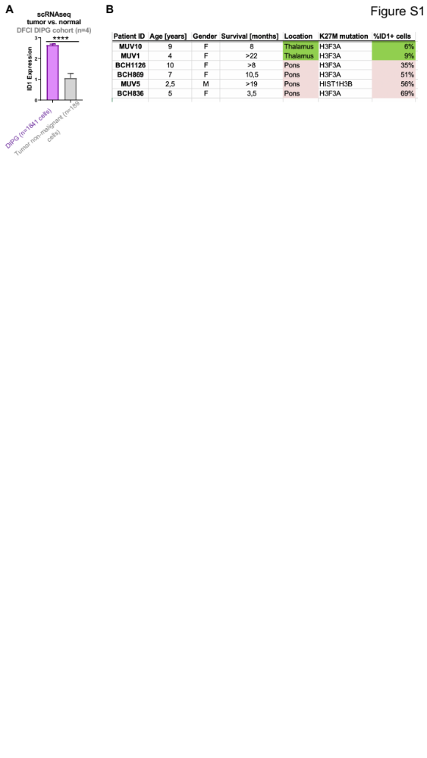

Supplementary Figure S1. ID1 expression in DMG by cell malignancy and tumor location. (A) ID1 expression of DMG tumor by cell malignancy from the Dana-Farber Cancer Institute (DFCI) DMG cohort (n=4 patients). Single-cell RNA-seq (scRNA-seq) was performed for n=1841 malignant DMG cells and n=189 non-malignant tumor cells. Data represent mean +/- SEM; ****P<0.0001, unpaired parametric t test. (B) ID1 is frequently (35-69%) expressed in pontine DMG cells and rarely (6-9%) expressed in thalamic DMGs.
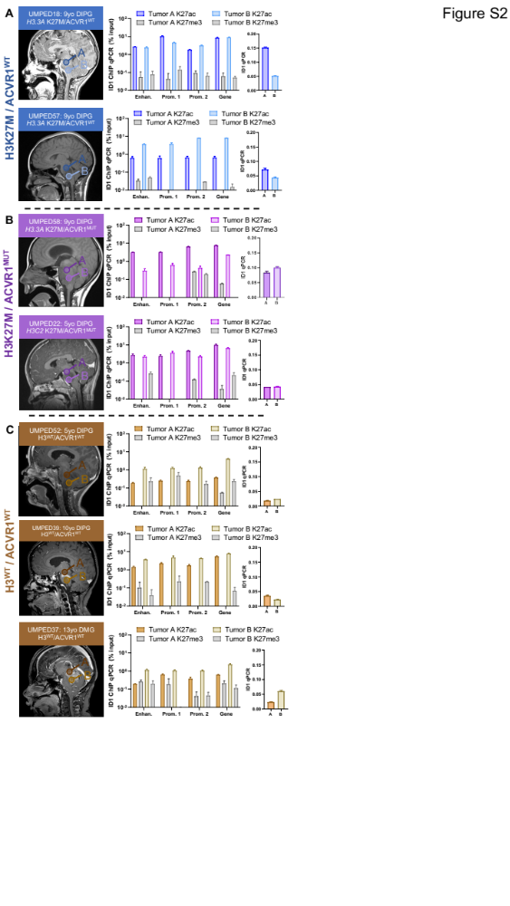
Supplementary Figure S2. Multifocal ChIP-qPCR analysis of ID1 expression in human DMG. (A-C) [Left panel]: Multifocal DMG tumor samples (2 per tumor) were obtained at autopsy from n=2 patients with H3K27M mutation and wildtype ACVR1 (ACVR1^{WT}), n=2 patients with H3K27M mutation and ACVR1 mutation (ACVR1^{MUT}) and n=3 patients with wildtype H3 (H3^{WT}) and ACVR1. Circles labeled “A” and “B” over MRI images represent the approximate region of tumor where a sample was obtained from. [Right panel]: Graphs on left represent percent relative enrichment for H3K27ac and H3K27me3 marks by ChIP-qPCR for each of the predicted ID1 gene body elements shown in main figure 2. Graphs on right represent ID1 expression, measured by qPCR, for the multifocal samples collected from patients in shown in left MRI images. Data represent mean +/- SEM.
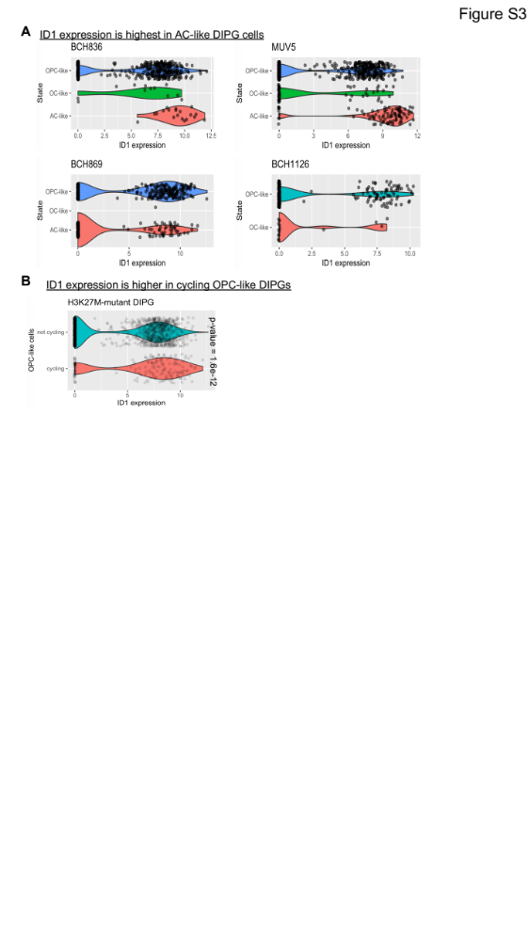
Supplementary Figure S3. ID1 expression from single cell RNA-sequencing of six different H3K27M-DMG patients across varying regions and malignant cell types [Filbin et al., Science, 2018]. (A) Violin plots depicting ID1 expression in three subtypes of H3K27M-DMG malignant cells [Data from pontine DMG patients in Fig. S1B]. (B) Violin plots depicting ID1 expression in cycling vs. non-cycling malignant H3K27M-DMG cells; P=1.6e⁻¹², Mann-Whitney U test. [DIPG- diffuse intrinsic pontine glioma, OPC- Oligodendrocyte precursor cell; OC- Oligodendrocyte; AC- Astrocyte].

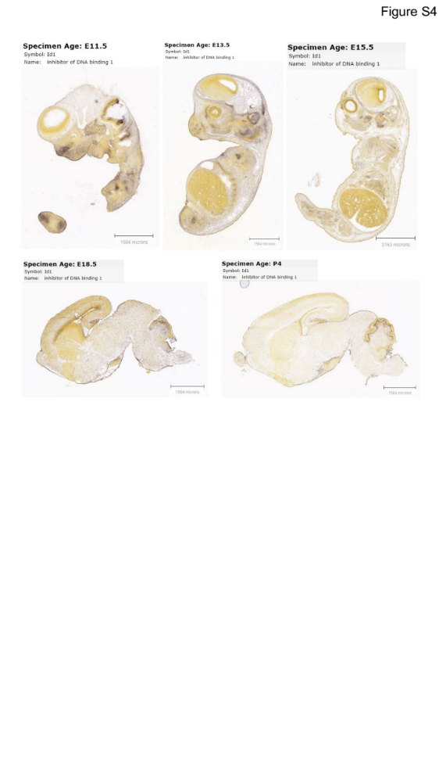

Supplementary Figure S4. In situ hybridization for ID1 RNA in developing mouse brain. ID1 RNA is high in the developing embryonic murine brain and drastically reduced in the post-natal brain. Image credit: Allen Institute. © 2014 Allen Developing Mouse Brain Atlas.
Available from: http://developingmouse.brain-map.org/

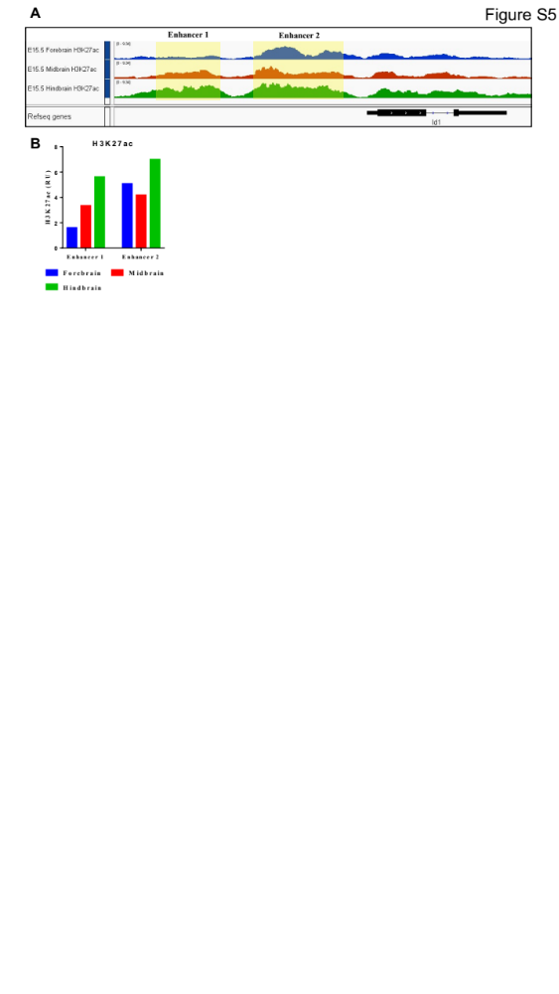
Supplementary Figure S5. H3K27ac at ID1 locus during murine development.
- H3K27ac peaks at the ID1 locus in E15.5 mouse hindbrain and predicted ID1 enhancer regions [Image generated using IGV browser]. (B) Relative enrichment of H3K27ac at predicted ID1 enhancers in E15.5 murine brain regions. Data retrieved from ENCODE Consortium; highlighted regions quantified using EaSeq (http://easeq.net).

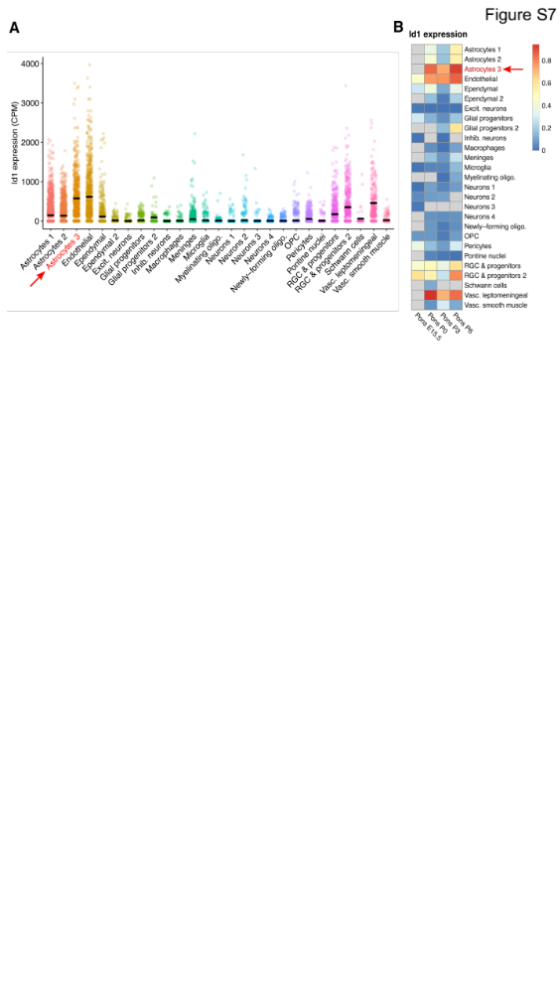
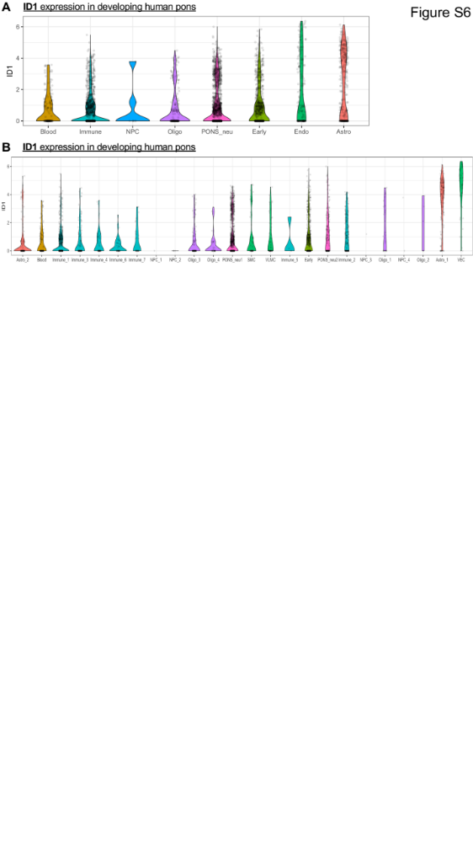
Supplementary Figure S6: ID1 expression in various cell types during normal human and murine development.
D
C
(A-B) Violin plots from analysis of Fan et al., Science Advances, 2020, depicting that AC-like cells show maximum ID1 expression during normal murine pontine development. Data points from all gestational weeks are combined for each cell type and sorted by median. [Astro- Astrocyte]. Single-cell ID1 expression in varying cell types in normal murine pontine development. (D) Heatmap of ID1 expression during normal murine pontine development [E15.5- Embryonic day 15.5; P0- Postnatal day 0]. Red arrow indicates increased ID1 expression in astrocytes from P0-P6. Primary data for parts (A) and (B) from Jessa et al., Nature Genetics, 2019.
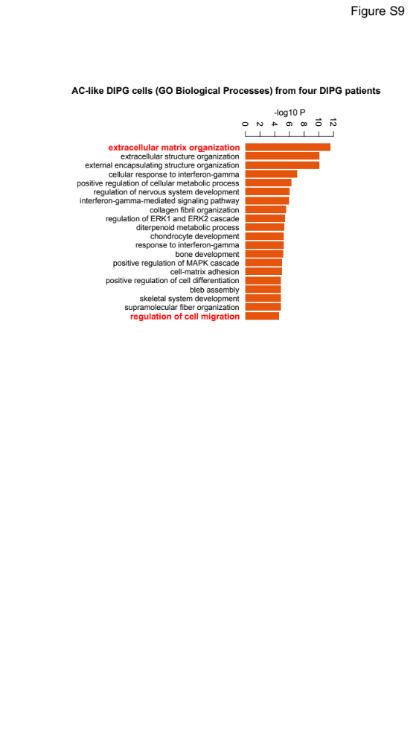
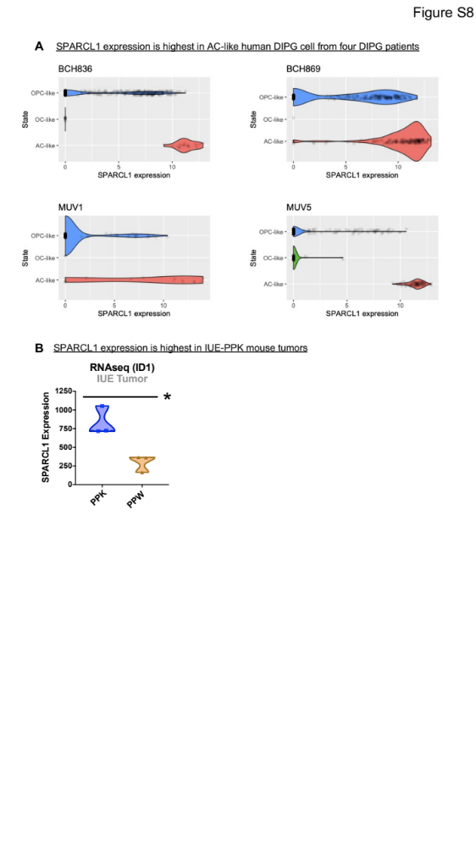
Figure S7
C
Supplementary Figure S7. ID1 expression and gene ontology analysis of four different H3K27M-DMG patients across varying malignant cell types. (A)Violin plots depicting SPARCL1 expression in three subtypes of H3K27M-DMG malignant cells [Data from pontine DMG patients in Fig. S1B]. Primary data from Filbin et al., Science, 2018. [DIPG- diffuse intrinsic pontine glioma, OPC- Oligodendrocyte precursor cell; OC- Oligodendrocyte; AC- Astrocyte]. (B) SPARCL1 expression measured in bulk RNA-sequencing from PPK and PPW IUE mouse tumors, *P<.01, welches t-test. (C) Gene ontology (GO) analysis demonstrates increased expression of genes related to extracellular matrix organization and regulation of cell migration in AC-like cells, as indicated with red.
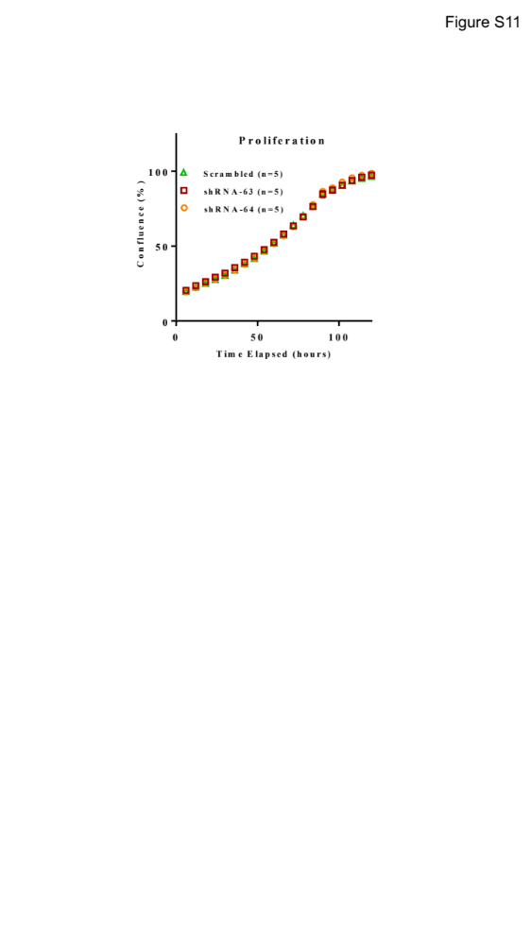
Figure S8
A
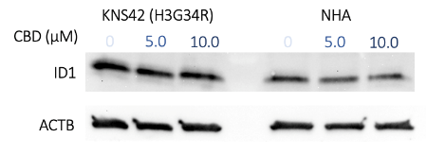
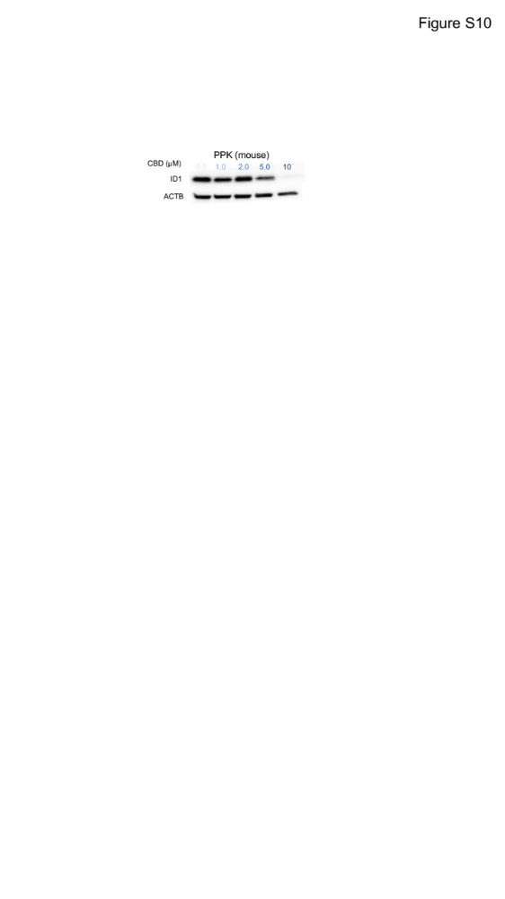
D
PPK (mouse)
DIPG007 (human)
C
B
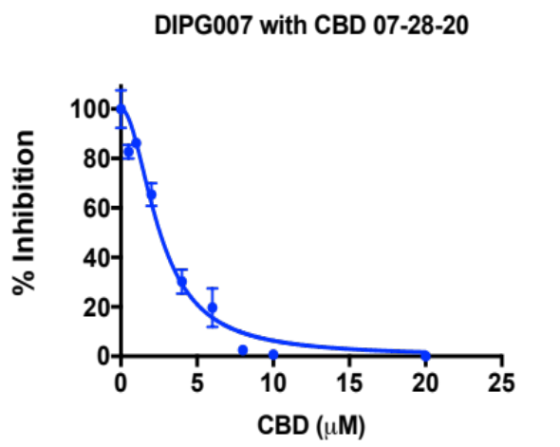
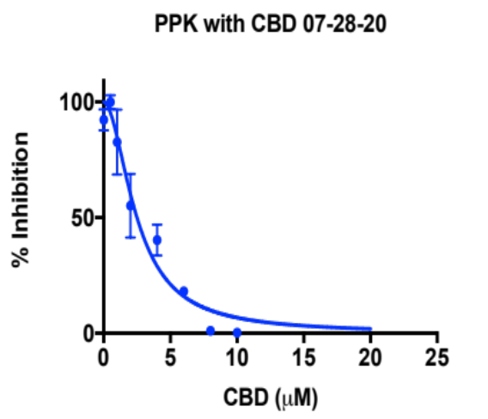
IC₅₀= 2.5 µM
100
% Viability
% Viability
100
IC₅₀= 2.4 µM

50
50
0
0
CBD (µM)
CBD (µM)
0 5 10 15 20
0 5 10 15 20
E
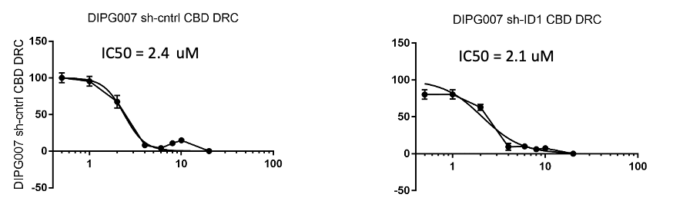
CBD µM
% Viability

DIPG007 Sh-control Proliferation with CBD
DIPG007 Sh-ID1 Proliferation with CBD
CBD µM
% Viability
IC₅₀= 2.4 µM
IC₅₀= 2.1 µM

Supplementary Figure S8. Pharmacological inhibition of ID1 expression and proliferative effect of ID1 loss in DMG cells. (A) WB for ID1 expression in PPK (murine HGG) cells treated with increasing concentrations of CBD. (B) WB for ID1 expression in human control cell lines KNS42 (HGG, H3G34V) and NHA (normal human astrocyte) with increasing concentrations of CBD. (C) Proliferation of DIPG007 (human DMG) cells following ID1 knockdown were measured using the IncuCyte® live-cell analysis system. NS, P > 0.05, unpaired parametric t-test. (D-E) DIPG007, DIPG007-Sh-ID1, DIPG007-Sh-control and PPK cells were plated in a 96-well plate and treated with CBD 72 hours prior to measurement using the XTT cell proliferation assay. Each data point represents an average of 3 wells, mean+/-SEM

B
Figure S9
A
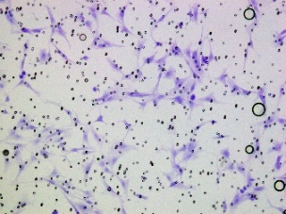
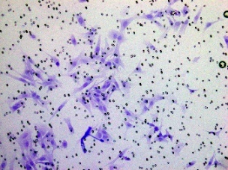
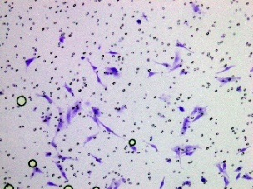
DMSO
2.5 µM CBD
5 µM CBD
****

**
****
D
C

E

Supplementary Figure S9. Genetic and pharmacological inhibition of ID1 decreases DMG cell invasion. (A) DIPG007 cells were treated for 2 days with DMSO (control), 2.5μM, or 5μM CBD and invasion was measured by Matrigel-coated Boyden chamber. Each data point represents an individual image, mean+/-SEM; ****P<0.0001, unpaired parametric t-test.
Each data point represents an individual image;. (B) Example images of data represented in (A). Magnification for all images is 20x. (C) Control DIPG007 cells were treated for 2 days with DMSO (control) or 5μM CBD and invasion was measured by Matrigel-coated Boyden chamber. Each data point represents an individual image, mean+/-SEM; ****P<0.0001, unpaired parametric t-test. (D) ID1-knockdown DIPG007 cells were treated for 2 days with DMSO (control) or 5μM CBD and invasion was measured by Matrigel-coated Boyden chamber. Each data point represents an individual image, mean+/-SEM; **P<0.01, unpaired parametric t-test. (D) Percent invasion of shControl vs. shID1 DIPG007 cells treated with 5μM CBD. Normalized to average DMSO (control) value in each cell line.

