SUPPORTING INFORMATION

Supplementary Methods
Subject/Caregiver Global Impression of Change Scale (S/CGIC)
The caregiver version of the S/CGIC included the following statement:
Since your child started treatment, please assess the status of your child’s overall condition (comparing their condition now to their condition before treatment) using the scale below.
The subject version of the S/CGIC included the following statement:
Since you started treatment, please assess the status of your overall condition (comparing your condition now to your condition before treatment) using the scale below.
In both cases, possible responses were very much improved, much improved, slightly improved, no change, slightly worse, much worse, or very much worse.

Last observation carried forward (LOCF) analyses
All percentage changes from baseline analyses were repeated with the inclusion of a LOCF imputation step, such that:
- If a patient had valid data for ≥1 consecutive periods from and inclusive of the first period but only missing periods thereafter, then imputation of the missing period(s) was carried out using the last 12 weeks of valid data.
- If a patient had intermittent missing periods (ie, ≤1 missing period(s) that fall after a populated period and 1 before subsequent populated periods) then the missing data periods were imputed with the closest earlier nonmissing period of data.
- If the patient had ≥1 consecutive periods of missing data from, and inclusive of, the first period then no imputation was used and data from the patient were excluded from any LOCF presentations.
Seizure reduction responder rates were also determined based on these analyses.

Supplementary Tables and Figures
Table S1. Summary of treatment discontinuation by visit windowª
Treatment period | All Studies  n/N (%) | GWPCARE1 Part A  n/N (%) | GWPCARE1 Part B  n/N (%) | GWPCARE2  n/N (%)
Week 1-12 | 18/264 (7) | 1/23 (4) | 6/105 (6) | 11/136 (8)
Week 13-24 | 21/246 (9) | 3/22 (14) | 7/99 (7) | 11/125 (9)
Week 25-36 | 17/225 (8) | 0/19 (0) | 13/92 (14) | 4/114 (4)
Week 37-48 | 7/208 (6) | 1/19 (5) | 4/79 (5) | 2/110 (2)
Week >48 | 12/201 (6) | 1/18 (6) | 11/75 (15) | 0/108 (0)
Overall | 75/264 (28) | 6/23 (26) | 41/105 (39) | 28/136 (21)
ªStudy was ongoing at the time of this interim analysis, so some patients had not yet reached the later visit windows.

Table S2. Patients with status epilepticus
Analysis period | Convulsive, n/N (%) | Nonconvulsive, n/N (%)
Baseline periodª | 1/105 (1) | 5/105 (5)
Week 1-12 | 9/232 (4) | 7/232 (3)
Week 13-24 | 6/171 (4) | 5/171 (3)
Week 25-36 | 4/142 (3) | 7/142 (5)
Week 36-48 | 2/117 (2) | 4/117 (3)
ªData from the 4-week baseline period of the parent randomized-controlled trial are shown for GWPCARE1 only, as GWPCARE2 was ongoing and still blinded at the time of this analysis.

Figure S1. Reduction in (A) convulsive seizure frequency and (B) total seizure frequency – LOCF analysis
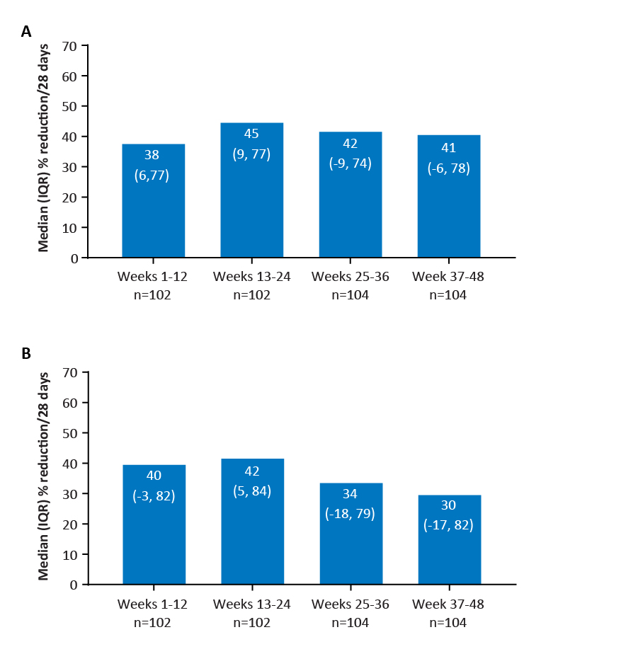
IQR=interquartile range; LOCF=last observation carried forward.

Figure S2. Responder rates for (A) convulsive and (B) total seizures based on LOCF analyses.
