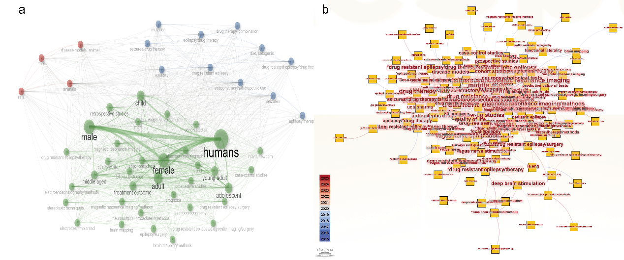
F I G U R E S 1 Keyword analysis. a) Word cloud distribution before removing interfering words; b) Analysis distribution of professional terms in CiteSpace.
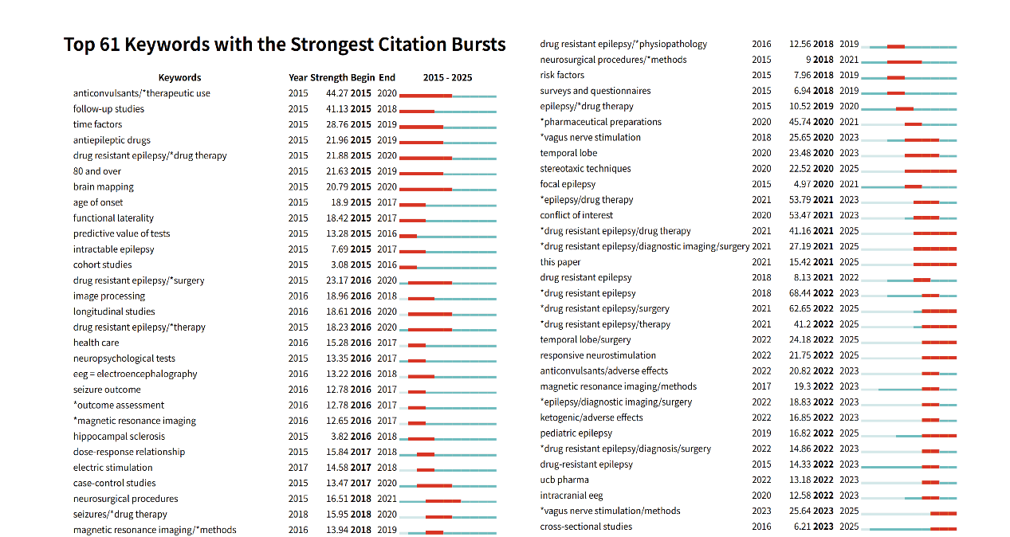
F I G U R E S 2 High-frequency vocabulary analyzed by CiteSpace and their respective prominent duration and intensity.

