Extended data items (Extended data Figures 1-10 and Table S1)
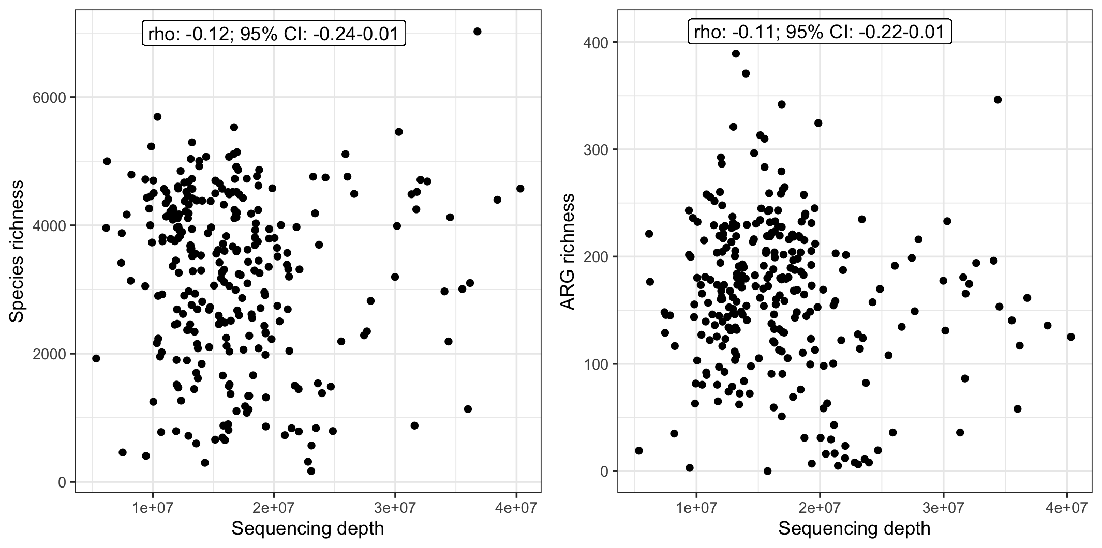
Figure 1. Sink-trap sample species richness (left-panel) and antimicrobial resistance gene (ARG) richness (right panel) versus sequencing depth. Panels reflect counts of unique bacterial species (left-panel) and unique ARGs identified plotted against sequencing depth. Each point represents a SinkBug sink-trap metagenome; Spearman’s rho and p-value labelled per facet.

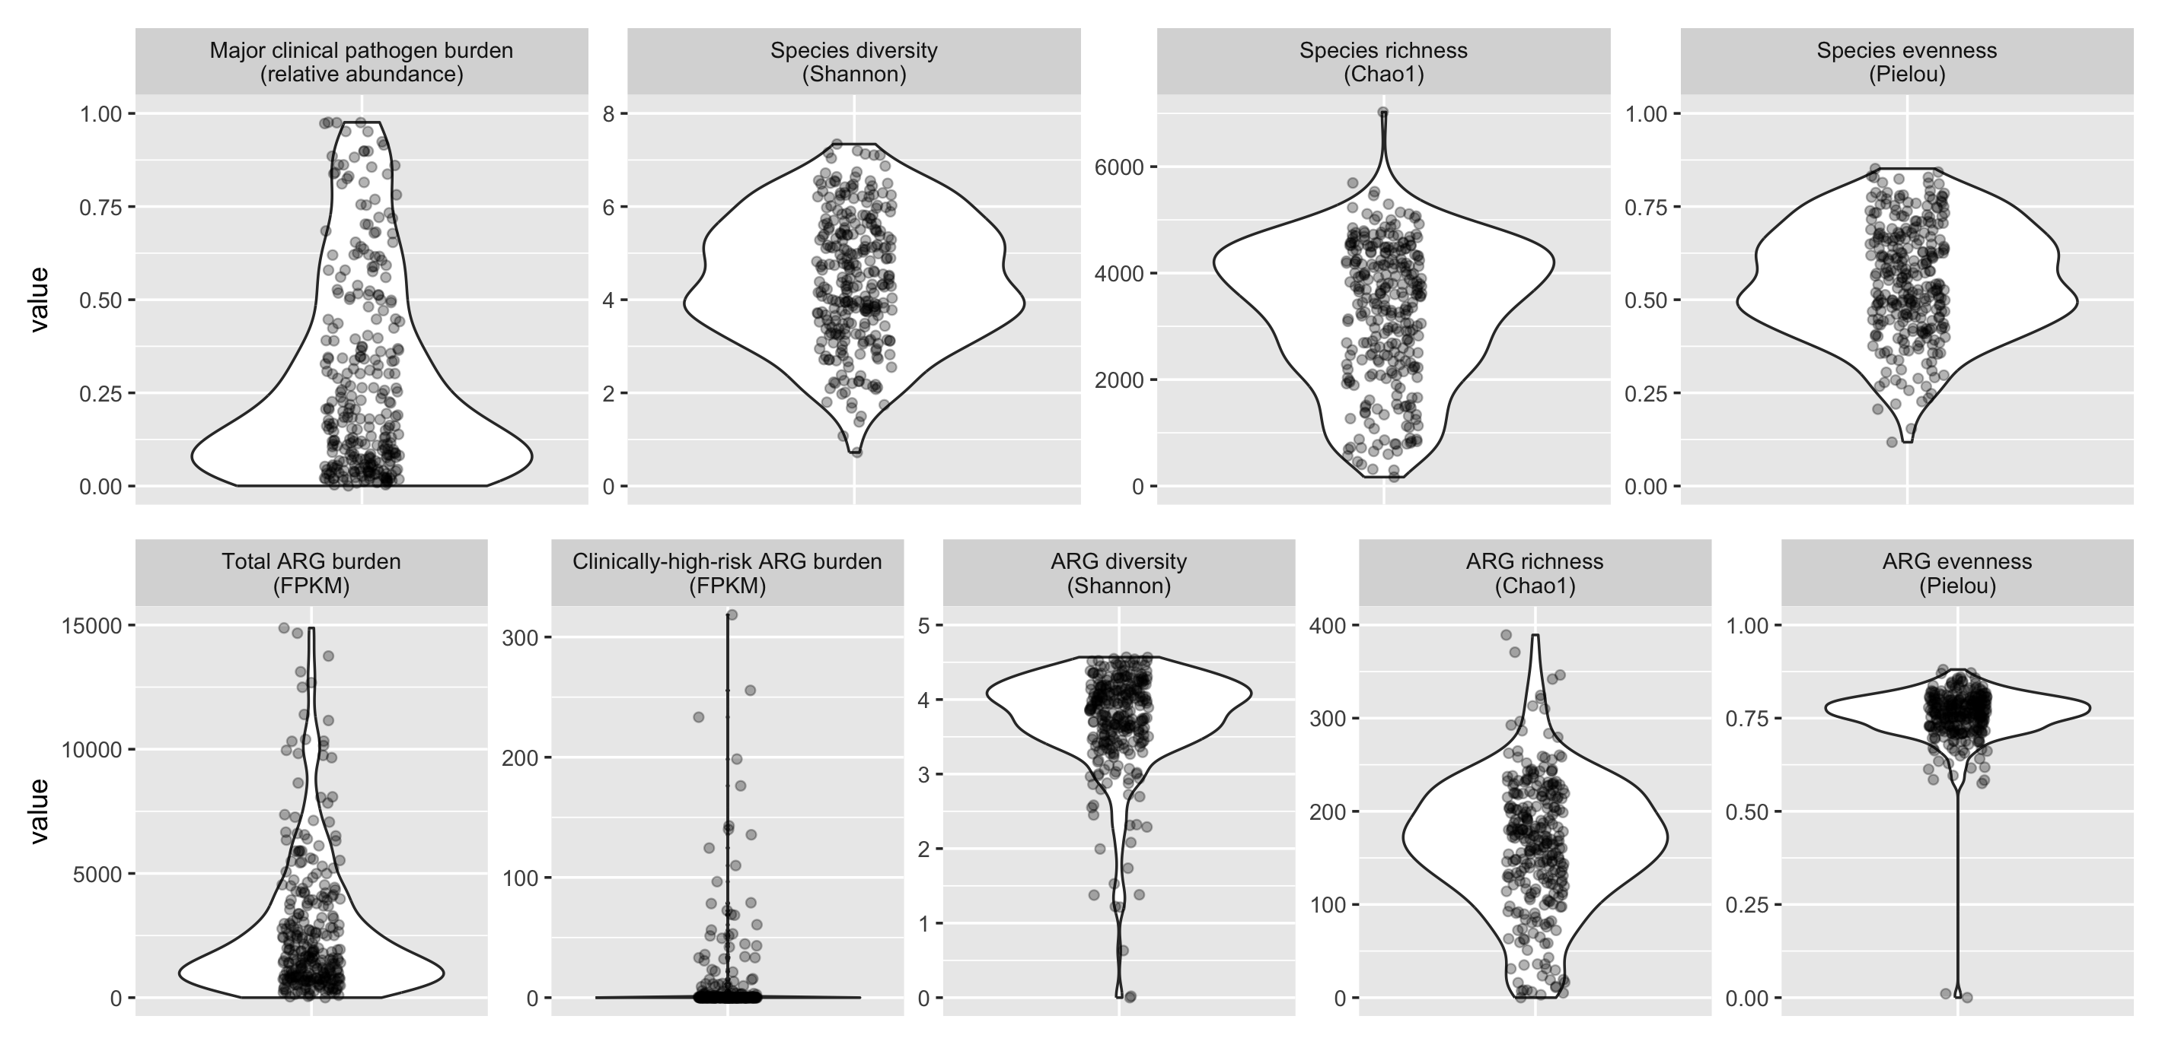

Figure 2. Sink-trap sample composition across sink samples. Panels reflect the distribution of nine different taxonomic and ARG composition metrics across all sink-trap samples, with each point representing a sink-trap metagenome. FPKM=Fragments per kilobase million.

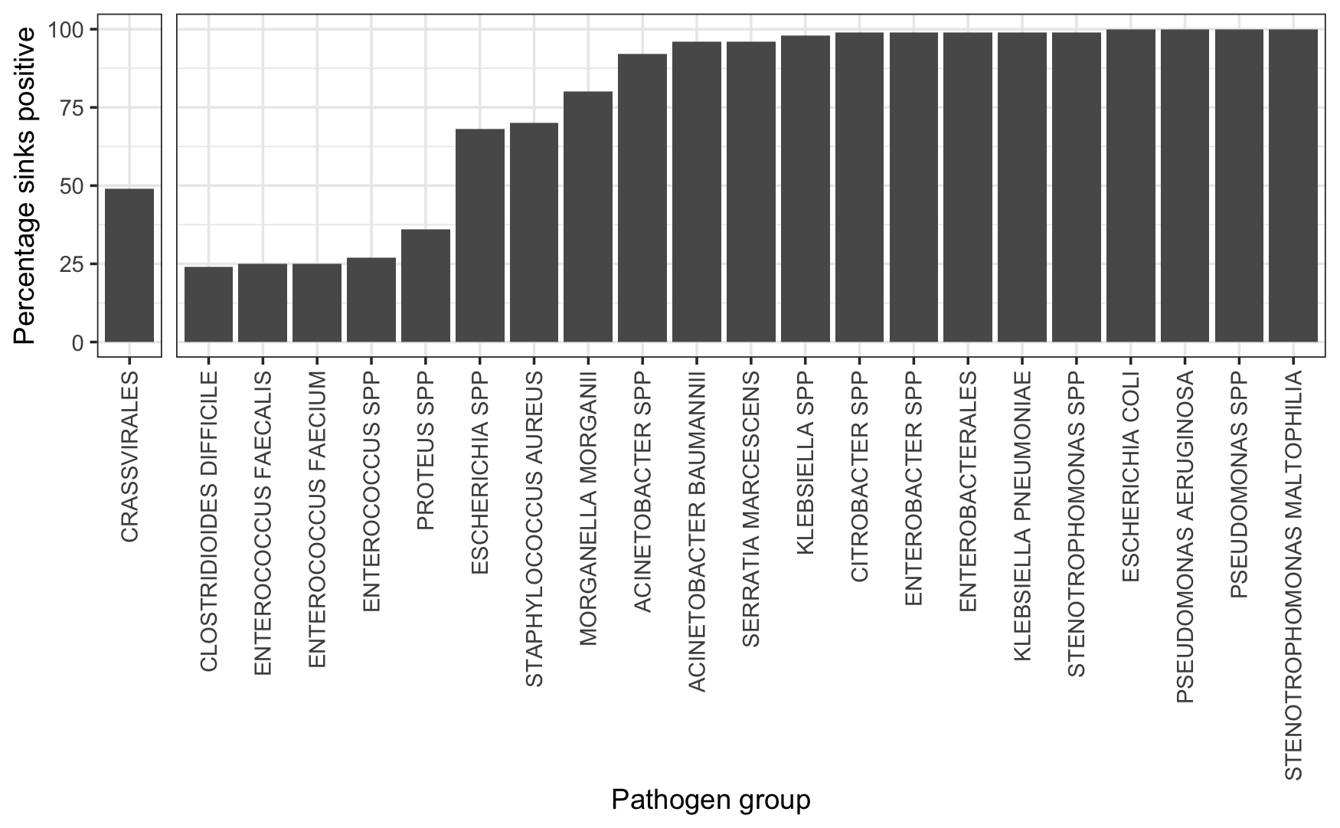

Figure 3. Sink positivity for major clinical pathogen groups and Crassvirales. Percentage of sink-traps (y) where any reads were identified as belonging to a major clinical pathogen group (x) or Crassvirales (consistent with faecal contamination).

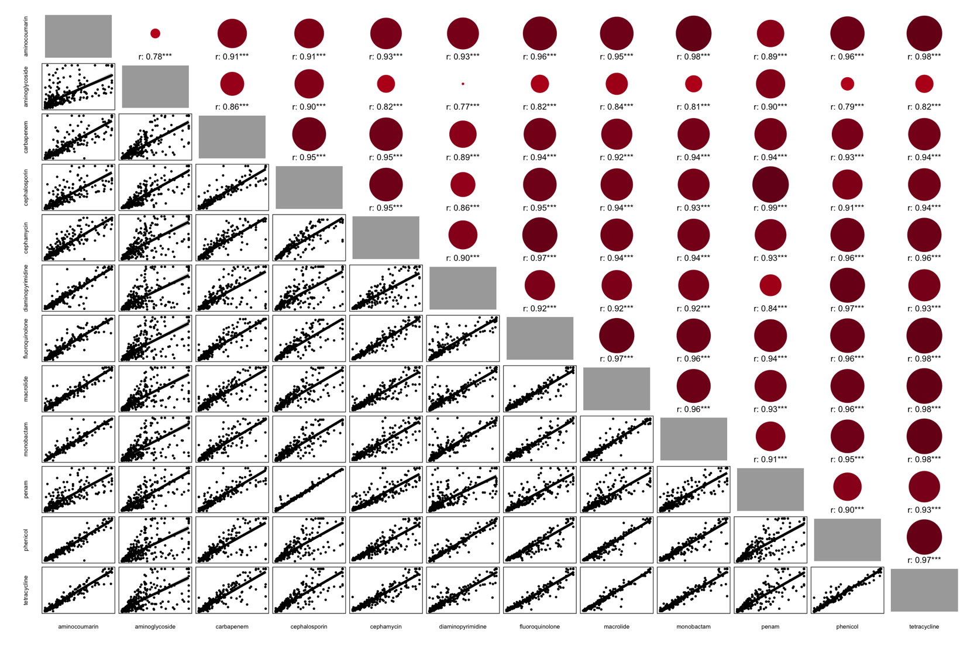
Figure 4. Pairwise Spearman correlation matrix of antibiotic-class-level FPKM. Correlation matrix of antibiotic-class resistance scores labelled on x and y axes per sink-trap. From bottom left: each point represents the respective antibiotic-class resistance score per sink-trap against a separate antibiotic-class resistance score for the same sink-trap; the line is a fitted “gam” smooth trend. From top right: Spearman correlations for mirrored pairwise comparisons where dot size reflects relative rho magnitude and colour reflects rho direction (red=positive, blue=negative). Spearman’s rho labelled per comparison with significance level reflected: ***<0.001; **<0.01; *<0.05; 0.1. FPKM=Fragments per kilobase million
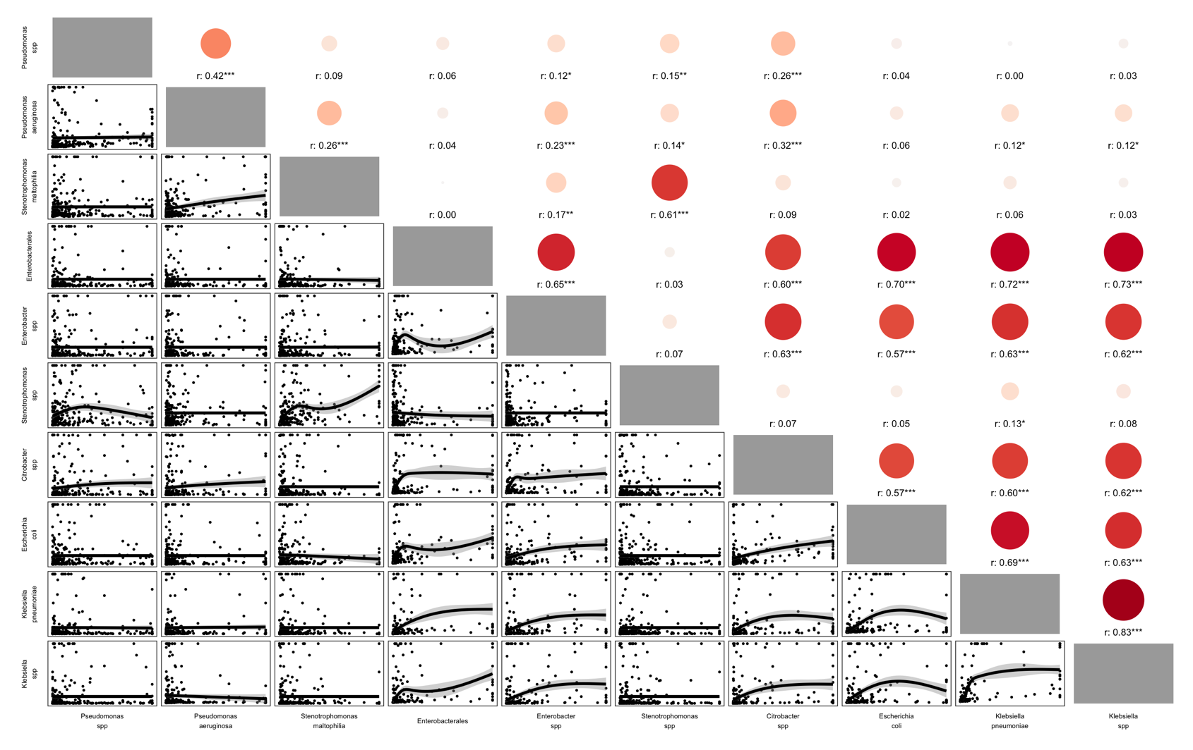
Figure 5. Pairwise Spearman correlation matrix of major clinical pathogen abundance. Correlation matrix of specific major clinical pathogen relative abundance labelled on x and y axes per sink-trap. Data was truncated to 5% and 95% to reduce the influence of outliers on the smoothed trends. From bottom left: each point represents the respective major clinical pathogen relative abundance per sink-trap against a separate major clinical pathogen for the same sink-trap; the line is a fitted “gam” smooth trend. From top right: Spearman correlations for mirrored pairwise comparisons where dot size reflects relative rho magnitude and colour reflects rho direction (red=positive, blue=negative). Spearman’s rho labelled per comparison with significance level reflected: ***<0.001; **<0.01; *<0.05; 0.1. Groups are exclusive, i.e. Enterobacterales is other Enterobacterales than those shown.

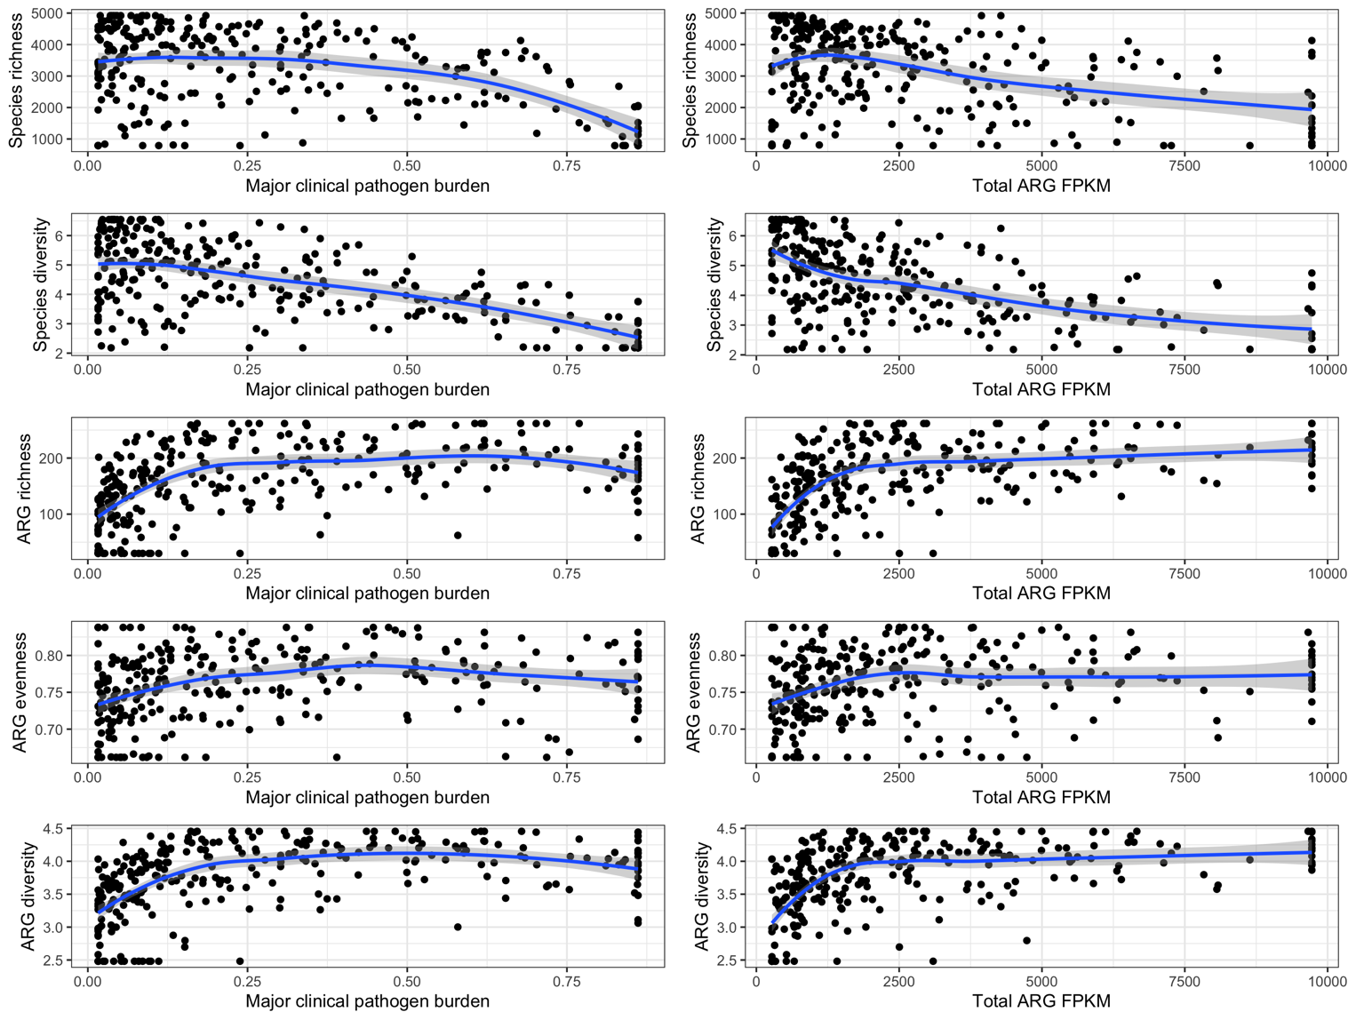

Figure 6. Association between major clinical pathogen, total ARG burden and other diversity metrics. Individual facets comparing pathogen/ARG burden of sink-traps against diversity metrics. Each point reflects a sink-trap and its respective burden (x) or diversity metric (y), with gam smooth trend lines and 95% confidence intervals (shaded).

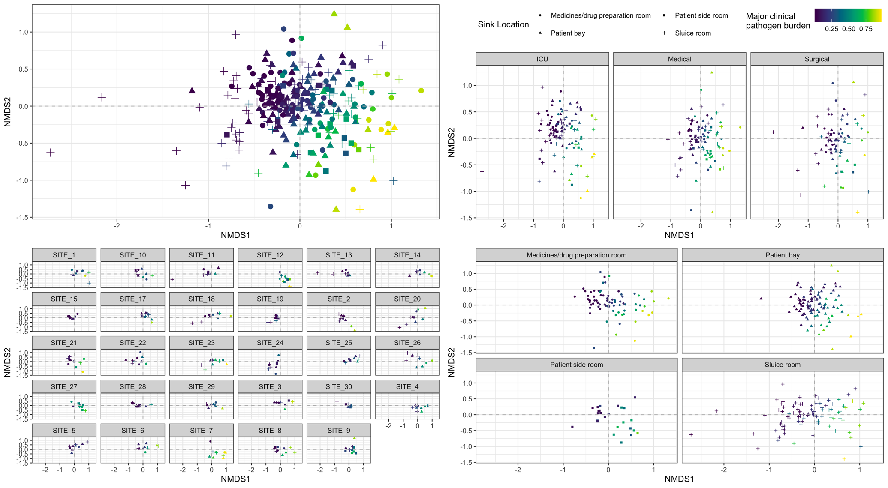

Figure 7. NMDS ordination of sink-trap taxonomic composition. NMDS ordination plots unfaceted (A) and faceted by ward location (B), hospital site (C) and sink location (D). Sink-traps are reflected by points where shape indicates sink location and colour indicates the total relative abundance of major clinical pathogens. Origin (0,0) is indicated by grey dashed lines.

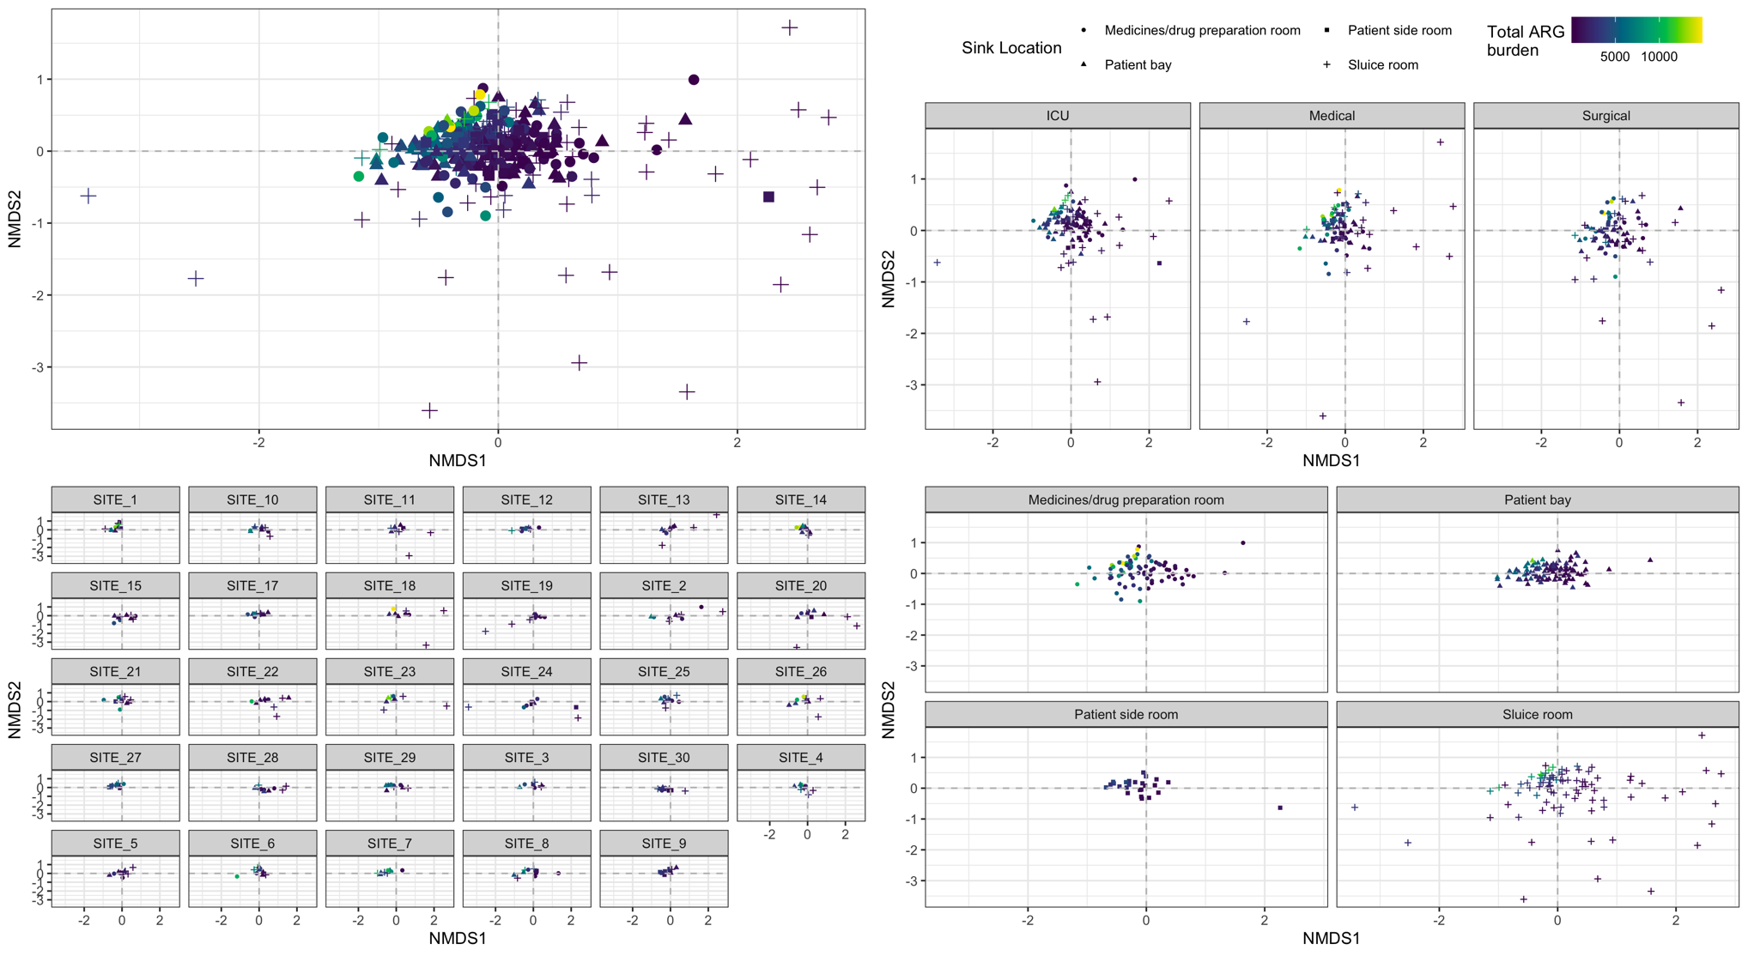
Figure 8. NMDS ordination of sink-trap resistome composition. NMDS ordination plots unfaceted (A) and faceted by ward location (B), hospital site (C) and sink location (D). Sink-traps are reflected by points where shape indicates sink location and colour indicates the total ARG burden (FPKM). Origin (0,0) is indicated by grey dashed lines.

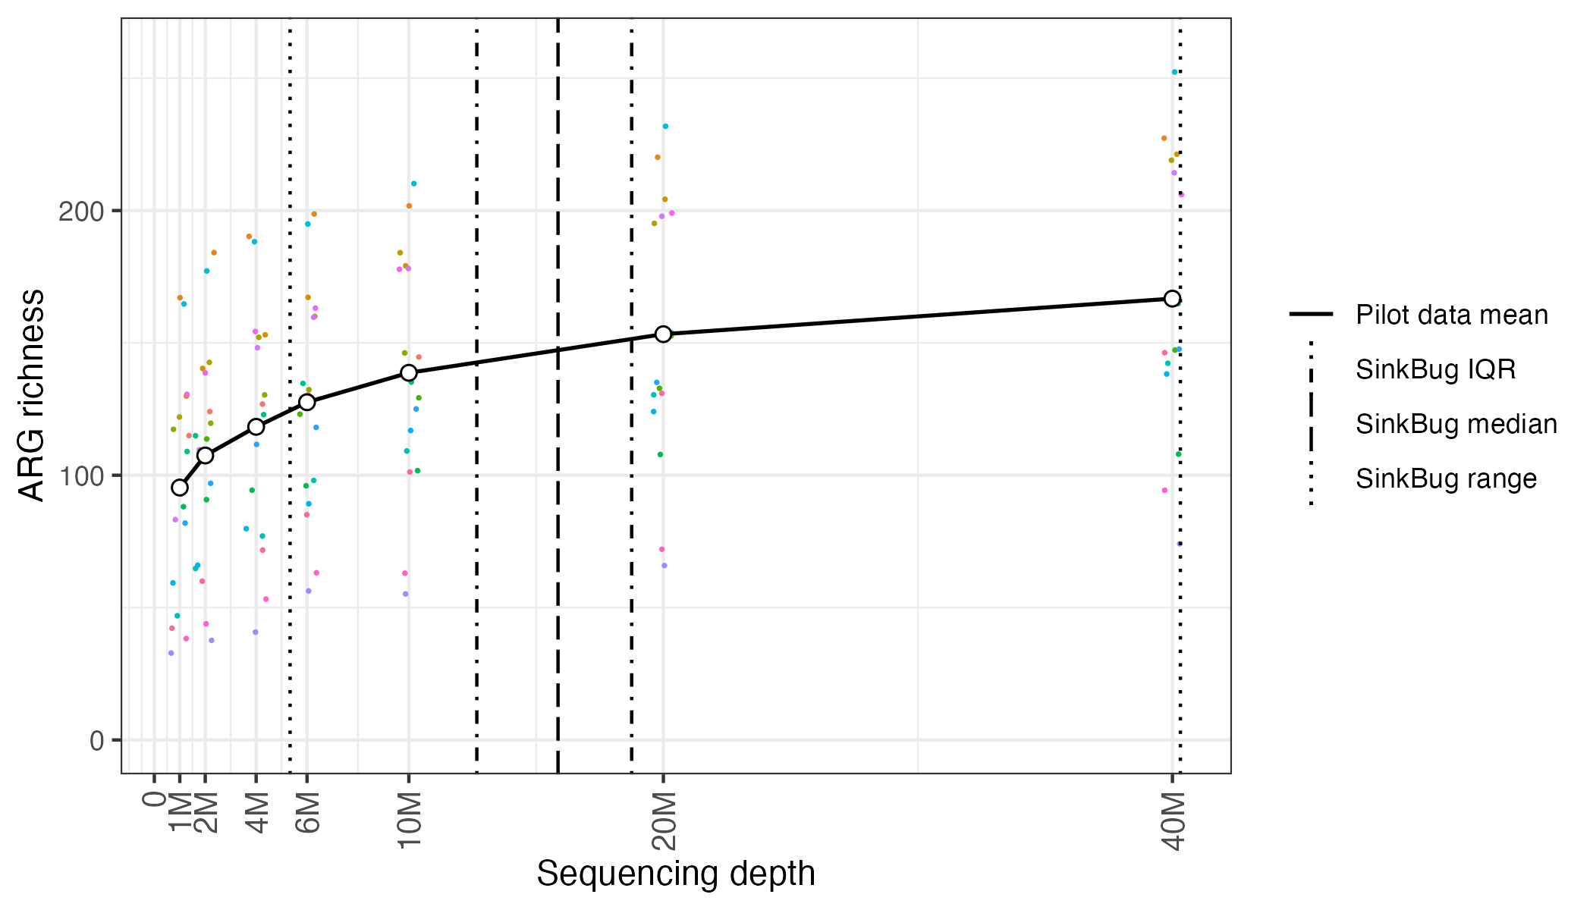
Figure 9. Antimicrobial resistance gene (ARG) recovery in 17 previously sampled sink metagenomes subsampled to different sequencing depth. Number of unique AMR genes (y-axis) identified in 17 previously sampled UK sink-trap metagenomes subsampled to specific sequencing depths (x-axis, number of paired-end reads) (colour reflects the same sample). Dashed line reflects median sequencing depth achieved for SinkBug (i.e. this study) metagenomes, with dot-dash and dotted lines representing interquartile range and absolute range respectively.

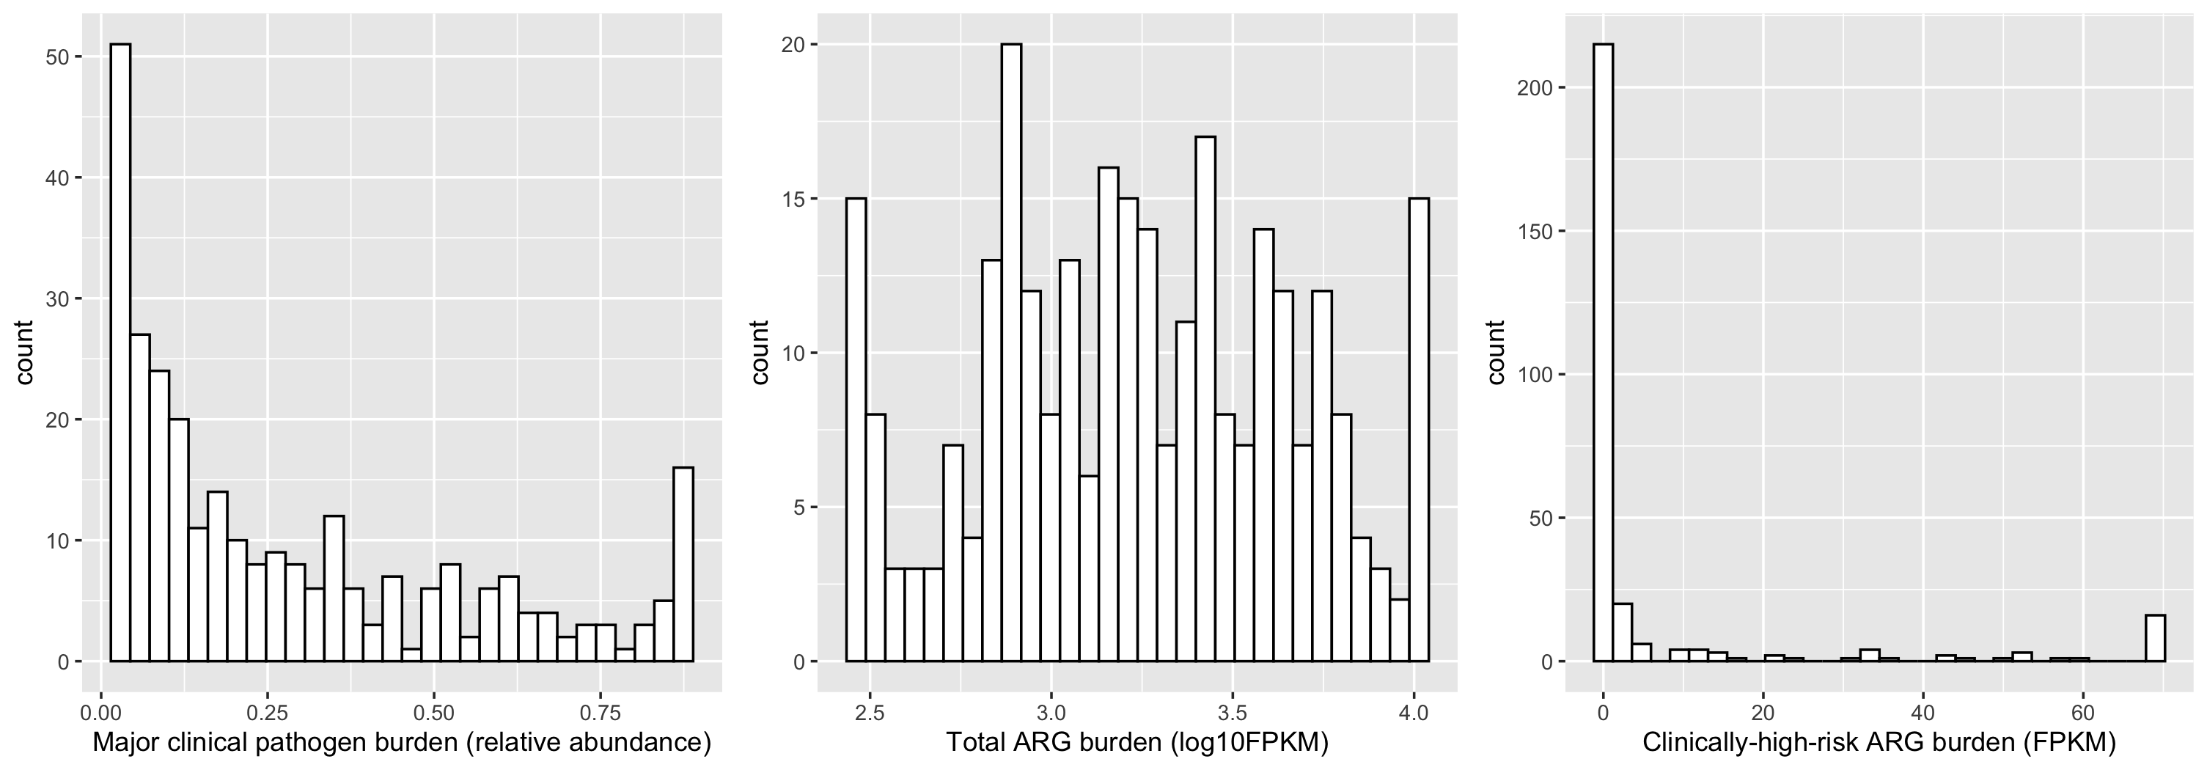

Figure 10. Distribution of outcomes considered in the Generalised Additive Models. Panels reflect distribution of major clinical pathogen burden, total ARG burden and clinically-high-risk ARG burden in sink-trap metagenomes, truncated to 5% and 95% percent.
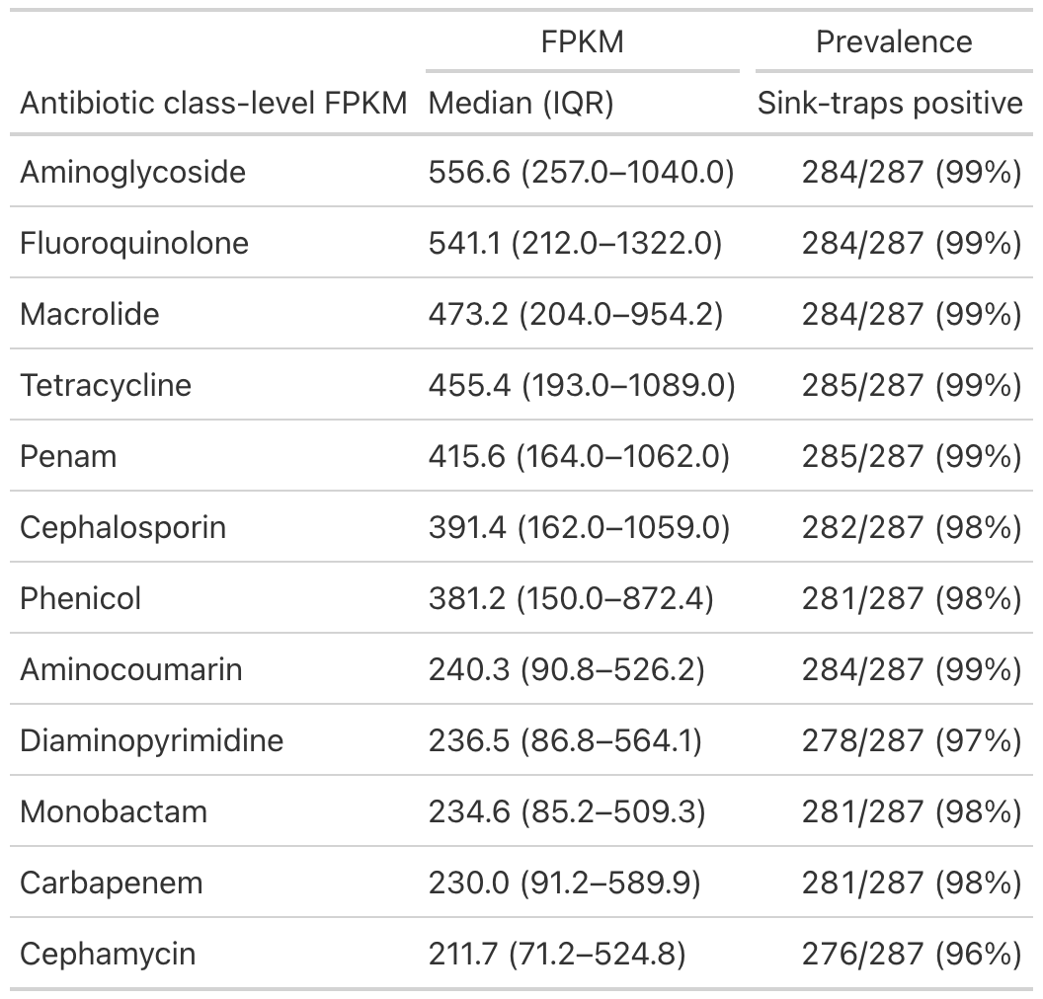
Table S1. Antibiotic class-level resistance FPKM and sink positivity across sink-traps.

