Supplementary Material

Effect of vaccination on transmission of COVID-19
Anoop S V Shah^{1,2,3}, Ciara Gribben,³ Jennifer Bishop,³ Peter Hanlon,⁴ David Caldwell,³ Rachael Wood,³ Martin Reid,³ Jim McMenamin,³ David Goldberg,³ Diane Stockton,³
Sharon Hutchinson,^{3,5} Chris Robertson,³ Paul M McKeigue,^{3,6} Helen M Colhoun, ^{3,6,7}
David A McAllister^{3,4}

- Non-communicable Disease Epidemiology, London School of Hygiene and Tropical Medicine, London, UK.
- Department of Cardiology, Imperial College NHS Trust
- Public Health Scotland, Edinburgh, UK.
- Institute of Health and Wellbeing, University of Glasgow, Glasgow, UK.
- School of Health and Life Sciences, Glasgow Caledonian University, Glasgow, UK.
- MRC Institute of Genetics & Molecular Medicine, University of Edinburgh, Edinburgh, UK.
- Usher Institute, University of Edinburgh, Edinburgh, UK.

Correspondence and requests for reprints:

Dr David A McAllister
Institute of Health and Wellbeing
University of Glasgow,
Glasgow
United Kingdom
E-mail: david.mcallister@glasgow.ac.uk

Contents
Effect of vaccination on transmission of COVID-19 1
Supplementary Tables and Figures 3
Supplementary table 1: Estimation of the number of cases prevented in household members by vaccinating healthcare workers as a fraction of the number of cases preventable via interrupting this route of transmission (ie those cases caused by sharing a household with a healthcare worker) 3
Supplementary figure 1: Overview of record linkage 4
Supplementary figure 2: Participant inclusion and exclusion healthcare workers and household members 5
Supplementary text 1 – Descriptions and sources of national databases used for individual record linkage 6
Scottish hospitalization record from SMR01 6
National Records of Scotland (NRS) 6
Prescribing Information System (PIS) 6
National microbiology register (Electronic Communication of Surveillance in Scotland [ECOSS]) 6
Scottish Workforce Information Standard System (SWISS) 7
General Practitioner Contractor Database (GPCD) 7
Rapid preliminary inpatient data (RAPID) 7
Supplement text 2: Definitions used to categorize healthcare workers and list of specialties, job roles and service areas by categorization 9
Definition of categorization for patient and non-patient facing and undetermined healthcare workers 9
Definition of categorization for patient facing roles into those at front door, exposed to aerosolized generating procedures (AGP), in intensive care and other 10
Definition of medical specialties into patient facing and non-patient facing roles* 11
Definition of nursing and midwifery, allied health professionals and support services into patient facing and non-patient facing roles* 14
Definition of relevant service areas 18
Supplement text 3: Comorbidity definitions 20

Supplementary Tables and Figures

Supplementary table 1: Estimation of the number of cases prevented in household members by vaccinating healthcare workers as a fraction of the number of cases preventable via interrupting this route of transmission (ie those cases caused by sharing a household with a healthcare worker)

Effect of sharing a household with a HCW |  | Effect of vaccination on all detectable cases |  | Effect of vaccination on preventable cases
Relative risk RR_{HHD} | Attributable fraction among the exposed AF_{HHD)} = (RR_{HHD} -1)/ RR_{HHD} | Relative risk (RR_{vax}) | Relative risk reduction RRR_{vax} = 1- RR_{vax} | Proportion of cases prevented = RRR_{vax}/AF_{HHD}
1.5 | 33.3% | 0.70 | 30% | 90%
2.0* | 50.0% | 0.70 | 30% | 60%
2.5 | 60.0% | 0.70 | 30% | 50%
3.0 | 66.7% | 0.70 | 30% | 45%

This tables illustrates shows the impact of vaccinating HCWs on transmission, taking into account that only a proportion of cases in household members could plausibly be prevented by vaccination healthcare workers, since they can also be infected via other routes.
We show the effect under different plausible estimates for the causal effect of sharing a household with a healthcare worker on the risk of developing COVID-19. The estimate in the second row (RR_{HHD} = 2.0) is close to our own previous empirical estimates for this association (BMJ 2020;371:m3582).

To perform thus calculation we made the following assumptions:-
- Vaccination of HCWs can only reduce the risk in household members by interrupting transmission from HCWs to household members and not via other mechanisms (eg by causing a modification of behavior in household members)
- That the estimated association for vaccination is a valid causal estimate – ie no bias and no confounding

Supplementary figure 1: Overview of record linkage
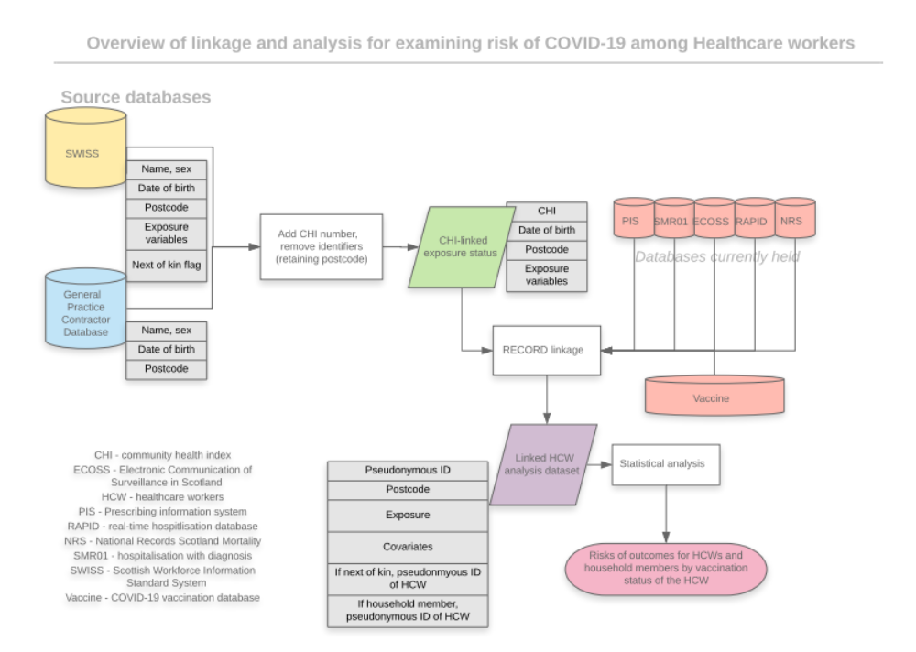

Supplementary figure 2: Participant inclusion and exclusion healthcare workers and household members

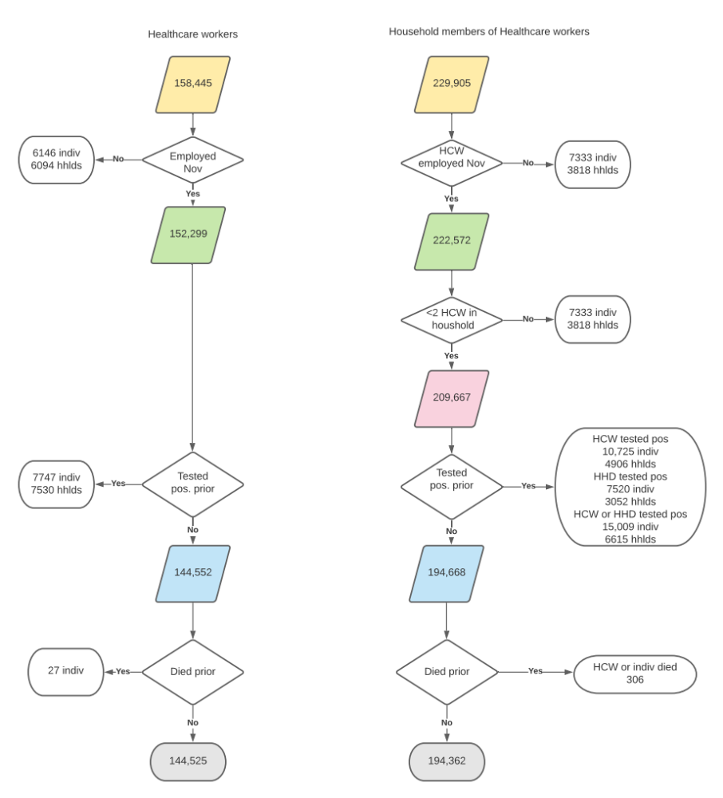

Died prior refers to deaths on or before the 8th of December 2020

Supplementary text 1 – Descriptions and sources of national databases used for individual record linkage

Scottish hospitalization record from SMR01

Comorbidities were defined from previous defined from the Scottish morbidity record 01 (SMR01) - General/Acute Inpatient & Day Case. SMR01 is an episode-based patient record relating to all inpatients and day cases discharged from non-obstetric and non-psychiatric specialties. A record is generated when a patient completes an episode of inpatient or day case care. Data collected include patient identifiable and demographic details, episode management details and general clinical information. Currently diagnoses are recorded using the ICD-10 classification and operations are recorded using the OPCS-4 classification. Further information on the national dataset and variables contained is available at https://www.ndc.scot.nhs.uk/Data-Dictionary/SMR-Datasets//Episode-Management/SMR-Record-Type/

National Records of Scotland (NRS)

The NRS covers all deaths in Scotland with approximately 55,000 deaths registered annually. The National Records of Scotland Death Records are linked with the NHS Scotland Scottish Morbidity Database which links together NHS Scotland inpatient, mental health and cancer registry datasets with the NRS Death Records. NRS records death status, cause of death and date of death.

Further information of the NRS death registry is available at https://www.ndc.scot.nhs.uk/National-Datasets/data.asp?SubID=13

Prescribing Information System (PIS)

The Prescribing Information System (PIS) is the definitive data source for all prescribing relating to all medicines and their costs that are prescribed and dispensed in the community in Scotland. The information is supplied by Practitioner & Counter Fraud Services Division (P&CFS) who is responsible for the processing and pricing of all prescriptions dispensed in Scotland. Primary care physicians write the vast majority of these prescriptions, with the remainder written by other authorised prescribers such as nurses and dentists. Also included in the dataset are prescriptions written in hospitals that are dispensed in the community. Note that prescriptions dispensed within hospitals are not included.

Further information on the Prescribing Information System operational in Scotland is available at https://www.ndc.scot.nhs.uk/National-Datasets/data.asp?SubID=9

National microbiology register (Electronic Communication of Surveillance in Scotland [ECOSS])

The Scottish microbiology surveillance registry, or ‘Electronic Communication of Surveillance in Scotland’ (ECOSS) as it is termed by NHS National Services Scotland, was used in the present study to provide individual patient-level data on SARS-Cov-2 testing and results. ECOSS is part of NHS Scotland’s Infection Intelligence Platform (IIP),^{1,2} which was set-up in response to the UK’s antimicrobial resistance (AMR) strategy (2013-2018) with the aim of providing “better access to and use of surveillance data”.³

Data were first collected and recorded within ECOSS in 2007. The dataset is maintained by NHS National Services Scotland on behalf of Health Protection Scotland. ECOSS is updated monthly and, as of 2017, it contained approximately 29 million records of positive microbiology laboratory specimens from across Scotland.¹ It provides data for numerous national clinical and research activities, audit projects and Scottish Government reports, including: the identification of cases of severe infectious disease, infectious disease outbreaks and the evaluation of longer term trends in the incidence of laboratory-reported infections; surveillance of episodes of Clostridium difficile infections, Escherichia coli bacteremia, Staphylococcus aureus bacteremia and surgical site infections.² NHS National Services Scotland monitors the completeness and accuracy of ECOSS data through its ‘Data Monitoring and Support Service’.¹ Further, NHS National Services Scotland routinely informs data users of any problems affecting the accuracy or assurance of these data.

More information on the ECOSS data system is available at https://www.hps.scot.nhs.uk/data/

Scottish Workforce Information Standard System (SWISS)

The Scottish Workforce Information Standard System (SWISS) is a national human resources database held by NHS Education Scotland which contains data on all directly employed staff (ie not contracted staff such as general practitioners except where they are also directly employed in some other role) working in the NHS in Scotland. It includes data for territorial health boards, and boards providing a national service. It records the job title using a nationally agreed standard as well as, for medical and dental staff the medical specialty. It also includes data on occupation grade, part-time/whole time status, and the designated service area.

More information on the SWISS database is available at https://turasdata.nes.nhs.scot/media/2prjxbg4/2020-06-02-workforce-report.pdf.

General Practitioner Contractor Database (GPCD)
The General Practitioner Contractor Database (GPCD) includes all contracted general practitioners working in Scotland. This includes GP partners who are independent contractors, and salaried GPs, but not locum GPs. GOs in training grades are employed centrally and so are included in SWISS.

More information on the GPCD database is available at https://www.isdscotland.org/Health-Topics/General-Practice/Workforce-and-Practice-Populations/.

Rapid preliminary inpatient data (RAPID)

The RAPID database has been operational since to 2001 to monitor and predict emergency admissions and bed occupancy across National Health Service Boards in Scotland. Data from this database has already been used to provide information to NHS boards, healthcare workers and the public on the direct and indirect effects of the COVID-19 pandemic. These dashboards can be found at: https://publichealthscotland.scot/our-areas-of-work/sharing-our-data-and-intelligence/coronavirus-covid-19-data/

In 2015 the data collection was expanded to include data items on individual patient level data on age, sex, times of admission and discharge, ward significant facility, diagnosis and operation codes and information on patient discharge.

Further information on the RAPID databases can be found here: https://www.ndc.scot.nhs.uk/National-Datasets/data.asp?ID=1&SubID=37

References

1. Bennie M, Malcolm W, Marwick CA, Kavanagh K, Sneddon J, Nathwani D. Building a national Infection Intelligence Platform to improve antimicrobial stewardship and drive better patient outcomes: the Scottish experience. J Antimicrob Chemother. 2017 Oct 1;72(10):2938-42.
2. NHS National Services Scotland (NSS), 2014. Infection Intelligence Platform (IIP)- High level guide to IIP component datasets held by NHS National Services Scotland, https://www.isdscotland.org/Health-Topics/Health-and-Social-Community-Care/Infection-Intelligence-Platform/Data/June-2014-Guide-to-IIP-Data.pdf (accessed 18th March, 2020)
3. Scottish Government, 2014. Scottish Management of Antimicrobial Resistance Action Plan 2014-2018. http://www.gov.scot/Publications/2014/07/9192 (accessed 2nd March, 2020)

Supplement text 2: Definitions used to categorize healthcare workers and list of specialties, job roles and service areas by categorization

These tables are also available in machine readable formats in our public-facing github repository.

Definition of categorization for patient and non-patient facing and undetermined healthcare workers

Definition | Description | Definition
Any staff | Any member of NHS staff. | Included in SWISS or GPCD database
Patient facing, any | Include if likely to currently be working in patient-facing role. | Specific list of AFC roles and/or medical specialties (see below)
Non-patient-facing | Any member of NHS staff likely to be in a non-patient-facing role. | Specific list of AFC roles and/or medical specialties (see below)
Undetermined | Staff where it is not possible to allocate with confidence to patient-facing or non-patient-facing roles | Any staff not in “Patient-facing, any” or “Non-patient-facing” (see below)

Definition of categorization for patient facing roles into those at front door, exposed to aerosolized generating procedures (AGP), in intensive care and other

Definition | Description | Definition* | Comparator(s)
Patient-facing, front-door COVID19 | Include if involved in acute medical receiving of patients with possible or probable COVID19 (ie not incidental finding such as COVID19 in patient with myocardial infarction). | Specific list of AFC roles and/or medical specialties and/or designated service area (see below). | Patient-facing, other
Patient-facing, Intensive care | Intensive care medicine and anaesthetic specialties | Specific list of AFC roles and/or medical specialties and/or designated service area (see below). | Patient-facing, other
Patient-facing, Resp-oral-nasal-AGP | Include if involved in work with high risk of exposure to oral, nasal or respiratory secretions and/or aerosol generating procedures (AGP) outwith intensive care settings. | Specific list of AFC roles and/or medical specialties and/or designated service area (see below). | Patient-facing, other
Patient-facing, other | Patient-facing role but not front-door COVID or resp-oral-nasal-AGP or intensive care. | Patient-facing role but not front-door COVID or resp-oral-nasal-AGP or intensive care.
*Nursing staff in the General Acute Nursing and Specialist Nursing and have been further assigned to specific roles according to the recorded service area. This was done for the following territorial Health Boards, in whom there is >= 95% completeness for the service area variable: - NHS Ayrshire & Arran, NHS Borders, NHS Dumfries & Galloway, NHS Forth Valley, NHS Grampian, NHS Greater Glasgow & Clyde, NHS Highland, NHS Orkney and NHS Shetland. The remaining territorial boards had lower completeness for service area (ranging from 91% to <1%)

Definition of medical specialties into patient facing and non-patient facing roles*

 | Non patient-facing | Patient-facing**
 |  | Any | Front-door | Resp-oral-nasal-AGP | Intensive care
Acute Internal Medicine |  | Yes | Yes
Allergy
Anaesthetics |  | Yes |  |  | Yes
Audio Vestibular Medicine
Audiological Medicine
Blood Transfusion
Breast Screening Service
Cardiology |  | Yes
Cardiothoracic Surgery |  | Yes
Chemical Pathology
Clinical Genetics
Clinical Neurophysiology
Clinical Oncology |  | Yes
Clinical Pharmacology and Therapeutics |  | Yes
Clinical Radiology
Community Psychiatry |  | Yes
Community Sexual And Reproductive Health |  | Yes
Dermatology
Diagnostic Neuropathology | Yes
Emergency Medicine |  | Yes | Yes
Endocrinology and Diabetes |  | Yes
Endodontics |  | Yes |  | Yes
Ent Surgery |  | Yes |  | Yes
Family Planning Service
Fixed & Removable Prosthodontics
Forensic Histopathology | Yes
Forensic Psychiatry
Gastroenterology |  | Yes
General (Internal) Medicine |  | Yes | Yes
General Psychiatry |  | Yes
General Surgery |  | Yes
Genito-Urinary Medicine |  | Yes
Geriatric Medicine |  | Yes | Yes
GP Other Than Obstetrics |  | Yes
Haematology
Histopathology | Yes
Homeopathy
Immunology
Infectious Diseases |  | Yes | Yes
Intensive Care Medicine |  | Yes |  |  | Yes
Medical Microbiology And Virology
Medical Oncology |  | Yes
Medical Ophthalmology |  | Yes
Microbiology
Neurology |  | Yes
Neurosurgery |  | Yes
Nuclear Medicine
Obstetrics And Gynaecology |  | Yes
Occupational Medicine |  | Yes
Old Age Psychiatry |  | Yes
Ophthalmology |  | Yes
Oral And Maxillofacial Surgery |  | Yes |  | Yes
Oral And Maxillofacial Pathology | Yes
Oral Medicine |  | Yes |  | Yes
Oral Microbiology
Oral Pathology
Oral Surgery |  | Yes |  | Yes
Orthodontics |  | Yes |  | Yes
Otolaryngology |  | Yes |  | Yes
Pain Management
Palliative Medicine
Plastic Surgery |  | Yes
Psychiatry Of Learning Disability
Psychotherapy
Public Health Medicine | Yes
Rehabilitation Medicine |  | Yes
Renal Medicine |  | Yes
Respiratory Medicine |  | Yes |  | Yes
Restorative Dentistry
Rheumatology |  | Yes
Special Care Dentistry |  | Yes |  | Yes
Surgical Dentistry |  | Yes |  | Yes
Trauma And Orthopaedic Surgery |  | Yes
Urology |  | Yes
Vascular Surgery |  | Yes
Virology

There are two specialty fields in the SWISS database. These are “specialty” with around 85% completeness, and “second specialty” with lower completeness. We added data from TURAS People (which holds data on doctors in training roles) to increase the completeness to approximately 98%.

* Specialities unable to be to categorized into patient facing or non-patient facing roles were categorized into undetermined.

**Patient facing medical specialties were categorized into front door, specialties exposed to aerosalized generating procedures and intensive care. Remaining specialties were categorized into ‘other’

Definition of nursing and midwifery, allied health professionals and support services into patient facing and non-patient facing roles*

 |  | Non patient-facing | Patient facing**
Job Family | Job Sub Family |  | Any | Front-door | Resp-oral-nasal-AGP | Intensive care
ADMINISTRATIVE SERVICES | FINANCE | Yes
ADMINISTRATIVE SERVICES | HUMAN RESOURCES | Yes
ADMINISTRATIVE SERVICES | INFORMATION SYSTEMS/TECHNOLOGY | Yes
ADMINISTRATIVE SERVICES | NA | Yes
ADMINISTRATIVE SERVICES | NHS24 CALL HANDLER | Yes
ADMINISTRATIVE SERVICES | OFFICE SERVICES | Yes
ADMINISTRATIVE SERVICES | PATIENT SERVICES | Yes
ALLIED HEALTH PROFESSION | AHP TRAINING/ADMINISTRATION | Yes
ALLIED HEALTH PROFESSION | AMBULANCE PARAMEDIC |  | Yes | Yes
ALLIED HEALTH PROFESSION | ARTS THERAPIES
ALLIED HEALTH PROFESSION | DIAGNOSTIC RADIOGRAPHY |  | Yes
ALLIED HEALTH PROFESSION | DIETETICS
ALLIED HEALTH PROFESSION | GENERIC THERAPIES
ALLIED HEALTH PROFESSION | OCCUPATIONAL THERAPY |  | Yes
ALLIED HEALTH PROFESSION | ORTHOPTICS
ALLIED HEALTH PROFESSION | ORTHOTICS |  | Yes
ALLIED HEALTH PROFESSION | PHYSIOTHERAPY |  | Yes |  | Yes
ALLIED HEALTH PROFESSION | PODIATRY |  | Yes
ALLIED HEALTH PROFESSION | PROSTHETICS
ALLIED HEALTH PROFESSION | SPEECH AND LANGUAGE THERAPY |  | Yes
ALLIED HEALTH PROFESSION | THERAPEUTIC RADIOGRAPHY |  | Yes | Yes
AMBULANCE SERVICES | AMBULANCE CARE ASSISTANT |  | Yes | Yes
AMBULANCE SERVICES | AMBULANCE TECHNICIAN |  | Yes | Yes
AMBULANCE SERVICES | DRIVER |  | Yes | Yes
AMBULANCE SERVICES | EMDC OPERATIVE | Yes
AMBULANCE SERVICES | OPERATIONAL MANAGER | Yes
AMBULANCE SERVICES | PTS DAY CONTROL | Yes
EMERGENCY SERVICES | AMBULANCE AUXILIARY |  | Yes | Yes
EMERGENCY SERVICES | AMBULANCE CARE ASSISTANT |  | Yes | Yes
EMERGENCY SERVICES | AMBULANCE PARAMEDIC |  | Yes | Yes
EMERGENCY SERVICES | AMBULANCE TECHNICIAN |  | Yes | Yes
EMERGENCY SERVICES | DRIVER |  | Yes | Yes
EMERGENCY SERVICES | EMDC OPERATIVE | Yes
EMERGENCY SERVICES | OPERATIONAL MANAGER | Yes
EMERGENCY SERVICES | PTS DAY CONTROL
HEALTHCARE SCIENCES | BIOMEDICAL SCIENCES LIFE
HEALTHCARE SCIENCES | CLIN PHOTO/ILLUSTRATE PHYSICAL
HEALTHCARE SCIENCES | CLINICAL PERFUSION PHYSIOLOGY
HEALTHCARE SCIENCES | CLINICAL PHYSIOLOGY
HEALTHCARE SCIENCES | CLINICAL SCIENCES LIFE
HEALTHCARE SCIENCES | CLINICAL SCIENCES PHYSICAL
HEALTHCARE SCIENCES | CLINICAL SCIENCES PHYSIOLOGY
HEALTHCARE SCIENCES | CLINICAL TECHNOLOGY LIFE
HEALTHCARE SCIENCES | CLINICAL TECHNOLOGY PHYSICAL
HEALTHCARE SCIENCES | MAXILLOFACIAL PROS PHYSICAL
HEALTHCARE SCIENCES | NA
HEALTHCARE SCIENCES | STERILE SERVICES LIFE
MEDICAL AND DENTAL SUPPORT | DENTAL NURSING |  | Yes |  | Yes
MEDICAL AND DENTAL SUPPORT | DENTAL TECHNOLOGY |  | Yes |  | Yes
MEDICAL AND DENTAL SUPPORT | OPERATING DEPARTMENT |  | Yes
MEDICAL AND DENTAL SUPPORT | ORAL HEALTH |  | Yes |  | Yes
MEDICAL AND DENTAL SUPPORT | PHYSICIANS ASSISTANT
MEDICAL AND DENTAL SUPPORT | THEATRE SERVICES |  | Yes
MEDICAL SUPPORT | OPERATING DEPARTMENT |  | Yes
MEDICAL SUPPORT | PHYSICIANS ASSISTANT |  | Yes
MEDICAL SUPPORT | THEATRE SERVICES |  | Yes
NURSING AND MIDWIFERY | COMMUNITY CHILDREN'S NURSING
NURSING AND MIDWIFERY | MIDWIFERY DIRECT CC |  | Yes
NURSING AND MIDWIFERY | MIDWIFERY INDIRECT CC |  | Yes
NURSING AND MIDWIFERY | NA
NURSING AND MIDWIFERY | NEONATAL MIDWIFERY CC |  | Yes
NURSING AND MIDWIFERY | NEONATAL MIDWIFERY DIRECT CC |  | Yes
NURSING AND MIDWIFERY | NEONATAL MIDWIFERY INDIRECT CC |  | Yes
NURSING AND MIDWIFERY | NEONATAL NURSING DIRECT CC |  | Yes
NURSING AND MIDWIFERY | NEONATAL NURSING INDIRECT CC |  | Yes
NURSING AND MIDWIFERY | NHS 24 NURSING | Yes
NURSING AND MIDWIFERY | NURSING TRAINING/ADMIN/MGT
NURSING AND MIDWIFERY | PAEDIATRIC NURSING |  | Yes | Yes
NURSING AND MIDWIFERY | PRACTICE NURSING |  | Yes
NURSING AND MIDWIFERY | PUBLIC HEALTH NURSING
NURSING AND MIDWIFERY | SCHOOL NURSING
NURSING AND MIDWIFERY | SEXUAL AND REPRODUCTIVE HEALTH
NURSING AND MIDWIFERY | SPECIALIST NURSING |  | Yes
NURSING AND MIDWIFERY | STAFF NURSERY
NURSING AND MIDWIFERY | TREATMENT ROOM NURSING |  | Yes
NURSING AND MIDWIFERY | BANK NURSING |  | Yes
NURSING AND MIDWIFERY | BTS NURSING |  | Yes | Yes
NURSING AND MIDWIFERY | CARE OF THE ELDERLY NURSING |  | Yes | Yes
NURSING AND MIDWIFERY | COMMUNITY GENERAL NURSING |  | Yes
NURSING AND MIDWIFERY | DISTRICT NURSING |  | Yes
NURSING AND MIDWIFERY | FAMILY PLANNING NURSING
NURSING AND MIDWIFERY | GENERAL ACUTE NURSING |  | Yes | Yes
NURSING AND MIDWIFERY | HEALTH VISITOR NURSING
NURSING AND MIDWIFERY | LEARNING DISABILITIES NURSING |  | Yes
NURSING AND MIDWIFERY | MENTAL HEALTH NURSING |  | Yes
NURSING AND MIDWIFERY | MIDWIFERY |  | Yes
OTHER THERAPEUTIC | GENETIC COUNSELLING
OTHER THERAPEUTIC | NA
OTHER THERAPEUTIC | OPTOMETRY
OTHER THERAPEUTIC | PHARMACY
OTHER THERAPEUTIC | PHARMACY TECHNICIANS | Yes
OTHER THERAPEUTIC | PLAY SPECIALIST |  | Yes
OTHER THERAPEUTIC | PSYCHOLOGY
PERSONAL AND SOCIAL CARE | CARE AT HOME |  | Yes
PERSONAL AND SOCIAL CARE | HEALTH PROMOTION
PERSONAL AND SOCIAL CARE | HOSPITAL CHAPLAINCY
PERSONAL AND SOCIAL CARE | RESIDENTIAL / DAY CARE |  | Yes
PERSONAL AND SOCIAL CARE | SOCIAL WORK
SENIOR MANAGERS | NA | Yes
SUPPORT SERVICES | CATERING SERVICES
SUPPORT SERVICES | DOMESTIC SERVICES
SUPPORT SERVICES | ESTATES
SUPPORT SERVICES | GENERAL SERVICES
SUPPORT SERVICES | GROUNDS SERVICES
SUPPORT SERVICES | HOTEL SERVICES
SUPPORT SERVICES | LAUNDRY/LINEN SERVICES
SUPPORT SERVICES | NA
SUPPORT SERVICES | PORTERING SERVICES |  | Yes
SUPPORT SERVICES | SECURITY SERVICES
SUPPORT SERVICES | STERILE SERVICES
SUPPORT SERVICES | STORES SERVICES
SUPPORT SERVICES | TRANSPORT SERVICES
UNALLOCATED / NOT KNOWN | NA
UNALLOCATED / NOT KNOWN | NOT KNOWN

* Roles unable to be to categorized into patient facing or non-patient facing were categorized into undetermined.

**Patient facing roles were categorized into front door, specialties exposed to aerosalized generating procedures and intensive care. Remaining specialties were categorized into ‘other’

Definition of relevant service areas

 | Front –door | Respiratory-oro-aerosol –generating procedures | Intensive care
Accident and Emergency | Yes
Anaesthetics |  |  | Yes
Ear Nose & Throat |  | Yes
Endocrinology & Diabetes
Gastroenterology
General Medicine | Yes
Infectious Diseases | Yes
Intensive Care |  |  | Yes
Neonatal/SCBU |  |  | Yes
Oral & Maxillofacial |  | Yes
Respiratory |  | Yes
Restorative Dentistry |  | Yes
Rheumatology
Surgical Dentistry |  | Yes

Supplement text 3: Comorbidity definitions
The following ICD-10 definitions were used to define each comorbidity (British National Formulary definitions are included in our public github repository).

CIRCULATORY DISORDERS
Ischaemic heart disease | I20-I25
Other heart disease | I00-102
 | I05-I09
 | I10-I15
 | I26-I28
 | I30-I52
Cerebrovascular Disease | I60-I69
 | G45 = Transient cerebral ischaemic attacks
 | G46 = Vascular syndromes of brain in cerebrovascular diseases
Other circulatory system diseases | I70-I79 Diseases of arteries, arterioles and capillaries
 | I80-I89 Diseases of veins, lymphatic vessels and lymph nodes, not elsewhere classified
 | I95-I99 Other and unspecified disorders of the circulatory system
 | Z958 presence of vascular implants and grafts
 | Z959 presence of vascular implants and grafts NOS
Neurological diseases except inflammatory
Epilepsy | G40-G47 Episodic and paroxysmal disorders
Mono and polyneuropathies | G50-G59 Nerve, nerve root and plexus disorders
 | G60-G64 Polyneuropathies and other disorders of the peripheral nervous system
Other neurological conditions | G10-G14 Systemic atrophies primarily affecting the central nervous system
 | G20-G26 Extrapyramidal and movement disorders
 | G30-G32 Other degenerative diseases of the nervous system
 | G35-G37 Demyelinating diseases of the central nervous system
 | G70-G73 Diseases of myoneural junction and muscle
 | G80-G83 Cerebral palsy and other paralytic syndromes
 | G90-G99 Other disorders of the nervous system
Respiratory diseases
Acute respiratory infections | J00-J06 Acute upper respiratory infections
 | J09-J18 Influenza and pneumonia
 | J20-J22 Other acute lower respiratory infections
Asthma | J45 Asthma
 | J46 Status asthmaticus
Other Chronic lower respiratory disease | J40 Bronchitis, not specified as acute or chronic
 | J41 Simple and mucopurulent chronic bronchitis
 | J42 Unspecified chronic bronchitis
 | J43 Emphysema
 | J44 Other chronic obstructive pulmonary disease
 | J47 Bronchiectasis
 | J60-J70 Lung diseases due to external agents
 | J80-J84 Other respiratory diseases principally affecting the interstitium
 | J85-J86 Suppurative and necrotic conditions of lower respiratory tract
 | J90-J94 Other diseases of pleura
 | J95-J99 Other diseases of the respiratory system
 | G473 Sleep apnoea
Tuberculosis | A15 Respiratory tuberculosis, bacteriologically and histologically confirmed
 | A16 Respiratory tuberculosis, not confirmed bacteriologically or histologically
 | A17 Tuberculosis of nervous system
 | A18 Tuberculosis of other organs
 | A19 Miliary tuberculosis
Connective tissue diseases
Connective tissue disorder | M050 Felty syndrome
 | M051 Rheumatoid lung disease
 | M052 Rheumatoid vasculitis
 | M053 Rheumatoid arthritis with involvement of other organs and systems
 | M058 Other seropositive rheumatoid arthritis
 | M059 Seropositive rheumatoid arthritis, unspecified
 | M060 Seronegative rheumatoid arthritis
 | M063 Rheumatoid nodule
 | M069 Rheumatoid arthritis, unspecified
 | M32 Systemic lupus erythematosus
 | M332 Polymyositis
 | M353 Polymyalgia rheumatica
 | M34 Systemic sclerosis
Decompensated liver disease | C22.0 hepatocellular carcinoma
 | I85.0 Oesophageal varices
 | I98.3 Oesophageal varices
 | K70.4 Alcoholic hepatic failure
 | K72.0 Acute and subacute failure of the liver
 | K72.1 Chronic hepatic failure
 | K72.9 Hepatic coma
 | K76.7 hepatorenal syndrome
 | R18 Ascites
Kidney disease
Advanced Chronic kidney disease or RRT | N18.3 Chronic kidney disease stage 3
 | N18.4 Chronic kidney disease stage 4
 | N18.5 Chronic kidney disease stage 5
 | Z490 Care involving dialysis
 | Z491 Care involving dialysis
 | Z492 Care involving dialysis
 | Z940 Kidney transplant status
 | Z992 Dependence on renal dialysis
Other chronic kidney disease | N00-N08 Glomerular diseases
 | N10-N16 Renal Tubulo-interstitial disease
 | N18.1 Chronic kidney disease stage 1
 | N18.2 Chronic kidney disease stage 2
 | N18.9 Chronic kidney disease unspecified
Diabetes
 | E10 Type 1 diabetes mellitus
 | E11 Type 2 diabetes mellitus
 | E12 Malnutrition-related diabetes mellitus
 | E13 Other specified diabetes mellitus
 | E14 Unspecified diabetes mellitus
Malignant neoplasms | C00-C97
Lung cancers | C34 Malignant neoplasm of bronchus and lung
Blood cancers | C81-C96 Malignant neoplasms, stated or presumed to be primary, of lymphoid, haematopoietic and related tissue
Other cancers | Everything else in C00-97 except c34 and C81-C96
Immunological disease
HIV | B20 –B23 Human immunodeficiency virus [HIV] disease
Certain disorders involving the immune system | D80-D89 Certain disorders involving the immune system
Sickle cell disease
SCD | D57 Sickle-cell disorders
Cystic fibrosis | E84 Cystic fibrosis
Organ transplantation other than kidney

