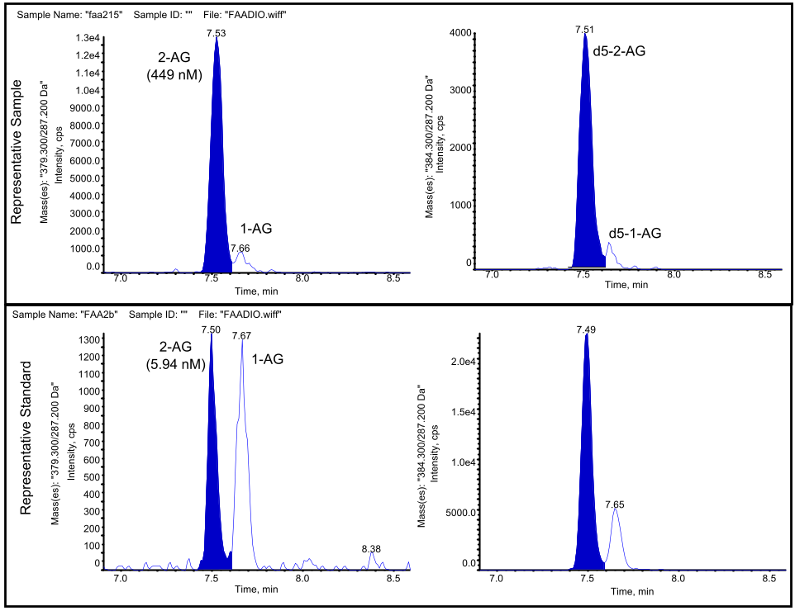
Supplemental Figure 1. Representative chromatograms of 2-AG and 1-AG resolution from a single plasma sample and low level calibration standard

