Supplementary Materials

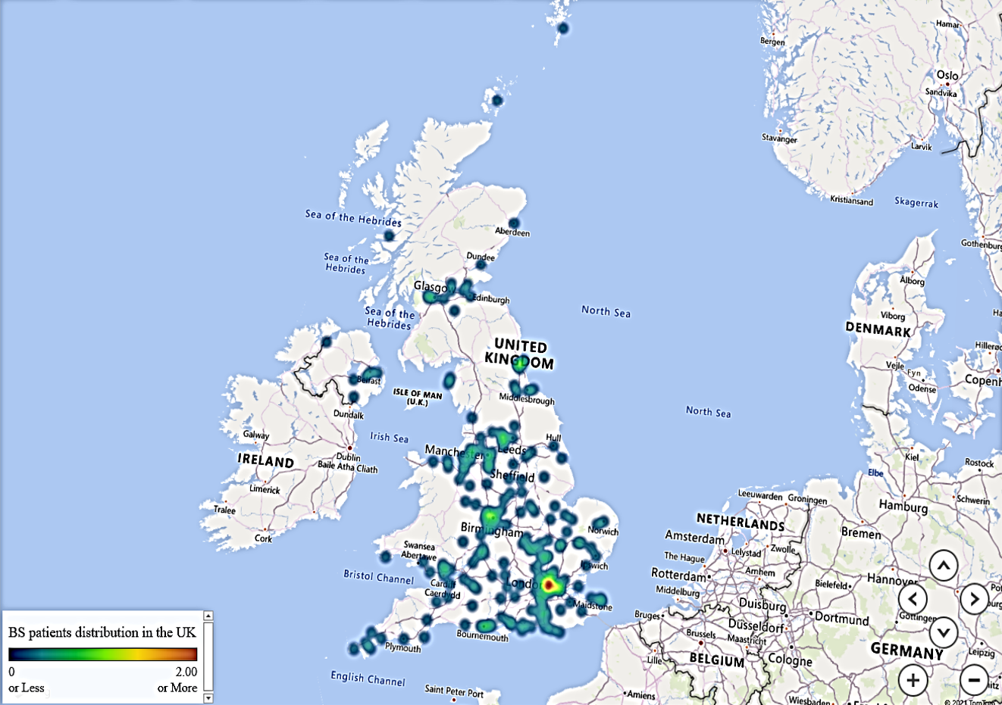
Figure S1: The geographic distribution of 2020 BS patient’s cohort (UK)

