Supplemental material
Figure S1
Flow Chart of Study Participants from baseline (MAZ. study) to follow-up (JAEL study) with final sample sizes included in data analyses.
Follow-Up (JAEL, t2)
Follow-Up (JAELred, t2)
Reason for drop-out (n=15):
- No valid measurement of OS biomarkers (n=15)
- Outlier in GRed (n=1)
Reason for drop-out (n=55):
- Afraid of needles (n=4)
- Digital Assessments (n=8)
- Weekend Assessments/ lab not open (n=7)
- Did not want to (n=13)
- Other (n=23)

Reason for drop-out (n=46):
- Unable to schedule a meeting and motivate participants to come to the in-person interviews (n=46)

Participants with available blood sample for follow-up study JAELred (N=131)

Face-to-Face Interviews of JAEL (N=185)

Included in the analytical sample (N=116)
(for GRed N=115)
Reason for drop-out (n=81):
- Did not consent to be contacted for follow-up (n=81)
Participants with consent for follow-up (N=511)
Baseline (MAZ., t1)
Included in the baseline MAZ. study (N=592)
Included in the follow-up study JAEL (N=231)

Reason for drop-out (n=280):
- Refused to participate (n=99)
- Did not provide informed consent (n=44)
- Could not be reached (n=129)
- Deceased (n=8)
Figure S2
Spearman's rank correlation coefficient between OS biomarkers and significant predictors from the random forest regression model
 | 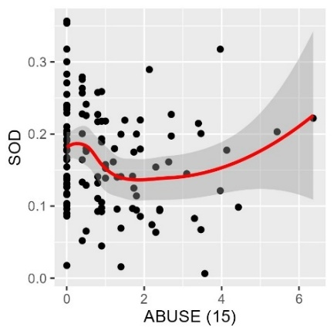
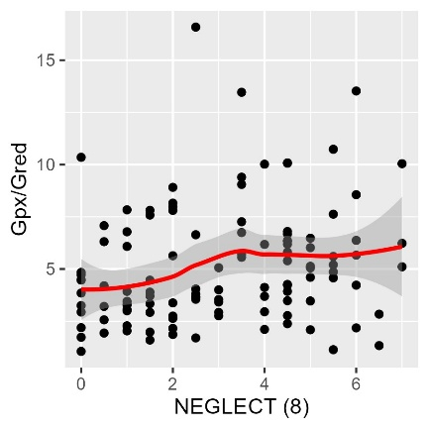 |  | 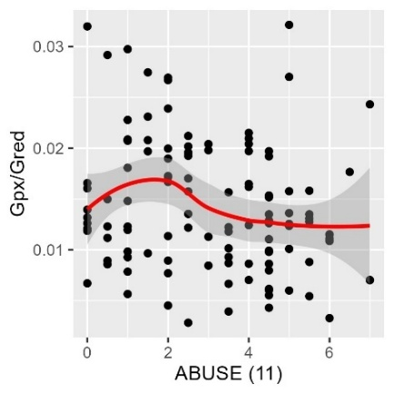
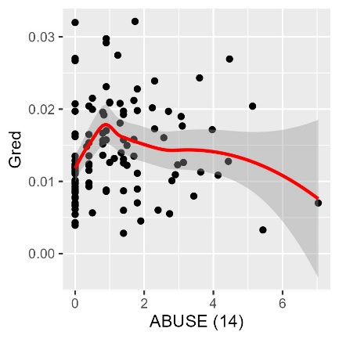 | 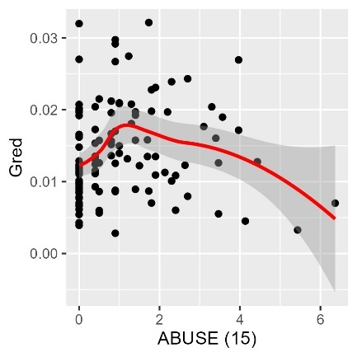 | 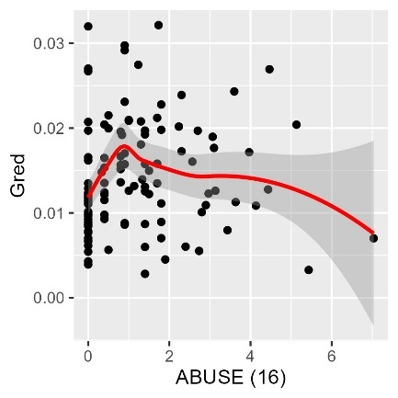
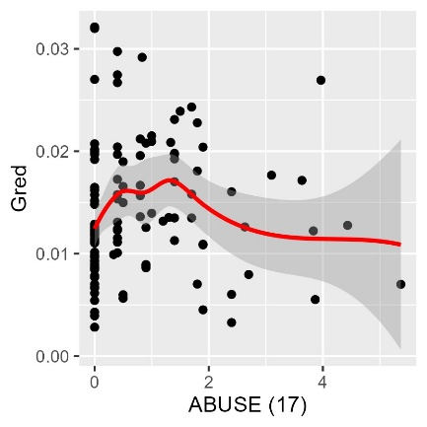 | 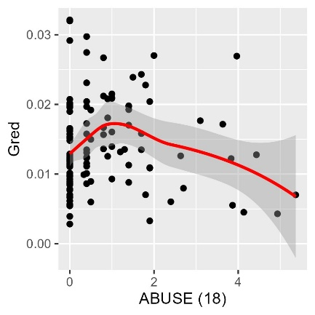
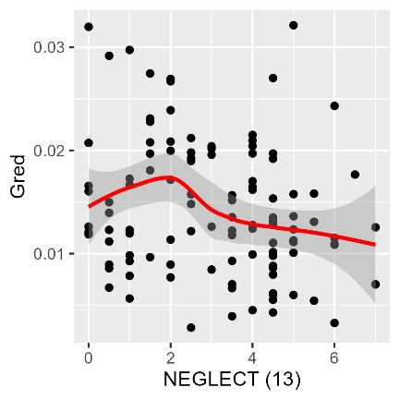 | 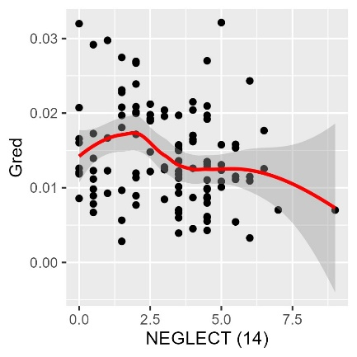 | 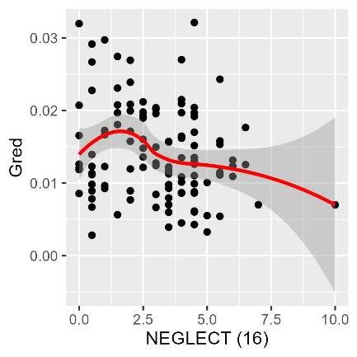
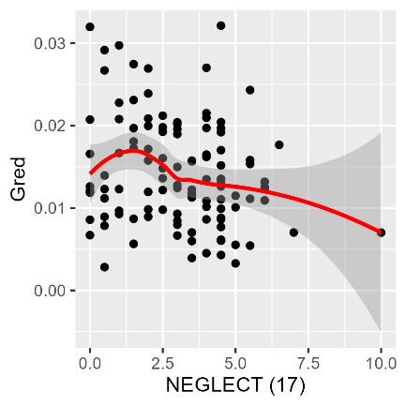 | 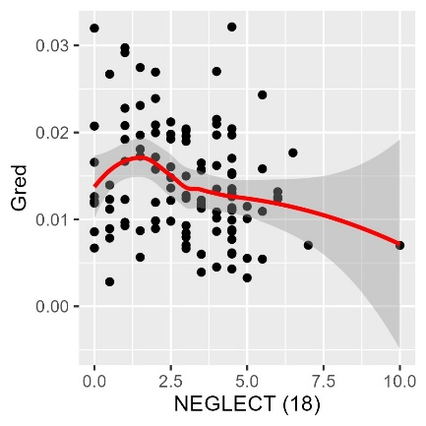
Note. The age at which the CM types were experienced is given in brackets.

