S2 File: Flowchart of sub-divided participants in each group.
HIV negative group: male (N = 16)
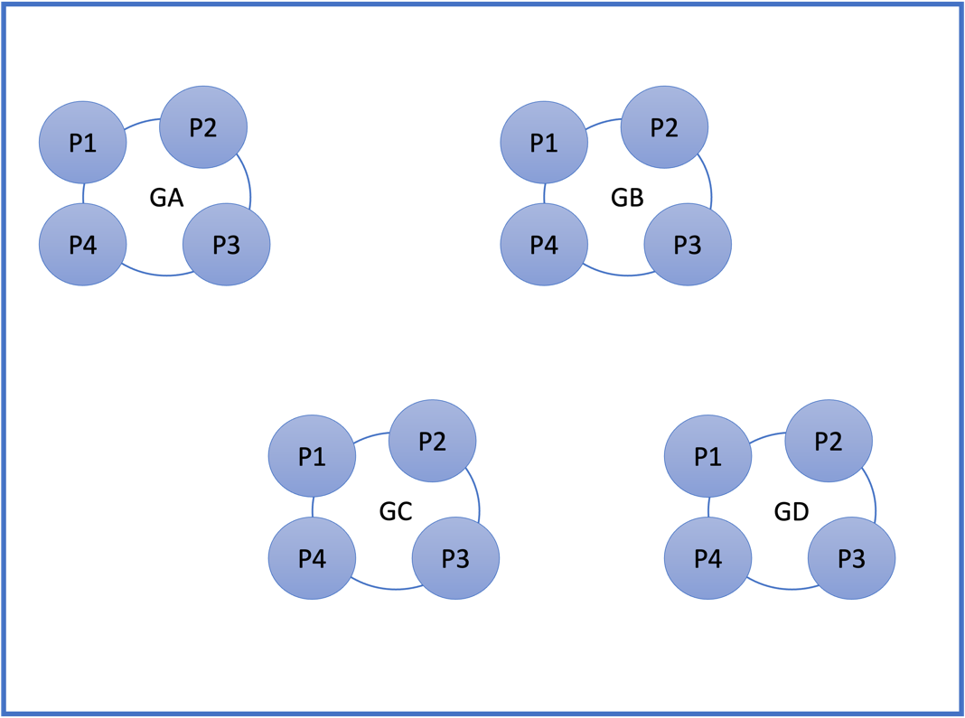

HIV negative group: female (N = 13)
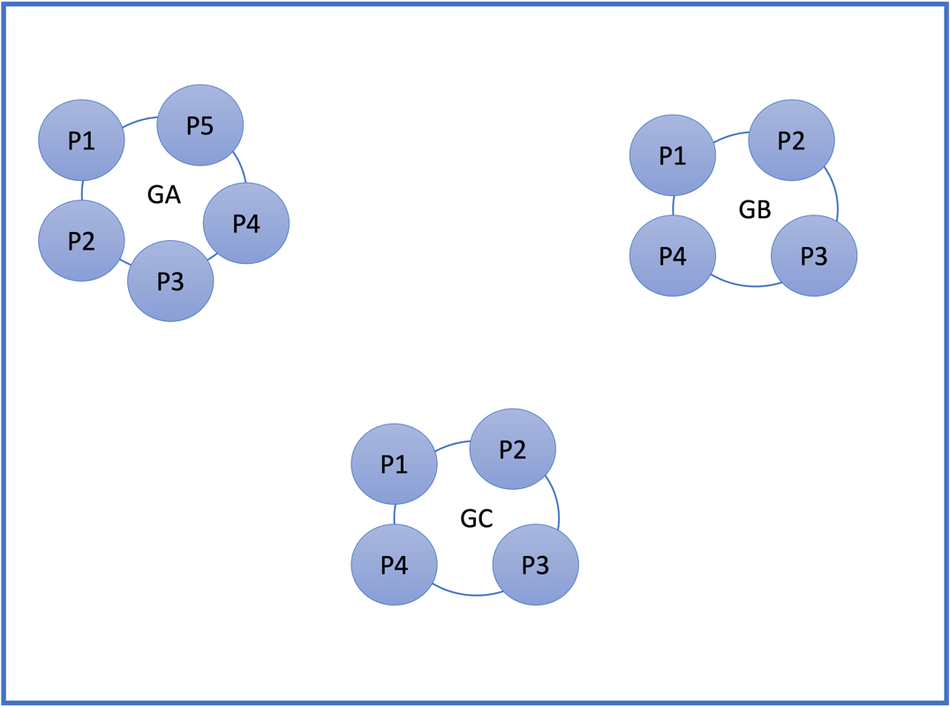

HIV positive group: male (N = 12)
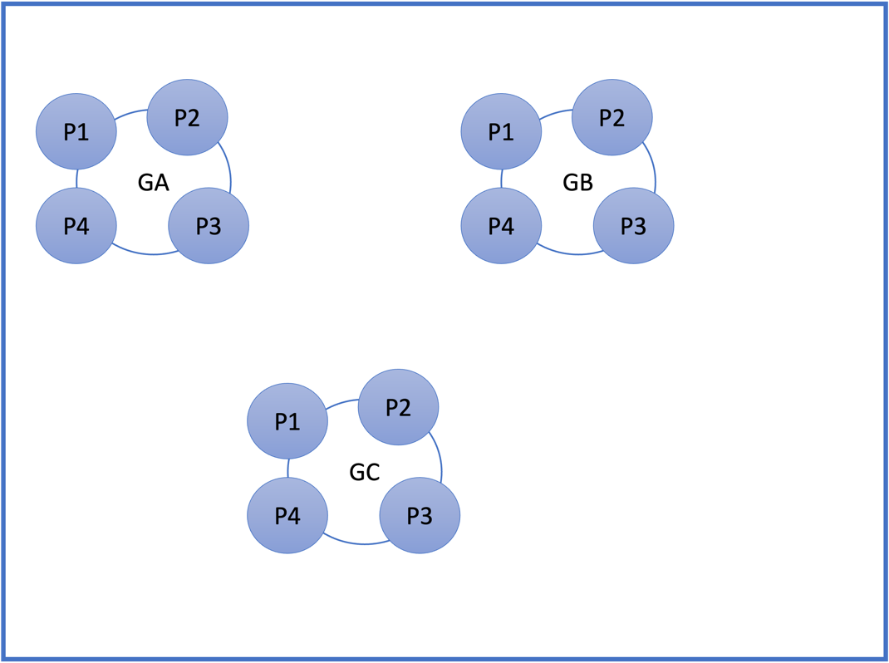

HIV positive group: female (N = 11)
