Changes in Healthcare Resource Use and Costs in Commercially Insured Insomnia Patients Initiating Suvorexant

Hrishikesh P. Kale¹, Zaina P. Qureshi², Ruchit Shah¹, Rezaul Khandker², Marc Botteman¹, Weilin Meng², Ruth Benca³
¹ OPEN Health Evidence & Access, USA; ² Merck & Co., Inc., Kenilworth, NJ, USA; ³ University of California, Irvine, USA

Corresponding Author:
Name: Zaina P. Qureshi
Address: 2000 Galloping Hill Rd, Kenilworth, NJ, USA
Telephone: 9087405113
Email: zaina.qureshi@merck.com

Supplemental Table 1. National Drug Codes for Suvorexant
Insomnia Treatment | National Drug Code
Suvorexant | 0006-0005-13, 0006-0005-30, 0006-0033-13  0006-0033-30, 0006-0325-13, 0006-0325-30, 006-0335-13, 0006-0335-30
Source: United States Food and Drug Administration. National Drug Code Directory. Accessed at: https://www.accessdata.fda.gov/scripts/cder/ndc/dsp_searchresult.cfm

Supplemental Table 2. ICD Diagnosis Codes for Mental Health Comorbidities
 | ICD-9-CM Diagnosis Codes | ICD-10-CM Diagnosis Codes
Depressive disorder | 296.2X, 296.3X, 300.4, 311 | F32, F33, F34.1, F53.0
ADD/ADHD | 314.01, 314.00, 314.9, 314.0, 314.1, 314.2, 314.8 | F90.2
Anxiety disorder | 293.84, 300.0, 300.00, 300.01, 300.02, 300.21, 300.22, 300.23, 300.29, 300.3, 308, 309.81, 300.09  300.2, 309.2 | F40, F41, F43.1, F43.22  F43.23
Psychotic disorders (schizophrenia and bipolar disorder) | 295.XX, 296.0x, 296.1x, 296.4x, 296.6x, 296.7x, 296.8x | F20, F31
Substance use disorders | 291.x, 292.x, 303.x, 304.x, 305.x, 965.0x, 967.x, 970.81, 980.0x, 648.3x, 655.5x, 760.7x | F10 - F19
Abbreviations: ADD/ADHD, attention deficit disorder/attention deficit hyperactivity disorder; ICD-9-CM, International Classification of Diseases, Ninth Revision, Clinical Modification; ICD-10-CM, International Classification of Diseases, Tenth Revision, Clinical Modification.

Supplemental Table 3. Sensitivity Analysis Results from Patient-Level Fixed Effects Modelª with Segmented Regression for Monthly Costs (2018 US Dollars) Before and After Initiation of Suvorexant
 | Prevalent Insomnia Cohort |  | Incident Insomnia Cohort
 | Estimate (SE) | p-value | Estimate (SE) | p-value
Total costs
Baseline (intercept) | 3444.70 (262.97) | <.0001 | 2220.97 (442.83) | <.0001
Slope before suvorexant initiation | 52.23 (5.01) | <.0001 | 74.93 (9.19) | <.0001
Level change after suvorexant initiation | -28.02 (49.42) | .5707 | -73.95 (90.58) | .4143
Change in slope after suvorexant initiation | -65.99 (7.18) | <.0001 | -108.41 (13.17) | <.0001
Medical cost
Baseline (intercept) | 2197.62 (241.56) | <.0001 | 1414.66 (414.22) | .0006
Slope before suvorexant initiation | 43.98 (4.97) | <.0001 | 66.73 (9.12) | <.0001
Level change after suvorexant initiation | -209.18 (49.01) | <.0001 | -244.70 (89.94) | .0065
Change in slope after suvorexant initiation | -45.41 (7.13) | <.0001 | -88.13 (13.08) | <.0001
Prescription drug cost
Baseline (intercept) | 1247.37 (86.14) | <.0001 | 806.60 (122.80) | <.0001
Slope before suvorexant initiation | 8.25 (0.67) | <.0001 | 8.20 (1.14) | <.0001
Level change after suvorexant initiation | 182.19 (6.58) | <.0001 | 171.54 (11.27) | <.0001
Change in slope after suvorexant initiation | -20.89 (0.96) | <.0001 | -20.51 (1.64) | <.0001
Abbreviation: US, United States.
ª Statistical model controlled for age at suvorexant initiation, sex, race/ethnicity, US Census region, insurance type, and Charlson comorbidity index score.

Supplemental Table 4. Subgroup Analysis Results from Segmented Regression for Total Monthly Healthcare Costs (2018 US Dollars) Before and After Initiation of Suvorexant Among Patients with Mental Health Comorbidities
 | Prevalent Insomnia Cohort |  | Incident Insomnia Cohort
 | Estimate (SE) | p-value | Estimate (SE) | p-value
Any mental health disorder
Baseline (intercept) | 3122.88 (79.96) | <.0001 | 2632.07 (110.86) | <.0001
Slope before suvorexant initiation | 61.68 (10.86) | <.0001 | 99.98 (15.06) | <.0001
Level change after suvorexant initiation | -147.10 (106.64) | .1830 | -258.25 (147.84) | .0960
Change in slope after suvorexant initiation | -97.67 (15.37) | <.0001 | -162.94 (21.30) | <.0001
Depressive disorder
Baseline (intercept) | 3626.77 (93.61) | <.0001 | 3197.00 (126.19) | <.0001
Slope before suvorexant initiation | 52.06 (12.72) | .0006 | 81.62 (17.15) | .0001
Level change after suvorexant initiation | -53.93 (124.84) | .6703 | 63.27 (168.29) | .7109
Change in slope after suvorexant initiation | -106.44 (17.99) | <.0001 | -184.59 (24.25) | <.0001
Anxiety disorder
Baseline (intercept) | 3323.73 (94.56) | <.0001 | 2839.38 (116.97) | <.0001
Slope before suvorexant initiation | 66.55 (12.85) | <.0001 | 106.16 (15.89) | <.0001
Level change after suvorexant initiation | -162.67 (126.10) | .2118 | -373.34 (155.99) | .0266
Change in slope after suvorexant initiation | -110.31 (18.17) | <.0001 | -173.10 (22.48) | <.0001
Substance use disorder
Baseline (intercept) | 3981.57 (127.48) | <.0001 | 2970.09 (238.19) | <.0001
Slope before suvorexant initiation | 88.02 (17.32) | <.0001 | 193.70 (32.36) | <.0001
Level change after suvorexant initiation | -411.44 (170.01) | .0252 | -762.56 (317.65) | .0262
Change in slope after suvorexant initiation | -148.17 (24.50) | <.0001 | -305.02 (45.77) | <.0001
Psychotic disorder
Baseline (intercept) | 4242.48 (185.58) | <.0001 | 4139.66 (267.07) | <.0001
Slope before suvorexant initiation | 49.56 (25.22) | .0634 | 25.16 (36.29) | .4961
Level change after suvorexant initiation | 180.44 (247.49) | .4744 | -38.47 (356.17) | .9151
Change in slope after suvorexant initiation | -121.92 (35.66) | .0027 | -111.69 (51.32) | .0417
No mental health comorbidity
Baseline (intercept) | 1609.11 (37.10) | <.0001 | 1527.72 (92.93) | <.0001
Slope before suvorexant initiation | 35.74 (5.04) | <.0001 | 34.30 (12.63) | .0133
Level change after suvorexant initiation | 245.13 (49.47) | <.0001 | 256.35 (123.93) | .0518
Change in slope after suvorexant initiation | -25.24 (7.13) | .0021 | -28.40 (17.86) | .1275
Abbreviation: US, United States.

Supplemental Figure 1. Study Design and Selection Criteria for (A) Prevalent Insomnia Cohort and (B) Incident Insomnia Cohort

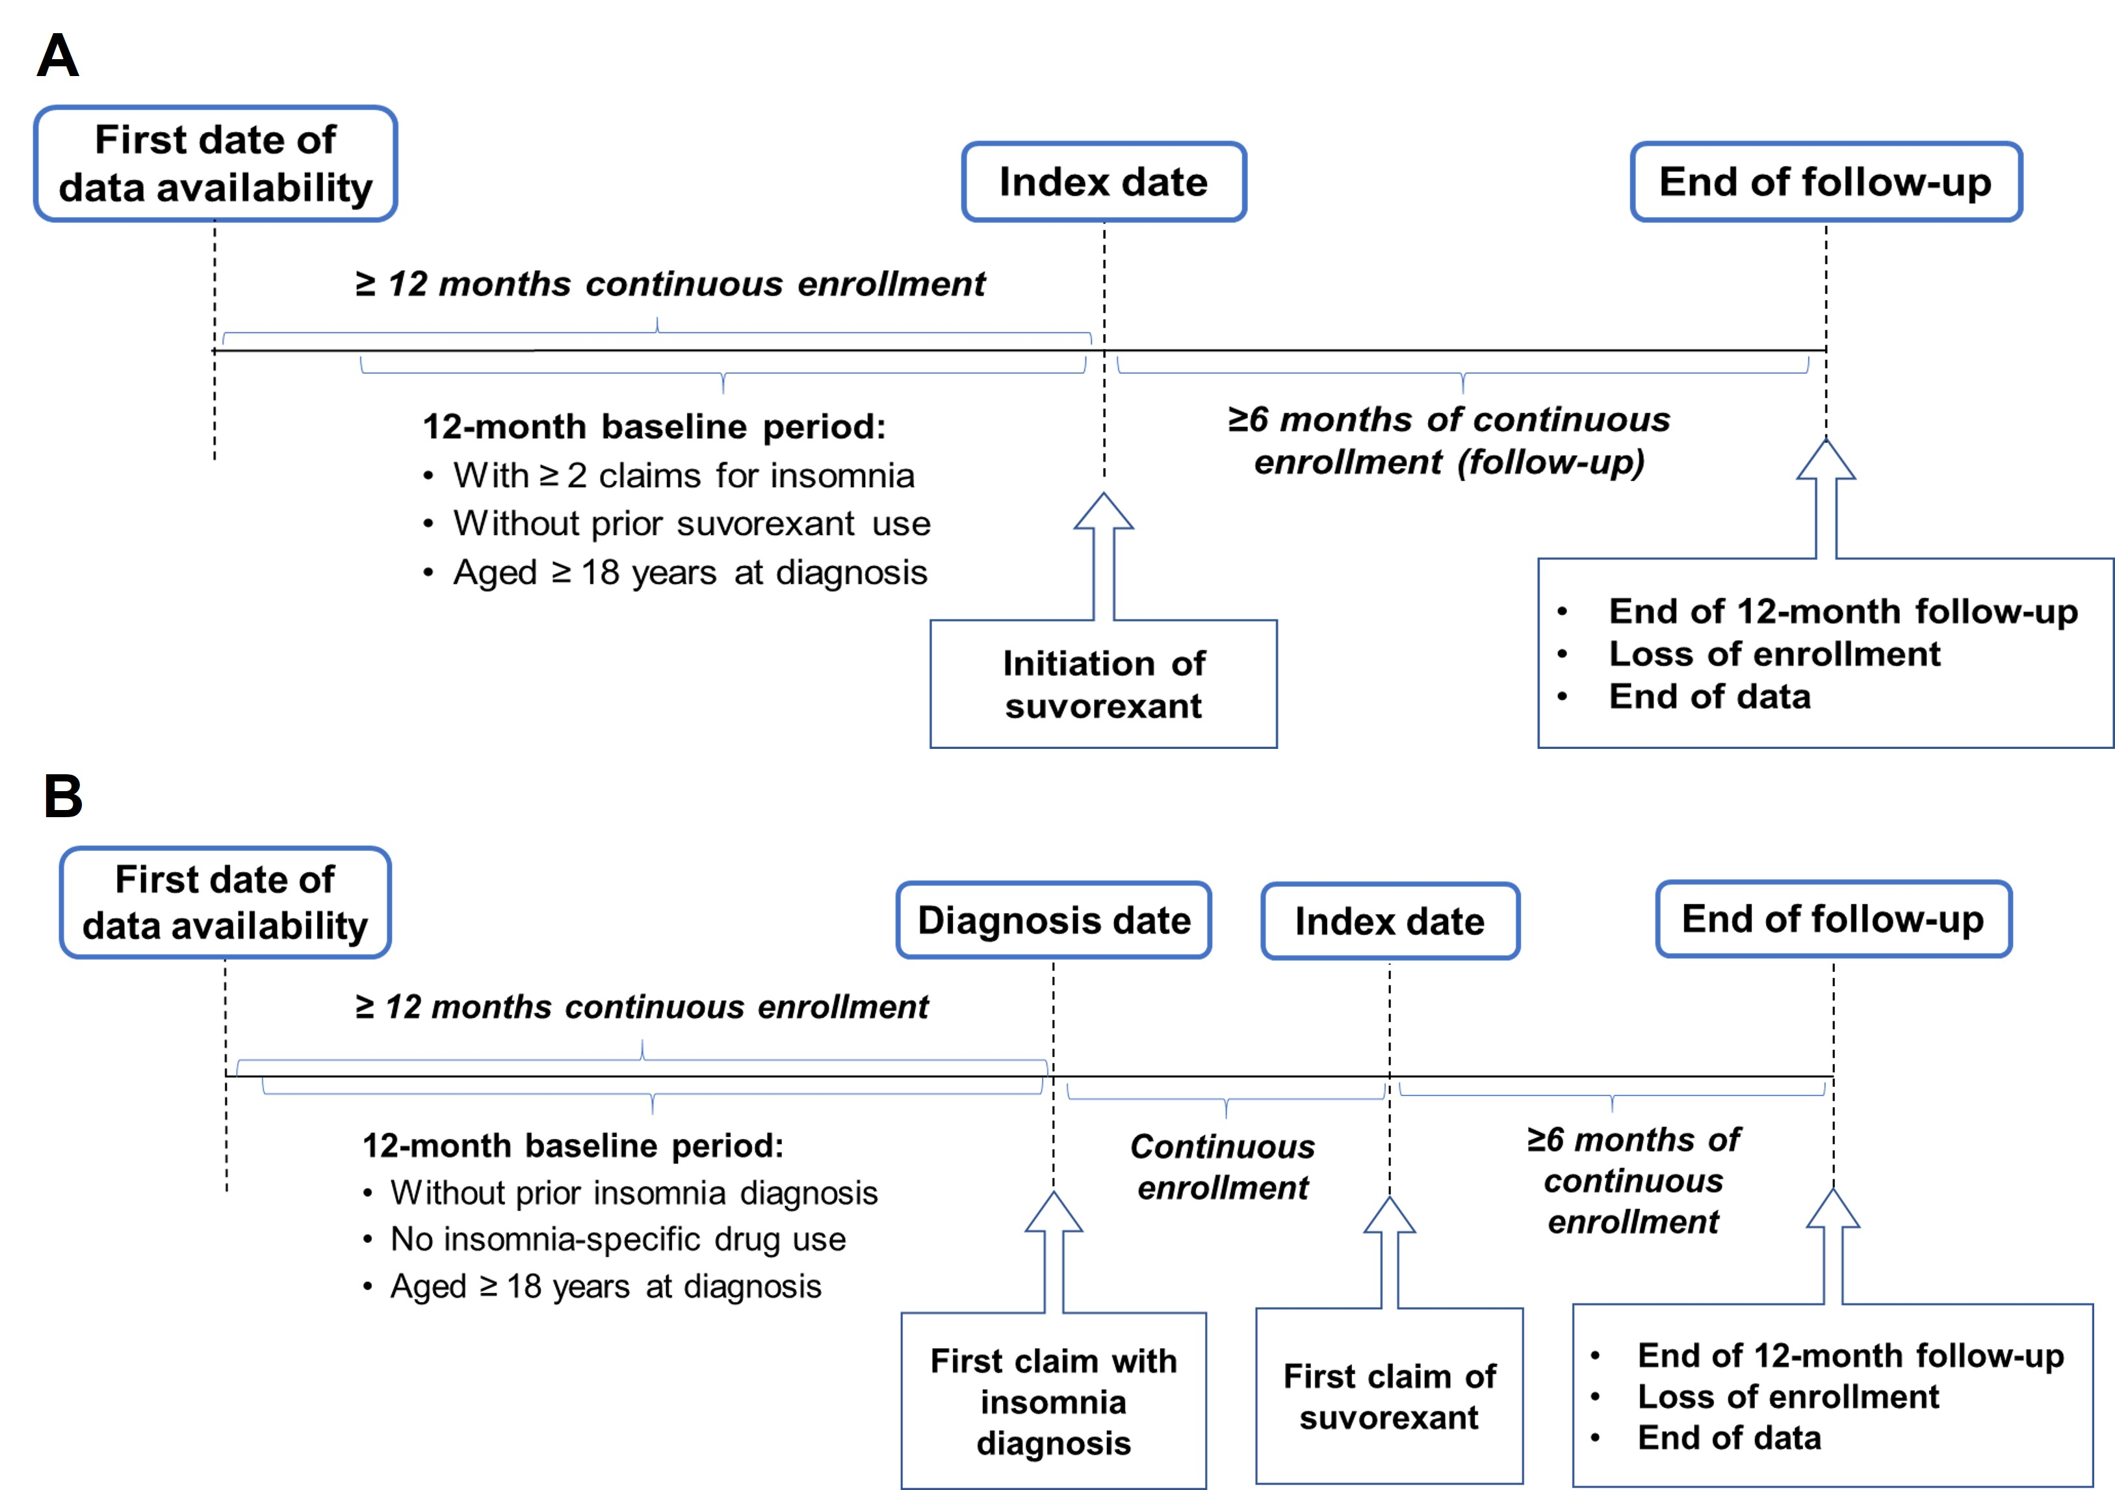

Supplemental Figure 2. Subgroup Analysis Results: Trend Over Time for Monthly Total Healthcare Costs (2018 US Dollars) Before and After Initiation of Suvorexant for Prevalent Insomnia Cohort Patients with (A) Depressive Disorders, (B) Anxiety Disorder, (C) Substance Use Disorder, and (D) Psychotic Disorders
Abbreviation: US, United States.
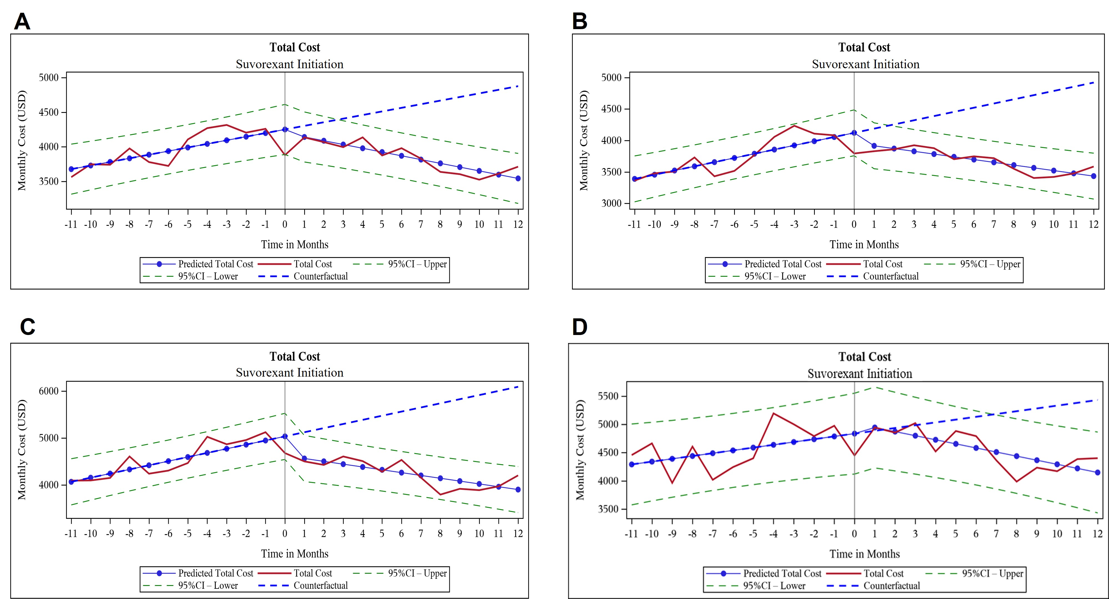

Supplemental Figure 3. Subgroup Analysis Results: Trend Over Time for Monthly Total Healthcare Costs (2018 US Dollars) Before and After Initiation of Suvorexant for Incident Insomnia Cohort Patients with (A) Depressive Disorders, (B) Anxiety Disorder, (C) Substance Use Disorder, and (D) Psychotic Disorders
Abbreviation: US, United States.

