Supporting Information

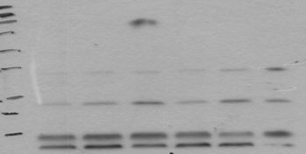
FGF21
MW
Ladder
ACEA
0h
ACEA
1h
ACEA
3h
ACEA
6h
ACEA
12h
ACEA
24h
70
55
43
34
25
17
kDa

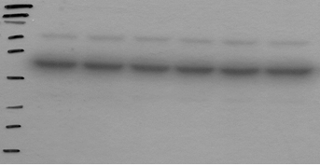
MW
Ladder
ACEA
0h
ACEA
1h
ACEA
3h
ACEA
6h
ACEA
12h
ACEA
24h
Beta Actin
70
55
43
34
25
17
kDa

S1 Fig. Western blot (uncopped) for Fig 2A.

