SUPPLEMENTAL

FIGURE S1
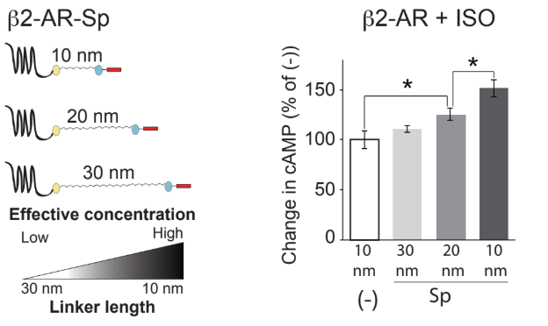
FIGURE S1. Length of tether and modulation of signaling in β2-AR. Left, schematic of Gαs C-terminal peptide (red) fused to β2-AR via 10, 20, or 30 nm ER/K linkers. Schematic shows effective concentration of protein interaction increasing as linker length decreases. Right, relative increase in cAMP production after isoproterenol (ISO) stimulation of 30, 20, and 10 nm β2-AR-s-pep (Sp) sensors compared to a β2-AR sensor lacking peptide (-). Results are represented as percent change from β2-AR no-pep (-) and expressed as mean ±S.E.M. *, p<0.05. N=9 technical repeats from 3 independent biological replicates.

FIGURE S2

FIGURE S2. cAMP stimulation by endogenous HEK 293 cell receptors. Representative forskolin-stimulated cAMP dose response curves of untransfected HEK 293 cells shown after stimulation by A1R agonists, CPA (blue) and NECA (pink), or CB₁ agonists, 2-AG (green) and WN (purple). Results expressed as ±S.E.M. from 3 technical replicates.

FIGURE S3

FIGURE S3. Characterization of cAMP modulation in adenosine receptor (A₁R) by SPASM sensors. Inhibition of forskolin-stimulated cAMP by tethered A₁R peptide sensors, s-, i-, and q-pep, normalized to no-pep (np) control, after stimulation by 50 nM CPA. Each independent experiment (total of n=8 experiments) is represented by a separate color. For each experiment, data for all four peptide sensors were collected together.

FIGURE S4

FIGURE S4. cAMP stimulation by endogenous HEK 293 cell receptors and adenosine receptor (A₁R). cAMP levels of untransfected HEK 293 cells (gray bars) and HEK 293 cells transfected with A1R (black bars). cAMP levels shown after stimulation by 0.5 μM forskolin (fsk) alone (left), 0.5 μM fsk + 30 μM CPA (middle), and 0.5 μM fsk + 30 μM NECA (right). Conditions with (+) antagonists were pre-treated with 100 nM of the A_{2A}R selective antagonist, SCH 442416 (SCH), and 1 μM of the A_{2B}R selective antagonist, PSB 1115 (PSB). Results are expressed as mean ±S.E.M. *****, p<0.00001; **, p<0.01. N=3 independent biological replicates.

FIGURE S5
FIGURE S5. IP₁ production by endogenous HEK 293 cell receptors and adenosine receptor (A₁R). IP₁ levels of untransfected HEK 293 cells (gray bars) and HEK 293 cells transfected with A₁R (black bars). IP₁ levels shown after stimulation by 100 μM CPA (left), and 100 μM NECA (right). Conditions with (+) antagonist were pre-treated with 1 μM of the A_{2B}R selective antagonist, PSB 1115 (PSB). Results are expressed as mean ±S.E.M. N=9 independent biological replicates.

FIGURE S6

FIGURE S6. Model of Gα peptide influence on GPCR-G protein signaling. Inset, SPASM sensor with attached peptide (x-pep) shown next to G-protein containing C-terminal Gα peptide (x-pep). Above, model of Gα peptides (s-pep, i-pep, or q-pep) that modulate Gs (red arrow), Gi (green inhibitory arrow), or Gq (blue arrow) signaling pathways in CB₁ or A₁R receptors after stimulation by different agonists. Q-pep and s-pep enhance Gs signaling. Q-pep and i-pep enhance Gi signaling while inhibiting Gq signaling.

