Supplementary Material

Supplementary Figures and Tables
CONTENTS
Figure S1: Proposed pathway of the biosynthesis of CBG metabolites in horses.
Figure S2: chromatogram and MS/MS spectrum of CBG.
Figure S3: chromatogram and MS/MS spectrum of CBG-G.
Figure S4: chromatogram of main phase I metabolites of CBG.
Figure S5: chromatogram of hydroxy and isomers of phase I metabolites of CBG.
Figure S6: chromatogram of tentative minority phase I metabolites of CBG.
Code of the PK model in MLXTRAN language.
Table S1. Extended PK by NLME model.
Table S2. Extended PK of secondary parameters.
Table S3. Extended table for simulated parameters.
Table S4. Clinical laboratory values.
Figure S7. Observations vs predictions plots for CBG.
Figure S8. Scatter plot of the residuals for CBG.
Figure S9. Observations vs predictions plots for CBG.
Figure S10 Scatter plot of the residuals for CBG.
Figure S11. Box plots of categorical covariates by micellar formulation versus oil formulation.
Figure S12: Box plots for statistical comparisons between C_{max}, T_{max}, AUC₂₄ and AUC_{ss} of CBG after simulated oral CBG administration for micellar (red) and oil (blue) formulations.
Figure S13: Box plots for statistical comparisons between AUC₂₄ and AUC_{ss} for CBG-G after simulated oral CBG administration for micellar (red) and oil (blue) formulations.
Figure S14: Box plots for statistical comparisons between C_{max} and C_{max-ss}, and T_{max} and T_{max-ss} for CBG after simulated oral CBG administration for micellar (red) and oil (blue) formulations.
Figure S15: Box plots for statistical comparisons between C_{max} and C_{max-ss}, and T_{max} and T_{max-ss} for CBG-G after simulated oral CBG administration for micellar (red) and oil (blue) formulations.

Supplementary Figure 1. Proposed pathway of the biosynthesis of CBG metabolites in horses. The metabolites enclosed in the dotted line correspond to the most abundant derivatives. The reduced forms were tentatively identified because they exhibit a similar fragmentation pattern to the unsaturated forms, but with an additional mass-to-charge ratio (m/z) of 2.0156 units, corresponding to the addition of two hydrogen atoms.

Supplementary Figure 2. Extracted ion chromatogram (A), MS/MS spectrum (B) and fragmentation scheme of cannabigerol (CBG) in positive ion mode.

Supplementary Figure 3. Extracted ion chromatogram (A) and MS/MS spectrum (B) of cannabigerol glucuronide in positive ion mode.

Supplementary Figure 4. Extracted ion chromatogram of 8’-hydroxy-CBG (A), and 2',3'-Epoxide-CBG and 6',7'-Epoxide-CBG isomers (B).

Supplementary Figure 5. Extracted ion chromatograms of dihydroxy-CBG isomers and the reduced forms of both dihydroxy-CBG and hydroxy-CBG isomers.

Supplementary Figure 6. Tentatively extracted ion chromatograms of reduced forms of hydroxy-CBG minority isomers.

DESCRIPTION: PK MODEL FOR CBG AND IS MAIN METABOLITE CBG-G AFTER INTRAVENOUS AND ORAL ADMINISTRATION OF CBG

[LONGITUDINAL]
input = {F, ka, beta, Cl, V1, Q2, V2, Vm, Fm, Clm}

PK:
depot(adm=1, target=A1) ; IV administration for CBG
depot(adm=2, target=A4, p=F) ; oral administration for CBG

EQUATION:
odeType = stiff

; Initial conditions
t_0=0
A1_0=0 ; IV central compartment for CBG
A2_0=0 ; Peripheral compartment for CBG
A3_0=0 ; Glucuronide metabolite CBG-G
A4_0=0 ; oral administration of CBG(micellar, oil)

; Parameter transformations, definition of Weibull absorption
kaw = ka*beta*((max(t,0)*ka)^(beta-1))

; ODE system
ddt_A1 = kaw*A4 - Cl*A1/V1 - Q2/V1*A1 + Q2/V2*A2
ddt_A2 = Q2/V1*A1 - Q2/V2*A2
ddt_A3 = Cl*Fm*A1/V1 - Clm*A3/Vm
ddt_A4 = - kaw*A4

; Concentrations
C1 = A1/V1 ; Plasma concentrations at central compartment
C2 = A2/V2 ; Peripheral concentrations 1
C3 = A3/Vm ; Glucuronide concentrations

; Area under the curve
AUC_0 = 0
ddt_AUC = C1

AUC24_0 = 0
if(t < 24)
dAUC24 = 1/V1 * A1
else
dAUC24 = 0
end
ddt_AUC24 = dAUC24

AUCC3_0 = 0
ddt_AUCC3 = C3

AUC24C3_0 = 0
if(t < 24)
dAUC24C3 = 1/Vm * A3
else
dAUC24C3 = 0
end
ddt_AUC24C3 = dAUC24C3

OUTPUT:
output = {C1, C3}
table = {AUC, AUCC3, AUC24, AUC24C3}

TABLE 1:
Extended table for pharmacokinetic parameters of CBG and CBG-G in horses after intravenous CBG at 1.0 mg/kg and oral CBG at 10.0 mg/kg by micellar and oil formulations, respectively.
 | NLME estimates |  |  | Boostrap analysis |  |  | Shrinkage
Parameter | Value | P2.5 | P97.5 | Median | P2.5 | P97.5 | (%)
F | 0.28 | 0.22 | 0.34 | 0.29 | 0.25 | 0.32 | -3.54
ka (1/h) | 0.99 | 0.65 | 1.53 | 0.95 | 0.54 | 1.1 | 1.08
Cov_{ka_formulation} | -1.18 | -1.65 | -0.71 | -1.22 | -1.68 | -0.61
β | 1.59 | 1.24 | 2.03 | 1.43 | 1.16 | 1.94 | 1.4
Cov_{γ_formulation} | -0.82 | -1.06 | -0.58 | -0.77 | -1.14 | -0.57
Cl (l/h/kg) | 1.67 | 1.36 | 2.05 | 1.75 | 1.37 | 2.04 | -3.03
V_{c} (L/kg) | 32.15 | 17.54 | 58.93 | 43 | 10.87 | 69.78 | -4.85
Q (L/h/kg) | 154.5 | 73 | 326.99 | 82.35 | 3.98 | 243.5 | -
V_{p} (L/kg) | 36.12 | 23.96 | 54.43 | 41.29 | 16.35 | 58.26 | 6.25
V_{m} (L/kg) | 0.0047 | 0.003 | 0.0075 | 0.0041 | 0.0015 | 0.0097 | -14.4
F_{m} | 0.75 | - | - |  |  |  | -
Cl_{m} (L/h/kg) | 0.016 | 0.013 | 0.021 | 0.016 | 0.014 | 0.023 | -5.85
Fixed Effects by Category
ka_{_micellar formulation} (1/h) | 0.99 | 0.65 | 1.53
β_{_micellar formulation} | 1.59 | 1.24 | 2.03
ka_{_oil formulation} (1/h) | 0.31 | 0.19 | 0.5
β__{oil formulation} | 0.7 | 0.54 | 0.91
Random Effects CV(%) |  |  |  |  | Residural error
IIV_F | 25.52 | IOV_F | 13.93 |  | b1 | 0.29
IIV_ka | 46.64 | IOV_ka | 37.99 |  | b2 | 0.41
IIV_β | 26.01 | IOV_β | 12.8
IIV_Cl | 27.95
IIV_V_{C} | 66.74
IIV_V_{P} | 21.22
IIV_V_{m} | 53.58
IIV_Cl_{m} | 32.23
TABLE 2:
Extended table for the secondary pharmacokinetic parameters for CBG and CBG-G after intravenous CBG at 1.0 mg/kc and oral administration of 10.00 mg/kg of CBG by oil or micellar formulations, respectively.
IV administration of CBG at 1.0 mg/kg
 | CBG |  |  |  | CBG-G
Parameter | Value | P2.5 | P97.5 | CV(%) | Value | P2.5 | P97.5 | CV(%)
AUC₂₄ (µmol/L·h) | 855.75 | 428.11 | 1298.36 | 41.45 | 62419.46 | 41094.77 | 89431.21 | 25.49
AUC (µmol/L·h) | 2376.23 | 980.09 | 3651.10 | 46.82 | 105071.97 | 57666.05 | 184625.94 | 42.44
C_{max} (µmol/L) | 74.92 | 42.33 | 107.24 | 31.04 | 5508.28 | 3184.34 | 7721.73 | 31.05
T_{max} (h) | 1.80 | 0.08 | 5.65 | 136.04 | 2.28 | 0.54 | 5.65 | 81.47
t_{1/2x} (h) | 29.22 | 14.27 | 63.66 | 62.89 | 21.01 | 7.57 | 48.01 | 69.23
V_{ss} (L/kg) | 74.31 | 44.84 | 100.60 | 27.69 | - | - | - | -
AUC_{m}/AUC_{p} | - | - | - | - | 54.25 | 18.15 | 107.70 | 58.26
Oral administration of CBG at 10.0 mg/kg by micellar formulation
 | CBG |  |  |  | CBG-G
Parameter | Value | P2.5 | P97.5 | CV(%) | Value | P2.5 | P97.5 | CV(%)
AUC₂₄ (µmol/L·h) | 1817.02 | 1129.50 | 2411.58 | 27.15 | 138645.04 | 90704.99 | 222624.35 | 33.21
AUC (µmol/L·h) | 4109.79 | 2796.72 | 6268.55 | 31.02 | 247414.22 | 166318.20 | 358258.57 | 26.80
C_{max} (µmol/L) | 132.70 | 85.11 | 220.72 | 36.66 | 10400.83 | 7255.67 | 15556.97 | 29.24
T_{max} (h) | 4.00 | 2.00 | 6.00 | 46.29 | 5.75 | 4.00 | 8.00 | 29.03
t_{1/2x} (h) | 28.58 | 18.09 | 38.36 | 30.39 | 23.56 | 12.27 | 54.38 | 66.53
AUC_{m}/AUC_{p} | - | - | - | - | 64.41 | 37.04 | 94.05 | 35.56
Oral administration of CBG at 10.0 mg/kg by oil formulation
 | CBG |  |  |  | CBG-G
 | Value | P2.5 | P97.5 | CV(%) | Value | P2.5 | P97.5 | CV(%)
AUC₂₄ (µmol/L·h) | 1635.11 | 486.63 | 2598.82 | 48.24 | 133925.40 | 74319.05 | 180650.92 | 31.00
AUC (µmol/L·h) | 5136.01 | 2636.62 | 8904.38 | 43.87 | 306448.70 | 153370.91 | 410339.26 | 33.14
C_{max} (µmol/L) | 101.38 | 33.65 | 156.87 | 46.55 | 8003.28 | 4243.13 | 10908.79 | 33.24
T_{max} (h) | 9.50 | 2.70 | 21.90 | 70.95 | 11.25 | 6.35 | 21.90 | 50.23
t_{1/2x} (h) | 43.63 | 19.49 | 90.03 | 56.47 | 31.34 | 20.26 | 51.67 | 43.50
AUC_{m}/AUC_{p} | - | - | - |  | 69.79 | 41.17 | 106.94 | 36.18
TABLE 3
Extended table for the simulated pharmacokinetics parameters of CBG after oral doses at 10 mg/kg each 24 h for 14 days for micellar and oil formulations, receptively (n = 5000).
 | CBG-G |  |  |  | CBG-G
Parameter | Value | P2.5 | P97.5 | %CV | Value | P2.5 | P97.5 | %CV
AUC_{24micellar formulation} | 2281.7 | 952.03 | 4300.66 | 38.89 | 185128.28 | 64604.92 | 400884.74 | 54.29
AUC_{ss_micellar formulation} | 5225.31 | 2156.21 | 10294.88 | 40.95 | 414732.88 | 158457.12 | 817194.4 | 46.75
Accumulation ratio | 2.35 | 1.45 | 3.68 | 25.59 | 2.38 | 1.49 | 3.74 | 25.67
AUC_{24_oil formulation} | 1901.64 | 752.99 | 3700.92 | 40.86 | 158703.12 | 47056.94 | 385820 | 61.35
AUC_{ss_oil formulation} | 4619.62 | 1822.6 | 8786.08 | 38.63 | 370173.09 | 146460.52 | 759635.86 | 47.07
Accumulation ratio | 2.54 | 1.47 | 4.17 | 28.15 | 2.57 | 1.48 | 4.26 | 28.38
 | CBG |  |  |  | CBG-G
Parameter | Value | P2.5 | P97.5 | %CV | Value | P2.5 | P97.5 | %CV
C_{max_micellar formulation} | 125.25 | 48.57 | 237.16 | 42.68 | 10227.83 | 3269.79 | 24504.18 | 60.72
C_{max_ss_micellar formulation} | 281.86 | 120.24 | 530.54 | 38.14 | 22364.13 | 8251.22 | 44102.16 | 47.55
T_{max_micellar formulation} | 2.99 | 1 | 7 | 55.68 | 3.65 | 1 | 8 | 45.98
T_{max_ss_micellar formulation} | 121.26 | 121 | 124 | 0.76 | 121.67 | 121 | 124.53 | 0.95
C_{max_oil formulation} | 93.11 | 36.23 | 187.37 | 42.89 | 7912.51 | 2290.96 | 20143.93 | 65.88
C_{max_ss_oil formulation} | 206.48 | 81.07 | 400.41 | 39.46 | 16624.39 | 6304.71 | 35340.27 | 49.39
T_{max_oil formulation} | 9.87 | 4 | 20 | 41.52 | 10.27 | 5 | 20 | 39.58
T_{max_ss_oil formulation} | 130.6 | 123 | 143 | 3.41 | 131 | 123 | 143 | 3.38

TABLE 4
Clinical laboratory values before and 72 hours after administration of cannabigerol (CBG) in horses. Data presented as mean with range.
 | Before administration | 72 h post administration
 | IV CBG at 1.00 mg/kg | IV CBG at 1.00 mg/kg
Urea (mg/dL) | 26.7 (24 – 32) | 32.30 (40 - 32)
Creatinine (mg/dL) | 1.03 (0.87 - 1.53) | 1.00 (0.80 - 1.28)
GLDH (IU/L) | 2.96 (2.50 - 5.30) | 2.80 (2.10 - 4.10)
AST (IU/L) | 214.3 (204 - 305) | 318.50 (270 - 366)
RBC (x10⁶/µL) | 7.22 (6.19 - 7.58) | 6.91 (6.48 - 9.00)
Ht (%) | 33.88 (29.30 - 36.8) | 37.54 (34.10 - 39.4)
Hb (g/dL) | 11.97 (10.10 - 14.9) | 10.52 (11.26 - 13.5)
WBC (x10³/µL) | 7.72 (6.82 - 8.2) | 6.98 (6.33 - 7.84)
PLT (x10³/µL) | 190.22 (93 - 172) | 105.57 (102 - 204)
 | Before administration | 72 h post administration
 | Oral micellar CBG at 10.00 mg/kg | Oral micellar CBG at 10.00 mg/kg
Urea (mg/dL) | 35.50 (26 - 51) | 32.00 (19 - 45)
Creatinine (mg/dL) | 1.00 (0.77 - 1.11) | 0.92 (0.70 - 1.0)
GLDH (IU/L) | 3.09 (1.90 - 6.90) | 2.57 (1.80 - 3.10)
AST (IU/L) | 302.10 (286 - 401) | 300.80 (297 - 451)
RBC (x10⁶/µL) | 7.87 (5.97 - 7.99) | 6.64 (5.99 - 9.68)
Ht (%) | 35.65 (30.90 - 38.0) | 37.28 (33.50 - 45.2)
Hb (g/dL) | 12.80 (10.90 - 14.3) | 14.56 (10.70 - 17.2)
WBC (x10³/µL) | 8.43 (6.77 - 9.02) | 7.06 (6.28 - 9.24)
PLT (x10³/µL) | 134.27 (124 - 185) | 200.29 (172 - 260)
 | Before administration | 72 h post administration
 | Oral OIL CBG at 10.00 mg/kg | Oral OIL CBG at 10.00 mg/kg
Urea (mg/dL) | 29.80 (24 - 51) | 34.00 (22 - 47)
Creatinine (mg/dL) | 0.95 (0.60 - 1.05) | 0.87 (0.50 -1.00)
GLDH (IU/L) | 280 (1.80 - 3.80) | 2.07 (1.60 - 3.10)
AST (IU/L) | 290.30 (212 - 430) | 277.10 (261 - 407)
RBC (x10⁶/µL) | 7.17 (6.21 - 9.05) | 7.98 (6.17 - 8.91)
Ht (%) | 33.48 (31.20 - 42.4) | 37.24 (30.12 - 40.7)
Hb (g/dL) | 12.31 (10.00 - 14.9) | 12.12 (10.50 - 14.5)
WBC (x10³/µL) | 8.09 (7.20 -10.33) | 7.68 (7.01 - 9.10)
PLT (x10³/µL) | 188.0 (158 - 231) | 164.20 (125 - 287)
GLDH, glutamate dehydrogenase; AST, aspartate aminotransferase; RBC, red blood cell; Ht, haematocrit; Hb, haemoglobin concentration; WBC, white blood cell; PLT, platelet.

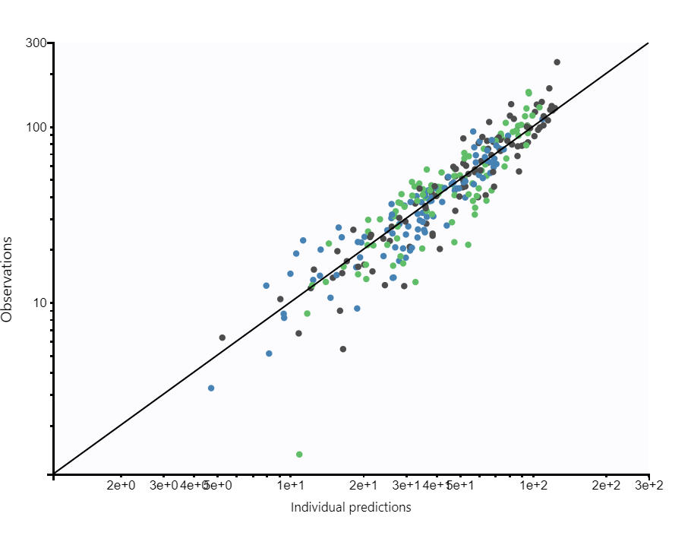
Supplementary Figure 7. Observations vs predictions plots for CBG concentrations. Observed concentrations for IV administration are displayed in blue colour, for oral micellar administration in black colour and in green for oral oil administration, respectively.

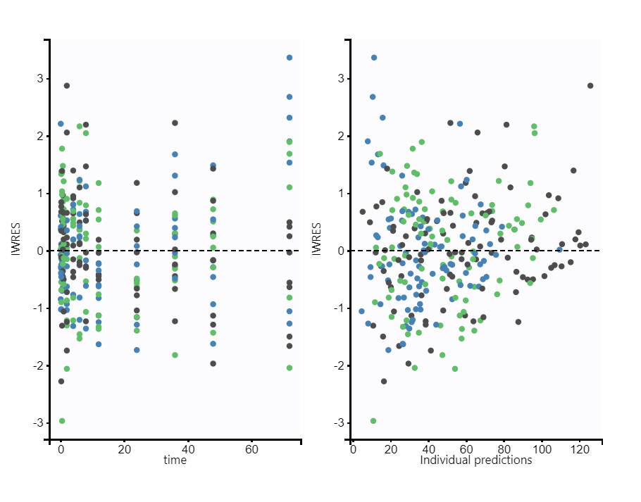

Supplementary Figure 8. Scatter plot of the residuals for CBG. Observed data for IV administration are displayed in blue colour, for oral micellar administration in black colour and in green for oral oil administration, respectively.
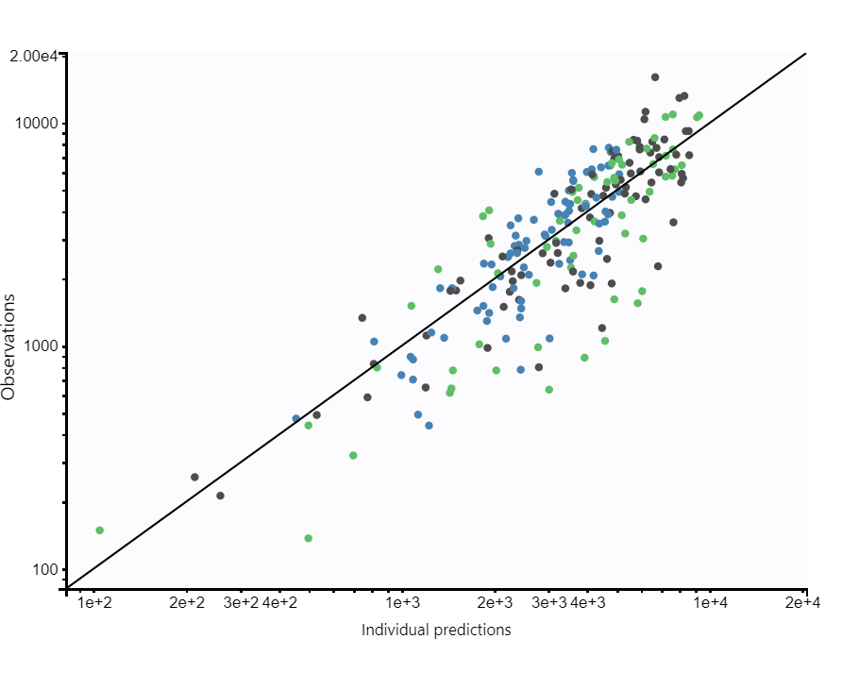
Supplementary Figure 9. Observations vs predictions plots for CBG-G concentrations. Observed concentrations for IV administration are displayed in blue colour, for oral micellar administration in black colour and in green for oral oil administration, respectively.

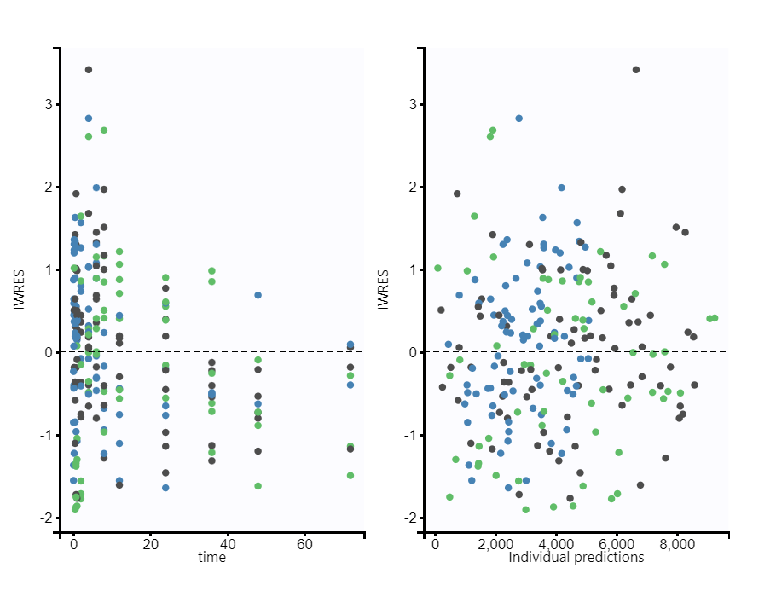
Supplementary Figure 10. Scatter plot of the residuals for CBG-G. Observed data for IV administration are displayed in blue colour, for oral micellar administration in black colour and in green for oral oil administration, respectively.

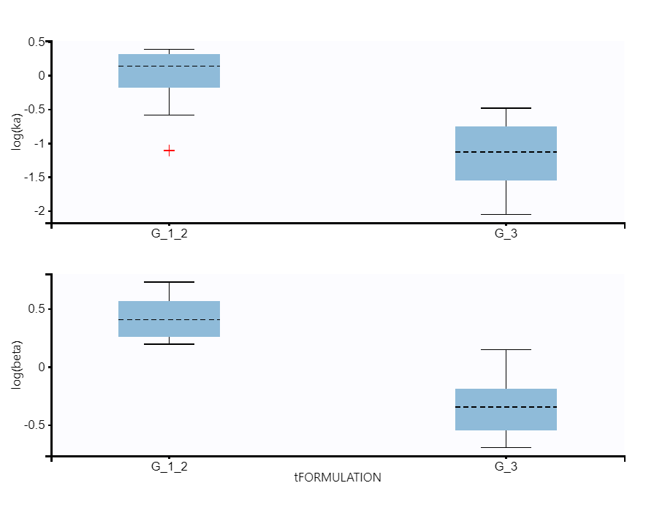
Supplementary Figure 11. Box plots of categorical covariates with effect of ka and β in horses: CBG by micellar formulation versus CBG by oil formulation.

Supplementary Figure 12: Box plots for statistical comparisons between C_{max}, T_{max}, AUC₂₄ and AUC_{ss} of CBG after simulated oral CBG administration for micellar (red) and oil (blue) formulations.

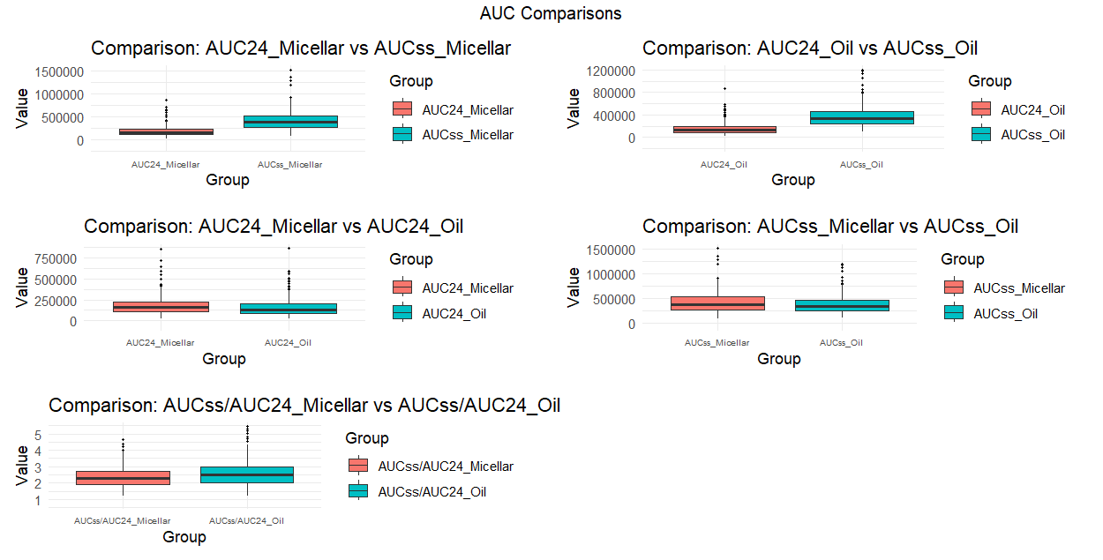
Supplementary Figure 13: Box plots for statistical comparisons between AUC₂₄ and AUC_{ss} for CBG-G after simulated oral CBG administration for micellar (red) and oil (blue) formulations.

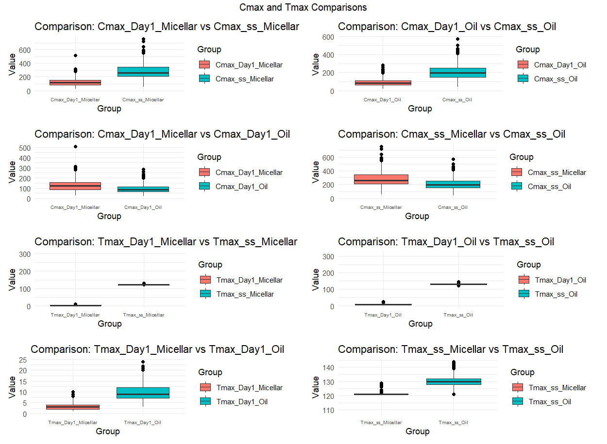
Supplementary Figure 14. Box plots for statistical comparisons between C_{max} and C_{max-ss}, and T_{max} and T_{max-ss} for CBG after simulated oral CBG administration for micellar (red) and oil (blue) formulations.
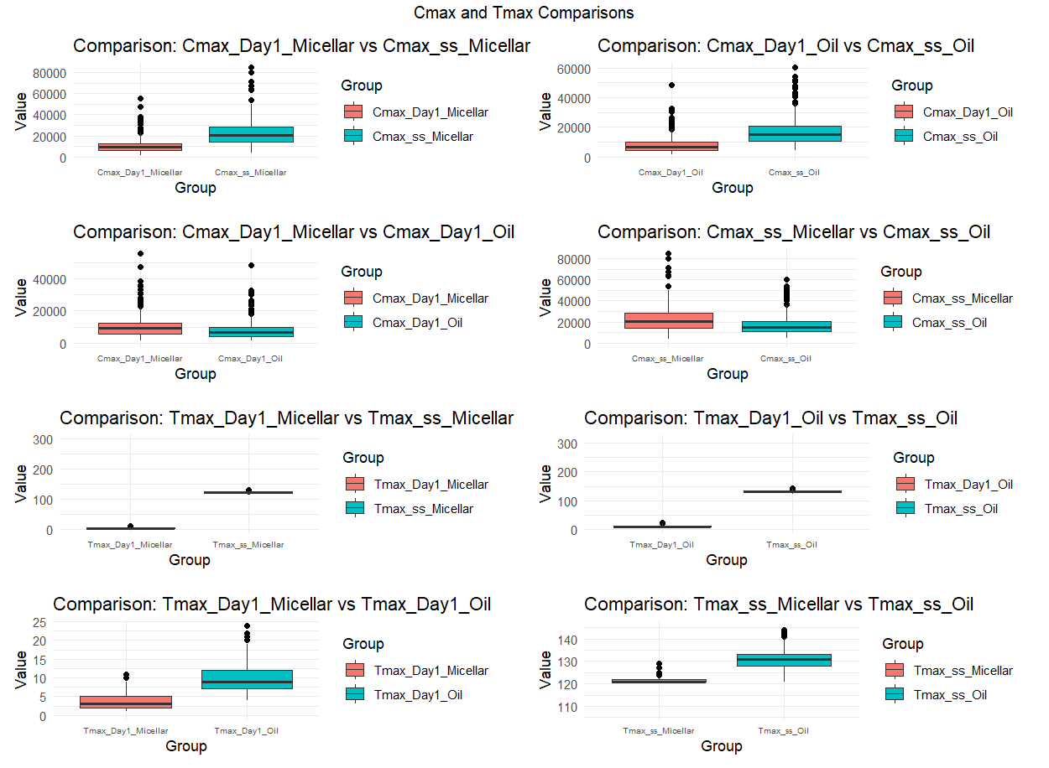
Supplementary Figure 15. Box plots for statistical comparisons between C_{max} and C_{max-ss}, and T_{max} and T_{max-ss} for CBG-G after simulated oral CBG administration for micellar (red) and oil (blue) formulations.

