Mpox severity and mortality in the DRC: a systematic review and meta-analysis (1970-2024)

Fabrice Zobel Lekeumo Cheuyem^{1,}*, Armel Zemsi², Jonathan Hangi Ndungo³, Chabeja Achangwa⁴, Davy Roméo Takpando-le-grand⁵, Jessy Goupeyou-Youmsi⁶, Solange Dabou⁶, Mohamadou Adama¹, Ariane Nouko¹, Marie Angèle Mbang⁷, Edwige Omona Guissana⁸, Rick Tchamani⁹, Vanessa Monique Mballa Assiene¹⁰, Ethel Ambo Eno¹¹, Constantine Tanywe Asahngwa², Saralees Nadarajah¹²

¹ Department of Public Health, Faculty of Medicine and Biomedical Sciences, The University of Yaoundé I, Yaoundé, Cameroon
² MRCG at LSHTM, Banjul, The Gambia
³ Higher Institute of Medical Techniques, Bunia, Democratic Republic of Congo
⁴ Department of Public Health, Faculty of Medical Sciences, University of West Indies, Bridgetown, Barbados
⁵ Field Coordinator Frontline Field Epidemiology Training Program, Bangui, Central African Republic
⁶ Division of Health Policy and Research, Nkafu Policy Institute, Denis and Lenora Foretia Foundation, Yaounde, Cameroon
⁷ Division of Vaccination, Department of Family Health, Ministry of Public Health, Yaounde, Cameroon
⁸ Department of Family Health, Ministry of Public Health, Yaounde, Cameroon
⁹ Rosière Higher School of Health Sciences, Yaounde, Cameroon
¹⁰ Public Health Emergency Operations Coordination Centre, Yaounde, Cameroon
¹¹ Women in Global Health, Yaounde, Cameroon
¹² Department of Mathematics, University of Manchester, Manchester, UK

*Corresponding author’s address:
Fabrice Zobel Lekeumo Cheuyem
Tel: +237 696 57 28 07; E-mail: zobelcheuyem@gmail.com
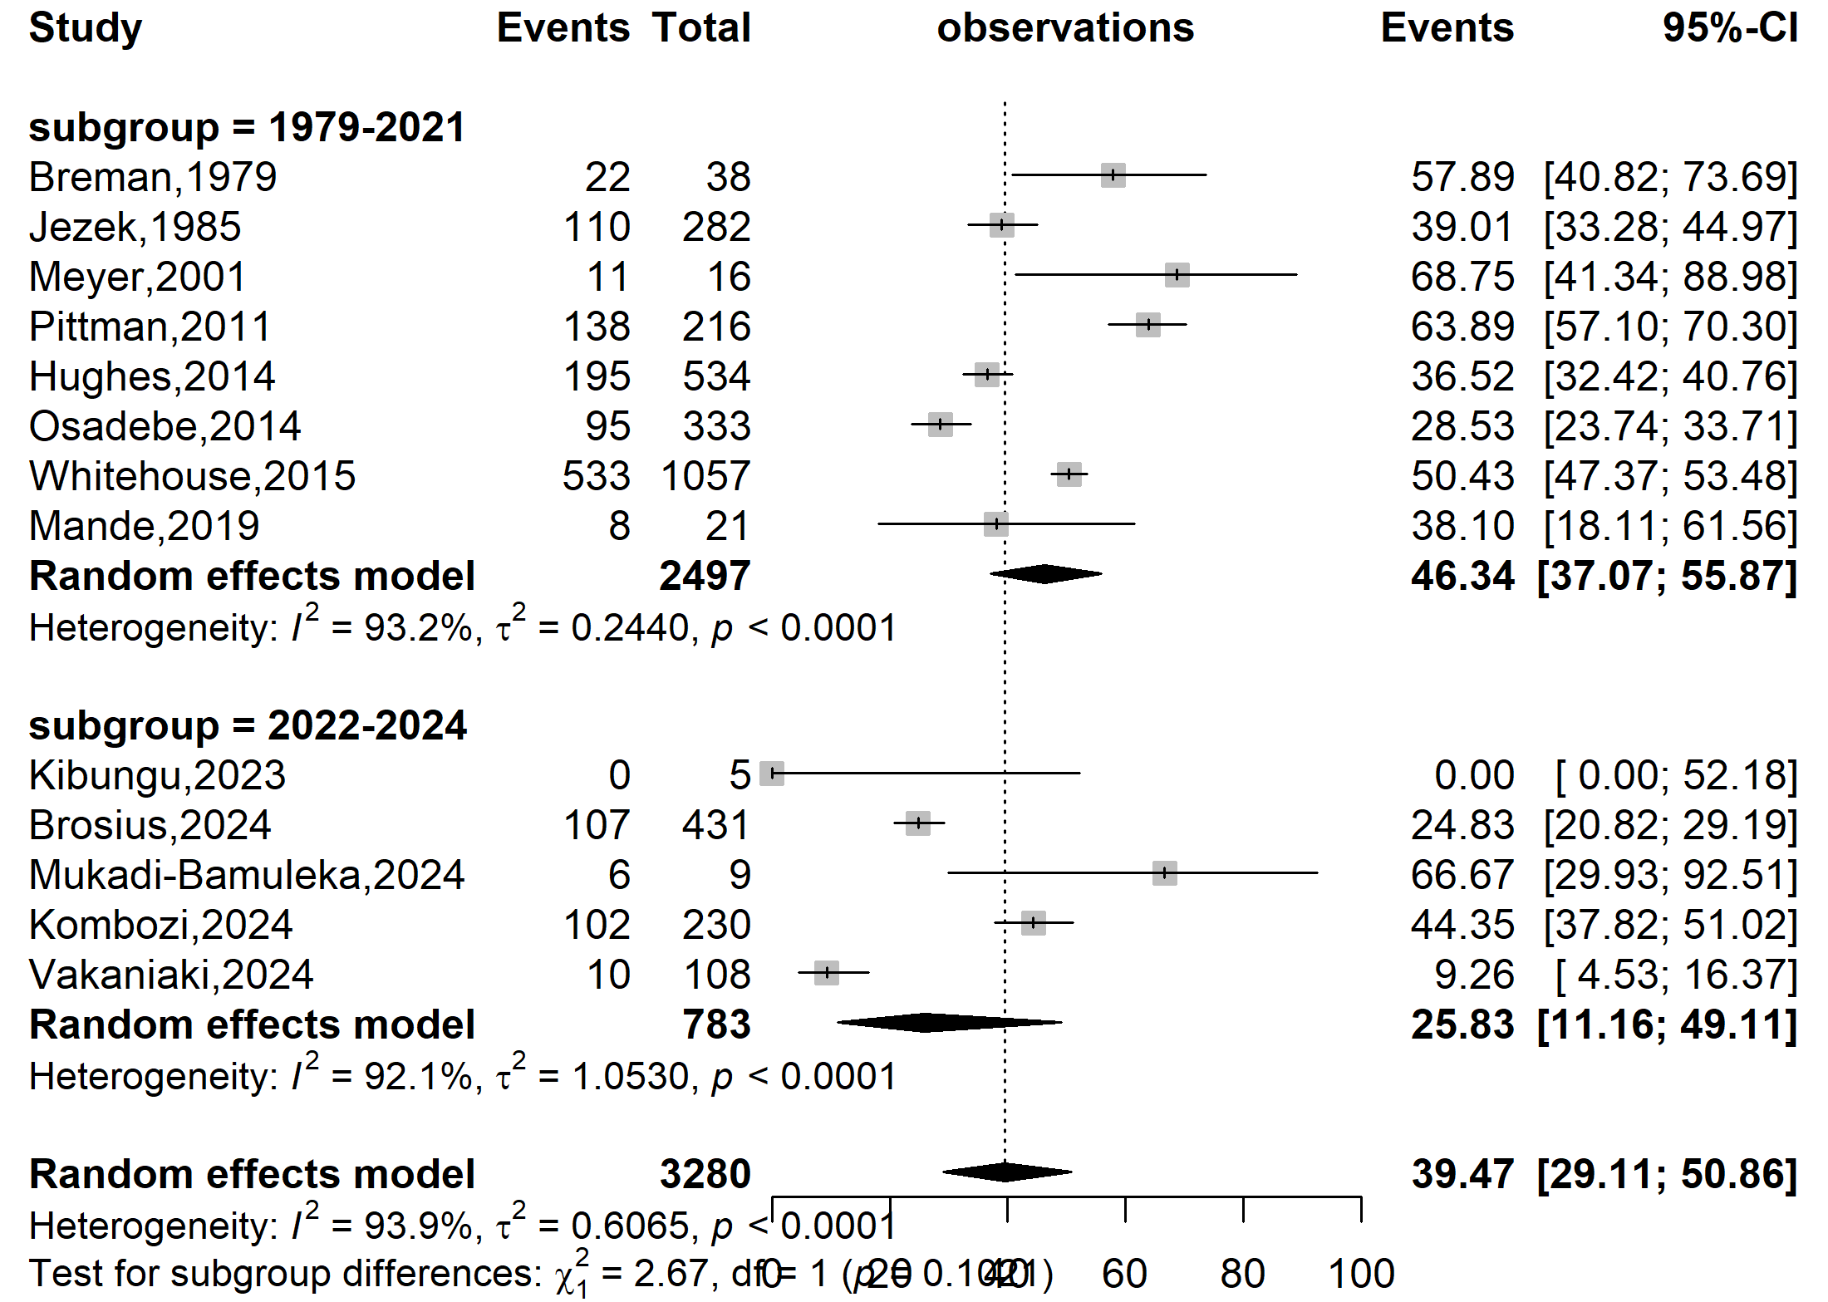
Severity rate (%)
Event rate (%)

Supplementary Fig. 1 Subgroup estimates of the Mpox severity rate in DRC, 1970-2024
(by before and after the global Mpox outbreak)

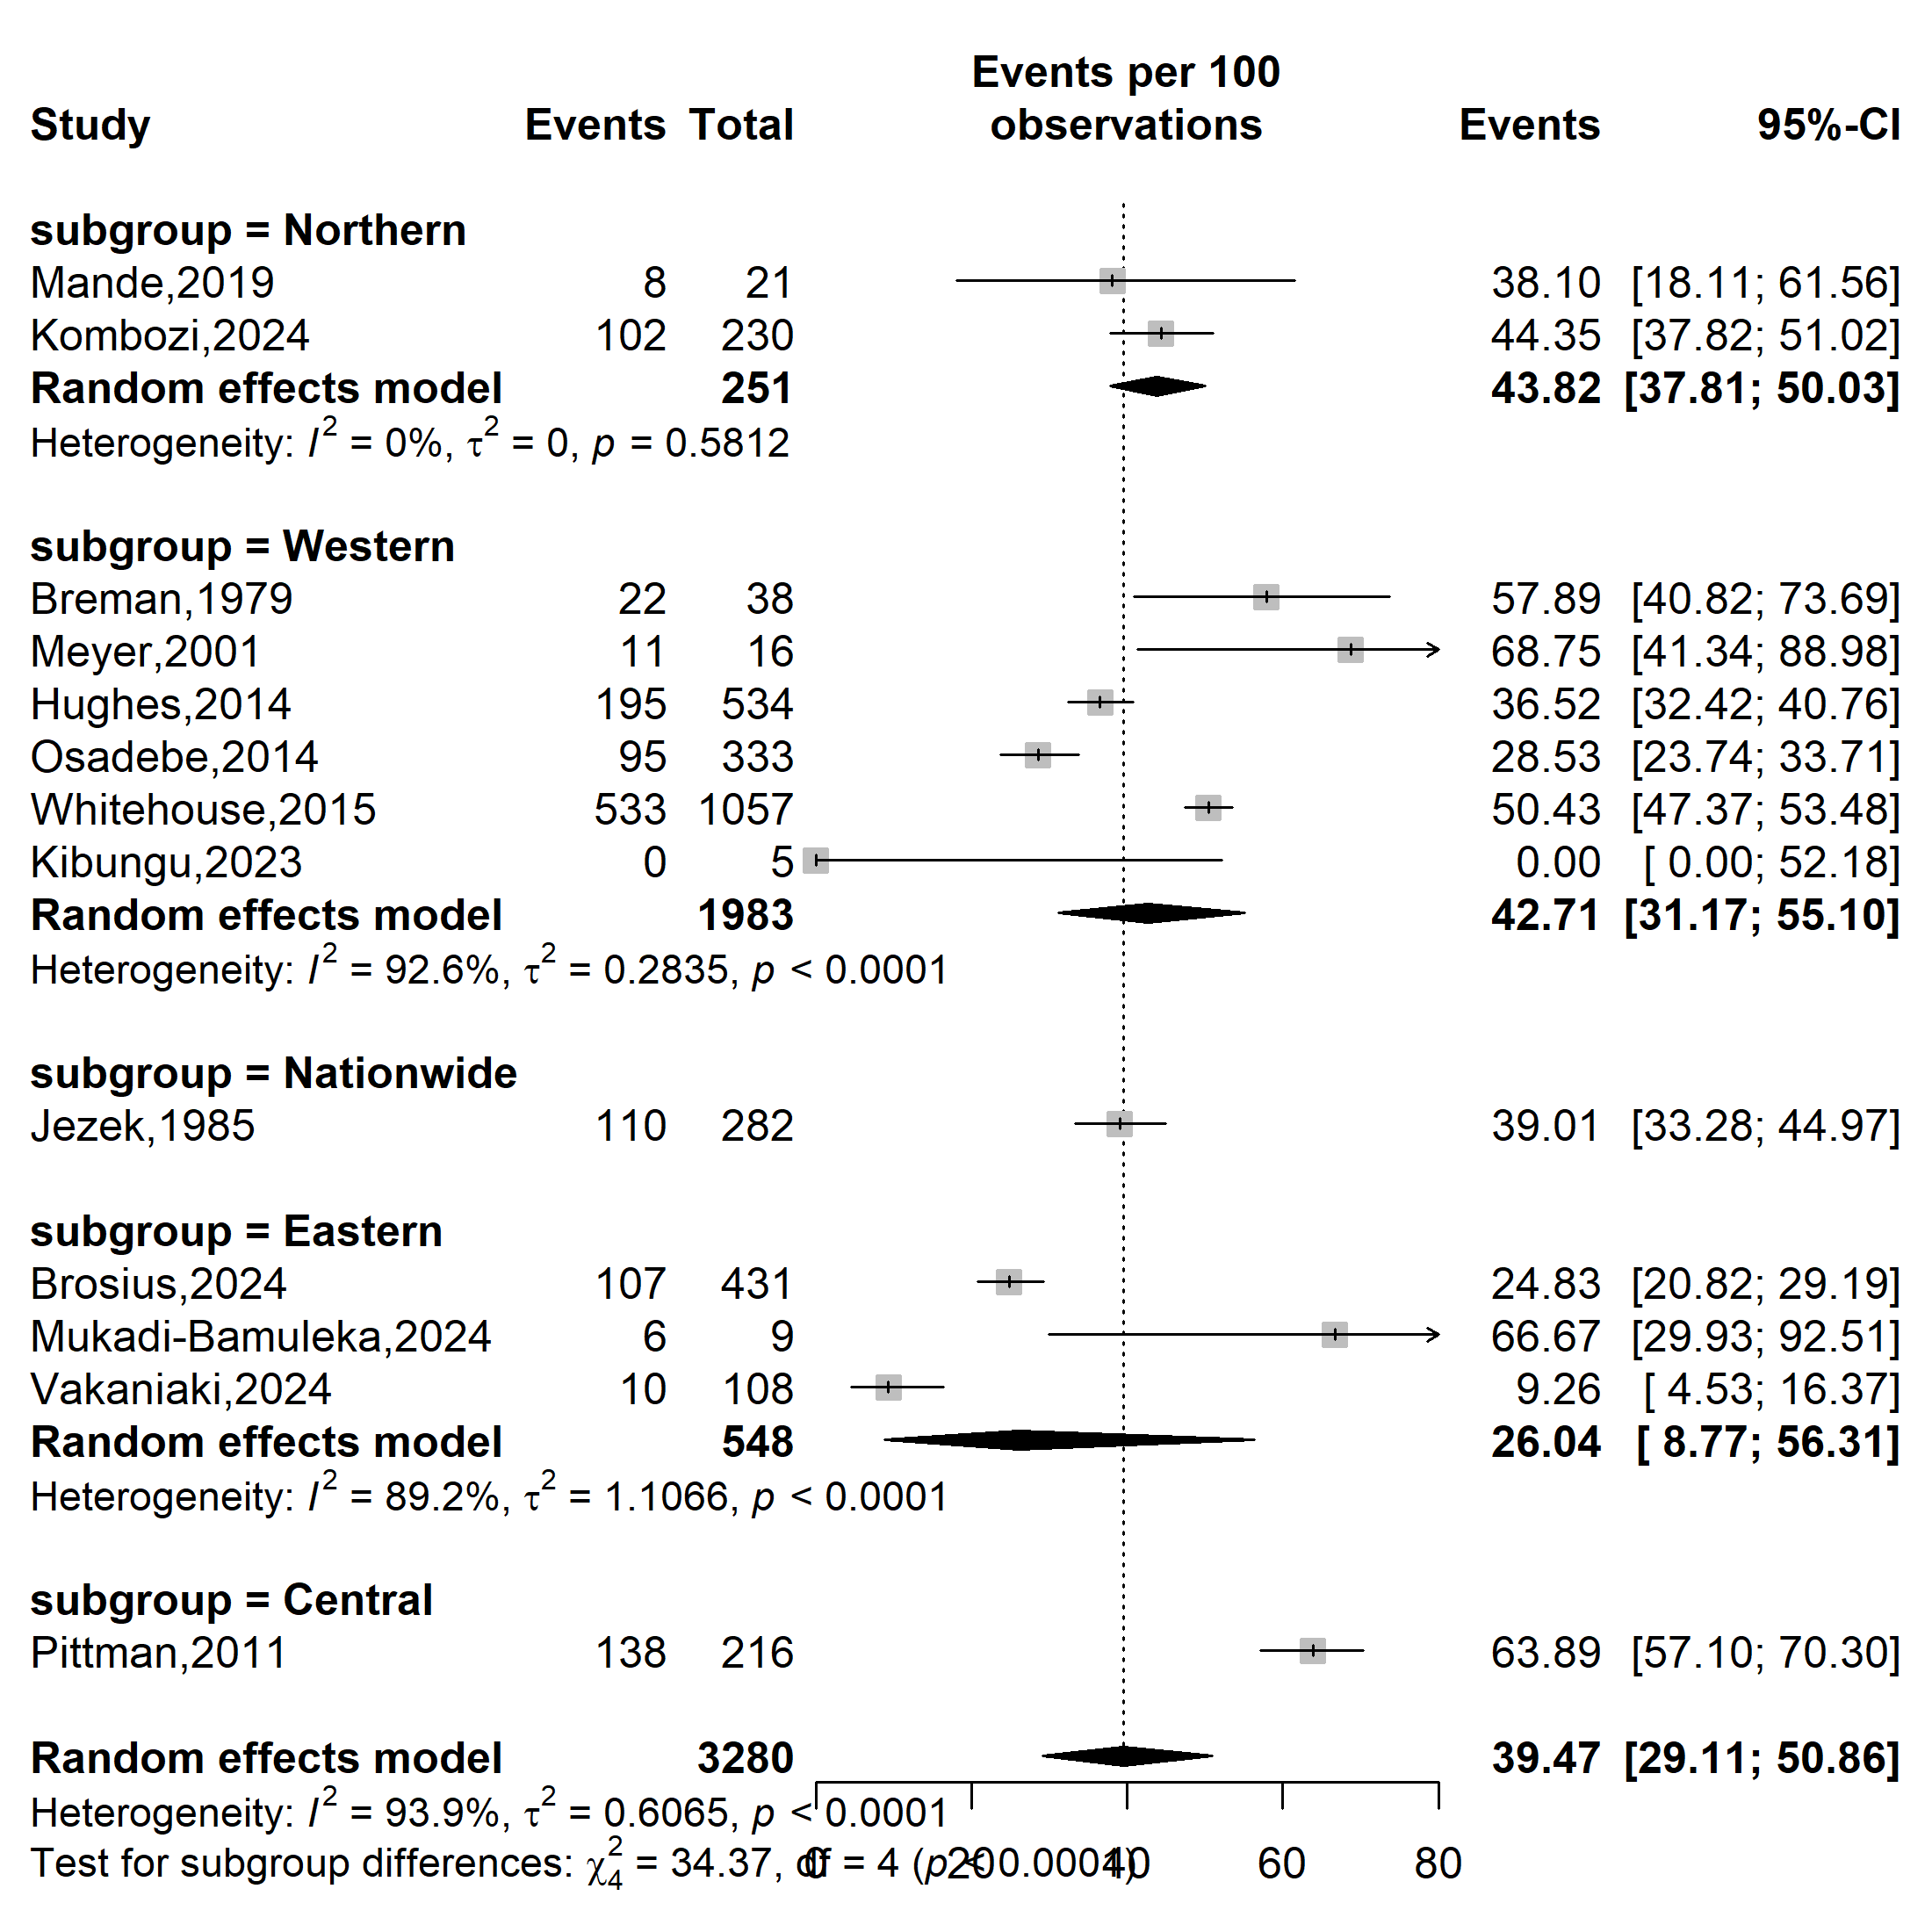
Severity rate (%)
Event rate (%)

Supplementary Fig. 2 Subgroup estimates of the Mpox severity rate in DRC, 1970-2024
(based on geographical localization: Eastern: North and South Kivu; Northern: Bas-uélé and Tshopo; Western: Equateur, Tshuapa, and Kwango; Central: Sankuru)

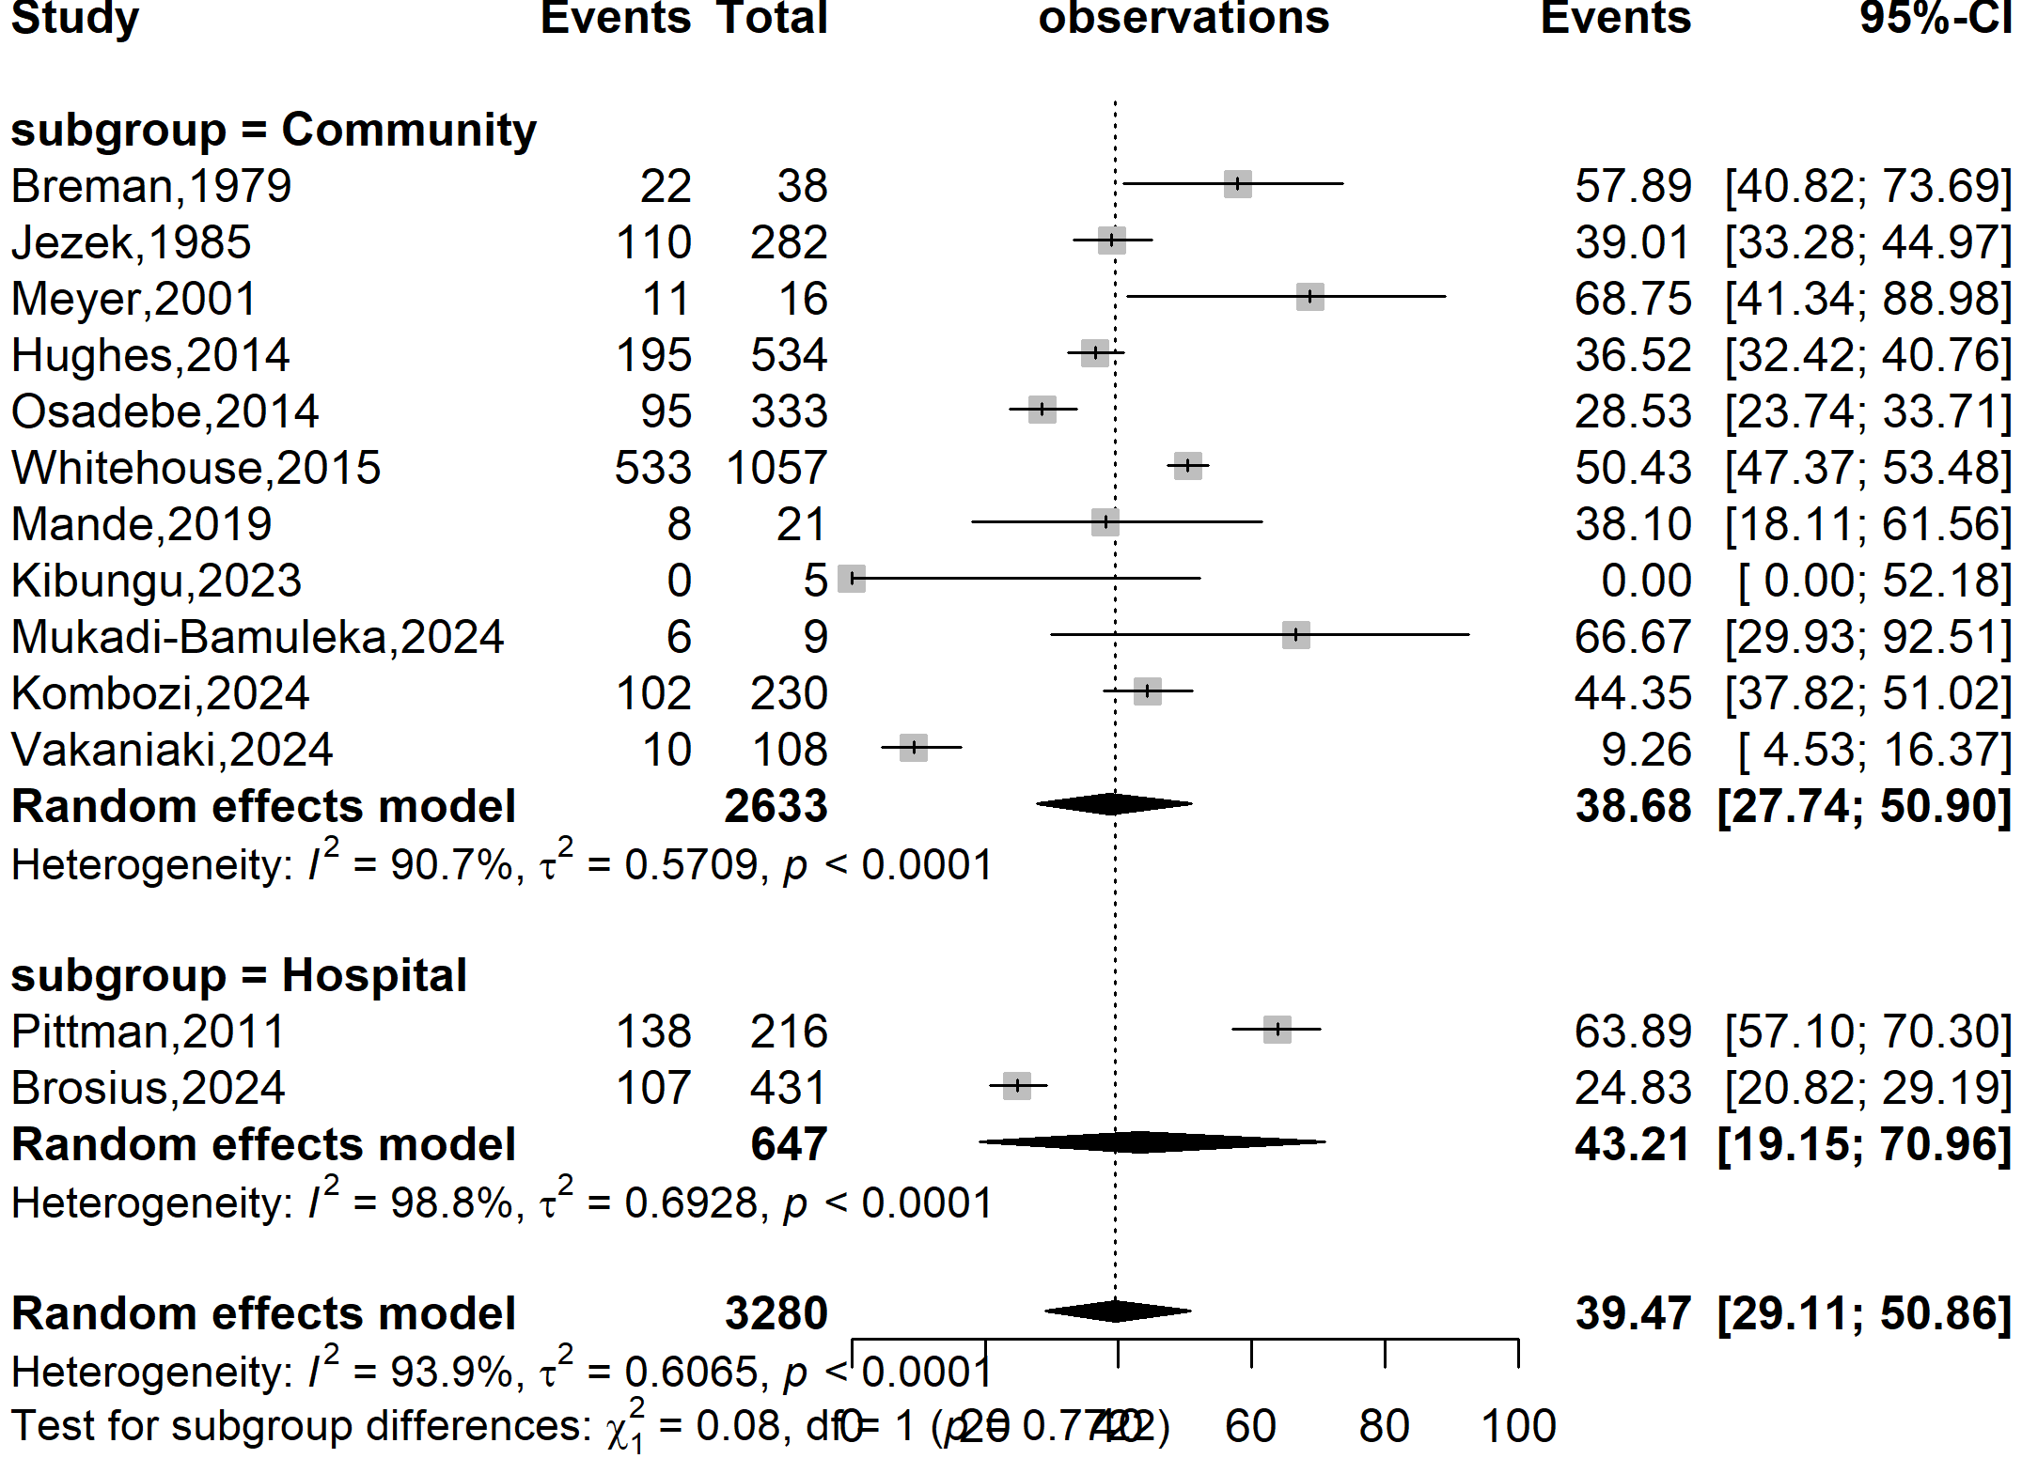
Event rate (%)

Severity rate (%)
Supplementary Fig. 3 Subgroup estimates of the Mpox severity rate in DRC, 1970-2024
(based on study setting)

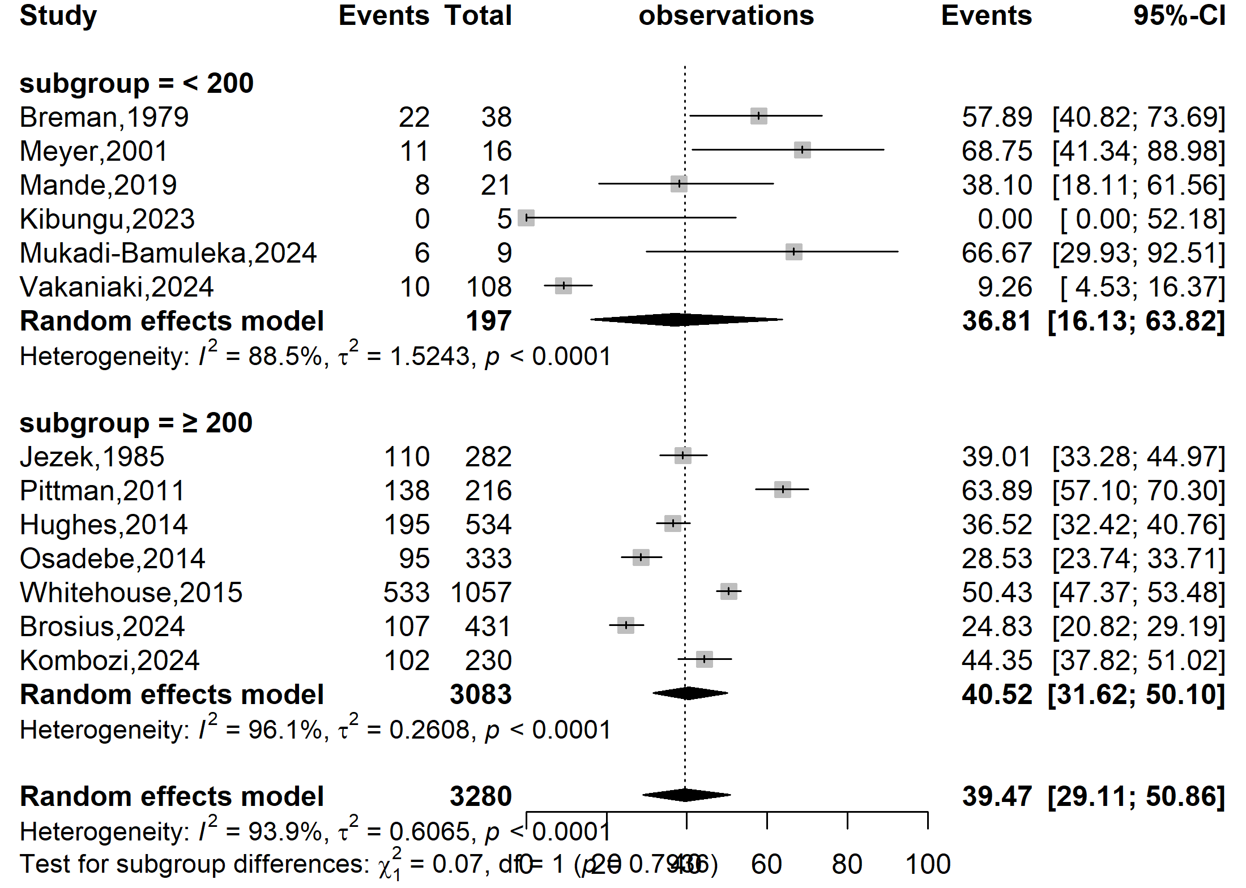
Event rate (%)

Severity rate (%)
Supplementary Fig. 4 Subgroup estimates of the Mpox severity rate in DRC, 1970-2024
(Based on the disease burden: median number of confirmed cases)

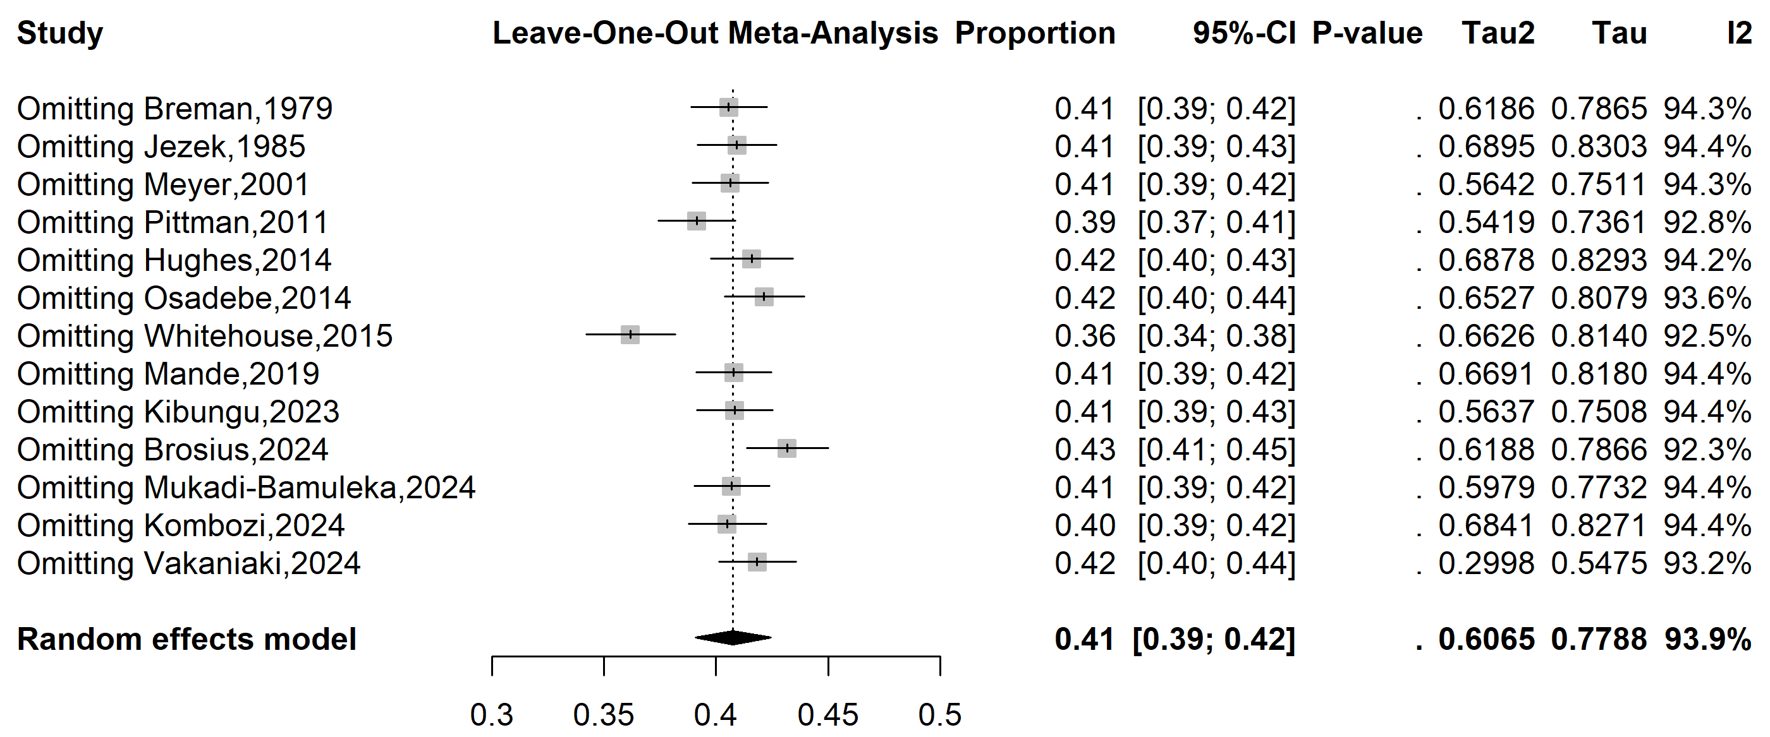
Supplementary Fig. 5 Sensitivity analysis of the pooled Mpox severity rate estimates in DRC, 1970-2024

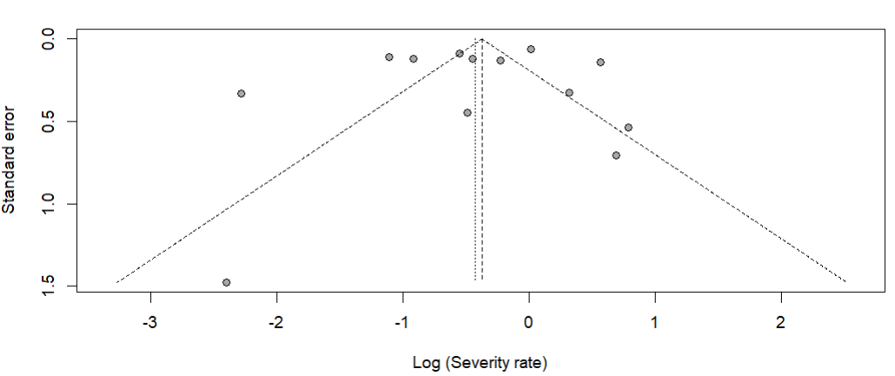
Egger’s test, p-value = 0.638
Begg’s test, p-value = 0.626

Supplementary Fig. 6 Funnel plot with pseudo 95% confidence limits and tests assessing the publication bias studies included

