Supporting information

Clinical and sociodemographic correlates of poor medication adherence in people with bipolar disorder: A systematic review and meta-analysis

Francesco Bartoli^{1,}*, Daniele Cavaleri¹, Ilaria Riboldi¹, Chiara Alessandra Capogrosso¹, Carlo Bassetti¹, Marco Broccia¹, Giorgio Cucchi¹, Cristina Crocamo¹, Martha Sajatovic², Giuseppe Carrà¹.

¹ School of Medicine and Surgery, University of Milano-Bicocca, via Cadore 48, 20900 Monza, Italy.
² Neurological and Behavioral Outcomes Center, University Hospitals Cleveland Medical Center, Case Western Reserve University, Cleveland, OH, 44106, USA.

Supplementary figures: 39

Abbreviations: k = number of studies; N = total number of participants; OR = odds ratio; SMD = standardized mean difference; CI = confidence interval; I² = heterogeneity statistic.

Supplementary Figure 1. Distribution of included studies by year of publication.

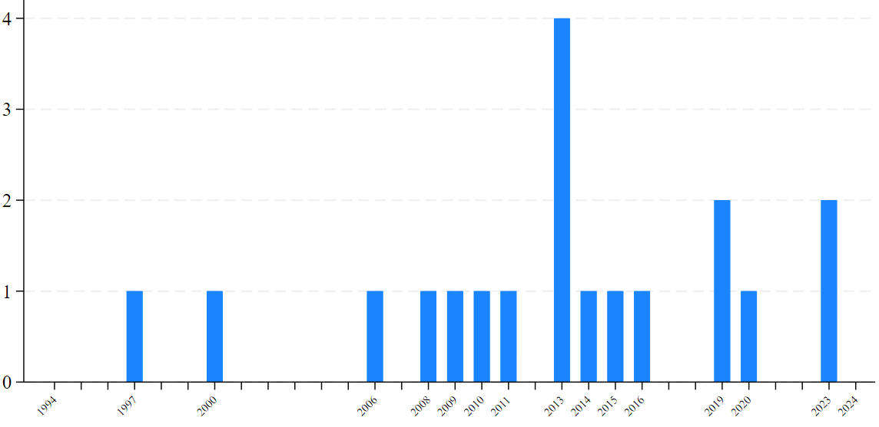

Supplementary Figure 2. Mean age of participants with poor adherence as compared with those with good adherence.

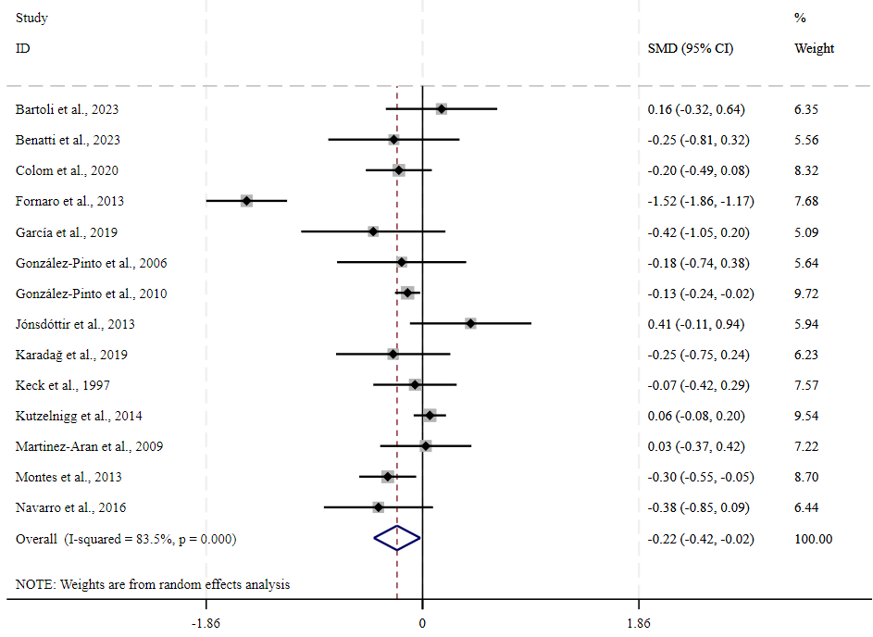
k=14; N=4,220; SMD=–0.22, 95%CI: –0.42 to –0.02, p=0.031; I²=83.5%
Supplementary Figure 3. Male gender in participants with poor adherence as compared with those with good adherence.

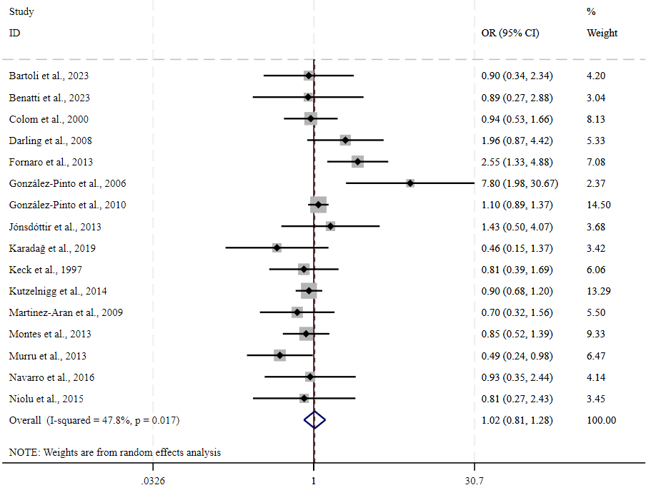
k=16; N=4,517; OR=1.02, 95%CI: 0.81 to 1.28, p=0.867; I²=47.8%
Supplementary Figure 4. Mean years of education of participants with poor adherence as compared with those with good adherence.

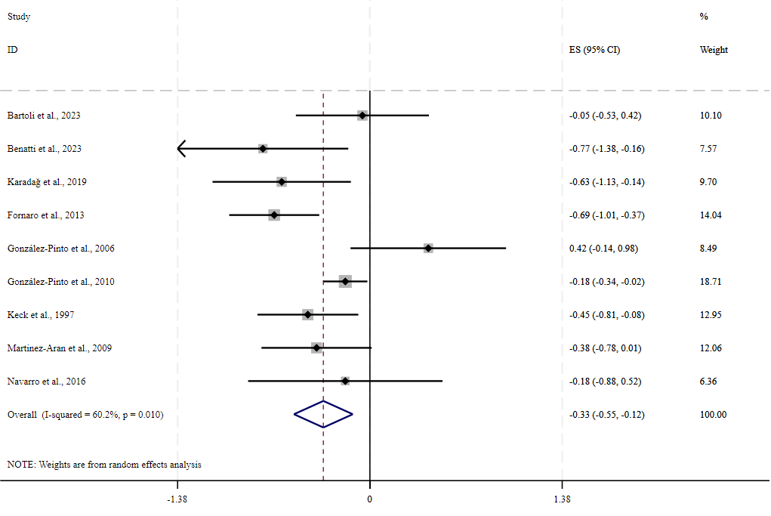
k=9; N=2,675; SMD=–0.34, 95%CI: –0.55 to –0.12, p=0.002; I²=60.2%
Supplementary Figure 5. Higher education in participants with poor adherence as compared with those with good adherence.

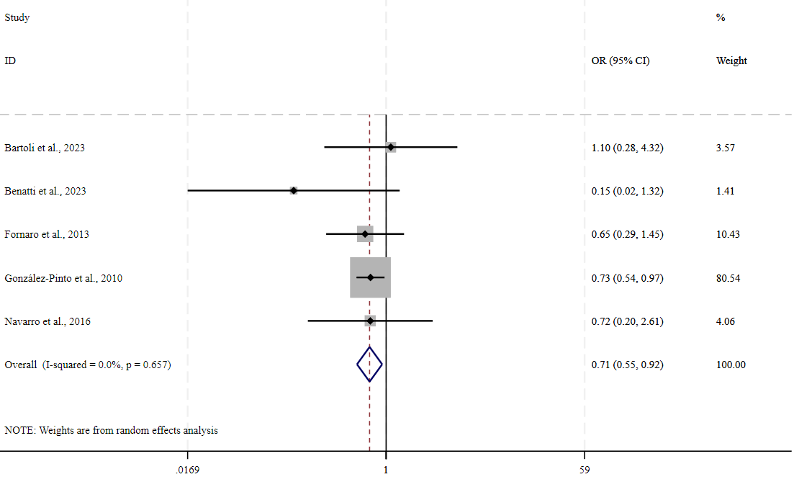
k=5; N=2,249; OR=0.71, 95%CI: 0.55 to 0.92, p=0.010; I²=0%
Supplementary Figure 6. Being in a relationship in participants with poor adherence as compared with those with good adherence.

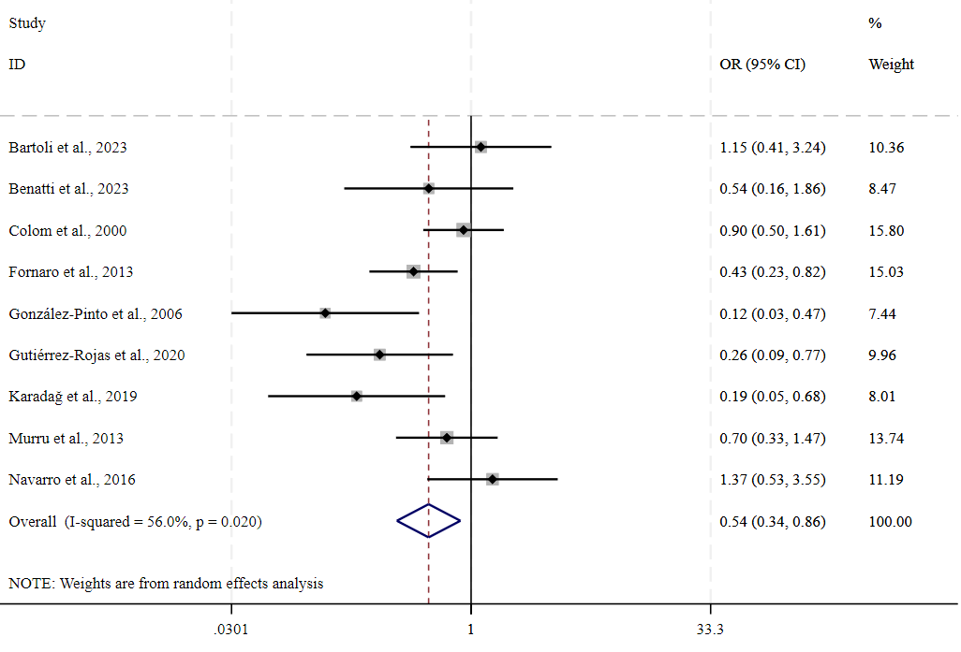
k=9; N=1,056; OR=0.54, 95%CI: 0.34 to 0.86, p=0.009; I²=56.0%
Supplementary Figure 7. Unemployment in participants with poor adherence as compared with those with good adherence.

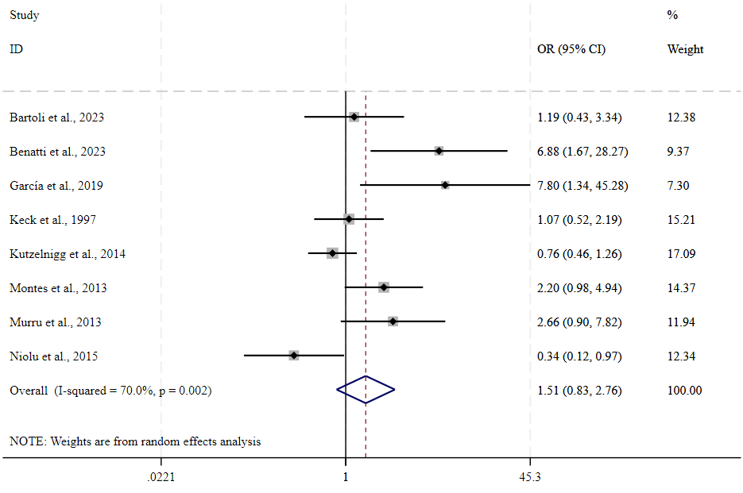
k=8; N=1,730; OR=1.51, 95%CI: 0.83 to 2.76, p=0.177; I²=70.0%
Supplementary Figure 8. Living alone in participants with poor adherence as compared with those with good adherence.

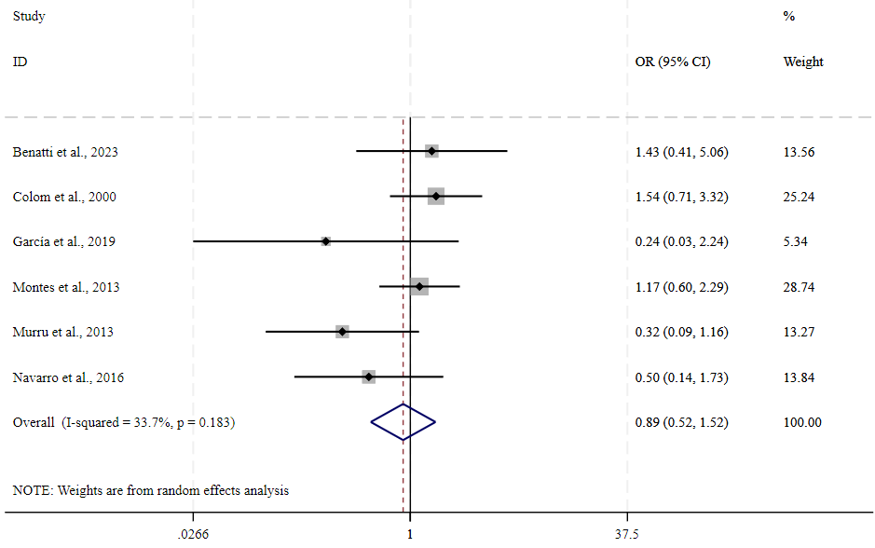
k=6; N=814; OR=0.89, 95%CI: 0.52 to 1.52, p=0.664; I²=33.7%
Supplementary Figure 9. Age at onset in participants with poor adherence as compared with those with good adherence.

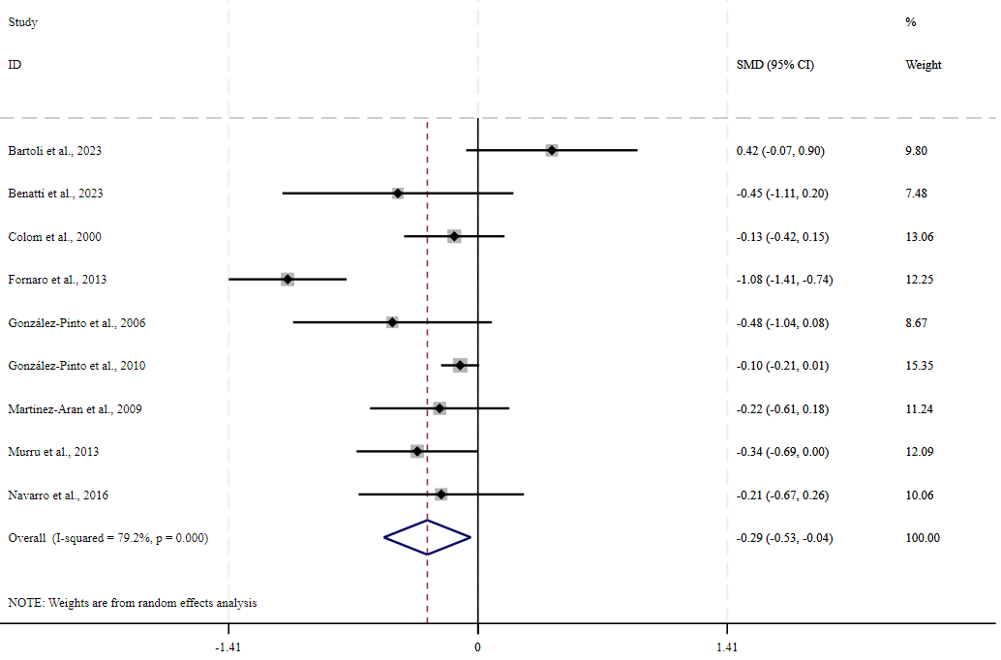
k=9; N=2,761; SMD=–0.29, 95%CI: –0.53 to –0.04, p=0.023; I²=79.2%
Supplementary Figure 10. Duration of illness in participants with poor adherence as compared with those with good adherence.

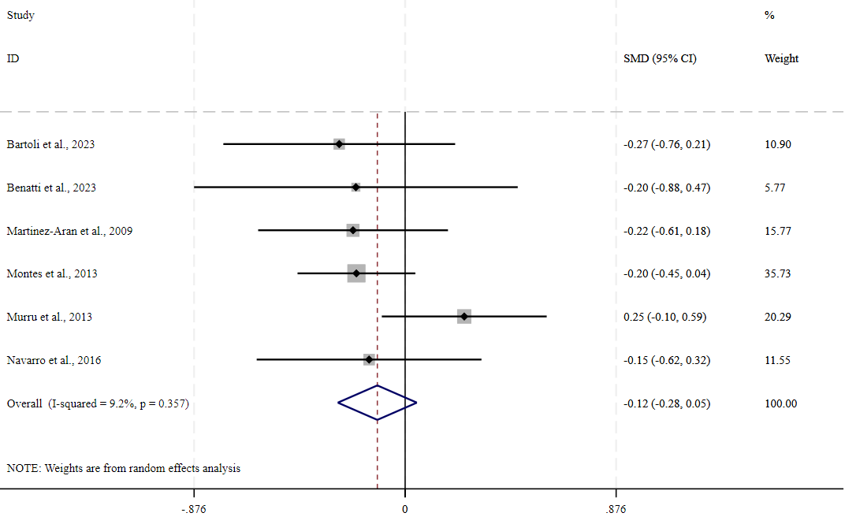
k=6; N=739; SMD=–0.12, 95%CI: –0.28 to 0.05, p=0.168; I²=9.2%
Supplementary Figure 11. Psychotic features in participants with poor adherence as compared with those with good adherence.

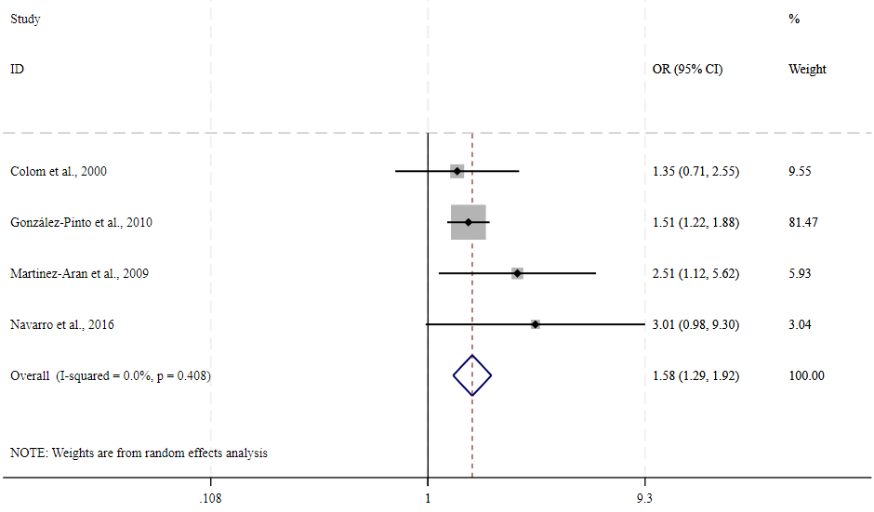
k=4; N=2,210; OR=1.58, 95%CI: 1.30 to 1.92, p<0.001; I²=0%
Supplementary Figure 12. History of suicide attempts in participants with poor adherence as compared with those with good adherence.

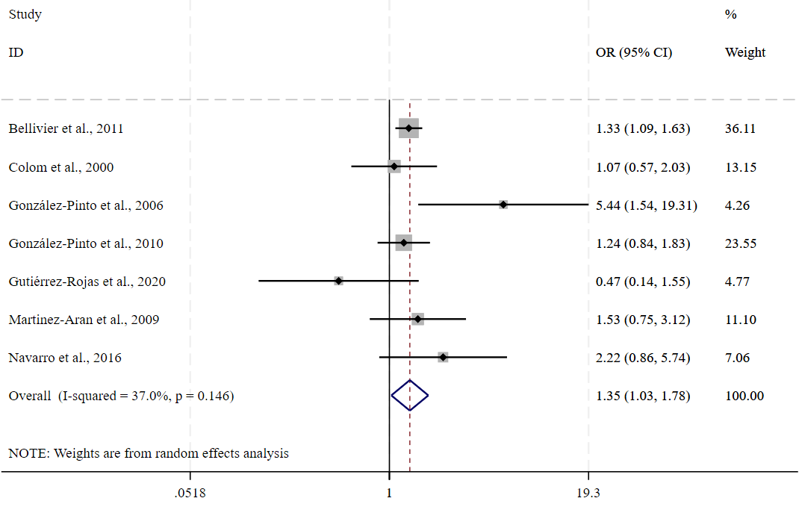
k=7; N=4,609; OR=1.36, 95%CI: 1.03 to 1.78, p=0.030; I²=37.0%
Supplementary Figure 13. Family history of mood disorders in participants with poor adherence as compared with those with good adherence.

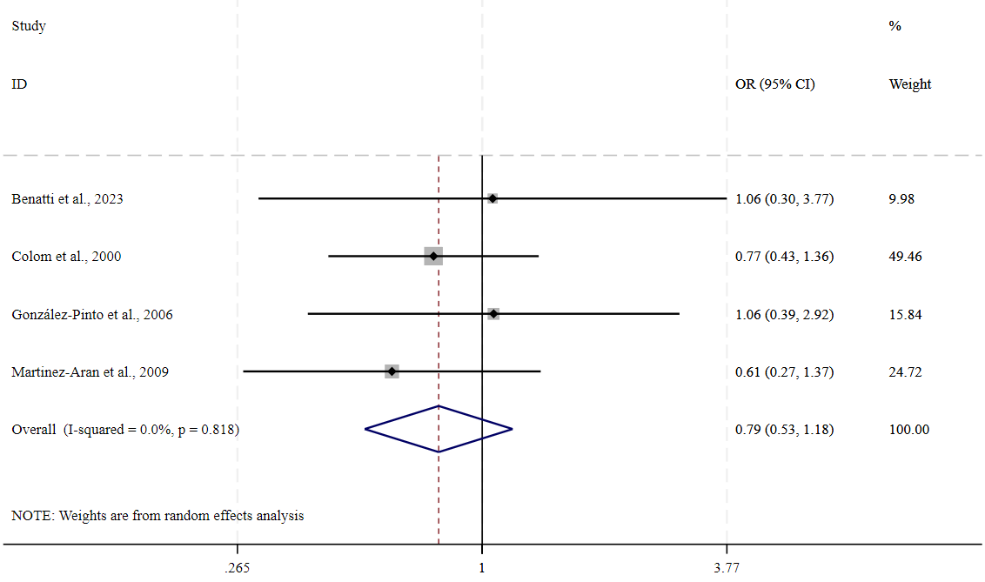
k=4; N=419; OR=0.79, 95%CI: 0.53 to 1.18, p=0.249; I²=0%
Supplementary Figure 14. Diagnosis of bipolar disorder type I in participants with poor adherence as compared with those with good adherence.

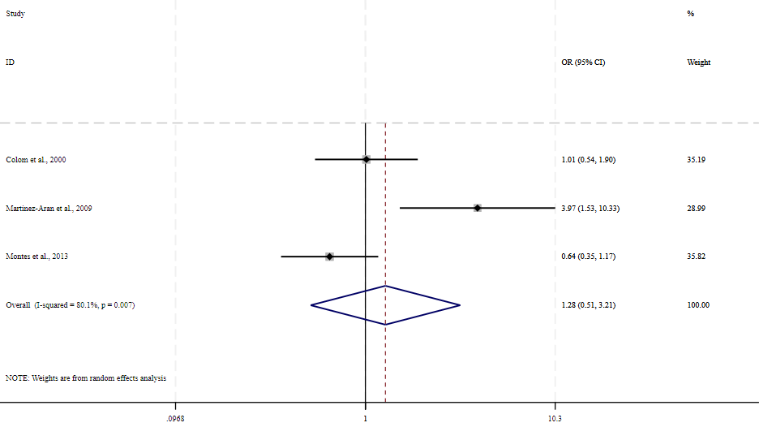
k=3; N=606; OR=1.28, 95%CI: 0.51 to 3.21, p=0.599; I²=80.1%
Supplementary Figure 15. Rapid cycling course in participants with poor adherence as compared with those with good adherence.

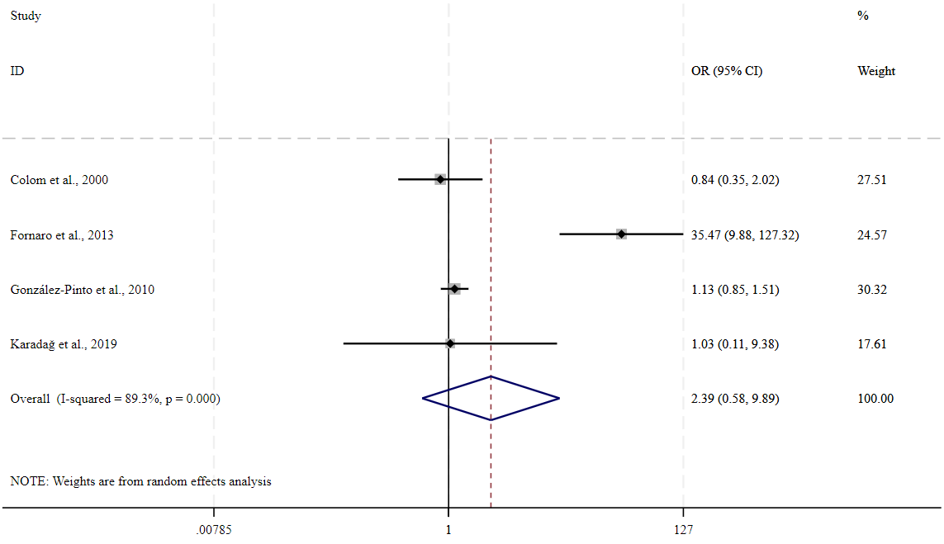
k=4; N=2,368; OR=2.40, 95%CI: 0.58 to 9.89, p=0.705; I²=89.3%
Supplementary Figure 16. Number of previous manic episodes in participants with poor adherence as compared with those with good adherence.

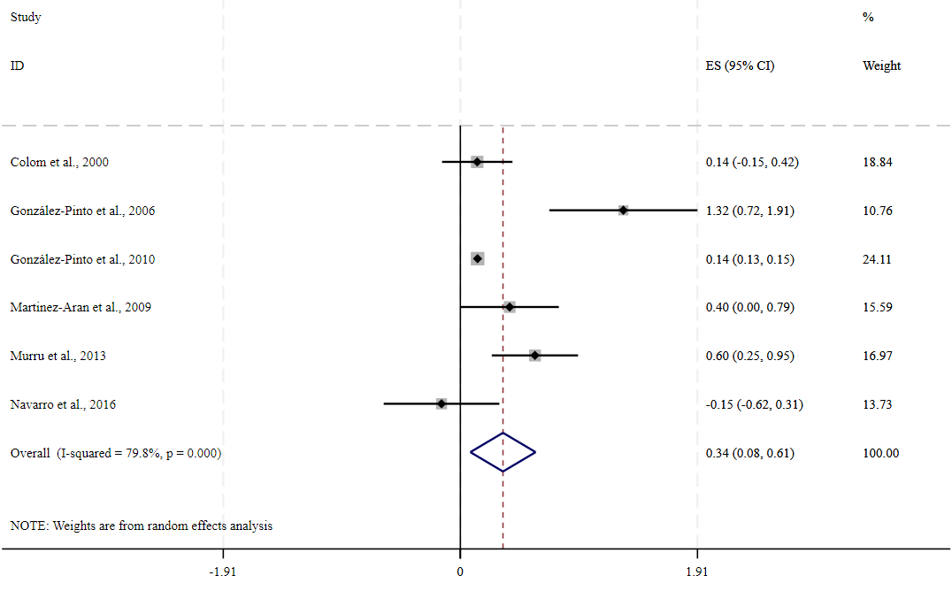
k=6; N=2,432; SMD=0.34, 95%CI: 0.08 to 0.61, p=0.011; I²=79.8%
Supplementary Figure 17. Number of previous mixed episodes in participants with poor adherence as compared with those with good adherence.

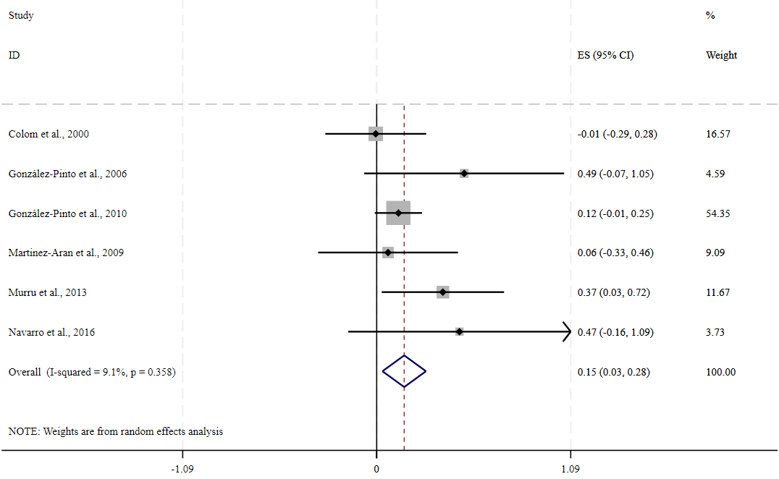
k=6; N=2,432; SMD=0.16, 95%CI: 0.03 to 0.28, p=0.013; I²=9.1%
Supplementary Figure 18. Total number of previous mood episodes in participants with poor adherence as compared with those with good adherence.

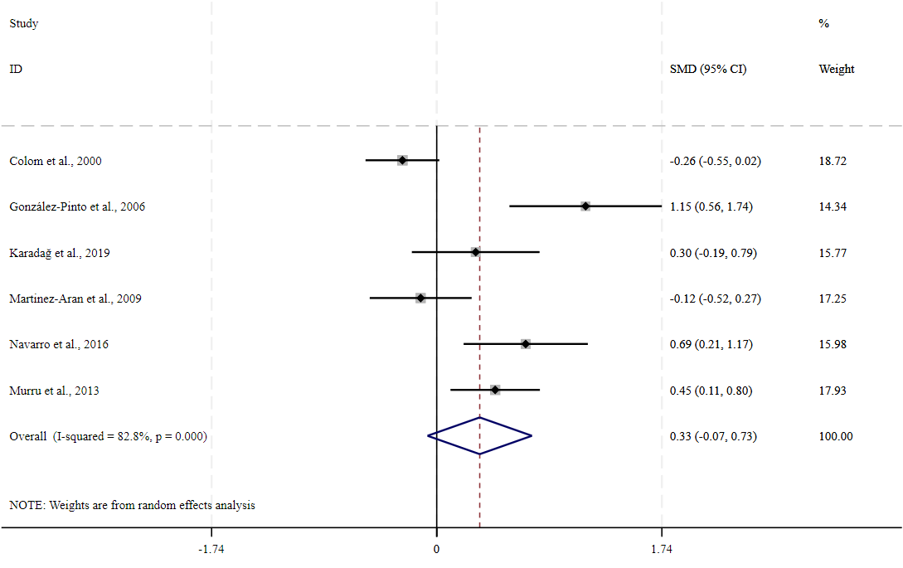
k=6; N=718; SMD=0.33, 95%CI: –0.07 to 0.73, p=0.106; I²=82.8%
Supplementary Figure 19. Number of previous depressive episodes in participants with poor adherence as compared with those with good adherence.

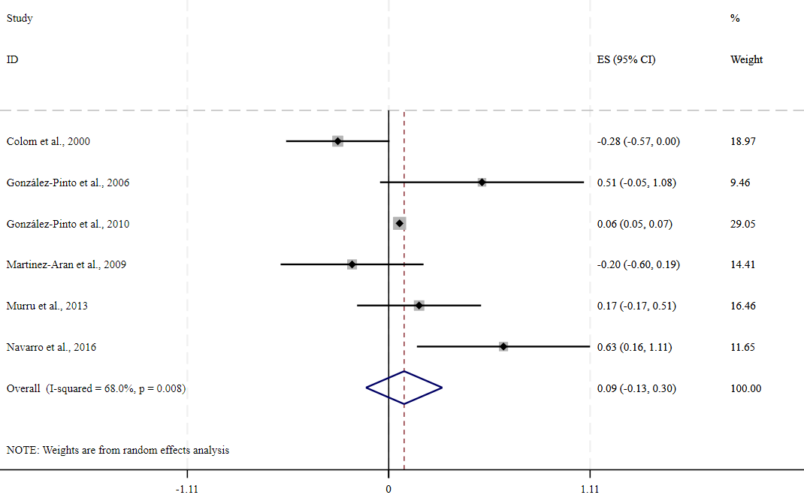
k=6; N=2,432; SMD=0.08, 95%CI: –0.13 to 0.30, p=0.429; I²=68.0%
Supplementary Figure 20. Number of previous hospitalizations in participants with poor adherence as compared with those with good adherence.

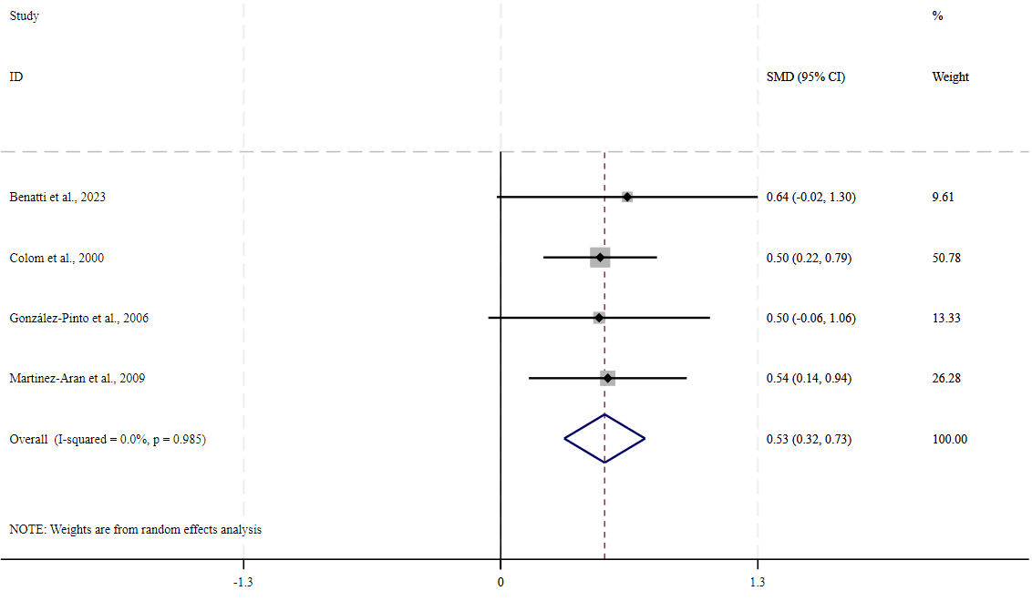
k=4; N=413; SMD=0.53, 95%CI: 0.32 to 0.73, p<0.001; I²=0%
Supplementary Figure 21. Having had at least one previous hospitalization in participants with poor adherence as compared with those with good adherence.

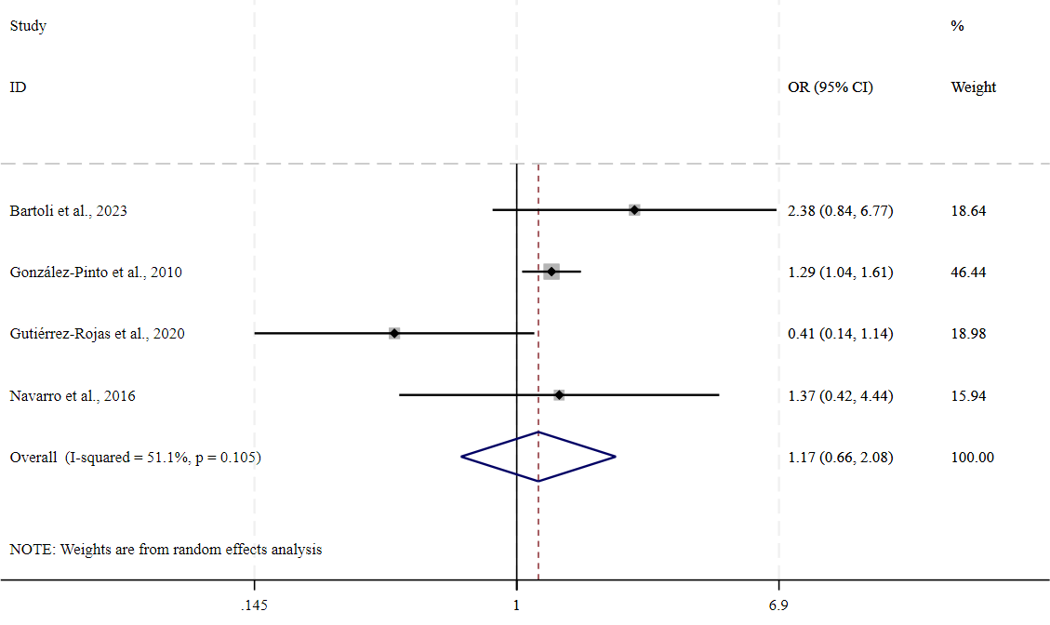
k=4; N=2,086; OR=1.17, 95%CI: 0.66 to 2.08, p=0.583; I²=51.1%
Supplementary Figure 22. Substance use disorder in participants with poor adherence as compared with those with good adherence.

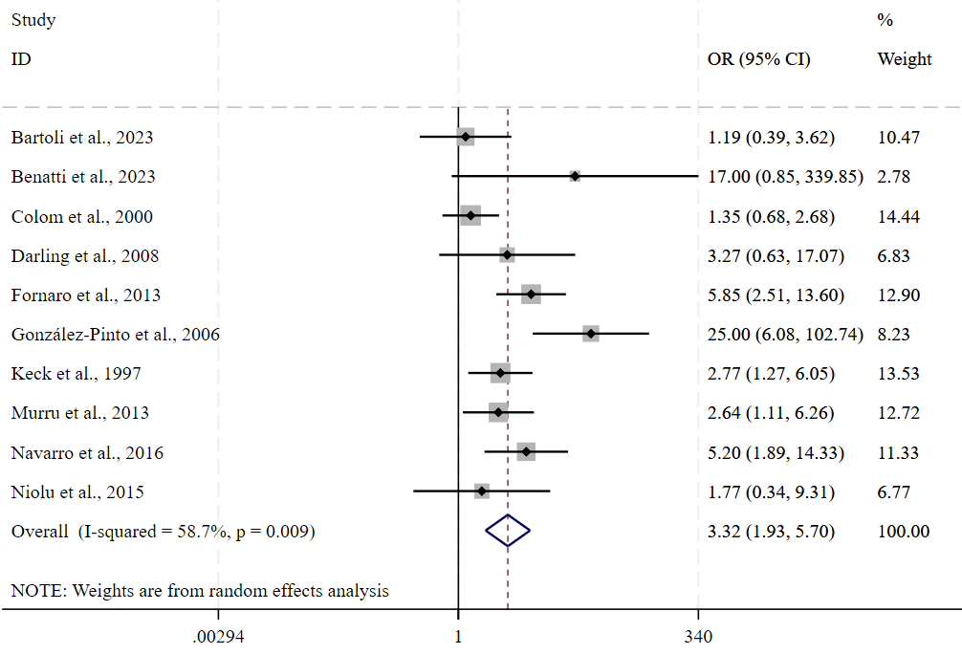
k=10; N=1,159; OR=3.32, 95%CI: 1.94 to 5.70, p<0.001; I²=58.7%
Supplementary Figure 23. Cannabis use disorder in participants with poor adherence as compared with those with good adherence.

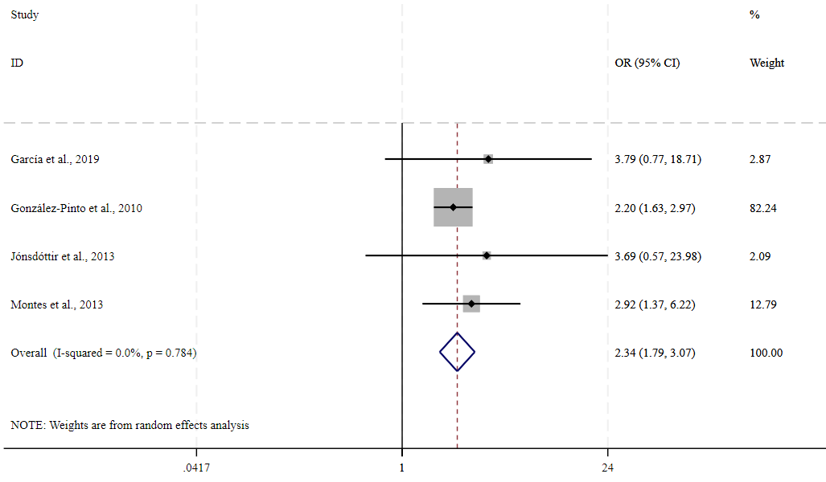
k=4; N=2,281; OR=2.34, 95%CI: 1.79 to 3.07, p<0.001; I²=0%
Supplementary Figure 24. Alcohol use disorder in participants with poor adherence as compared with those with good adherence.

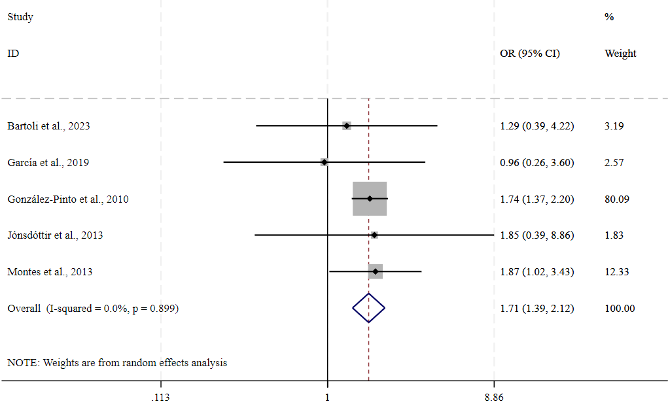
k=5; N=2,352; OR=1.71, 95%CI: 1.39 to 2.12, p<0.001; I²=0%
Supplementary Figure 25. Comorbid generalized anxiety disorder in participants with poor adherence as compared with those with good adherence.

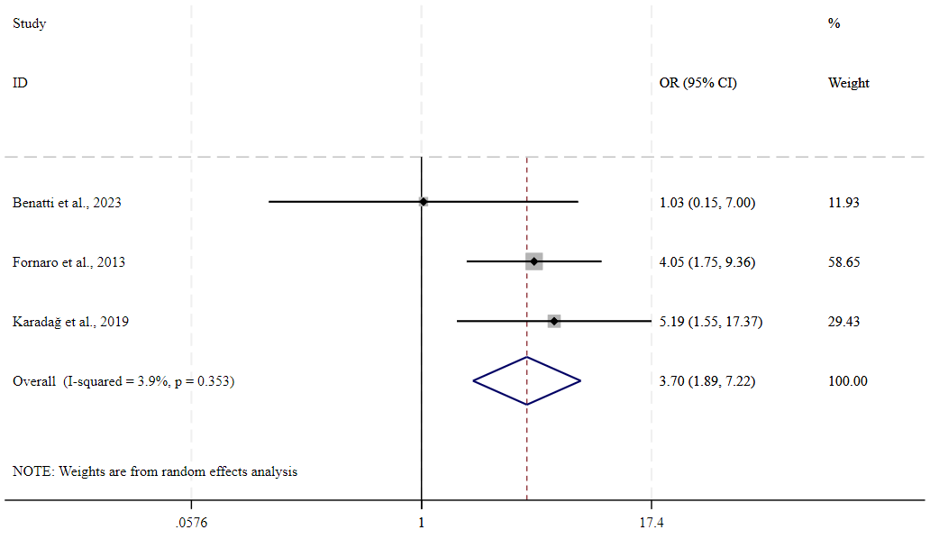
k=3; N=375; OR=3.70, 95%CI: 1.90 to 7.22, p<0.001; I²=3.9%
Supplementary Figure 26. Comorbid personality disorder in participants with poor adherence as compared with those with good adherence.

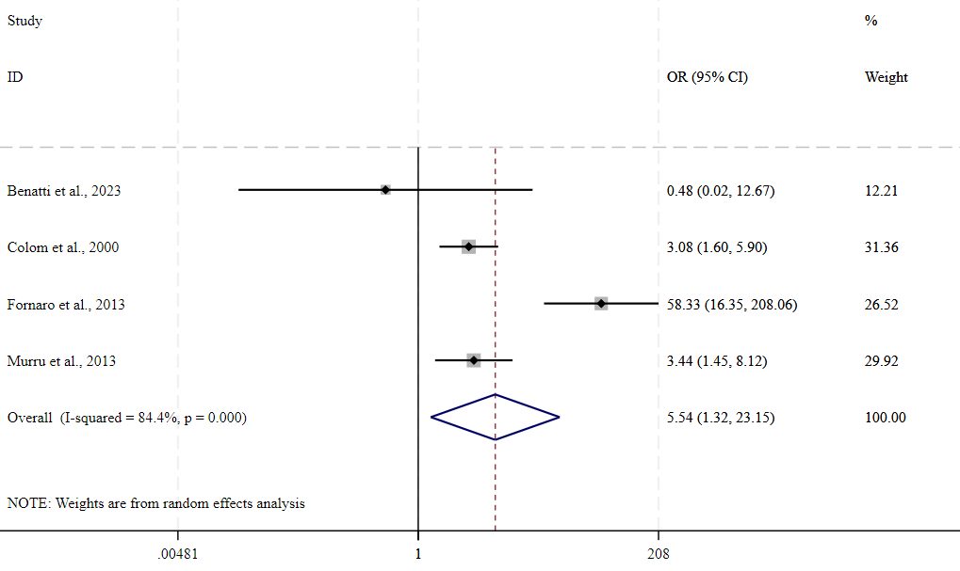
k=4; N=605; OR=5.54, 95%CI: 1.32 to 23.15, p=0.019; I²=84.4%
Supplementary Figure 27. Polypharmacotherapy in participants with poor adherence as compared with those with good adherence.

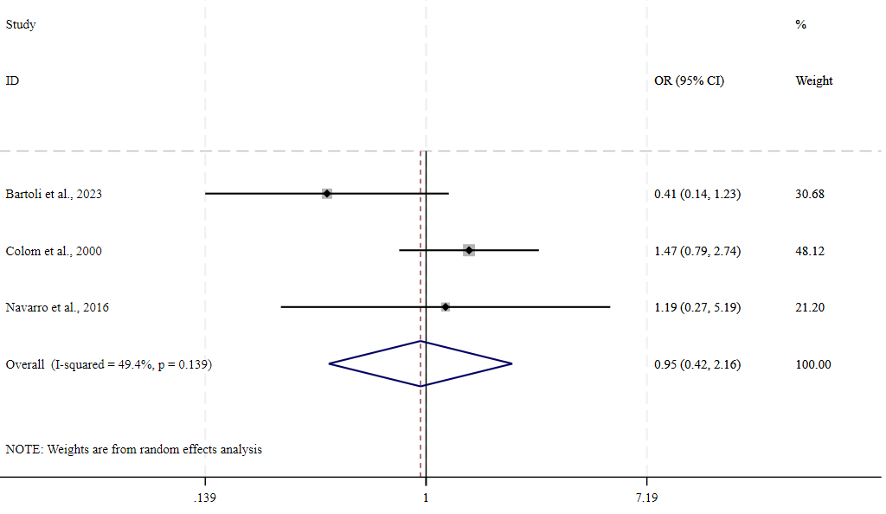
k=3; N=347; OR=0.95, 95%CI: 0.42 to 2.16, p=0.905; I²=49.4%
Supplementary Figure 28. Lithium use in participants with poor adherence as compared with those with good adherence.

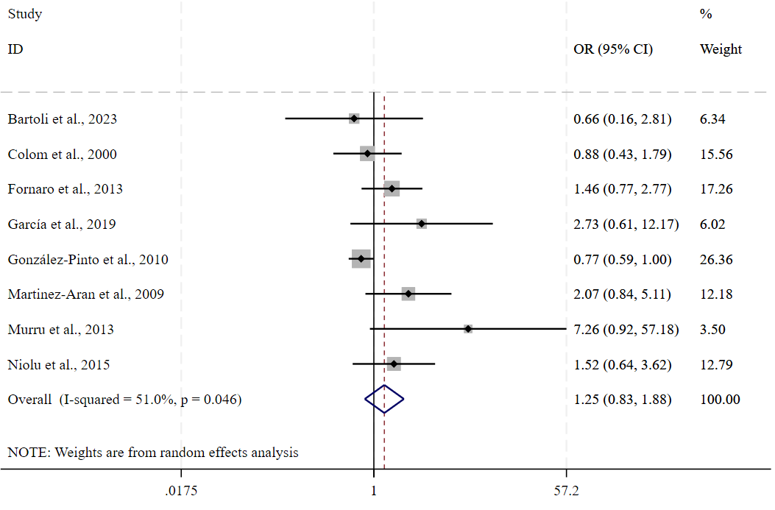
k=8; N=2,706; OR=1.25, 95%CI: 0.83 to 1.88, p=0.293; I²=51.0%
Supplementary Figure 29. Valproate use in participants with poor adherence as compared with those with good adherence.

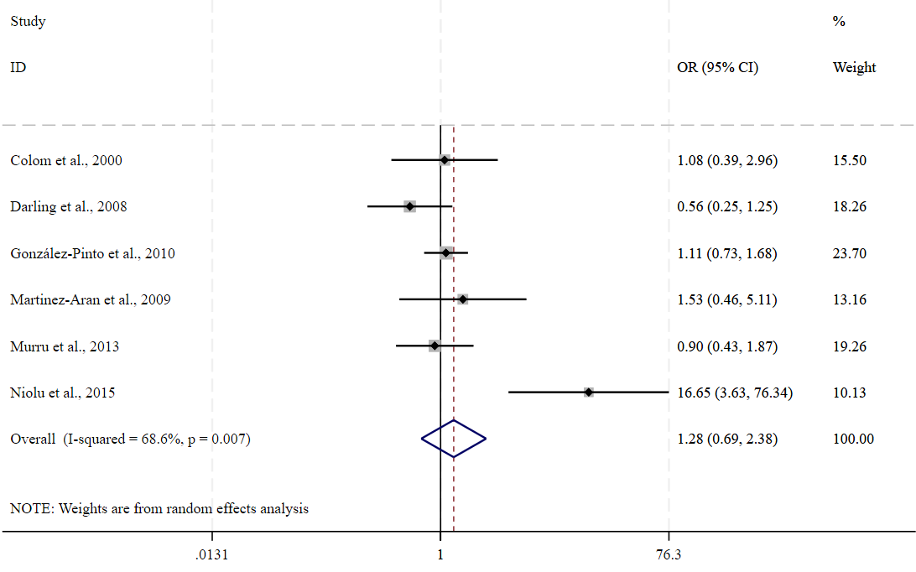
k=6; N=2,463; OR=1.28, 95%CI: 0.69 to 2.38, p=0.428; I²=68.6%
Supplementary Figure 30. Carbamazepine use in participants with poor adherence as compared with those with good adherence.

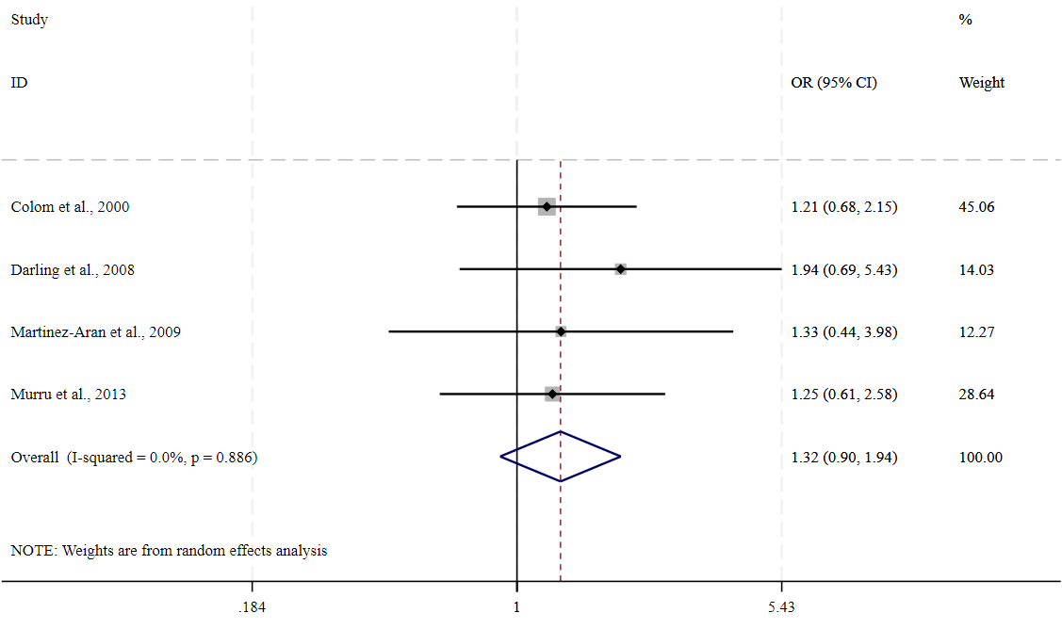
k=4; N=544; OR=1.32, 95%CI: 0.90 to 1.94, p=0.157; I²=0%
Supplementary Figure 31. Antidepressant use in participants with poor adherence as compared with those with good adherence.

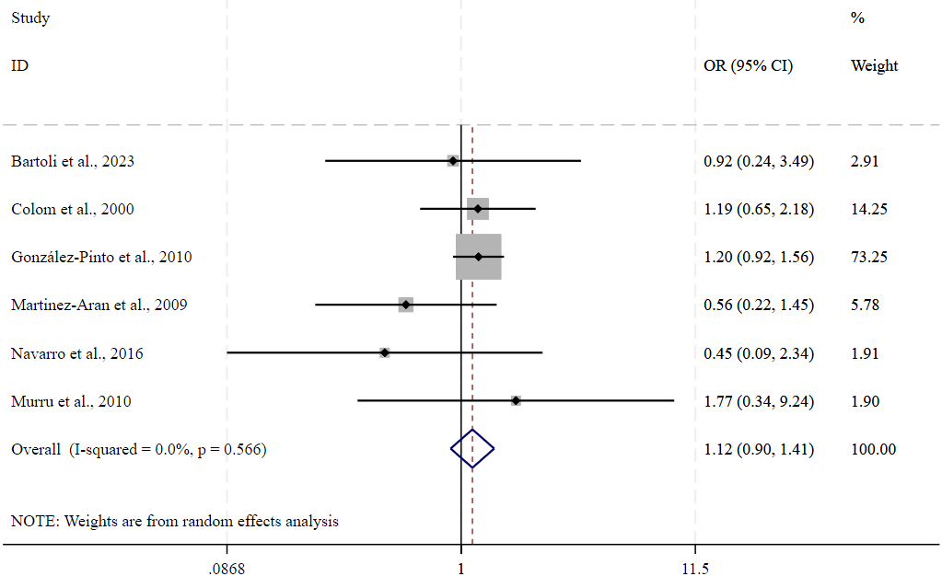
k=6; N=2,386; OR=1.13, 95%CI: 0.90 to 1.41, p=0.312; I²=0%
Supplementary Figure 32. Antipsychotic use in participants with poor adherence as compared with those with good adherence.

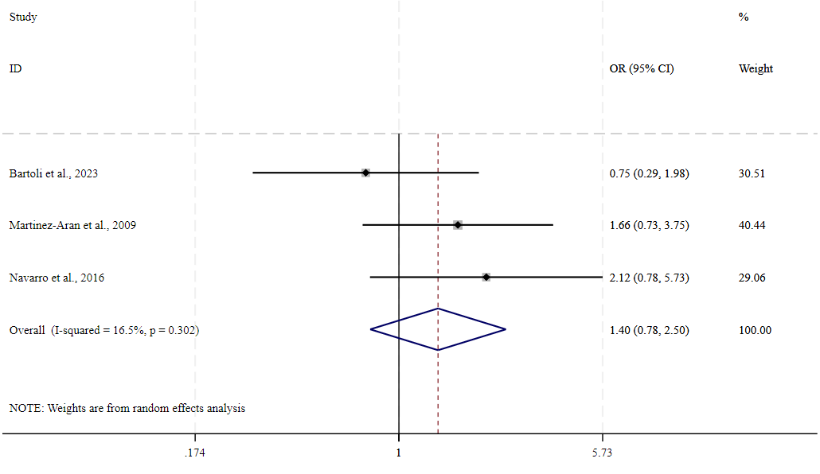
k=3; N=250; OR=1.40, 95%CI: 0.78 to 2.50, p=0.258; I²=16.5%
Supplementary Figure 33. First-generation antipsychotic use in participants with poor adherence as compared with those with good adherence.

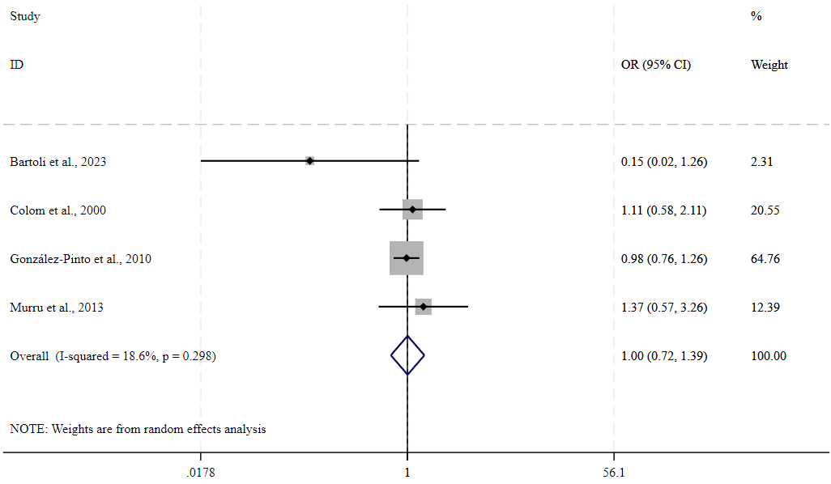
k=4; N=2,239; OR=1.00, 95%CI: 0.72 to 1.39, p=0.980; I²=18.6%
Supplementary Figure 34. Second-generation antipsychotic use in participants with poor adherence as compared with those with good adherence.

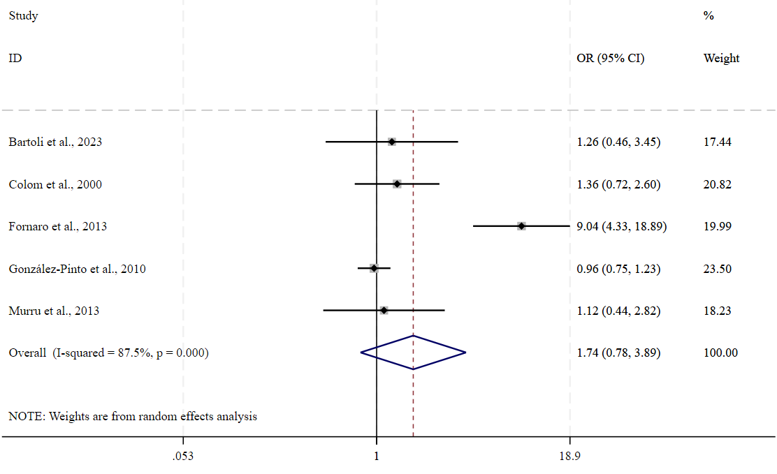
k=5; N=2,463; OR=1.75, 95%CI: 0.78 to 3.89, p=0.174; I²=87.5%
Supplementary Figure 35. Global severity scores in participants with poor adherence as compared with those with good adherence.

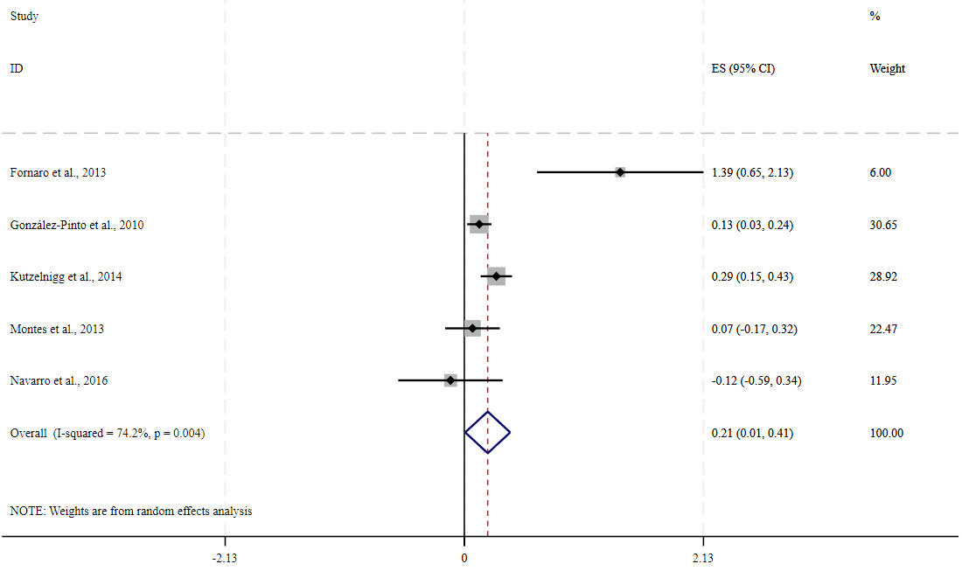
k=5; N=3,321; SMD=0.21, 95%CI: 0.01 to 0.41, p=0.042; I²=74.2%
Supplementary Figure 36. Insight scores in participants with poor adherence as compared with those with good adherence.

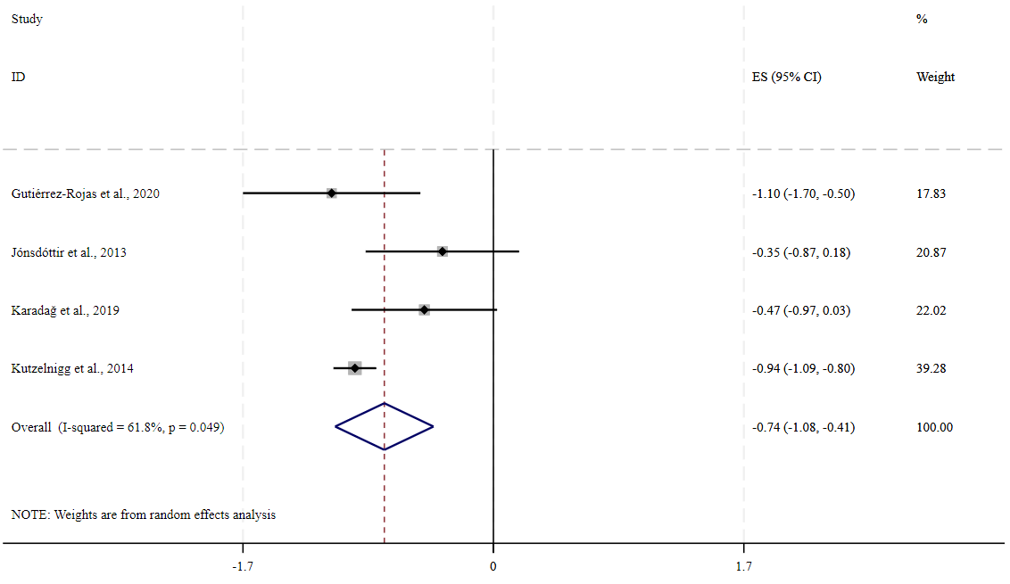
k=4; N=1,219; SMD=–0.74, 95%CI: –1.08 to –0.41, p<0.001; I²=61.8%
Supplementary Figure 37. Global functioning scores in participants with poor adherence as compared with those with good adherence.

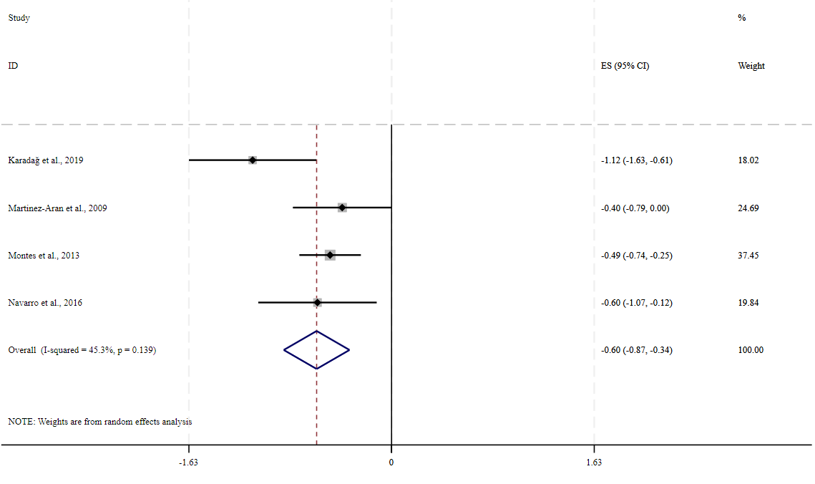
k=4; N=599; SMD=–0.60, 95%CI: –0.87 to –0.34, p<0.001; I²=45.3%
Supplementary Figure 38. Presence of general medical comorbidities in participants with poor adherence as compared with those with good adherence.

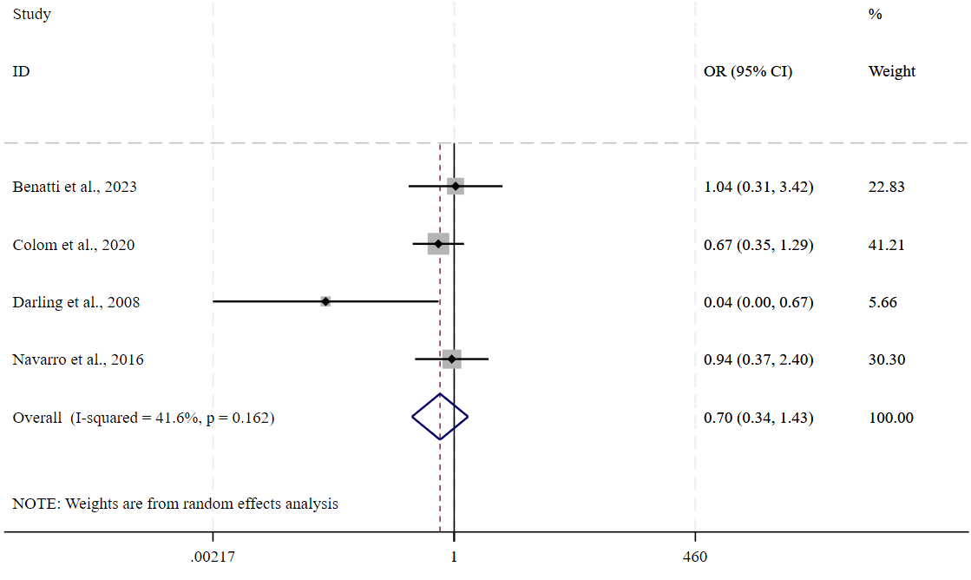
k=4; N=427; OR=0.70, 95%CI: 0.34 to 1.43, p=0.324; I²=41.6%
Supplementary Figure 39. Drug attitude scores in participants with poor adherence as compared with those with good adherence.

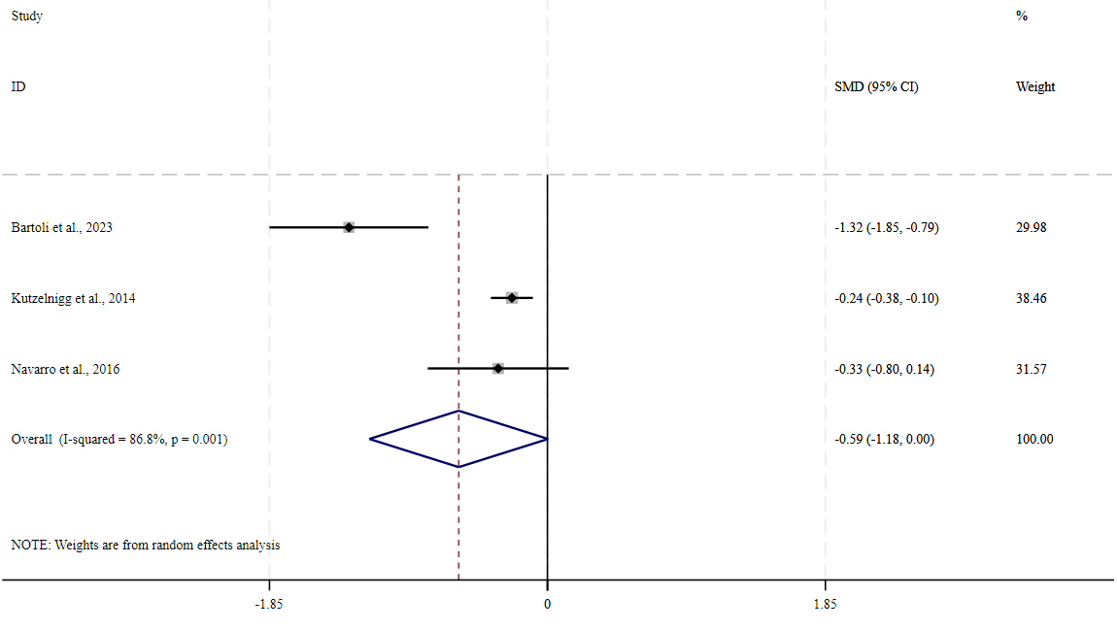
k=3; N=1,038; SMD=–0.59, 95%CI: –1.19 to 0.00, p=0.052; I²=86.8%

