Supplementary Information:
Alternative analyses of the delay-discounting task with area under the curve (AUC) and normalized AUC
There is a debate in the preclinical literature on impulsivity about the best way to analyze impulsivity using delay-discounting curves (the two debated options are curve-fitting approaches or to compute the area under the delay-discounting curve). In addition to extracting the k parameter (see Methods section) we have also computed the AUC (normalized and non-normalized). When using these AUCs as input variables, the clustering approach was inadequate as it created two groups with a very unequal number of animals, even after removing two outliers (see SI Fig.1). In spite of this, the correlation obtained for Cnr1 and the k parameter had an equivalent correlation between both the AUC (Magnard et al., 2018) and the normalized AUC (Myerson et al., 2001), with or without two identified outliers, and Cnr1, supporting the robustness of our results.

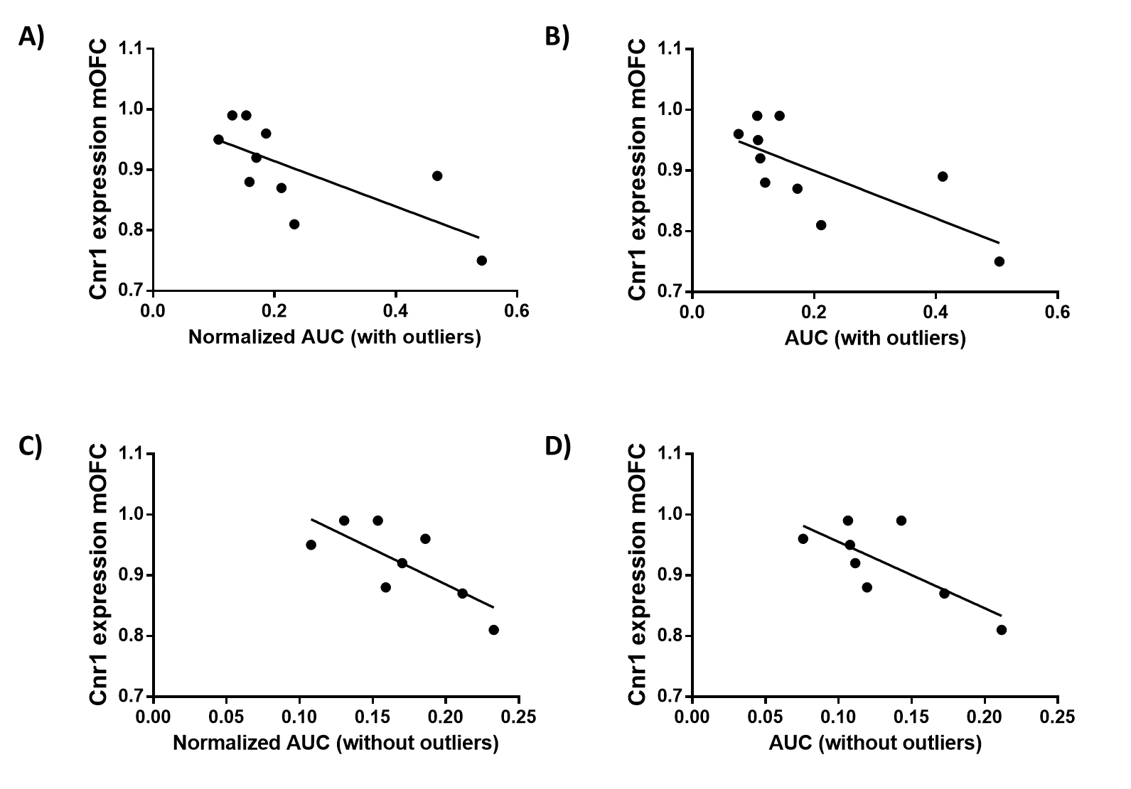
SI. Fig 1. The relationship between Cnr1 gene expression and impulsive behavior measured with the AUC methods (alternative analysis)
Impulsive choice was positively correlated with impulsivity measured by both measures of AUC, with or without outliers (a smaller AUC indicates a faster switch in the preference in favor of the immediate lever i.e. higher impulsivity) A) Impulsive choice (as defined by the normalized AUC, without removing outliers) was positively correlated with Cnr1 (CB₁ cannabinoid receptor) gene expression in the mOFC (Kendall’s τ=-0.584; p=0.02). B) Impulsive choice (as defined by the AUC, without removing the outliers) was positively correlated with Cnr1 (CB₁ cannabinoid receptor) gene expression the mOFC (Kendall’s τ-0.629=; p=0.012). C) Impulsive choice (as defined by the normalized AUC without the two outliers) was positively correlated with Cnr1 (CB₁ cannabinoid receptor) gene expression the mOFC (Pearson’s r=-0.747; p=0.033). D) Impulsive choice (as defined by the AUC without the outliers) was positively correlated with Cnr1 (CB₁ cannabinoid receptor) gene expression in the mOFC (Pearson’s r=-0.740; p=0.036).

SI Table 1. Primer sets used for RT-qPCR amplification.
Gene | Description | Forward primer | Reverse primer
Grin1 | glutamate ionotropic receptor NMDA type subunit 1 | AACCTGCAGAACCGCAAG | GCTTGATGAGCAGGTCTATGC
Grin2a | glutamate ionotropic receptor NMDA type subunit 2A | TGTGAAGAAATGCTGCAAGG | GAACGCTCCTCATTGATGGT
Gria1 | glutamate ionotropic receptor AMPA type subunit 1 | AGAGGCTGGTGGTGGTTGACT | ACCCTGGTATGGTCTCGGGA
Gria2 | glutamate ionotropic receptor AMPA type subunit 2 | GGCGTGTAATCCTGGACTGT | ACACCAGGGAATCGTCGTAG
Gabrg2 | gamma-aminobutyric acid type A receptor gamma 2 subunit | CGGAAACCAAGCAAGGATAA | ACAGTCCTTGCCATCCAAAC
Gabrd | gamma-aminobutyric acid type A receptor delta subunit | GCTGGACCTGGAGAGCTATG | CCGAAGCTGGAAGTGTAAGC
Gabra1 | gamma-aminobutyric acid type A receptor alpha 1 subunit | TTGACTGTGAGAGCCGAATG | AAACGTGACCCATCTTCTGC
Gabra2 | gamma-aminobutyric acid type A receptor alpha 2 subunit | CCATGCACTTGGAGGACTT | ACTGGCCCAGCAAATCATAC
Cnr1 | cannabinoid receptor 1 | GTCGATCCTAGATGGCCTTGC | GTCATTCGAGCCCACGTAGAG
Dagla | diacylglycerol lipase, alpha | CTTTGCTGAATTTTTCCGTGACC | TTGTTTGCCTCATCCAGCAC
Mgll | monoacylglycerol lipase | CTACCTGCTCATGGAATC | GACACCCACGTATTTATTTC
Napepld | N-acyl phosphatidylethanolamine phospholipase D | AGATATGGACTCAAGAGTGAAGACTTC | TCCTCAAAGGCTTTGTCATCGG
Faah | fatty acid amide hydrolase | GTTACAGAGTGGAGAGCTGTCC | GTCTCACAGTCGGTCAGATAGG
Gapdh | glyceraldehyde-3-phosphate dehydrogenase | TCCCTGTTCTAGAGACAG | CCACTTTGTCACAAGAGA

SI Table 2. Uncorrected p-values for all the t-tests performed. Red cells show significant values and cells with border contain the values that are significant after the FDR correction.

Statistical aproach | Clustering aproach |  |  |  | Correlational aproach
 | DDT |  | 2-CSRTT |  | DDT |  | 2-CSRTT
 | lOFC | mOFC | lOFC | mOFC | lOFC | mOFC | lOFC | mOFC
Grin1 | 0,972 | 0,814 | 1,000 | 0,424 | 0,683 | 0,842 | 0,189 | 0,336
Grin2a | 0,947 | 0,374 | 0,069 | 0,549 | 0,945 | 0,805 | 0,449 | 0,484
Gria1 | 0,763 | 0,263 | 0,035 | 0,792 | 0,913 | 0,040 | 0,351 | 0,848
Gria2 | 0,711 | 0,792 | 0,157 | 0,915 | 0,732 | 0,938 | 0,518 | 0,672
Gabrg2 | 0,485 | 0,933 | 0,100 | 0,981 | 0,845 | 0,609 | 0,231 | 0,784
Gabrd | 0,338 | 0,933 | 0,660 | 0,905 | 0,177 | 0,815 | 0,902 | 0,646
Gabra1 | 0,636 | 0,559 | 0,006 | 0,394 | 0,889 | 0,223 | 0,0498 | 0,585
Gabra2 | 0,836 | 0,886 | 0,558 | 0,832 | 0,835 | 0,820 | 0,811 | 0,744
Cnr1 | 0,421 | 0,003 | 0,936 | 0,609 | 0,266 | 0,009 | 0,669 | 0,324
Dagla | 0,940 | 0,153 | 0,967 | 0,964 | 0,430 | 0,178 | 0,476 | 0,595
Mgll | 0,863 | 0,927 | 0,202 | 0,536 | 0,956 | 0,896 | 0,470 | 0,804
Napepld | 0,621 | 0,111 | 0,065 | 0,126 | 0,337 | 0,048 | 0,052 | 0,640
Faah | 1,000 | 0,063 | 0,425 | 0,724 | 0,835 | 0,436 | 0,955 | 0,515

