Supplementary Material

Table S1: Antibodies used for immunofluorescence analyses
Name of Antibody | Source | Dilution | Catalog No. | Supplier | Supplier Location
Anti-mouse Alexa 488 | Goat | 1:1400 | A11001 | Life | Eugene, OR
Anti-rabbit  Alexa 488 | Goat | 1:1200 | A1103 | Life | Eugene, OR
Elafin | Rabbit | 1:100 | Ab4774 | Abcam | Cambridge, MA
Filaggrin | Mouse | 1:500 | SC-66192 | Santa Cruz Biotechnology | Heidelberg, Germany
Ki67 | Mouse | 1:300 | 556003 | BD Biosciences | San Diego, CA
Psoriasin | Rabbit | 1:300 | Ab83534 | Abcam | Cambridge, MA
Transglutaminase 1 | Rabbit | 1:300 | 12912-3-AP | Cedarlane | Burlington, Canada

Table S2. Total Levels of NAEs and MAGs in healthy and psoriatic skin substitutes after ALA treatments.
 |  | Mean ±SD (pmol/g of tissue) |  |  |  | P-value
Bioactive lipids |  | HS⁻ | PS⁻ | PS^{ALA+} |  | PS⁻ vs PS^{ALA+} | PS⁻ vs HS⁻
 | Total NAEs | 18059 ± 8714 | 23434 ± 10425 | 18414 ± 7792 |  | NS | NS
 | Total n-3 NAEs | 7.442 ± 2.906 | 4.292 ± 3.521 | 47.67 ± 35.09 |  | 0.0360 | NS
 | Total n-6 NAEs | 433.1 ± 139.9 | 337.6 ± 51.62 | 435.6 ± 130.6 |  | NS | NS
 | Total SFA and MUFA NAEs | 17618 ± 8610 | 23092 ± 10398 | 17931 ± 7651 |  | NS | NS
 | Total MAGs | 85522 ± 21270 | 52214 ± 18798 | 40127 ± 21740 |  | 0.0445 | NS
 | Total n-3 MAGs | 210.3 ± 155.0 | 399.5 ± 116.8 | 1419 ± 766.3 |  | NS | 0.0282
 | Total n-6 MAGs | 3479 ± 2574 | 3488 ± 1250 | 3328 ± 1579 |  | NS | NS
 | Total SFA and MUFA MAGs | 81832 ± 20075 | 48327 ± 17474 | 37231 ± 19639 |  | NS | NS
 | EPEA | 2.495 ± 2.087 | 1.231 ± 0.318 | 35.231 ± 33.795 |  | NS | 0.0092
 | DHEA | 4.950 ± 1.212 | 3.060 ± 3.273 | 12.438 ± 8.226 |  | NS | NS
 | LEA | 405.863 ± 128.938 | 301.914 ± 53.279 | 322.531 ± 173.104 |  | NS | NS
 | AEA | 27.230 ± 14.497 | 35.645 ± 10.693 | 68.690 ± 74.762 |  | NS | NS
 | PEA | 3239.398 ± 1590.636 | 1570.453 ± 673.182 | 884.676 ± 527.979 |  | NS | NS
 | OEA | 9357.315 ± 4058.082 | 4841.281 ± 1448.029 | 6708.243 ± 4529.641 |  | NS | NS
 | SEA | 5021.438 ± 3075.666 | 16680.360 ± 8507.989 | 10338.169 ± 4098.643 |  | 0.0008 | NS
 | 1/2-EPG | 5.967 ± 11.935 | 33.906 ± 9.619 | 159.945 ± 65.101 |  | NS | NS
 | 1/2-DPG | 139.172 ± 87.616 | 80.905 ± 34.809 | 992.747 ± 783.973 |  | NS | 0.0001
 | 1/2-DHG | 65.196 ± 56.074 | 284.642 ± 86.580 | 266.657 ± 85.587 |  | NS | NS
 | 1/2-LG | 2929.705 ± 2262.649 | 2155.287 ± 835.924 | 2711.371 ± 1534.934 |  | NS | NS
 | 1/2-AG | 549.474 ± 319.569 | 1333.079 ± 539.524 | 616.559 ± 598.092 |  | NS | NS
 | 1/2-PG | 16387.083 ± 3289.947 | 9903.221 ± 3417.547 | 14656.913 ± 7275.696 |  | NS | NS
 | 1/2-OG | 20079.818 ± 12122.743 | 38423.299 ± 14465.388 | 22573.843 ± 14773.886 |  | NS | NS

Abbreviations: MAG, monoacylglycerol; MUFA, monounsaturated fatty acid; NAE, N-acylethanolamine; NS, not significant; SD, standard deviation; SFA, saturated fatty acid.

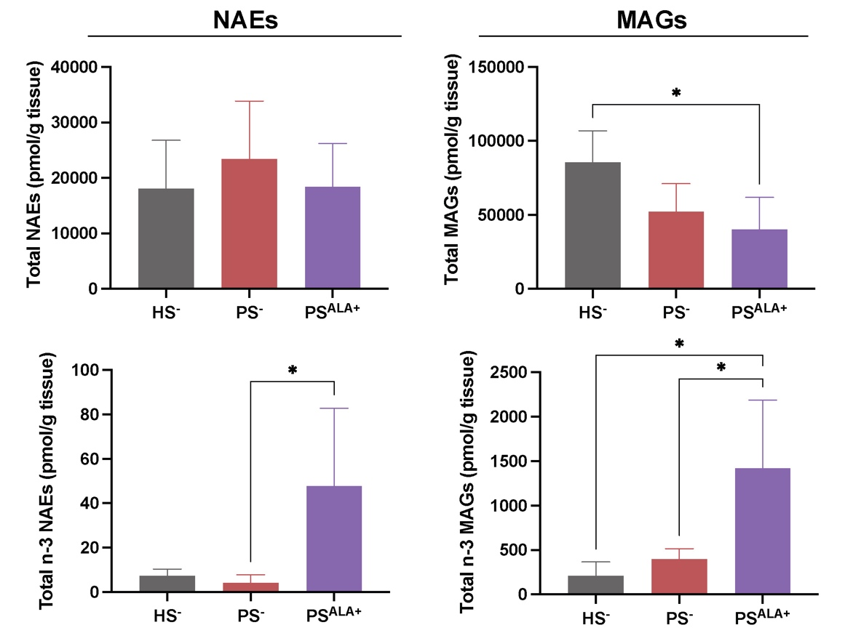
Figure S1. Levels of total NAEs and MAGs in healthy and psoriatic skin substitutes treated with either 10 μM ALA or vehicle. Levels of NAEs and MAGs were determined by LC-MS/MS. Statistical significance was determined using one-way ANOVA followed by Tukey’s post-hoc test. *p<0.05.

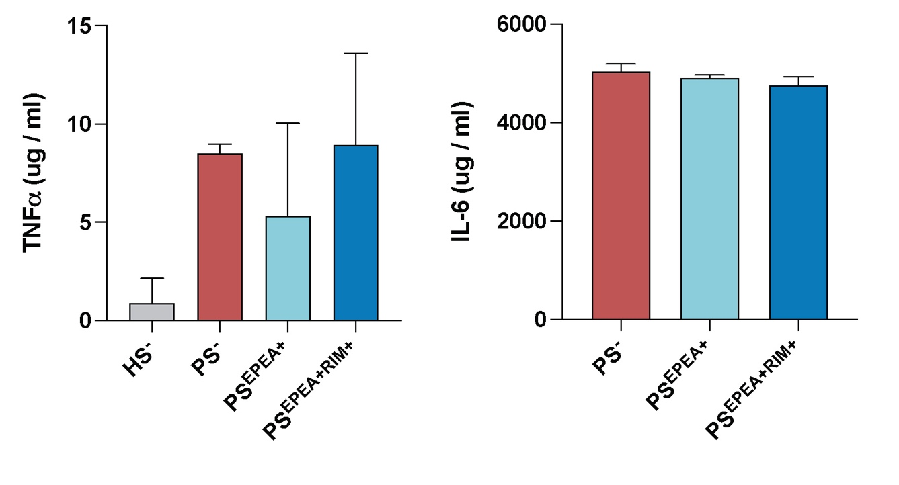
Figure S2. Levels of TNFα and IL-6 released in the culture media of psoriatic skin substitutes treated with either 10 μM EPEA, or vehicle. Cytokine were quantified by ELISA. Statistical significance was determined using one-way ANOVA followed by Tukey’s post-hoc test.

