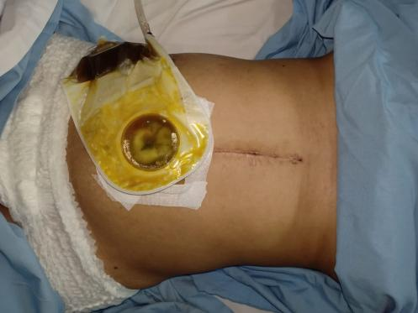
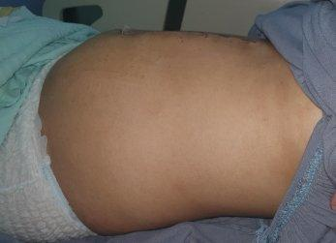
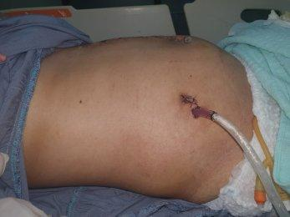

Figure 1. Clinical pictures of the patient.
There was an open wound produced a yellowish fluid since about 2 weeks prior to admission in her abdomen.

