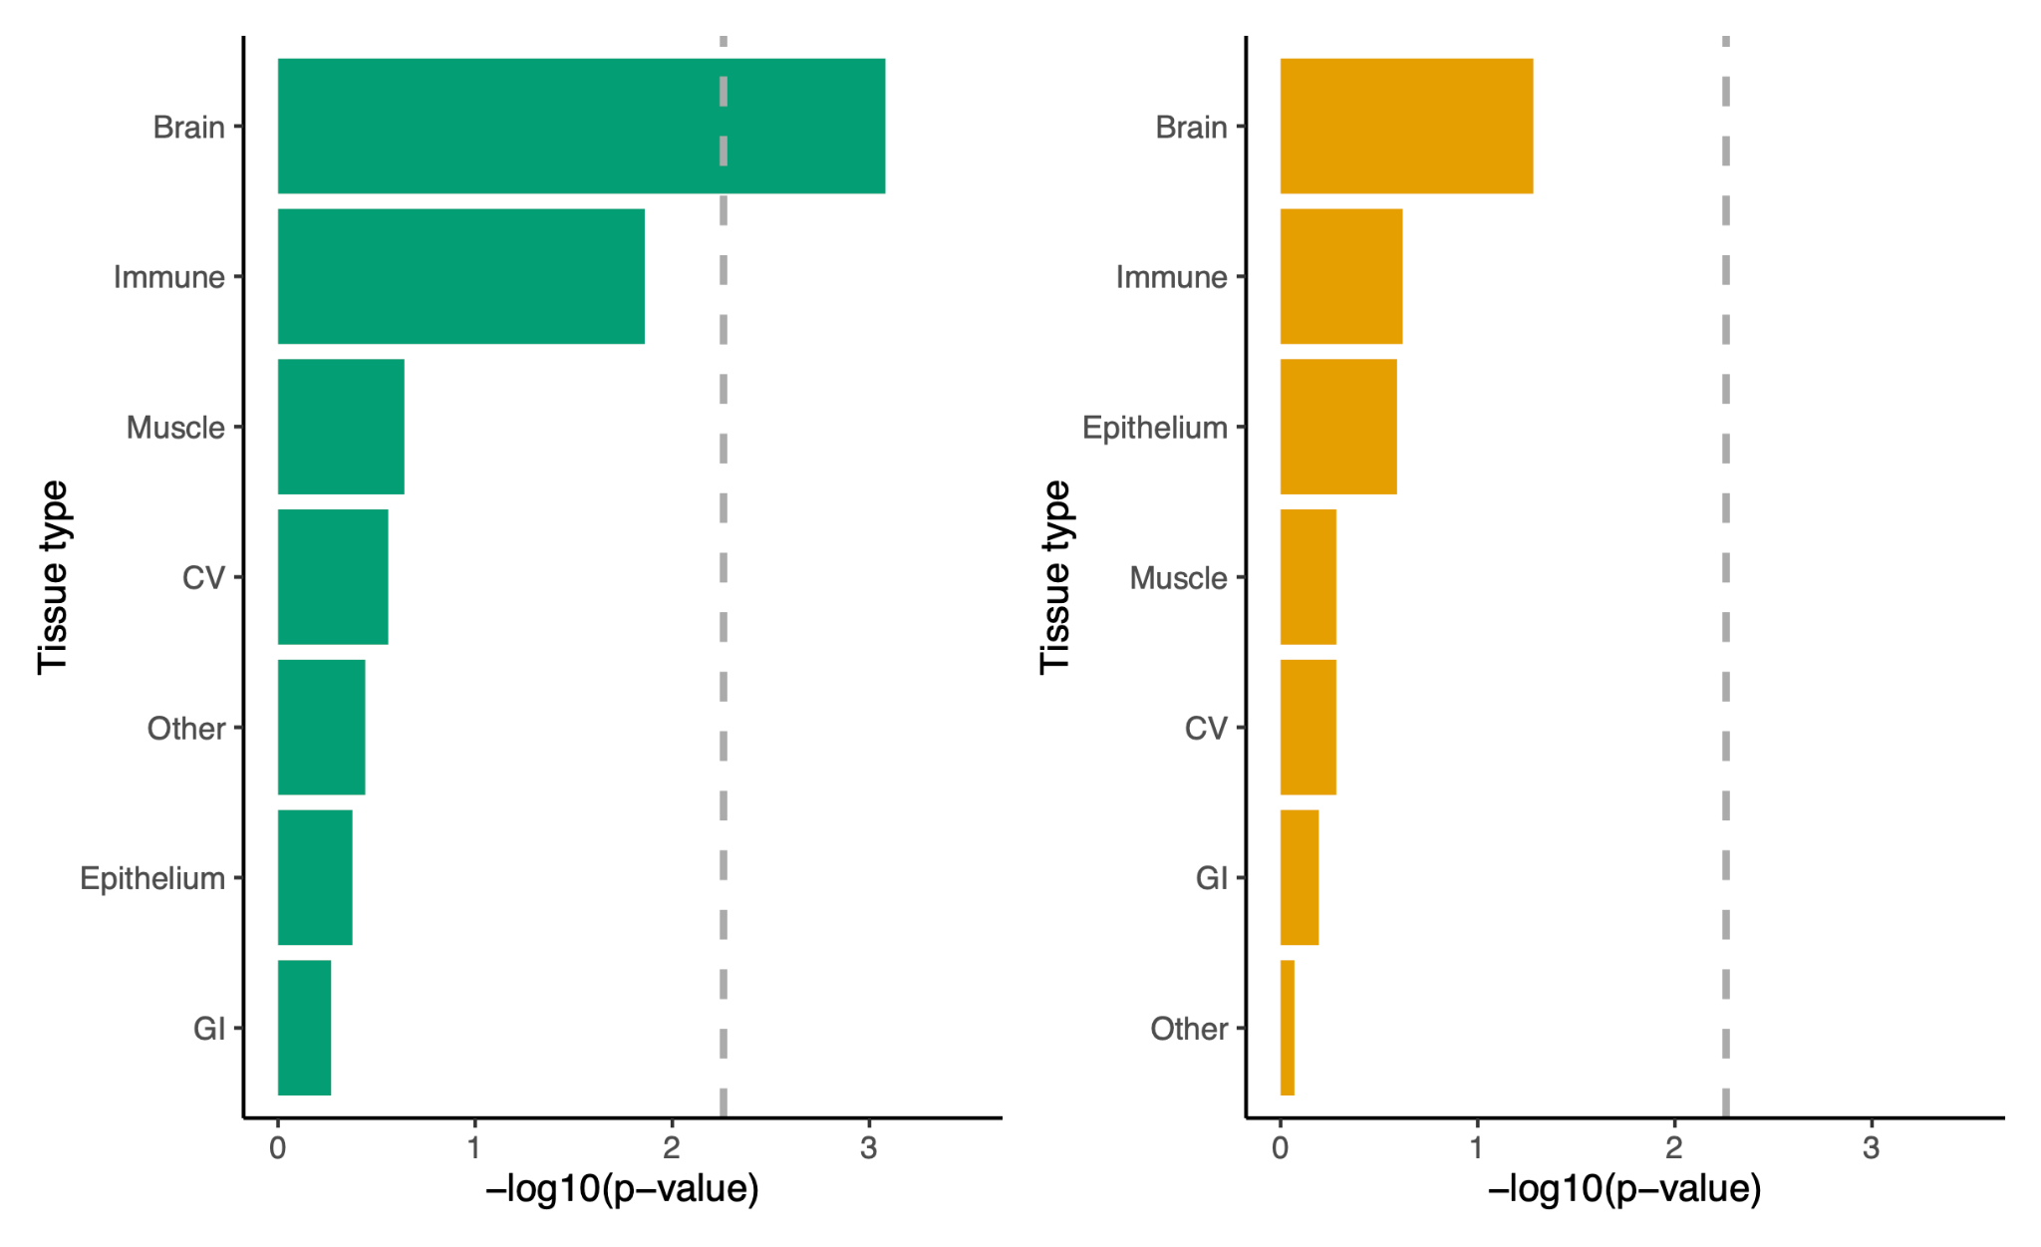

Supplemental Figure 1. Enrichment of the genetic covariance between cannabis use disorder and schizophrenia (green) and tobacco smoking and schizophrenia (orange) in broad tissue types. Statistical significance after Bonferroni correction for multiple testing is indicated by the dashed gray line. CV = cardiovascular; GI = gastrointestinal.

