Table S1. An example of the binary system configurations.
Number of lipids | Lipids |  | Systems
Number of lipids |  |  | 2-PG | 2-AG | ArEA | AEA
Number of lipids | Upper  leaflet | POPC | 291 | 291 | 291 | 291
Number of lipids | Upper  leaflet | Endocannabinoids | 32 | 32 | 32 | 32
Number of lipids | Lower  leaflet | POPC | 293 | 293 | 293 | 293
Number of lipids | Lower  leaflet | Endocannabinoids | 32 | 32 | 32 | 32

Table S2. An example of the sarcolemma membrane with Kir2.1 embedded system configurations.
Number of lipids | Lipids |  | Systems with Kir2.1
Number of lipids |  |  | 2-PG | 2-AG | ArEA | Control
Number of lipids | Upper  leaflet | POPC | 284 | 284 | 284 | 300
Number of lipids | Upper  leaflet | PLPC | 203 | 203 | 203 | 220
Number of lipids | Upper  leaflet | PAPC | 257 | 257 | 257 | 272
Number of lipids | Upper  leaflet | PAPE | 3 | 3 | 3 | 3
Number of lipids | Upper  leaflet | PUPE | 7 | 7 | 7 | 7
Number of lipids | Upper  leaflet | OAPE | 3 | 3 | 3 | 3
Number of lipids | Upper  leaflet | POPG | 0 | 0 | 0 | 0
Number of lipids | Upper  leaflet | SAPI | 0 | 0 | 0 | 0
Number of lipids | Upper  leaflet | POPS | 0 | 0 | 0 | 0
Number of lipids | Upper  leaflet | DPPA | 0 | 0 | 0 | 0
Number of lipids | Upper  leaflet | PSM | 106 | 106 | 106 | 105
Number of lipids | Upper  leaflet | BSM | 43 | 43 | 43 | 43
Number of lipids | Upper  leaflet | DODG | 25 | 25 | 25 | 25
Number of lipids | Upper  leaflet | CHOL | 505 | 505 | 505 | 501
Number of lipids | Upper  leaflet | POP2 | 0 | 0 | 0 | 0
Number of lipids | Upper  leaflet | Endocannabinoids | 41 | 41 | 41 | 0
Number of lipids | Lower  leaflet | POPC | 175 | 175 | 175 | 188
Number of lipids | Lower  leaflet | PLPC | 125 | 125 | 125 | 138
Number of lipids | Lower  leaflet | PAPC | 158 | 158 | 158 | 171
Number of lipids | Lower  leaflet | PAPE | 52 | 52 | 52 | 52
Number of lipids | Lower  leaflet | PUPE | 133 | 133 | 133 | 134
Number of lipids | Lower  leaflet | OAPE | 53 | 53 | 53 | 54
Number of lipids | Lower  leaflet | POPG | 15 | 15 | 15 | 16
Number of lipids | Lower  leaflet | SAPI | 51 | 51 | 51 | 51
Number of lipids | Lower  leaflet | POPS | 15 | 15 | 15 | 16
Number of lipids | Lower  leaflet | DPPA | 15 | 15 | 15 | 16
Number of lipids | Lower  leaflet | PSM | 6 | 6 | 6 | 6
Number of lipids | Lower  leaflet | BSM | 2 | 2 | 2 | 2
Number of lipids | Lower  leaflet | DODG | 29 | 29 | 29 | 29
Number of lipids | Lower  leaflet | CHOL | 576 | 576 | 576 | 581
Number of lipids | Lower  leaflet | POP2 | 23 | 23 | 23 | 24
Number of lipids | Lower  leaflet | Endocannabinoids | 47 | 47 | 47 | 0

Table S3. The modelled endocannabinoid structures.
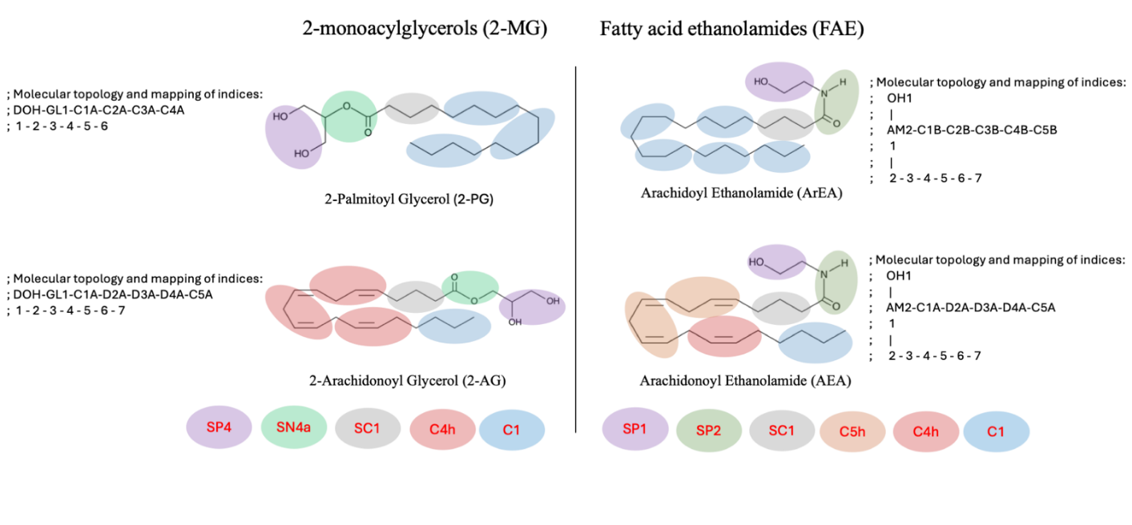

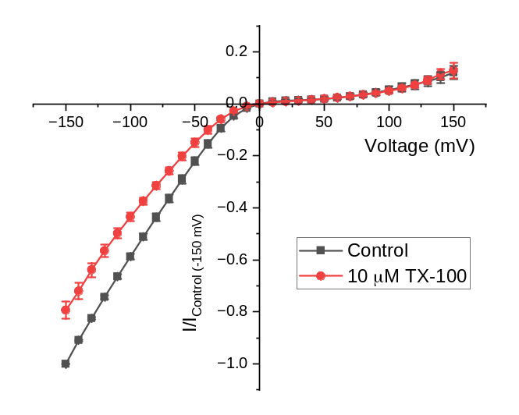
Supp. Fig. S1. Increased membrane elasticity decreases Kir2.1 current. Current-voltage (I-V) relationship of Kir2.1 currents before and after treatment with TX-100 which has been demonstrated to increase membrane elasticity. (n = 5, P < 0.001)

