Accumulation of somatic mutations leads to genetic mosaicism in Cannabis

Kristian Adamek¹, Andrew Maxwell Phineas Jones¹, Davoud Torkamaneh^{2*}
¹ Department of Plant Agriculture, University of Guelph, Guelph, N1G 2W1, ON, Canada
² Département de Phytologie, Université Laval, Québec, G1V 0A6, QC, Canada
* Correspondence: davoud.torkamaneh.1@ulaval.ca

Supplemental Materials

Supplemental Figure S1. Comparison of nucleotide variants called from the first and second runs of WGS on the original top tissue with a near identical agreement in variant calling.
Supplemental Figure S2. LD decay graph that shows a rapid decay to half in merely a few kb.

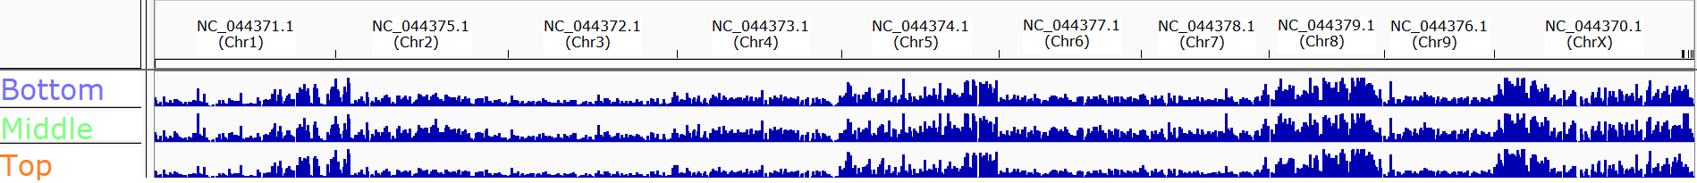
Supplemental Figure S3. A visual representing the distribution of nucleotide diversity through the full genome from the bottom, middle and top samples. Chromosomes 1, 5, 8 and X are under a heavier burden of nucleotide variants.

