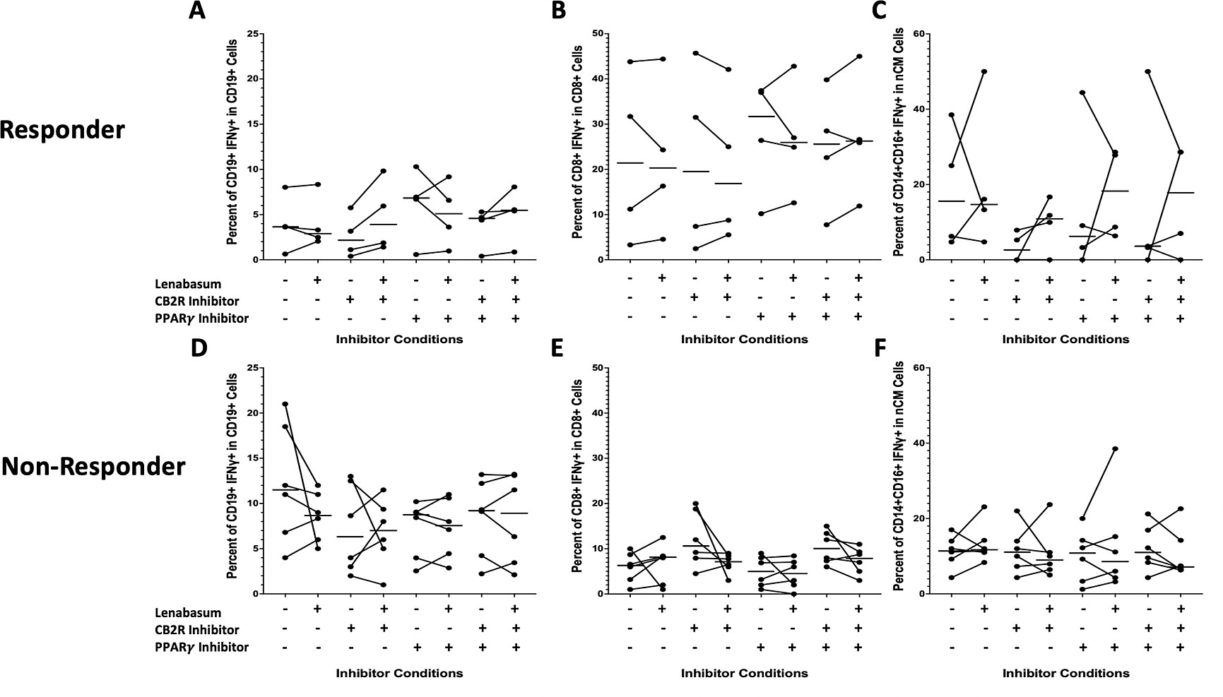

Figure S4: Flow cytometry of DM whole blood leukocytes displaying percent positivity of IFNγ across CD19⁺, CD8T⁺, and ncMs in non-responders and responders with various CB2R/PPARγ inhibitions and lenabasum treatment. Black line reflects the median. A) IFNγ positivity in CD19⁺ cells in responders with lenabasum treatment and CB2R/PPARγ inhibition. B) IFNγ positivity in CD8T⁺ cells in responders with lenabasum treatment and CB2R/PPARγ inhibition. C) IFNγ positivity in ncMs in responders with lenabasum treatment and CB2R/PPARγ inhibition. D) IFNγ positivity in CD19⁺ in non-responders with lenabasum treatment and CB2R/PPARγ inhibitions. E) IFNγ positivity in CD8T⁺ cells in non-responders with lenabasum treatment and CB2R/PPARγ inhibition. F) IFNγ positivity in ncMs in non-responders with lenabasum treatment and CB2R/PPARγ inhibition.

