Daily Web Survey Data Collection of Time-Varying Cannabis Use Motives and Contexts, with Implications for Adaptive Interventions: A Pilot Study

Supplemental Materials
Table A1. Descriptive statistics of demographics by transitions.
 | Transition 1  n = 3  M (SD) | Transition 2  n = 7  M (SD) | Transition 3  n = 36  M (SD) | Transition 4  n = 2  M (SD)
Age | 50.67 (22.37) | 53.14 (17.28) | 47.97 (17.12) | 54.00 (18.38)
 | n | n | n | n
Sex
Female | 3 | 4 | 23 | 1
Male | 0 | 3 | 13 | 1
Sexual Orientation
Heterosexual | 3 | 6 | 29 | 2
Other | 0 | 1 | 7 | 0
Race
African American | 0 | 2 | 9 | 0
White | 2 | 3 | 23 | 2
Other | 1 | 2 | 4 | 0
Citizenship
US Citizen | 3 | 7 | 34 | 2
Other | 0 | 0 | 2 | 0
Education Level
8th Grade or Lower | 0 | 0 | 1 | 0
High School Degree | 1 | 3 | 6 | 1
Some College (But No College Degree) | 1 | 1 | 6 | 0
Associate’s Degree | 0 | 2 | 2 | 0
Bachelor’s Degree | 0 | 0 | 13 | 1
Graduate Degree | 1 | 1 | 8 | 0

Table A2. Mental health at baseline and follow-up by type of transition.
 | Transition 1  n = 3 |  | Transition 2  n = 7 |  | Transition 3  n = 36 |  | Transition 4  n = 2
 | Baseline | Follow-up | Baseline | Follow-up | Baseline | Follow-up | Baseline | Follow-up
 | M (SD) |  | M (SD) |  | M (SD) |  | M (SD)
FS | 50.33 (5.13) | 50.67 (4.62) | 43.29 (6.16) | 49.43 (3.51) | 43.06 (9.57) | 43.94 (11.96) | 43.50 (0.71) | 44.50 (0.71)
 | n (%) |  | n (%) |  | n (%) |  | n (%)
PHQ-9
Minimal |  | 1 (33.4) | 5 (71.4) | 4 (57.1) | 11 (32.4) | 16 (44.5) | 1 (50.0) | 1 (50.0)
Mild | 3 (100.0) | 1 (33.3) | 1 (14.3) | 3 (42.9) | 12 (35.3) | 12 (33.3) |  | 1 (50.0)
Moderate |  | 1 (33.3) | 1 (14.3) |  | 10 (29.4) | 4 (11.1) | 1 (50.0)
Moderately Severe |  |  |  |  | 1 (2.9) | 4 (11.1)
GAD-7
Minimal | 1 (33.4) | 1 (33.3) | 4 (57.1) | 4 (57.1) | 20 (57.1) | 21 (58.3) | 1 (50.0) | 1 (50.0)
Mild | 1 (33.3) | 2 (66.7) | 2 (28.6) | 1 (14.3) | 6 (17.1) | 9 (25.0) | 1 (50.0) | 1 (50.0)
Moderate | 1 (33.3) |  |  | 2 (28.6) | 8 (22.9) | 4 (11.1)
Severe |  |  | 1 (14.3) |  | 1 (2.9) | 2 (5.6)
UCLA-3
Not lonely | 2 (66.7) | 3 (100.0) | 5 (71.4) | 4 (57.1) | 19 (52.8) | 22 (61.1) | 1 (50.0) | 2 (100.0)
Lonely | 1 (33.3) |  | 2 (28.6) | 3 (42.9) | 17 (47.2) | 14 (38.9) | 1 (50.0)
Note: FS—Flourishing Scale for positive mental health; PHQ-9—Patient Health Questionnaire for depression; GAD-7—Generalized Anxiety Disorder for anxiety; UCLA-3—Three-Item Loneliness Scale for loneliness.

Table A3. Estimated transition probabilities and estimated means of cannabis use occasions in the past week in the follow-up survey (n = 48).
 | Week 1 Weekend Motive Class | Week 4 Weekend Motive Class | Estimated Transition Probability | Estimated Mean of Follow-up Past-Week Cannabis Use Occasions (SE)
Transition 1 | Enjoyment, Relaxation, Availability | Relaxation, Availability | 0.94 | 5.31 (0.85)
Transition 2 | Enjoyment, Relaxation, Availability | Multiple Motives | 0.06 | 45.00 (2.12)
Transition 3 | Multiple Motives | Relaxation, Availability | 0.17 | 4.32 (0.40)
Transition 4 | Multiple Motives | Multiple Motives | 0.83 | 7.79 (1.41)

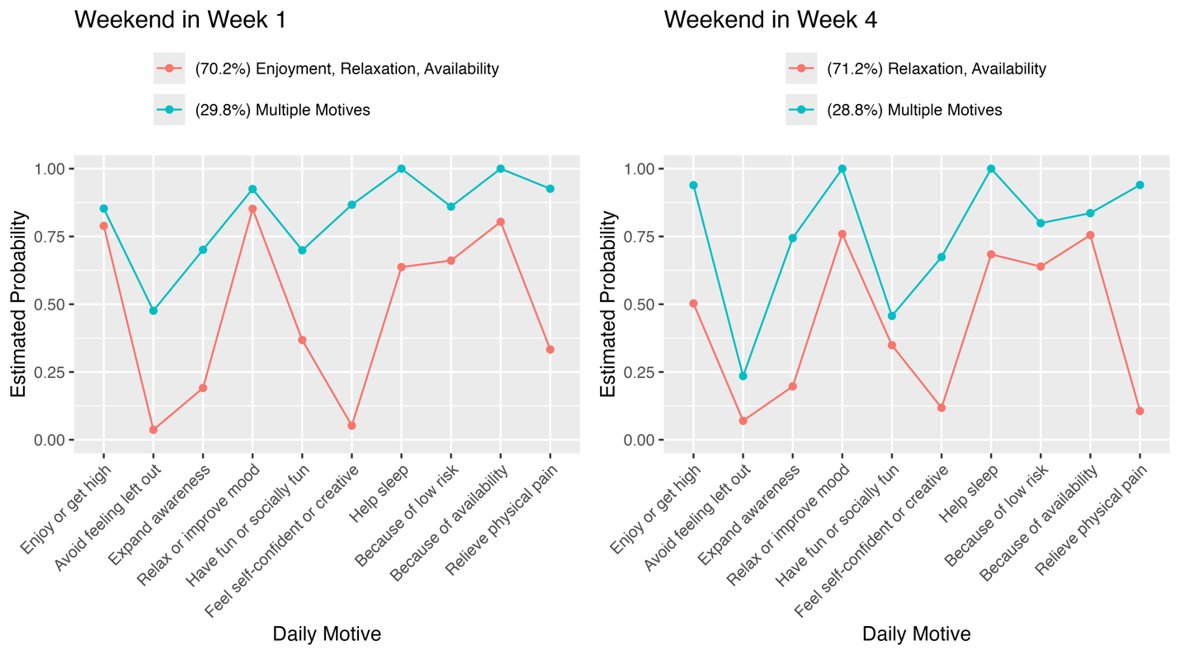
Figure A. Estimated probabilities of endorsing motives in two classes on weekend (Friday–Sunday) in Week 1 and Week 4 in the RI-LTA (n = 48; BIC = 1321.33; Entropy = 0.953). The percentage of the sample in each class is indicated in parentheses.

