Supporting Information
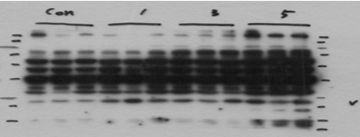
FGF21
MW
Ladder
Con
ACEA
Day 1
ACEA
Day 3
ACEA
Day 5
70
55
43
34
25
17

kDa

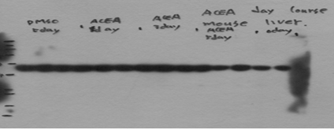
Beta Actin
MW
Ladder
Con
ACEA
Day 1
ACEA
Day 3
ACEA
Day 5
70
55
43
34
25
17

kDa

S3 Fig. Western blot (uncopped) for Fig 2C.

