Supplementary Material

Efficient propagation protocol and genetic similarity assessment of medicinal cannabis based on photoautotrophic micropropagation
Juwen Liang^{1,3†}, Xiuye Wei^{2†}, Jun Liu^{1,3}, Qing Zhou^{1,3} and Dongxian He^{1,3,4}*

Supplementary Table 1. ISSR primers for genetic similarity analysis.
Primer | Repeat | Forward primer sequence (5'-3') | Reverse primer sequence (5'-3') | References
CAN01 | (AAG)7 | AGGAACACTTTGAAAGCGAG | CGGTCATCTACCTTGAGCTT | Xin, 2015
CAN02 | (AG)9 | GGACAACACAGAAATGAGCA | CACTTTGCAGCCTATTTCCT | Xin, 2015
CAN03 | (CTA)9 | CAAATGCCACACCACCTTC | GTAGGTAGCCAGGTATAGGTAG | Adamek et al., 2023
CAN04 | (TTG)9 | TTGATGGTGGTGAAACGGC | CCCCAATCTCAATCTCAACCC | Adamek et al., 2023
CAN05 | (GTT)7 | GGTTGGGATGTTGTTGTTGTG | AGAAATCCAAGGTCCTGATGG | Adamek et al., 2023
CAN06 | (ACG)7 | TGGTTTCAGTGGTCCTCTC | ACGTGAGTGATGACACGAG | Adamek et al., 2023

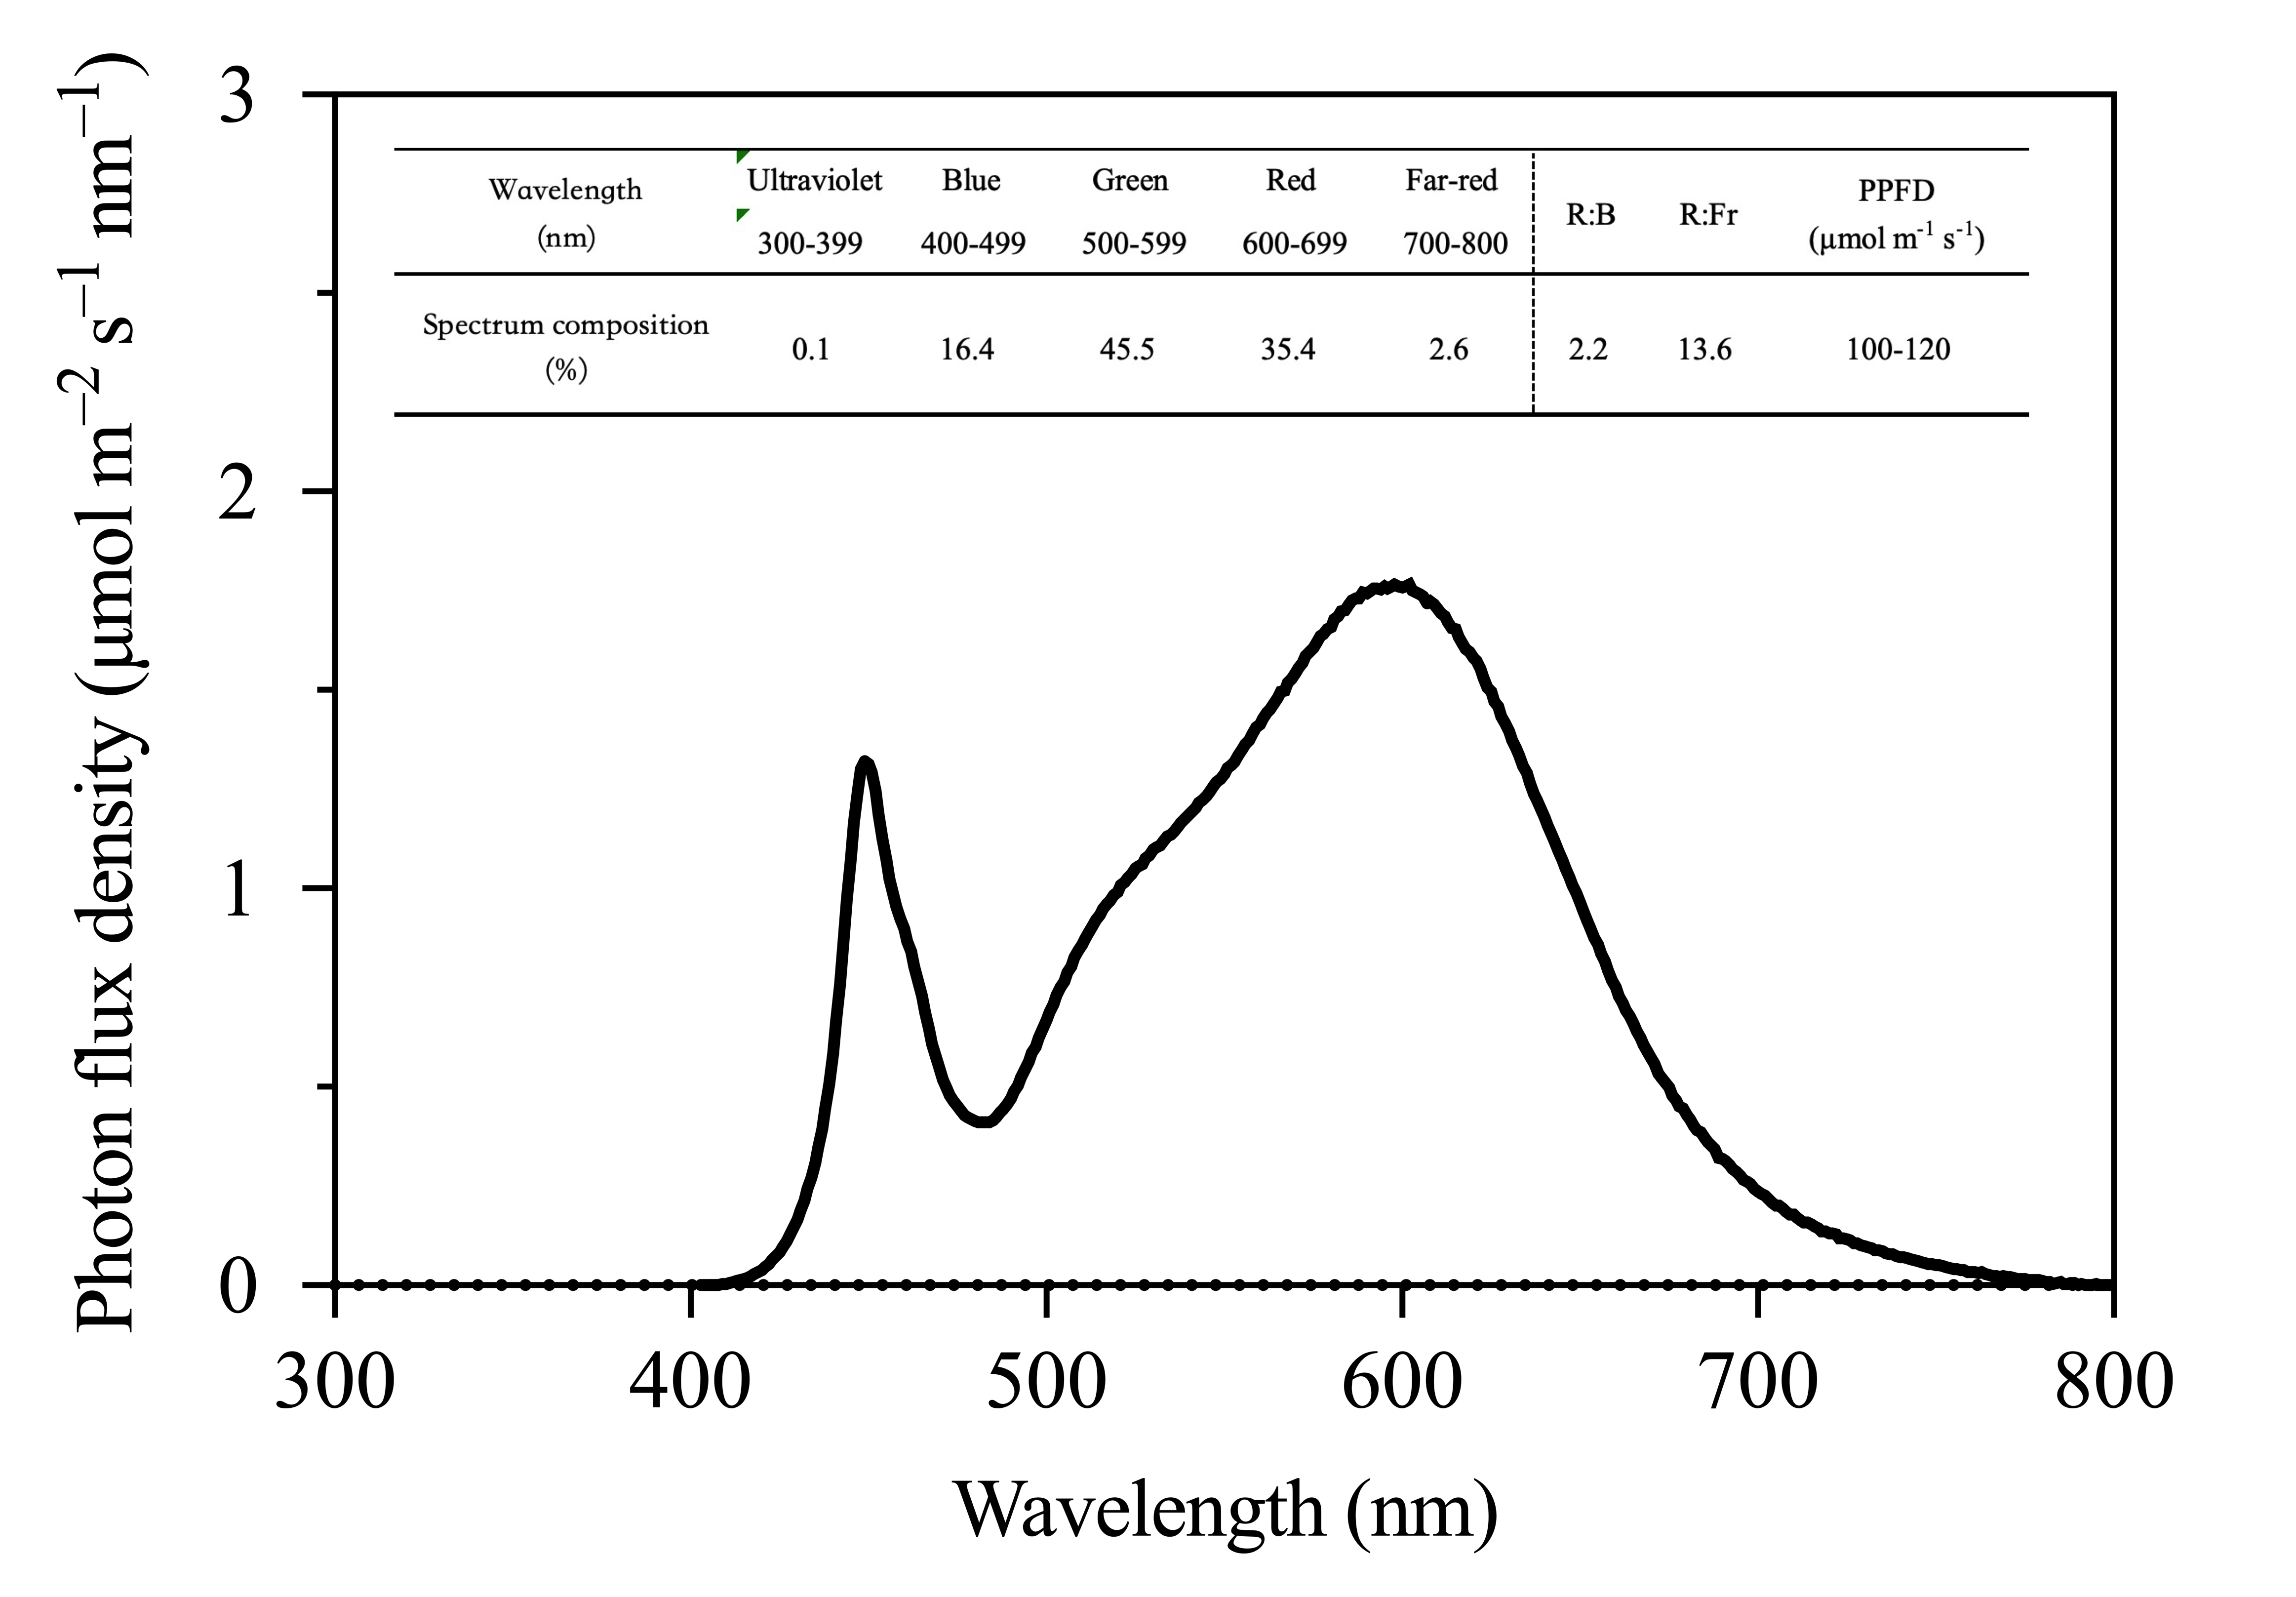
Supplementary Figure 1. Spectral distribution of white LED lamps. The spectral distribution across the 300~800 nm wavelength range was quantified using a fiber optic spectrometer (AvaSpec-ULS2048, Avantes Inc., the Netherlands). The spectral composition was as follows: 0.1% ultraviolet light (300~399 nm), 16.4% blue light (400~499 nm), 45.5% green light (500~599 nm), 35.4% red light (600~699 nm), and 2.6% far-red light (700~800 nm).
Supplementary Table 2. ANOVA results for effects of inoculation density and cultivar on plant performance over time in the PAM system.
Measurements |  | Days after inoculation
Measurements |  | 21 | 35 | 42 | 49 | 56 | 63 | 70 | 77 | 84 | 91 | 98
Mother plant survival rate | I | NS | * | * | ** | NS | NS | NS | NS | ** | ** | **
Mother plant survival rate | C | NS | * | * | ** | * | * | * | * | NS | NS | NS
Mother plant survival rate | I × C | NS | * | * | ** | NS | * | * | * | NS | NS | **
Shoot tip yield per vessel per harvest | I | ** | * | ** | * | NS | NS | NS | NS | NS | NS | NS
Shoot tip yield per vessel per harvest | C | NS | * | * | NS | NS | NS | NS | NS | NS | NS | NS
Shoot tip yield per vessel per harvest | I × C | NS | NS | * | NS | NS | NS | NS | NS | NS | NS | NS
Cumulative yield per vessel | I | ** | ** | ** | ** | ** | ** | ** | ** | ** | ** | **
Cumulative yield per vessel | C | NS | NS | * | NS | NS | NS | NS | NS | NS | NS | NS
Cumulative yield per vessel | I × C | NS | NS | NS | NS | NS | NS | NS | NS | NS | NS | NS
Propagation coefficient | I | * | ** | ** | ** | ** | ** | ** | ** | ** | ** | **
Propagation coefficient | C | NS | NS | * | NS | NS | NS | NS | NS | NS | NS | NS
Propagation coefficient | I × C | NS | NS | NS | NS | * | NS | NS | NS | NS | NS | NS
Abbreviations are defined as follows: I denotes mother plant inoculation density; C denotes cultivar; I×C represents their interaction effect. Statistical significance levels are marked with * for p < 0.05 and ** for p < 0.01 (n = 12); NS indicates no significant difference.
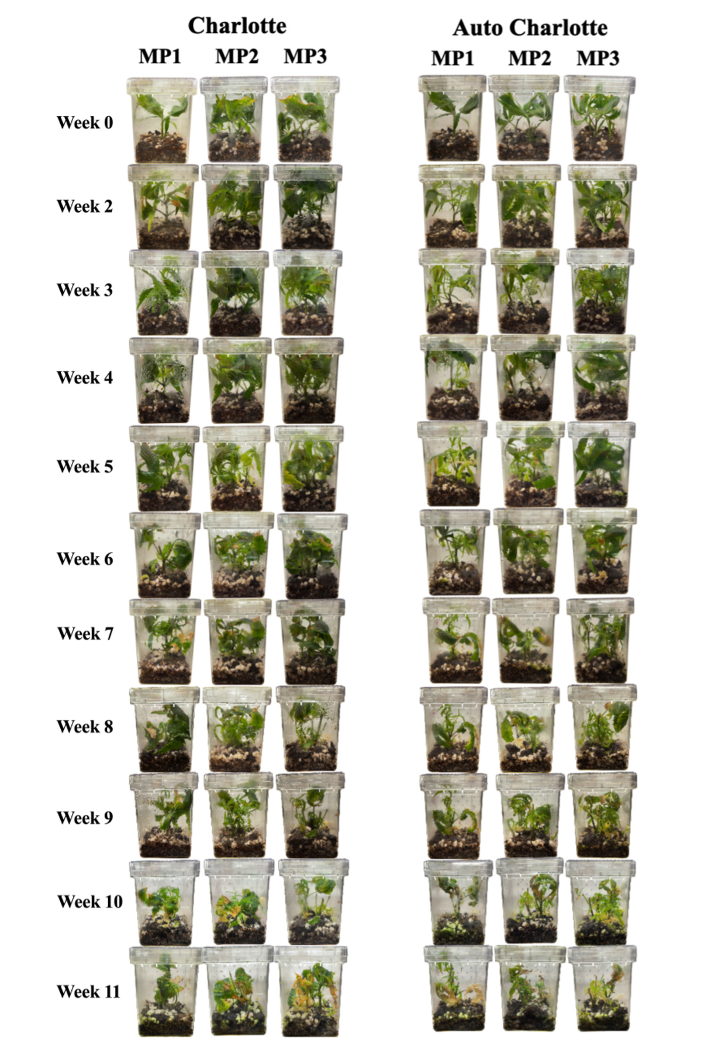
Supplementary Figure 2. Growth status of mother plants throughout the culture cycle. Among them, MP1, MP2, and MP3 represent the number of mother plants inoculated per vessel, which are 1, 2, and 3 plants, respectively. Week 0, Week 2, ..., Week 11 indicate the number of weeks after the first harvest.
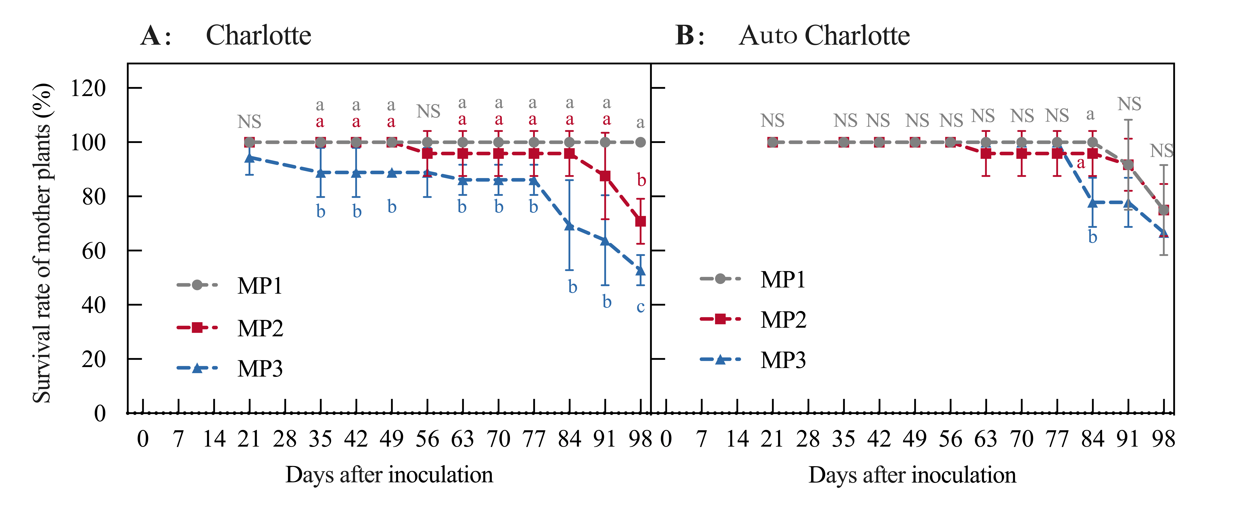
Supplementary Figure 3. Changes in the survival rate of mother plants under different inoculation densities. (A, B) Results for the ‘Charlotte’ and ‘Auto Charlotte’ cultivars, respectively. Among them, MP1, MP2, and MP3 represent the number of mother plants inoculated per container, which are 1, 2, and 3 plants, respectively. Different letters indicate significant differences (P < 0.05, n = 12). NS denotes no significant difference.
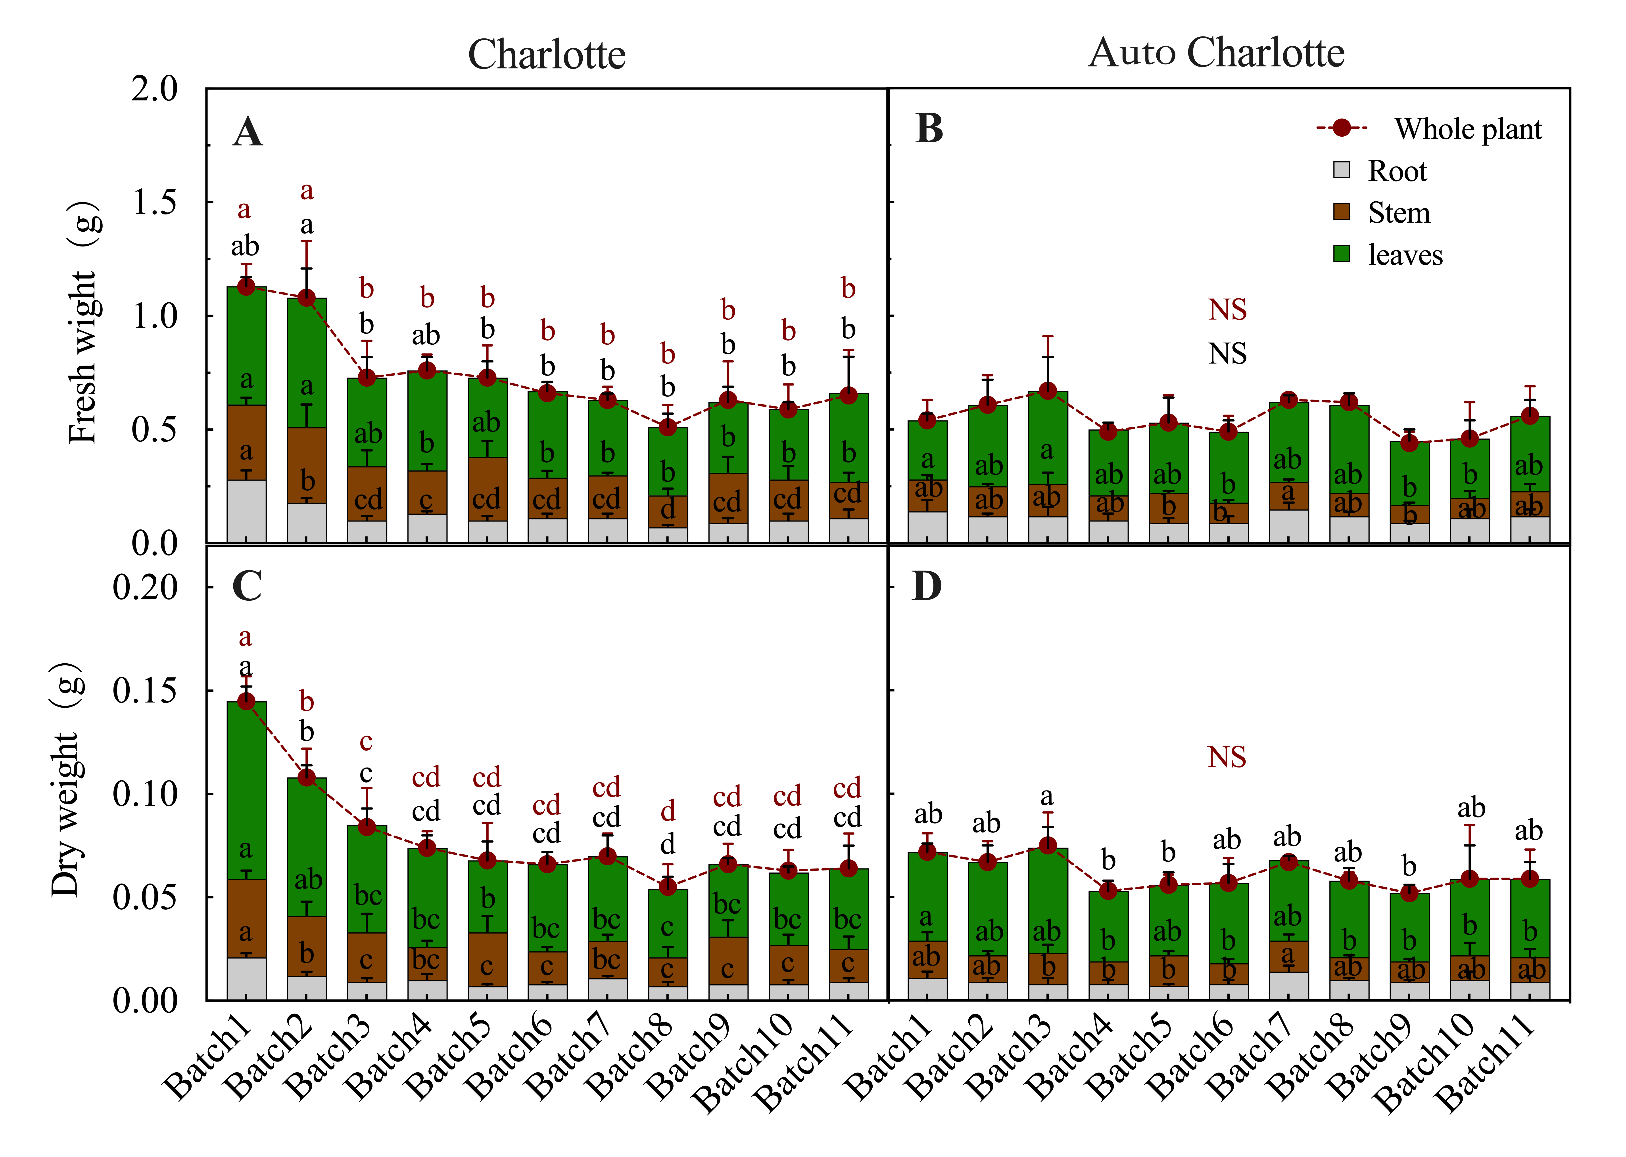
Supplementary Figure 4. Biomass of plantlets from different batches. (A, C) The fresh weight and dry weight of roots, stems, leaves, and whole plants of ‘Charlotte’ plantlets across batches; (B, D) The corresponding indicators of ‘Auto Charlotte’ plantlets. Different letters indicate significant differences (P < 0.05, n = 4). NS denotes no significant difference.
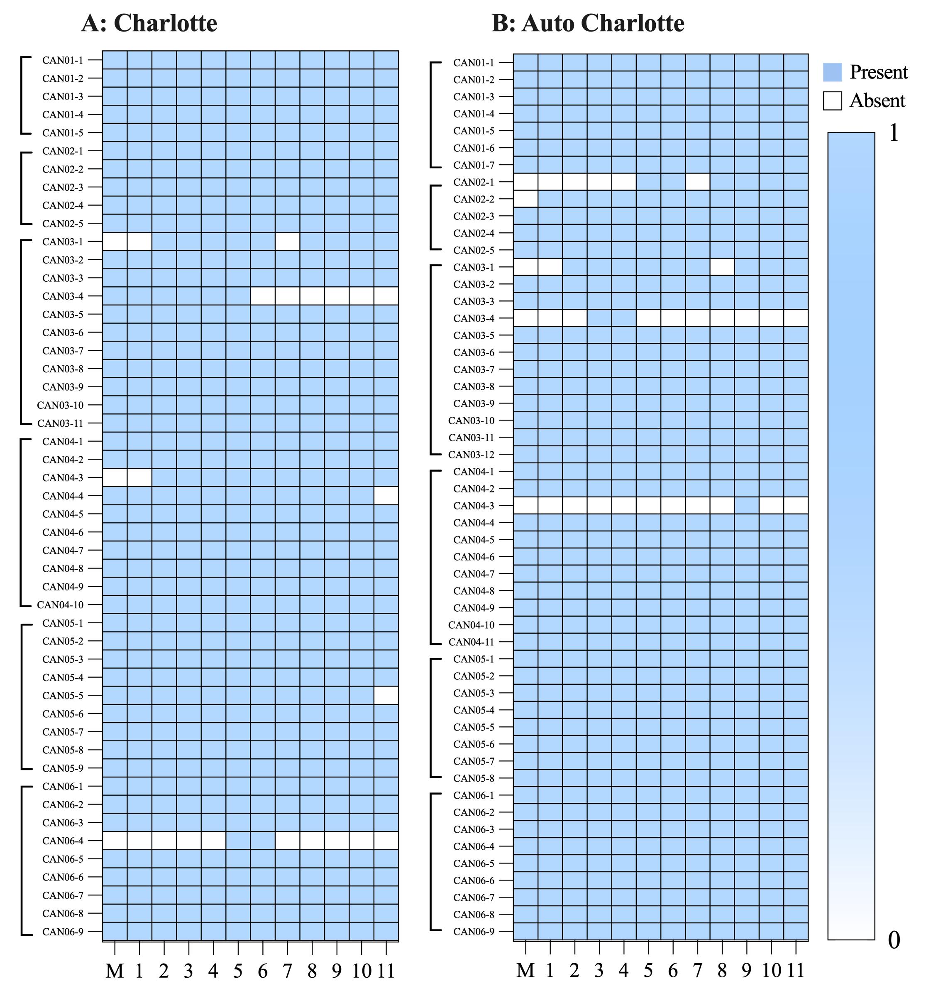
Supplementary Figure 5. The 0/1 matrix diagrams of amplification products from mother plants and plantlet samples using different primers. (A, B) The results for ‘Charlotte’ and ‘Auto Charlotte’ cultivars, respectively. Among them, CAN01, CAN02, CAN03, CAN04, CAN05, and CAN06 represent the primer names.

