Supplementary Material

Supplementary Figure 1. Scheme of the hemp fiber retted within the prototype bioreactor further processed into 100% hemp yarns (courtesy of Prototipo Studio – Lampoon Magazine).

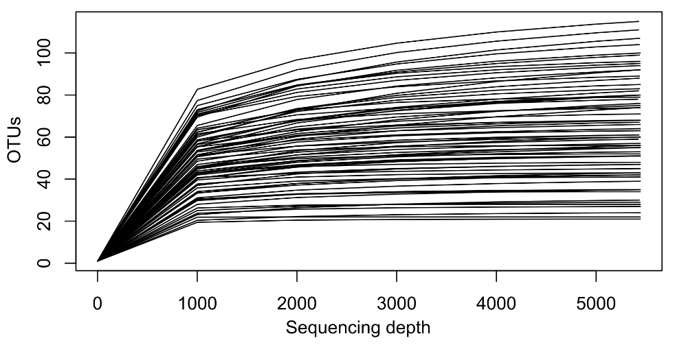
Supplementary Figure 2. Rarefaction curves of all samples, generated after rarefaction to 5,443 reads per sample.
Supplementary Table 1. Average percentages (%) of the most abundant bacterial phyla and orders within each retting cycle. Differences in the phyla/orders absolute abundance among the different cycles were tested using ANOVA, and significant differences (p-value < 0.05) are evidenced in bold and reported with different letters.
Cycle | Bacteroidota | Proteobacteria | Firmicutes | Bacteroidales | Enterobacterales | Pseudomonadales | Flavobacteriales | Oscillospirales | Burkholderiales | Clostridiales
C1 | 39.3 | 49.6 | 11.0 (bc) | 9.06 (b) | 15.7 (b) | 25.5 (a) | 29.4 (a) | 0.39 (c) | 3.06 (ab) | 6.43 (a)
C2 | 45.8 | 42.1 | 12.1 (bc) | 32.4 (a) | 32.4 (a) | 4.38 (b) | 11.8 (b) | 2.24 (c) | 2.60 (ab) | 6.68 (a)
C3 | 52.7 | 33.1 | 14.1 (abc) | 44.0 (a) | 21.2 (ab) | 7.72 (b) | 8.58 (bc) | 6.60 (bc) | 1.70 (b) | 5.51 (ab)
C4 | 50.3 | 38.0 | 11.6 (bc) | 45.8 (a) | 10.9 (b) | 14.9 (ab) | 3.38 (bc) | 6.01 (bc) | 6.59 (ab) | 3.16 (ab)
C5 | 49.9 | 41.7 | 8.41 (c) | 41.8 (a) | 14.2 (b) | 14.1 (ab) | 7.20 (bc) | 5.50 (bc) | 4.75 (ab) | 1.10 (b)
C6 | 45.4 | 38.2 | 16.2 (abc) | 42.5 (a) | 9.78 (b) | 14.0 (ab) | 2.70 (bc) | 9.71 (ab) | 7.25 (a) | 2.17 (ab)
C7 | 47.6 | 32.7 | 19.5 (ab) | 45.9 (a) | 11.6 (b) | 12.5 (ab) | 1.41 (c) | 9.45 (ab) | 4.74 (ab) | 2.68 (ab)
C8 | 43.2 | 32.2 | 24.3 (a) | 43.2 (a) | 17.8 (b) | 8.78 (ab) | 0.38 (c) | 14.7 (a) | 3.54 (ab) | 4.95 (ab)

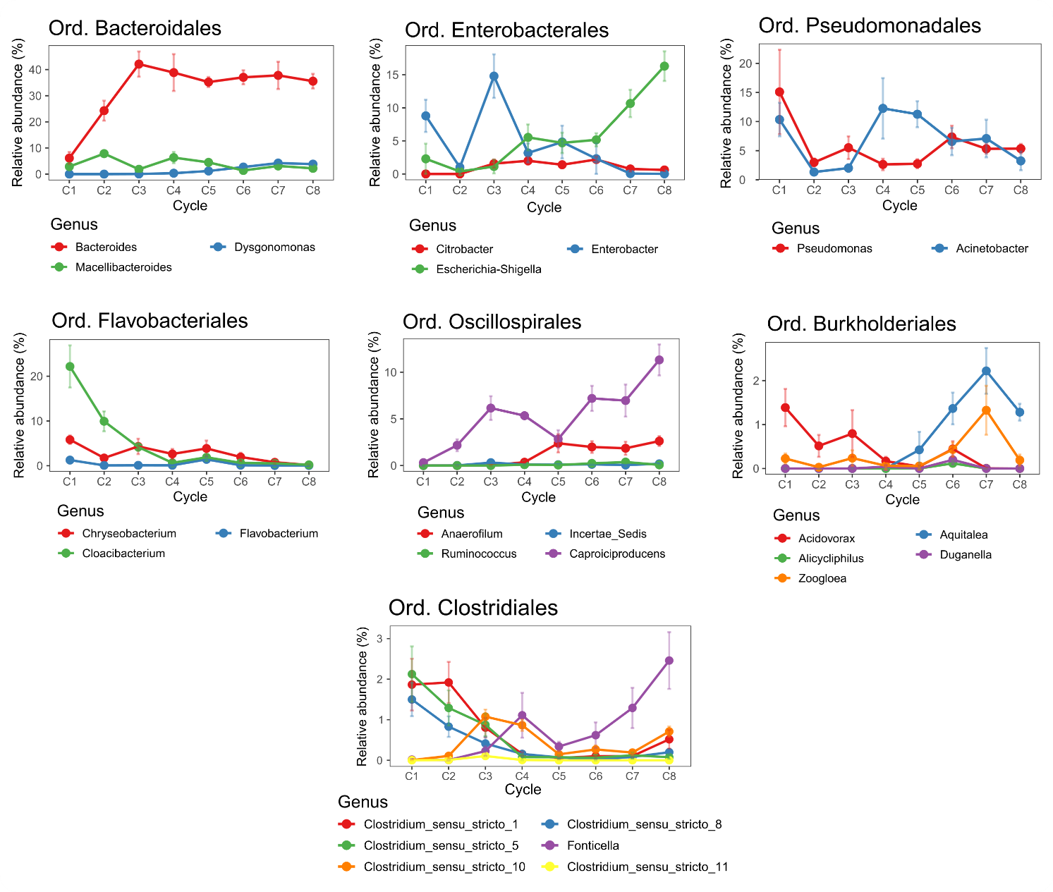
Supplementary Figure 3. Average relative abundances of the bacterial genera belonging to the most abundant orders across cycles. Error bars represent the standard error. Only genera showing a clear trend across successive cycles are displayed. Different genera are shown in distinct colors.

Supplementary Table 2. Average percentages (%) of the retting enzyme functions and enzymatic guilds, calculated over the total predicted enzyme function pool, within each retting cycle. Differences in the enzyme functions absolute abundance among the different cycles were tested using ANOVA, and significant differences (p-value < 0.05) are evidenced in bold and reported with different letters.
Cycle | Cellulases | EC:3.2.1.21 | EC:3.2.1.4 | EC:3.2.1.91 | Hemicellulases | EC:3.2.1.23 | EC:3.2.1.51 | EC:3.2.1.55 | EC:3.2.1.177 | EC:3.2.1.78 | EC:3.2.1.25 | EC:3.2.1.8 | EC:3.2.1.37 | Pectinases | EC:3.1.1.11 | EC:3.1.1.73 | EC:4.2.2.23 | EC:4.2.2.10 | EC:4.2.2.2
C1 | 0.244 (b) | 0.197 (b) | 0.046 (b) | <0.001 | 0.378 (b) | 0.166 (b) | 0.111 (b) | 0.038 (b) | 0.017 (b) | 0.022 (b) | 0.016 (b) | 0.007 (a) | 0.001 | 0.029 (b) | 0.026 (b) | 0.002 | <0.001 | <0.001 (b) | <0.001
C2 | 0.561 (a) | 0.523 (a) | 0.038 (b) | 0 | 1.149 (a) | 0.479 (a) | 0.335 (a) | 0.142 (a) | 0.049 (a) | 0.092 (a) | 0.048 (a) | 0.001 (b) | 0.002 | 0.095 (a) | 0.093 (a) | 0.002 | 0 | 0 (b) | 0
C3 | 0.133 (b) | 0.100 (b) | 0.034 (b) | 0 | 0.117 (b) | 0.062 (b) | 0.026 (b) | 0.010 (b) | 0.008 (b) | 0.005 (b) | 0.004 (b) | 0.002 (b) | <0.001 | 0.010 (b) | 0.010 (b) | <0.001 | 0 | <0.001 (b) | <0.001
C4 | 0.159 (b) | 0.095 (b) | 0.064 (ab) | 0 | 0.127 (b) | 0.058 (b) | 0.028 (b) | 0.013 (b) | 0.007 (b) | 0.006 (b) | 0.008 (b) | 0.005 (ab) | 0.001 | 0.011 (b) | 0.010 (b) | 0.001 | 0 | <0.001 (b) | <0.001
C5 | 0.218 (b) | 0.169 (b) | 0.049 (b) | 0 | 0.253 (b) | 0.107 (b) | 0.070 (b) | 0.027 (b) | 0.015 (b) | 0.017 (b) | 0.014 (b) | 0.004 (ab) | 0.001 | 0.021 (b) | 0.020 (b) | 0.001 | <0.001 | <0.001 (b) | <0.001
C6 | 0.134 (b) | 0.093 (b) | 0.041 (b) | 0 | 0.082 (b) | 0.036 (b) | 0.025 (b) | 0.005 (b) | 0.006 (b) | 0.001 (b) | 0.004 (b) | 0.002 (b) | 0.002 | 0.008 (b) | 0.006 (b) | 0.002 | <0.001 | <0.001 (b) | <0.001
C7 | 0.196 (b) | 0.131 (b) | 0.064 (ab) | <0.001 | 0.115 (b) | 0.055 (b) | 0.028 (b) | 0.011 (b) | 0.006 (b) | 0.005 (b) | 0.004 (b) | 0.005 (ab) | 0.001 | 0.008 (b) | 0.006 (b) | 0.001 | 0.001 | 0.001 (a) | <0.001
C8 | 0.208 (b) | 0.123 (b) | 0.086 (a) | <0.001 | 0.124 (b) | 0.057 (b) | 0.033 (b) | 0.011 (b) | 0.008 (b) | 0.004 (b) | 0.003 (b) | 0.008 (a) | 0.001 | 0.008 (b) | 0.007 (b) | 0.001 | <0.001 | <0.001 (ab) | <0.001

Supplementary Table 3. Average percentages (%) of the most abundant bacterial orders within each sampling time of the first three retting cycles. Differences in the orders absolute abundance among the different sampling times within each cycle were tested using ANOVA, and significant differences (p-value < 0.05) are evidenced in bold and reported with different letters.
Cycle | Time | Bacteroidales | Enterobacterales | Pseudomonadales | Flavobacteriales | Oscillospirales | Burkholderiales | Clostridiales
C1 | T1 | 0.09 (c) | 17.5 | 53.4 (a) | 12.2 (b) | 0 (b) | 3.30 | 0.01 (b)
C1 | T2 | 7.19 (b) | 19.6 | 15.9 (b) | 38.9 (a) | 0.11 (b) | 1.66 | 10.3 (a)
C1 | T3 | 19.9 (a) | 10.1 | 7.12 (b) | 37.1 (a) | 1.03 (a) | 4.23 | 8.99 (ab)
C2 | T1 | 26.3 | 10.5 (b) | 3.29 | 21.6 (a) | 1.57 (b) | 6.25 (a) | 12.2
C2 | T2 | 31.3 | 47.3 (a) | 4.57 | 10.7 (b) | 0.42 (c) | 1.41 (b) | 2.82
C2 | T3 | 39.6 | 39.3 (a) | 5.27 | 3.25 (c) | 4.27 (a) | 0.13 (b) | 5.05
C3 | T1 | 36.0 | 19.3 | 14.8 (a) | 8.22 | 4.27 (b) | 2.01 | 8.81 (a)
C3 | T2 | 49.4 | 19.9 | 5.23 (b) | 13.1 | 3.86 (b) | 1.89 | 5.43 (ab)
C3 | T3 | 46.7 | 24.3 | 3.11 (b) | 4.44 | 11.7 (a) | 1.19 | 2.29 (b)

Supplementary Table 4. Average percentages (%) of the retting enzyme functions and enzymatic guilds, calculated over the total predicted enzyme function pool, within each sampling time of the first three retting cycles. Differences in the enzyme functions absolute abundance among the different sampling times within each cycle were tested using ANOVA, and significant differences (p-value < 0.05) are evidenced in bold and reported with different letters.
Cycle | Time | Cellulases | EC:3.2.1.21 | EC:3.2.1.4 | EC:3.2.1.91 | Hemicellulases | EC:3.2.1.23 | EC:3.2.1.51 | EC:3.2.1.55 | EC:3.2.1.177 | EC:3.2.1.78 | EC:3.2.1.25 | EC:3.2.1.8 | EC:3.2.1.37 | Pectinases | EC:3.1.1.11 | EC:3.1.1.73 | EC:4.2.2.23 | EC:4.2.2.10 | EC:4.2.2.2
C1 | T1 | 0.140 (b) | 0.098 (b) | 0.042 | 0 | 0.095 (b) | 0.042 (b) | 0.020 (b) | 0.007 (b) | 0.010 | 0.003 (b) | 0.004 (b) | 0.009 | 0.002 | 0.016 | 0.009 | 0.004 | 0.002 | 0 | 0.001
C1 | T2 | 0.285 (a) | 0.248 (a) | 0.036 | <0.001 | 0.518 (a) | 0.231 (a) | 0.159 (a) | 0.054 (a) | 0.020 | 0.031 (ab) | 0.019 (ab) | 0.002 | 0.001 | 0.034 | 0.033 | 0.001 | 0 | <0.001 | <0.001
C1 | T3 | 0.306 (a) | 0.246 (a) | 0.061 | 0 | 0.520 (a) | 0.224 (a) | 0.153 (a) | 0.054 (a) | 0.021 | 0.034 (a) | 0.024 (a) | 0.010 | 0.001 | 0.037 | 0.037 | 0.001 | <0.001 | <0.001 | 0
C2 | T1 | 0.334 (b) | 0.292 (b) | 0.041 | 0 | 0.565 (b) | 0.230 (b) | 0.169 (b) | 0.069 (b) | 0.026 (b) | 0.039 (b) | 0.023 (b) | 0.004 (a) | 0.005 | 0.045 (b) | 0.039 (b) | 0.006 | 0 | 0 | 0
C2 | T2 | 0.738 (a) | 0.702 (a) | 0.036 | 0 | 1.577 (a) | 0.659 (a) | 0.459 (a) | 0.197 (a) | 0.065 (a) | 0.131 (a) | 0.066 (a) | 0 (b) | 0 | 0.131 (a) | 0.131 (a) | 0 | 0 | 0 | 0
C2 | T3 | 0.612 (a) | 0.574 (a) | 0.038 | 0 | 1.304 (a) | 0.548 (a) | 0.377 (a) | 0.162 (a) | 0.056 (a) | 0.107 (a) | 0.054 (a) | <0.001 (b) | 0.001 | 0.109 (a) | 0.109 (a) | 0.001 | 0 | 0 | 0
C3 | T1 | 0.209 (a) | 0.156 (a) | 0.053 | 0 | 0.196 (a) | 0.105 (a) | 0.044 | 0.017 (a) | 0.013 (a) | 0.010 (a) | 0.006 (a) | 0.002 | <0.001 | 0.018 (a) | 0.017 (a) | <0.001 | 0 | 0 | <0.001
C3 | T2 | 0.097 (b) | 0.081 (b) | 0.026 | 0 | 0.097 (ab) | 0.049 (b) | 0.026 | 0.007 (b) | 0.004 (b) | 0.004 (ab) | 0.003 (b) | 0.004 | <0.001 | 0.007 (b) | 0.006 (b) | <0.001 | 0 | <0.001 | 0
C3 | T3 | 0.058 (b) | 0.062 (b) | 0.022 | 0 | 0.058 (b) | 0.032 (b) | 0.009 | 0.005 (b) | 0.007 (b) | 0.002 (b) | 0.001 (b) | 0.001 | 0.001 | 0.007 (b) | 0.007 (b) | 0.001 | 0 | 0 | <0.001

