Newcastle Ottawa Quality Assessment
Study Name | UHR v HC
Study Name | NOS score | Quality
Addington et al. 2012 | 8 | High
Auther et al. 2012 | 6 | Medium
Bloemen et al. 2010 | 6 | Medium
Buchy et al. 2015 | 6 | Medium
Hagenmuller et al. 2016 | 5 | Medium
Pruessner et al. 2011 | 6 | Medium
Russo et al. 2014 | 6 | Medium
Stojanovic et al. 2014 | 6 | Medium
Study Name | UHR Cannabis v non-cannabis users
Auther et al. 2012 | 4 | Medium
Auther et al. 2015 | 7 | Medium
Bugra et al. 2013 | 7 | Medium
Corcoran et al. 2008 | 5 | Medium
Dragt et al. 2012 | 4 | Medium
Gill et al. 2015 | 4 | Medium
Mizrahi et al. 2014 | 7 | Medium
Van Tricht et al. 2013 | 5 | Medium

Meta-analysis outputs
Lifetime cannabis use (UHR individuals)
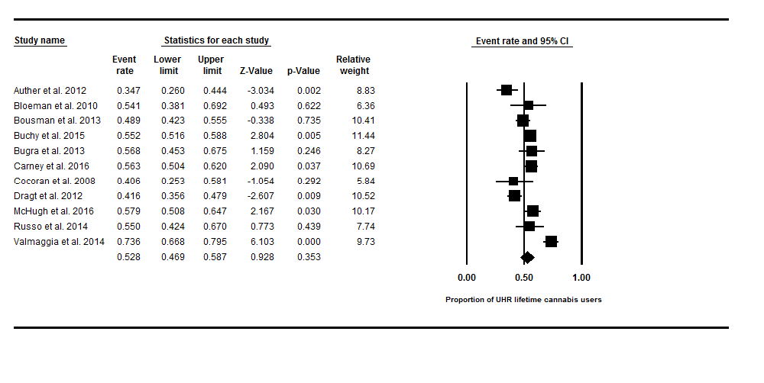
Current cannabis use disorders (UHR individuals)
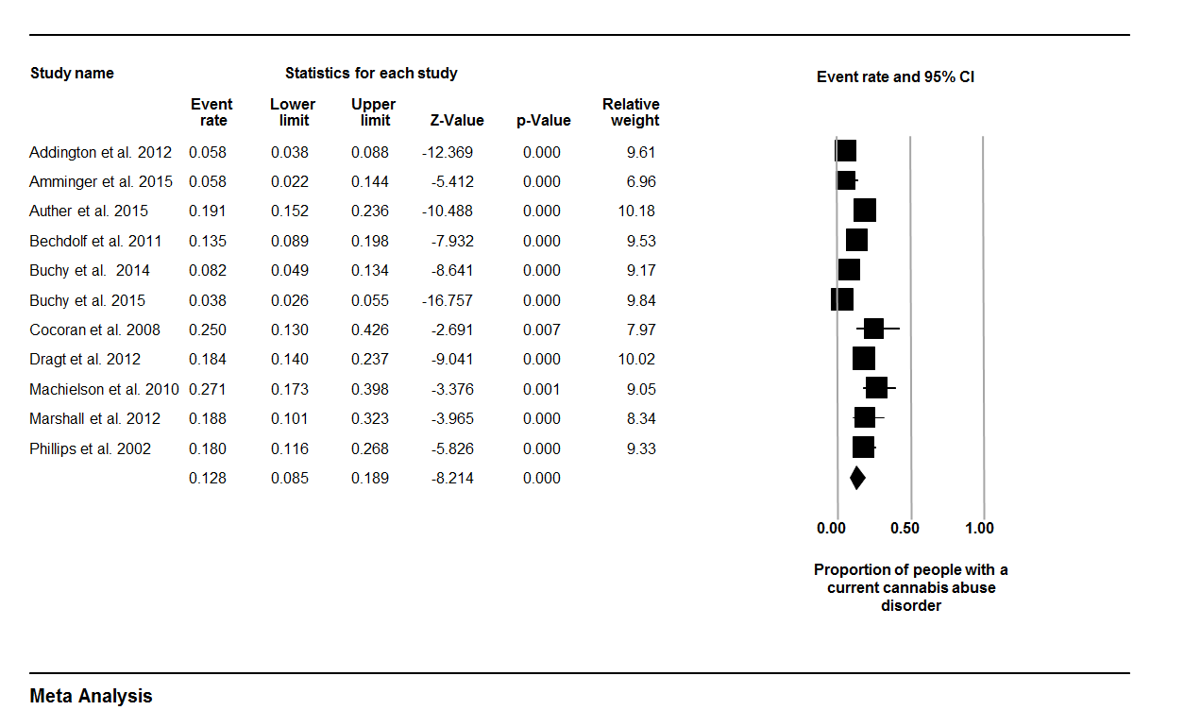

UHR v Healthy Controls
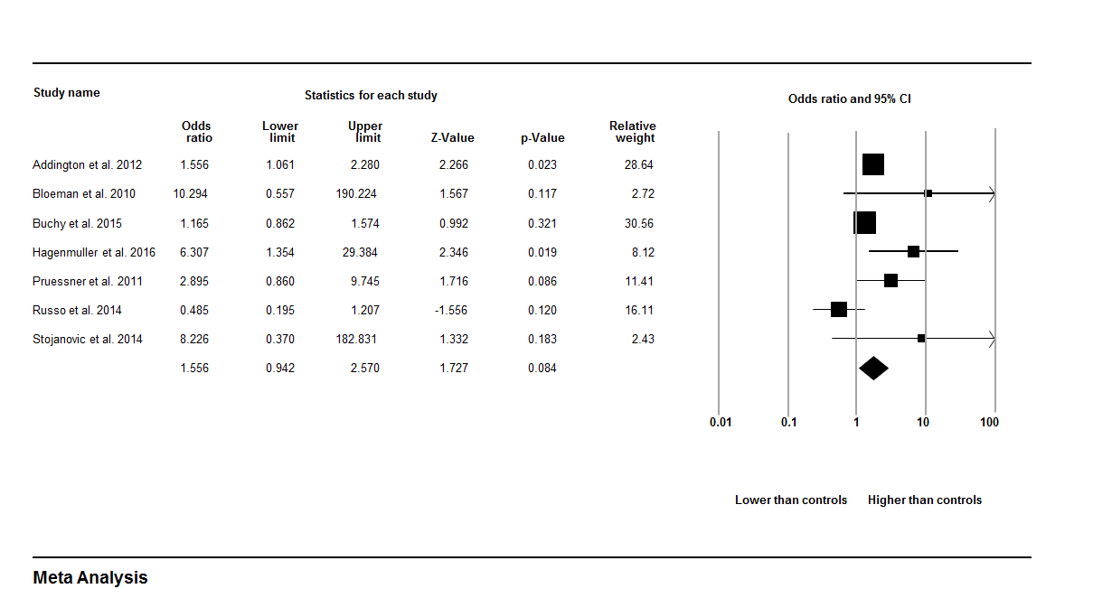
Current cannabis use

Lifetime cannabis use
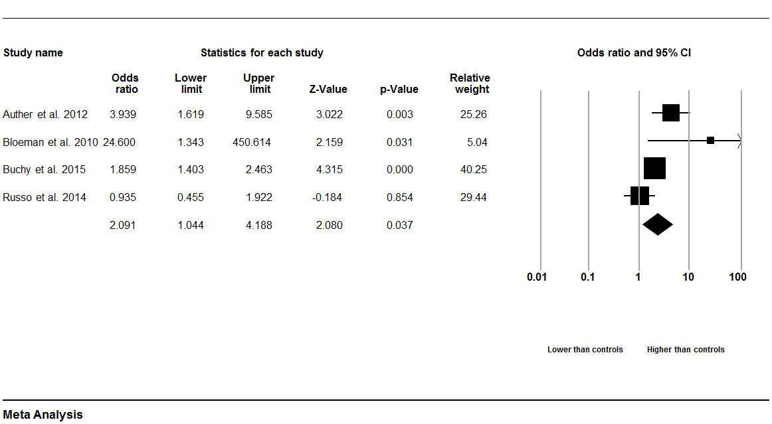

CUD
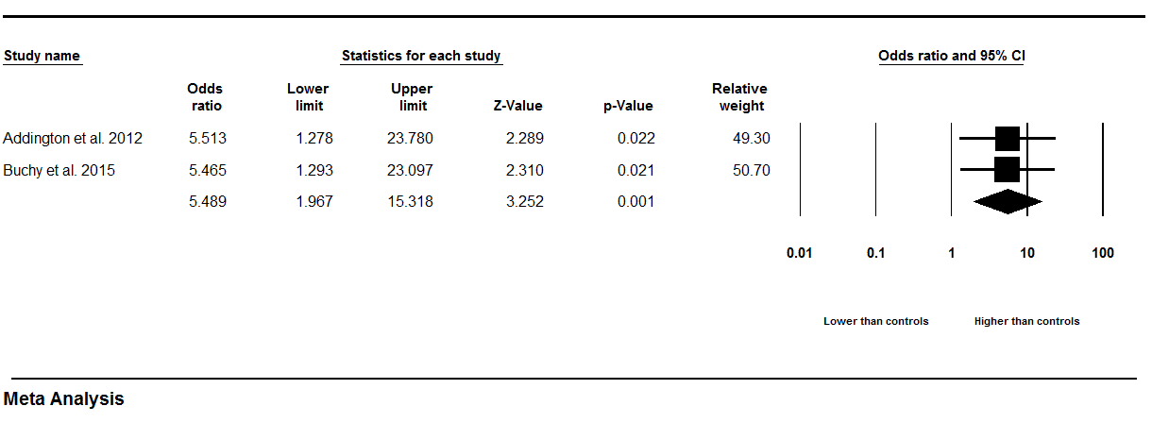

UHR cannabis users compared with UHR non-cannabis users
Total Positive Symptoms
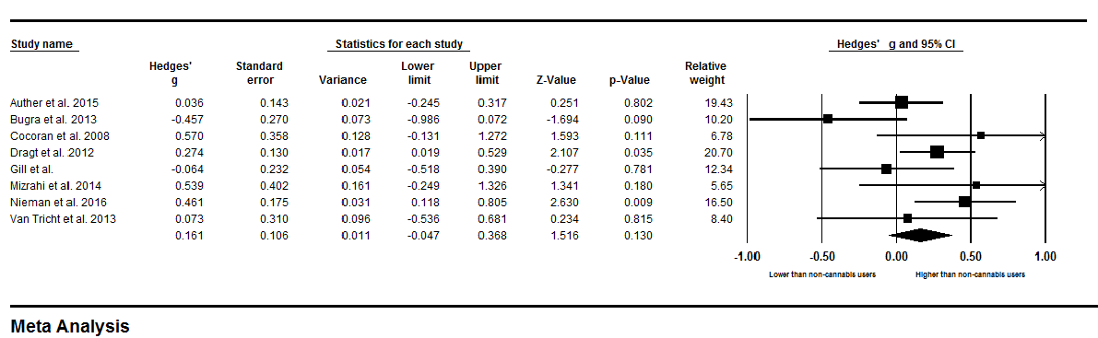

Disorganised speech 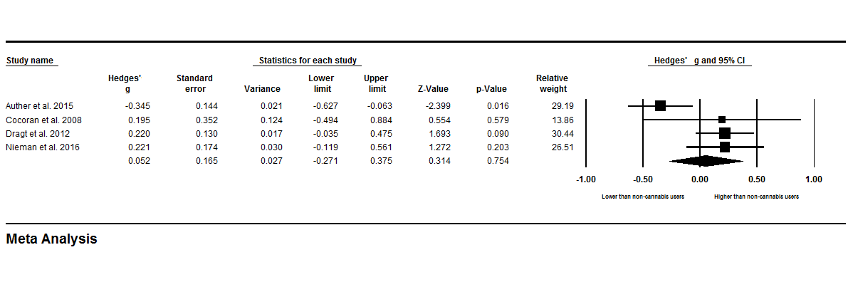
Perceptual abnormalities
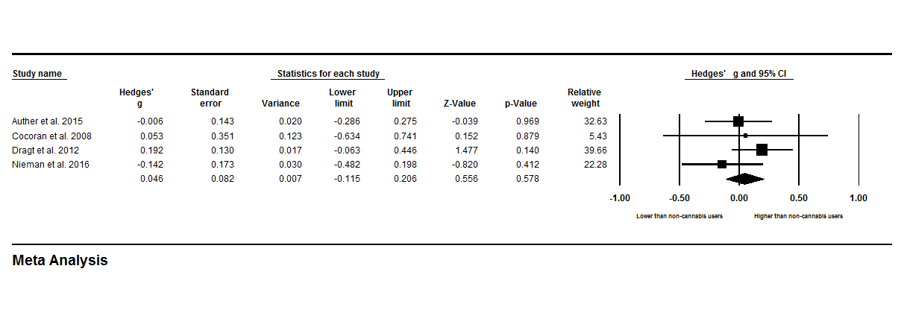

Unusual thought content
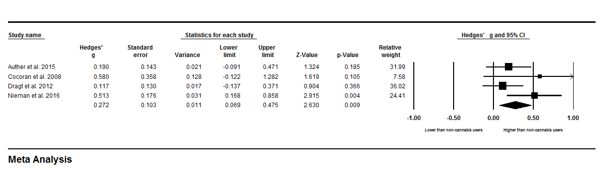

Suspiciousness
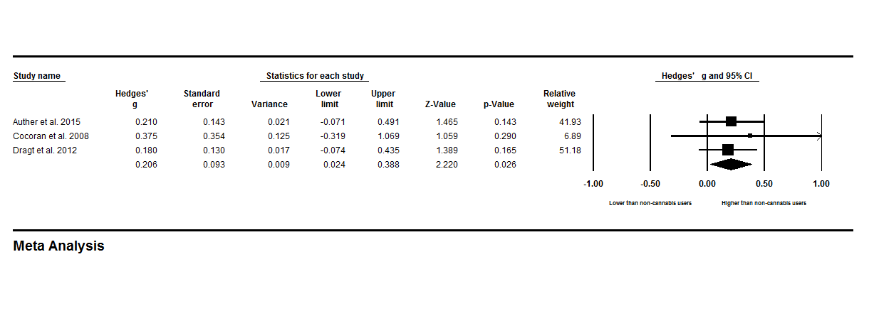

Grandiosity
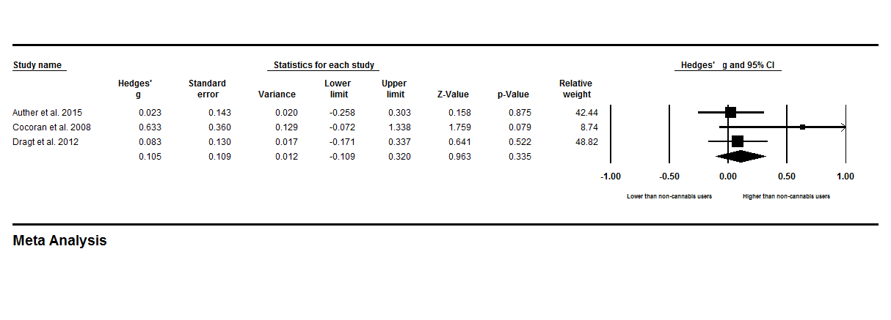

Total Negative Symptoms
