Geometric Deep learning Prioritization and validation of cannabis phytochemicals as anti-HCV non-nucleoside direct-acting inhibitors.
Ssemuyiga Charles^{1,2*} and Mulumba Pius Edgar^{1,2}
charles.ssemuyiga@kiu.ac.ug
¹Department of Microbiology, Kampala International University, School of Natural and Applied Sciences (SONAS), Kansanga, Kampala, Uganda. ²PharmaQsar Bioinformatics Firm, Kampala, Uganda.
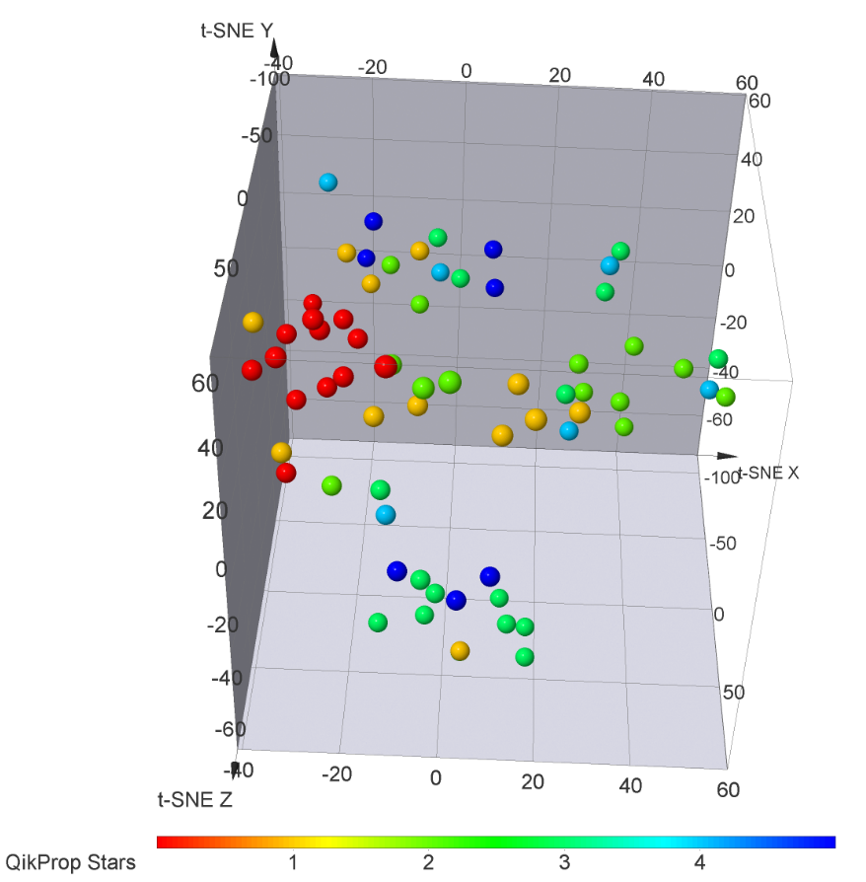

Figure S1: The results of ADMET analysis for the selected compounds Showing the t-SNE based on the ADMET properties of the compounds. Only compounds with stars ≤ 5 were presented.

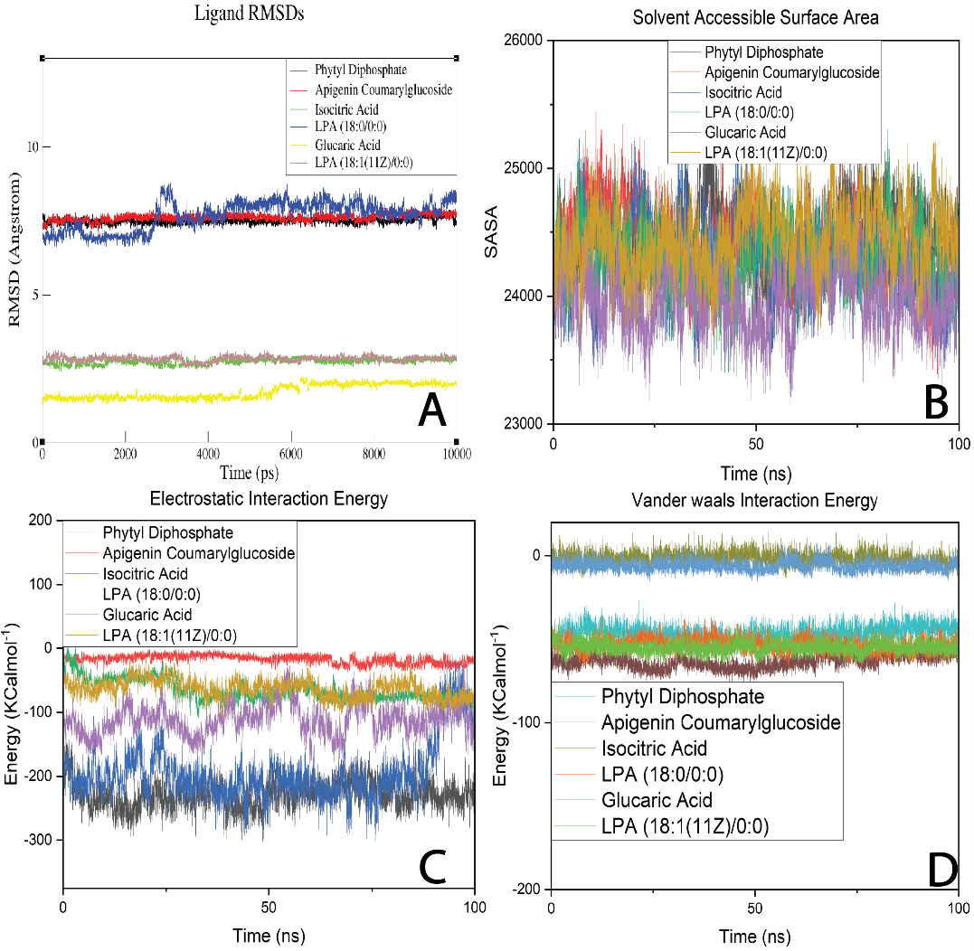

Figure S2: The changes in Ligand RMSDs for simulated complexes (A), Solvent Accessible Surface Area (B), Electrostatic Interaction Energy (C), and Vander Waals Interaction Energy (D) are illustrated.
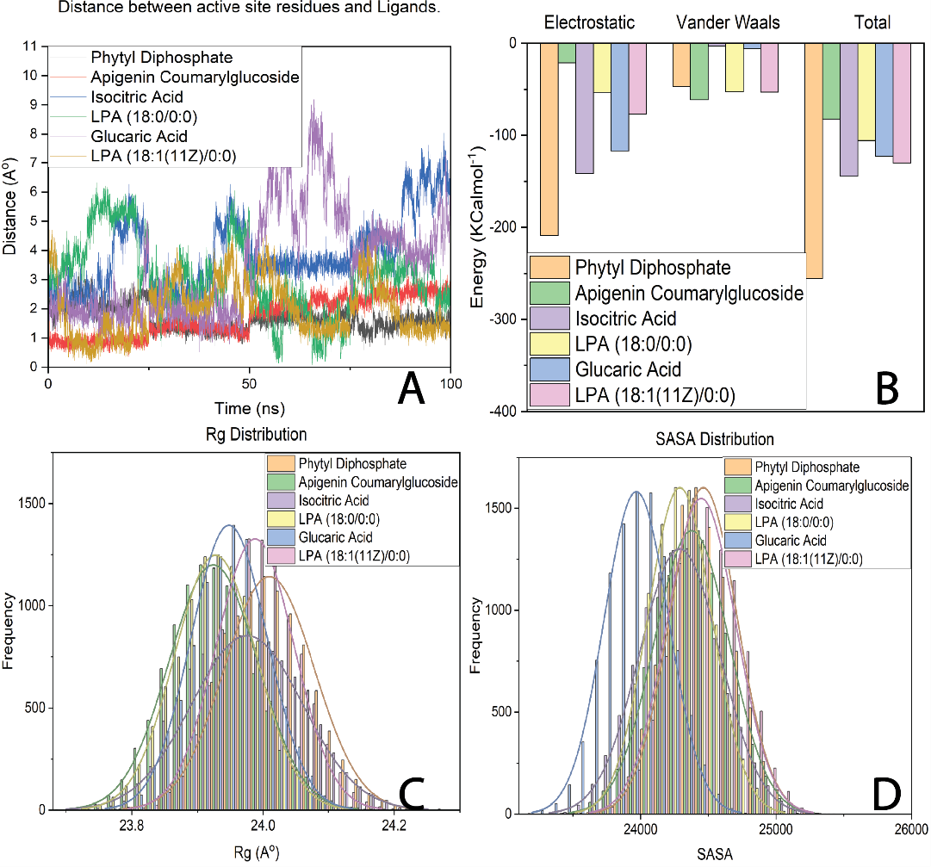

Figure S3: The fluctuation in the distance between ligands and active site residues (A), overview of interaction energies (B), Rg Distribution (C), and SASA Distribution (D) throughout the simulation.
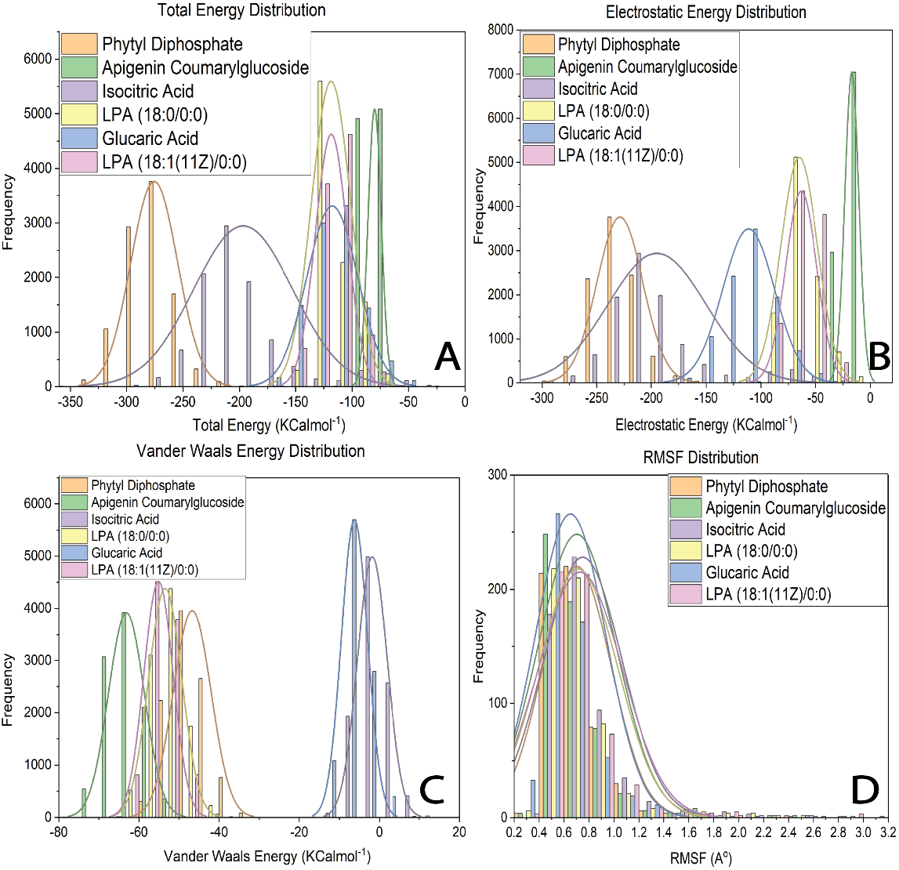
Figure S4: The dispersion of Total Energy (A), Electrostatic Energy (B), Vander Waals Energy (C), and RMSF (D).

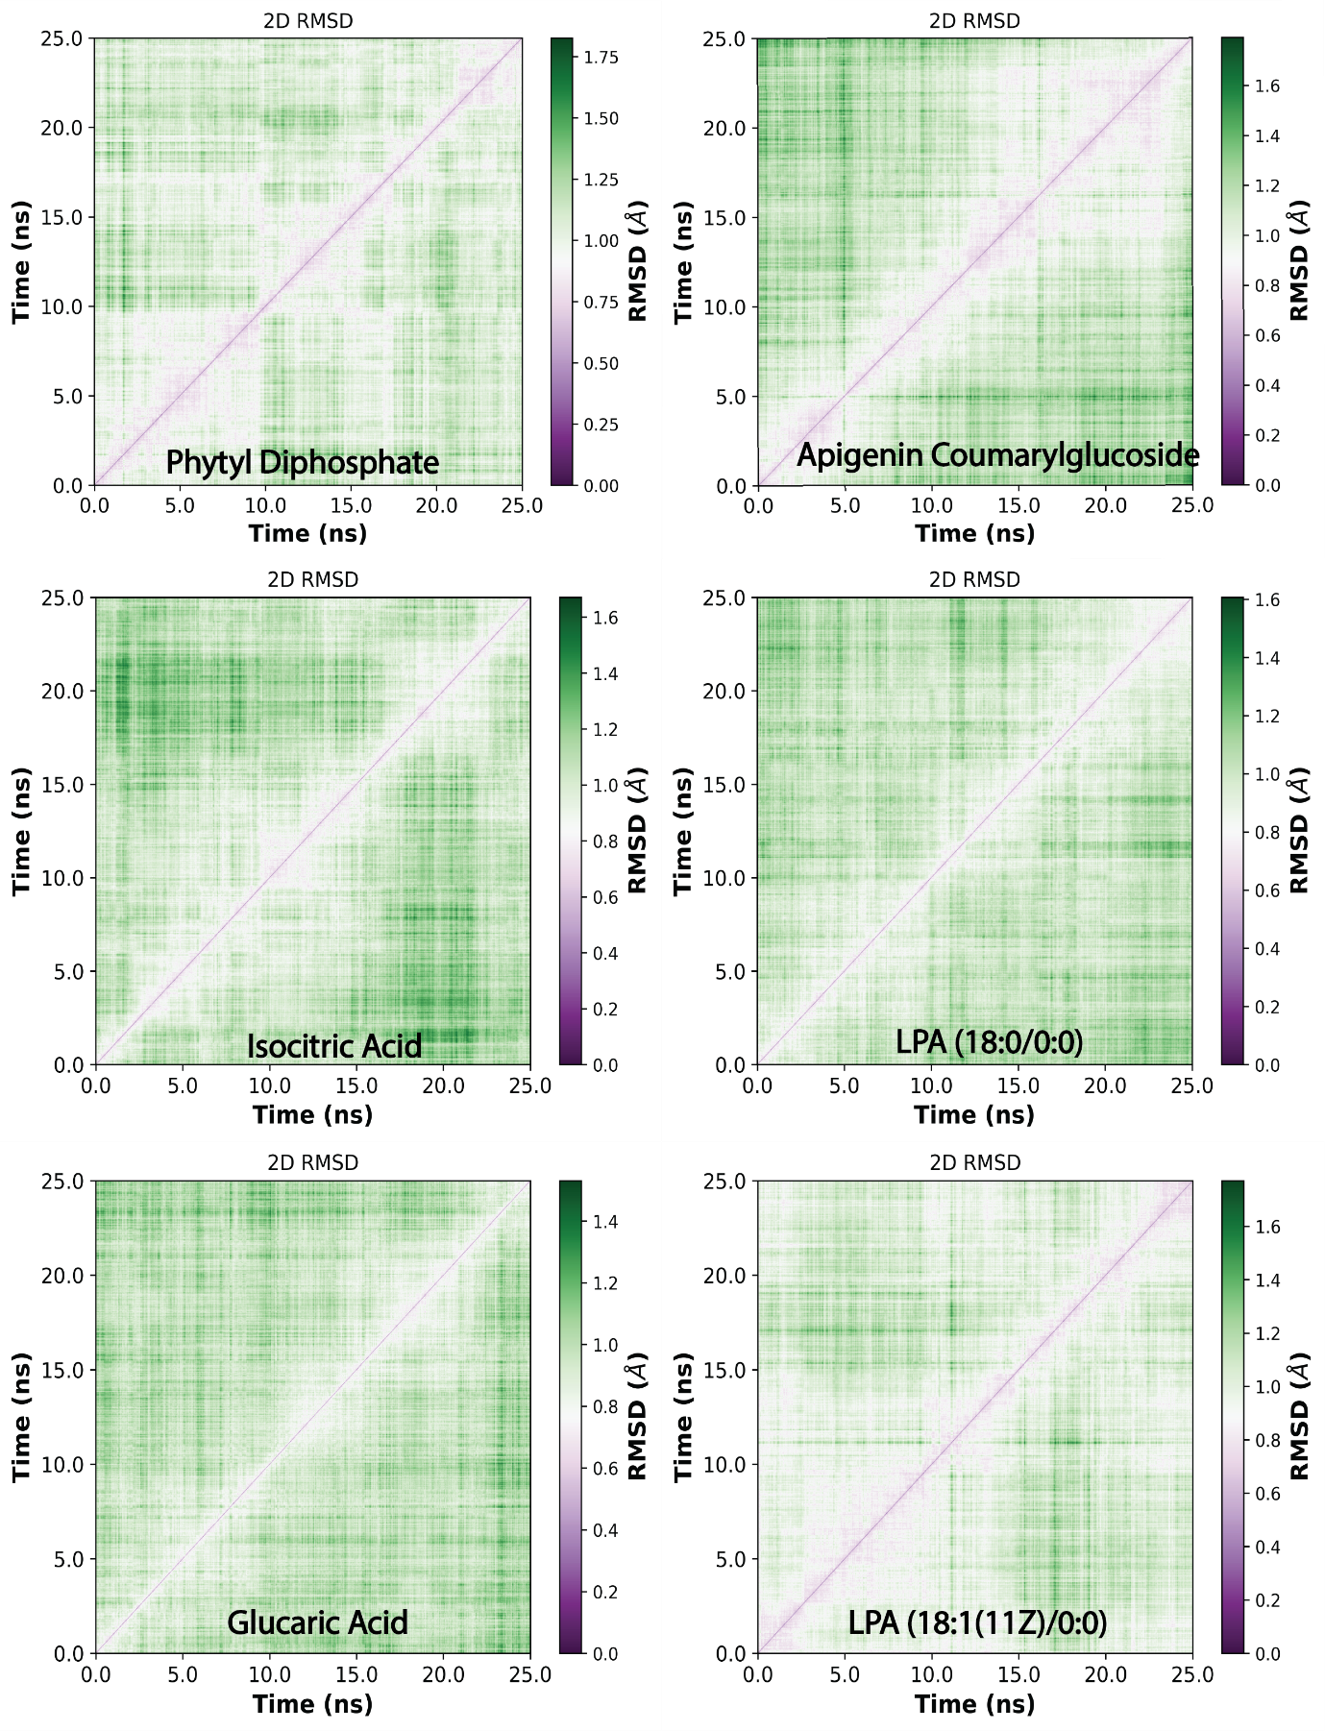

Figure S5: The root-mean-square deviations (RMSDs) of all small molecule complexes are represented in an all-to-all comparison. The color scale indicates the RMSD in angstroms.

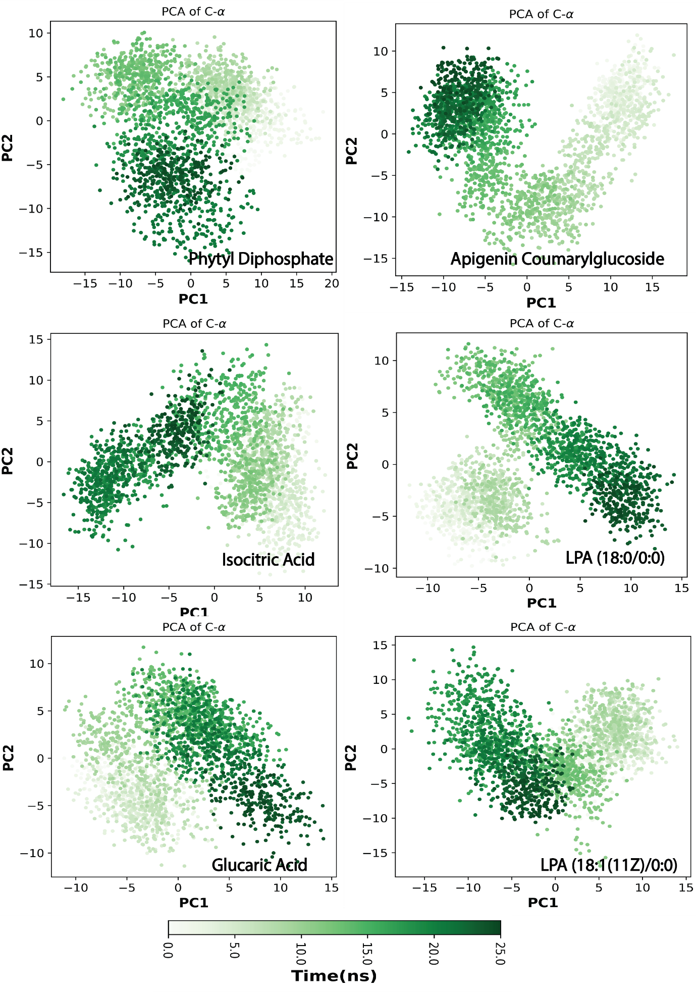

Figure S6:The outcomes of principal component analysis (PCA) for all simulated systems depicts the dynamic energy fluctuations plotted in the conformational space of Cα-atoms. This is illustrated by the two eigenvectors, 1 and 2, generated for the docked complexes.

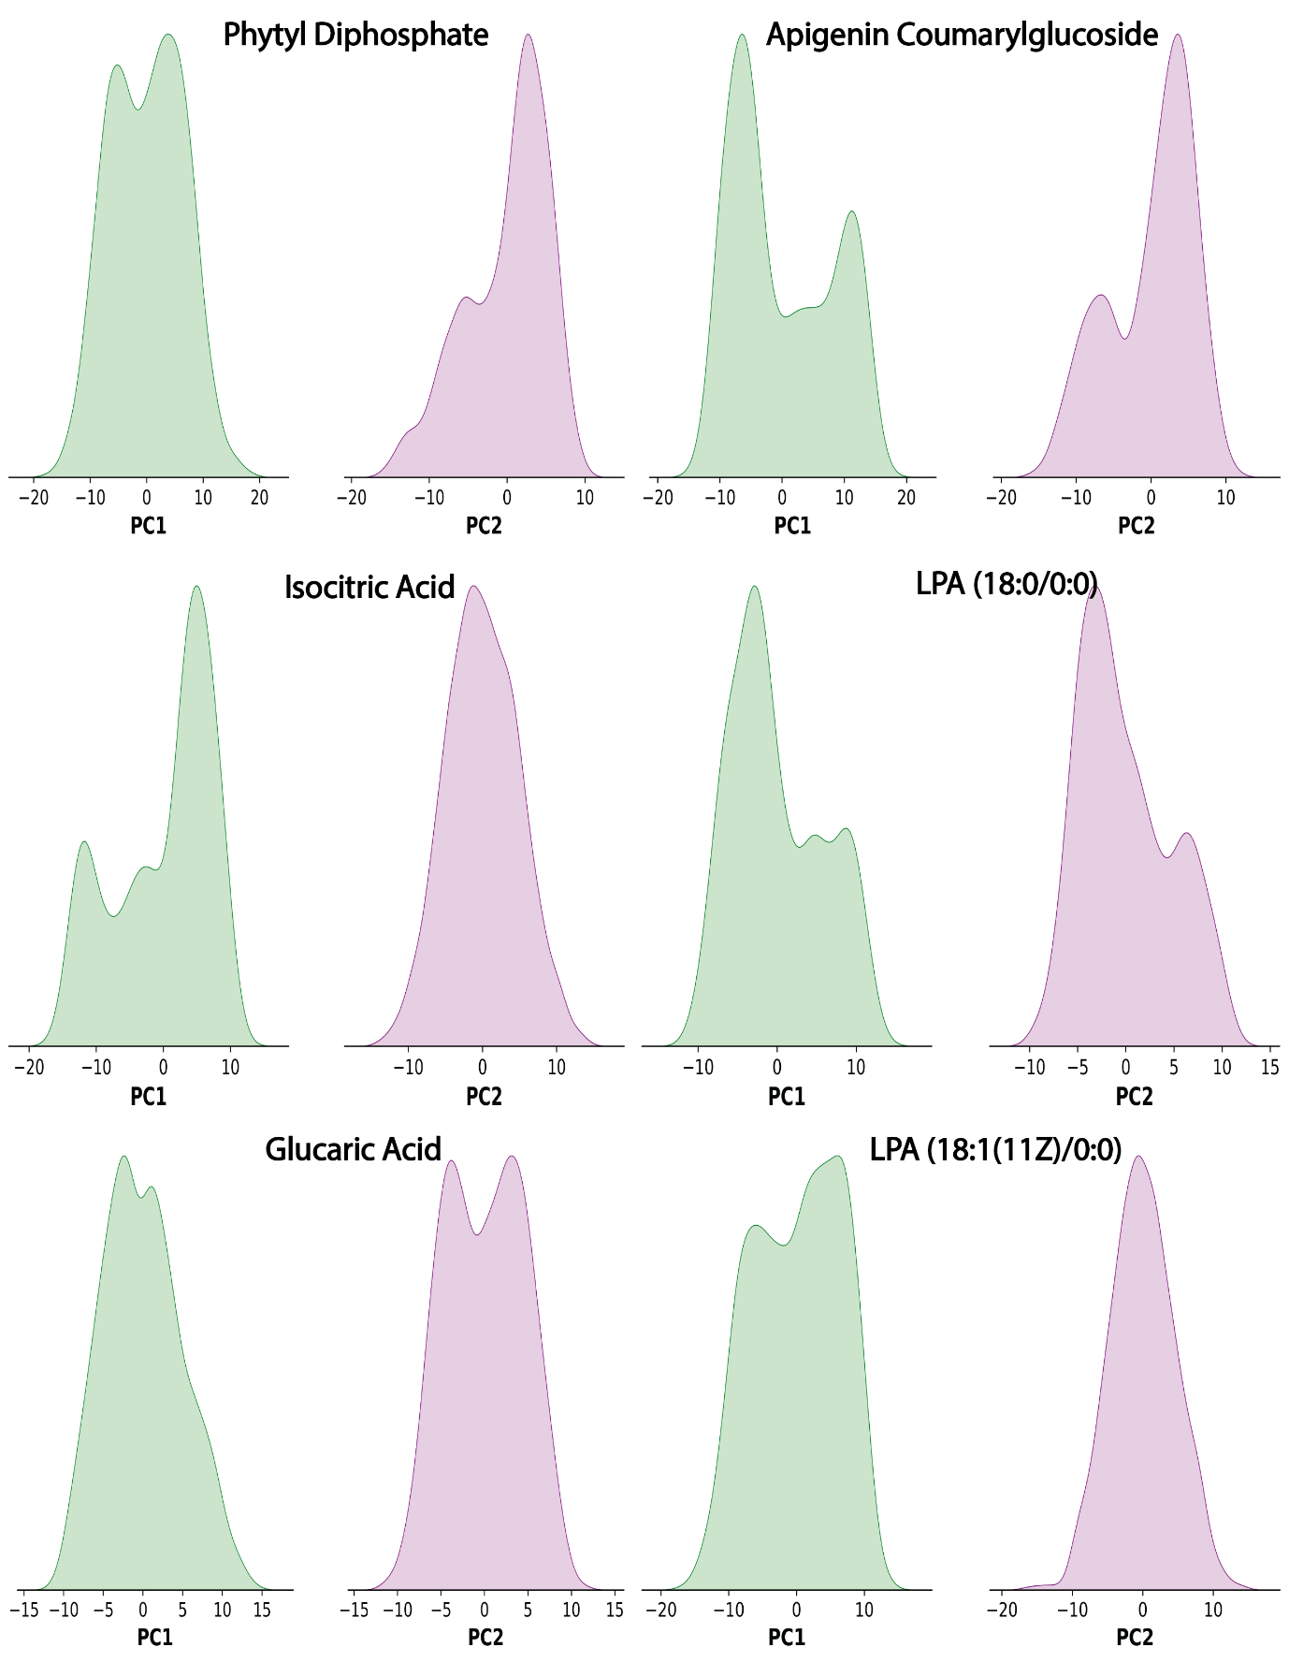

Figure S7: The Distribution of PC for different complexes.

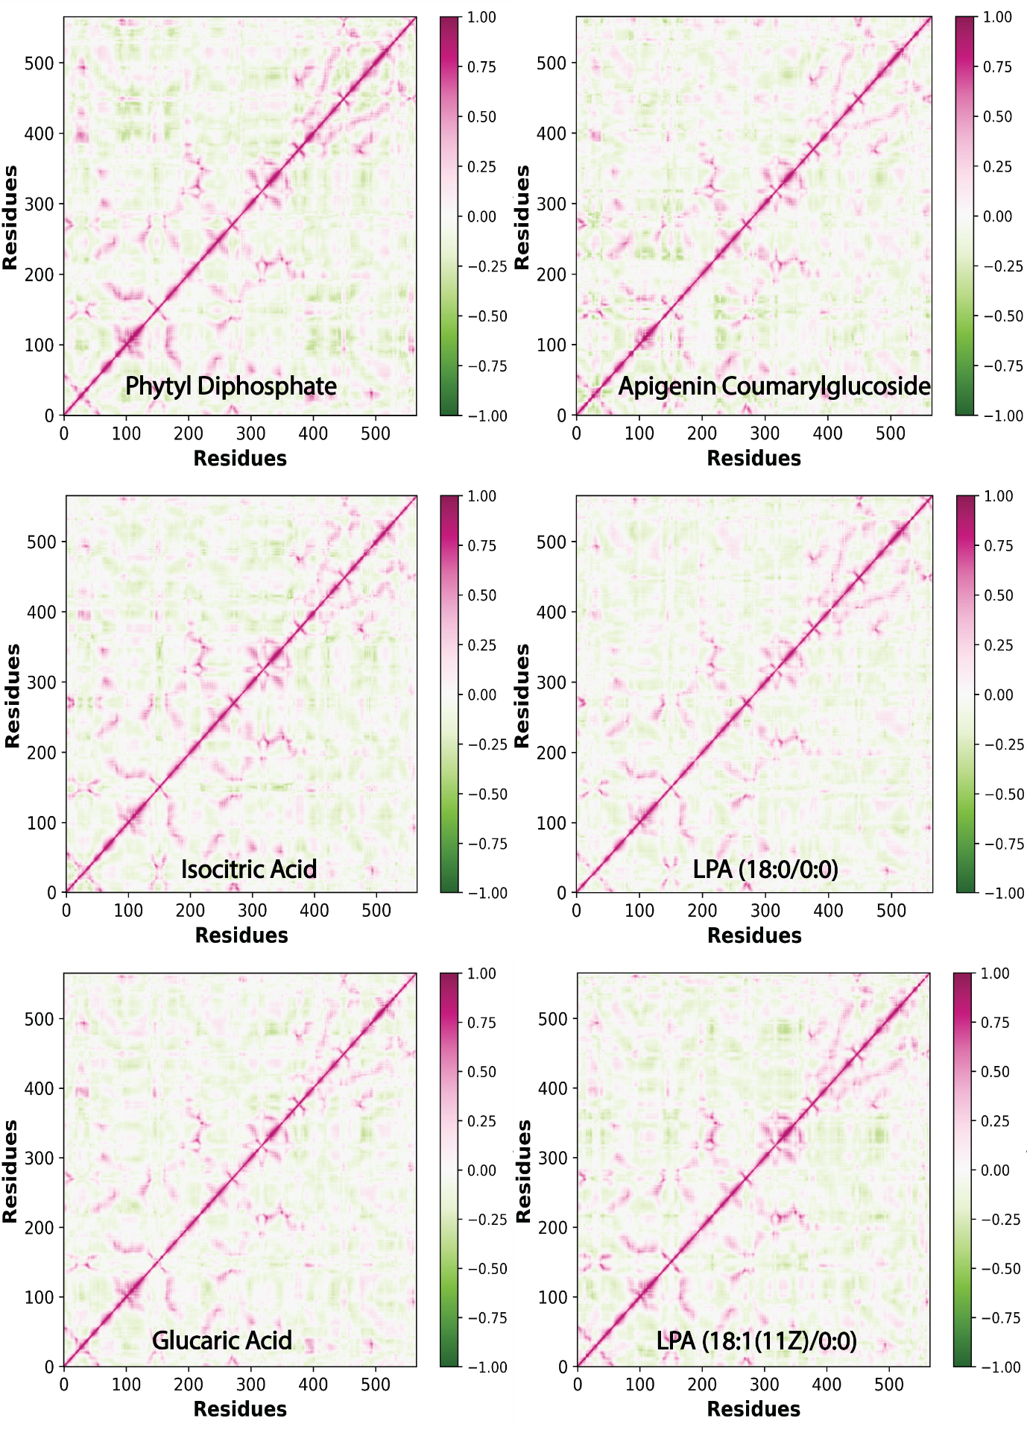
Figure S8: Results of global motion analysis for simulated complexes are presented. The color range, spanning from red (indicating positive correlation, +1) to green (indicating negative correlation, −1), represents cross-correlation values.

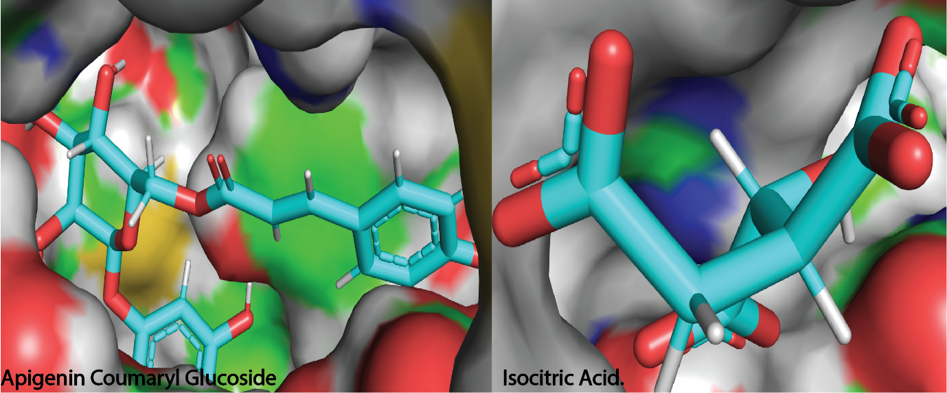
Figure S9: The Figure shows the proximity towards non-polar protein sections achieved by the two ligands.

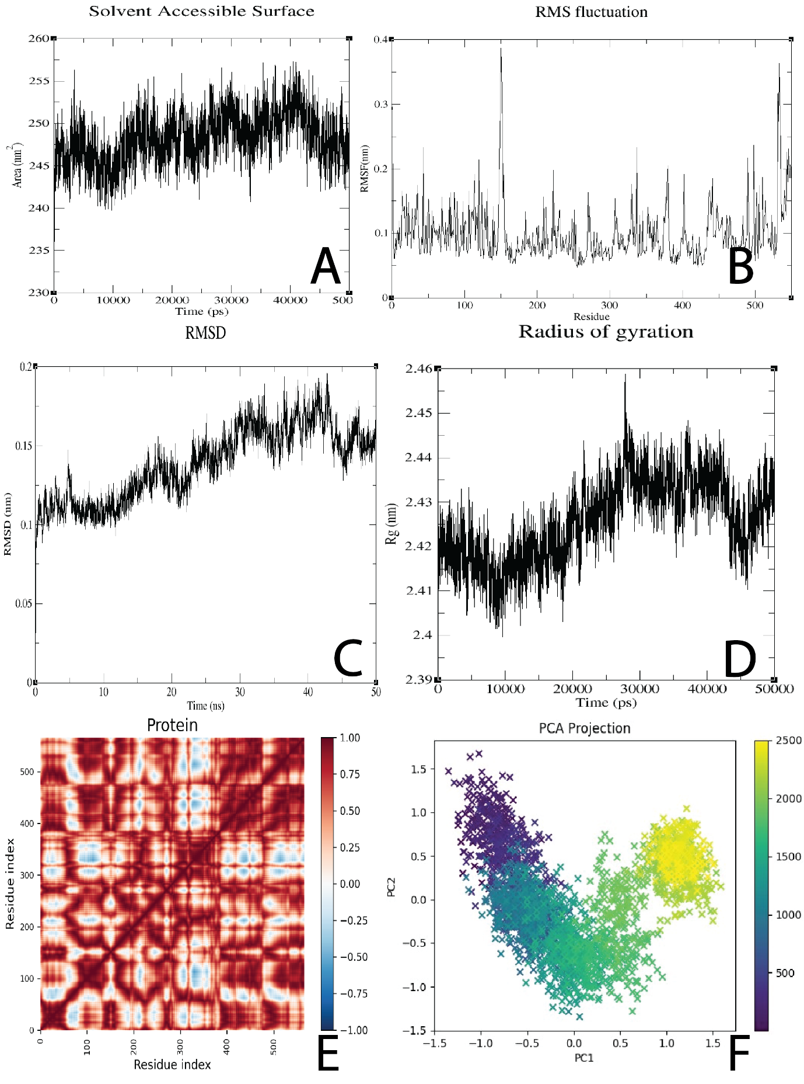

Figure S10:The simulation results of the apo protein.

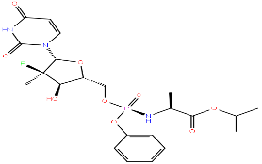
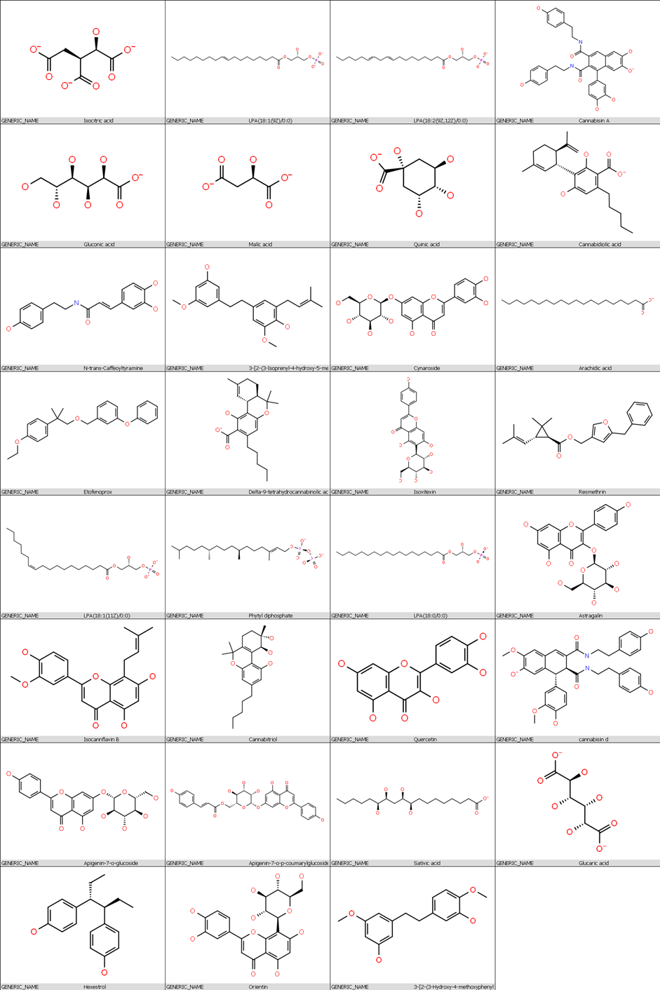
sofosbuvir
Figure S11: Compounds ranked as the best in this study.

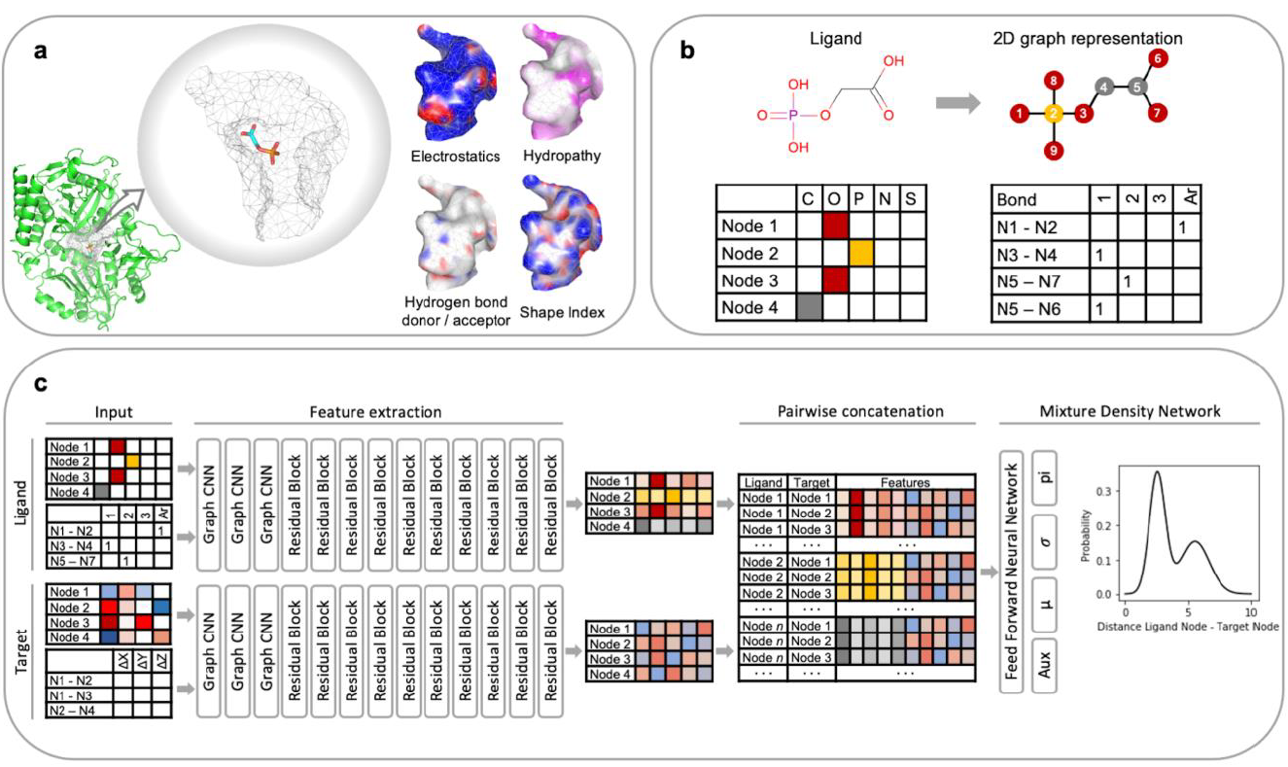
Figure S12: Adopted from (Méndez-Lucio et al., 2021). A deep learning model was employed to learn the potential for predicting binding conformations. a, The protein target is depicted as a polygonal mesh of the molecular surface, with each node encoding four properties: electrostatics, hydropathy, hydrogen bond donor/acceptor status, and shape index. b, The ligand is represented as a graph, where nodes correspond to atoms and edges represent bonds. c, Both ligand and target representations are processed by a neural network that extracts features using graph convolutions. These features are then pairwise concatenated and fed into a mixture density network, which predicts a set of probability distributions that form a potential.

Table S1: The table summarizes the RAASs investigated in the study, In addition to substitutions of L159F, C316R, E237G, and L320F, the following additional substitutions apply for each of the indicated mutant proteins.
MUTANT1 | S282T and V321I
MUTANT2 | S282T and V321A
MUTANT3 | S282R and V321I
MUTANT4 | S282R and V321A

Table S2: The results of re-docking the respective mutants with the identified hits.
Ligand | Wild-Type | Mutant1 | Mutant2 | Mutant3 | Mutant4 | Average
3-[2-(3-Isoprenyl-4-hydroxy-5-methoxy-phenyl)ethyl]-5-methoxyphenol | -8.456 | -5.437 | -5.126 | -4.821 | -4.662 | -5.7004
Apigenin-7-o-glucoside | -8.522 | -6.235 | -5.198 | -3.907 | -6.53 | -6.0784
Apigenin-7-o-p-coumarylglucoside | -12.038 | -5.539 | -5.847 | -7.856 | -7.41 | -7.738
Arachidic acid | -8.237 | -5.127 | -2.635 | -3.791 | -2.851 | -4.5282
Astragalin | -8.016 | -6.817 | -8.207 | -6.286 | -7.141 | -7.2934
Cannabidiolic acid | -8.282 | -6.908 | -6.16 | -6.781 | -6.838 | -6.9938
Cannabisin A | -9.873 | -5.442 | 1.295 | -4.548 | -3.736 | -4.4608
cannabisin d | -8.722 | -8.406 | -8.458 | -4.936 | -5.917 | -7.2878
Cannabistilbene I | -8.378 | -4.68 | -3.427 | -4.146 | -4.22 | -4.9702
Cannabitriol | -8.908 | -4.602 | -5.045 | -4.907 | -4.922 | -5.6768
Cynaroside | -9.935 | -6.407 | -7.198 | -7.113 | -7.019 | -7.5344
Delta-9-tetrahydro cannabinolic acid A | -8.202 | -2.81 | -3.623 | -3.724 | -3.738 | -4.4194
Etofenoprox | -8.22 | -4.099 | -10.077 | -3.504 | -3.792 | -5.9384
Glucaric acid | -10.667 | -10.443 | -8.922 | -10.12 | -10.48 | -10.1264
Gluconic acid | -9.602 | -9.629 | -5.225 | -6.445 | -8.486 | -7.8774
Isocannflavin B | -8.54 | -4.992 | -9.582 | -5.147 | -4.856 | -6.6234
Isocitric acid | -11.05 | -8.858 | -7.224 | -9.455 | -9.446 | -9.2066
Isovitexin | -8.002 | -7.353 | -2.21 | -6.547 | -6.103 | -6.043
LPA (18:0/0:0) | -11.05 | -2.732 | -5.604 | -5.197 | -6.769 | -6.2704
LPA (18:1(11Z)/0:0) | -10.621 | -6.635 | -5.765 | -5.88 | -4.925 | -6.7652
LPA (18:1(9Z)/0:0) | -9.978 | -5.876 | -4.234 | -6.491 | -3.952 | -6.1062
LPA (18:2(9Z,12Z)/0:0) | -10.21 | -5.399 | -5.493 | -4.883 | -3.815 | -5.96
Malic acid | -8.808 | -7.035 | -7.931 | -7.015 | -6.905 | -7.5388
N-trans-Caffeoyltyramine | -8.499 | -4.628 | -4.131 | -4.383 | -3.578 | -5.0438
Orientin | -8.627 | -8.44 | -8.397 | -8.325 | -8.38 | -8.4338
Phytyl diphosphate | -12.275 | -3.993 | -2.812 | -4.403 | -6.156 | -5.9278
Quercetin | -8.36 | -6.395 | -5.244 | -6.072 | -6.214 | -6.457
Quercetin-o-glucoside | -9.621 | -7.088 | -6.956 | -9.118 | -8.517 | -8.26
Quinic acid | -8.736 | -6.4 | -8.913 | -8.872 | -8.847 | -8.3536
Resmethrin | -8.053 | -3.28 | -3.757 | -4.278 | -4.27 | -4.7276
Sativic acid | -10.062 | -7.576 | -7.407 | -7.788 | -7.884 | -8.1434
Sofosbuvir | -6.887 | -5.63 | -6.145 | -6.434 | -6.739 | -6.367

Table S3: The Results of docking the identified cannabis compounds with NS3/4 protease.
Ligand | Docking score | Glide ligand efficiency | Glide ligand efficiency sa | Glide ligand efficiency ln | XP GScore | Glide gscore | Glide energy | Glide emodel | XP HBond
Cynaroside | -7.84 | -0.245 | -0.778 | -1.756 | -7.84 | -7.84 | -46.917 | -63.101 | -3.282
Gluconic acid | -7.473 | -0.575 | -1.352 | -2.096 | -7.473 | -7.473 | -30.232 | -35.49 | -4.446
Glucaric acid | -7.19 | -0.514 | -1.238 | -1.976 | -7.191 | -7.191 | -28.174 | -33.439 | -3.376
Orientin | -7.011 | -0.219 | -0.696 | -1.57 | -7.047 | -7.047 | -43.442 | -53.958 | -3.413
Isocitric acid | -6.554 | -0.504 | -1.185 | -1.838 | -6.554 | -6.554 | -34.513 | -38.809 | -2.378
Apigenin-7-o-glucoside | -6.549 | -0.211 | -0.664 | -1.477 | -6.549 | -6.549 | -38.668 | -56.407 | -3.209
Isovitexin | -6.451 | -0.208 | -0.654 | -1.455 | -6.497 | -6.497 | -43.219 | -50.648 | -3.261
Quercetin | -6.29 | -0.286 | -0.801 | -1.537 | -6.322 | -6.322 | -36.101 | -46.809 | -3.328
AstragalinÂ | -5.869 | -0.183 | -0.582 | -1.314 | -5.898 | -5.898 | -39.557 | -54.545 | -2.986
Sativic acid | -5.686 | -0.237 | -0.683 | -1.361 | -5.689 | -5.689 | -37.842 | -34.79 | -2.57
Malic acid | -5.574 | -0.619 | -1.288 | -1.743 | -5.574 | -5.574 | -28.32 | -27.522 | -1.51
quercetin-o-glucoside | -5.492 | -0.166 | -0.534 | -1.221 | -7.412 | -7.412 | -35.845 | -46.4 | -3.3
3-[2-(3-Isoprenyl-4-hydroxy-5-methoxy-phenyl)ethyl]-5-methoxyphenol | -5.2 | -0.208 | -0.608 | -1.233 | -5.201 | -5.201 | -37.671 | -43.702 | -1.18
Apigenin-7-o-p-coumarylglucoside | -5.155 | -0.123 | -0.427 | -1.088 | -5.155 | -5.155 | -49.496 | -67.856 | -2.514
LPA(18:1(9Z)/0:0) | -4.94 | -0.17 | -0.523 | -1.131 | -5.042 | -5.042 | -41.16 | -46.601 | -2.421
Sofosbuvir | -4.927 | -0.137 | -0.452 | -1.075 | -4.93 | -4.93 | -41.964 | -51.977 | -1.137
Isocannflavin B | -4.854 | -0.18 | -0.539 | -1.13 | -4.875 | -4.875 | -36.47 | -47.357 | -1.934
Cannabistilbene I | -4.516 | -0.196 | -0.558 | -1.092 | -4.517 | -4.517 | -34.501 | -48.176 | -1.177
Cannabitriol | -4.424 | -0.177 | -0.517 | -1.049 | -4.424 | -4.424 | -29.362 | -35.96 | -0.96
N-trans-Caffeoyltyramine | -4.289 | -0.195 | -0.546 | -1.048 | -4.372 | -4.372 | -39.717 | -50.048 | -2.205
cannabisin d | -4.115 | -0.089 | -0.321 | -0.852 | -4.815 | -4.815 | -52.2 | -62.318 | -2.173
LPA(18:2(9Z,12Z)/0:0) | -3.972 | -0.137 | -0.421 | -0.91 | -5.063 | -5.063 | -46.29 | -45.22 | -3.54
Delta-9-tetrahydrocannabinolic acid A | -3.948 | -0.152 | -0.45 | -0.927 | -3.949 | -3.949 | -32.941 | -41.229 | -1.31
LPA(18:0/0:0) | -3.697 | -0.127 | -0.392 | -0.846 | -4.787 | -4.787 | -43.029 | -55.704 | -3.565
Resmethrin | -3.127 | -0.125 | -0.366 | -0.741 | -3.127 | -3.127 | -37.717 | -46.416 | -1.03
Etofenoprox | -2.825 | -0.101 | -0.306 | -0.652 | -2.825 | -2.825 | -35.608 | -47.95 | 0
Phytyl diphosphate | -2.666 | -0.092 | -0.282 | -0.61 | -3.903 | -3.903 | -46.348 | -56.252 | -2.1
Cannabidiolic acid | -2.601 | -0.1 | -0.296 | -0.611 | -2.601 | -2.601 | -33.081 | -40.176 | -0.638
Cannabisin A | -2.119 | -0.048 | -0.17 | -0.443 | -4.682 | -4.682 | -50.186 | -64.541 | -1.325
Arachidic acid | -0.865 | -0.039 | -0.11 | -0.211 | -0.869 | -0.869 | -26.53 | -31.342 | -0.337

Table S4: Comparison of docking scores for wild type and mutant1.
t-Test: Paired Two Sample for Means
 | Wild-Type | Mutant1
Mean | -9.23241 | -6.09034
Variance | 1.60499 | 3.424794
Observations | 32 | 32
Pearson Correlation | 0.109156
Hypothesized Mean Difference | 0
df | 31
t Stat | -8.36217
P(T<=t) one-tail | 9.55E-10
t Critical one-tail | 1.695519
P(T<=t) two-tail | 1.91E-09
t Critical two-tail | 2.039513

Table S5: Comparison of docking scores for wild type and mutant2.
t-Test: Paired Two Sample for Means
 | Wild-Type | Mutant2
Mean | -9.23241 | -5.80181
Variance | 1.60499 | 6.078866
Observations | 32 | 32
Pearson Correlation | -0.05176
Hypothesized Mean Difference | 0
df | 31
t Stat | -6.85811
P(T<=t) one-tail | 5.48E-08
t Critical one-tail | 1.695519
P(T<=t) two-tail | 1.1E-07
t Critical two-tail | 2.039513

Table S6: Comparison of docking scores for wild type and mutant3.
t-Test: Paired Two Sample for Means
 | Wild-Type | Mutant3
Mean | -9.23241 | -6.03666
Variance | 1.60499 | 3.33795
Observations | 32 | 32
Pearson Correlation | 0.314305
Hypothesized Mean Difference | 0
df | 31
t Stat | -9.67971
P(T<=t) one-tail | 3.47E-11
t Critical one-tail | 1.695519
P(T<=t) two-tail | 6.93E-11
t Critical two-tail | 2.039513

Table S7:Comparison of docking scores for wild type and mutant4.
t-Test: Paired Two Sample for Means
 | Wild-Type | Mutant4
Mean | -9.23241 | -6.09681
Variance | 1.60499 | 3.88007
Observations | 32 | 32
Pearson Correlation | 0.303824
Hypothesized Mean Difference | 0
df | 31
t Stat | -8.90372
P(T<=t) one-tail | 2.38E-10
t Critical one-tail | 1.695519
P(T<=t) two-tail | 4.75E-10
t Critical two-tail | 2.039513

References
Méndez-Lucio, O., Ahmad, M., del Rio-Chanona, E. A., & Wegner, J. K. (2021). A geometric deep learning approach to predict binding conformations of bioactive molecules. Nature Machine Intelligence 2021 3:12, 3(12), 1033–1039. https://doi.org/10.1038/s42256-021-00409-9

