Supplementary Material
Table S1. Multiple linear regression analyses of predictors of CAMI ‘Prejudice/Exclusion’ and ‘Tolerance and Support for Community Care’ subscales
Predictors | CAMI: Prejudice/Exclusion |  | CAMI: Tolerance and support for community care
 | Standardised effect size (95% CI) | P value | Standardised effect size (95% CI) | P value
Year
2023 | 0.29 (0.23 to 0.36) | <0.001 | 0.10 (0.02 to 0.18) | 0.013
2021 | 0.35 (0.28 to 0.41) | <0.001 | 0.21 (0.14 to 0.29) | <0.001
2019 | 0.29 (0.23 to 0.35) | <0.001 | 0.28 (0.21 to 0.35) | <0.001
2017 | 0.22 (0.16 to 0.28) | <0.001 | 0.22 (0.15 to 0.29) | <0.001
2016 | 0.19 (0.12 to 0.25) | <0.001 | 0.27 (0.19 to 0.34) | <0.001
2015 | 0.13 (0.07 to 0.19) | <0.001 | 0.23 (0.16 to 0.30) | <0.001
2014 | 0.13 (0.07 to 0.20) | <0.001 | 0.19 (0.12 to 0.26) | <0.001
2013 | 0.03 (-0.03 to 0.09) | 0.402 | 0.13 (0.06 to 0.20) | <0.001
2012 | -0.02 (-0.08 to 0.04) | 0.531 | 0.13 (0.06 to 0.20) | <0.001
2011 | -0.06 (-0.012 to 0.01) | 0.070 | 0.11 (0.04 to 0.18) | 0.003
2010 | 0.01 (-0.05 to 0.07) | 0.776 | 0.13 (0.06 to 0.20) | <0.001
2009 | -0.07 (-0.14 to -0.01) | 0.021 | 0.09 (0.02 to 0.16) | 0.011
2008 (ref) | - | - | - | -
Gender
Female | 0.17 (0.15 to 0.20) | <0.001 | 0.12 (0.10 to 0.15) | <0.001
Male (ref) | - | - | - | -
Age
16-24 | 0.20 (0.16 to 0.24) | <0.001 | -0.21 (-0.26 to -0.17) | <0.001
25-44 | 0.24 (0.21 to 0.27) | <0.001 | -0.08 (-0.11 to -0.04) | <0.001
45-64 | 0.29 (0.25 to 0.32) | <0.001 | 0.05 (0.02 to 0.09) | 0.005
65+ (ref) | - | - | - | -
Ethnicity
Asian | -0.50 (-0.55 to -0.45) | <0.001 | -0.22 (-0.27 to -0.16) | <0.001
Black | -0.37 (-0.43 to -0.30) | <0.001 | -0.23 (-0.31 to -0.16) | <0.001
Other | -0.28 (-0.37 to -0.19) | <0.001 | -0.19 (-0.29 to -0.09) | <0.001
White (ref) | - | - | - | -
Socioeconomic position
AB | 0.41 (0.37 to 0.44) | <0.001 | 0.22 (0.18 to 0.26) | <0.001
C1 | 0.29 (0.26 to 0.33) | <0.001 | 0.16 (0.12 to 0.19) | <0.001
C2 | 0.10 (0.07 to 0.14) | <0.001 | 0.10 (0.06 to 0.14) | <0.001
DE (ref) | - | - | - | -
Familiarity with mental health
Self | 0.86 (0.81 to 0.91) | <0.001 | 0.69 (0.64 to 0.74) | <0.001
Other | 0.56 (0.53 to 0.59) | <0.001 | 0.40 (0.37 to 0.43) | <0.001
None (ref) | - | - | - | -
Region
North East | 0.26 (0.19 to 0.32) | <0.001 | 0.24 (0.16 to 0.31) | <0.001
North West | 0.20 (0.15 to 0.25) | <0.001 | 0.19 (0.14 to 0.25) | <0.001
York and Hum | 0.26 (0.20 to 0.31) | <0.001 | 0.28 (0.22 to 0.34) | <0.001
East Midlands | 0.15 (0.10 to 0.21) | <0.001 | 0.19 (0.13 to 0.25) | <0.001
West Midlands | 0.19 (0.14 to 0.24) | <0.001 | 0.12 (0.07 to 0.18) | <0.001
East of England | 0.19 (0.14 to 0.24) | <0.001 | 0.18 (0.12 to 0.24) | <0.001
South East | 0.16 (0.12 to 0.21) | <0.001 | 0.13 (0.07 to 0.18) | <0.001
South West | 0.27 (0.22 to 0.32) | <0.001 | 0.20 (0.25 to 0.26) | <0.001
London (ref) | - | - | - | -

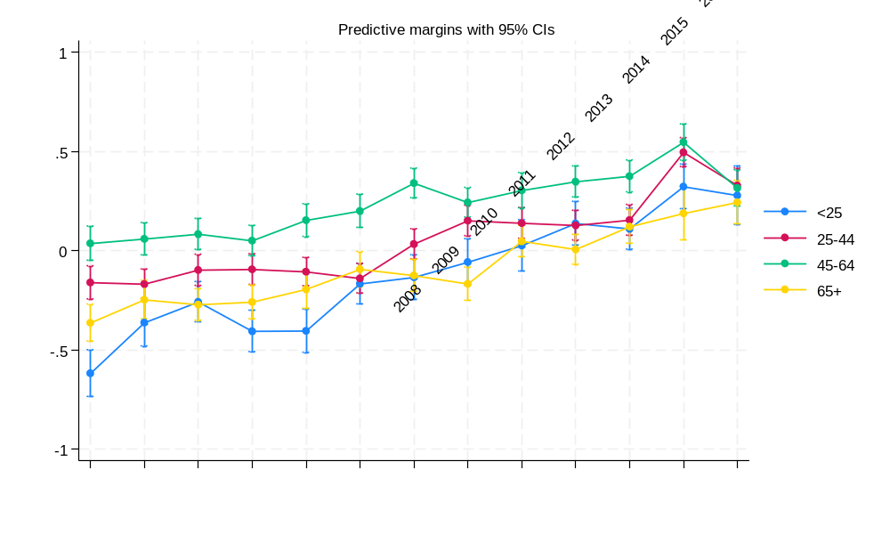
Figure S1. Marginal estimates of year*age group interaction (95% CIs) for mental health related attitudes (CAMI scores)

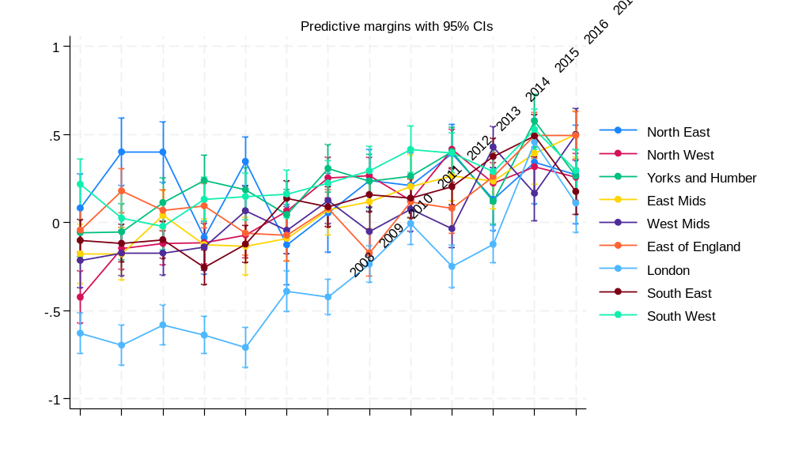
Figure S2. Marginal estimates of year*region interaction (95% CIs) for mental health related attitudes (CAMI scores)
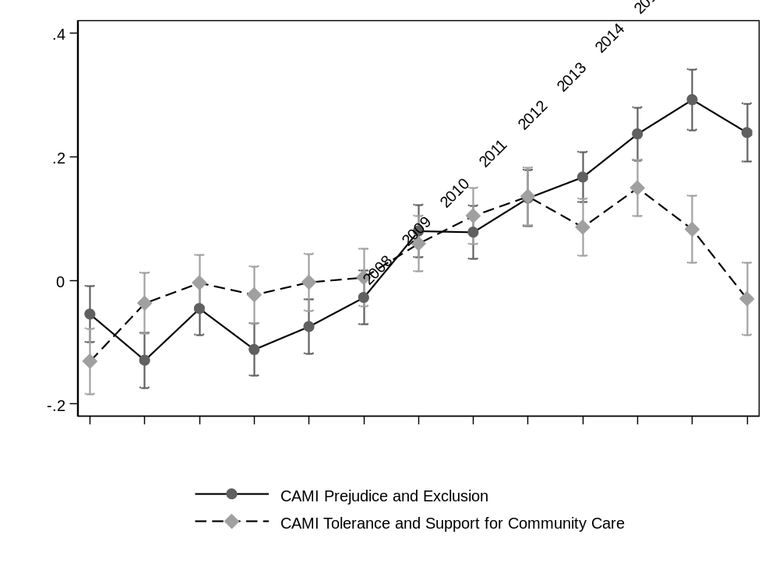
Figure S3. Marginal estimates of CAMI subscale scores by year (95% CIs)
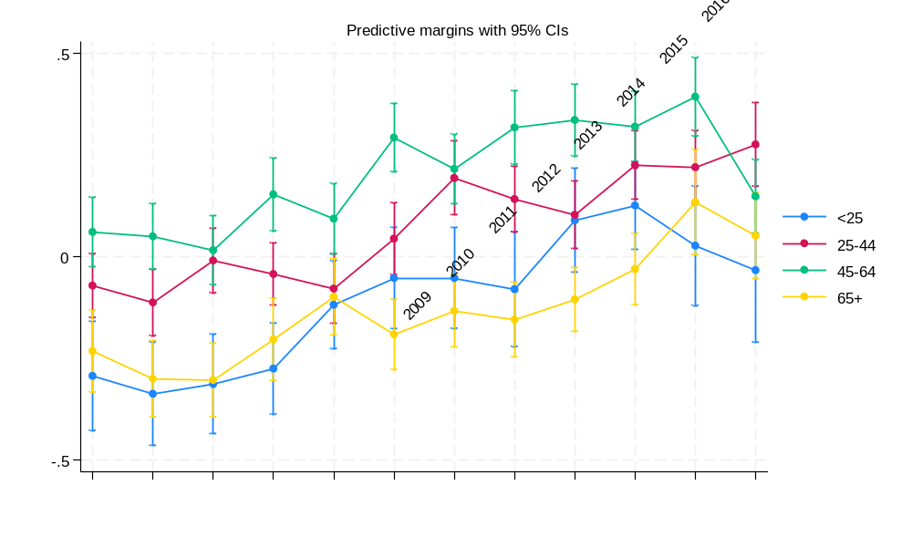
Figure S4. Marginal estimates of year*age group interaction (95% CIs) for mental health related knowledge (MAKS scores)
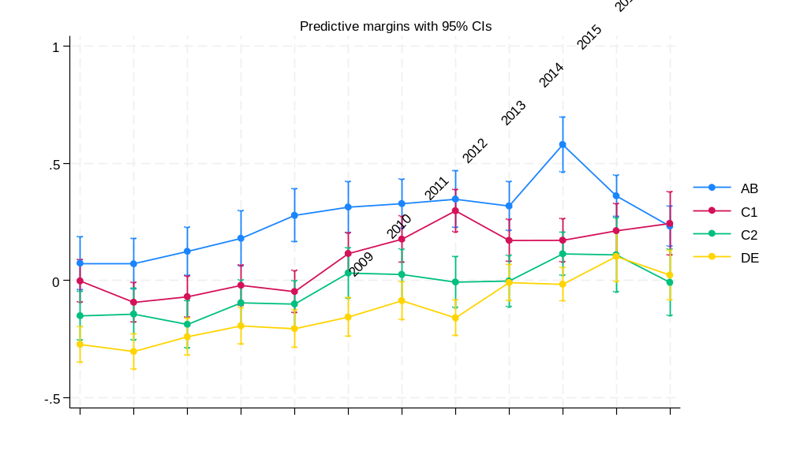
Figure S5. Marginal estimates of year*class interaction (95% CIs) for mental health related knowledge (MAKS scores)

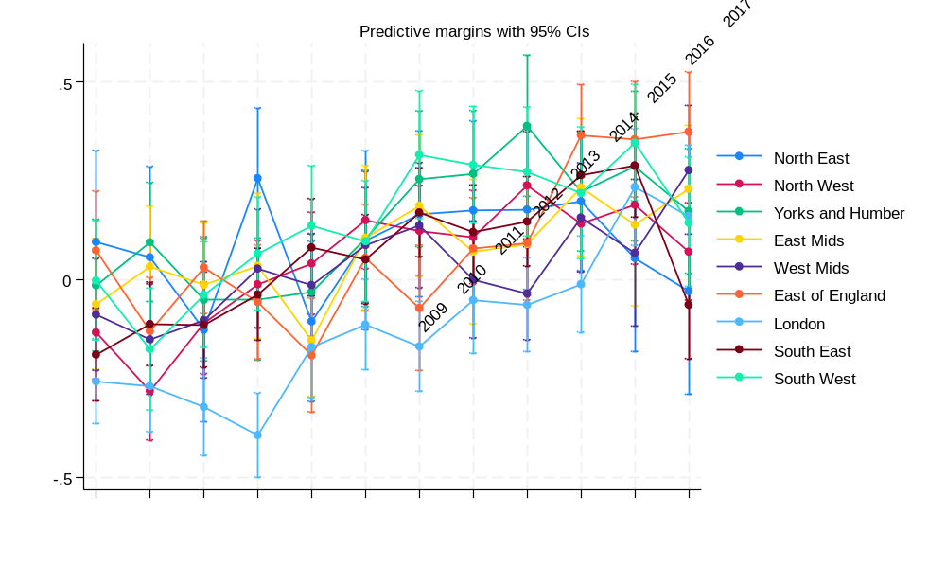
Figure S6. Marginal estimates of year*region interaction (95% CIs) for mental health related knowledge (MAKS scores)
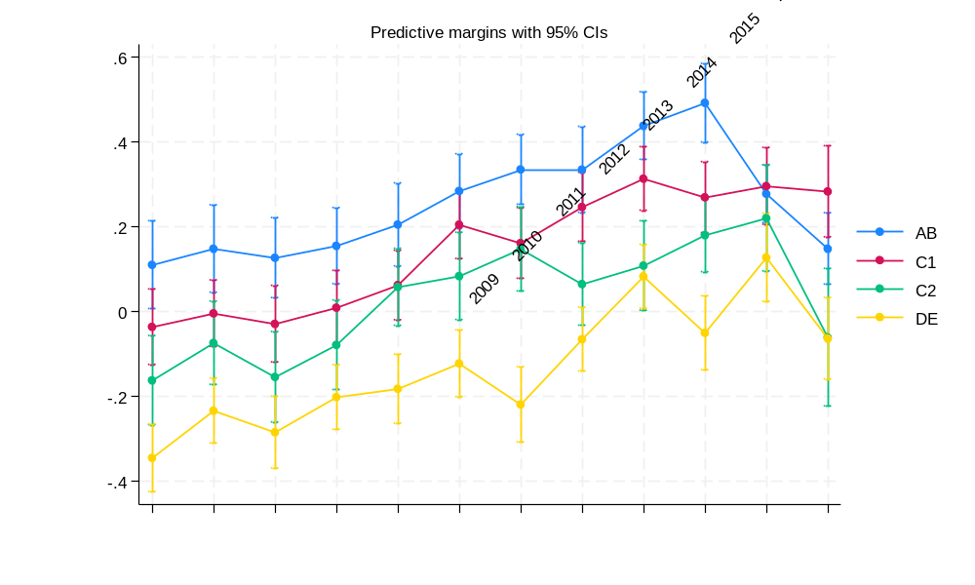
Figure S7. Marginal estimates of year*socioeconomic position interaction (95% CIs) for mental health related knowledge (RIBS IB scores)
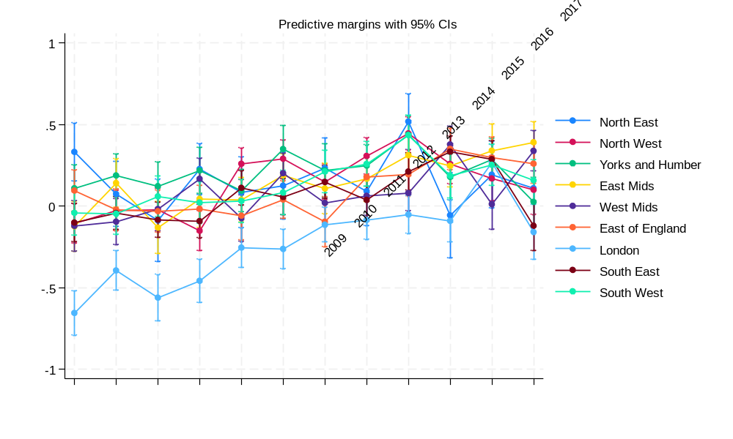
Figure S8. Marginal estimates of year*region interaction (95% CIs) for mental health related knowledge (RIBS IB scores)

Table S2. BSAS 2015 sample characteristics for participants residing in England, N=1865
 | N(%)
Age group
Missing N=5
16-24y | 131 (7.0)
25-34y | 279 (15.0)
35-44y | 334 (18.0)
45-54y | 337 (18.1)
55-64y | 294 (15.8)
65+y | 485 (26.1)
Gender
Missing N=0
Male | 788 (42.2)
Female | 1077 (57.8)
Ethnicity
Missing N=2
Asian | 111 (6.0)
Black | 68 (3.6)
Other | 34 (1.8)
White | 1650 (88.6)
Socioeconomic position
Missing N=92
AB | 704 (39.70
C1 | 369 (20.8)
C2 | 314 (17.7)
DE | 386 (21.8)
Local government region
Missing N=0
North East | 103 (5.5)
North West | 263 (14.1)
Yorks and Humber | 172 (9.2)
East Midlands | 219 (11.7)
West Midlands | 200 (10.7)
Eats of England | 177 (9.5)
London | 207 (11.1)
South East | 349 (18.7)
South West | 175 (9.4)

Table S3. Logistic regressions assessing changes in willingness to interact with people with schizophrenia or depression between 2015 (BSAS) and 2023 (AMI)
Vignette: Schizophrenia (Andy) | OR (95% CI) | p value
And now we would like you to think about how willing, or unwilling, you would be to ...

…move next door to Andy? | 1.01 (0.88 to 1.17) | 0.854
…spend time socializing with Andy? | 1.22 (1.05 to 1.41) | 0.007
…make friends with Andy? | 1.07 (0.92 to 1.23) | 0.384
…have Andy as a colleague/workmate? | 1.47 (1.27 to 1.70) | <0.001
…have Andy marry into the family? | 1.66 (1.42 to 1.95) | <0.001
…have Andy provide childcare for someone in your family? | 1.54 (1.23 to 1.93) | <0.001
Vignette: Depression (Stephen) | OR (95% CI) | p value
And now we would like you to think about how willing, or unwilling, you would be to ...

…move next door to Stephen? | 1.13 (0.96 to 1.33) | 0.136
…spend time socializing with Stephen? | 1.50 (1.28 to 1.76) | <0.001
…make friends with Stephen? | 1.25 (1.06 to 1.47) | 0.006
…have Stephen as a colleague/workmate? | 1.60 (1.37 to 1.87) | <0.001
…have Stephen marry into the family? | 1.68 (1.44 to 1.95) | <0.001
…have Stephen provide childcare for someone in your family? | 2.29 (1.92 to 2.73) | <0.001
Note: BSAS 2015 acts as reference category
AMI=Attitudes to Mental Illness; BSAS: British Social Attitudes Survey; CI=confidence interval; OR=odds ratio

Table S4. Changes in attitudes to mental health in the workplace measured in the British Social Attitudes Survey (BSAS 2015) and ‘Time to Change’ (2023)
 | BSAS 2015  N=2140 | Time to Change 2023  N=1638
Views on promotion prospects | 2015 | 2023
Depression
% just as likely as anyone else to be promoted | 16.5 | 25.5
% slightly less likely | 47.5 | 44.6
% much less likely | 36.0 | 29.9
% medical history definitely/probably should make a difference | 37.5 | 15.4
Schizophrenia
% just as likely as anyone else to be promoted | 8.3 | 17.7
% slightly less likely | 32.1 | 36.4
% much less likely | 59.6 | 45.8
% medical history definitely/probably should make a difference | 50.0 | 20.4
Diabetes
% just as likely as anyone else to be promoted | 56.9 | 63.8
% slightly less likely | 35.4 | 31.0
% much less likely | 7.6 | 5.2
% medical history definitely/probably should make a difference | 25.2 | 13.5

Table S5. Logistic regressions assessing change in attitudes towards promotions in the workplace for people with depression, schizophrenia, or diabetes between 2015 (BSAS) and 2023 (AMI)
 |  | Just as likely to be promoted |  | Condition definitely/probably should not make a difference
 |  | OR (95% CI) | P value | OR (95% CI) | P value
Depression | BSAS 2015 | Ref |  | Ref
 | AMI 2023 | 1.76 (1.49 to 2.11) | <0.001 | 1.48 (1.23 to 1.81) | <0.001
Schizophrenia | BSAS 2015 | Ref |  | Ref
 | AMI 2023 | 2.47 (1.97 to 3.11) | <0.001 | 1.50 (1.25 to 1.81) | <0.001
Diabetes | BSAS 2015 | Ref |  | Ref
 | AMI 2023 | 1.31 (1.13 to 1.52) | <0.001 | 1.38 (1.13 to 1.68) | 0.001
AMI=Attitudes to Mental Illness; BSAS: British Social Attitudes Survey; CI=confidence interval; OR=odds ratio

