Effects of family planning counseling during maternal healthcare on postpartum modern contraceptive uptake in low- and middle-income countries: A systematic review and meta-analysis
Supplementary Table 01. Search strategy of Medline database (date: January 2015 to April 2024)
# | Searches | Results
1 | (Family planning counseling OR family planning information OR family planning advice OR contraceptive counseling).mp | 1,617
2 | (Postpartum* OR post-partum* OR Postnatal*).ti,ab. OR (Postpartum* OR post-partum* OR Postnatal*).sh. | 188,604
3 | (contraceptive* OR family planning OR birth control OR depo? Medroxyprogesterone OR Depo-Provera OR Sayana Press OR IUD OR IUCD OR IUS OR intrauterine device* OR intrauterine system* OR oral contraceptive pill* OR hormonal contraceptive pill* OR birth control pill OR emergency contraceptive pill*OR cervical cap* OR vaginal diaphragm* OR vaginal ring* OR implant* OR subdermal implant* OR implanon OR jadelle OR norplant* OR sinoimplant OR sterilization OR vasectomy OR contraception behavior OR long-acting reversible contraception).ti,ab. OR family planning/ OR birth control/ OR contraception/ OR Contraception Behavior/ OR Family Planning Services/ | 532,994
4 | (Use* OR uptake OR utilization* OR adoption* OR initiation*).ti,ab. OR (Use* OR uptake OR utilization* OR adoption* OR initiation*).sh. | 7,889,916
5 | (Angola* OR Benin* OR Botswana* OR Burkina Faso* OR Burundi* OR Cabo Verde* OR Cameroon* OR Central African Republic* OR Chad* OR Comoros* OR Congo* OR Cote D'ivoire* OR Ivory coast* OR Guinea* OR Eritrea* OR Eswatini* OR Swaziland* OR Ethiopia* OR Gabon* OR Gambia* OR Ghana* OR Guinea* OR Guinea-Bissau* OR Kenya* OR Lesotho* OR Liberia* OR Madagascar* OR Malawi* OR Mali* OR Mauritania* OR Mauritius* OR Mozambique* OR Namibia* OR Niger* OR Nigeria* OR Rwanda* OR (Sao Tome and Principe*) OR Senegal* OR Seychelles* OR Sierra Leone* OR Somalia* OR South Africa* OR South Sudan* OR Sudan* OR Tanzania* OR Togo* OR Uganda* OR Zambia* OR Zimbabwe*).ti,ab. OR (sub-Saharan Africa OR Africa OR East Africa OR West Africa OR South Africa OR Central Africa).ti,ab. OR (sub-Saharan Africa OR Africa OR East Africa OR West Africa OR South Africa OR Central Africa).sh. | 1,053,931
6 | 2 and 3 and 4 | 3,268
7 | 1 or 6 | 4,698
8 | 7 and 5 | 841
9 | (HIV or adolescent or postabortion or post-abortion or refugee or migrant).mp. | 2,443,191
10 | 8 not 9 | 394
11 | Limit 10 to English language | 370

Supplementary Table 02. Search strategy of Embase database (date: January 2015 to April 2024)
# | Searches | Results
1 | (Family planning counseling OR family planning information OR family planning advice OR contraceptive counseling).mp. | 1951
2 | (Postpartum* OR post-partum* OR Postnatal*).ti,ab. OR (Postpartum* OR post-partum* OR Postnatal*).sh. | 237,172
3 | (contracepti* OR family planning OR birth control OR depo? Medroxyprogesterone OR Depo-Provera OR Sayana Press OR IUD OR IUCD OR IUS OR intrauterine device* OR intrauterine system* OR oral contraceptive pill* OR hormonal contraceptive pill* OR birth control pill OR emergency contraceptive pill*OR cervical cap* OR vaginal diaphragm* OR vaginal ring* OR implant* OR subdermal implant* OR implanon OR jadelle OR norplant* OR sinoimplant OR sterilization OR vasectomy OR contraception behavior OR long-acting reversible contraception).ti,ab. OR family planning/ OR birth control/ OR contraception/ OR Contraception Behavio?r/ OR Family Planning Services/ | 713,261
4 | (Use* OR uptake OR utilization* OR adoption* OR initiation*).ti,ab. OR (Use* OR uptake OR utilization* OR adoption* OR initiation*).sh. | 10,262,706
5 | (Angola* OR Benin* OR Botswana* OR Burkina Faso* OR Burundi* OR Cabo Verde* OR Cameroon* OR Central African Republic* OR Chad* OR Comoros* OR Congo* OR Cote D'ivoire* OR Ivory coast* OR Guinea* OR Eritrea* OR Eswatini* OR Swaziland* OR Ethiopia* OR Gabon* OR Gambia* OR Ghana* OR Guinea* OR Guinea-Bissau* OR Kenya* OR Lesotho* OR Liberia* OR Madagascar* OR Malawi* OR Mali* OR Mauritania* OR Mauritius* OR Mozambique* OR Namibia* OR Niger* OR Nigeria* OR Rwanda* OR (Sao Tome and Principe*) OR Senegal* OR Seychelles* OR Sierra Leone* OR Somalia* OR South Africa* OR South Sudan* OR Sudan* OR Tanzania* OR Togo* OR Uganda* OR Zambia* OR Zimbabwe*).ti,ab. OR (sub-Saharan Africa OR Africa OR East Africa OR West Africa OR South Africa OR Central Africa).ti,ab. OR (sub-Saharan Africa OR Africa OR East Africa OR West Africa OR South Africa OR Central Africa).sh. | 1,351,451
6 | 2 and 3 and 4 | 4,004
7 | 1 or 6 | 5,700
8 | 7 and 5 | 859
9 | (HIV or adolescent or postabortion or post-abortion or refugee or migrant).mp. | 2,036,452
10 | 8 not 9 | 420
11 | Limit 10 to English language | 409

Supplementary Table 03. Search strategy of Global Health database (date: January 2015 to April 2024)
# | Searches | Results
1 | (Family planning counseling OR family planning information OR family planning advice OR contraceptive counseling).mp. | 424
2 | (Postpartum* OR post-partum* OR Postnatal*).ti,ab. OR (Postpartum* OR post-partum* OR Postnatal*).sh. | 27,598
3 | (contraception* OR family planning OR birth control OR depo? Medroxyprogesterone OR Depo-Provera OR Sayana Press OR IUD OR IUCD OR IUS OR intrauterine device* OR intrauterine system* OR oral contraceptive pill* OR hormonal contraceptive pill* OR birth control pill OR emergency contraceptive pill*OR cervical cap* OR vaginal diaphragm* OR vaginal ring* OR implant* OR subdermal implant* OR implanon OR jadelle OR norplant* OR sinoimplant OR sterilization OR vasectomy OR contraception behavior OR long-acting reversible contraception).ti,ab. OR family planning/ OR birth control/ OR contraception/ OR Contraception Behavior/ OR Family Planning Services/ | 35,767
4 | (Use* OR uptake OR utilization* OR adoption* OR initiation*).ti,ab. OR (Use* OR uptake OR utilization* OR adoption* OR initiation*).sh. | 1,286,816
5 | (Angola* OR Benin* OR Botswana* OR Burkina Faso* OR Burundi* OR Cabo Verde* OR Cameroon* OR Central African Republic* OR Chad* OR Comoros* OR Congo* OR Cote D'ivoire* OR Ivory coast* OR Guinea* OR Eritrea* OR Eswatini* OR Swaziland* OR Ethiopia* OR Gabon* OR Gambia* OR Ghana* OR Guinea* OR Guinea-Bissau* OR Kenya* OR Lesotho* OR Liberia* OR Madagascar* OR Malawi* OR Mali* OR Mauritania* OR Mauritius* OR Mozambique* OR Namibia* OR Niger* OR Nigeria* OR Rwanda* OR (Sao Tome and Principe*) OR Senegal* OR Seychelles* OR Sierra Leone* OR Somalia* OR South Africa* OR South Sudan* OR Sudan* OR Tanzania* OR Togo* OR Uganda* OR Zambia* OR Zimbabwe*).ti,ab. OR (sub-Saharan Africa OR Africa OR East Africa OR West Africa OR South Africa OR Central Africa).ti,ab. OR (sub-Saharan Africa OR Africa OR East Africa OR West Africa OR South Africa OR Central Africa).sh. | 302,980
6 | 2 and 3 and 4 | 883
7 | 1 or 6 | 1,249
8 | 7 and 5 | 505
9 | (HIV or adolescent or postabortion or post-abortion or refugee or migrant).mp. | 215,725
10 | 8 not 9 | 320
11 | Limit 10 to English language | 323

Supplementary Table 04. Search strategy of Scopus database (date: January 2015 to April 2024)
# | Searches | Results
#1 | TITLE-ABS-KEY ("Family planning counseling*" OR "family planning information" OR "family planning advice" OR  "contraceptive counseling*") | 760
#2 | TITLE-ABS-KEY (“Postpartum*” OR “post-partum*” OR “postnatal*”) | 226,414
#3 | TITLE-ABS-KEY (contraceptive* OR "family planning" OR "birth control" OR "depo? Medroxyprogesterone" OR "Depo-Provera "OR "Sayana Press" OR "IUD" OR "IUCD*" OR "IUS" OR "intrauterine device*" OR "intrauterine system*" OR "ral contraceptive pill*" OR "hormonal contraceptive pill*" OR "birth control pill" OR "emergency contraceptive pill*" OR "cervical cap*" OR "vaginal diaphragm*" OR "vaginal ring*" OR "implant*" OR "subdermal implant*" OR "implanon" OR "jadelle" OR "norplant*" OR "sinoimplant*" OR "sterilization" OR "vasectomy" OR "contraception behavior" OR "long-acting reversible contraception") | 1,041,555
#4 | TITLE-ABS-KEY ("Use*" OR "uptake" OR "utilization*" OR "adoption*" OR "initiation*") | 22,782,654
# | TITLE-ABS-KEY (Angola* OR Benin* OR Botswana* OR "Burkina Faso*" OR Burundi* OR "Cabo Verde*" OR Cameroon* OR "Central African Republic*" OR Chad* OR Comoros* OR Congo* OR "Cote D'ivoire*" OR "Ivory coast*" OR Guinea* OR Eritrea* OR Eswatini* OR Swaziland* OR Ethiopia* OR Gabon* OR Gambia* OR Ghana* OR Guinea* OR "Guinea-Bissau*" OR Kenya* OR Lesotho* OR Liberia* OR Madagascar* OR Malawi* OR Mali* OR Mauritania* OR Mauritius* OR Mozambique* OR Namibia* OR Niger* OR Nigeria* OR Rwanda* OR "Sao Tome and Principe*" OR Senegal* OR Seychelles* OR "Sierra Leone*" OR Somalia* OR "South Africa*" OR "South Sudan*" OR Sudan* OR Tanzania* OR Togo* OR Uganda* OR Zambia* OR Zimbabwe* OR "sub-Saharan Africa" OR Africa OR "East Africa" OR "West Africa" OR "South Africa" OR "Central Africa") | 2,020,233
#6 | #2 AND #3 AND #4 | 4,407
#7 | #1 OR #6 | 5,093
#8 | #7 AND #5 | 863
#9 | #8 AND NOT (HIV OR adolescent OR postabortion OR post-abortion OR refugee OR migrant) AND (LIMIT-TO (LANGUAGE," English")) | 290
#10 | #9 AND (LIMIT-TO ( AFFILCOUNTRY , "Nigeria" ) OR LIMIT-TO ( AFFILCOUNTRY , "Ethiopia" ) OR LIMIT-TO ( AFFILCOUNTRY , "South Africa" ) OR LIMIT-TO ( AFFILCOUNTRY , "Kenya" ) OR LIMIT-TO ( AFFILCOUNTRY , "Tanzania" ) OR LIMIT-TO ( AFFILCOUNTRY , "Uganda" ) OR LIMIT-TO ( AFFILCOUNTRY , "Ghana" ) OR LIMIT-TO ( AFFILCOUNTRY , "Malawi" ) OR LIMIT-TO ( AFFILCOUNTRY , "Burkina Faso" ) OR LIMIT-TO ( AFFILCOUNTRY , "Rwanda" ) OR LIMIT-TO ( AFFILCOUNTRY , "Zambia" ) OR LIMIT-TO ( AFFILCOUNTRY , "Congo" ) OR LIMIT-TO ( AFFILCOUNTRY , "Democratic Republic Congo" ) OR LIMIT-TO ( AFFILCOUNTRY , "Guinea" ) OR LIMIT-TO ( AFFILCOUNTRY , "Sudan" ) OR LIMIT-TO ( AFFILCOUNTRY , "Zimbabwe" ) OR LIMIT-TO ( AFFILCOUNTRY , "Botswana" ) OR LIMIT-TO ( AFFILCOUNTRY , "Cameroon" ) OR LIMIT-TO ( AFFILCOUNTRY , "Liberia" ) OR LIMIT-TO ( AFFILCOUNTRY , "Mali" ) OR LIMIT-TO ( AFFILCOUNTRY , "Mozambique" ) OR LIMIT-TO ( AFFILCOUNTRY , "Senegal" ) OR LIMIT-TO ( AFFILCOUNTRY , "Sierra Leone" ) OR LIMIT-TO ( AFFILCOUNTRY , "Undefined" ) ) | 217

Supplementary Table 05. Search strategy of PubMed database (date: January 2015 to April 2024)
# | Searches | Results
#1 | Family planning counselling[tiab] OR family planning counselling[mh] OR family planning counseling[tiab] OR family planning counseling[mh] OR family planning information [tiab] OR family planning advice[tiab] contraceptive counselling[tiab] OR contraceptive counselling[mh] OR contraceptive counseling[tiab] OR contraceptive counseling[mh] | 2,950
#2 | Postpartum*[tiab] OR Postpartum*[mh] OR post-partum*[tiab] OR post-partum*[mh] or postnatal*[tiab] or postnatal*[mh] | 231,117
#3 | contraceptive*[tiab] OR family planning[tiab] OR family planning[mh] OR birth control[tiab] OR birth control[mh] OR Depot Medroxyprogesterone[tiab] OR depomedroxyprogesterone[tiab] OR Depo-Provera[tiab] OR Sayana Press[tiab] OR IUD[tiab] OR IUCD[tiab] OR IUS OR intrauterine device*[tiab] OR intra-uterine device*[tiab] OR intrauterine system*[tiab] OR intra-uterine system*[tiab] OR oral contraceptive pill*[tiab] OR hormonal contraceptive pill*[tiab] OR birth control pill[tiab] OR emergency contraceptive pill*[tiab] OR cervical cap*[tiab] OR vaginal diaphragm*[tiab] OR vaginal ring*[tiab] OR implant*[tiab] OR subdermal implant*[tiab] OR implanon[tiab] OR jadelle[tiab] OR norplant*[tiab] OR sino-implant*[tiab] OR sinoimplant*[tiab] OR sterilization[tiab] OR sterilisation[tiab] OR vasectomy[tiab] OR contraception behaviour[tiab] OR long-acting reversible contraception[tiab] OR family planning[mh] OR birth control[mh] OR contraception[mh] OR Family Planning Services[mh] | 544,236
#4 | Use[tiab] OR uptake[tiab] OR utilization[tiab] OR utilisation[tiab] OR adoption[tiab] OR initiation[tiab] OR Use[mh] OR uptake[mh] OR utilization[mh] OR utilisation[mh] OR adoption[mh] OR initiation[mh] | 3,677,906
#5 | Angola*[tiab] OR Benin* [tiab] OR Botswana*[tiab] OR Burkina Faso*[tiab] OR Burundi*[tiab] OR Cabo Verde*[tiab] OR Cameroon*[tiab] OR Central African Republic*[tiab] OR Chad*[tiab] OR Comoros*[tiab] OR Congo*[tiab] OR Cote D'ivoire*[tiab] OR Ivory coast*[tiab] OR Guinea*[tiab] OR Eritrea*[tiab] OR Eswatini*[tiab] OR Swaziland*[tiab] OR Ethiopia*[tiab] OR Gabon*[tiab] OR Gambia*[tiab] OR Ghana*[tiab] OR Guinea*[tiab] OR Guinea-Bissau*[tiab] OR Kenya*[tiab] OR Lesotho*[tiab] OR Liberia*[tiab] OR Madagascar*[tiab] OR Malawi*[tiab] OR Mali*[tiab] OR Mauritania*[tiab] OR Mauritius*[tiab] OR Mozambique*[tiab] OR Namibia*[tiab] OR Niger*[tiab] OR Nigeria*[tiab] OR Rwanda*[tiab] OR Sao Tome and Principe*[tiab] OR Senegal*[tiab] OR Seychelles*[tiab] OR Sierra Leone*[tiab] OR Somalia*[tiab] OR South Africa*[tiab] OR South Sudan*[tiab] OR Sudan*[tiab] OR Tanzania*[tiab] OR Togo*[tiab] OR Uganda*[tiab] OR Zambia*[tiab] OR Zimbabwe*[tiab] OR sub-Saharan Africa[tiab] OR sub-Saharan Africa[mh] OR Africa[tiab] OR Africa[mh] OR East Africa[tiab] OR East Africa[mh] OR West Africa[tiab] OR West Africa[mh] OR South Africa[tiab] OR South Africa[mh] OR Central Africa[tiab] OR Central Africa[mh] | 1,121,789
#6 | HIV OR Adolescent OR postabortion OR post-abortion OR migrant OR refugee | 2,715,880
#7 | #2 AND #3 AND #4 | 2,789
#8 | #1 OR #7 | 5,545
#9 | #8 AND 5 | 958
#10 | #7 AND #5 Filters:English | 924
#11 | #10 NOT #6 Filters:English | 345

Supplementary Table 06. Search strategy of Web Science database (date: January 2015 to April 2024)
# | Searches | Results
#1 | TS= ("Family planning counseling*" OR "family planning information" OR "family planning advice" OR "contraceptive counseling*") | 395
#2 | TS= ("Postpartum*" OR "post-partum*" OR "postnatal*") | 183,159
#3 | TS= (contraceptive* OR "family planning" OR "birth control" OR "depo? Medroxyprogesterone" OR "Depo-Provera "OR "Sayana Press" OR "IUD" OR "IUCD*" OR "IUS" OR "intrauterine device*" OR "intrauterine system*" OR "oral contraceptive pill*" OR "hormonal contraceptive pill*" OR "birth control pill" OR "emergency contraceptive pill*" OR "cervical cap*" OR "vaginal diaphragm*" OR "vaginal ring*" OR "implant*" OR "subdermal implant*" OR "implanon" OR "jadelle" OR "norplant*" OR "sinoimplant*" OR "sterilization" OR "vasectomy" OR "contraception behavior" OR "long-acting reversible contraception") | 638,837
#4 | TS= (“Use*” OR “uptake” OR “utilization*” OR “adoption*” OR “initiation*”) | 15,774,374
#5 | TS= (Angola* OR Benin* OR Botswana* OR "Burkina Faso*" OR Burundi* OR "Cabo Verde*" OR Cameroon* OR "Central African Republic*" OR Chad* OR Comoros* OR Congo* OR "Cote D'ivoire*" OR "Ivory coast*" OR Guinea* OR Eritrea* OR Eswatini* OR Swaziland* OR Ethiopia* OR Gabon* OR Gambia* OR Ghana* OR Guinea* OR "Guinea-Bissau*" OR Kenya* OR Lesotho* OR Liberia* OR Madagascar* OR Malawi* OR Mali* OR Mauritania* OR Mauritius* OR Mozambique* OR Namibia* OR Niger* OR Nigeria* OR Rwanda* OR "Sao Tome and Principe*" OR Senegal* OR Seychelles* OR "Sierra Leone*" OR Somalia* OR "South Africa*" OR "South Sudan*" OR Sudan* OR Tanzania* OR Togo* OR Uganda* OR Zambia* OR Zimbabwe* OR "sub-Saharan Africa" OR Africa OR "East Africa" OR "West Africa" OR "South Africa" OR "Central Africa") | 1,537,528
#7 | #2 AND #3 AND #4 | 2,567
#8 | #1 OR #7 | 2,917
#9 | #8 AND #5 | 530
#10 | #9 AND English | 526
#11 | TS=(HIV OR adolescent OR postabortion OR "post-abortion" OR refugee OR migrant) | 872,020
#12 | #10 NOT #11 | 350

Supplementary Table 07. Summary of selected observational studies on family planning counselling and postpartum modern contraceptive uptake in low- and lower-middle income countries, January 2015 to April, 2024.

Authors, year, and country | Study design and settings | Sample | Outcomes | Confounders adjustment
Arero WD et al., 2022, Ethiopia ¹ | Cross sectional, Facility-based study | 393 | Long-acting reversible contraceptive use | Maternal age, mode of delivery, current birth outcome, number of parity, number of alive kids, completed family size, next delivery plan within two years, ever heard of a LARC, Previous LARC use, monthly income
Hagos KN et al.,2023  Ethiopia ² | Case control, Facility-based study | 308 | Postpartum contraceptive use | Maternal age, residence, ANC visits, still birth
Murry LL et al.,2021, India ³ | Cross sectional, Facility-based study | 284 | Contraceptive use | Religion, education, number of ANC visit, breast feeding status, resume menses after birth, resumed sexual activity
Mruts KB et al.,2023, Ethiopia ⁴ | Prospective cohort, National study | 769 | Unmet need for contraception | Child immunization
Adofo E et al.,2021, Ghana ⁵ | Cross sectional, Facility-based study | 422 | Contraceptive use | Age, education, occupation, resumption of menses, residence, age of child, fear of infertility, agreed to contraceptive use on ANC counselling, Partners discussion on contraceptive
Wudineh KG et al.,2023, Ethiopia ⁶ | Cross sectional , Facility-based study | 417 | Immediate postpartum reversible long-acting contraceptive uptake | Age, residency, discussion with partner, ANC follow-up, attitude to FP, outcome of neonate, plan to conceive next pregnancy, history of FP use
Melkie A et al.,2021, Ethiopia ⁷ | Cross sectional, Facility-based study | 423 | Utilization of IPPIUCD | Age, education, birth spacing
Kiondo SK et al.,2020, Tanzania ⁸ | Cross sectional, Community based study | 141 | LARC use | Age, marital status, residence, occupation, income per month and Partner’s level of education, Number of living children, mode of index delivery, place of index delivery, menstrual resumption, duration of postpartum period and discussing FP use with partner.
Silesh M et al.,2022, Ethiopia ⁹ | Cross sectional, Facility-based study | 394 | IPPFP utilisation | age, residence, women’s educational status, husband’s educational status, ever used FP, partner support to use FP, knowledge on FP attitude towards FP, history of abortion, mode of delivery, current birth outcome, planning status of history of ANC for current pregnancy, and maternal satisfaction with intrapartum care.
Nugussa B et al.,2023, Ethiopia ¹⁰ | Cross sectional , Community based study | 385 | Utilization of modern postpartum family planning | Age of current child, planned birth, parity, condition of menses, visiting HF after delivery, ever used modern FP methods, Decision of FP use, husband approval on FP use, discussion with a partner about FP
Maeregayehu T et al.,2022, Ethiopia ¹¹ | Retrospective cohort, Community based study | 594 | Use of postpartum modern contraceptive | educational status of women, occupation status of women, Number of ANC visit, Distance to the health facility, FP counseling during child immunization, fertility desire, resume sexual intercourse, resume menses, discuss with the partner on FP, who decide on PPFP use, Knowledge of Postpartum family planning.
Tilahun T et al.,2022, Ethiopia ¹² | Cross sectional, Facility-based study | 989 | Postpartum family planning uptake | Parity, FP utilization before the index pregnancy, previous history of ppfp uptake, place of delivery, skilled birth attendance, Faced difficulty during COVID-19 restrictions, ANC during the index pregnancy
Getaneh M et al.,2021, Ethiopia ¹³ | Cross sectional, Community based study | 630 | Extended postpartum period modern contraceptive utilization | educational status, discussion with husband, link to family planning during child immunization, sexual resumption, menstrual resumption, fertility desire
Agula C et al.,2022  , Ghana ¹⁴ | Cross sectional, Regional study | 624 | Modern contraceptive use in postpartum period | Age, marital status, education, religion, number of live births, Attended postnatal care after birth
Abebe GF et al.,2023  , Ethiopia ¹⁵ | Cross sectional, Community based study | 385 | Utilization of modern contraceptives | Education, husband’s education, residence, number of children, heard about FP, ANC follow-up, contraceptive used previously, started menstruation, resumed sexual intercourse
Ezekiel MJ et al.,2022  , Tanzania ¹⁶ | Cross sectional, Regional study | 299 | Taking FP method | Occupation, mode of payment, parity, number of ANC visit
Tafa L et al.,2021  , Ethiopia ¹⁷ | Cross sectional, Facility-based study | 625 | PPFP use | Previous FP information, FP information from health facility visit, ANC attendance, menses resumption, Sexual resumption
Nakiwunga N et al.,2022  , Uganda ¹⁸ | Cross sectional, Facility-based study | 397 | Contraceptive uptake | Parity, ever had abortion, children alive, Mode of delivery, birth interval, planned time for next pregnancy, Number of ANC, ever used contraception, Method used before
Abraha TH et al.,2017  , Ethiopia ¹⁹ | Cross sectional, Community based study | 590 | Postpartum modern contraceptive use | Education, parity, living children, currently breastfeed, ANC, PNC, Postpartum period (wk), Discussed FP with husband, husband approval of FP, Knowledge of postpartum FP, Received FP counseling by health extension work, experienced problems with previous contraceptive use, mense’s returned after birth, sexual resumption
Andualem G et al.,2022  , Ethiopia ²⁰ | Cross sectional, Community based study | 402 | Utilization of modern PPFP methods in the extended postpartum period | Maternal education, number of ANC visits, discussed contraceptive use with a partner, previous use of FP, PNC check-up, Linkage to FP unit during child immunization, Attitude towards FP, knowledge towards FP, menses resumption, sexual resumption
Gebeyehu NA et al.,2020  , Ethiopia²¹ | Cross sectiona, Facility-based study | 416 | Intention to use contraception | Education, children alive, Attending ANC follow-up, Attending PNC follow-up, Discussion with partner on PPFP, menses resumption, sexual resumption, previous use of contraceptive, Husband approval of contraceptives, knowledge of contraceptive
Coomson JL et al.,2019  , Ghana ²² | Cross sectional, Facility-based study | 320 | Post partum modern contraceptive use | Age, sexual resumption, menses resumption, ever used modern contraceptive, discussion with partner, partner approval, knowledge about available FP methods
Gebremedhin Jnr M et al.,2021  , Ethiopia ²³ | Cross sectional, Facility-based study | 452 | Immediate PPIUCD Acceptance | Age, residence, parity, Previous FP use, ANC follow-up, prior discussion
Geda YF et al.,2021  , Ethiopia ²⁴ | Cross sectional, Facility-based study | 286 | Immediate Postpartum intrauterine contraceptive utilization | Age, occupation, educational status, birth interval, discuss about PPFP with partner, needs partner approval to use PPFP, knowledge about PPIUCD
Samuel B et al.,2023  , Ethiopia ²⁵ | Cross sectional, Facility-based study | 373 | Informed choice of LARC | Education, occupation, husband’s education, previous contraception use, Frequency of listening to a radio, heard about LARCs at community conversation, Seen posters with messages about LARCs in the facility
Omona K et al.,2020  , Uganda ²⁶ | Cross sectional, Facility-based study | 202 | Utilization of IUCD | Education, religion, occupation, culture allow IUCD use, social interaction, IUCD methods are available in this hospital, knowledge on the method, Is IUCD free of charge
Rahayuwati L et al.,2023  , Indonesia ²⁷ | Cross sectional, Regional study | 280 | Contraceptive use | Not applicable
Shiferaw Y et al.,2023  , Ethiopia ²⁸ | Cross sectional, Facility-based study | 392 | Utilization of immediate postpartum intrauterine contraceptive device | Age, birth interval, use of FP in the past, plan to have another child, ever heard of IUCD, attitude towards the use of PPIUCD
Belayihun B et al.,2021  , Ethiopia ²⁹ | Cross sectional, Facility-based study | 884 | Immediate postpartum LARC use | Age, marital status, education, residence, children alive, ever use FP, PPFP information, ANC follow-up, use of MWHs, Mode of delivery, child immunization
Abera Y et al.,2015  , Ethiopia ³⁰ | Cross sectional, Community based study | 703 | Contraceptive use | Age, marital status, education, husband’s education, children alive, fertility desire, Postpartum period, menses resumption, place of delivery, ANC visit, LAM knowledge
Gejo NG et al.,2019  , Ethiopia ³¹ | Cross sectional, Facility-based study | 368 | Postpartum family planning use | Education, monthly income, menses resumption, sexual resumption, currently breastfeeding, parity, ANC, Problem experienced while using contraception, postpartum period
Hounkponou F et al.,2019  , Africa ³² | Cross sectional, Community based study | 453 | Postpartum Contraceptive Use | Contraceptive method use history, sexual resumption, Discussion about contraceptive use, partner’s permission needed
Tafere TE et al.,2018, Ethiopia ³³ | Prospective cohort, Facility-based study | 823 | Post-partum modern family planning use | Residence, education, occupation, Counselling on BPRCP, Counselling on breast feeding, at least one PNC visit, Satisfaction on ANC service during pregnancy
Jima GH et al.,2020, Ethiopia ³⁴ | Cross sectional, Community based study | 1160 | Postpartum family planning utilization | Education, residence, partner’s education, knowledge, attitude, ANC, PNC, Prior use of Contraception, sexual resumption, Couple discussion on FP, Husband approval of FP use, Socio cultural influence
Hagos H et al.,2020, Ethiopia ³⁵ | Cross sectional, Facility-based study | 182 | Postpartum IUCD utilization | Not applicable
Assefaw M et al., 2021, Ethiopia ³⁶ | Case control, Facility-based study | 420 | Uptake of a postpartum intra uterine contraceptive device | Age, marital status, education, family size, children alive, parity, Plan to have children, ANC, ever use FP, Ever heard about PPIUCD, Knowledge about PPIUCD, attitude about PPIUCD
Usso AA et al., 2021, Ethiopia ³⁷ | Cross sectional, Facility-based study | 530 | Utilization of LARC | Residence, monthly income, mode of delivery, time to reach near health facility, previous use of modern contraceptives, ANC, discussion with partner on contraceptives, main decision maker on contraceptives, Attitude toward LARC, Disrespect and abuse during childbirth
Tariku M et al., 2022, Ethiopia ³⁸ | Cross sectional, Facility-based study | 418 | Uptake of LARC | Age, ethnicity, occupation, planned birth, ANC visits, Heard about LARC, Previous use of LARC,
Nigussie AT et al., 2016, Ethiopia ³⁹ | Cross sectional, Community based study | 545 | Currently FP utilization | Education, birth interval, complementary feeding, ANC visit, place of delivery, Have PNC visit, discuss partner, husband decide, decide yourself, postpartum period, Information about FP, attitude
Ismael K et al., 2023, Ethiopia ⁴⁰ | Cross sectional, Community based study | 804 | Timely initiation of postpartum contraceptive utilization | Education, monthly income, residence, Receive ANC, place of delivery, have PNC follow-up, menses returned, Discussed family planning with husband
Joshi AK et al., 2020  , Nepal ⁴¹ | Cross sectional, Community based study | 427 | Postpartum Family Planning method utilization | Ethnicity, education, occupation, husband’s occupation, husband’s education, menses resumption, knowledge of FP, past FP use, use of media, PNC visit
Wayessa MB et al., 2020  , Ethiopia ⁴² | Prospective cohort, Facility based study | 726 | IUCD uptake | Age at first marriage, Gravidity, history of abortion, number of children, children’s sex, sex preference, plans to have more child, decision on having child, level of knowledge, attitudes towards IUCD
Tesfaye T et al., 2023, Ethiopia⁴³ | Cross-sectional, Facility based study | 470 | Postpartum Family Planning method utilization | Not applicable
Mickler AK et al., 2021, Ethiopia ⁴⁴ | Cross-sectional, Facility based study | 936 | Postpartum contraception use | Age, residence, parity, prior use of contraception, delivery mood, delivery attendant, facility type, availability of contraceptive methods
Pearson E et al., 2020, Tanzania ⁴⁵ | Cluster-randomized controlled trial, Facility based study | 14950 | IUCD uptake | Age, education, parity, marital status, religion,
Abdulkadir Z et al., 2020, Nigeria⁴⁶ | Randomized controlled trial, Facility based study | 150 | Postpartum contraception use | Not applicable
Hersh AR et al., 2018, Colombia⁴⁷ | Multicenter randomized-controlled trial, Facility based study | 240 | Long-acting reversal contraception uptake | Not applicable
Mruts KB et al., 2022, Ethiopia ⁴⁸ | Cross- sectional, Facility based study | 1650 | Postpartum contraception use | Age, residence, region, quintile, education, employment, marital status, parity, religion, intended last child, sex of last child, ANC, Place of delivery, PNC, fertility intention, family planning massages, distance of health services.
Ayiasi RM et al., 2015, Uganda ⁴⁹ | Community based intervention study | 1385 | Postpartum modern contraception use | Initiation of breast feeding, pre- lacteal test, contraceptive methods, user willingness, pregnancy test, contraceptive choose willingness.
Karra M et al., 2017, Sri Lanka ⁵⁰ | Cross- sectional, Facility based study | 13731 | IUCD uptake | Not applicable
Wu WJ et al., 2020, Nepal ⁵¹ | Pre–post-intervention study | 953 | Postpartum modern contraception use | Age, monthly expenditure, caste, delivery mode, sex of child
Pradhan E et al., 2019, Nepal ⁵² | Cluster randomized controlled trial, Facility based study | 75587 | IUCD uptake | Age, education, Time to travel from home to hospital, parity, ethnicity, region, abortion
Kaewkiattikun K., 2017, Thailand ⁵³ | Randomized controlled trial, Facility-based study | 233 | Long-acting reversal contraception uptake | Age, education, occupation, income, knowledge about contraception, pregnancy intention, previous family planning, ANC, mode of delivery
Rajan S et al., 2016, India ⁵⁴ | Cross- sectional, Regional study | 2733 | Postpartum modern contraception use | Age, age at marriage, education, religion, caste, wealth index, number of living children, city, residence
Chhabra HK et al., 2016, India ⁵⁵ | Cross- sectional, Facility-based study | 117 | Postpartum contraception uptake | Not applicable
Puri MC et al., 2021, Nepal ⁵⁶ | Cluster randomized control trial, Facility-based study | 21280 | Unmet need of postpartum contraceptive uptake | Age, age at marriage, education, religion, ethnicity, wealth index, residence, abortion, months since delivery, sex composition of living child.
Nurcahyani L et al., 2023, Indonesia ⁵⁷ | Quasi-experimental methods, Facility-based study | 110 | Postpartum contraception uptake | Age, parity.
Willcox ML et al., 2021, Uganda ⁵⁸ | Focus group discussions, In-depth interviews, Community-based study | 323 | Postpartum contraception uptake | Not applicable
Puri MC et al.,  2020, Nepal ⁵⁹ | In-depth interviews, Facility-based study | 25 | Immediate postpartum intrauterine device use | Not applicable
Puri MC et al.,  2020, Nepal ⁶⁰ | In-depth interviews, Facility-based study | 24 | Postpartum contraception uptake | Not applicable
Jalang’o R et al., 2017, Kenya ⁶¹ | Mixed method, Facility-based study | 20 | Postpartum family planning uptake | Not applicable

Quality assessment of the included studies
Supplemental Table 08. Newcastle-Ottawa scale assessment of study quality for cross-sectional study
Author | Selection |  |  |  |  | Comparability |  | Outcome |  | Study quality
Author | 1 | 2 | 3 | 4 |  | 5 |  | 6 | 7 | Study quality
Author | Representativeness of the sample | Sample size | Ascertainment of exposure | Non-respondents |  | The subjects in different outcome groups are comparable, based on the study design or analysis. Confounding factors are controlled. |  | Assessment of outcome | Statistical test is appropriate | Study quality
Arero WD et al., 2022, Ethiopia | * | * | * | * |  | * |  | * | * | 7
Murry LL et al.,2021, India | * | * | * | * |  | * |  | * |  | 6
Adofo E et al.,2021, Ghana | * | * | * | * |  | * |  | * | * | 7
Wudineh KG et al.,2023, Ethiopia | * | * | * | * |  | * |  | * | * | 7
Melkie A et al.,2021, Ethiopia | * |  | * | * |  | * |  | * | * | 6
Kiondo SK et al.,2020, Tanzania | * | * | * | * |  | * |  | * | * | 7
Silesh M et al.,2022, Ethiopia | * | * | * | * |  | * |  | * | * | 7
Nugussa B et al.,2023, Ethiopia | * | * | * | * |  | * |  | * | * | 7
Tilahun T et al.,2022, Ethiopia | * | * | * | * |  | * |  | * | * | 7
Getaneh M et al.,2021, Ethiopia | * | * | * | * |  | * |  | * | * | 7
Agula C et al.,2022, Ghana | * | * | * | * |  | * |  | * | * | 7
Abebe GF et al.,2023, Ethiopia | * | * | * | * |  | * |  | * | * | 7
Ezekiel MJ et al.,2022, Tanzania | * | * | * | * |  | * |  | * | * | 7
Tafa L et al.,2021, Ethiopia | * | * | * | * |  | * |  | * | * | 7
Nakiwunga N et al.,2022, Uganda | * | * | * | * |  | * |  | * | * | 7
Abraha TH et al.,2017, Ethiopia | * | * | * | * |  | * |  | * | * | 7
Andualem G et al.,2022, Ethiopia | * | * | * | * |  | * |  | * | * | 7
Gebeyehu NA et al.,2020, Ethiopia | * | * | * | * |  | * |  | * | * | 7
Coomson JL et al.,2019, Ghana | * | * | * | * |  | * |  | * | * | 7
Gebremedhin Jnr M et al.,2021, Ethiopia | * | * | * | * |  | * |  | * | * | 7
Geda YF et al.,2021, Ethiopia | * | * | * | * |  | * |  | * | * | 7
Samuel B et al.,2023, Ethiopia | * | * | * | * |  | * |  | * | * | 7
Omona K et al.,2020, Uganda | * |  | * | * |  |  |  | * | * | 5
Rahayuwati L et al.,2023, Indonesia | * | * | * |  |  | * |  | * | * | 6
Shiferaw Y et al.,2023, Ethiopia | * | * | * | * |  | * |  | * | * | 7
Belayihun B et al.,2021, Ethiopia | * | * | * | * |  | * |  | * | * | 7
Abera Y et al.,2015  , Ethiopia | * | * | * | * |  | * |  | * | * | 7
Gejo NG et al.,2019  , Ethiopia | * | * | * | * |  | * |  | * | * | 7
Hounkponou F et al.,2019, Africa | * | * | * | * |  | * |  | * | * | 7
Jima GH et al.,2020, Ethiopia | * | * | * | * |  | * |  | * | * | 7
Hagos H et al.,2020, Ethiopia | * | * | * | * |  | * |  | * | * | 7
Usso AA et al., 2021, Ethiopia | * | * | * | * |  | * |  | * | * | 7
Tariku M et al., 2022, Ethiopia | * | * | * | * |  | * |  | * | * | 7
Nigussie AT et al., 2016, Ethiopia | * | * | * | * |  | * |  | * | * | 7
Ismael K et al., 2023, Ethiopia | * | * | * | * |  | * |  | * | * | 7
Joshi AK et al., 2020, Nepal | * | * | * | * |  | * |  | * | * | 7

Supplemental Table 09. Newcastle-Ottawa scale assessment of study quality for case-control study
Author | Selection |  |  |  |  | Comparability |  |  | Exposure |  |  | Study quality
Author | 1 | 2 | 3 | 4 |  | 5A | 5B |  | 6 | 7 | 8 | Study quality
Author | Is the case definition adequate? | Representativeness of the cases | Selection of controls | Definition of controls |  | Case-control comparable on basis of age | Case-control comparable on other factor(s) |  | Ascertainment of exposure | Same method of ascertainment for cases and control | Non-response rate | Study quality
Hagos KN et al.,2023  Ethiopia | * | * | * | * |  | * | * |  | * | * | * | 9
Assefaw M et al., 2021, Ethiopia | * | * | * |  |  | * | * |  | * | * | * | 8

Supplemental Table 10. Newcastle-Ottawa scale assessment of study quality for cohort study
Author | Selection |  |  |  |  | Comparability |  |  | Outcome |  |  | Study  quality
Author | 1 | 2 | 3 | 4 |  | 5A | 5B |  | 6 | 7 | 8 | Study  quality
Author | Exposed cohort truly representative | Non-exposed cohort drawn from the same community | Ascertain-ment of exposure | Outcome of interest not present at start |  | Cohorts comparable on basis of age | Cohorts comparable on other factor(s) |  | Quality of outcome assessment | Follow-up long enough for outcomes to occur | Complete accounting for cohorts | Study  quality
Mruts KB et al.,2023, Ethiopia | * |  | * | * |  |  | * |  | * | * | * | 7
Maeregayehu T et al.,2022, Ethiopia | * |  | * | * |  |  | * |  | * | * | * | 7
Tafere TE et al.,2018, Ethiopia | * |  | * | * |  |  | * |  | * | * | * | 7
Wayessa MB et al., 2020  , Ethiopia | * | * | * | * |  | * | * |  | * | * | * | 9

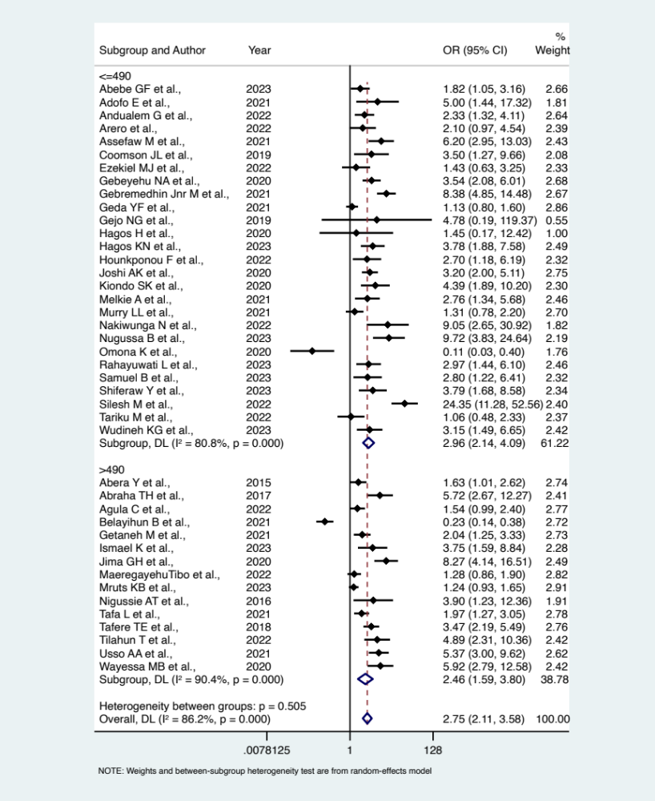
Supplementary figure 01: Summary effects of family planning counselling on modern contraception uptake in the post-partum period stratified across sample size

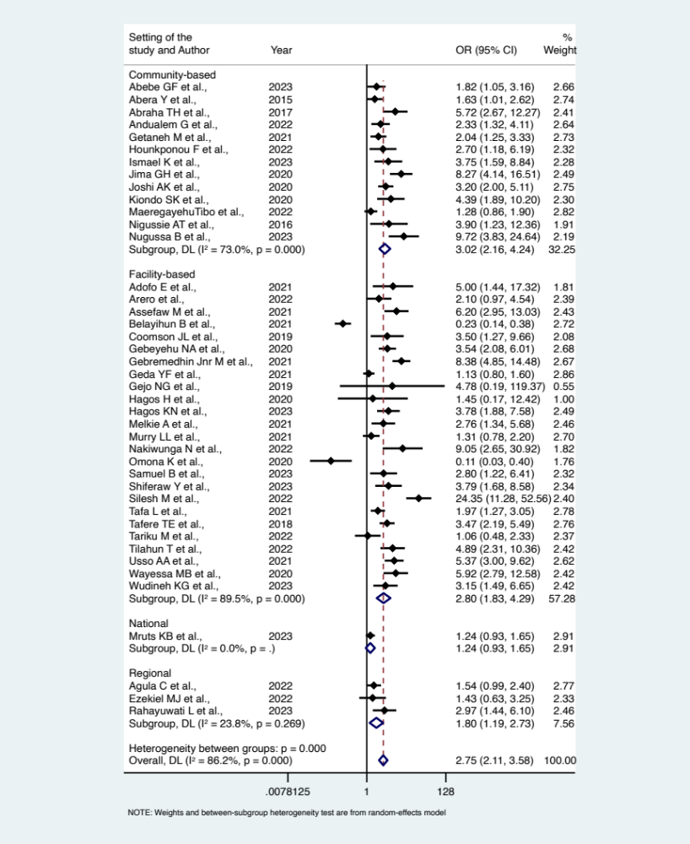
Supplementary figure 02: Summary effects of family planning counselling on modern contraception uptake in the post-partum period stratified across study setting
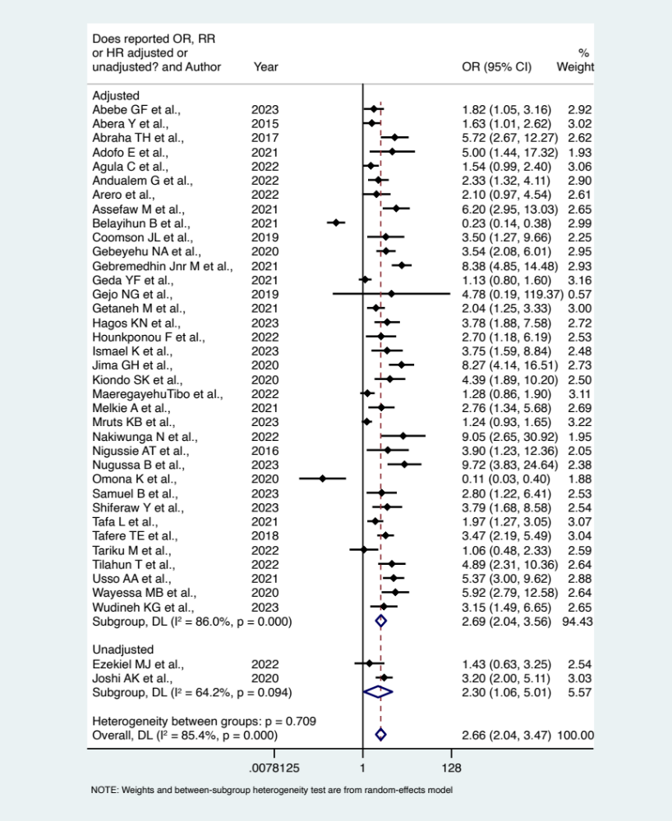
Supplementary figure 03: Summary effects of family planning counselling on modern contraception uptake in the post-partum period stratified across confounder adjustment
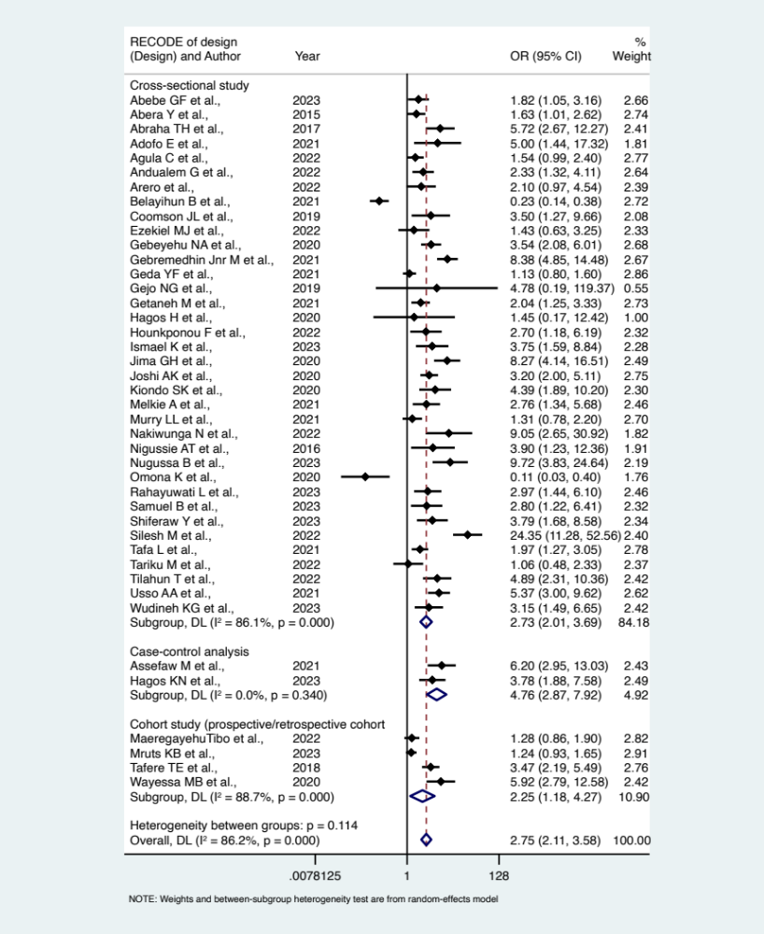
Supplementary figure 04: Summary effects of family planning counselling on modern contraception uptake in the post-partum period stratified across study design
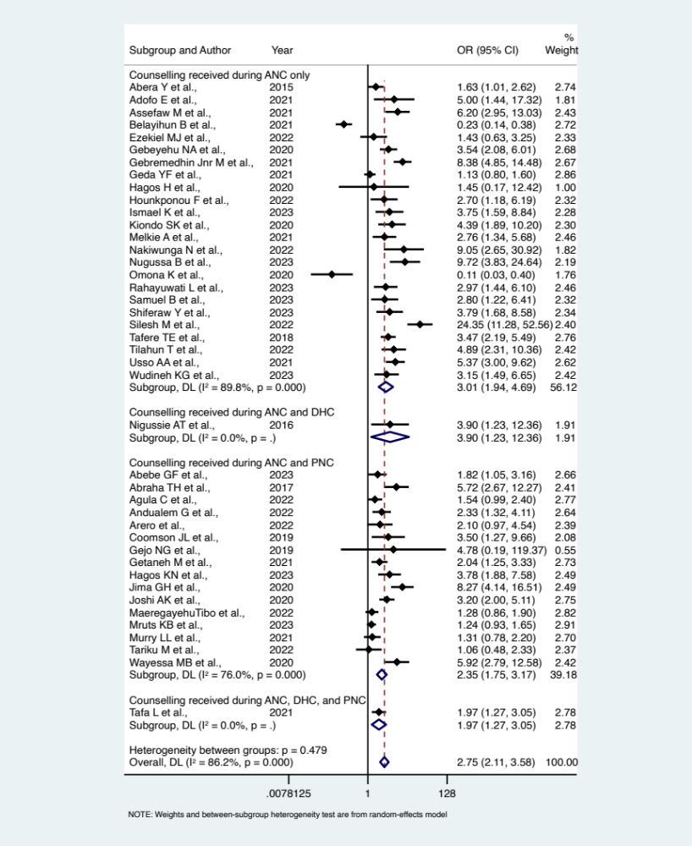
Supplementary figure 05: Summary effects of family planning counselling on modern contraception uptake in the post-partum period stratified across stage of maternal healthcare when counselling received
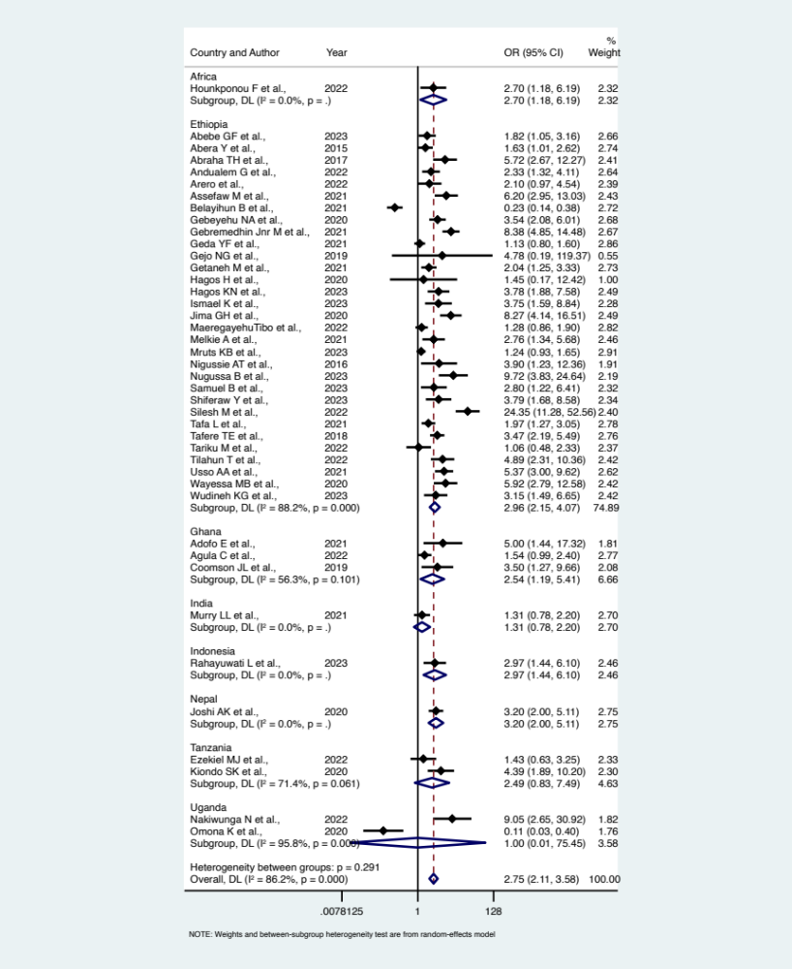
Supplementary figure 06: Summary effects of family planning counselling on modern contraception uptake in the post-partum period stratified across countries of included studies.
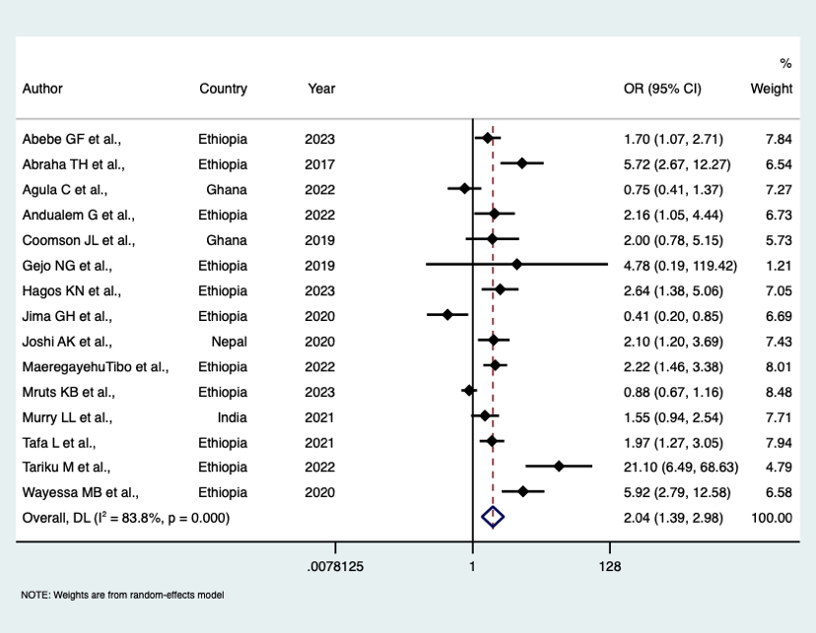
Supplementary figure 07: Effects on contraception counselling during accessing postnatal care on modern contraception uptake during accessing postnatal healthcare services.

References:
1. Arero WD, Teka WG, Hebo HJ, Woyo T, Amare B. Prevalence of long-acting reversible contraceptive methods utilization and associated factors among counseled mothers in immediate postpartum period at Jimma University medical center, Ethiopia. Contracept Reprod Med 2022; 7(1): 17.
2. Hagos KN, Gesese AA. Process evaluation of postpartum contraceptive service delivery in Ayder Comprehensive Specialized Hospital Mekelle, Tigray, Ethiopia in 2020. BMC Health Services Research 2023; 23(1).
3. Murry LL DS, Thuileiphy T, Kumari V, Gudiya G, Joshi P. Knowledge, Attitude and Utilization of Family Planning Methods among Postpartum Women in a Selected Tertiary Care Facility in India. Journal of Midwifery and Reproductive Health 2021; 9(1): 2597-604.
4. Mruts KB, Tessema GA, Kassaw NA, Gebremedhin AT, Scott JA, Pereira G. Achieving reductions in the unmet need for contraception with postpartum family planning counselling in Ethiopia, 2019-2020: a national longitudinal study. Arch Public Health 2023; 81(1): 79.
5. Adofo E, Dun-Dery EJ, Kotoh AM, Dun-Dery F, Avoka JA, Ashinyo ME. Fear of infertility limits contraceptive usage among first-time mothers in Ghana: A cross-sectional study. SAGE Open Med 2021; 9: 20503121211021256.
6. Wudineh KG, Desalegn S, Ewunetu M, Shiferaw S. Utilization of immediate post-partum long acting reversible contraceptives and its associated factors among mothers who gave birth in Addis Ababa public hospitals, Ethiopia: An institutional based cross-sectional study. PLoS One 2023; 18(8): e0280167.
7. Melkie A, Addisu D, Mekie M, Dagnew E. Utilization of immediate postpartum intrauterine contraceptive device and associated factors among mothers who gave birth at selected hospitals in west Gojjam zone, Ethiopia, multi-level facility-based study, 2019. Heliyon 2021; 7(1): e06034.
8. Kiondo KS, Maro E, Kiwango S, Alloyce JP, Shayo BC, Mahande MJ. Prevalence and factors associated with postpartum use of long-acting reversible contraception in Bukombe District, Geita Region, Tanzania: a community- based study. Contracept Reprod Med 2020; 5(1): 24.
9. Silesh M, Lemma T, Abdu S, Fenta B, Tadese M, Taye BT. Utilisation of immediate postpartum family planning among postpartum women at public hospitals of North Shoa Zone, Ethiopia: a cross-sectional study. BMJ Open 2022; 12(2): e051152.
10. Nugussa B, Solomon T, Tadelu H. Modern Postpartum Family Planning and Associated Factors Among Postpartum Women in a Rural District of Ethiopia, 2021: A Cross-Sectional Study. Inquiry 2023; 60: 469580231153268.
11. Maeregayehutibo, Adem A, Dache A. Time to initiate postpartum modern contraceptive use and predictors among women of reproductive age group in Dilla Town, Southern Ethiopia: a retrospective cohort study. Contraception and Reproductive Medicine 2022; 7(1).
12. Tilahun T, Bekuma TT, Getachew M, Oljira R, Seme A. Barriers and determinants of postpartum family planning uptake among postpartum women in Western Ethiopia: a facility-based cross-sectional study. Archives of Public Health 2022; 80(1).
13. Getaneh M, Jara D, Alle A, Arora A, Tsegaye TB, Birhanu MY. Modern Contraceptive Use and Associated Factors During Extended Postpartum Period Among Women Who Gave Birth in the Last 12 Months at Northwest Ethiopia. Int J Gen Med 2021; 14: 3313-25.
14. Agula C, Henry EG, Asuming PO, et al. Postpartum contraceptive initiation and use: Evidence from Accra, Ghana. Womens Health (Lond) 2022; 18: 17455057221141290.
15. Abebe GF, Alie, M. S., Girma, D., Adugna, A., & Negesse, Y. Magnitude of Modern Contraceptive Utilization and its Associated Factors Among Postpartum Women in Bench Sheko Zone, Southwest Ethiopia, 2021: Community-Based Cross-Sectional Study. SAGE Open Med 2023.
16. Ezekiel MJ, Akwary ER, Mbotwa C, Mosha IH. Factors associated with uptake of postpartum family planning services in Dodoma City Council, Tanzania: A cross-section study. Tanzania Journal of Health Research 2022; 23(1): 1-9.
17. Tafa L, Worku Y. Family planning utilization and associated factors among postpartum women in Addis Ababa, Ethiopia, 2018. PLoS One 2021; 16(1): e0245123.
18. Nakiwunga N, Kakaire O, Ndikuno CK, Nakalega R, Mukiza N, Atuhairwe S. Contraceptive uptake and associated factors among women in the immediate postpartum period at Kawempe Hospital. BMC Womens Health 2022; 22(1): 281.
19. Abraha TH, Teferra AS, Gelagay AA. Postpartum modern contraceptive use in northern Ethiopia: prevalence and associated factors. Epidemiol Health 2017; 39: e2017012.
20. Andualem G, Aklilu A, Belay G, Feyisa W, Alemnew F. Factors associated with utilization of modern postpartum family planing methods during the extended postpartum period among mothers who gave birth in the last 12 months at Injibara town, Northwest, Ethiopia: a cross-sectional study. Contracept Reprod Med 2022; 7(1): 25.
21. Gebeyehu NA, Lake EA, Gelaw KA, Azeze GA. The Intention on Modern Contraceptive Use and Associated Factors among Postpartum Women in Public Health Institutions of Sodo Town, Southern Ethiopia 2019: An Institutional-Based Cross-Sectional Study. Biomed Res Int 2020; 2020: 9815465.
22. Coomson JI, Manu A. Determinants of modern contraceptive use among postpartum women in two health facilities in urban Ghana: a cross-sectional study. Contracept Reprod Med 2019; 4: 17.
23. Gebremedhin M, Alemayehu A, Yihune M, Dessu S, Melis T, Nurahmed N. Acceptability and Factors Associated with Immediate Postpartum Intrauterine Contraceptive Device Use Among Women Who Gave Birth at Government Hospitals of Gamo Zone, Southern Ethiopia, 2019. Open Access J Contracept 2021; 12: 93-101.
24. Geda YF, Nejaga SM, Belete MA, Lemlem SB, Adamu AF. Immediate postpartum intrauterine contraceptive device utilization and influencing factors in Addis Ababa public hospitals: a cross-sectional study. Contracept Reprod Med 2021; 6(1): 4.
25. Samuel B, Tsegaye B, Dulla D, Aynalem A, Israel E, Gebrie M. Informed choice and its associated factors among women received immediate postpartum long-acting reversible contraceptives at public hospitals in Sidama Regional State, Ethiopia, 2022. Contracept Reprod Med 2023; 8(1): 32.
26. Omona K, Namuli W. Factors influencing utilization of intra-uterine device among postpartum mothers at Gombe Hospital, Butambala disrtict, Uganda. Cogent medicine 2020; 7(1): 1846264.
27. Rahayuwati L, Nurhidayah I, Ekawati R, et al. Determinant Factors of Post-Partum Contraception among Women during COVID-19 in West Java Province, Indonesia. Int J Environ Res Public Health 2023; 20(3).
28. Shiferaw Y, Jisso M, Fantahun S, Eshetu B, Assefa AA, Gebretsadik A. Acceptance, utilization, and factors associated with immediate postpartum intrauterine contraceptive device among mothers delivered at public health facilities in Hawassa city, Ethiopia: Institution-based study. Reprod Health 2023; 20(1): 39.
29. Belayihun B, Asnake M, Tilahun Y, Molla Y. Factors associated with long-acting reversible contraceptive use in the immediate postpartum period in Ethiopia. Ethiopian Journal of Health Development 2021; 35(5).
30. Abera Y, Mengesha ZB, Tessema GA. Postpartum contraceptive use in Gondar town, Northwest Ethiopia: a community based cross-sectional study. BMC Womens Health 2015; 15: 19.
31. Gejo NG, Anshebo AA, Dinsa LH. Postpartum modern contraceptive use and associated factors in Hossana town. PLoS One 2019; 14(5): e0217167.
32. Hounkponou F, Glèlè Ahanhanzo Y, Biaou COA, et al. Postpartum Contraceptive Use In Parakou (A City In Northern Benin) In 2018: A Community Based Cross-Sectional Study. Open Access J Contracept 2019; 10: 19-26.
33. Tafere TE, Afework MF, Yalew AW. Counseling on family planning during ANC service increases the likelihood of postpartum family planning use in Bahir Dar City Administration, Northwest Ethiopia: a prospective follow up study. Contracept Reprod Med 2018; 3: 28.
34. Jima G, Garbaba W. Postpartum family planning utilization and associated factors among women who gave birth in the last 12 months prior to the study in Lode Hetosa District, South East Ethiopia. J Women’s Heal Care 2020; 9(3).
35. Hagos HT, Dawit & Necho, Worku & Biru, Shemelis. Postpartum intra-uterine contraceptive device utilization among mothers who delivered at debre tabor general hospital: cross sectional study design. International Journal of Family & Community Medicine 2020; 4(5): 139-45.
36. Mandefro Assefaw WG, Getnet Azanew, Ayenew Engida,Zenebe Tefera. Determinants of Postpartum Intrauterine Contraceptive Device Uptake among Women Delivering in Public Hospitals of South Gondar Zone, Northwest Ethiopia, 2019: An Unmatched Case-Control Study. Obstetrics and Gynecology International 2021; 2021: 11.
37. Usso A A AHA, Dessie Y, and Tura A K. Utilization of Immediate Postpartum Long Acting Reversible Contraceptives among Women Who Gave Birth in Public Health Facilities in Eastern Ethiopia: A Cross-Sectional Study. International Journal of Reproductive Medicine 2021; 2021: 8.
38. Tariku M LB, Tantu T,, B D. Uptake of Immediate Postpartum LARCs and Associated
Factors among Mothers Who Gave Birth at Hawassa University
Comprehensive Specialized Hospital, Hawassa, Ethiopia. International Journal of Reproductive Medicine 2022; 2022: 8.
39. Nigussie AT GDaTG. Postpartum Family Planning Utilization and Associated Factors among Women
who Gave Birth in the Past 12 Months, Kebribeyah Town, Somali Region,
Eastern Ethiopia. Journal of Women's Health Care 2016; 6.
40. Ismael K CT, Abdo M. Timely initiation of postpartum contraceptive
utilization in Sebata Hawas district, Ethiopia:
A cross-sectional study. PLOS Glob Public Health. PLOS Glob Public Health 2023; 3.
41. Joshi K A TDP, Poudyal A, Shrestha N, Acharya U, Dhungana G P. Utilization of Family Planning Methods Among Postpartum Mothers in Kailali District, Nepal. International Journal of Women's Health 2020; 12: 487–94.
42. Wayessa M B ATW, Habtewold E M, Adlo A M, Teklu A M, Abeya S G, Negero W O. Focused Family Planning Counseling Increases
Immediate Postpartum Intrauterine Contraceptive
Device Uptake: A Quasi-Experimental Study. Journal of Contraception 2020; 11(91–102 ).
43. Tesfaye T, Mamo E, Teshome A, et al. Effect of Package of Interventions on the Use and Quality of Postpartum Family Planning Services at Yekatit 12 Hospital Medical College (Y12HMC), Addis Ababa, Ethiopia. Health Serv Insights 2023; 16: 11786329231160017.
44. Mickler AK, Karp C, Ahmed S, et al. Individual and facility-level factors associated with women's receipt of immediate postpartum family planning counseling in Ethiopia: results from national surveys of women and health facilities. BMC Pregnancy Childbirth 2021; 21(1): 809.
45. Pearson E, Senderowicz L, Pradhan E, et al. Effect of a postpartum family planning intervention on postpartum intrauterine device counseling and choice: evidence from a cluster-randomized trial in Tanzania. BMC Womens Health 2020; 20(1): 102.
46. Abdulkadir Z, Grema BA, Michael GC, Omeiza SY. Effect of Antenatal Couple Counselling on Postpartum Uptake of Contraception among Antenatal Clients and their Spouses attending Antenatal Clinic of a Northern Nigeria Tertiary Hospital: A Randomized Controlled Trial. West Afr J Med 2020; 37(6): 695-702.
47. Hersh AR, Muñoz LF, Rincón M, et al. Video compared to conversational contraceptive counseling during labor and maternity hospitalization in Colombia: A randomized trial. Contraception 2018; 98(3): 210-4.
48. Mruts KB, Tessema GA, Dunne J, Gebremedhin AT, Scott J, Pereira GF. Does family planning counselling during health service contact improve postpartum modern contraceptive uptake in Ethiopia? A nationwide cross-sectional study. BMJ Open 2022; 12(5): e060308.
49. Ayiasi RM, Muhumuza C, Bukenya J, Orach CG. The effect of prenatal counselling on postpartum family planning use among early postpartum women in Masindi and Kiryandongo districts, Uganda. Pan Afr Med J 2015; 21: 138.
50. Karra M, Canning D, Foster S, et al. Location and content of counselling and acceptance of postpartum IUD in Sri Lanka. Reproductive Health 2017; 14(1).
51. Wu WJ, Tiwari A, Choudhury N, et al. Community-based postpartum contraceptive counselling in rural Nepal: a mixed-methods evaluation. Sex Reprod Health Matters 2020; 28(2): 1765646.
52. Pradhan E, Canning D, Shah IH, et al. Integrating postpartum contraceptive counseling and IUD insertion services into maternity care in Nepal: results from stepped-wedge randomized controlled trial. Reprod Health 2019; 16(1): 69.
53. Kaewkiattikun K. Effects of immediate postpartum contraceptive counseling on long-acting reversible contraceptive use in adolescents. Adolesc Health Med Ther 2017; 8: 115-23.
54. Rajan S, Speizer IS, Calhoun LM, Nanda P. Counseling during Maternal and Infant Health Visits and Postpartum Contraceptive use in Uttar Pradesh, India. Int Perspect Sex Reprod Health 2016; 42(4): 167-78.
55. Chhabra HK, Mohanty IR, Mohanty NC, Thamke P, Deshmukh YA. Impact of Structured Counseling on Choice of Contraceptive Method Among Postpartum Women. J Obstet Gynaecol India 2016; 66(6): 471-9.
56. Puri MC, Huber-Krum S, Canning D, Guo M, Shah IH. Does family planning counseling reduce unmet need for modern contraception among postpartum women: Evidence from a stepped-wedge cluster randomized trial in Nepal. PLoS One 2021; 16(3): e0249106.
57. Lia Nurcahyani L, Dyah W, Arief TI, Yanti C, Yeni F. Effects of using an application for postpartum contraceptive use in family planning counseling during pregnancy. Kesmas: Jurnal Kesehatan Masyarakat Nasional (National Public Health Journal) 2023; 16(2): 137-44.
58. Willcox ML, Mubangizi V, Natukunda S, et al. Couples' decision-making on post-partum family planning and antenatal counselling in Uganda: A qualitative study. PLoS One 2021; 16(5): e0251190.
59. Puri MC, Joshi S, Khadka A, Pearson E, Dhungel Y, Shah IH. Exploring reasons for discontinuing use of immediate post-partum intrauterine device in Nepal: a qualitative study. Reprod Health 2020; 17(1): 41.
60. Puri MC, Moroni M, Pearson E, Pradhan E, Shah IH. Investigating the quality of family planning counselling as part of routine antenatal care and its effect on intended postpartum contraceptive method choice among women in Nepal. BMC Womens Health 2020; 20(1): 29.
61. Jalang’O R, Thuita F, Barasa SO, Njoroge P. Determinants of contraceptive use among postpartum women in a county hospital in rural KENYA. BMC Public Health 2017; 17(1).

