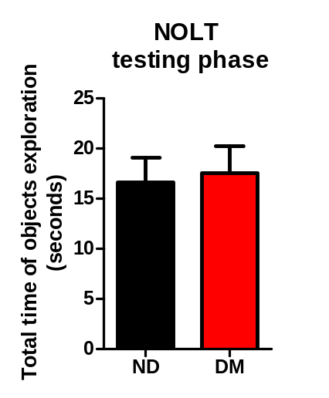Supplementary material
B
A
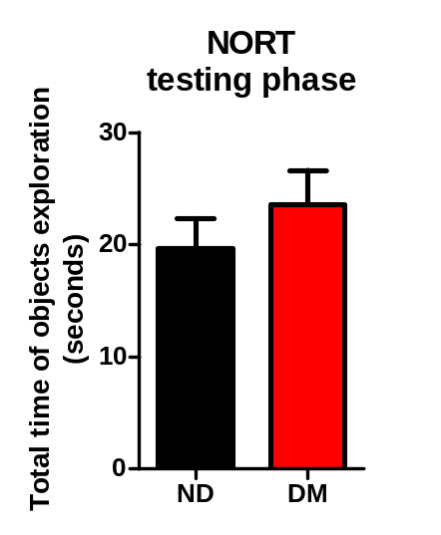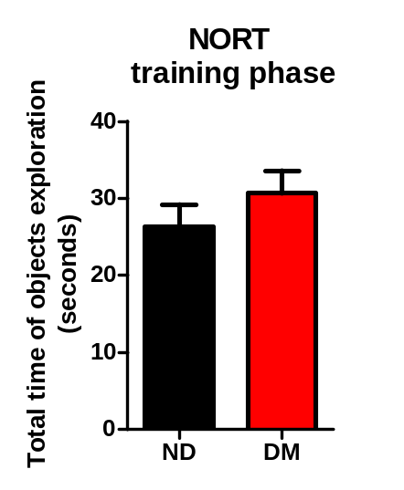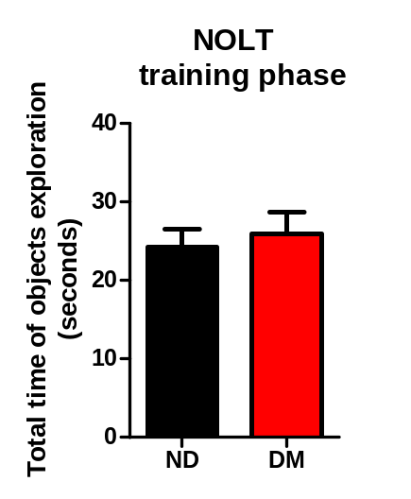
D
C

Supplementary Figure 1. Total time of objects exploration during training (A, C) and testing (B, D) in novel object location recognition test (NOLT) and in novel object recognition test (NORT), respectively. Normal control mice (ND) (n = 12), diabetic mice (DM) (n =9-10).

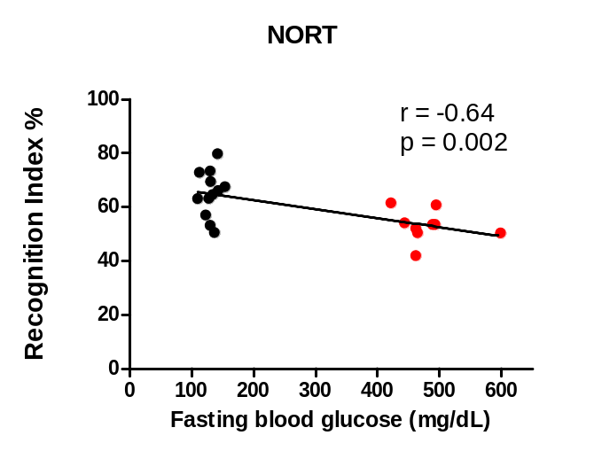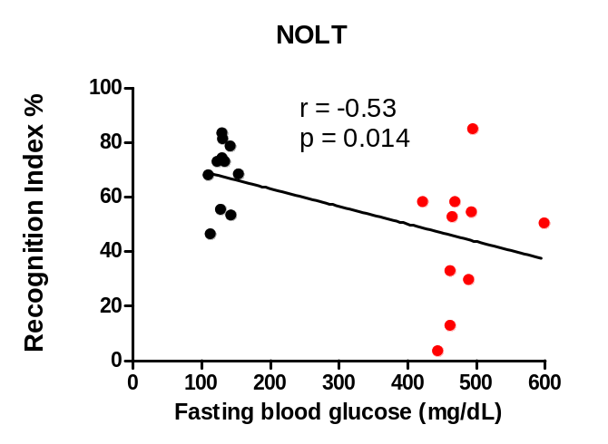

Supplementary Figure 2. Negative correlation between fasting blood glucose (FBG) and the percentage of recognition index in NOLT and NORT test. Normal control mice (n = 12), diabetic mice (n =9-10).

