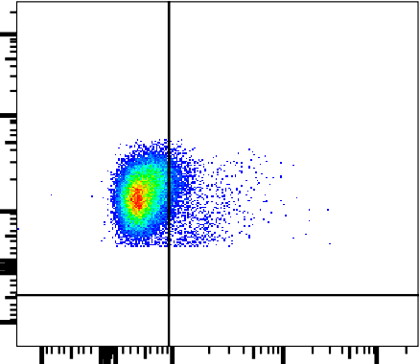
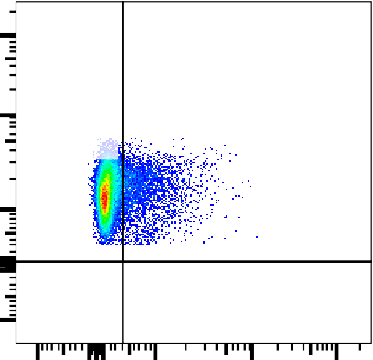
10 5 10 5
CD4+ IFNb- 92.3
Q3 0
Q4 0
Q2 7.70
Q1 92.3
CD4+ IFNb+ 7.70
Q9 87.4
CD4+ CB2R- 87.4
Q12 0
Q11 0
Q10 12.6
CD4+ CB2R+ 12.6

10 4 10 4
CD4
CD4

10 3
0
-10 3

0 10 4

IFNβ
10 3
0

-10 3

0 10 4

CB2R

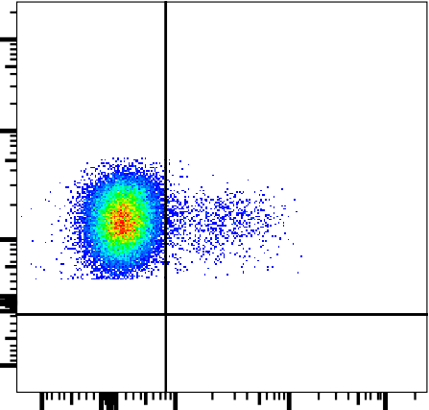
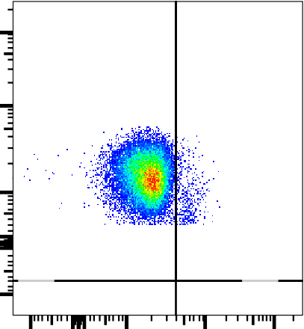
10 5 10 5
Q13 96.8
Q14 3.23
CD4+ IFNg- 96.8
Q16 0
Q15
0
CD4+ IFNg+ 3.23
Q21 98.3
Q22 1.70
CD4+ 15LOX- 98.3
Q24 0
Q23 0
CD4+ 15LOX+ 1.70

10 4 10 4
CD4
CD4

10 3

0

-10 3

0 10 4

IFNγ
10 3

0

-10 3

0 10 4

15LOX

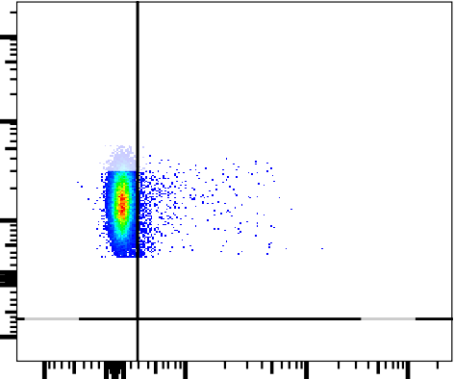
10 5
Q6 2.74
CD4+ COX2- 97.3
Q7 0
Q8 0
Q5 97.3
CD4+ COX2+ 2.74

10 4
CD4

10 3
0

-10 3
Representative IFN, CB2R, 15LOX, and COX2 Gating Strategy
Figure S2: Representative flow cytometry cytokine gating strategy using CD4⁺ T cells. The same gating strategy to determine IFNβ, ΙFNγ, CB2R, 15LOX, and COX2 levels was followed for all cell types.

0 10 4 10 5
COX2

