Appendix

Table 1. Overview of Qualtrics®^{XM} survey questions and skip logic
Display Questions 1-6 to all respondents
Q1. What is your age category?
- 18 - 24
- 25 - 30
- 31 - 40
- 41 - 50
- 51 - 60
- 60+

Q2. What is your gender?
- Male
- Female
- Transgender
- Prefer not to say

Q3. In what range was your most recent percent predicted FEV1?
- Below 30%
- 30 - 50%
- 51 - 70%
- 71 - 90%
- Above 90%
- I don't know

Q4. How many pulmonary exacerbations have you had in the past year that were treated with ORAL antibiotics?
- None
- 1 - 2
- 3 - 4
- More than 4
- I don't know

Q5. How many pulmonary exacerbations have you had in the past year that were treated with IV antibiotics?
- None
- 1 - 2
- 3 - 4
- More than 4
- I don't know

Q6. Have you ever used any cannabis-containing products (e.g. marijuana, tinctures, oils, edibles, tea, hashish)?
- Yes
- No

Display Question 7 if "Yes" to ever using any cannabis-containing products
Q7. Would you consider yourself a current user of cannabis-containing products (i.e. use on a regular or relatively regular basis, and/or ongoing on an as-needed basis)?
- Yes
- No

Display Questions 8-10 if “Yes” to being a current user of cannabis-containing products
Q8. Where do you get your supply of cannabis-containing products? Please check all that apply.
- A government-licensed dispensary
- An unlicensed dispensary
- An unlicensed dealer
- Grow your own supply
- A friend or family member
- Prefer not to say
- Other

Q9. How long have you been using cannabis-containing products?
- Less than 1 year
- 1 - 3 years
- 4 - 6 years
- 7 - 10 years
- More than 10 years

Q10. How often do you use cannabis-containing products?
- 6 - 7 days per week
- 3 - 5 days per week
- 1 - 2 days per week
- Less than weekly, but at least once per month
- Less than monthly
- Other

Display Question 11 if "Yes" to ever using any cannabis-containing products
Q11. Did the frequency of your use of cannabis-containing products change after the legalization in Canada in October 2018?
- Yes, my frequency of use increased
- Yes, my frequency of use decreased
- No, my frequency of use did not change
- Unsure

Display Questions 12-16 if “Yes” to being a current user of cannabis-containing products
Q12. In what way(s) do you like to administer or take your cannabis-containing products? Please select all that apply.
- Smoked as a joint or blunt
- Smoked in a dry pipe
- Smoked in a water pipe or bong
- Vaporized in a water pipe or bong
- Vaporized with an e-cigarette device or vaping pen
- Vaporized with an electronic handheld device that is not an e-cigarette or vaping pen
- Orally in a capsule
- As hash or hashish
- Eaten as edibles (e.g. in baked goods or candies)
- Prepared to drink as a tea
- As drops or tinctures (e.g. THC-only, CBD-only, THC and CBD combination)
- As oil (e.g. THC-only, CBD-only, THC and CBD combination)
- As wax (e.g. crumble, honeycomb, budder)
- As shatter
- Topically as a cream, gel, or lotion
- Other

Q13. Which is your preferred way to take cannabis-containing products, and why is it your preferred way? You may select more than one option. If you do not have a preferred way, please say so.
- Smoked as a joint or blunt
- Smoked in a dry pipe
- Smoked in a water pipe or bong
- Vaporized in a water pipe or bong
- Vaporized with an e-cigarette device or vaping pen
- Vaporized with an electronic handheld device that is not an e-cigarette or vaping pen
- Orally in a capsule
- As hash or hashish
- Eaten as edibles (e.g. in baked goods or candies)
- Prepared to drink as a tea
- As drops or tinctures (e.g. THC-only, CBD-only, THC and CBD combination)
- As oil (e.g. THC-only, CBD-only, THC and CBD combination)
- As wax (e.g. crumble, honeycomb, budder)
- As shatter
- Topically as a cream, gel, or lotion
- Other
- I do not have a preferred way

Q14. What is the average amount of cannabis-containing products you use in a day (e.g. number of joints or blunts, grams, millilitres, etc.)? If you do not know, please say so.
_________________________________________

Q15. Some cannabis-containing products have varying amounts of tetrahydrocannabinol (THC) and cannabidiol (CBD). What is your preference for proportions of THC and CBD in the cannabis-containing product(s) you use?
- I prefer only THC, with no CBD
- I prefer to have both, but more THC than CBD
- I prefer to have both, but more CBD than THC
- I prefer only CBD, with no THC
- I do not have a preference
- Other

Q16. Do you use cannabis-containing products recreationally (e.g. for the euphoric effects or "high") or to medically manage symptoms?
- Recreationally
- Medically
- Both recreationally and medically

Display Questions 17-18 if “Yes” to being a current user of cannabis-containing products for medical +/- recreational reasons
Q17. What symptom(s) have you used cannabis-containing products to medically manage, and how effectively do the cannabis-containing products manage the symptom(s)?
 | I have never used for this symptom | Very ineffective | Somewhat ineffective | Somewhat effective | Very effective | Unsure
Sinus pain | o | o | o | o | o | o
Chest pain | o | o | o | o | o | o
Abdominal pain | o | o | o | o | o | o
Joint pain | o | o | o | o | o | o
Insomnia / lack of sleep | o | o | o | o | o | o
Low appetite | o | o | o | o | o | o
Stress | o | o | o | o | o | o
Anxiety | o | o | o | o | o | o
Depression | o | o | o | o | o | o
Nausea | o | o | o | o | o | o
Migraine / headache | o | o | o | o | o | o
Airway inflammation / as an 'airway opener' | o | o | o | o | o | o
Other | o | o | o | o | o | o
Q18. Do you use only cannabis-containing products to manage the above symptom(s)?
- Yes, I use only cannabis-containing products
- No, I use cannabis-containing products together with other medication(s)
- It depends on which symptom I am treating (i.e. for some I use cannabis-containing products only, and for others I use both cannabis-containing products and other medication(s)
- Other

Display Question 19 if “Yes” to being a current user of cannabis-containing products for medical reasons in addition to other prescription or non-prescription medications
Q19. How effective are cannabis-containing products in managing your symptom(s) when compared to other prescription and non-prescription medications obtained at a pharmacy?
 | I don't use cannabis for this symptom | Cannabis is significantly less effective | Cannabis is slightly less effective | Cannabis is just as effective | Cannabis is slightly more effective | Cannabis is significantly more effective | Unsure
Sinus pain | o | o | o | o | o | o | o
Chest pain | o | o | o | o | o | o | o
Abdominal pain | o | o | o | o | o | o | o
Joint pain | o | o | o | o | o | o | o
Insomnia / lack of sleep | o | o | o | o | o | o | o
Low appetite | o | o | o | o | o | o | o
Stress | o | o | o | o | o | o | o
Anxiety | o | o | o | o | o | o | o
Depression | o | o | o | o | o | o | o
Nausea | o | o | o | o | o | o | o
Migraine / headache | o | o | o | o | o | o | o
Airway inflammation / as an 'airway opener' | o | o | o | o | o | o | o
Other | o | o | o | o | o | o | o
Display Questions 20 if “Yes” to being a current user of cannabis-containing products
Q20. How has use of cannabis-containing products affected your quality of life (QoL)?
- It has significantly decreased my QoL
- It has somewhat decreased my QoL
- It has not impacted my QoL
- It has somewhat increased my QoL
- It has significantly increased my QoL
- Unsure

Display Questions 21-24 to all respondents
Q21. What is your perception about the following safety and potential short- or long-term side effects associated with use of cannabis-containing products? Please note: some answers may be specific to certain routes of administration.
 | This is not concerning | This is somewhat concerning | This is very concerning | I was not aware of this effect | Unsure
Memory impairment | o | o | o | o | o
Impaired coordination | o | o | o | o | o
Slow reaction time | o | o | o | o | o
Impaired judgment and decision-making | o | o | o | o | o
Impaired driving | o | o | o | o | o
Anxiety or panic attacks | o | o | o | o | o
Hallucinations | o | o | o | o | o
Lethargy or fatigue | o | o | o | o | o
Dizziness | o | o | o | o | o
Increased heart rate | o | o | o | o | o
Addiction or dependence | o | o | o | o | o
Impaired brain development | o | o | o | o | o
Airway irritation | o | o | o | o | o
Risk for mental illness | o | o | o | o | o
Chest tightness or wheeze (if inhaled) | o | o | o | o | o
Shortness of breath (if inhaled) | o | o | o | o | o
Increased sputum (if inhaled) | o | o | o | o | o
Increased cough (if inhaled) | o | o | o | o | o

Q22. Are you aware that tetrahydrocannabinol (THC) and cannabidiol (CBD) can interact with other medications?
- Yes
- No

Q23. If you have additional comments or general perceptions about the potential benefits and why a person can try cannabis-containing products, or the safety and potential short- or long-term side effects associated with use of cannabis-containing products, please share them here.
_________________________________________

Q24. Has your general perception about the safety and potential short- or long-term side effects associated with use of cannabis-containing products changed since the legalization of cannabis in Canada in October 2018?
- Yes
- No
- Unsure

Display Question 25 if “Yes” to perception about safety and potential short- or long-term side effects associated with cannabis changed after legalization in October 2018
Q25. In what way has your general perception about the safety and potential short- or long-term side effects associated with use of cannabis-containing products changed since the legalization of cannabis in Canada in October 2018?
_________________________________________

Display Questions 26-29 to all respondents
Q26. How do you think cannabis-containing products compare to cigarettes for the potential to cause addition or dependence?
- Cannabis is less likely than cigarettes to cause addiction or dependence
- Cannabis is just as likely as cigarettes to cause addiction or dependence
- Cannabis is more likely than cigarettes to cause addiction or dependence
- Unsure

Q27. How do you think cannabis-containing products compare to cigarettes for the potential to cause physical harm?
- Cannabis is less likely than cigarettes to cause physical harm
- Cannabis is just as likely as cigarettes to cause physical harm
- Cannabis is more likely than cigarettes to cause physical harm
- Unsure

Q28. How do you think cannabis-containing products compare to cigarettes for the potential to negatively affect mental health?
- Cannabis is less likely than cigarettes to negatively affect mental health
- Cannabis is just as likely as cigarettes to negatively affect mental health
- Cannabis is more likely than cigarettes to negatively affect mental health
- Unsure

Q29. Thank you for making it this far in the survey! To move to the next section, please choose option ‘B’ as your answer.
- A
- B
- C

Please note that the following questions are about vaping in general, and are not specific to vaping cannabis products.

Display Question 30 to all respondents
Q30. Have you used a water pipe, bong, e-cigarette device, vape pen, or other hand-held vaporizer to vape cannabis (CBD- and/or THC-containing), nicotine, or flavoured liquid?
- Yes
- No

Display Question 31 if "Yes" to ever trying vaping
Q31. Would you consider yourself a current vaper (i.e. regular or relatively regular use)?
- Yes
- No

Display Question 32-35 if "Yes" to being a current vaper
Q32. How long have you been vaping for?
- Less than 1 year
- 1 - 3 years
- 4 - 6 years
- 7 - 10 years
- More than 10 years

Q33. How often do you vape?
- 6 - 7 days per week
- 3 - 5 days per week
- 1 - 2 days per week
- Less than weekly, but at least once per month
- Less than monthly
- Other

Q34. What product(s) do you vape? Please select all that apply.
- Marijuana
- Cannabis oil (THC-containing only)
- Cannabis oil (CBD-containing only)
- Cannabis oil (THC- and CBD-containing)
- Nicotine
- Tobacco
- Flavoured liquid (without any other products)
- Other

Q35. What device(s) do you use to vape? Please select all that apply.
- Water pipe
- Bong
- E-cigarette device
- Vaping pen
- Other

Display Questions 36-39 to all respondents
Q36. What is your general perception about the safety associated with vaping, in general and specifically vaping of marijuana, cannabis oil, nicotine, tobacco, or flavoured liquid?
 | Very unsafe | Somewhat unsafe | Somewhat safe | Very safe | Unsure
Vaping in general | o | o | o | o | o
Vaping marijuana | o | o | o | o | o
Vaping THC oil | o | o | o | o | o
Vaping CBD oil | o | o | o | o | o
Vaping THC/CBD oil | o | o | o | o | o
Vaping nicotine | o | o | o | o | o
Vaping tobacco | o | o | o | o | o
Vaping flavoured liquid | o | o | o | o | o
Q37. What is your general perception about the potential short- and long-term side effects associated with vaping, in general and specifically vaping of marijuana, cannabis oil, nicotine, tobacco, or flavoured liquid?
 | No side effects of concern | Some side effects of concern | Many side effects of concern | Unsure
Vaping in general | o | o | o | o
Vaping marijuana | o | o | o | o
Vaping cannabis oil | o | o | o | o
Vaping nicotine | o | o | o | o
Vaping tobacco | o | o | o | o
Vaping flavoured liquid | o | o | o | o
Q38. If you have concern about some or many side effects secondary to vaping, please state which side effects you have concern about.
________________________________________________________________

Q39. Has your general perception about the safety and potential short- or long-term side effects associated with vaping changed with the 2019 media attention on vaping-related lung injury and death?
- Yes
- No
- I was not aware of any media attention regarding vaping-related lung injury and death

Display Question 40 if “Yes” to general perception of safety and potential short- or long-term side effects associated with vaping changed with the 2019 media attention regarding vaping-related lung injury and death
Q40. In what way has your general perception about the safety and potential short- or long-term side effects associated with vaping changed with the 2019 media attention on vaping-related lung injury and death?
________________________________________________________________

Display Questions 41-46 to all respondents
Q41. How do you think vaping compares to smoking for the potential to cause addiction or dependence?
- Vaping is less likely than smoking to cause addiction or dependence
- Vaping is just as likely as smoking to cause addiction or dependence
- Vaping is more likely than smoking to cause addiction or dependence
- Unsure

Q42. How do you think vaping compares to smoking for the potential to cause physical harm?
- Vaping is less likely than smoking to cause physical harm
- Vaping is just as likely as smoking to cause physical harm
- Vaping is more likely than smoking to cause physical harm
- Unsure

Q43. How do you think vaping compares to smoking for the potential to negatively affect mental health?
- Vaping is less likely than smoking to negatively affect mental health
- Vaping is just as likely as smoking to negatively affect mental health
- Vaping is more likely than smoking to negatively affect mental health
- Unsure

Q44. Would you feel comfortable discussing use of cannabis-containing products and/or vaping with your cystic fibrosis clinic team?
- Yes
- No
- Unsure

Q45. What could the cystic fibrosis clinic team do to create a safe place to discuss these topics?
________________________________________________________________

Q46. If you have any additional comments or feedback, we welcome you to please share below.
________________________________________________________________

Appendix Figure 1. Formulations of cannabis-containing products used (N=47 respondents, n=114 responsesª)
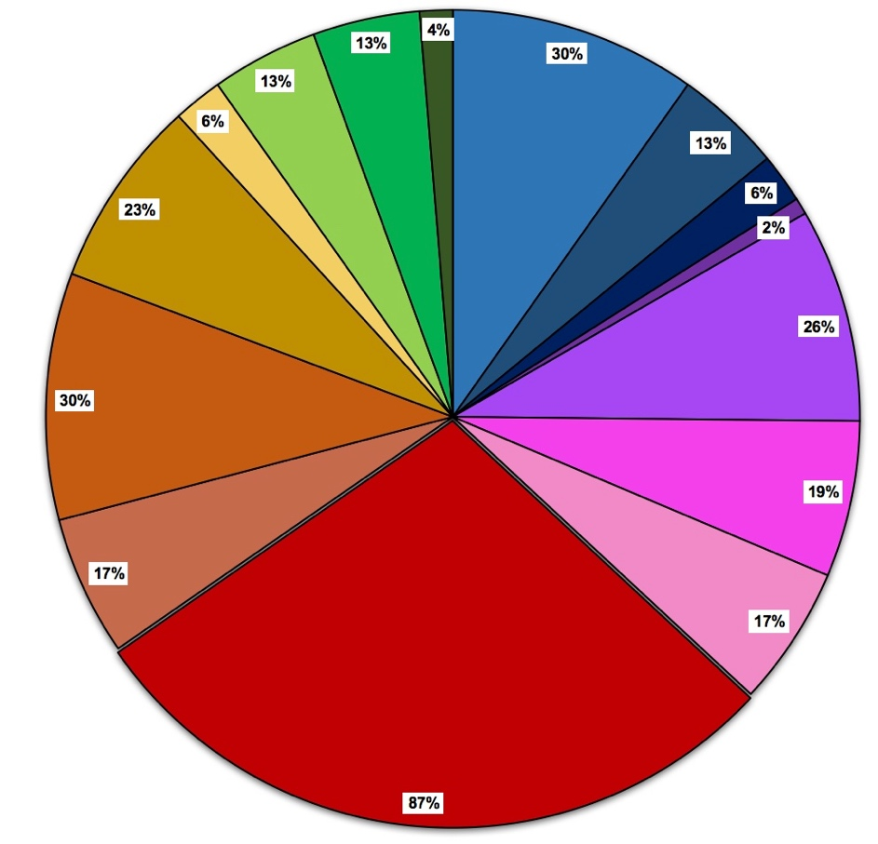
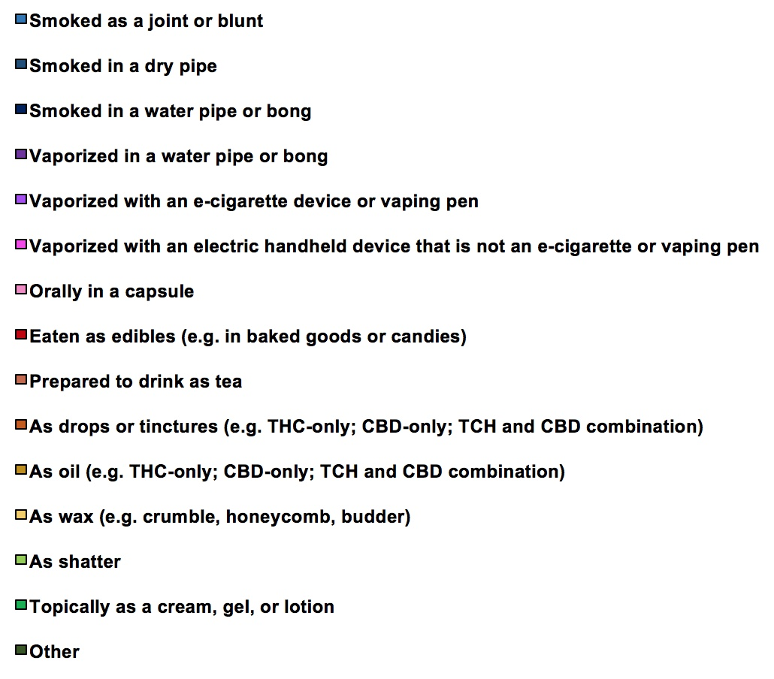
ªRespondents could select more than one option

Appendix Figure 2. Preferred formulations of cannabis-containing products used (N=47 respondents, n=81 responsesª)
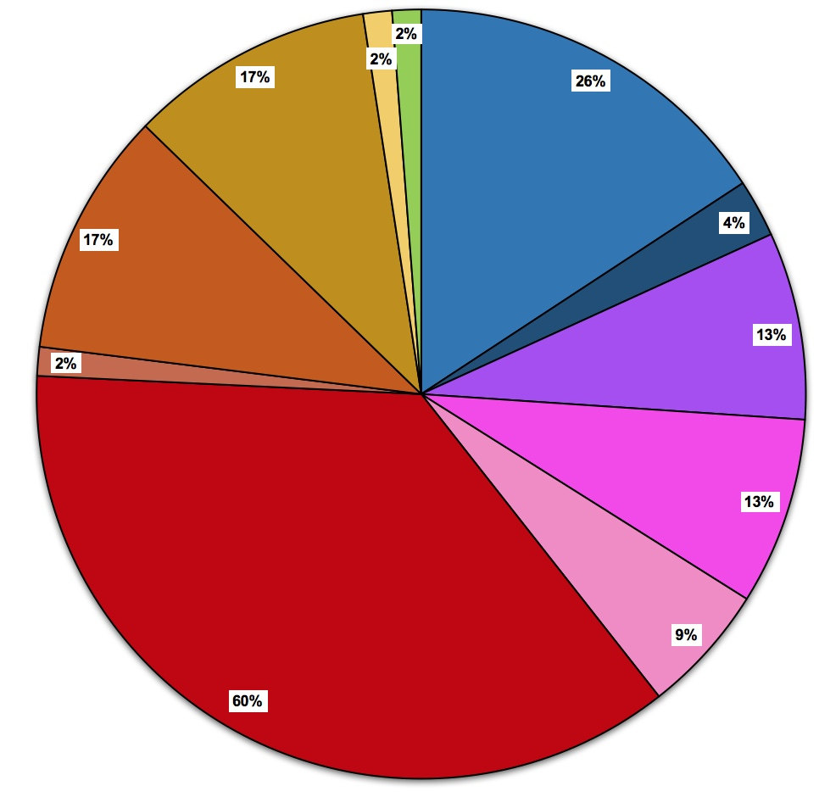
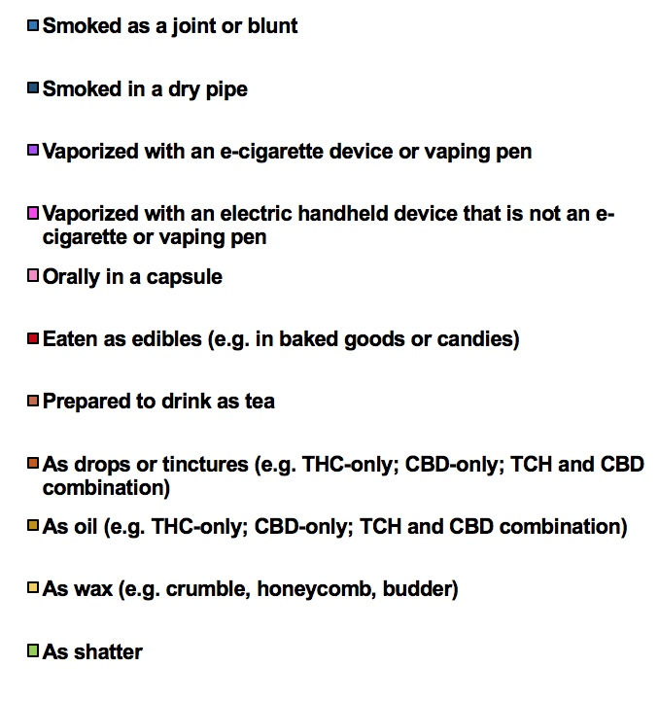

ªRespondents could select more than one option

Appendix Table 2. Reported impact of cannabis use on quality of life (N=47)
Question: How has use of cannabis-containing products affected your quality of life (QoL)? | n (%)
- Significantly decreased QoL | 1 (2)
- Somewhat decreased QoL | 2 (4)
- Has not impacted QoL | 10 (21)
- Somewhat increased QoL | 12 (26)
- Significantly increased QoL | 18 (38)
- Unsure | 4 (9)

Appendix Table 3. Reported perceptions of safety and side effects associated with cannabis-containing products (N=110; n=47 current users, n=63 non-users^{b})
Side effect | Very concerning,  n (%) |  | Somewhat concerning, n (%) |  | Not concerning,  n (%) |  | Not aware of effect,  n (%) |  | Unsure,  n (%) |  | p-value
Side effect | Non-user | Current User | Non-user | Current User | Non-user | Current User | Non-user | Current User | Non-user | Current User
Shortness of breathª | 41 (65) | 11 (23) | 16 (25) | 7 (15) | 3 (5) | 20 (43) | 0 | 2 (4) | 3 (5) | 7 (15) | 5.8 x 10⁻⁸
Impaired driving | 39 (62) | 11 (23) | 14 (22) | 8 (17) | 6 (10) | 22 (47) | 0 | 1 (2) | 4 (6) | 5 (11) | 8.0 x 10⁻⁶
Airway irritation | 39 (62) | 6 (13) | 14 (22) | 13 (28) | 5 (8) | 19 (40) | 1 (2) | 4 (9) | 4 (6) | 5 (11) | 1.8 x 10⁻⁷
Chest tightness or wheezeª | 38 (60) | 11 (23) | 18 (29) | 6 (13) | 3 (5) | 19 (40) | 1 (2) | 5 (11) | 3 (5) | 6 (13) | 1.2 x 10⁻⁷
Increased coughª | 38 (60) | 13 (28) | 18 (29) | 7 (16) | 4 (6) | 19 (40) | 0 | 3 (6) | 3 (5) | 5 (11) | 2.8 x 10⁻⁶
Impaired brain development | 35 (56) | 2 (4) | 12 (19) | 8 (17) | 9 (14) | 30 (64) | 3 (5) | 3 (6) | 4 (6) | 4 (9) | 7.9 x 10⁻¹⁰
Increased sputumª | 33 (52) | 10 (21) | 18 (29) | 8 (17) | 6 (10) | 19 (40) | 3 (5) | 4 (9) | 3 (5) | 6 (13) | 9.5 x 10⁻⁵
Addiction or dependence | 32 (51) | 5 (11) | 17 (27) | 5 (11) | 8 (13) | 32 (68) | 1 (2) | 3 (6) | 5 (8) | 2 (4) | 1.9 x 10⁻⁹
Risk for mental illness | 31 (49) | 4 (9) | 14 (22) | 9 (19) | 9 (14) | 24 (51) | 5 (8) | 5 (11) | 4 (6) | 5 (11) | 4.2 x 10⁻⁶
Impaired judgment and decision-making | 28 (44) | 1 (2) | 24 (38) | 16 (34) | 8 (13) | 25 (53) | 0 | 3 (6) | 3 (5) | 2 (4) | 4.2 x 10⁻⁹
Anxiety/panic attacks | 26 (41) | 4 (9) | 21 (33) | 11 (23) | 6 (10) | 27 (57) | 7 (11) | 4 (9) | 3 (5) | 1 (2) | 2.4 x 10⁻⁷
Slow reaction time | 24 (38) | 0 | 24 (38) | 17 (36) | 9 (14) | 28 (60) | 2 (3) | 1 (2) | 4 (6) | 1 (2) | 4.4 x 10⁻⁹
Hallucinations | 20 (32) | 3 (6) | 19 (30) | 4 (9) | 12 (19) | 31 (66) | 7 (11) | 8 (17) | 5 (8) | 1 (2) | 6.5 x 10⁻⁷
Increased heart rate | 19 (30) | 3 (6) | 22 (35) | 7 (15) | 9 (14) | 30 (64) | 8 (13) | 6 (13) | 5 (8) | 1 (2) | 6.3 x 10⁻⁷
Impaired coordination | 18 (29) | 1 (2) | 25 (40) | 10 (21) | 12 (19) | 29 (62) | 4 (6) | 4 (9) | 4 (6) | 3 (6) | 3.3 x 10⁻⁶
Memory impairment | 17 (27) | 6 (13) | 22 (35) | 16 (34) | 10 (16) | 20 (43) | 9 (14) | 2 (4) | 5 (8) | 3 (6) | 0.014
Lethargy or fatigue | 17 (27) | 1 (2) | 23 (37) | 15 (32) | 17 (27) | 28 (60) | 2 (3) | 2 (4) | 4 (6) | 1 (2) | 2.2 x 10⁻⁴
Dizziness | 15 (24) | 1 (2) | 25 (40) | 5 (11) | 12 (19) | 35 (75) | 6 (10) | 5 (11) | 5 (8) | 1 (2) | 1.2 x 10⁻⁸
ª Specific to inhaled formulations
^{b} ‘Non-user’ comprised of ‘past users’ and ‘never users’ of cannabis products

Appendix Table 4. Reported perception of respiratory-related side effects of cannabis in users of inhaled cannabis formulations and cannabis users who do not use inhaled formulations (N=25 and N=22, respectively)^{a,b}
 | Very concerning,  n (%) |  | Somewhat concerning, n (%) |  | Not concerning,  n (%) |  | Not aware of effect, n (%) |  | Unsure, n (%) |  | p-value
Side effect | Inhaled user | Inhaled non-user | Inhaled user | Inhaled non-user | Inhaled user | Inhaled non-user | Inhaled user | Inhaled non-user | Inhaled user | Inhaled non-user
Shortness of breath | 8 (32) | 3 (14) | 7 (28) | 0 (0) | 8 (32) | 12 (55) | 1 (4) | 1 (6) | 1 (4) | 6 (27) | 3.7 x 10⁻³
Airway Irritation | 5 (20) | 1 (6) | 12 (48) | 1 (6) | 8 (32) | 11 (50) | 0 (0) | 4 (18) | 0 (0) | 5 (23) | 5.1 x 10⁻⁵
Chest tightness  or wheeze | 8 (32) | 3 (14) | 6 (24) | 0 (0) | 8 (32) | 11 (50) | 3 (12) | 2 (9) | 0 (0) | 6 (27) | 2.4 x 10⁻³
Increased cough | 9 (36) | 4 (18) | 7 (28) | 0 (0) | 7 (28) | 12 (55) | 1 (4) | 2 (9) | 1 (4) | 4 (18) | 7.7 x 10⁻³
Increased sputum | 7 (28) | 3 (14) | 8 (32) | 0 (0) | 7 (28) | 12 (55) | 2 (8) | 2 (9) | 1 (4) | 5 (23) | 4.4 x 10⁻³
ª 'Inhaled user' refers to current user of cannabis who reported use of inhaled formulations, 'Inhaled non-user' refers to current user of cannabis who reported not using inhaled formulations
^{b} ’Inhaled users’ could also report use of non-inhaled formulations

Appendix Table 5. Reported perceptions about the safety and potential side effects associated with vaping overall
Type of vaping | General safety associated with vaping (N=110ª), n (%) |  |  | Potential short- and long-term side effects (N=110^{a,d}), n (%)
Type of vaping | Very or somewhat unsafe^{b} | Very or somewhat safe^{c} | Unsure | None of concern | Some of concern | Many of concern | Unsure
Vaping in general | 87 (79) | 13 (12) | 10 (9) | 3 (3) | 32 (29) | 57 (52) | 18 (16)
Marijuana | 74 (67) | 22 (20) | 12 (11) | 10 (9) | 37 (34) | 39 (36) | 24 (22)
THC oil | 71 (65) | 18 (16) | 20 (18) | 9 (8)^{e} | 36 (33)^{e} | 37 (34)^{e} | 27 (25)^{e}
CBD oil | 70 (64) | 18 (16) | 20 (18)
THC/CBD oil | 70 (64) | 19 (17) | 20 (18)
Nicotine | 93 (85) | 5 (5) | 12 (11) | 3 (3) | 23 (21) | 66 (60) | 18 (16)
Tobacco | 89 (81) | 3 (3) | 17 (16) | 3 (3) | 18 (16) | 70 (64) | 19 (17)
Flavoured liquid | 89 (81) | 3 (3) | 17 (16) | 2 (2) | 29 (26) | 56 (51) | 22 (20)
CBD, cannabidiol; EVALI, e-cigarette or vaping product use-associated lung injury; THC, tetrahydrocannabinol
ª Respondents who did not select an answer are not included above; therefore, the responses may not add to N=110
^{b} "Very unsafe" and "Somewhat unsafe" were separate responses in the questionnaire, but were combined for data analyses
^{c} "Very safe" and "Somewhat safe" were separate responses in the questionnaire, but were combined for data analyses
^{d} N=39 (35%) respondents reported outcomes of concern, including: respiratory symptoms (e.g. cough, chest pain); damage to the lungs (including EVALI and "popcorn lung"); increased risk of lung infections; accelerated lung function decline, with potential to be life-shortening; inhalation of irritants (e.g. oil, metals, carcinogens); second-hand smoke (including putting others at risk); cognitive and motor impairment; mental illness; addiction; hallucinations; dry mouth and tooth decay; and potential removal from the lung transplant list.
^{e} "Cannabis oil" was used to encompass THC and/or CBD-containing products for this question

Appendix Table 6. Reported perceptions about the general safety of vaping by ppFEV₁
Type of vaping | General safety associated with vaping^{a,b} | Reported ppFEV₁ |  |  |  |  |  | p-value
Type of vaping | General safety associated with vaping^{a,b} | Below 30% (N=1), n (%) | 30-50% (N=18^{c}), n (%) | 51-70% (N=29), n (%) | 71-90% (N=29^{d}), n (%) | Above 90% (N=23e), n (%) | Don't know (N=10), n (%) | p-value
Vaping in General | Very or somewhat unsafe | 1 (100) | 12 (67) | 22 (76) | 21 (72) | 22 (96) | 9 (90) | 0.16
Vaping in General | Very or somewhat safe | 0 (0) | 5 (28) | 2 (7) | 5 (17) | 1 (4) | 0 (0) | 0.16
Vaping in General | Unsure | 0 (0) | 1 (6) | 5 (17) | 3 (10) | 0 (0) | 1 (10) | 0.16
Marijuana | Very or somewhat unsafe | 1 (100) | 12 (71) | 17 (59) | 19 (66) | 18 (82) | 7 (70) | 0.67
Marijuana | Very or somewhat safe | 0 (0) | 4 (24) | 6 (21) | 6 (21) | 4 (18) | 2 (20) | 0.67
Marijuana | Unsure | 0 (0) | 1 (6) | 6 (21) | 4 (14) | 0 (0) | 1 (10) | 0.67
THC Oil | Very or somewhat unsafe | 1 (100) | 12 (67) | 16 (55) | 18 (62) | 18 (82) | 6 (60) | 0.16
THC Oil | Very or somewhat safe | 0 (0) | 3 (17) | 5 (17) | 6 (21) | 4 (18) | 0 (0) | 0.16
THC Oil | Unsure | 0 (0) | 3 (17) | 8 (28) | 5 (17) | 0 (0) | 4 (40) | 0.16
CBD Oil | Very or somewhat unsafe | 1 (100) | 12 (71) | 16 (55) | 18 (62) | 17 (77) | 6 (60) | 0.45
CBD Oil | Very or somewhat safe | 0 (0) | 3 (18) | 6 (21) | 5 (17) | 4 (18) | 0 (0) | 0.45
CBD Oil | Unsure | 0 (0) | 2 (12) | 7 (24) | 6 (21) | 1 (5) | 4 (40) | 0.45
THC/CBD Oil | Very or somewhat unsafe | 1 (100) | 12 (67) | 16 (55) | 17 (58) | 18 (82) | 6 (60) | 0.18
THC/CBD Oil | Very or somewhat safe | 0 (0) | 3 (17) | 6 (21) | 6 (21) | 4 (18) | 0 (0) | 0.18
THC/CBD Oil | Unsure | 0 (0) | 3 (17) | 7 (24) | 6 (21) | 0 (0) | 4 (40) | 0.18
Nicotine | Very or somewhat unsafe | 1 (100) | 12 (67) | 24 (83) | 23 (79) | 23 (100) | 10 (100) | 0.018
Nicotine | Very or somewhat safe | 0 (0) | 4 (22) | 1 (3) | 0 (0) | 0 (0) | 0 (0) | 0.018
Nicotine | Unsure | 0 (0) | 2 (11) | 4 (14) | 6 (21) | 0 (0) | 0 (0) | 0.018
Tobacco | Very or somewhat unsafe | 1 (100) | 11 (61) | 24 (83) | 23 (82) | 22 (96) | 8 (80) | 0.24
Tobacco | Very or somewhat safe | 0 (0) | 2 (11) | 1 (3) | 0 (0) | 0 (0) | 0 (0) | 0.24
Tobacco | Unsure | 0 (0) | 5 (28) | 4 (14) | 5 (18) | 1 (4) | 2 (20) | 0.24
Flavoured Liquid | Very or somewhat unsafe | 1 (100) | 14 (78) | 24 (83) | 24 (83) | 20 (91) | 6 (60) | 0.38
Flavoured Liquid | Very or somewhat safe | 0 (0) | 0 (0) | 1 (3) | 0 (0) | 1 (5) | 1 (10) | 0.38
Flavoured Liquid | Unsure | 0 (0) | 4 (22) | 4 (14) | 5 (17) | 1 (5) | 3 (30) | 0.38
CBD, cannabidiol; ppFEV₁, percent predicted Forced Expiratory Volume in 1 Second; THC, tetrahydrocannabinol
ª "Very unsafe" and "Somewhat unsafe" were separate responses in the questionnaire, but were combined for data analyses
^{b} "Very safe" and "Somewhat safe" were separate responses in the questionnaire, but were combined for data analyses
^{c} Respondents who did not select an answer are not included above; therefore, the responses may not add to N=18
^{d} Respondents who did not select an answer are not included above; therefore, the responses may not add to N=29
^{e} Respondents who did not select an answer are not included above; therefore, the responses may not add to N=23

