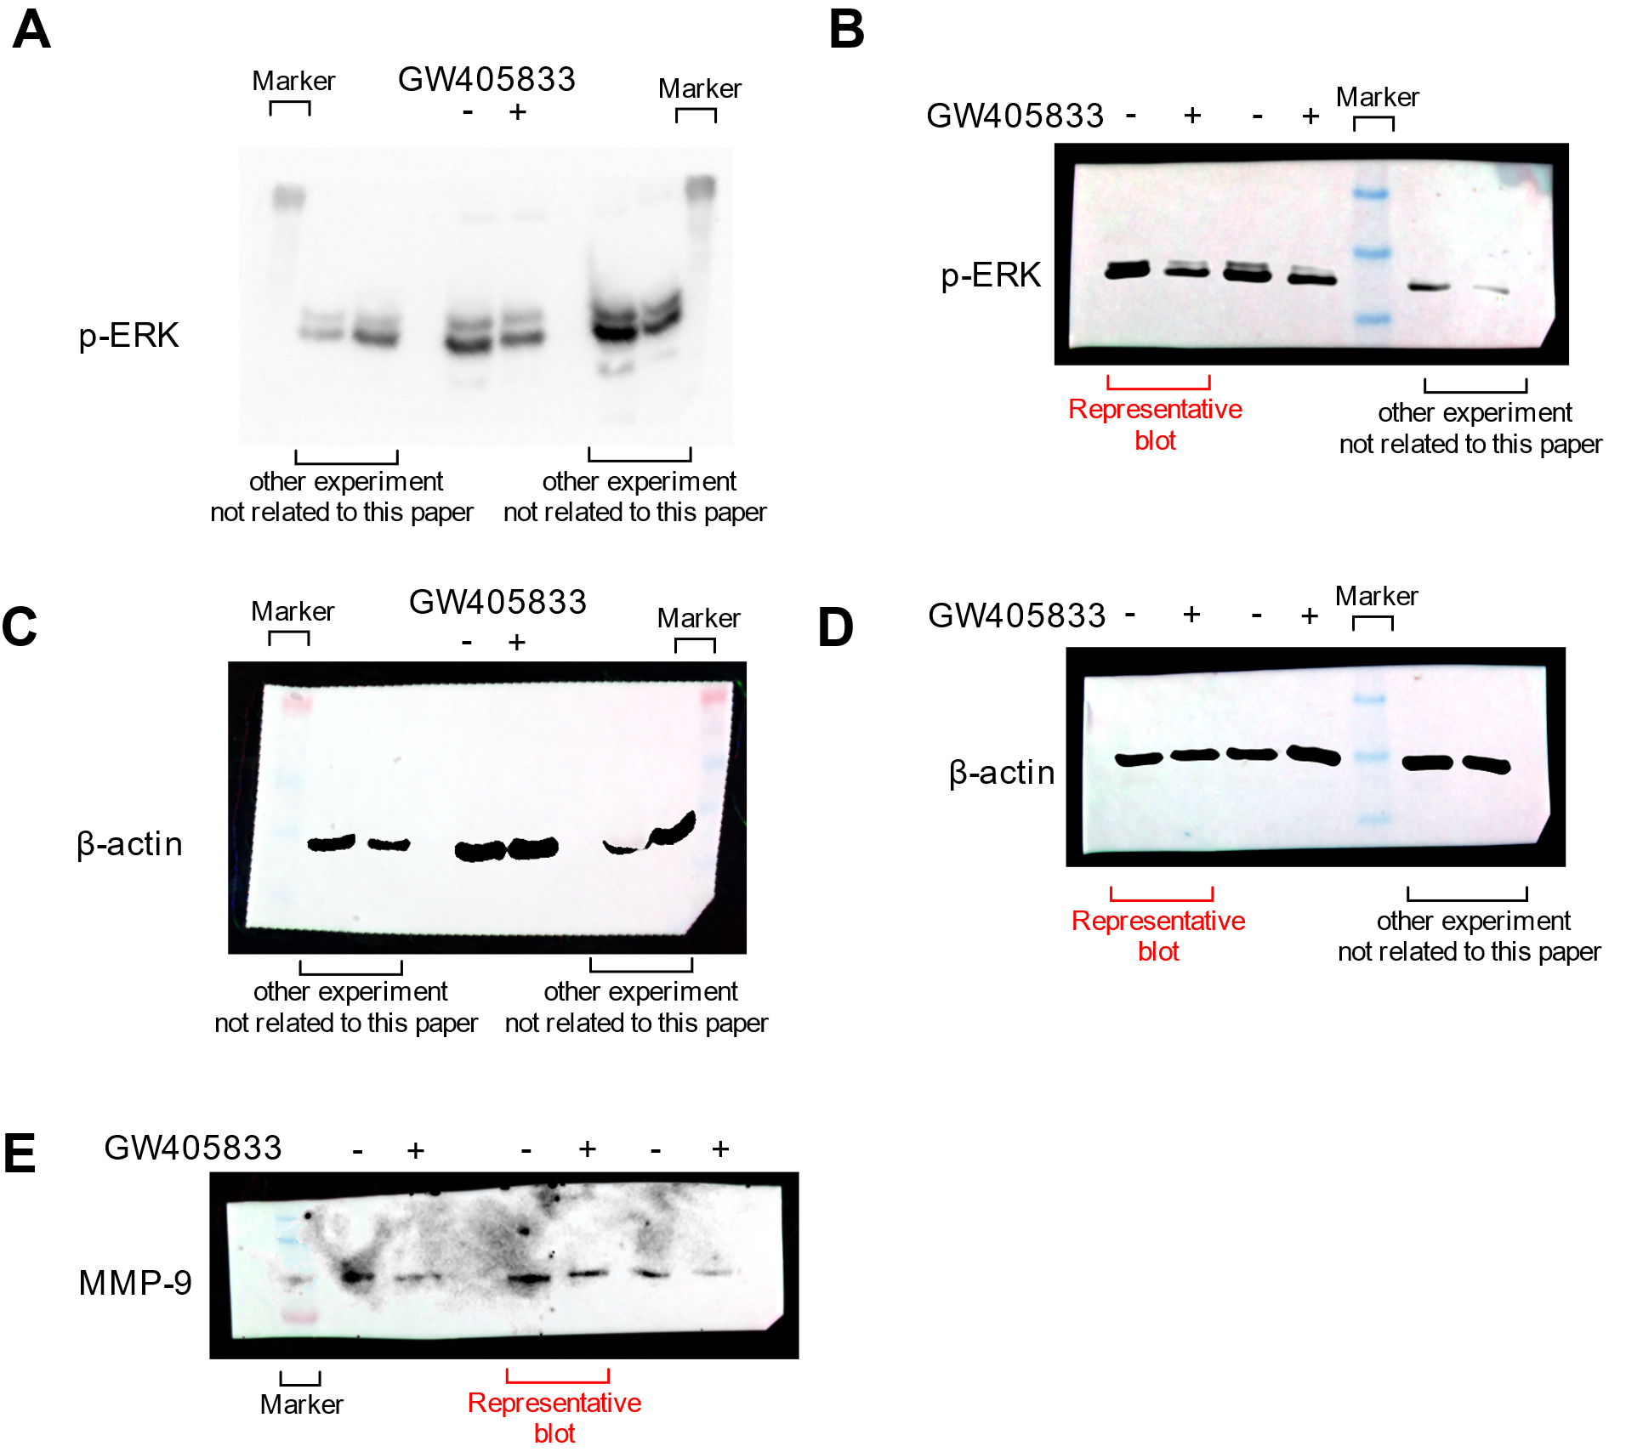
Supplementary Figure 1. Original Western blot for three biological replicates corresponding to Figure 3 and 6. (A) Whole blot representing p-ERK (44 and 42 kDa) from biological replicate 1 after membrane cutting. (B) Whole blot representing p-ERK (44 and 42 kDa) from biological replicates 2 and 3 after membrane cutting. (C) Whole blot representing β-actin (42 kDa) from biological replicate 1 after stripping and reprobing membrane A. (D) Whole blot representing β-actin (42 kDa) from biological replicates 2 and 3 after stripping and reprobing membranes B and biological replicates 1 and 2 of membrane B. (E) Whole blot representing MMP-9 (92 kDa) of three biological replicates after membrane cutting, which were normalized to their own β-actin as shown in supplementary figure 2C.

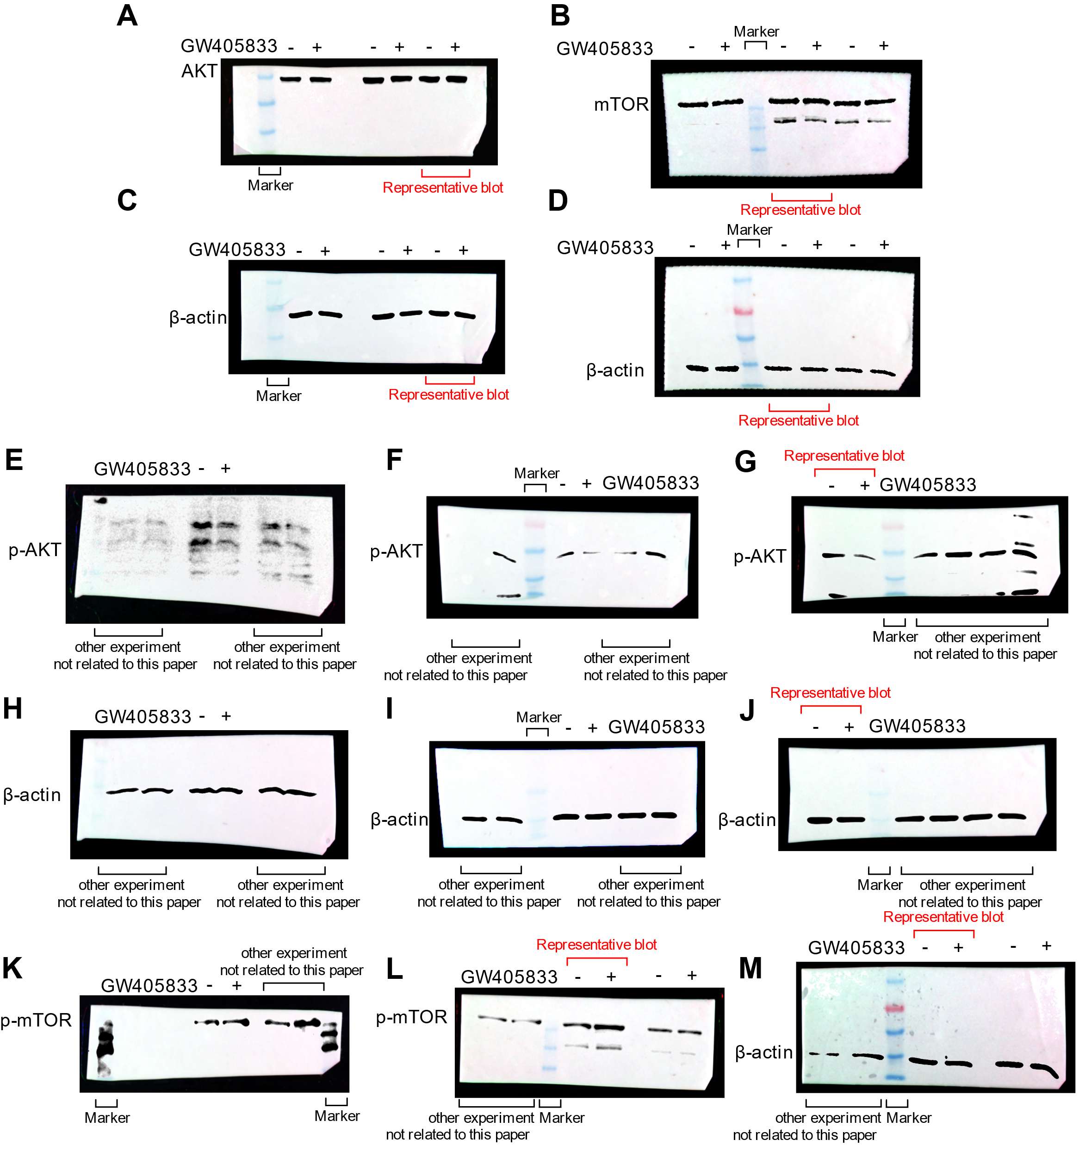
Supplementary Figure 2. Original Western blot for three biological replicates corresponding to Figure 3. (A) Whole blot representing AKT (60 kDa) from three biological replicates after membrane cutting. (B) Whole blot representing mTOR (289 kDa) from three biological replicates after membrane cutting. (C) Whole blot representing β-actin (42 kDa) from three biological replicates after stripping and reprobing membrane A. (D) Whole blot representing β-actin (42 kDa) from three biological replicates after membrane cutting, separate from membrane B. (E) Whole blot representing p-AKT (60 kDa) from biological replicate 1 after membrane cutting. (F) Whole blot representing p-AKT (60 kDa) from biological replicate 2 after membrane cutting. (G) Whole blot representing p-AKT (60 kDa) from biological replicate 3 after membrane cutting. (H) Whole blot representing β-actin (42 kDa) from biological replicate 1 after stripping and reprobing membrane E. (I) Whole blot representing β-actin (42 kDa) from biological replicate 2 after stripping and reprobing membrane F. (J) Whole blot representing β-actin (42 kDa) from biological replicate 3 after stripping and reprobing membrane G. (K) Whole blot representing p-mTOR (289 kDa) from biological replicate 1 after membrane cutting. (L) Whole blot representing p-mTOR (289 kDa) from biological replicates 2 and 3 after membrane cutting. (M) Whole blot representing β-actin (42 kDa) from biological replicates 2 and 3 after membrane cutting, separate from membrane L.

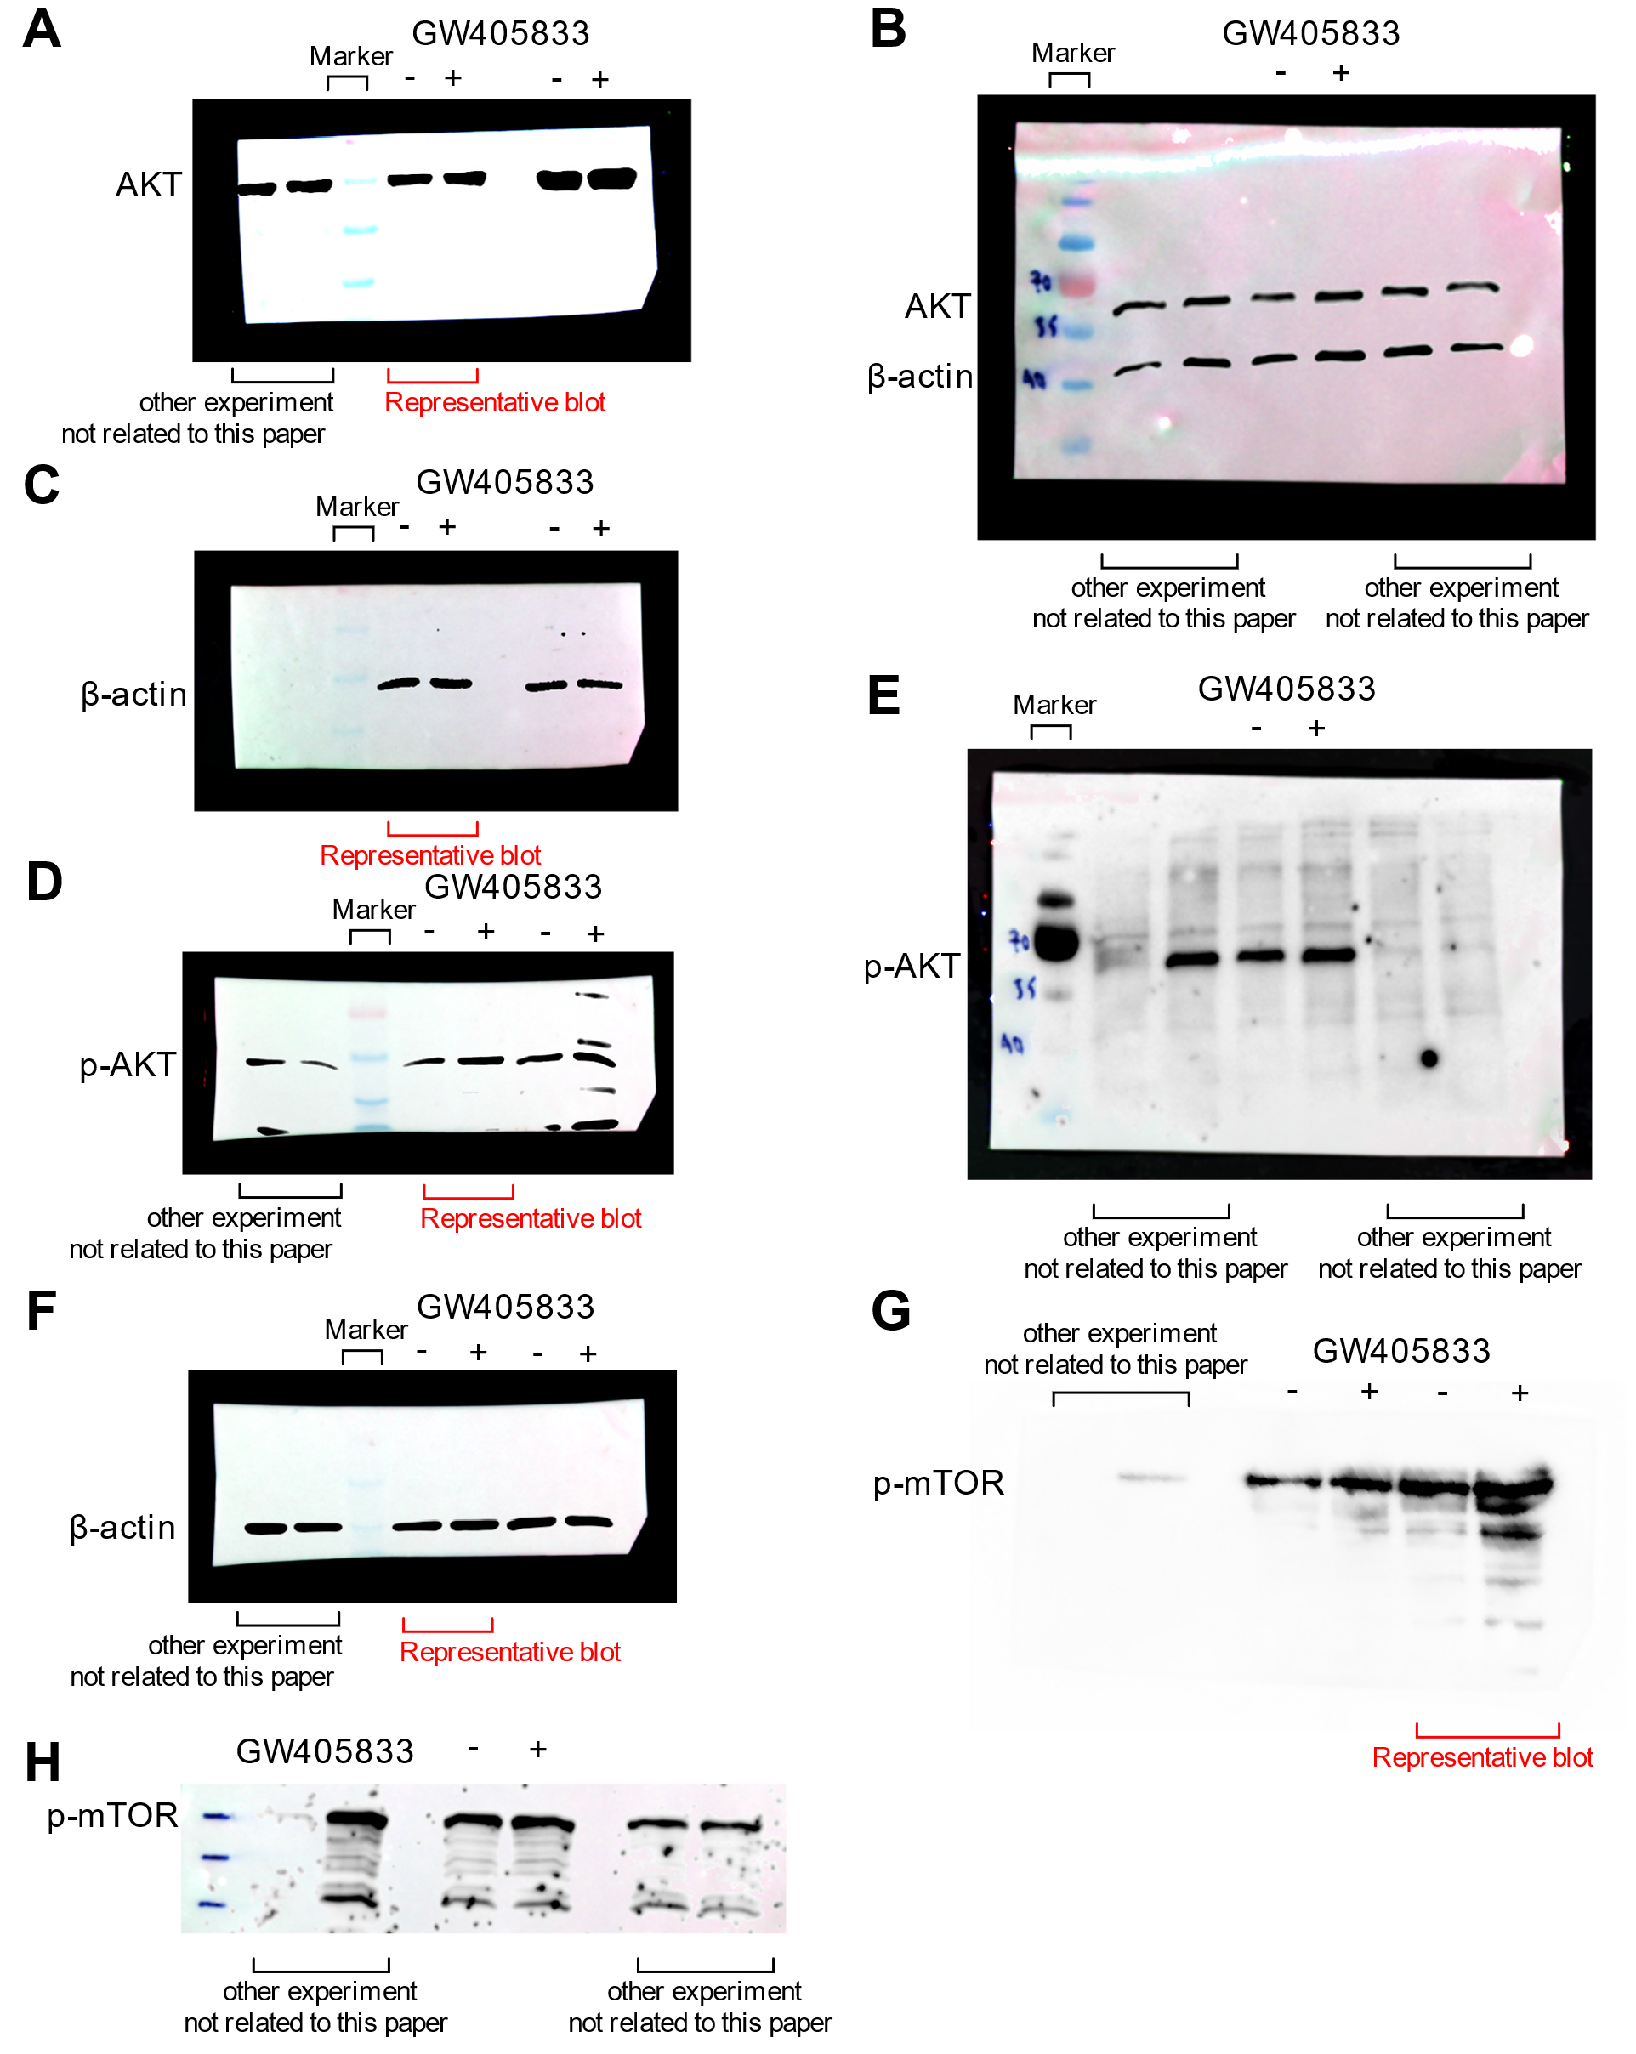
Supplementary Figure 3. Original Western blot for three biological replicates corresponding to Figure 4. (A) Whole blot representing AKT (60 kDa) from biological replicates 1 and 2 after membrane cutting. (B) Whole blot representing AKT (60 kDa) and β-actin (42 kDa) from biological replicate 3 after stripping and reprobing membrane E. (C) Whole blot representing β-actin (42 kDa) from biological replicates 1 and 2 after stripping and reprobing membrane A. (D) Whole blot representing p-AKT (60 kDa) from biological replicates 1 and 2 after membrane cutting. (E) Whole blot representing p-AKT (60 kDa) from biological replicate 3 after membrane cutting. (F) Whole blot representing β-actin (42 kDa) from biological replicates 1 and 2 after stripping and reprobing membrane D. (G) Whole blot representing p-mTOR (289 kDa) from biological replicate 1 and 2 after membrane cutting, separate from membrane F. (H) Whole blot representing p-mTOR (289 kDa) from biological replicates 3 after membrane cutting, separate from membrane B.
Table S1. The table shows the reference figures corresponding to the original blots of each protein, which were measured accordingly by ImageJ image analysis.
Cell lines | Proteins | Biological  replicates | Reference figure  (Target proteins) | Reference figure of normalized protein  (β-actin)
MDA-MB-231 | p-ERK | 1 | S1 fig. A | S1 fig. C
 |  | 2* | S1 fig. B | S1 fig. D
 |  | 3 | S1 fig. B | S1 fig. D
 | MMP-9 | 1 | S1 fig. E | S2 fig. C
 |  | 2* | S1 fig. E | S2 fig. C
 |  | 3 | S1 fig. E | S2 fig. C
 | AKT | 1 | S2 fig. A | S2 fig. C
 |  | 2 | S2 fig. A | S2 fig. C
 |  | 3* | S2 fig. A | S2 fig. C
 | mTOR | 1 | S2 fig. B | S2 fig. D
 |  | 2* | S2 fig. B | S2 fig. D
 |  | 3 | S2 fig. B | S2 fig. D
 | p-ATK | 1 | S2 fig. E | S2 fig. H
 |  | 2 | S2 fig. F | S2 fig. I
 |  | 3* | S2 fig. G | S2 fig. J
 | p-mTOR | 1 | S2 fig. K | S1 fig. C
 |  | 2* | S2 fig. L | S2 fig. M
 |  | 3 | S2 fig. L | S2 fig. M
UMR-106 | AKT | 1 | S3 fig. A | S3 fig. C
 |  | 2* | S3 fig. A | S3 fig. C
 |  | 3 | S3 fig. B | S3 fig. B
 | p-AKT | 1 | S3 fig. D | S3 fig. F
 |  | 2* | S3 fig. D | S3 fig. F
 |  | 3 | S3 fig. E | S3 fig. B
 | p-mTOR | 1* | S3 fig. H | S3 fig. F
 |  | 2 | S3 fig. H | S3 fig. F
 |  | 3 | S3 fig. G | S3 fig. B

“ * ” This symbol represents the representative blot that were shown in the figure.

