Supplemental Figure 1. Adjusted Associations Between Sociodemographic, Pain, Mental Health, and Behavioral Factors and Presence of Cannabis in the Urine Drug Screen for Veterans <55 years old. All factors listed were included in the model.
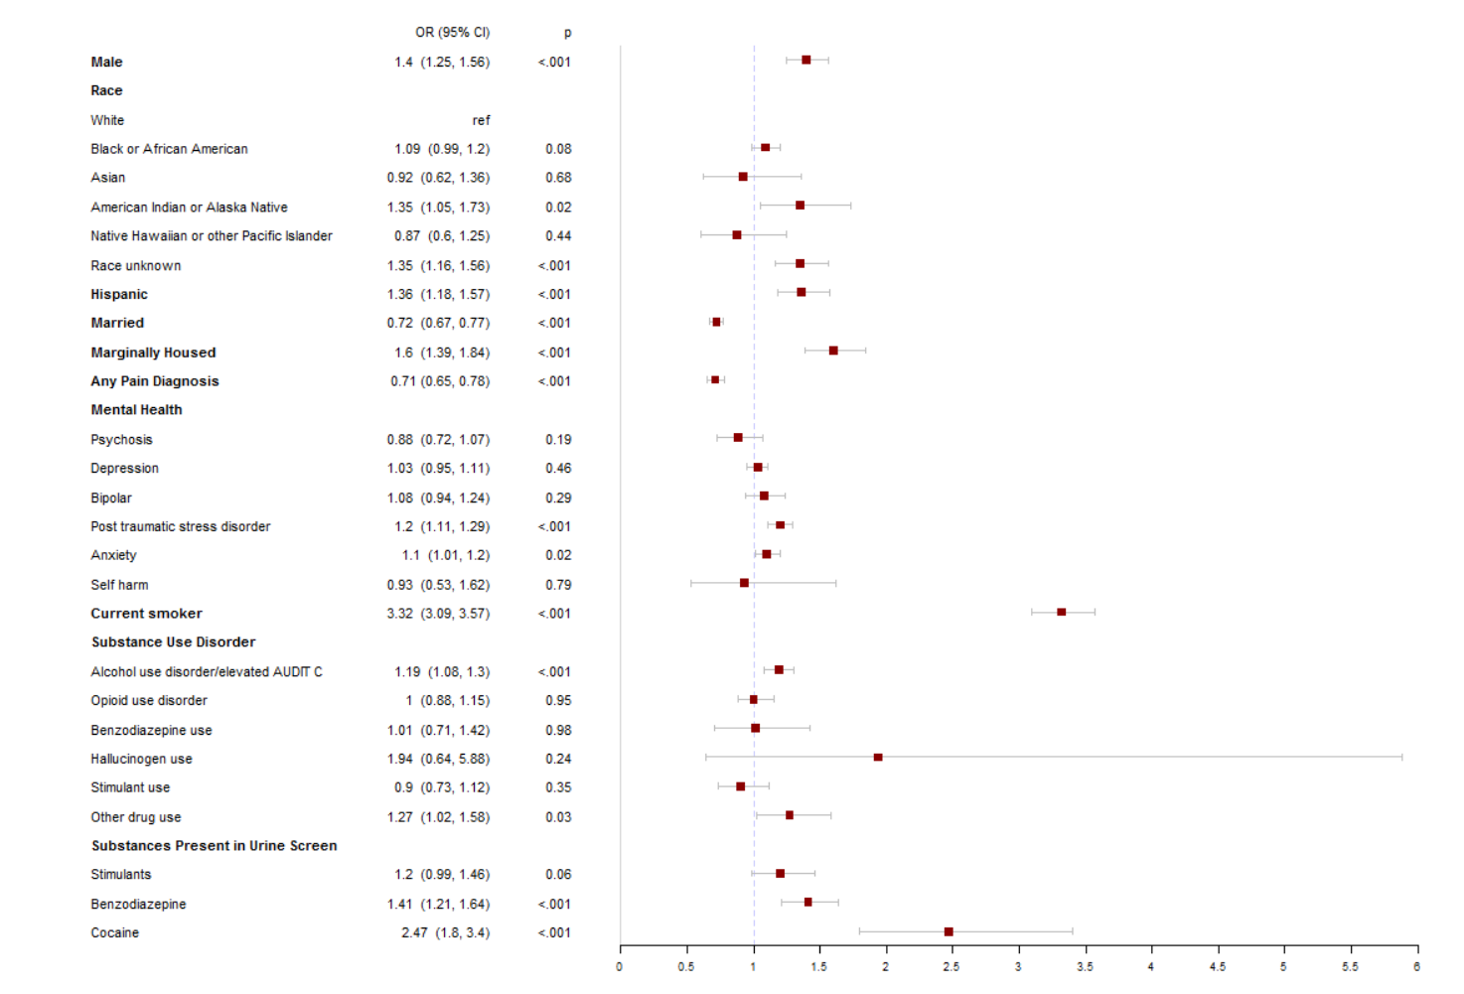

Supplemental Figure 2. Adjusted Associations Between Sociodemographic, Pain, Mental Health, and Behavioral Factors and Presence of Cannabis in the Urine Drug Screen for Veterans 55 years or older. All factors listed were included in the model.

