Supplementary Information

Table S1: Antibiotic from the Watch category of the WHO AWaRe classification (2023)
Concept ID | Ingredient Name | Vocabulary
19101402 | arbekacin | RxNorm
35198192 | aspoxicillin hydrate | RxNorm Extension
1734104 | azithromycin | RxNorm
19015123 | azlocillin | RxNorm
36849346 | BEKANAMYCIN | RxNorm Extension
35198093 | biapenem | RxNorm Extension
1740546 | carbenicillin | RxNorm
1768849 | cefaclor | RxNorm
19070174 | cefamandole | RxNorm
43009082 | cefbuperazone sodium | RxNorm Extension
43009044 | cefcapene pivoxil hydrochloride hydrate | RxNorm Extension
1796458 | cefdinir | RxNorm
1747005 | cefditoren | RxNorm
1748975 | cefepime | RxNorm
19028241 | cefetamet | RxNorm
1796435 | cefixime | RxNorm
40798704 | Cefmenoxime | RxNorm Extension
19072255 | cefmetazole | RxNorm
43008993 | cefminox sodium | RxNorm Extension
19028286 | cefodizime | RxNorm
19072857 | cefonicid | RxNorm
1773402 | cefoperazone | RxNorm
19028288 | ceforanide | RxNorm
36848891 | CEFOSELIS | RxNorm Extension
1774470 | cefotaxime | RxNorm
1774932 | cefotetan | RxNorm
19051271 | cefotiam | RxNorm
1775741 | cefoxitin | RxNorm
35197975 | cefozopran hydrochloride | RxNorm Extension
43009045 | cefpiramide sodium | RxNorm Extension
19001904 | cefpirome | RxNorm
1749008 | cefpodoxime | RxNorm
1738366 | cefprozil | RxNorm
19051345 | cefsulodin | RxNorm
1776684 | ceftazidime | RxNorm
35198137 | cefteram pivoxil | RxNorm Extension
1749083 | ceftibuten | RxNorm
1777254 | ceftizoxime | RxNorm
1777806 | ceftriaxone | RxNorm
1778162 | cefuroxime | RxNorm
19095043 | chlortetracycline | RxNorm
1797258 | cilastatin | RxNorm
997496 | cinoxacin | RxNorm
1797513 | ciprofloxacin | RxNorm
1750500 | clarithromycin | RxNorm
19047240 | clofoctol | RxNorm
19047265 | clomocycline | RxNorm
1592954 | delafloxacin | RxNorm
1714527 | demeclocycline | RxNorm
19023508 | dibekacin | RxNorm
1790024 | dirithromycin | RxNorm
1713905 | doripenem | RxNorm
1743222 | enoxacin | RxNorm
1717963 | ertapenem | RxNorm
1746940 | erythromycin | RxNorm
40239985 | fidaxomicin | RxNorm
19050750 | fleroxacin | RxNorm
43009087 | flomoxef sodium | RxNorm
19064329 | flumequine | RxNorm
36852196 | FLURITHROMYCIN | RxNorm Extension
956653 | fosfomycin | RxNorm
19010400 | fusidate | RxNorm
35197938 | garenoxacin mesilate hydrate | RxNorm Extension
1789276 | gatifloxacin | RxNorm
1716721 | gemifloxacin | RxNorm
1747032 | grepafloxacin | RxNorm
1778262 | imipenem | RxNorm
43009022 | isepamicin sulfate | RxNorm Extension
19123240 | josamycin | RxNorm
1784749 | kanamycin | RxNorm
35834909 | lascufloxacin hydrochloride | RxNorm Extension
1742253 | levofloxacin | RxNorm
1790692 | lincomycin | RxNorm
1707800 | lomefloxacin | RxNorm
1708100 | loracarbef | RxNorm
19092353 | lymecycline | RxNorm
1709170 | meropenem | RxNorm
19003644 | methacycline | RxNorm
19007701 | mezlocillin | RxNorm
19072089 | micronomicin | RxNorm
19072122 | midecamycin | RxNorm
1708880 | minocycline | RxNorm
19009138 | miocamycin | RxNorm
19126622 | moxalactam | RxNorm
1716903 | moxifloxacin | RxNorm
36878831 | nadifloxacin | RxNorm Extension
36860386 | NEMONOXACIN | RxNorm Extension
915981 | Neomycin | RxNorm
19017585 | netilmicin | RxNorm
1721543 | norfloxacin | RxNorm
923081 | Ofloxacin | RxNorm
19023254 | oleandomycin | RxNorm
19129642 | oxolinic acid | RxNorm
925952 | oxytetracycline | RxNorm
35197853 | panipenem | RxNorm Extension
35198003 | pazufloxacin mesilate | RxNorm Extension
19027679 | pefloxacin | RxNorm
19088795 | phenethicillin | RxNorm
19010564 | pipemidate | RxNorm
1746114 | piperacillin | RxNorm
40799027 | Piromidic Acid | RxNorm Extension
19125201 | pristinamycin | RxNorm
35197897 | prulifloxacin | RxNorm Extension
43009067 | ribostamycin sulfate | RxNorm Extension
1777417 | rifabutin | RxNorm
1763204 | rifampin | RxNorm
19035924 | rifamycin SV | RxNorm
1735947 | rifaximin | RxNorm
35198144 | rokitamycin | RxNorm Extension
19136024 | rolitetracycline | RxNorm
19036545 | rosoxacin | RxNorm
19063874 | roxithromycin | RxNorm
35884386 | Rufloxacin | RxNorm Extension
35200881 | sarecycline | RxNorm
19136044 | sisomicin | RxNorm
35198165 | sitafloxacin hydrate | RxNorm Extension
36855357 | SOLITHROMYCIN | RxNorm Extension
1733765 | sparfloxacin | RxNorm
19070251 | spiramycin | RxNorm
1836191 | streptomycin | RxNorm
19136210 | streptozocin | RxNorm
19000817 | sulbenicillin | RxNorm
1741122 | tazobactam | RxNorm
35198145 | tebipenem pivoxil | RxNorm Extension
19078399 | teicoplanin | RxNorm
1702911 | telithromycin | RxNorm
19041153 | temafloxacin | RxNorm
19100438 | temocillin | RxNorm
1702364 | ticarcillin | RxNorm
902722 | Tobramycin | RxNorm
36857682 | TOSUFLOXACIN | RxNorm Extension
19006043 | troleandomycin | RxNorm
1712549 | trovafloxacin | RxNorm
1707687 | vancomycin | RxNorm

Table S2: Antibiotic from the Access category of the WHO AWaRe classification (2023)
Concept ID | Ingredient Name | Vocabulary
19123877 | amdinocillin | RxNorm
19088223 | amdinocillin pivoxil | RxNorm
1790868 | amikacin | RxNorm
1713332 | amoxicillin | RxNorm
1717327 | ampicillin | RxNorm
19018516 | azidocillin | RxNorm
1734205 | bacampicillin | RxNorm
19018742 | brodimoprim | RxNorm
40798709 | cefacetrile | RxNorm Extension
1769535 | cefadroxil | RxNorm
19070680 | cefatrizine | RxNorm
40798700 | cefazedone | RxNorm Extension
1771162 | cefazolin | RxNorm
43009083 | cefroxadine | RxNorm Extension
43008994 | ceftezole sodium | RxNorm Extension
1786621 | cephalexin | RxNorm
19052683 | cephaloridine | RxNorm
19086759 | cephalothin | RxNorm
19086790 | cephapirin | RxNorm
1786842 | cephradine | RxNorm
990069 | chloramphenicol | RxNorm
997881 | clindamycin | RxNorm
36863501 | clometocillin | RxNorm Extension
1800835 | cloxacillin | RxNorm
1724666 | dicloxacillin | RxNorm
1738521 | doxycycline | RxNorm
36851057 | epicillin | RxNorm Extension
19054936 | floxacillin | RxNorm
45892419 | gentamicin | RxNorm
19069006 | hetacillin | RxNorm
19072054 | methampicillin | RxNorm
1361385 | methicillin | RxNorm
1707164 | metronidazole | RxNorm
1713930 | nafcillin | RxNorm
40798981 | nifurtoinol | RxNorm Extension
920293 | nitrofurantoin | RxNorm
19024197 | ornidazole | RxNorm
1724703 | oxacillin | RxNorm
36857825 | penamecillin | RxNorm Extension
1728416 | penicillin G | RxNorm
1729720 | penicillin V | RxNorm
19047071 | pivampicillin | RxNorm
19096054 | propicillin | RxNorm
19037983 | secnidazole | RxNorm
1701651 | spectinomycin | RxNorm
1836241 | sulbactam | RxNorm
1836391 | sulfadiazine | RxNorm
19000818 | sulfadimethoxine | RxNorm
19136423 | sulfalene | RxNorm
36856579 | sulfamazone | RxNorm Extension
19136426 | sulfamerazine | RxNorm
19136429 | sulfamethazine | RxNorm
1036425 | sulfamethizole | RxNorm
1836430 | sulfamethoxazole | RxNorm
19000820 | sulfamethoxypyridazine | RxNorm
36854873 | sulfametomidine | RxNorm Extension
40799118 | sulfametoxydiazine | RxNorm Extension
19040624 | sulfametrole | RxNorm
19136481 | sulfamoxole | RxNorm
1036475 | sulfanilamide | RxNorm
40799120 | sulfaperin | RxNorm Extension
40799121 | sulfaphenazole | RxNorm Extension
19136493 | sulfapyridine | RxNorm
1036487 | sulfathiazole | RxNorm
19000821 | sulfisomidine | RxNorm
1836503 | sulfisoxazole | RxNorm
43009009 | sultamicillin | RxNorm Extension
19002077 | talampicillin | RxNorm
1836948 | tetracycline | RxNorm
19137362 | thiamphenicol | RxNorm
1702559 | tinidazole | RxNorm
1705674 | trimethoprim | RxNorm

Table S3: Conditions of interest and their ancestor concepts.
Condition of Interest | Ancestor Concept IDs | Ancestor Concept Names | Notes
Cardiac infection | 314383 | Myocarditis
Cardiac infection | 4138837 | Pericarditis
Cardiac infection | 441589 | Endocarditis
Care-related infection | 4193161 | Disorder following clinical procedure
Care-related infection | 318445 | Post cardiac operation functional disturbance
Care-related infection | 4123283 | Disorder of stoma
Care-related infection | 43021974 | Complication associated with device
Care-related infection | 4201387 | Tracheostomy present
Care-related infection | 442019 | Complication of procedure
Ear infection | 4044878 | Infection of ear
Ear infection | 380731 | Otitis externa
Exacerbation of COPD | 255573 | Chronic obstructive pulmonary disease
Exacerbation of COPD | 257004 | Acute exacerbation of chronic obstructive pulmonary disease
Exacerbation of cystic fibrosis | 441267 | Cystic fibrosis
Exacerbation of cystic fibrosis | 44808532 | Exacerbation of cystic fibrosis
Eye infection | 4134613 | Eye infection
Eye infection | 37160823 | Infection of eyelid caused by Mycobacterium leprae
GI infection | 37396146 | Gastrointestinal infection
GI infection | 44783254 | Infection of masticator space
GI infection | 198678 | Intestinal infectious disease
GI infection | 198337 | Infectious diarrheal disease
Infection caused by antimicrobial resistant bacteria | 4249827 | Infection caused by antimicrobial resistant bacteria
Infection caused by antimicrobial resistant bacteria | 37017452 | Drug resistance to antibacterial agent
Infection caused by antimicrobial resistant bacteria | 44806682 | Infection resistant to multiple antibiotics
Lower respiratory tract infection | 4175297 | Lower respiratory tract infection
Lower respiratory tract infection | 4133224 | Lobar pneumonia
Lower respiratory tract infection | 618954 | Exacerbation of bronchiectasis caused by infection
Neutropenia and agranulocytosis | 320073 | Neutropenia
Neutropenia and agranulocytosis | 440689 | Agranulocytosis
Other infection | 432545 | Bacterial infectious disease | Excluding concepts found in other conditions of interest
Sepsis and septic shock | 132797 | Sepsis
Sepsis and septic shock | 196236 | Septic shock
Signs and symptoms | 201965 | Shock
Signs and symptoms | 437663 | Fever
Signs and symptoms | 254761 | Cough
Signs and symptoms | 4305080 | Abnormal breathing
Signs and symptoms | 31967 | Nausea
Signs and symptoms | 441408 | Vomiting
Signs and symptoms | 196523 | Diarrhoea
Signs and symptoms | 254061 | Pleural effusion
Signs and symptoms | 197672 | Urinary incontinence
Signs and symptoms | 4103189 | Finding of heart rate | Excluding normal heart rate findings
Signs and symptoms | 373995 | Delirium
Signs and symptoms | 433595 | Oedema
Signs and symptoms | 321689 | Apnoea
Signs and symptoms | 253321 | Stridor
Signs and symptoms | 200528 | Ascites
Signs and symptoms | 435517 | Acidosis
Signs and symptoms | 4128820 | Feeding finding
Signs and symptoms | 435515 | Hypo-osmolality and or hyponatremia
Signs and symptoms | 4214962 | Blood pressure finding | Excluding normal blood pressure findings
Signs and symptoms | 44784217 | Cardiac arrhythmia
Skin infection | 201093 | Infection of skin and/or subcutaneous tissue
Skin infection | 141095 | Acne
Upper respiratory tract infection | 4181583 | Upper respiratory infection
Upper respiratory tract infection | 4234533 | Tonsillitis
Urinary tract infection | 81902 | Urinary tract infectious disease

Table S4: Patient characteristics for the top five antibiotics in Barts
Variable name | Variable level | Estimate name | Piperacillin / Tazobactam | Clarithromycin | Ciprofloxacin | Ceftriaxone | Meropenem
Number  records |  | N | 19,976 | 11,794 | 11,359 | 10,841 | 7,417
Number  subjects |  | N | 16,392 | 10,562 | 9,761 | 10,250 | 6,276
Cohort start  date |  | Range | 2022-01-01  to  2025-05-04 | 2022-01-01  to  2025-05-03 | 2022-01-01  to  2025-05-04 | 2022-01-01  to  2025-05-04 | 2022-01-01  to  2025-05-03
Age |  | Median  [Q25 –  Q75] | 65 [50 - 77] | 65 [44 - 79] | 62 [43 - 76] | 38 [19 - 60] | 61 [44 - 74]
Age |  | Range | 0 to 113 | 0 to 114 | 0 to 113 | 0 to 114 | 0 to 102
Sex | Female | N (%) | 8,554  (42.82%) | 5,981  (50.71%) | 5,644  (49.69%) | 4,993  (46.06%) | 3,212  (43.31%)
Sex | Male | N (%) | 11,422  (57.18%) | 5,813  (49.29%) | 5,715  (50.31%) | 5,848  (53.94%) | 4,205  (56.69%)

Table S5: Patient characteristics for the top five antibiotics in GOSH
Variable name | Variable level | Estimate name | Piperacillin / Tazobactam | Teicoplanin | Vancomycin | Ciprofloxacin | Meropenem
Number  records |  | N | 4,227 | 2,025 | 1,757 | 1,571 | 1,527
Number  subjects |  | N | 3,143 | 1,635 | 1,367 | 1,204 | 1,173
Cohort  start date |  | Range | 2022-01-01  to  2025-02-17 | 2022-01-04  to  2025-02-17 | 2022-01-02  to  2025-02-16 | 2022-01-02  to  2025-02-17 | 2022-01-03  to  2025-02-17
Age |  | Median  [Q25 –  Q75] | 2 [0 - 8] | 4 [0 - 11] | 1 [0 - 7] | 4 [1 - 10] | 2 [0 - 7]
Age |  | Range | 0 to 17 | 0 to 17 | 0 to 17 | 0 to 17 | 0 to 17
Sex | Female | N (%) | 1,772  (41.92%) | 879  (43.41%) | 757  (43.08%) | 692  (44.05%) | 644  (42.17%)
Sex | Male | N (%) | 2,455  (58.08%) | 1,146  (56.59%) | 1,000  (56.92%) | 879  (55.95%) | 883  (57.83%)

Table S6: Patient characteristics for the top five antibiotics in Lancashire
Variable name | Variable level | Estimate name | Cefuroxime | Clarithromycin | Piperacillin / Tazobactam | Ciprofloxacin | Levofloxacin
Number  records |  | N | 10,801 | 9,870 | 6,642 | 2,400 | 2,314
Number  subjects |  | N | 9,634 | 8,281 | 5,857 | 2,177 | 1,984
Cohort  start date |  | Range | 2022-01-01  to  2024-12-30 | 2022-01-01  to  2025-01-01 | 2022-01-01  to  2024-12-31 | 2022-01-01  to  2024-12-29 | 2022-01-02  to  2024-12-27
Age |  | Median  [Q25 –  Q75] | 69 [50 - 80] | 75 [62 - 84] | 72 [60 - 81] | 68 [55 - 78] | 76 [62 - 84]
Age |  | Range | 0 to 104 | 0 to 104 | 0 to 104 | 1 to 102 | 7 to 101
Sex | Female | N (%) | 5,475  (50.69%) | 4,655  (47.16%) | 2,843  (42.80%) | 1,184  (49.33%) | 1,222  (52.81%)
Sex | Male | N (%) | 5,326  (49.31%) | 5,215  (52.84%) | 3,799  (57.20%) | 1,216  (50.67%) | 1,092  (47.19%)

Table S7: Patient characteristics for the top five antibiotics in Leeds
Variable name | Variable level | Estimate name | Piperacillin / Tazobactam | Clarithromycin | Cefuroxime | Ciprofloxacin | Teicoplanin
Number  records |  | N | 26,365 | 11,567 | 11,270 | 10,043 | 9,608
Number  subjects |  | N | 20,460 | 10,318 | 10,412 | 8,661 | 8,401
Cohort  start date |  | Range | 2022-01-01  to  2025-03-18 | 2022-01-01  to  2025-03-19 | 2022-01-01  to  2025-03-19 | 2022-01-01  to  2025-03-19 | 2022-01-01  to  2025-03-18
Age |  | Median  [Q25 –  Q75] | 72 [57 - 81] | 72 [54 - 82] | 40 [28 - 60] | 64 [44 - 77] | 61 [42 - 75]
Age |  | Range | 0 to 108 | 0 to 108 | 0 to 100 | 0 to 102 | 0 to 105
Sex | Female | N (%) | 11,562  (43.85%) | 5,522  (47.74%) | 7,178  (63.69%) | 4,845  (48.24%) | 4,569  (47.55%)
Sex | Male | N (%) | 14,803  (56.15%) | 6,045  (52.26%) | 4,092  (36.31%) | 5,198  (51.76%) | 5,039  (52.45%)

Table S8: Patient characteristics for the top five antibiotics in UCLH
Variable name | Variable level | Estimate name | Cefuroxime | Ciprofloxacin | Piperacillin / Tazobactam | Clarithromycin | Teicoplanin
Number  records |  | N | 44,228 | 19,251 | 10,450 | 9,842 | 5,547
Number  subjects |  | N | 39,445 | 16,506 | 7,995 | 8,759 | 4,887
Cohort  start date |  | Range | 2022-01-01  to  2025-05-12 | 2022-01-01  to  2025-05-12 | 2022-01-01  to  2025-05-09 | 2022-01-01  to  2025-05-12 | 2022-01-01  to  2025-05-09
Age |  | Median  [Q25 –  Q75] | 50 [35 - 67] | 52 [32 - 67] | 59 [41 - 71] | 57 [36 - 71] | 57 [37 - 70]
Age |  | Range | 0 to 107 | 0 to 101 | 0 to 104 | 0 to 105 | 0 to 104
Sex | Female | N (%) | 27,009  (61.07%) | 9,688  (50.32%) | 4,541  (43.45%) | 5,175  (52.58%) | 2,995  (53.99%)
Sex | Male | N (%) | 17,219  (38.93%) | 9,563  (49.68%) | 5,909  (56.55%) | 4,667  (47.42%) | 2,552  (46.01%)

Variable name | Variable level | Estimate name | Neomycin | Fusidate | Ciprofloxacin | Erythromycin | Clarithromycin
Number  records |  | N | 4,477,598 | 2,029,304 | 1,561,067 | 1,295,225 | 769,070
Number  subjects |  | N | 2,627,866 | 1,446,531 | 1,019,792 | 722,514 | 537,083
Cohort  start date |  | Range | 2012-01-01  to  2024-12-18 | 2012-01-01  to  2024-12-17 | 2012-01-01  to  2024-12-18 | 2012-01-01  to  2024-12-18 | 2012-01-01  to  2024-12-17
Age |  | Median  [Q25 –  Q75] | 49 [28 - 66] | 44 [11 - 68] | 59 [41 - 74] | 16 [6 - 31] | 6 [3 - 13]
Age |  | Range | 0 to 111 | 0 to 111 | 0 to 109 | 0 to 111 | 0 to 112
Sex | Female | N (%) | 2,535,489 (56.63%) | 1,114,817  (54.94%) | 769,680  (49.30%) | 805,653  (62.20%) | 399,320  (51.92%)
Sex | Male | N (%) | 1,942,109 (43.37%) | 914,487 (45.06%) | 791,387  (50.70%) | 489,572  (37.80%) | 369,750  (48.08%)

Table S9: Patient characteristics for the top five antibiotics in CPRD Aurum

Table S10: Patient characteristics for the top five antibiotics in DataLoch
Variable name | Variable level | Estimate name | Clarithromycin | Fusidate | Neomycin | Oxytetracycline | Erythromycin
Number  records |  | N | 394,394 | 390,456 | 353,001 | 178,584 | 136,037
Number  subjects |  | N | 209,695 | 237,399 | 173,806 | 65,386 | 60,640
Cohort  start date |  | Range | 2012-01-31  to  2025-03-31 | 2012-01-31  to  2025-03-31 | 2012-01-31 to  2025-03-31 | 2012-01-31  to  2025-03-31 | 2012-01-31  to  2025-03-31
Age |  | Median  [Q25 –  Q75] | 50 [31 - 66] | 38 [14 - 62] | 51 [31 - 66] | 50 [31 - 65] | 30 [18 - 48]
Age |  | Range | 0 to 108 | 0 to 107 | 0 to 105 | 0 to 105 | 0 to 107
Sex | Female | N (%) | 244,700  (62.04%) | 215,991  (55.32%) | 206,292  (58.44%) | 92,335  (51.70%) | 87,630  (64.42%)
Sex | Male | N (%) | 149,694  (37.96%) | 174,465  (44.68%) | 146,709  (41.56%) | 86,249  (48.30%) | 48,407  (35.58%)

Figure S1: Quarterly crude incidence rates of the top five Watch antibiotic used in Barts, stratified by sex.
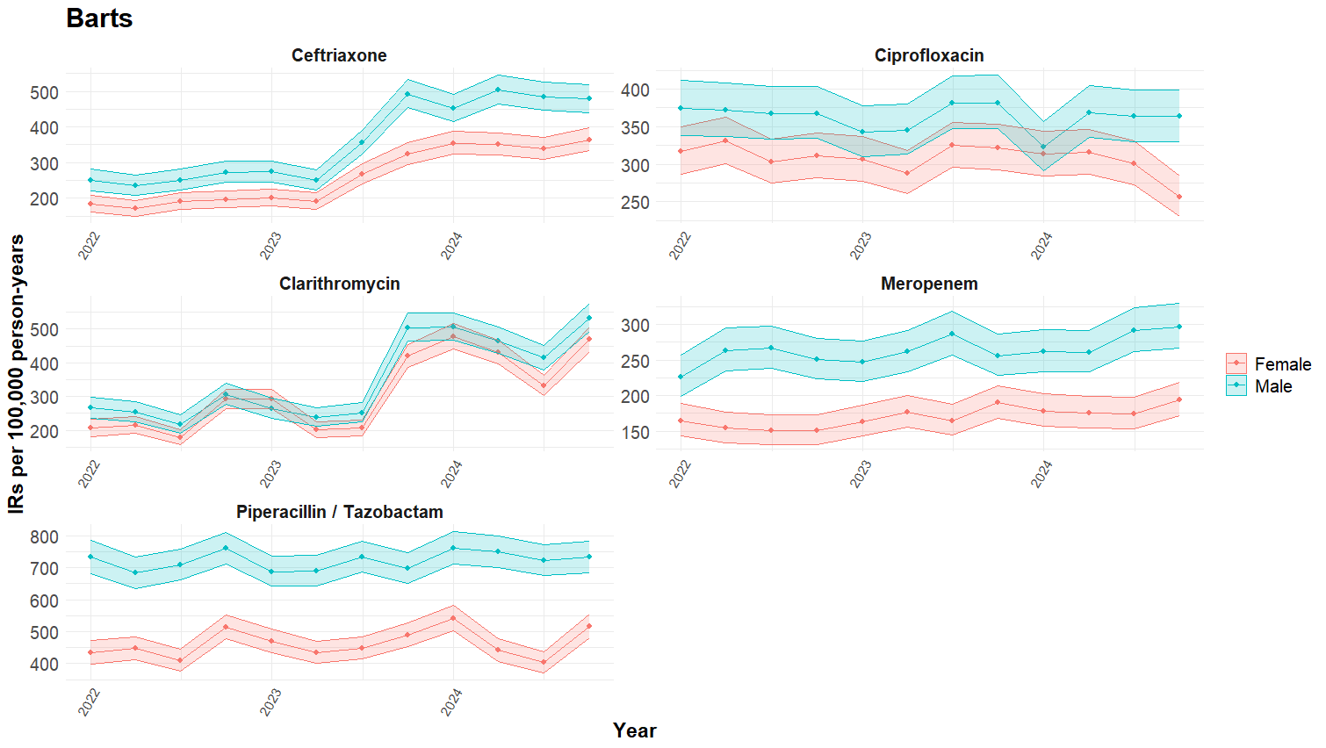

Figure S2: Quarterly crude incidence rates of the top five Watch antibiotic used in GOSH, stratified by sex.
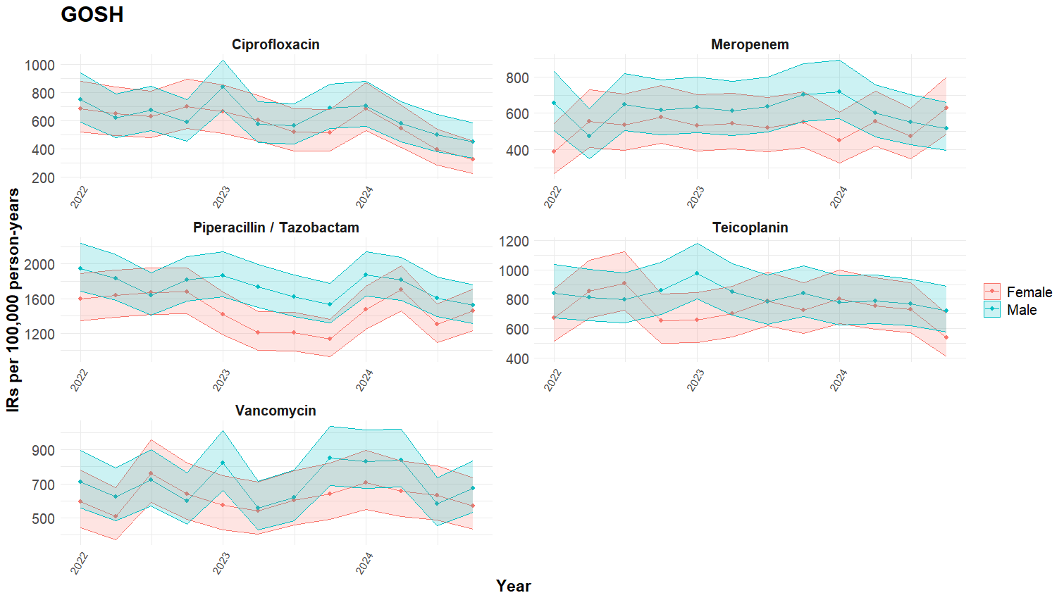

Figure S3: Quarterly crude incidence rates of the top five Watch antibiotic used in Lancashire, stratified by sex.
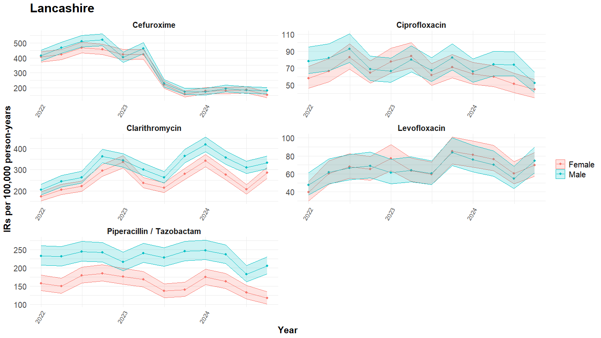

Figure S4: Quarterly crude incidence rates of the top five Watch antibiotic used in Leeds, stratified by sex.
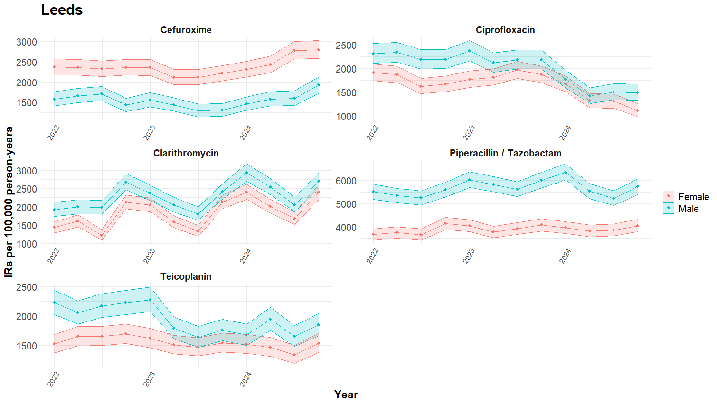

Figure S5: Quarterly crude incidence rates of the top five Watch antibiotic used in UCLH, stratified by sex.
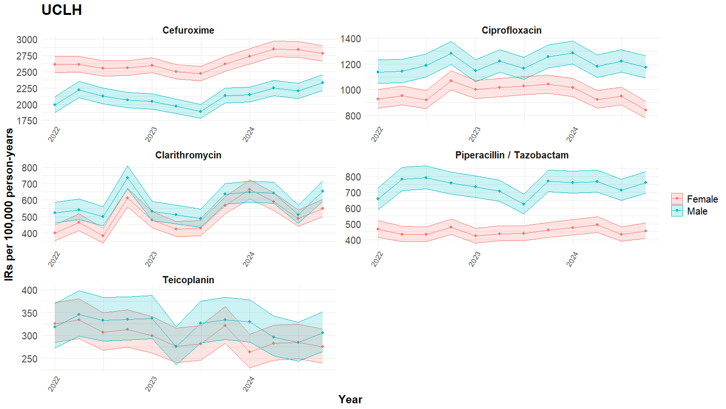

Figure S6: Quarterly crude incidence rates of the top five Watch antibiotic used in CPRD Aurum, stratified by sex.
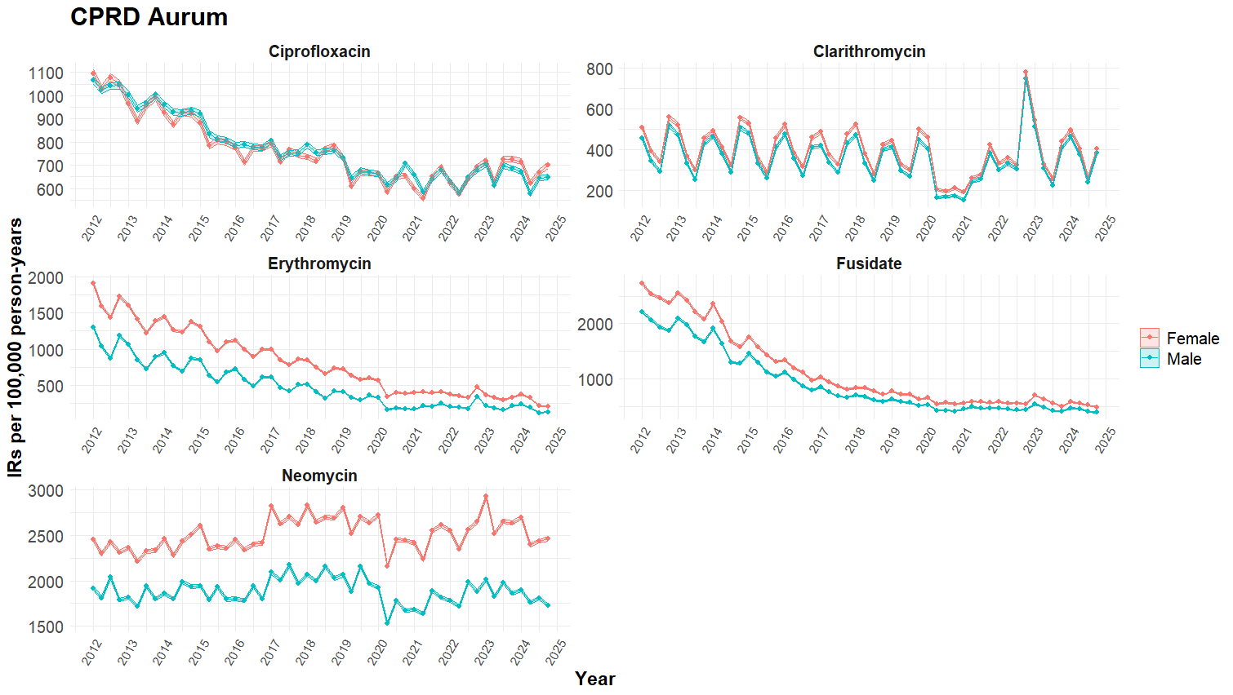

Figure S7: Quarterly crude incidence rates of the top five Watch antibiotic used in DataLoch, stratified by sex.
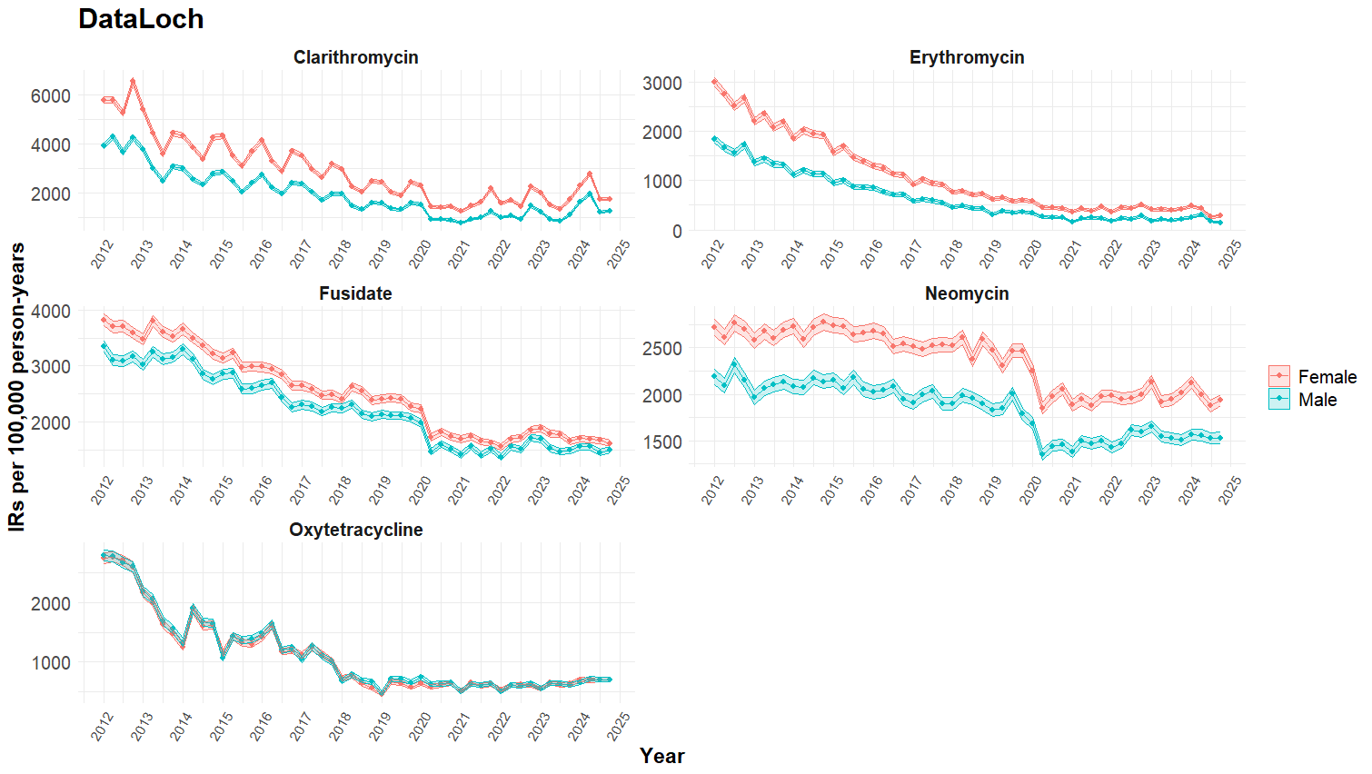

Figure S8: Quarterly crude incidence rates of the top five Watch antibiotic used in Barts, stratified by broad age group.
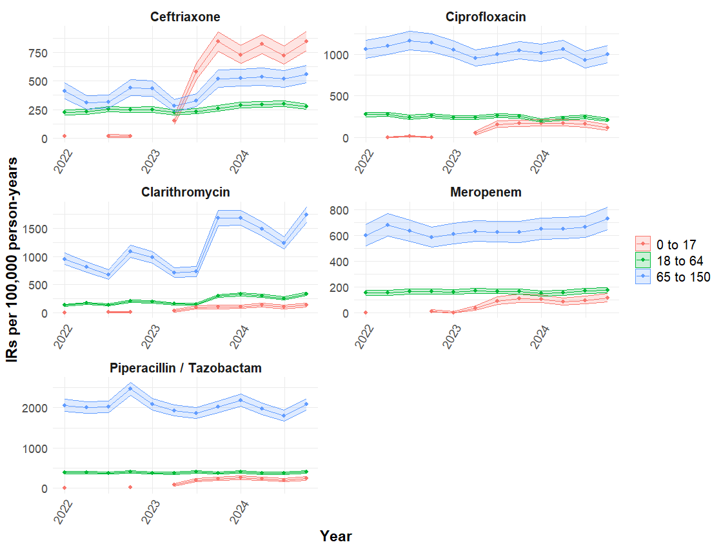

Figure S9: Quarterly crude incidence rates of the top five Watch antibiotic used in Lancashire, stratified by broad age group.
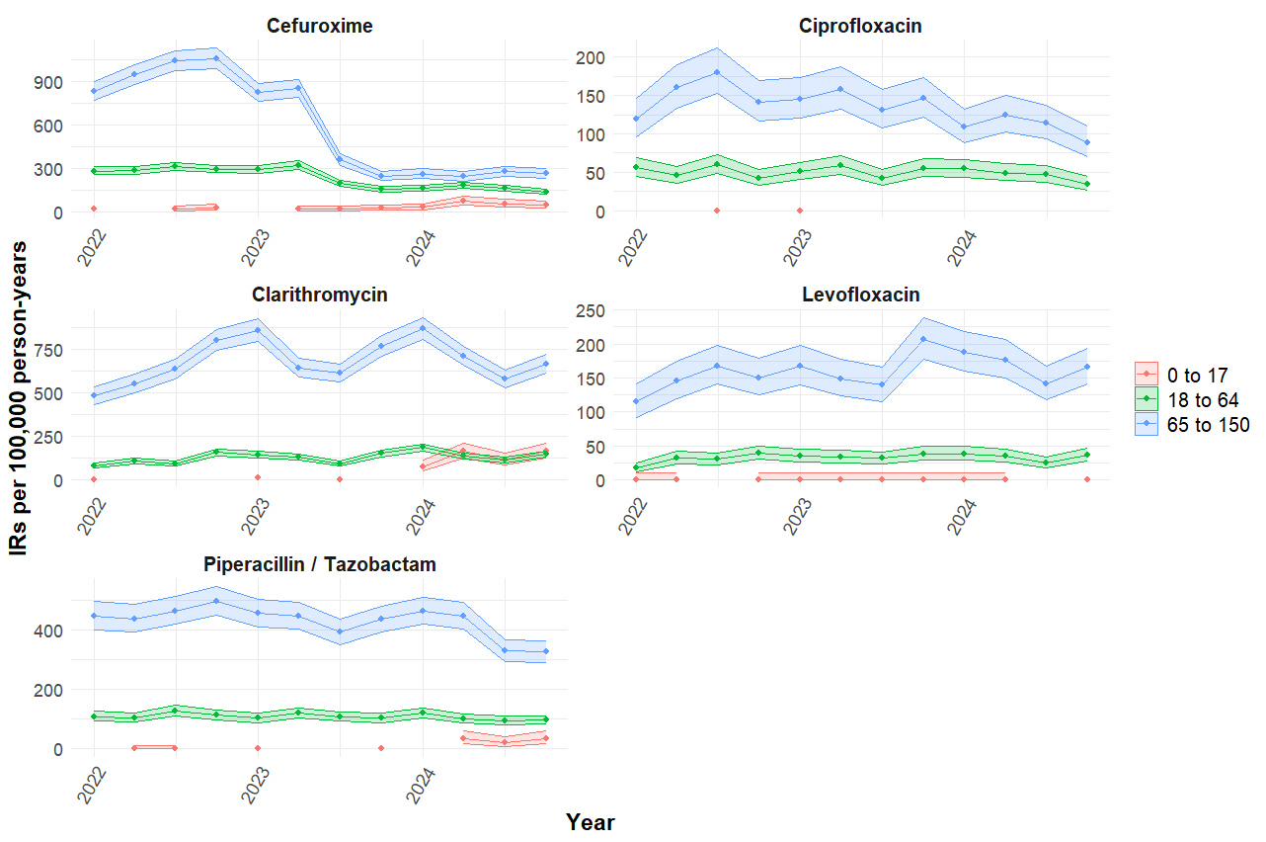

Figure S10: Quarterly crude incidence rates of the top five Watch antibiotic used in Leeds, stratified by broad age group.
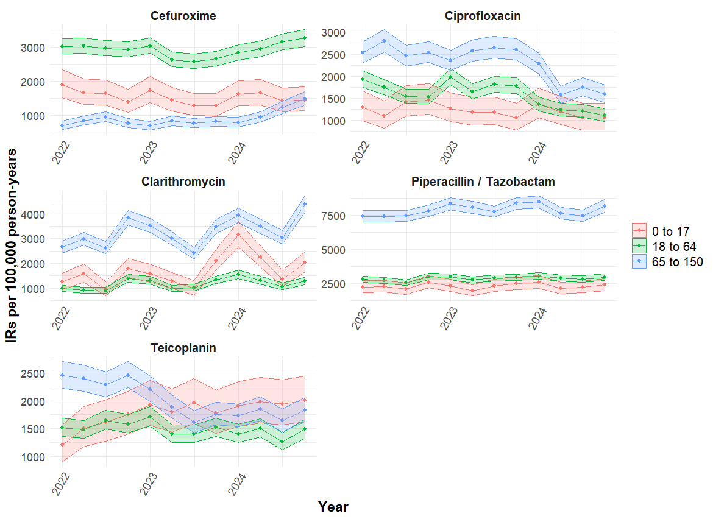

Figure S11: Quarterly crude incidence rates of the top five Watch antibiotic used in UCLH, stratified by broad age group.
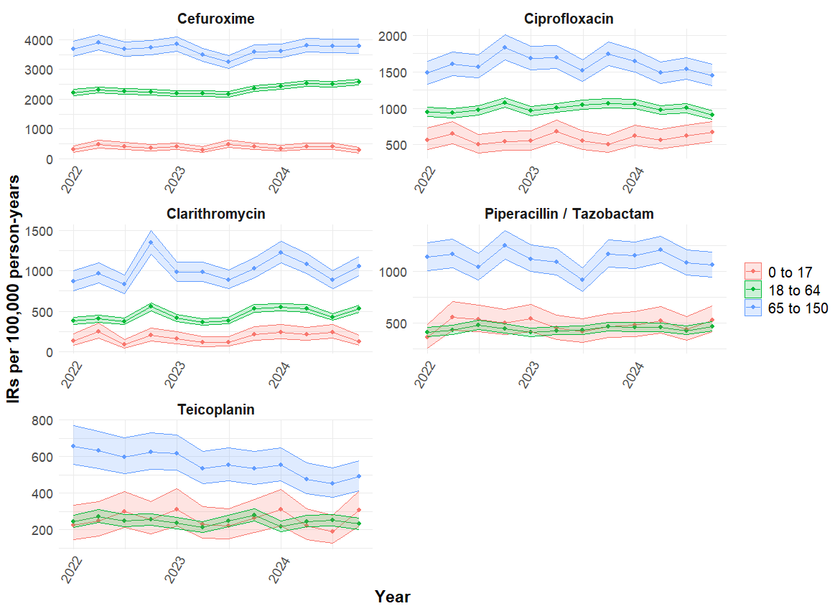

Figure S12: Quarterly crude incidence rates of the top five Watch antibiotic used in CPRD Aurum, stratified by broad age group.
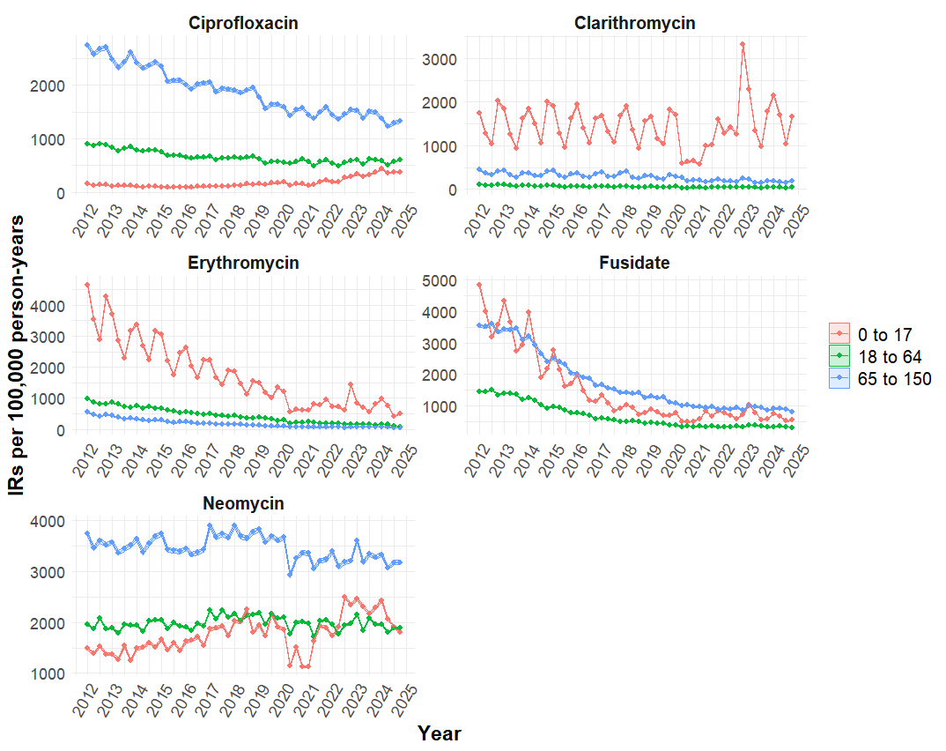

Figure S13: Quarterly crude incidence rates of the top five Watch antibiotic used in DataLoch, stratified by broad age group.
