Supplementary Materials:
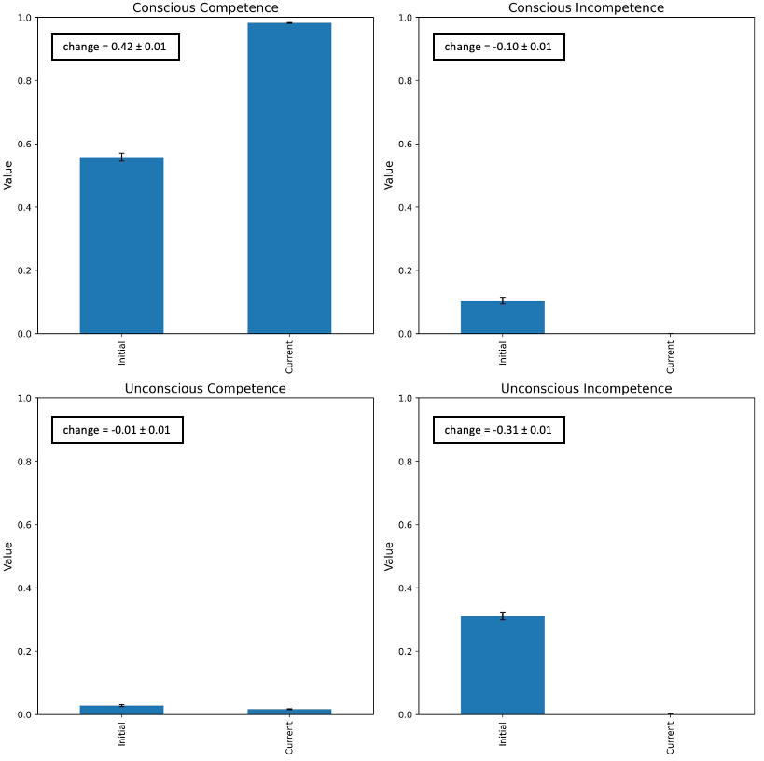
Figure A. aESNC Efficacy.

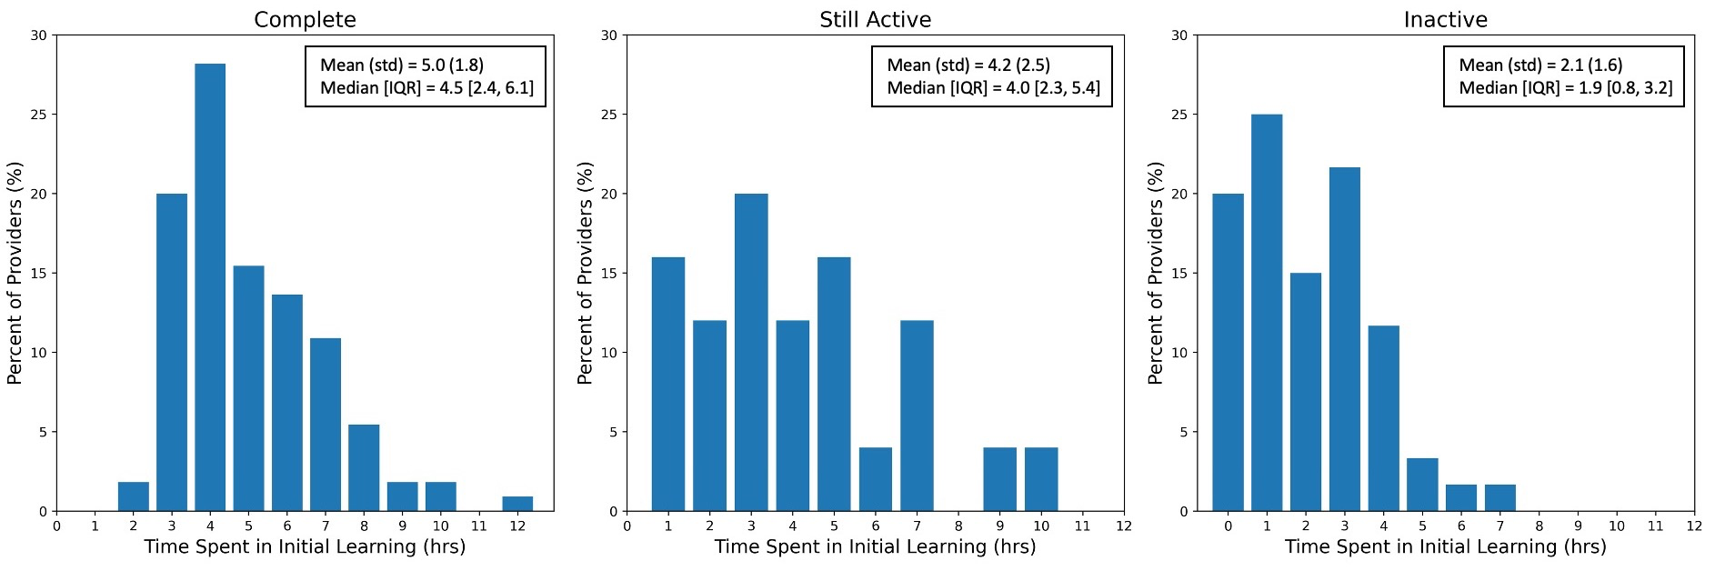
Figure B1 . Figure B2. Figure B3.
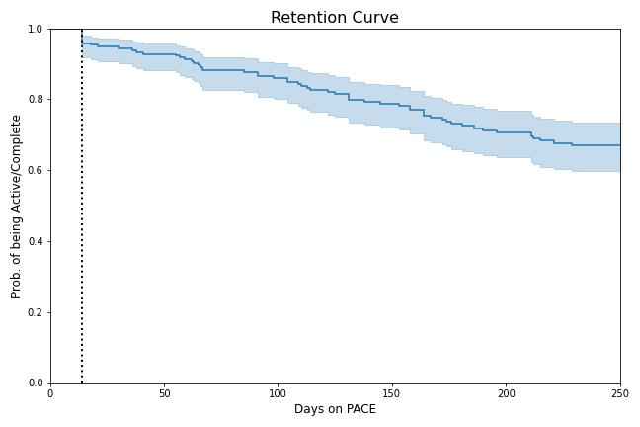
Figure B4.
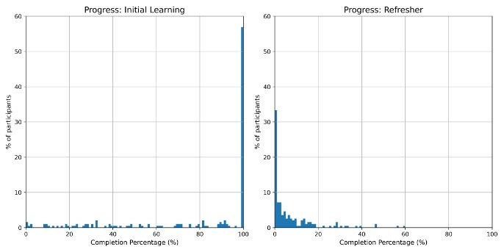
Figure C1, C2. Progress Distribution
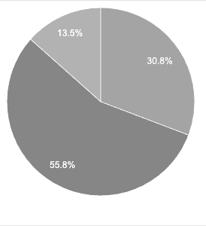
Figure D1: Nudge types

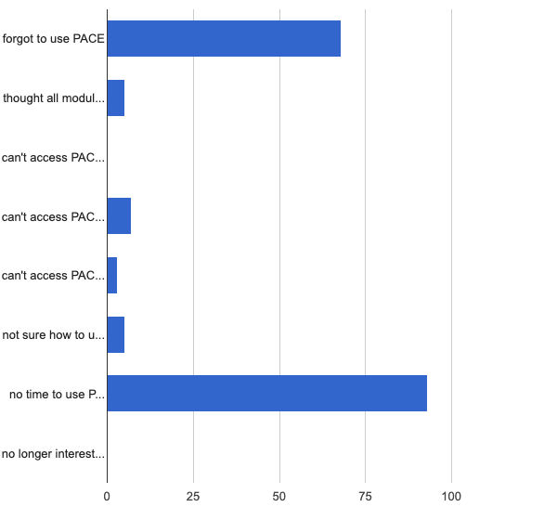
Figure D2: Reasons for > 30days inactivity

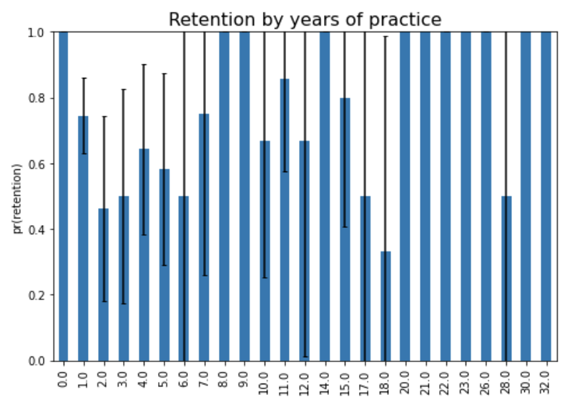
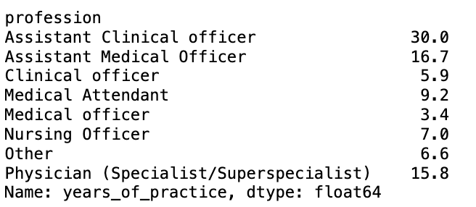

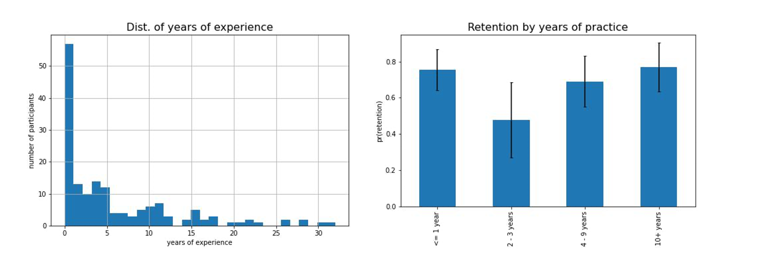
Figure. Years of experience
Providers with 2-3 years of experience have the lowest retention rates.

